Software Requirements Specification (SRS)
Project Title: Online Examination System (OES)
Standard: IEEE 830-1998 Format
1. Introduction
1.1 Purpose
The purpose of this Software Requirements Specification (SRS) document is to define the functional and non-functional requirements of the Online Examination System (OES). It provides a comprehensive description of system behavior, constraints, hardware/software interfaces, and performance expectations.
This document is intended for system architects, software developers, quality assurance testers, project managers, and institutional administrators participating in the development or deployment of the system.
1.2 Scope
The Online Examination System is a web-based application designed to automate and streamline the end-to-end examination process for educational institutions and corporate training programs.
Core Capabilities:
- Role-Based Access: Dedicated portals for Administrators, Instructors/Exam Setters, and Students.
- Exam Authoring: Question bank management supporting multiple question types (MCQs, True/False, Short Answer).
- Scheduling & Assignment: Setting fixed or flexible time windows for specific student batches.
- Secure Test Delivery: Controlled exam environment with dynamic time tracking, question shuffling, and anti-cheating mechanisms.
- Automated & Manual Evaluation: Immediate grading for objective questions and manual scoring workflows for subjective responses.
- Analytics & Reporting: Performance metrics, marksheets, pass/fail ratios, and exportable grade books.

1.3 Definitions, Acronyms, and Abbreviations
Term / Acronym | Definition
OES | Online Examination System
SRS | Software Requirements Specification
MCQ | Multiple Choice Question
GUI | Graphical User Interface
DBMS | Database Management System
RBAC | Role-Based Access Control
HTTPS | Hypertext Transfer Protocol Secure
API | Application Programming Interface

1.4 References
- IEEE Std 830-1998: IEEE Recommended Practice for Software Requirements Specifications.
- UML 2.5 Specification: Object Management Group (OMG).
- OWASP Top 10 Web Application Security Risks (2021).
1.5 Overview
The remainder of this document is organized as follows:
- Section 2 (Overall Description): High-level view of product perspective, user roles, operating environment, and global constraints.
- Section 3 (Specific Requirements): Detailed functional requirements, external interface definitions, and non-functional system attributes.
- Section 4 (Appendices & UML Models): Descriptions of primary use cases, class structures, and event sequence flows.
2. Overall Description
2.1 Product Perspective
The OES is a standalone, web-centric solution operating on a standard 3-Tier Architecture:
- Presentation Layer: Client-side Web GUI built using modern front-end frameworks (HTML5, CSS3, JavaScript/React/Vue).
- Business Logic Layer: Application server (Node.js/Python/Java) handling routing, authentication, evaluation algorithms, and security enforcement.
- Data Storage Layer: Relational DBMS (PostgreSQL/MySQL) storing user profiles, test configurations, item banks, and historical results.
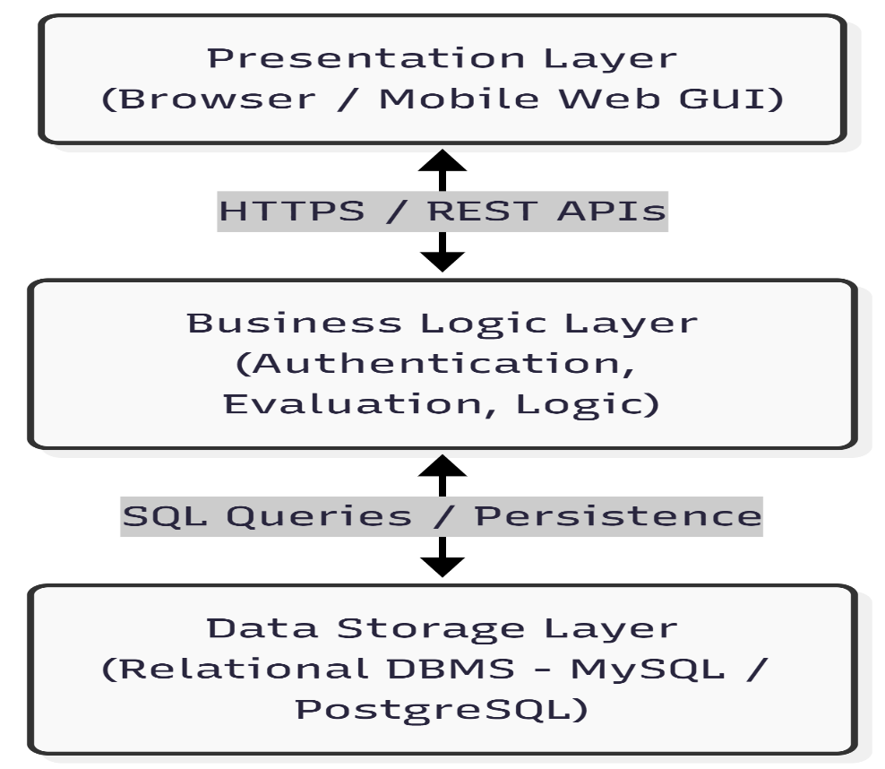

2.2 Product Functions
The system serves three primary user personas:
Administrator Functions
- Manage system users (create, update, deactivate accounts).
- Define system-wide parameters (academic terms, departments, courses).
- Audit activity logs and enforce security policies.
- Generate aggregate analytical reports across courses.
Instructor / Exam Setter Functions
- Create and organize question banks tagged by subject, topic, and difficulty.
- Draft exam papers with configurable rules (duration, passing marks, retake limits).
- Assign exams to specific student groups or cohorts.
- Manually grade subjective/essay responses and publish final scorecards.
Student Functions
- Access a personalized dashboard showing upcoming and completed exams.
- Attempt scheduled exams within a secure, time-bound interface.
- Receive real-time progress indicators (timer, answered/unanswered matrix).
- View instant scores for objective tests and overall grade reports upon publication.
2.3 User Characteristics
User Role | Technical Skill Level | Primary Responsibilities
Administrator | Moderate to High | System configuration, database maintenance, user access control.
Instructor | Basic to Moderate | Question creation, exam scheduling, manual evaluation, grade review.
Student | Basic | System login, exam navigation, answer submission, result checking.
2.4 Constraints
- Connectivity: Requires an active internet connection; brief disconnects must be handled via client-side caching and auto-resync.
- Browser Support: Compatibility limited to modern browser engines (Chrome, Firefox, Edge
- +-, Safari).
- Single Session: A student account may only have one active exam session at any given moment.
- Data Integrity: Exam attempts cannot be reset once submitted without administrator override.
2.5 Assumptions and Dependencies
- Users possess valid login credentials and access to standard desktop or tablet devices.
- Server hosting infrastructure (cloud/on-premise) maintains reliable power and network uptime.
- Browser JavaScript and local storage features remain enabled on student devices.
3. Specific Requirements
3.1 External Interface Requirements
3.1.1 User Interface
- Responsive Dashboard: Adaptive design optimized for desktop screens and tablets (minimum resolution $1024×768$).
- Exam Console UI: Minimalist interface displaying one question at a time or a navigable grid, featuring a prominent, unalterable countdown timer and color-coded status legend (Answered, Unanswered, Marked for Review).
3.1.2 Hardware Interface
- Server: Multi-core x86_64 architecture with a minimum 16 GB RAM and SSD storage.
- Client: Any standard computer or mobile tablet with physical/virtual keyboard and pointing device.
3.1.3 Software Interface
- Database Management System: PostgreSQL 13+ or MySQL 8.0+.
- Notification Services: Integration with SMTP server or third-party API (e.g., SendGrid, Twilio) for sending automated emails and OTP alerts.
3.1.4 Communication Interface
- Protocols: HTTPS (TLS 1.3) for all web transactions to ensure end-to-end encryption.
- Architecture: RESTful Web APIs or WebSockets for bidirectional real-time timer sync and response state saving.
3.2 Functional Requirements
3.2.1 User Authentication & Account Management
- FR-1.1: The system shall support secure registration and account creation using email verification.
- FR-1.2: The system shall authenticate users via unique credentials and enforce Role-Based Access Control (RBAC).
- FR-1.3: The system shall lock an account after 5 consecutive failed login attempts to prevent brute-force attacks.
- FR-1.4: The system shall allow users to reset passwords via automated secure email links.
3.2.2 Question Bank & Exam Creation
- FR-2.1: The system shall allow instructors to create, update, and delete questions (MCQ, True/False, Fill-in-the-Blank, Short Essay).
- FR-2.2: The system shall allow tagging questions by difficulty level (Easy, Medium, Hard), subject, and topic.
- FR-2.3: The system shall enable instructors to configure exam parameters: overall duration, pass percentage, start/end date-time, negative marking, and question order randomization.
- FR-2.4: The system shall support batch uploading of questions via formatted CSV/Excel templates.
3.2.3 Exam Execution & Delivery
- FR-3.1: The system shall grant exam access to registered students strictly within the scheduled time window.
- FR-3.2: The system shall display a real-time countdown timer that automatically triggers submission when time expires.
- FR-3.3: The system shall auto-save student answers every 10 seconds to protect against internet drops or browser crashes.
- FR-3.4: The system shall provide anti-cheating restrictions including blocking copy-paste operations, disabling context menus, and logging tab-switch events.
3.2.4 Evaluation & Score Publishing
- FR-4.1: The system shall immediately auto-grade all objective question responses upon submission.
- FR-4.2: The system shall provide a dedicated portal for instructors to review and manually score subjective/essay questions.
- FR-4.3: The system shall calculate overall marks, percentages, and grade designations according to pre-configured rubrics.
- FR-4.4: The system shall notify students via email or dashboard alert as soon as exam results are officially published.
3.2.5 Reporting & Analytics
- FR-5.1: The system shall generate individual marksheets detailing question-by-question analysis, correct answers, and feedback.
- FR-5.2: The system shall compute batch statistics including average score, median score, standard deviation, and pass/fail percentage.
- FR-5.3: The system shall allow export of grade books in PDF and CSV/XLSX formats.
3.3 Non-Functional Requirements
3.3.1 Performance Requirements
- PR-1: The system shall support at least 500 concurrent active exam sessions without degrading response time beyond 2 seconds per page transition.
- PR-2: Answer auto-save API requests shall complete within $<500\text{ ms}$.
- PR-3: Database queries for score generation shall execute within $<1.5\text{ seconds}$ for a batch of 1,000 students.
3.3.2 Security Requirements
- SR-1: All stored user passwords must be hashed using strong standard algorithms (e.g., bcrypt with salt factor $≥10$).
- SR-2: Session tokens (e.g., JWT) must expire after 30 minutes of inactivity and be stored in HTTP-only cookies.
- SR-3: The system must sanitize all inputs to prevent SQL Injection (SQLi) and Cross-Site Scripting (XSS) vulnerabilities.
3.3.3 Reliability & Availability
- RR-1: System availability shall meet or exceed 99.5% uptime during scheduled academic examination periods.
- RR-2: In the event of a client-side crash or loss of connection, zero answer data entered prior to the last 10-second auto-save checkpoint shall be lost.
3.3.4 Maintainability & Portability
- MR-1: System architecture must maintain separation between API backend and UI frontend using standardized REST APIs.
- MR-2: The application client must render consistently across modern versions of Chrome, Firefox, Safari, and Edge on Windows, macOS, Linux, and Android/iOS browsers.
4. Appendices & UML System Specifications
4.1 Primary Use Case Definitions
UC-1: User Authentication
- Primary Actors: Student, Instructor, Administrator
- Precondition: User is registered in the system database.
- Flow: User enters credentials $→$ System validates role $→$ Redirects to role-specific dashboard.
UC-2: Manage Question Bank
- Primary Actor: Instructor
- Precondition: Instructor is logged in.
- Flow: Select subject $→$ Add/Edit question item $→$ Set correct answer key and point value $→$ Save to Database.
UC-3: Create & Schedule Exam
- Primary Actors: Instructor, Administrator
- Precondition: Question bank contains sufficient items.
- Flow: Set exam metadata (Title, Duration, Schedule) $→$ Attach questions (Manual or Random selection) $→$ Assign student cohort $→$ Publish schedule.
UC-4: Attempt Exam
- Primary Actor: Student
- Precondition: Current time falls within active exam window; student is enrolled.
- Flow: Launch exam interface $→$ Timer begins $→$ Answer questions (auto-saved periodically) $→$ Manual click "Submit" or automatic auto-submit on timer expiration.
UC-5: Evaluate & Publish Results
- Primary Actors: Instructor, System
- Precondition: Exam session closed for all students.
- Flow: System computes objective scores $→$ Instructor manually grades subjective items $→$ Instructor signs off $→$ System updates student scorecards and dispatches notifications.
4.2 Structural & Behavioral Specifications
Class Diagram Conceptual Summary
- User (Base Class): Attributes (UserID, Name, Email, PasswordHash, Role); Methods (Login(), Logout()).
- Student (Subclass): Attributes (RollNumber, Batch); Methods (ViewExams(), AttemptExam(), ViewResult()).
- Instructor (Subclass): Attributes (EmployeeID, Department); Methods (CreateQuestion(), ScheduleExam(), GradeSubjective()).
- Question: Attributes (QuestionID, Text, Type, Marks, Difficulty); Methods (ValidateAnswer()).
- Exam: Attributes (ExamID, Title, Duration, StartTime, PassPercentage); Methods (AddQuestion(), StartExam(), SubmitExam()).
- ExamAttempt: Attributes (AttemptID, Score, Status, StartTime, SubmitTime); Methods (SaveProgress(), CalculateScore()).
Sequence Flow: Attempting an Exam
