Machine Learning

Programming #3

Kirtan Patel PSU ID: 973582669

Algorithm #2 Fuzzy C Means

This is the algorithm of Fuzzy C Means. Centroid Update formula and membership values update formulas are used as explained in lecture. The fuzzifier (m) value is 1:1.

Just like K Means this algorithm is ran for ‘r’ number of times (here r=10) for each ‘c’ value.

Centroids are initiated and membership grades of each data point with respect to ‘c’ clusters. The data points are placed in the clusters based on membership grades and then centroids are updated, and weights are recalculated. We repeat this this until centroids

**Observations:**

**r = 2**

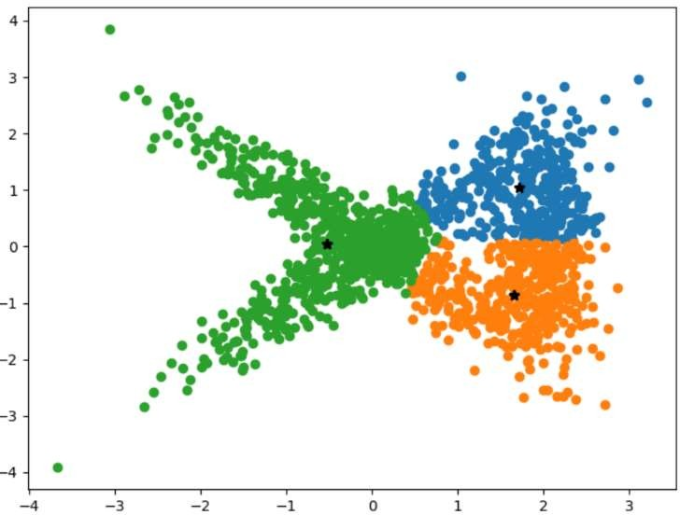

**1. Number of clusters c = 3 r = 1**

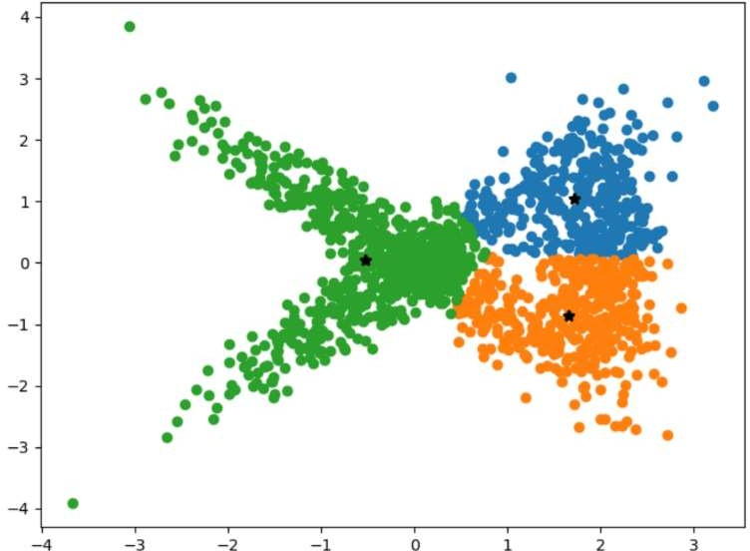

**r = 3 r = 4**

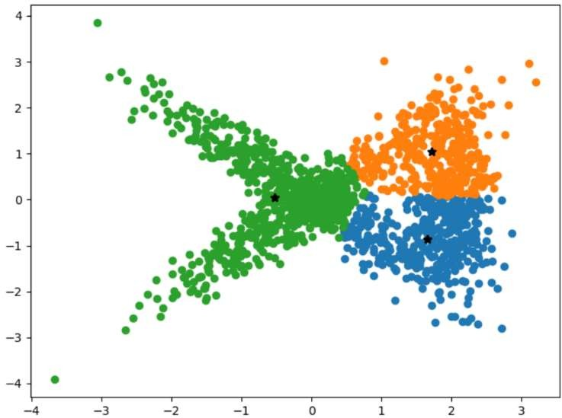 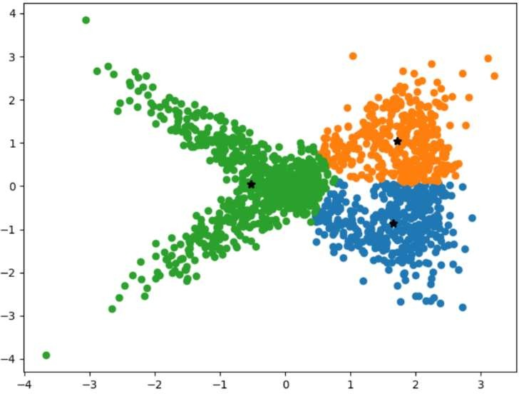

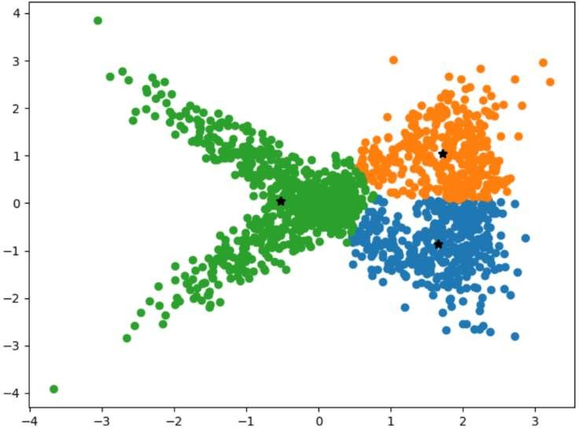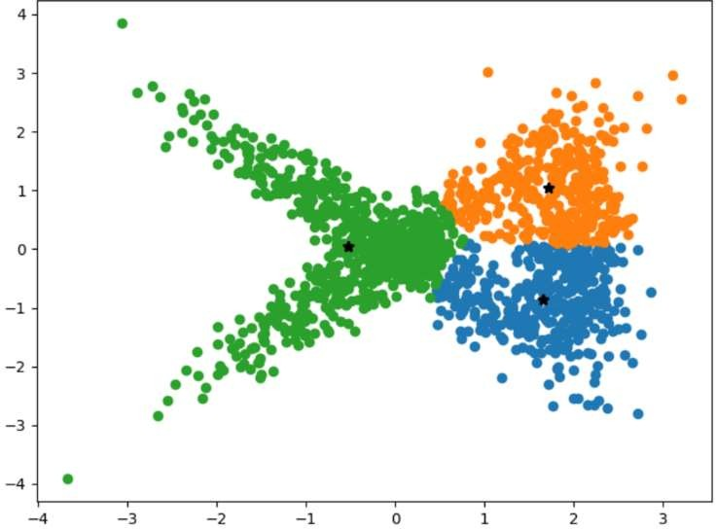**r = 5 r = 6**

**r = 7 r = 8**

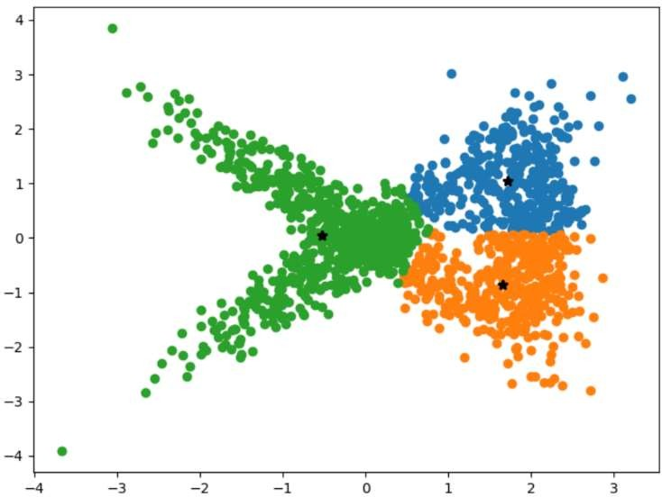 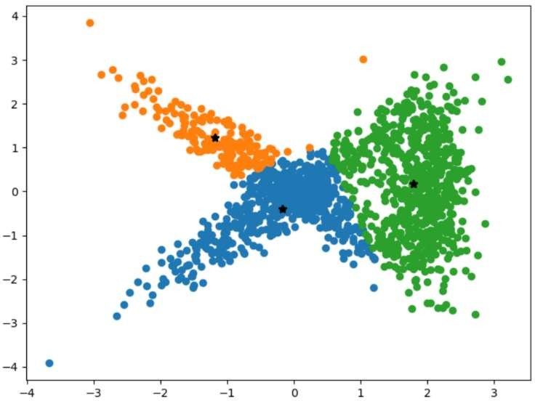

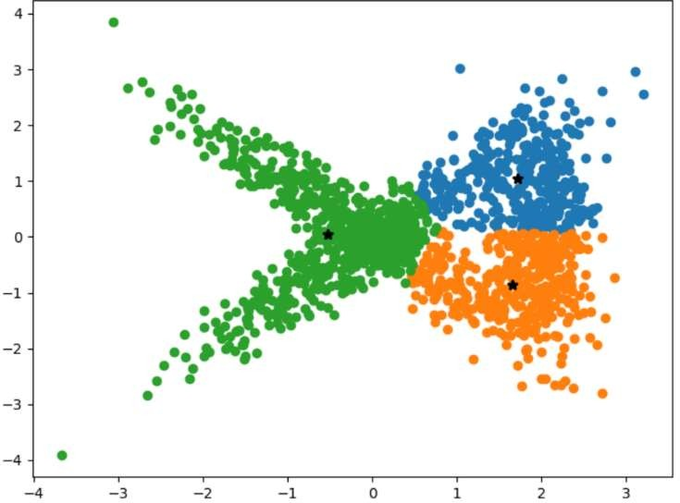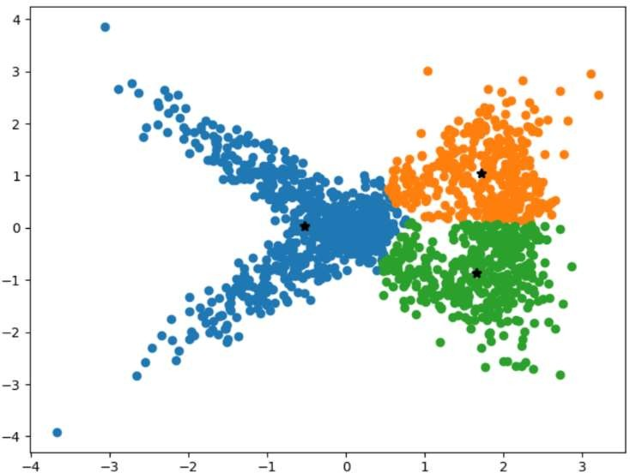**r = 9 r = 10**

**Errors in C=3**



1. **Number of clusters c = 4**

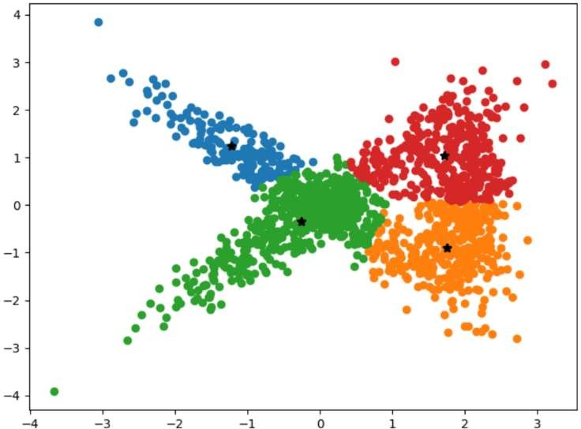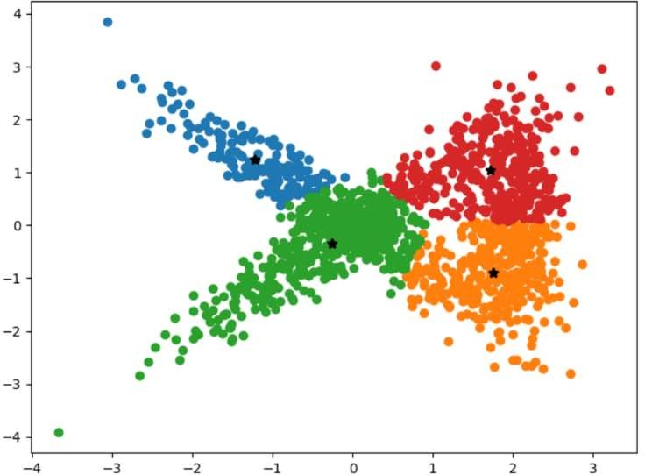**r = 1 r = 2**

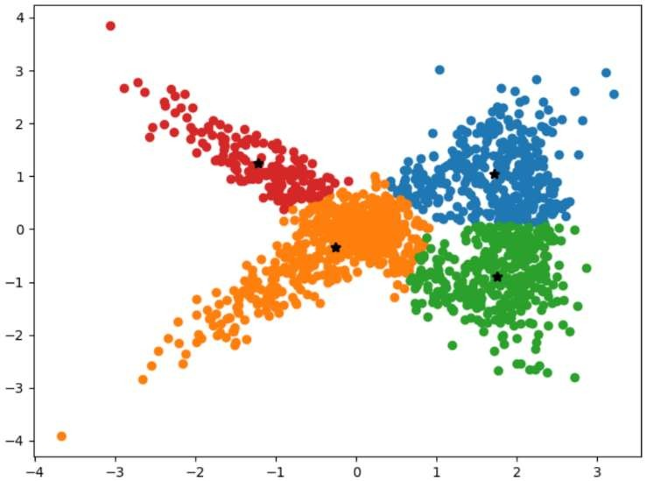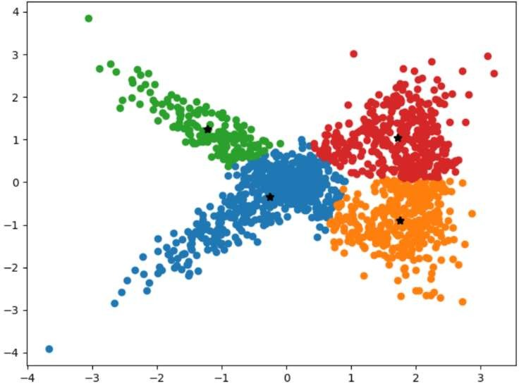 **r = 3 r = 4**

**r = 5 r = 6**

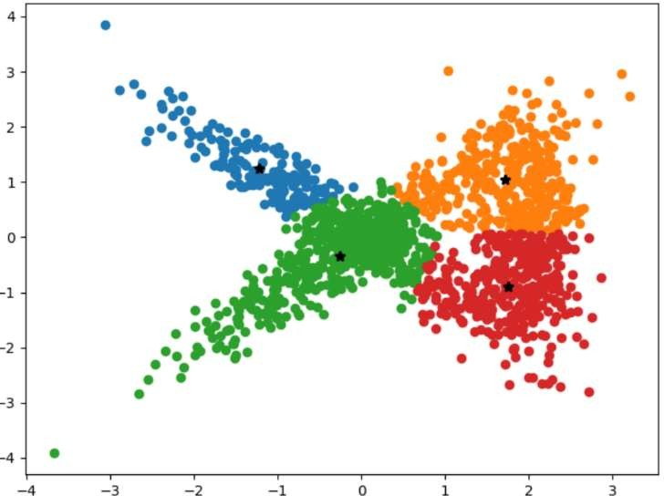 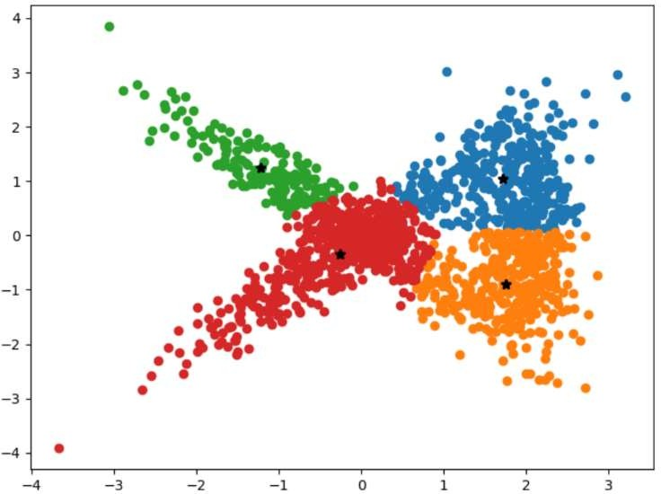

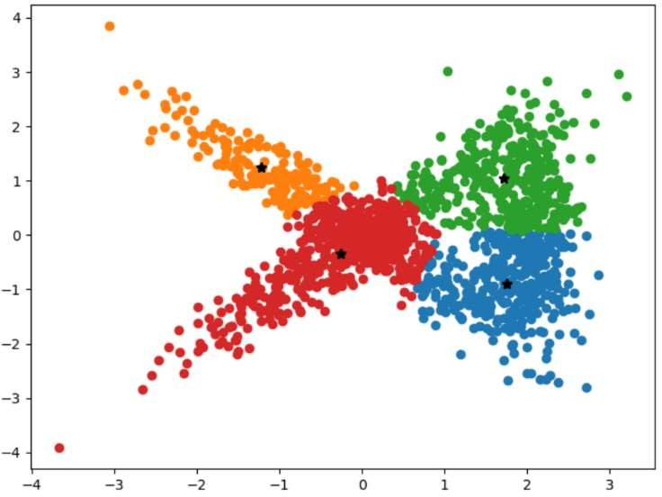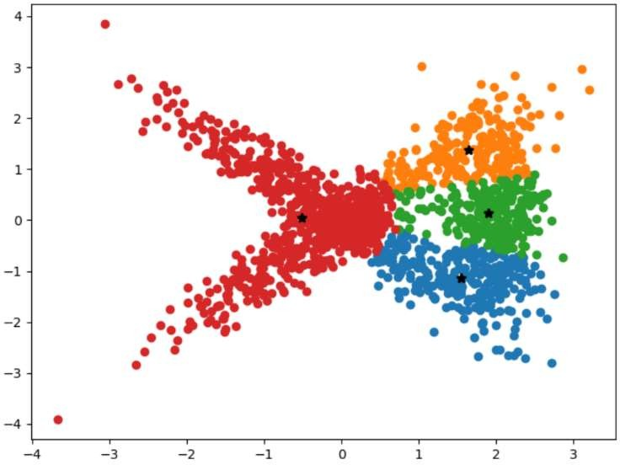 **r = 7 r=8**

**r = 9 r =10**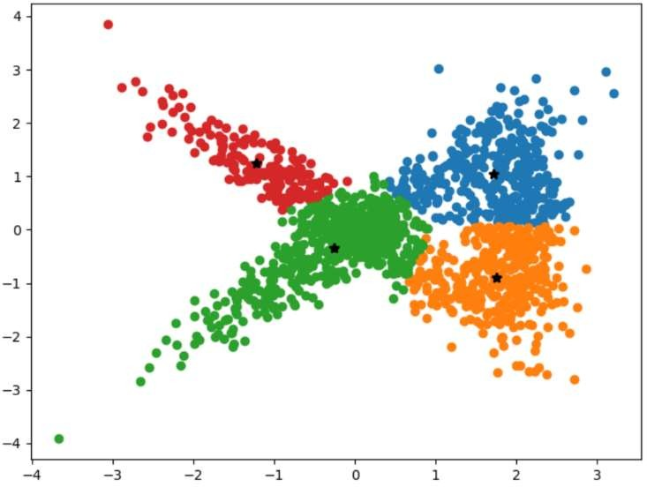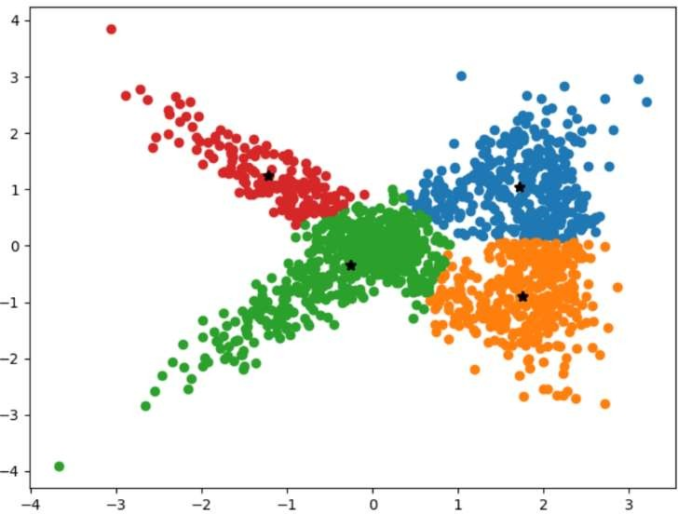

**Errors in C=4**



1. **Number of Clusters c = 5**

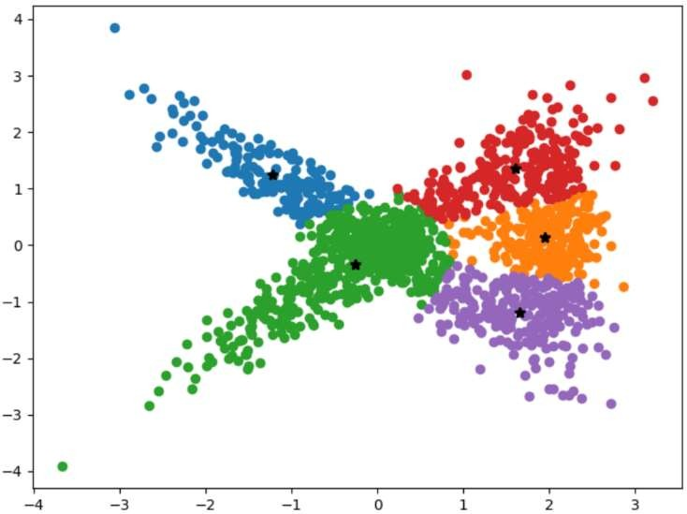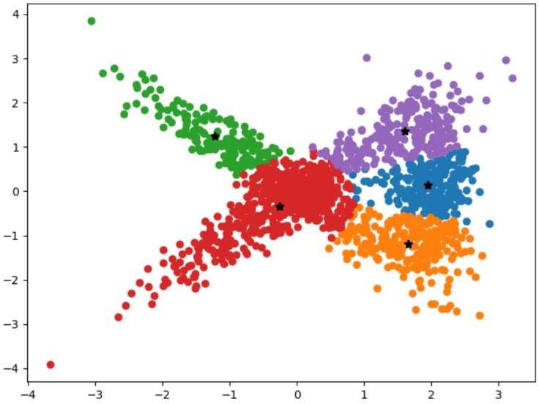**r = 1 r = 2**

**r = 3 r = 4**

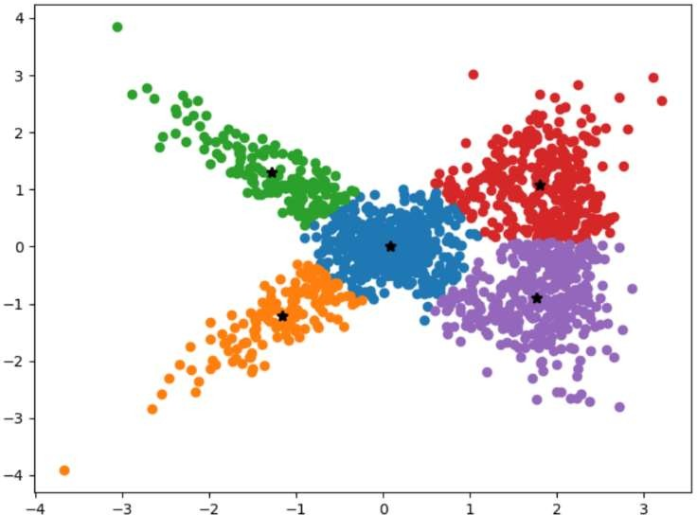 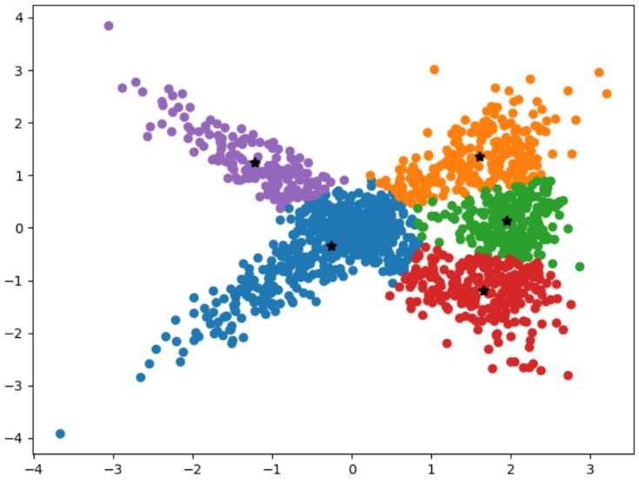

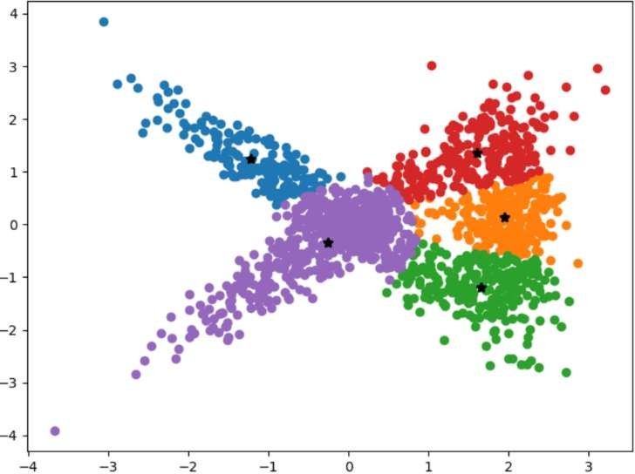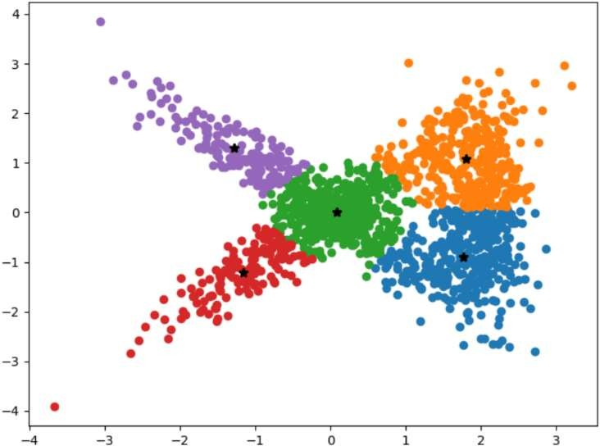**r = 5 r = 6**

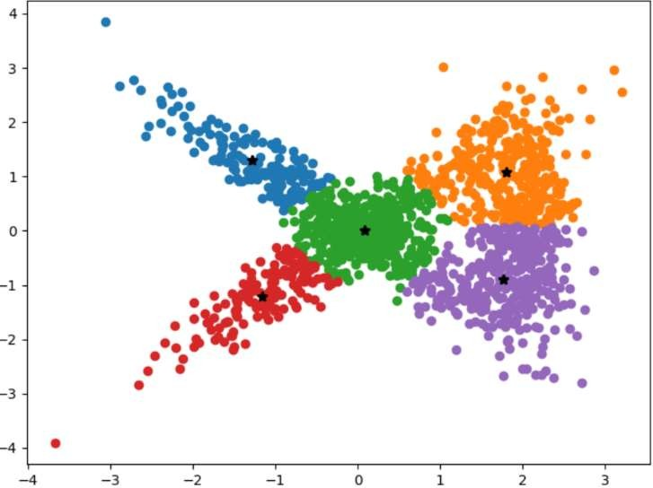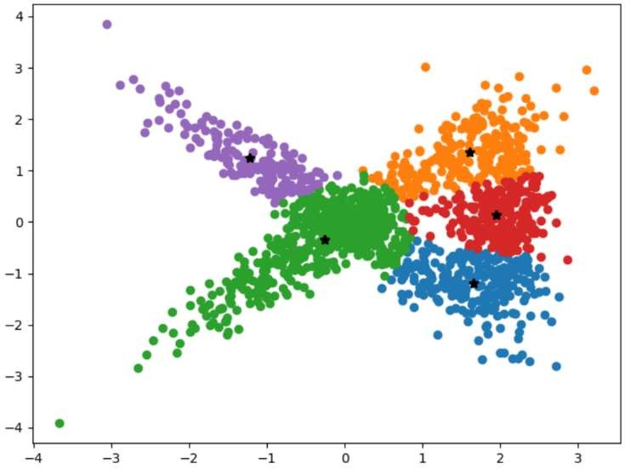**r = 7 r = 8**

**r = 9 r = 10**

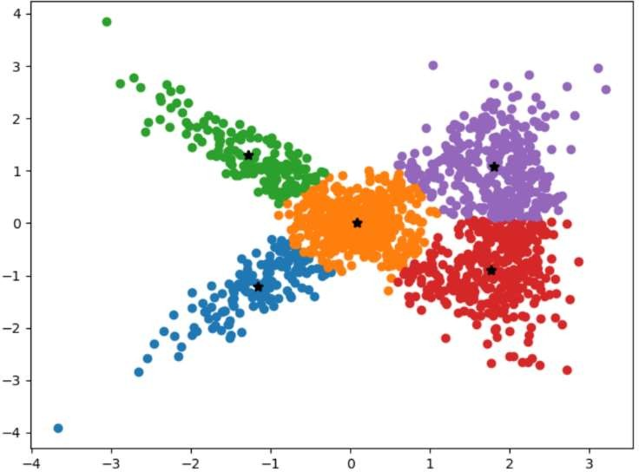 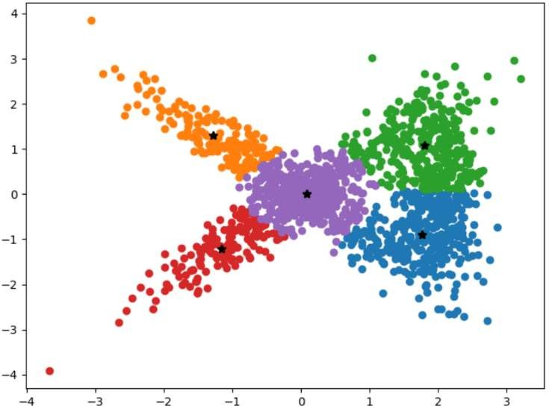

**Errors in c=5**



1. **Number of Clusters c = 7**

**r = 1 r = 2**

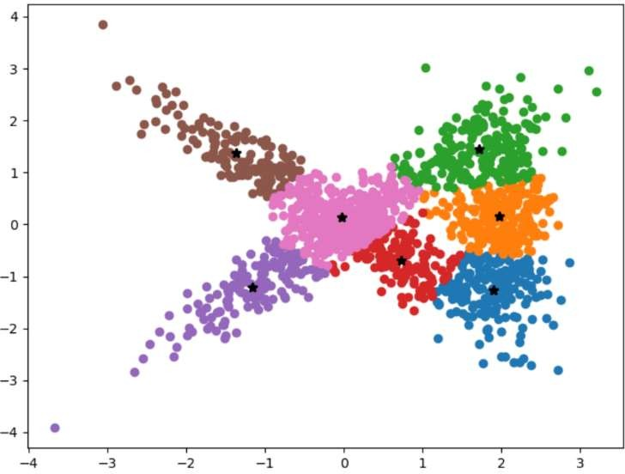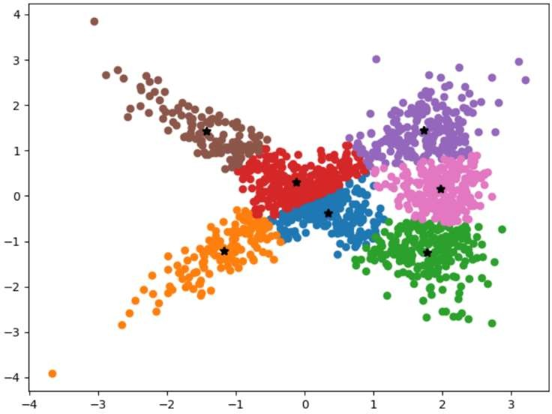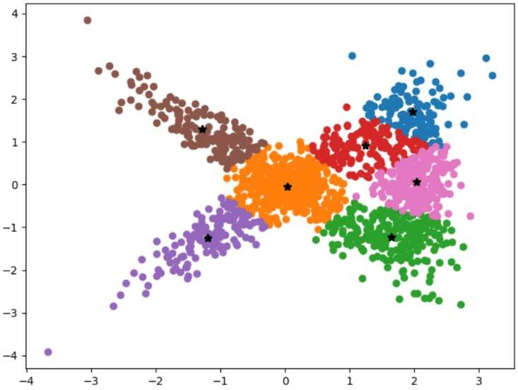

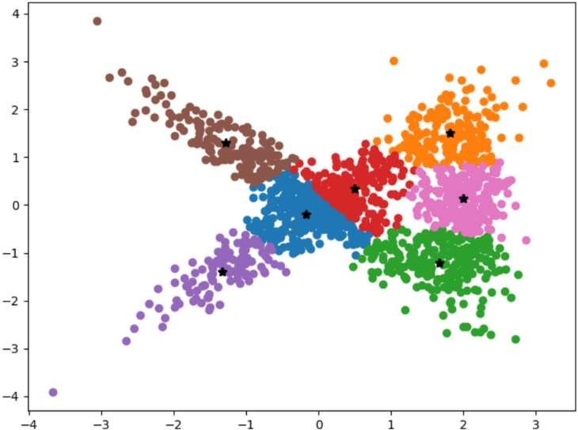 **r=3 r=4**

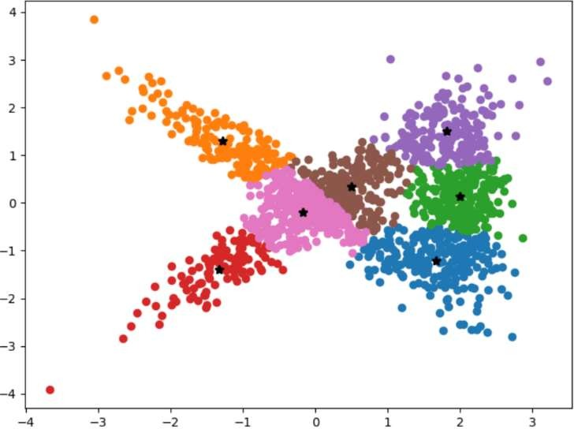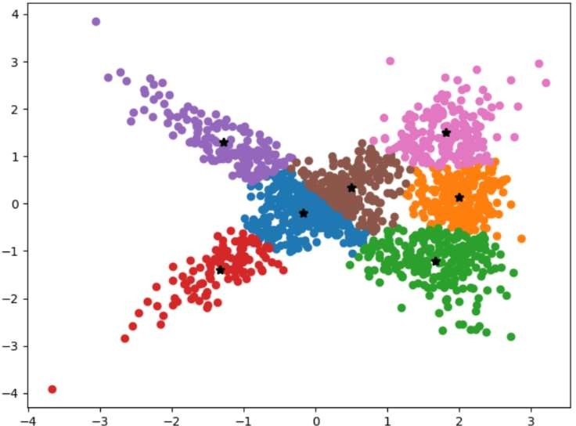**r = 5 r = 6**

**r = 7 r = 8**

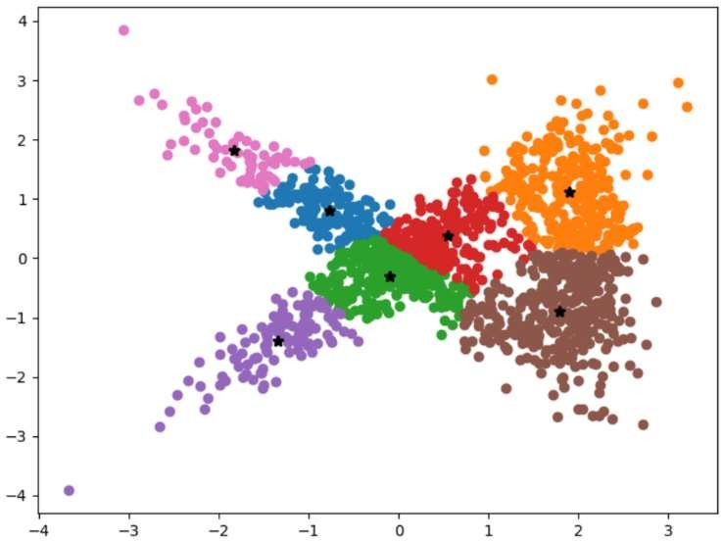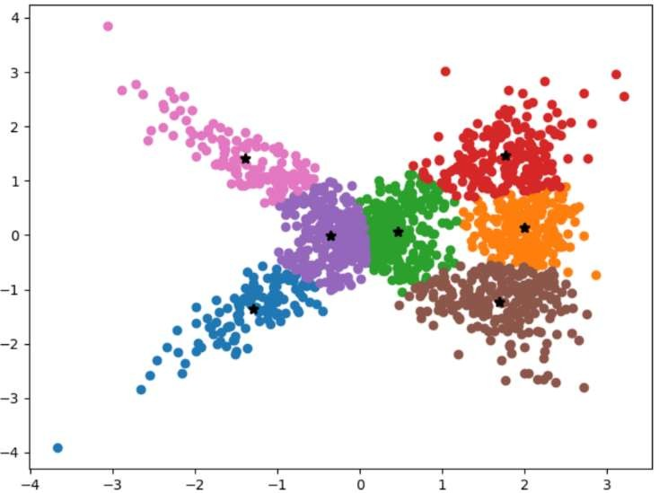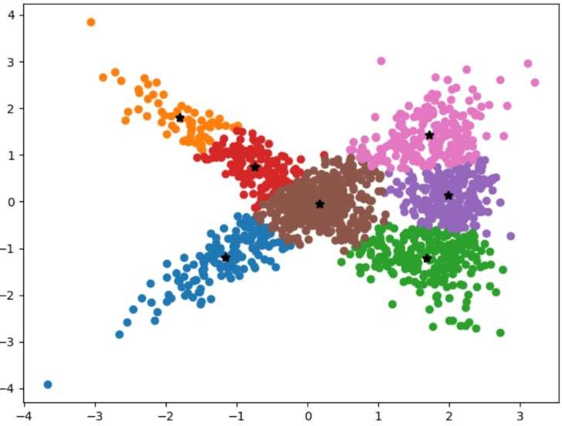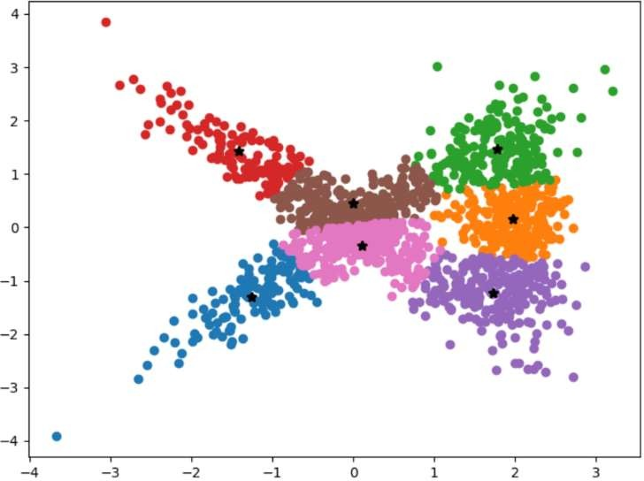

**r = 9** **r = 10**

**Errors in C=7**



1. **Number of clusters c = 8**

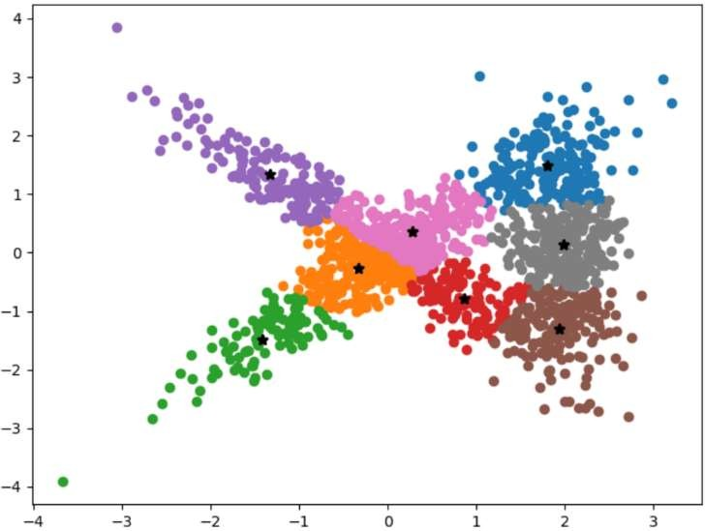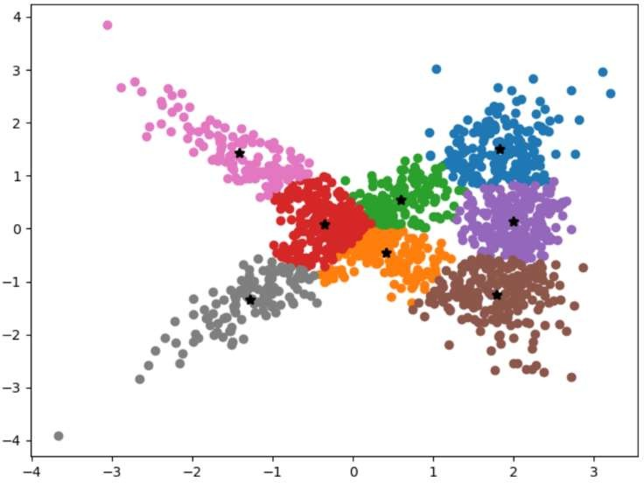**r = 1 r = 2**

**r = 3 r = 4**

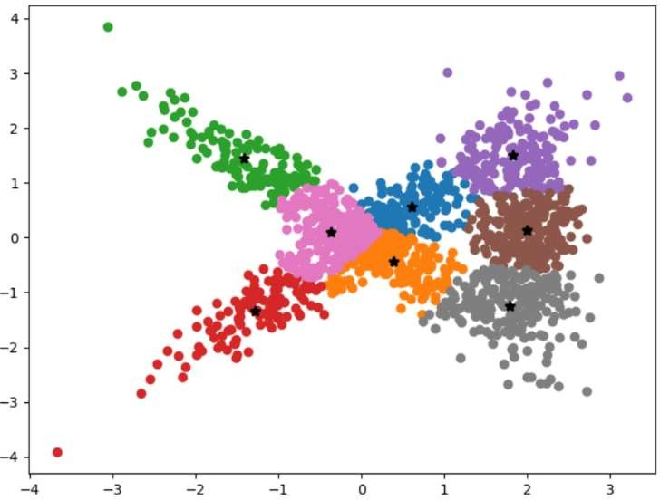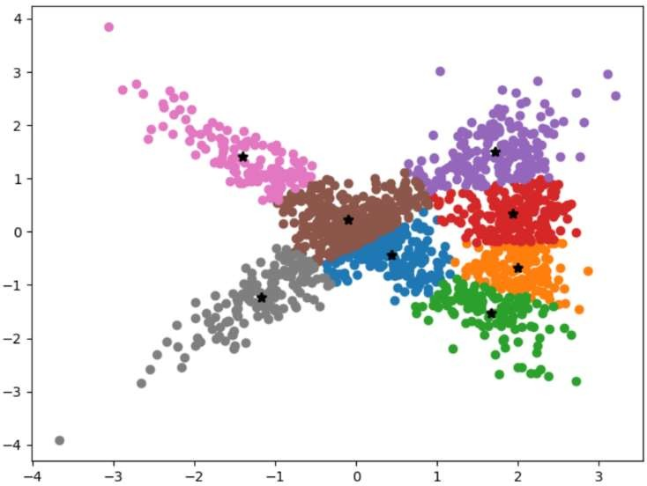

**r = 5 r =6**

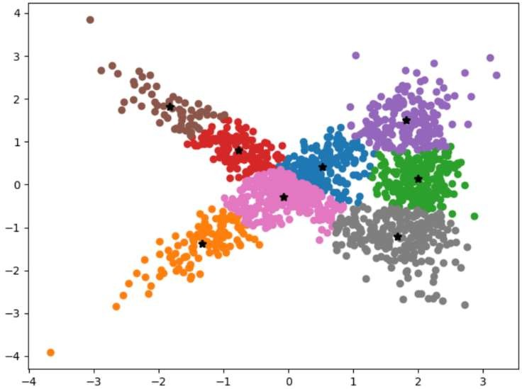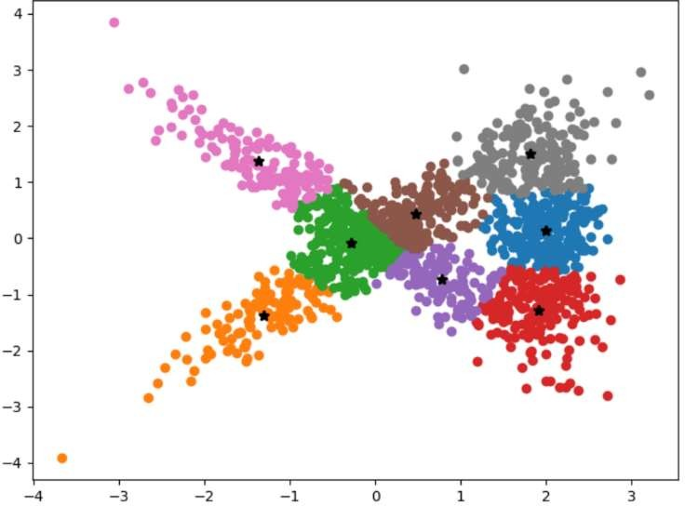

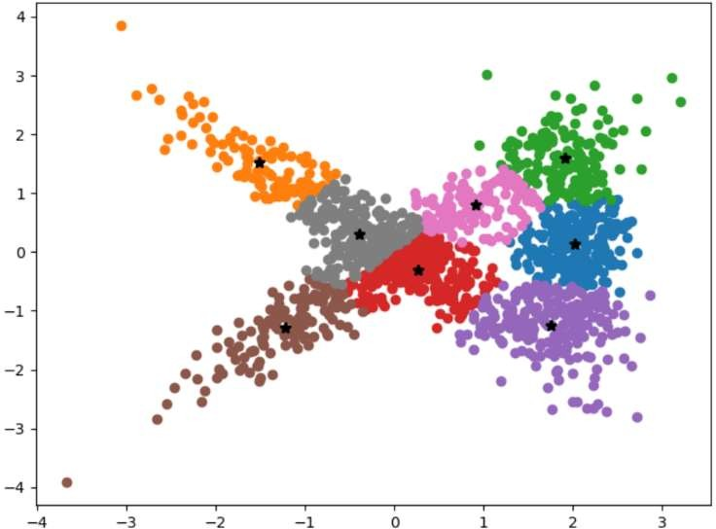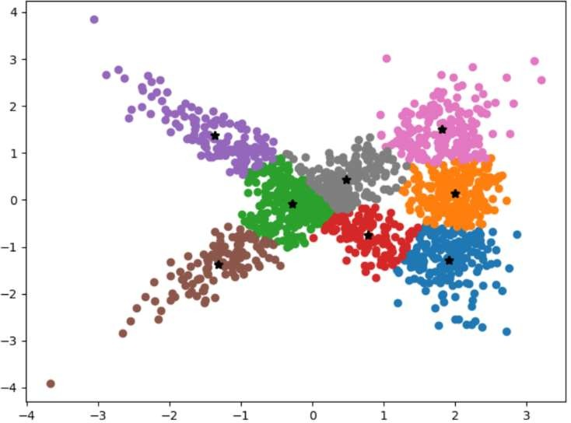**r = 7 r = 8**

**r = 9 r =10**

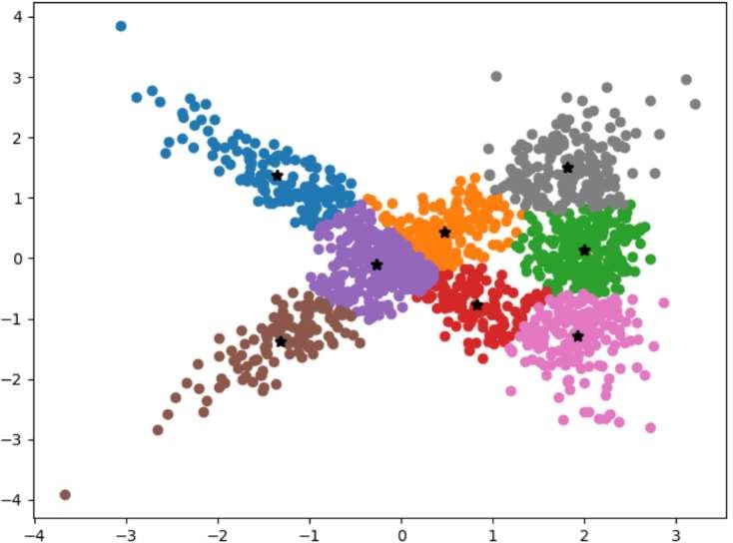 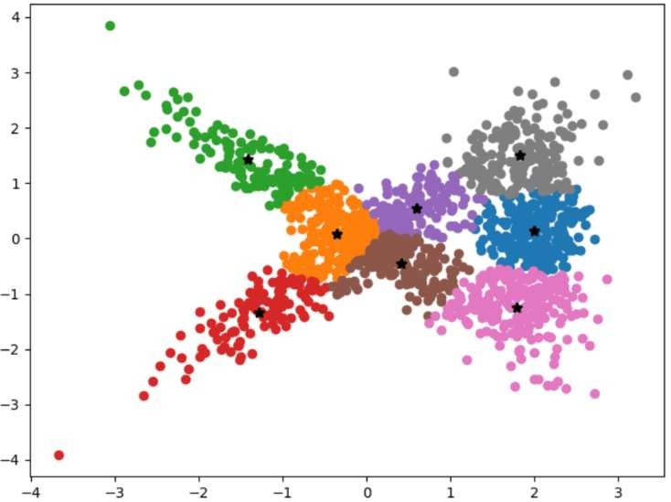

**Errors in C=8**



For different number of clusters ‘c’ (c = 3 to 8). And for each ‘c’ value it is ran for ‘r’ (10) times. Below table shows selected models sum-square-error for each ‘c’ value and ‘r’ value at which that model occurred.

|  |  |  |
| --- | --- | --- |
| **C Value** | **Minimum Sum-Square Error** | **Model occurred at ‘r’** |
| C = 3 | 1536.793 | 10 |
| C = 4 | 1100.432 | 5 |
| C = 5 | 770.895 | 6 |
| C = 6 | 624.607 | 8 |
| C = 7 | 550.547 | 9 |
| C = 8 | 476.817 | 5 |