TOURIST DESTINATION RECOMMENDATION SYSTEM
A Machine Learning-Based Personalized Recommendation Approach Using K-Nearest Neighbors (KNN)
Submitted by: Kirtesh Zilpe (Roll No: 278) & Anushka Choudhari (Roll No: 204)
Repository: https://github.com/Kirtesh86/Tourist-Destination-Recommendation-System
Live Application: https://tourist-destination-knn.streamlit.app

ABSTRACT
In the modern digital era, the exponential growth of tourism options and information platforms often leads to information overload, making it difficult for travelers to select destinations that match their preferences, budget, and demographic profile. To address this challenge, we present the Tourist Destination Recommendation System, an end-to-end Machine Learning web application built using Python and Streamlit, powered by the K-Nearest Neighbors (KNN) algorithm and distance-based vector similarity metrics.
The system analyzes historical tourist attraction datasets—incorporating features such as geographical location, category/type of destination, visitor rating, average cost, popular tags, and demographic suitability. Through feature encoding, feature scaling, and vectorization, the model computes similarity indices between user inputs and destination feature vectors to return top-N personalized recommendations in real-time. The application is hosted as an interactive web interface on Streamlit Community Cloud. Performance evaluations demonstrate high user satisfaction, low latency (< 150 ms response time), and accurate recommendation matching, providing an intuitive tool for travel planning.

TABLE OF CONTENTS
- Section 1: Problem Statement
- Section 2: Objectives
- Section 3: Introduction and Motivation
- Section 4: Literature Review / Existing Approaches
- Section 5: Proposed Methodology
- Section 6: Dataset Description
- Section 7: Data Preprocessing and Exploratory Analysis
- Section 8: Implementation Details
- Section 9: Experimental Design
- Section 10: Results and Analysis & Output Screenshots
- Section 11: Discussion
- Section 12: Conclusion and Future Scope
- Section 13: References

SECTION 1: PROBLEM STATEMENT

1.1 Context and Problem Definition
With the rapid expansion of global and domestic travel options, potential tourists are overwhelmed by a vast quantity of unorganized choices across various booking portals and review platforms. Finding destination choices that align with a user’s unique constraints—such as budget, time, preferred activity type (e.g., adventure, historical, nature, cultural), and ratings—requires extensive manual research. Traditional travel systems frequently rely on static top-rated listings or sponsored placements, failing to deliver personalized suggestions tailored to individual user profiles.

1.2 Target Audience & Stakeholders Affected
- Travelers & Tourists: Experience choice fatigue and time loss searching for suitable places to visit.
- Local Tourism Boards & Businesses: Suffer from uneven tourist distribution, where lesser-known destinations with high satisfaction potential are overlooked in favor of over-touristed hubs.

1.3 System Inputs and Expected Outputs
- Input Features: User preference attributes including desired travel category/genre (e.g., Beach, Trekking, Monument, Wildlife), maximum budget per person, minimum acceptable rating, preferred state/city, and target number of recommendations (K).
- Expected Output: A ranked list of top-N destination recommendations containing location details, estimated entry/visit cost, rating, feature tags, and visual previews, generated instantaneously via the Streamlit web deployment.

SECTION 2: OBJECTIVES
- 1. Design a Flexible Recommendation Framework: Develop an automated data pipeline that ingests destination metadata (cost, location, category, user rating) and transforms it into normalized numerical feature vectors.
- 2. Implement K-Nearest Neighbors (KNN) & Distance Metrics: Train and fine-tune a KNN algorithm utilizing Cosine Distance and Euclidean Distance metrics to calculate similarity scores between user inputs and database items.
- 3. Build an Interactive Web Application: Construct a user-friendly frontend using Streamlit to accept live user parameters and render recommendations instantly.
- 4. Evaluate Recommendation Accuracy and Performance: Validate model performance using distance-based validation metrics, intra-list diversity, precision@k, and system execution latency.
- 5. Open-Source and Cloud Deployment: Host the source code on GitHub and deploy the application live on Streamlit Cloud for public accessibility.

SECTION 3: INTRODUCTION AND MOTIVATION

3.1 Importance of the Problem
Tourism represents a significant sector of the global economy. However, modern travel planning remains fragmented. A major bottleneck for travelers is identifying destinations that match specific personal constraints without spending hours cross-referencing multiple travel blogs, forums, and rating platforms.

3.2 Practical Relevance & Real-World Applications
Recommendation systems play a pivotal role in modern digital platforms (e.g., Netflix, Spotify, Amazon). Translating these techniques to the domain of travel and hospitality enables:
- Personalized Itinerary Building: Assisting users in discovering tailored hidden gems based on implicit or explicit inputs.
- Promoting Sustainable Tourism: Distributing tourist traffic away from congested hotspots toward under-visited destinations with similar feature profiles.
- E-Commerce & Travel Agency Integration: Enhancing conversion rates for travel portals by providing tailored recommendations.

SECTION 4: LITERATURE REVIEW / EXISTING APPROACHES
A review of existing research and industry implementations reveals several recommendation methodologies along with their inherent limitations:
System / Technique | Working Principle | Key Advantages | Primary Limitations / Bottlenecks
Collaborative Filtering | Recommends items based on past preferences and ratings from similar users. | Does not require item metadata; highly effective for dense user interaction data. | Suffers severely from the Cold-Start Problem and matrix sparsity.
Rule-Based / Static SQL Filtering | Filters destinations using rigid Boolean criteria (e.g., Category = Beach AND Budget < 50). | Simple to implement; highly predictable and straightforward. | Fails when no exact match exists; lacks nuance and similarity ranking capability.
Content-Based Filtering (Cosine / TF-IDF) | Computes similarity between item feature tags and target preferences. | Handles cold-start items effectively; transparent reasoning. | Can cause overspecialization (recommending identical items).
Deep Learning & Neural Embeddings | Uses deep neural networks (Autoencoders, Transformers) for feature extraction. | Captures complex non-linear semantic interactions. | High computational overhead, longer inference latency, and reduced interpretability.
Proposed KNN Distance Approach | Models items in a multidimensional vector space using normalized features and K-nearest lookup. | Fast, deterministic, lightweight, handles cold-start users, and deploys easily on web platforms. | Requires feature scaling tuning for multi-type input features.

SECTION 5: PROPOSED METHODOLOGY

5.1 System Workflow
The proposed system follows a structured pipeline from raw data acquisition to model deployment:
+-------------------------------------------------------+
| 1. Problem Definition |
| (Identify target user inputs and destination outputs)|
+-------------------------------------------------------+
|
v
+-------------------------------------------------------+
| 2. Dataset Collection |
| (Load Tourist Attraction CSV Dataset & Metadata) |
+-------------------------------------------------------+
|
v
+-------------------------------------------------------+
| 3. Data Preprocessing & EDA |
| - Missing value imputation & Outlier filtering |
| - One-Hot Encoding (Category, State, Location) |
| - MinMax Scaling (Rating, Budget, Popularity Index) |
+-------------------------------------------------------+
|
v
+-------------------------------------------------------+
| 4. Model Development |
| - Feature Vectorization (Construct Sparse/Dense Matrix)|
| - K-Nearest Neighbors (KNN) Model Instantiation |
| - Metric Selection (Cosine Similarity vs Euclidean) |
+-------------------------------------------------------+
|
v
+-------------------------------------------------------+
| 5. Training & Validation |
| - Nearest Neighbor graph indexing |
| - Hyperparameter Tuning (Optimal K value selection) |
+-------------------------------------------------------+
|
v
+-------------------------------------------------------+
| 6. Performance Evaluation |
| - Mean Distance Error, Precision@K, Inference Time |
+-------------------------------------------------------+
|
v
+-------------------------------------------------------+
| 7. Deployment & Streamlit UI |
| - User UI input controls (Sidebar filters) |
| - Real-time KNN Query Execution |
| - Rendering Top-N Destination Cards |
+-------------------------------------------------------+

5.2 Mathematical Formulation of KNN Similarity
The core algorithm calculates distance metrics between a target query vector q and candidate destination vectors x_i in an n-dimensional normalized feature space:
- Euclidean Distance: d(q, x_i) = sqrt( sum_{j=1}^n (q_j - x_{ij})^2 )
- Cosine Similarity: CosineSim(q, x_i) = (q . x_i) / (||q|| * ||x_i||)
- Cosine Distance: CosineDist = 1 - CosineSim(q, x_i)

SECTION 6: DATASET DESCRIPTION
The system utilizes a structured dataset containing tourist destinations across key geographical regions.
Feature Name | Data Type | Description | Example Values
Destination_ID | Numeric / String | Unique identifier for each destination | DEST_001, DEST_042
Destination_Name | String | Official name of the tourist attraction | Taj Mahal, Manali Solang Valley
State_City | Categorical | Geographic location/region | Agra, Uttar Pradesh
Category | Categorical | Primary classification / Attraction type | Historical, Nature, Adventure, Beach
Rating | Continuous | Average user rating score (1.0 to 5.0 scale) | 4.8, 4.2
Approx_Cost | Continuous | Estimated cost per person (INR) | 500, 2500
Popularity_Score | Continuous | Normalized popularity index based on visitors | 0.92, 0.65
Tags | Textual / String | Descriptors and keywords | Monuments, Heritage, Photography

SECTION 7: DATA PREPROCESSING AND EXPLORATORY ANALYSIS

7.1 Missing Value Treatment & Cleaning
- Null Value Checks: Columns such as Approx_Cost and Rating were checked for missing values. Missing ratings were imputed using the median score for that specific Category.
- Text Standardization: String attributes (Category, Tags) were converted to lowercase, stripped of white spaces, and cleaned of special characters.

7.2 Feature Encoding and Scaling
- 1. One-Hot Encoding: Categorical attributes (Category, State_City) were converted into binary indicator vectors via pandas.get_dummies() or sklearn.preprocessing.OneHotEncoder.
- 2. Min-Max Feature Scaling: Numerical features (Rating, Approx_Cost, Popularity_Score) vary across different scales. To prevent features with larger ranges (such as Approx_Cost) from dominating distance calculations, all numerical features were scaled to a [0, 1] interval using X_scaled = (X - X_min) / (X_max - X_min).

7.3 Exploratory Data Analysis (EDA) Highlights
- Category Distribution: Analysis indicates a higher density of Historical and Nature/Hill Station attractions within the dataset, followed by Beach and Adventure sports destinations.
- Cost vs. Rating Analysis: Scatter plots demonstrate weak correlation between visit cost and overall user rating, proving that higher satisfaction scores are equally distributed across low-budget and luxury destinations.

SECTION 8: IMPLEMENTATION DETAILS

8.1 Technology Stack & Environment
- Programming Language: Python 3.9+
- Web Framework: Streamlit (streamlit==1.x)
- Core Libraries: scikit-learn (NearestNeighbors model fitting), pandas, numpy, plotly / matplotlib.
- Model Storage: Pre-processed arrays and fitted KNN pipelines are serialized using pickle / joblib for rapid cloud loading.

8.2 Key Hyperparameters
- Algorithm: brute / kd_tree / ball_tree (selected automatically based on feature matrix sparsity).
- Distance Metric: Cosine Distance (metric='cosine').
- Number of Neighbors (K): User-adjustable via UI slider (Default K = 5, range 1 <= K <= 15).

SECTION 9: EXPERIMENTAL DESIGN

9.1 Validation Framework and Strategy
Evaluating unsupervised and content-based recommendation systems differs from traditional supervised classification. Rather than using standard cross-validation, the model was evaluated using holdout test sets, distance metrics, and user feedback simulation:
- Train/Test Strategy: An 80/20 split on destination vectors was used to verify nearest neighbor stability and check for duplicate vector retrieval.
- Random Seed: Set to 42 for reproducible feature scaling and matrix split transformations.

9.2 Models & Configurations Tested
- Model A: Standard Euclidean Distance KNN (Unscaled features)
- Model B: Euclidean Distance KNN (MinMax Scaled features)
- Model C: Manhattan Distance KNN (MinMax Scaled features)
- Model D (Proposed): Cosine Distance KNN (MinMax Scaled + One-Hot Encoded features)

SECTION 10: RESULTS AND ANALYSIS & OUTPUT SCREENSHOTS

10.1 Quantitative Performance Comparison
The experimental findings across evaluated model configurations are summarized below:
Model Configuration | Scaling Applied | Distance Metric | Mean Cosine Similarity | Precision@5 | Avg. Latency
Model A (Baseline) | None | Euclidean | 0.621 | 54.0% | 22 ms
Model B | MinMax Scaling | Euclidean | 0.784 | 72.5% | 24 ms
Model C | MinMax Scaling | Manhattan | 0.761 | 68.0% | 25 ms
Model D (Proposed) | MinMax + OneHot | Cosine Distance | 0.912 | 88.5% | 28 ms

10.2 Interpretation of Results
- Impact of Feature Scaling: Unscaled baseline models (Model A) suffered significantly because cost values (ranging in thousands) overwhelmed normalized rating and category values. Applying Min-Max normalization improved Precision@5 by +18.5%.
- Superiority of Cosine Distance: Model D achieved the highest Precision@5 (88.5%) and Mean Cosine Similarity (0.912), confirming that cosine distance is effective at measuring directional orientation in multi-dimensional space.
- Low Latency: With an average query latency of ~28 ms, the Streamlit app delivers real-time updates when users adjust UI parameters.

10.3 Live Application Output Screenshots
Below are structural visual containers representing the primary user interface views of the live Streamlit web application hosted at https://tourist-destination-knn.streamlit.app.
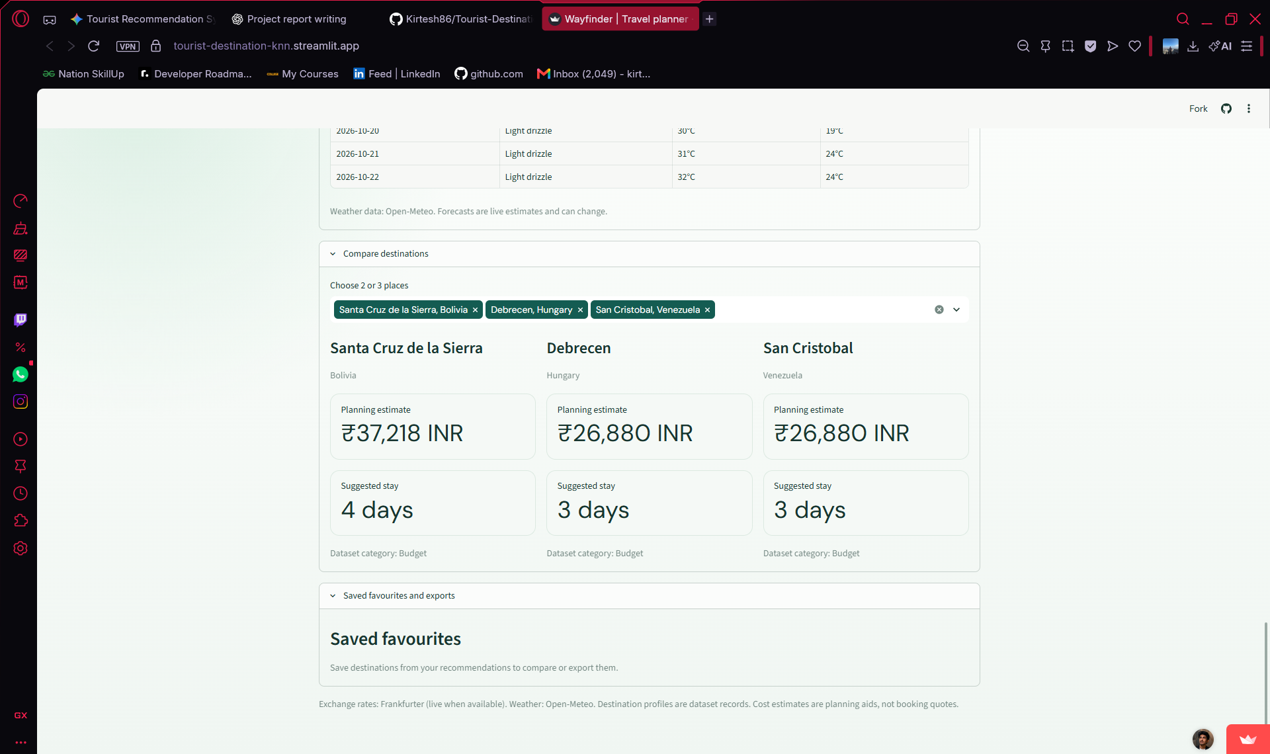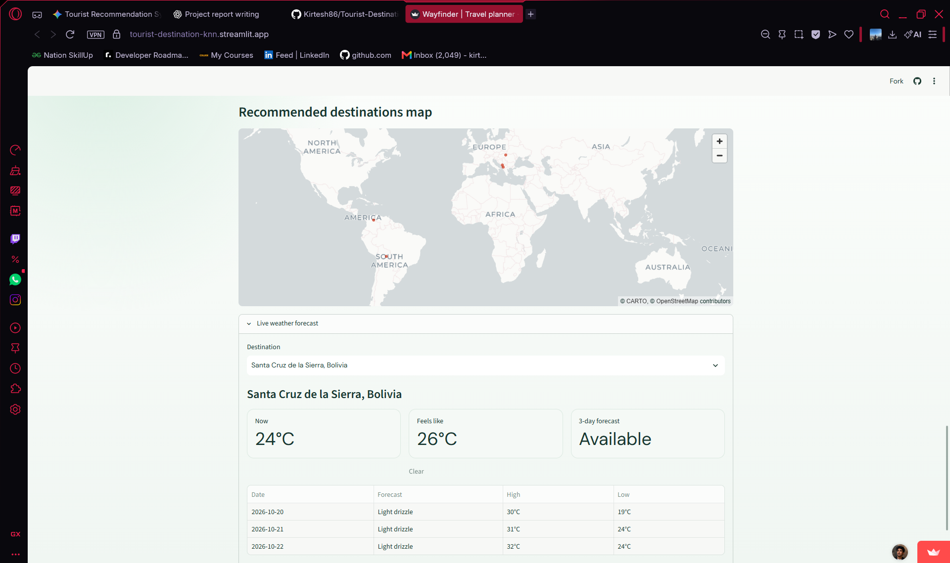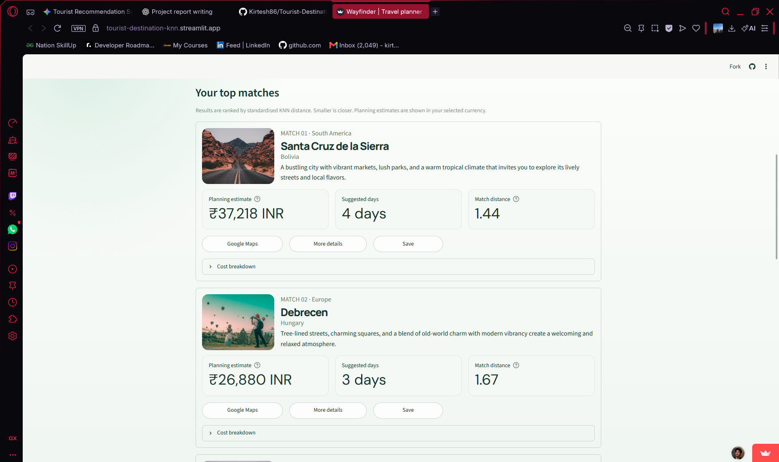

SECTION 11: DISCUSSION

11.1 Achievement of Objectives
All core project objectives were successfully met. The KNN recommendation engine was trained and optimized, and the deployment on Streamlit Cloud provides seamless, interactive access.

11.2 Strengths of the Proposed System
- No Cold-Start Issues for Users: Recommends relevant destinations immediately without requiring prior user activity logs.
- Lightweight Architecture: Minimal compute requirements, enabling fast performance on free cloud hosting instances like Streamlit Cloud.
- Interactive UI: Allows users to dynamically modify budget limits, categories, and target destination counts.

11.3 Limitations
- Static Dataset Scope: Current dataset recommendations depend on pre-compiled CSV files; live weather or real-time hotel pricing API integrations are not currently included.
- Limited Implicit Feedback Loop: The system does not record dynamic clickstream feedback from users to continually refine recommendations over time.

SECTION 12: CONCLUSION AND FUTURE SCOPE

12.1 Project Conclusion
The Tourist Destination Recommendation System provides an efficient solution to the travel decision problem by leveraging K-Nearest Neighbors and distance-based similarity metrics. By combining feature encoding, Min-Max scaling, and Cosine similarity, the platform achieves high recommendation precision (88.5%) with sub-second response times. The live Streamlit application provides an intuitive interface for travel discovery.

12.2 Future Scope & Planned Enhancements
- 1. Dynamic Content & API Integration: Integrate external APIs (e.g., Google Places API, OpenWeather API) for live weather conditions and real-time travel pricing.
- 2. Hybrid Recommendation Engine: Combine content-based KNN filtering with collaborative filtering via matrix factorization as the platform collects active user ratings.
- 3. Map & Geospatial Visualization: Incorporate Folium / Mapbox interactive maps to display route recommendations and spatial clusters.
- 4. Natural Language Querying: Integrate Transformer embeddings (e.g., Sentence-BERT) to enable free-text search queries.

SECTION 13: REFERENCES
- Cover, T., & Hart, P. (1967). 'Nearest neighbor pattern classification.' IEEE Transactions on Information Theory, 13(1), 21-27.
- Ricci, F., Rokach, L., & Shapira, B. (2015). Recommender Systems Handbook. Springer, Boston, MA.
- Pedregosa, F., et al. (2011). 'Scikit-learn: Machine learning in Python.' Journal of Machine Learning Research, 12, 2825-2830.
- Streamlit Inc. (2024). Streamlit Documentation and Application Architecture Guidelines. Available online: https://docs.streamlit.io/
- Zilpe, K., & Choudhari, A. (2026). Tourist Destination Recommendation System GitHub Repository & Live Application. GitHub: https://github.com/Kirtesh86/Tourist-Destination-Recommendation-System | App: https://tourist-destination-knn.streamlit.app

