DSA0502 – QUERY PROCESSING FOR DATA SCIENCE
CO2 – AT1 – DESIGN AND CONNECTIVITY
NAME: B KIRTHANAA REG. NO – 192324244

Experiment 1: Hotel Reservation and Booking System
Question
Develop a Hotel Reservation and Booking System using Python and SQLite. The system should maintain customer information, room details, reservations, and payments. It should demonstrate customer management, room booking, reservation updates, and invoice generation while maintaining a normalized database structure.
Aim:
To design and implement a Hotel Reservation and Booking System using Python and SQLite for managing customers, rooms, bookings, payments, reservation updates, and invoice generation.
Program:
import sqlite3

# Connect Database
conn = sqlite3.connect("hotel.db")
cur = conn.cursor()

# Create Tables
cur.execute("CREATE TABLE IF NOT EXISTS Customer(ID INTEGER, Name TEXT)")
cur.execute("CREATE TABLE IF NOT EXISTS Room(RoomNo INTEGER, Type TEXT, Price INTEGER, Status TEXT)")
cur.execute("CREATE TABLE IF NOT EXISTS Booking(ID INTEGER, CustomerID INTEGER, RoomNo INTEGER, CheckIn TEXT, CheckOut TEXT)")
cur.execute("CREATE TABLE IF NOT EXISTS Payment(ID INTEGER, BookingID INTEGER, Amount INTEGER)")

# Clear Old Data
cur.execute("DELETE FROM Customer")
cur.execute("DELETE FROM Room")
cur.execute("DELETE FROM Booking")
cur.execute("DELETE FROM Payment")

# Insert Data
cur.execute("INSERT INTO Customer VALUES(1,'Rahul')")
cur.executemany("INSERT INTO Room VALUES(?,?,?,?)",[
(101,"Standard",2000,"Available"),
(102,"Deluxe",3000,"Available"),
(103,"Suite",5000,"Available")
])

# Book Room
cur.execute("INSERT INTO Booking VALUES(1,1,101,'2026-08-01','2026-08-03')")
cur.execute("UPDATE Room SET Status='Booked' WHERE RoomNo=101")
cur.execute("INSERT INTO Payment VALUES(1,1,6000)")
conn.commit()

# Show Booking
print("Booking Details")
cur.execute("""
SELECT Name, RoomNo, CheckIn, CheckOut
FROM Customer, Booking
WHERE Customer.ID = Booking.CustomerID
""")
for row in cur.fetchall():
print(row)

# Update Booking
cur.execute("UPDATE Booking SET CheckOut='2026-08-04' WHERE ID=1")
conn.commit()

print("\nUpdated Booking")
cur.execute("SELECT * FROM Booking")
print(cur.fetchall())

# Show Invoice
print("\nInvoice")
cur.execute("""
SELECT Customer.Name, Payment.Amount
FROM Customer, Booking, Payment
WHERE Customer.ID=Booking.CustomerID
AND Booking.ID=Payment.BookingID
""")
for row in cur.fetchall():
print(row)

conn.close()

OUTPUT:
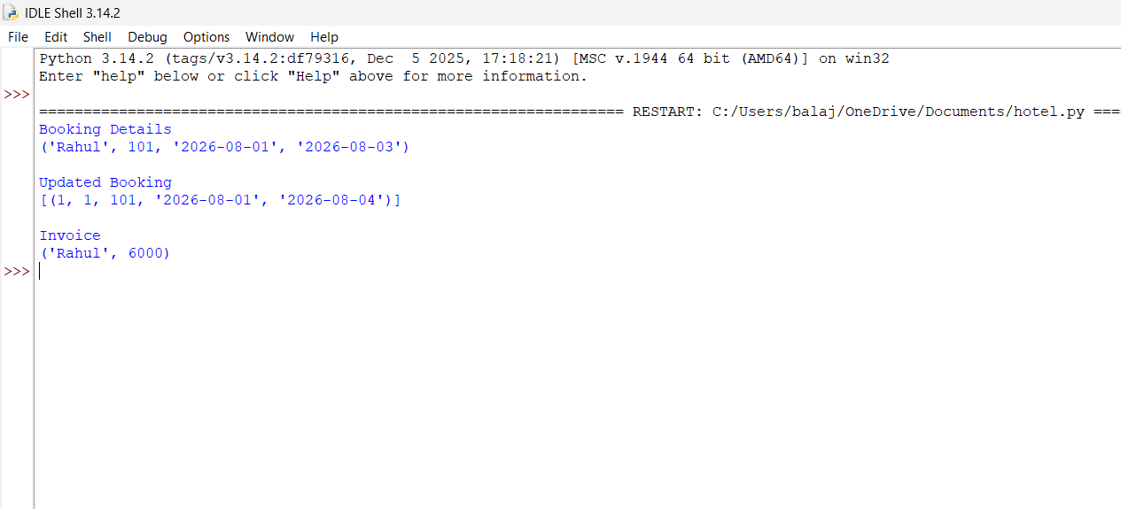

Experiment 2: Employee Payroll Management System
Question
Develop an Employee Payroll Management System using Python and SQLite. The system should maintain employee details, department information, attendance records, salary details, and payroll information. It should demonstrate employee management, payroll generation, salary updates, and payroll display using database connectivity.
Aim
To design and implement an Employee Payroll Management System using Python and SQLite for managing employee details, departments, attendance, salary, and payroll generation.
Program
import mysql.connector

# Connect to MySQL
conn = mysql.connector.connect(
host="localhost",
user="root",
password="kirth123",
database="employee_payroll"
)

cur = conn.cursor()

# Create Tables
cur.execute("""
CREATE TABLE IF NOT EXISTS Employee(
ID INT PRIMARY KEY,
Name VARCHAR(50),
Salary INT
)
""")

cur.execute("""
CREATE TABLE IF NOT EXISTS Payroll(
ID INT PRIMARY KEY,
Tax INT,
NetSalary INT
)
""")

# Delete Old Data
cur.execute("DELETE FROM Employee")
cur.execute("DELETE FROM Payroll")

# Insert Employee
cur.execute("INSERT INTO Employee VALUES(1,'Rahul',30000)")

# Calculate Payroll
salary = 30000
tax = 3000
net = salary - tax

cur.execute("INSERT INTO Payroll VALUES(%s,%s,%s)", (1, tax, net))

conn.commit()

# Display Employee Details
print("Employee Details")
cur.execute("SELECT * FROM Employee")
for row in cur.fetchall():
print(row)

# Update Salary
cur.execute("UPDATE Employee SET Salary=32000 WHERE ID=1")
cur.execute("UPDATE Payroll SET Tax=3200, NetSalary=28800 WHERE ID=1")
conn.commit()

# Display Payroll
print("\nPayroll Details")
cur.execute("""
SELECT Employee.Name, Employee.Salary, Payroll.Tax, Payroll.NetSalary
FROM Employee
JOIN Payroll
ON Employee.ID = Payroll.ID
""")

for row in cur.fetchall():
print(row)

conn.close()
OUTPUT:
