**Date: 20 June 2025**

**Report and Data Analytics Feedbacks:**

**Operator Report (Past Date Analysis – 10/06/2025):**

1. Operator ID 16 shows a total duration of 10h 36m. Break time was included under Mode3, as previously explained on 16/06/2025.

**Machine ID Report (Past Date Analysis – 19/06/2025):**

1. While navigating from All Machines → Single Machine ID → All Machines, the dashboard is displays a white screen. It returns to normal upon manual refresh.
2. Production Time and NPT Time calculations have been verified.
3. Needle Time for individual machine IDs appears correct. However, the overall Needle Time % for all machine IDs seems inconsistent. ex: In raw data report wise calculation, the Needle Time % is 31.45%, whereas the dashboard displays 24.70% for Line 6. Kindly verify needle time calculation on dashboard.
4. 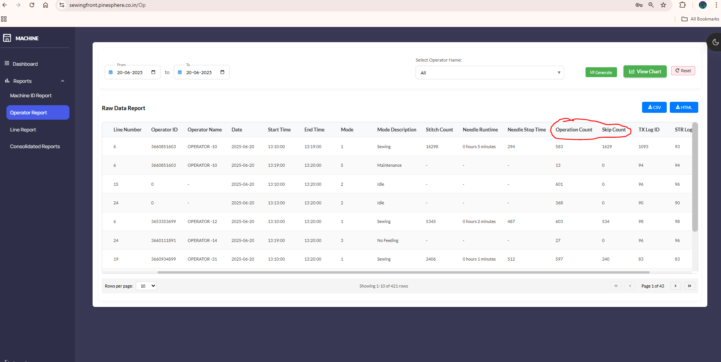In the raw data table of the Operation Report and Line Report, the column titles for Duration and SPM are incorrectly labelled as Operation Count and Skip Count.

**Line Report (Past Date Analysis – 19/06/2025):**

1. While navigating from All Lines → Single Line → All Lines, the dashboard temporarily shows a white screen, which resolves upon refreshing.
2. Production Time and NPT Time are verified.
3. 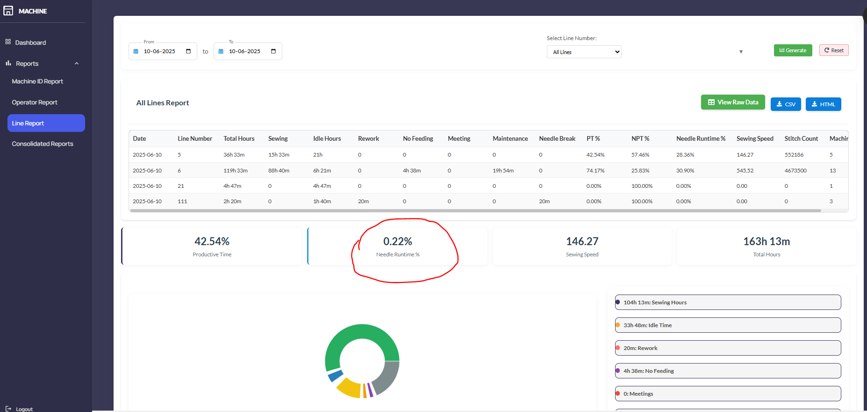Needle Time % needs to recheck: Line 6 summary shows in dash board 0.07%, but raw data wise report calculation indicates 31.45%.
4. 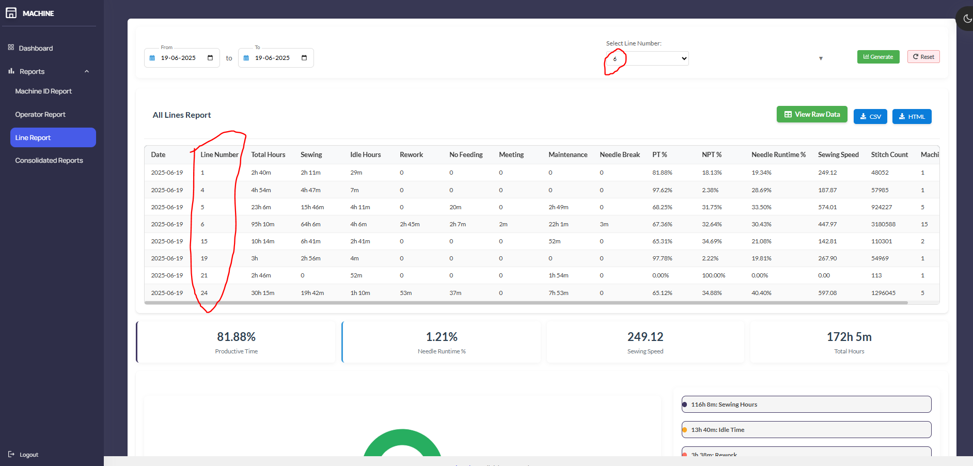Sometimes selecting an individual line report, the summary unexpectedly shows data for all lines.

**Date: 17 June 2025**

**Report and Data Analytics:**

Take data between 8:30AM and 7:30PM.

Morning break- 10:30 to 10:40, Lunch- 13:20 to 14:00, Evening break- 16:20 to 16:30.

If start time is >=10:30 and end time is<= 10:40 or

If start time is >=13:20 and end time is<= 14:00 or

If start time is >=16:20 and end time is<= 16:30, then omit this data.

Total data available will be for 10 Hours.

**FAQS:**

1. If operator is in sewing mode during morning break till 10:32, then what should we do with the data from 10:30 to 10:32?
2. If operator is in no feeding mode during lunch break till 13:32, then what should what should we do with the data from 13:20 to 13:30 and 13:30 to 13:32?
3. If operator is in maintenance mode during morning break from till 16:10 to 16:50, then we will data for every 10 mins. We should omit the data between 16:20 and 16:30.

**Machine or Line wise Calculation report:**

1. Select the data of the chosen machines or line between from date and to date entered by the user.
2. Don’t consider line number or operator id.
3. There is no difference in calculation between past date and current date.
4. There is no difference in calculation between Specific (Machine or Line) and Consolidated report.

|  |  |  |
| --- | --- | --- |
| **S.no** | **Description** | **Calculation** |
| 1 | Sewing | Sum of all Mode-1 duration |
| 2 | Idle | Sum of all Mode-2 duration |
| 3 | Rework | Sum of all Mode-6 duration |
| 4 | No feeding | Sum of all Mode-3 duration |
| 5 | Meeting | Sum of all Mode-4 duration |
| 6 | Maintenance | Sum of all Mode-5 duration |
| 7 | Needle break | Sum of all Mode-7 duration |

|  |  |  |
| --- | --- | --- |
| **S.no** | **Description** | **Calculation** |
| 1 | Productive time - PT | Sewing Hours |
| 2 | Non-productive time - NPT | Sum of mode-2 to Mode-7 duration. |
| 3 | Total Hours | PT + NPT |
| 4 | PT% | PT/Total hours * 100 |
| 5 | NPT% | NPT/Total hours * 100 |
| 6 | Needle time % | Total needle run time/PT * 100 |
| 7 | SPM | Total SPM / Number of instances. |

**Operator wise Calculation report:**

1. Select the data of the chosen operator from date and to date entered by the user.
2. Don’t consider machine id or line id.
3. There is difference in calculation between past date and current date.
4. In Consolidated report, if summary type is operator, then idle time = N/A.

|  |  |  |
| --- | --- | --- |
| **S.no** | **Description** | **Calculation** |
| 1 | Sewing | Sum of all Mode-1 duration |
| 2 | Idle | *as per operator idle time calculation shown below.* |
| 3 | Rework | Sum of all Mode-6 duration |
| 4 | No feeding | Sum of all Mode-3 duration |
| 5 | Meeting | Sum of all Mode-4 duration |
| 6 | Maintenance | Sum of all Mode-5 duration |
| 7 | Needle break | Sum of all Mode-7 duration |

|  |  |  |
| --- | --- | --- |
| **S.no** | **Description** | **Calculation** |
| 1 | Productive time - PT | Sewing Hours |
| 2 | Non-productive time - NPT | Sum of mode-2 to Mode-7 duration. |
| 3 | Total Hours | PT + NPT |
| 4 | PT% | PT/Total hours * 100 |
| 5 | NPT% | NPT/Total hours * 100 |
| 6 | Needle time % | Total needle run time/PT * 100 |
| 7 | SPM | Total SPM / Number of instances. |

**Past date:**

1. Work hours = Sum (sewing, maintenance, needle break, no feeding, meeting, rework).
2. Consumed hours = 10.
3. If work hours > Consumed hours, make idle hours = 0.
4. If work hours < Consumed hours, make idle hours = Consumed hours – work hours.

**Current date:**

1. Work hours = Sum (sewing, maintenance, needle break, no feeding, meeting, rework)
2. Consumed hours = Current time – 8:30 hrs.
3. If Current time > 10:30 and < 10:40, then Consumed hours = Consumed hours – (current time – 10:30).
4. If Current time > 10:40, then Consumed hours = Consumed hours -10m.
5. If Current time > 13:20 and < 14:00, then Consumed hours = Consumed hours – (current time – 13:20).
6. If Current time > 14:00, then Consumed hours = Consumed hours -40m.
7. If Current time > 16:20 and < 16:30, then Consumed hours = Consumed hours – (current time – 16:20).
8. If Current time > 16:30, then Consumed hours = Consumed hours -10m.
9. If work hours > Consumed hours, make idle hours = 0.
10. If work hours < Consumed hours, make idle hours = Consumed hours – work hours.

**Date: 16 June 2025**

**Common Updates:**

1. Keep data from machine id 1 to 20 only. Remove data from all other machine ids which are used for testing.
2. Take data between 8:30AM and 7:30PM.
3. Morning break- 10.30 to 10.40, Lunch- 13.20 to 14.00, Evening break- 16.20 to 16.30.
4. If start time is >=10:30 and end time is<= 10:40 or
5. If start time is >=13:20 and end time is<= 14:00 or
6. If start time is >=16:20 and end time is<= 16:30, then omit this data.
7. Total data available will be for 10 Hours.

Above logic should apply for all reports and all modes.

1. 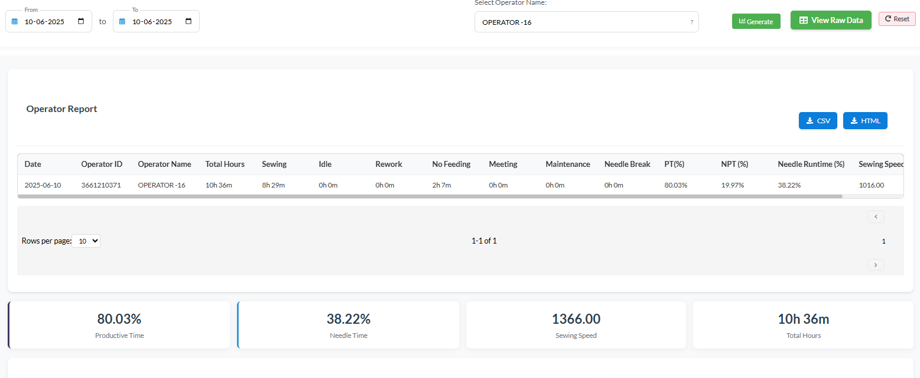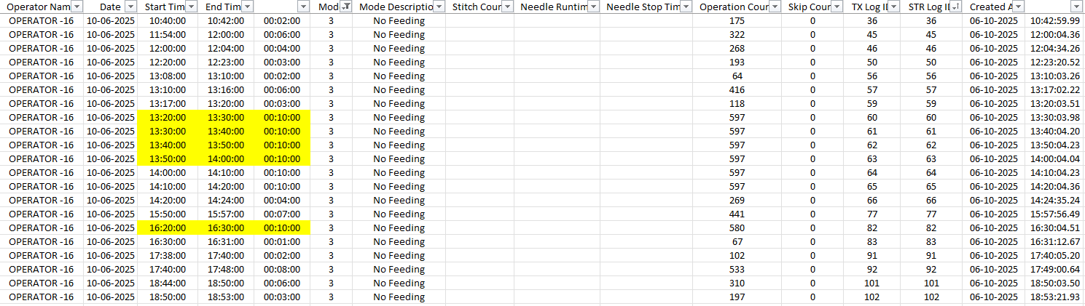10/06/2025 Operator 16 show’s 10h 36m, In raw data report break time is include, but in actual scenario we not include the break time in any of the mode.
2. For live data or current date data, operator wise report should show idle time calculation based on running time. For eg: if supervisor sees data by 2:30 pm, idle time = current consumed time – work hours. We will discuss this during meeting.

**Operator Report:** I have selected all operators. But pi chart is indicated for 1st operator only.

**Line Report:** I have selected all lines. But tiles section chart is indicated for 1st line only.

**Consolidated report:**

1. Provide summary view by default as in other reports (Machine ID/ Operator/Line).
2. Generate button is preferrable to have.
3. Below view is not required.

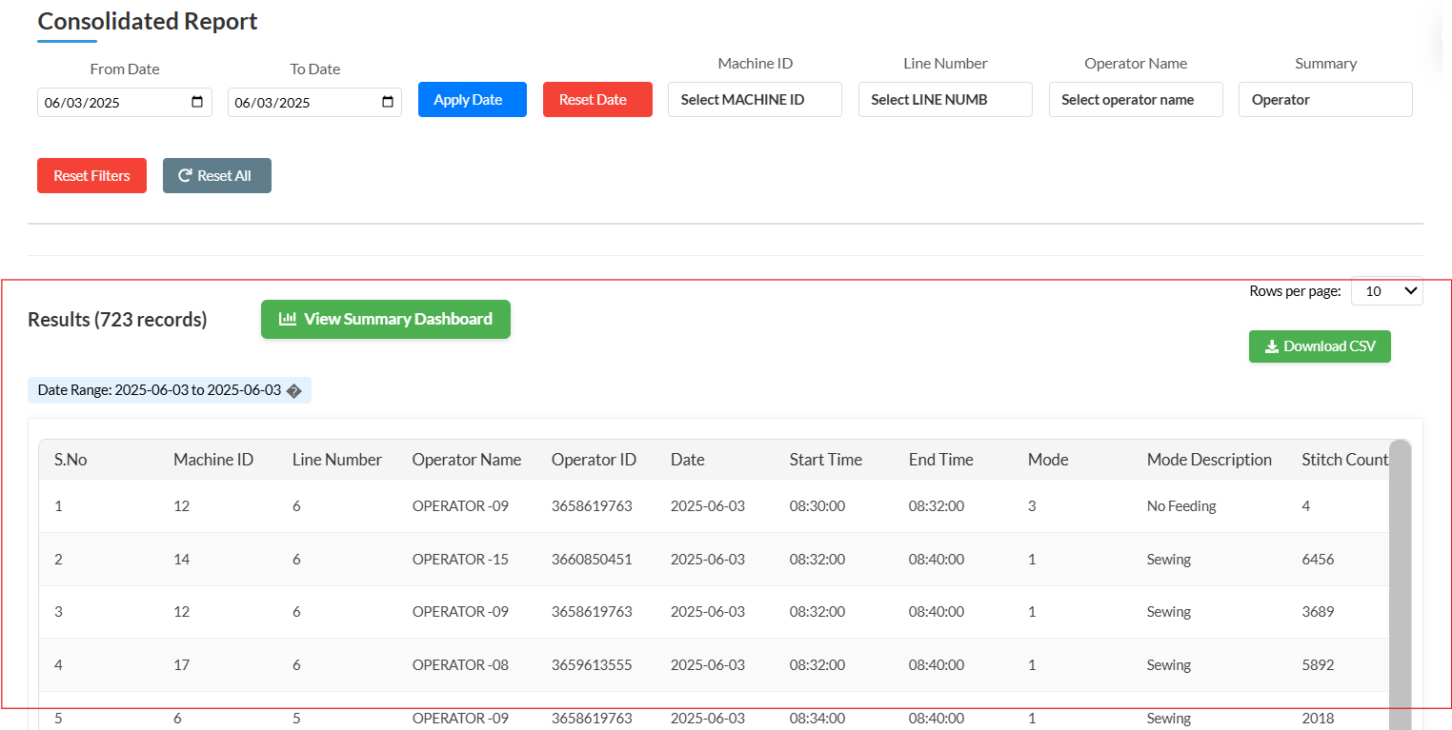

1. Below summary is not required.

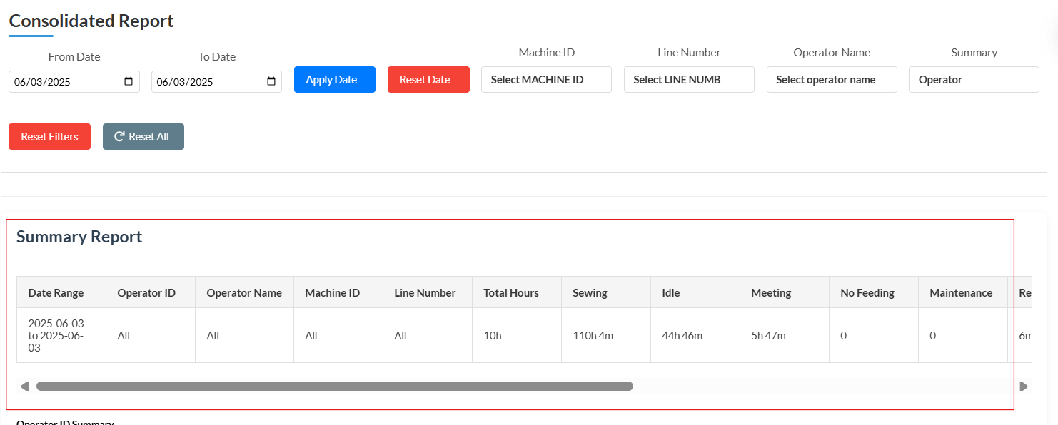

1. Keep Machine summary as default.

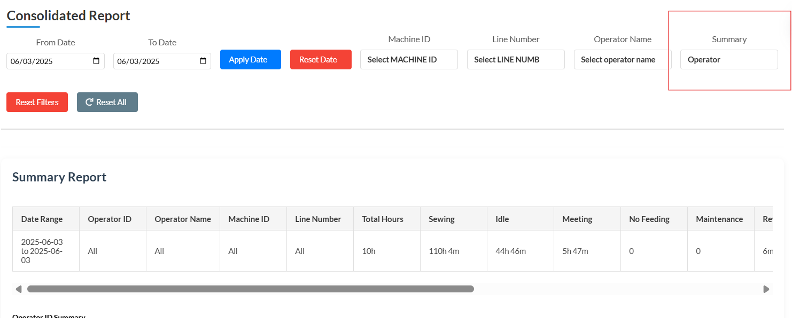

1. If user selects report type as Operator, then keep idle time as N/A. This is because we may not know whether the operator has worked in any other machine apart from the select machines.
2. When machine id summary is selected,
3. date should be added
4. total hours = sum of all modes. This is not matching.
5. idle hours = zero in all cases.
6. Pi chart and summary table data has differences.
7. Tiles section to be added.

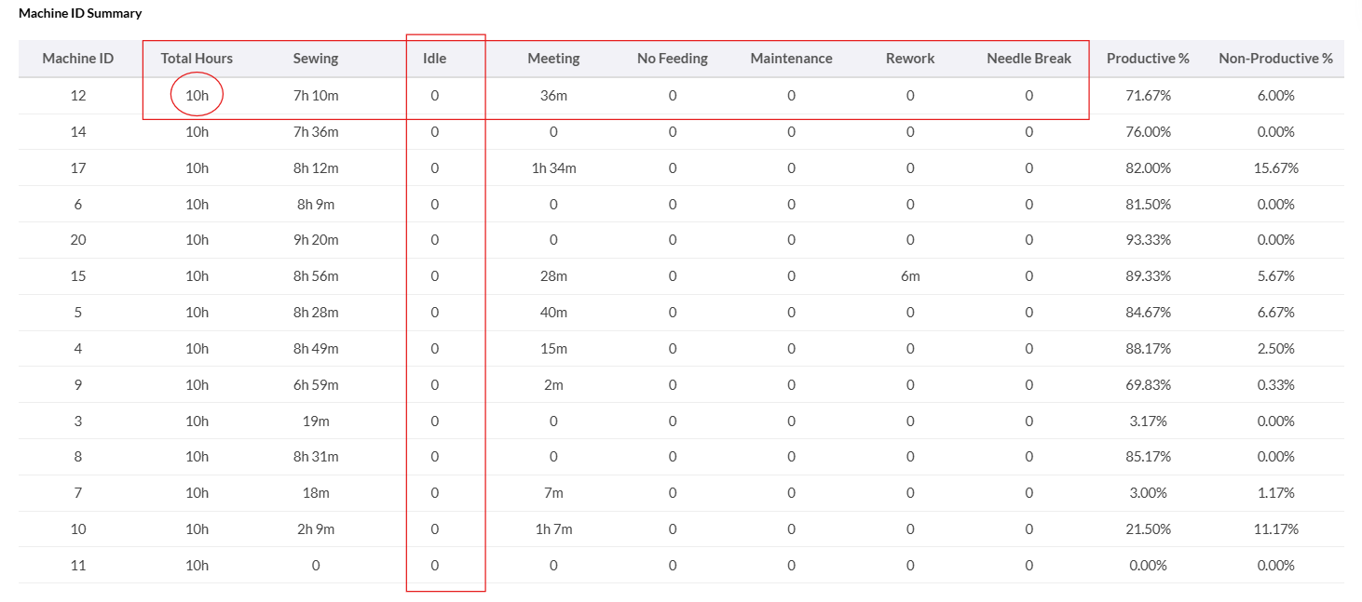

1. When changed the summary from machine to line, all the conditions listed for machine summary should be met.

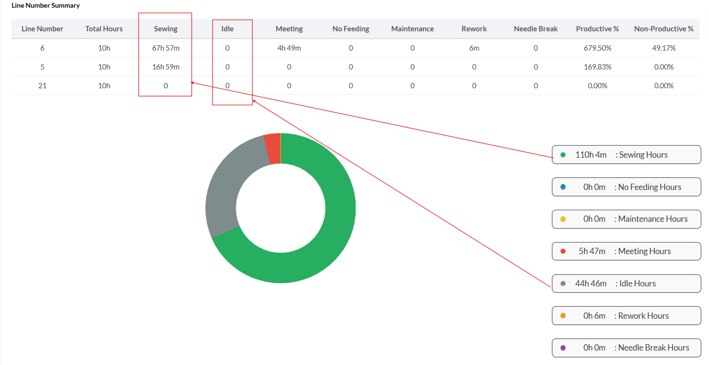

Next Priority Tasks:

1. Summary Table order – Date, Machine ID/Ope ID/Line Number, Total Hours, Sewing, PT %, Needle Time %, NPT %, Idle, Rework, No Feeding, Meeting , Maintenance, Needle Break, Sewing Speed, Stitch Count.
2. Tiles section to be update to contain in order
   1. Total Hours
   2. Sewing Hours (time, %)
   3. NPT (time, %)
   4. Needle Time %
   5. Stitch Count
3. Pi chart to be updated to contain only NPT hours breakdown in order Idle, Rework, No feeding, Meeting, Maintenance, Needle Break. (avoid green colour for any mode indication).
4. Keep the Summary table, Tiles section, Pi chart, Raw data table same for all reports.
5. Keep below buttons common in all reports.
6. From date, To date, Apply date, Reset date
7. Filter selection, generate, reset filter.

**Date: 09 June 2025**

**Operator wise report:**

1. Work hours = Sum (sewing, maintenance, needle break, no feeding, meeting, rework)
2. If work hours > 10, make idle hours = 0.
3. If work hours < 10, make idle hours = 10 – work hours.
4. Total hours = work hours + idle hours.
5. Productive time = Sewing hours / Total hours in %.
6. NPT = (total hours – sewing hours)/ total hours in %.
7. Sewing speed, Stitch count – Both are Integer values. No decimal point required.
8. Needle run time = Needle run time / sewing hours in %
9. Working time = 8:30 am to 7:30pm.

**Date: 07 June 2025**

**General updates:**

**Actual Modes Used in Poppy’s:**Mode 1 – Sewing, Machine on, Operator ID available.  
Mode 2 – Operator Logout and Machine Idle, Machine off, Operator ID is null.  
Mode 3 – No Feeding, Machine off, Operator ID available.  
Mode 4 – Meeting, Machine off, Operator ID available.  
Mode 5 – Maintenance, Machine on, Operator ID available.  
Mode 6 – Rework, Machine on, Operator ID available.  
Mode 7 – Needle Break, Machine off, Operator ID available.

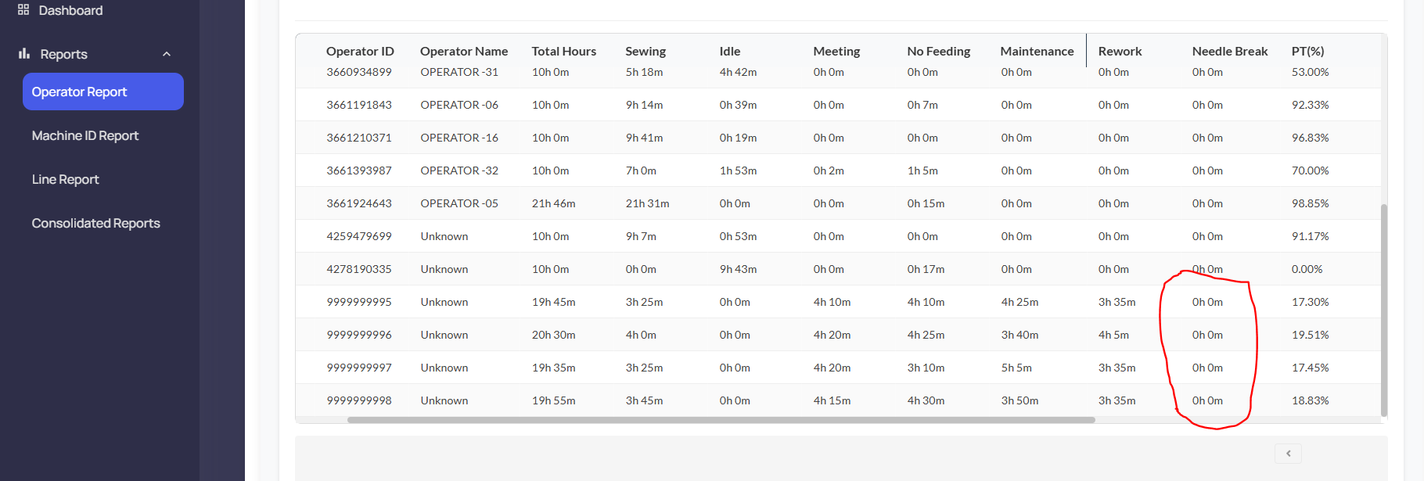**Raw Data Report:**Mode 1, Mode 2, and Mode 5 are displayed correctly.  
**Mode 3 is wrongly shown as Rework**.  
**Mode 4 appears as Needle Break**.  
Mode 6 is shown as N/A.   
Mode 7 data is not reflected in the API reports, but device transmit the data to API.

|  |
| --- |
|  |

**Operator wise report feedback:**

1. I have selected all operators. But pi chart is indicated for 1st operator only.
2. 30/05/2025 report, Total operator worked = 15. So total hours should be min 150 hours. But in calculation it shows only 106h.

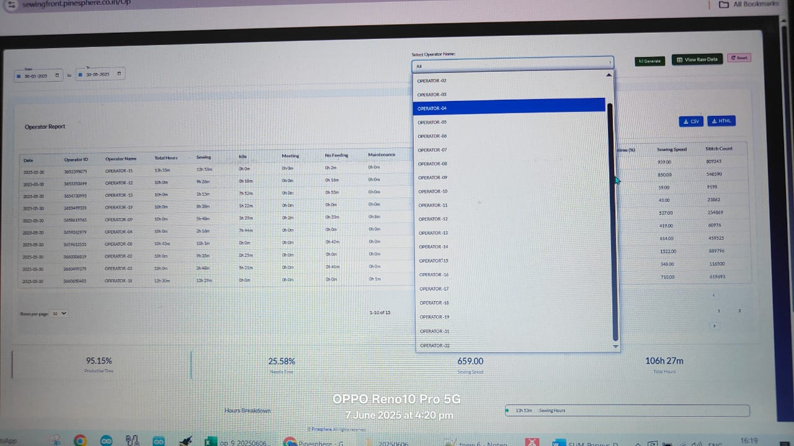

1. 06/06/2025 **Operator-09** shows a total working time of **10h 27m,** Notably**,** from **13:20 to 14:00**, the operator was in Mode 3 (No Feeding), which should have been **considered a break**. In Total hours it includes break time also (total No feed mode time including break 1h 42m).

**Line wise report feedback:**

1. When selecting **all lines**, the **summary report,** 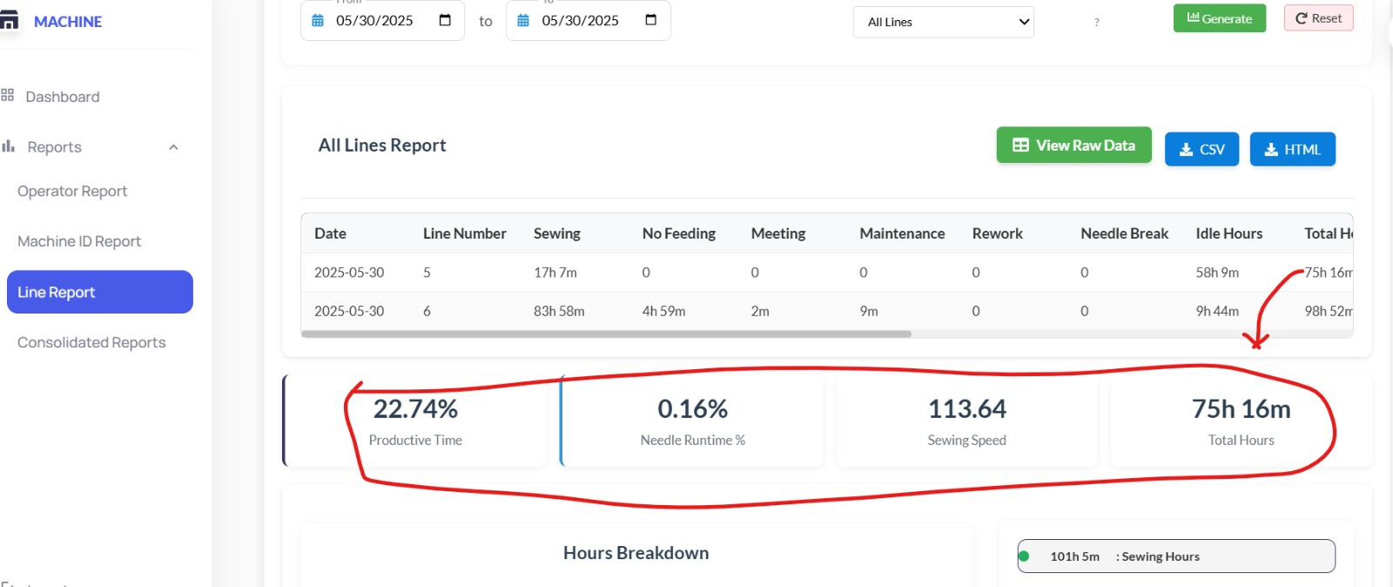tiles section showing only the first line number data which is line number 5.
2. When selecting an **individual line**, the **summary report** correctly shows data for **all lines** and the **pie chart reflects all line-wise data** only.

**Consolidated report feedback:**

1. 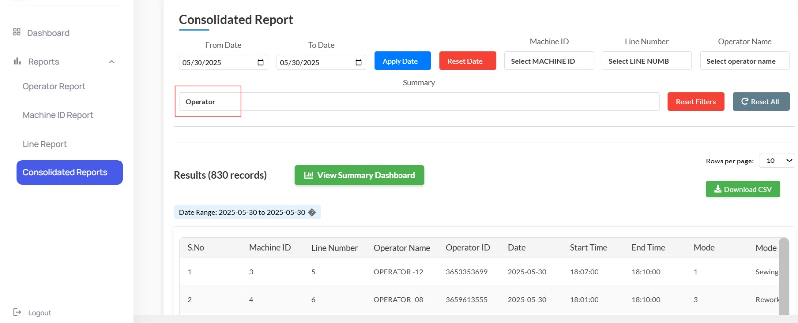Reduce the size of Report Type drop down list.
2. 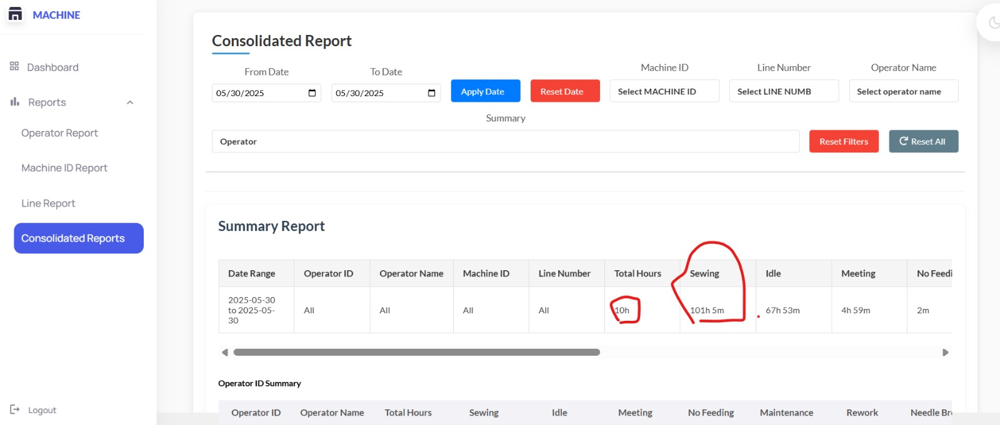Show Summary dash board by default as in other reports.

**Date: 27 May 2025**

**General updates:**

1. If start date is greater than end date, then pop-up indication required.
2. In all reports, Needle run time to be provided in hrs instead of secs and stitch count doesn’t need decimal points.

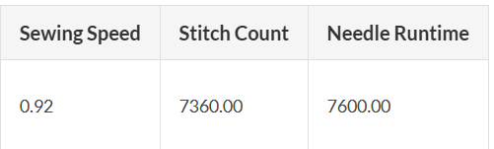

1. In summary chart, kindly provide summary in hours and mins format. It is difficult to interpret the decimal in hours. (hrs:mins)

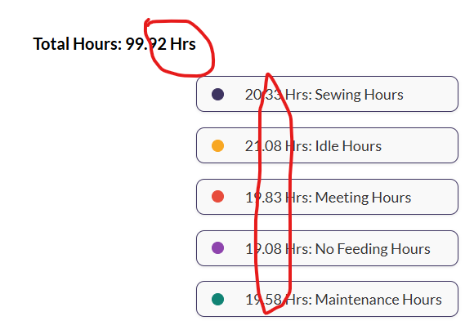

1. While downloading the CSV report, it should be sorted by start time or stored log id.
2. Below changes to be updated in the summary.

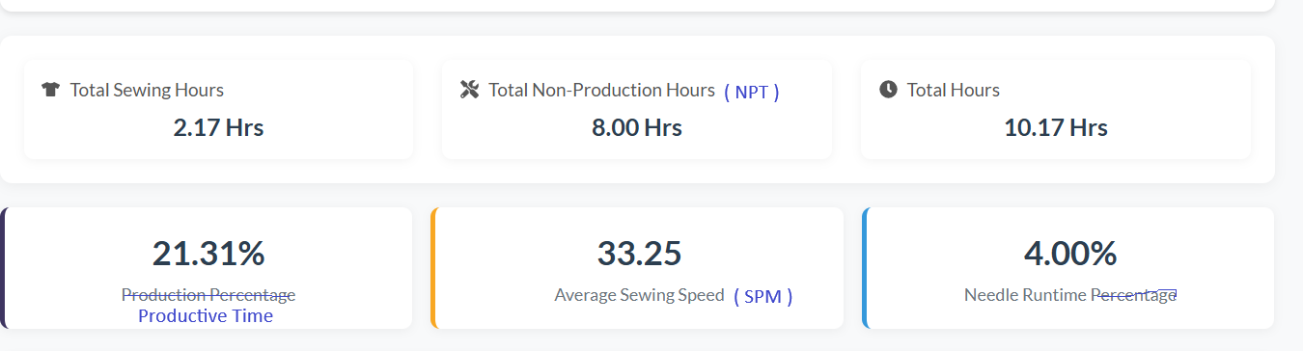

**Additional modes inclusion**

We have to include 2 additional modes.

1. Mode-6 - Rework
2. Mode-7 - Needle Break

Both these modes come under Non-productive time.

In all the reports new modes should be included in the Pi chart and Text on side of the chart.

Productive time = Sewing mode.

Non-productive time in Line wise & Machine wise summary report = No feeding hrs + Meeting hrs + Maintenance hrs + Idle hrs + Rework + Needle Break.

Idle hours in Operator wise summary report = 10 – sum(No feeding hrs + Meeting hrs + Maintenance hrs + Rework + Needle Break).

**Validation criteria for duplicate data:**

1. If the Tx Log ID is less than 1000, the API should store the data in the database with same Tx Log ID and Str Log ID.
2. If the Tx Log ID is greater than 1000 (e.g., 1020), the API should subtract 1000 from the Tx Log ID (1020 - 1000 = 20). Then it should check whether Str Log ID 20 already exists in the database for the same Machine ID on the same date with same start time and end time.
3. If Yes: The API will not store the data for Log ID 1020 and will return a 200 Success Response.
4. If No: The API will store the data for Log ID 1020 and return a 200 Success Response with Tx Log ID = 1020 and Str Log ID = 20.

**Consolidated report updates:**

1. Consolidated report should show the summary by default.
2. All data fetched after providing start date and end date without clicking the Generate button.
3. Summary data generated by selecting a filter without clicking the Generate button.
4. I feel this causes auto reset of the data while scrolling, which is undesired.
5. I feel it is better to have separate buttons for Reset filters and Reset date.
6. It’s better to auto reset filters, while reset date is applied.
7. Kindly provide a single line summary for each Machine ID, Operator Id and Line ID.

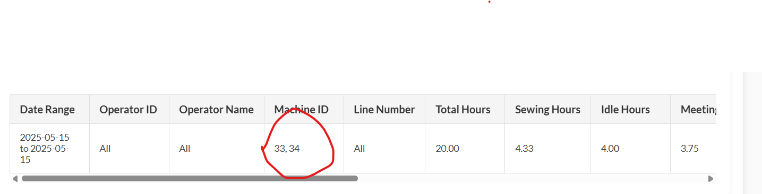

1. Priority levels: Line number, machine id, operator id.
2. If line number is only selected, then report should contain 10 hrs data for each machine id in each line.
3. If line number and machine id are selected, then report should contain 10 hrs data for each machine id.

*Approach-1 while Operator is selected in consolidated report:*

1. In dummy data while testing, SPARK team has generated idle data with operator id. But in real time, operator id = 0 in idle mode.
2. If operator id is selected, then idle hours = 10 – sum(No feeding hrs + Meeting hrs + Maintenance hrs + Rework + Needle Break).
3. This idle hour can’t be shown on each machine id and it should be shown in the summary data with highest machine id.

*Approach-2 while Operator is selected in consolidated report:*

1. If operator id is selected along with line number and/or machine id, then idle hours should be made zero and only available data should be taken for calculation. This is because the same operator might have worked on another machine or another line which we might not know.

**Date: 03-05-2025**

**Operating modes**

|  |  |  |
| --- | --- | --- |
| **Mode#** | **Mode** | **Mode Duration** |
| 1 | Sewing | Sum of all Mode-1 duration |
| 2 | No feeding | Sum of all Mode-3 duration |
| 3 | Meeting | Sum of all Mode-4 duration |
| 4 | Maintenance | Sum of all Mode-5 duration |
| 5 | Idle | Sum of all Mode-2 duration |

**List of data transmitted from each device to server:**

|  |  |  |  |  |
| --- | --- | --- | --- | --- |
| **S.no** | **JSON** | **Field** | **Description** | **Example** |
| 1 | MACHINE_ID | **Machine ID** | ID of the Sewing Machine | 100 |
| 2 | LINE_NUMB | **Line Number** | Line number in which the machine is present | 5 |
| 3 | OPERATOR_ID | **Operator ID** | RFID used by the operator | 135792468 |
| 4 | DATE | **Date** | Date, Month, Year of the data | 2025:04:07 |
| 5 | START_TIME | **Start time** | Start time of the data log | 11:10 |
| 6 | END_TIME | **End time** | End time of the data log | 11:20 |
| 7 | MODE | **Mode** | Mode of operation (sewing/ no feeding/ rework….) | 1 |
| 8 | STITCH_COUNT | **Stitch Count** | Number of stitches done by the operator during above time | 3579 |
| 9 | NEEDLE_RUNTIME | **Needle Run Time** | Pulley run time in secs | 200 |
| 10 | NEEDLE_STOPTIME | **Needle Stop Time** | Pulley stop time in secs | 400 |
| 11 | Tx_LOGID | **Tx Log ID** | Data log ID transmitted by the device | 1 |
| 12 | Str_LOGID | **Stored Log ID** | Data log ID stored in the server | 1 |
| 13 | DEVICE_ID | **Duration (secs)** | (End time - Start time) in secs | 600 |
| 14 | RESERVE | **Speed per minute (SPM)** | Average stitches per minute | 125 |

**Report and Data Analytics:**

Take data between 8:30AM and 7:30PM.

Morning break- 10.30 to 10.40, Lunch- 13.20 to 14.00, Evening break- 16.20 to 16.30.

If start time is >=10:30 and end time is<= 10:40 or

If start time is >=13:20 and end time is<= 14:00 or

If start time is >=16:20 and end time is<= 16:30, then omit this data.

Total data available will be for 10 Hours.

|  |  |  |
| --- | --- | --- |
| **S.no** | **Description** | **Calculation** |
| 1 | Sewing Hours | Sum of all Mode-1 duration |
| 2 | No feeding hours | Sum of all Mode-3 duration |
| 3 | Meeting Hours | Sum of all Mode-4 duration |
| 4 | Maintenance hours | Sum of all Mode-5 duration |
| 5 | Idle Hours | Sum of all Mode-2 duration |

**Line wise and Machine wise summary report**

|  |  |  |
| --- | --- | --- |
| **S.no** | **Description** | **Calculation** |
| 1 | Sewing Hours | Sum of all Mode-1 duration |
| 2 | No feeding hours | Sum of all Mode-3 duration |
| 3 | Meeting Hours | Sum of all Mode-4 duration |
| 4 | Maintenance hours | Sum of all Mode-5 duration |
| 5 | Idle Hours | Sum of all Mode-2 duration |
| 6 | Productive time - PT | Sewing Hours |
| 7 | Non-productive time - NPT | No feeding hrs + Meeting hrs + Maintenance hrs + Idle hrs |
| 8 | Total Hours | PT + NPT |
| 9 | Needle time % | Total needle run time/sewing hours * 100 |
| 10 | SPM | Total SPM / Number of instances. |

**Operator wise summary report**

|  |  |  |
| --- | --- | --- |
| **S.no** | **Description** | **Calculation** |
| 1 | Sewing Hours | Sum of all Mode-1 duration |
| 2 | No feeding hours | Sum of all Mode-3 duration |
| 3 | Meeting Hours | Sum of all Mode-4 duration |
| 4 | Maintenance hours | Sum of all Mode-5 duration |
| 5 | Idle Hours | 10 hours – (Sewing Hours + No feeding hrs + Meeting hrs + Maintenance hrs) |
| 6 | Productive time - PT | Sewing Hours |
| 7 | Non-productive time - NPT | No feeding hrs + Meeting hrs + Maintenance hrs + Idle hrs |
| 8 | Total Hours | PT + NPT |
| 9 | Needle time % | Total needle run time/sewing hours * 100 |
| 10 | Average SPM | Total SPM / Number of instances. |

**Data transmission from each device to server will happen in JSON format specified below.**

Payload =

"{

\"MACHINE_ID\":" + strs[0] + ",

\"LINE_NUMB\":" + strs[1] + ",

\"OPERATOR_ID\":" + strs[2] + ",

\"DATE\":\"" + strs[5] + ":" + strs[4] + ":" + strs[3] + "\",

\"START_TIME\":\"" + strs[6] + ":" + strs[7] + ":00\",

\"END_TIME\":\"" + strs[8] + ":" + strs[9] + ":00\",

\"MODE\":" + strs[10] + ",

\"STITCH_COUNT\":" + strs[11] + ",

\"NEEDLE_RUNTIME\":" + strs[12] + ",

\"NEEDLE_STOPTIME\":" + strs[13] + ",

\"Tx_LOGID\":" + strs[14] + ",

\"Str_LOGID\":" + strs[15] + ",

\"DEVICE_ID\":" + strs[16] + ",

\"RESERVE\":" + strs[17] +"

}";

**Response expected from Server while data stored properly.**

{

"code":200,

"message":"Data stored successfully",

}

**Response expected from Server while data is not stored.**

{

"code":xxx,

"message":"Data not stored",

}

**Validation criteria for duplicate data:**

1. If the Tx Log ID is less than 1000, the system should store the data in the database.

2. If the Tx Log ID is greater than 1000 (e.g., 1020), the system should subtract 1000 from the Log ID (1020 - 1000 = 20). The system should then check whether a Log ID 20 already exists in the database for the respective Machine ID on the same date.

If Yes: The system will not store the API data for Log ID 1020 and will return a 200 Success Response.

If No: The system will store the API data for Log ID 1020 and return a 200 Success Response.

Now Tx Log ID = 1020 and Tx Log ID = (1020-1000) = 20.

|  |  |  |  |
| --- | --- | --- | --- |
| **S.no** | **RFID CARD NO** | **OPERATOR NAME** | **REMAKRS** |
| 1 | 3658143475 | OPERATOR -01 |  |
| 2 | 3660306819 | OPERATOR -02 |  |
| 3 | 3660499379 | OPERATOR -03 |  |
| 4 | 3659262979 | OPERATOR -04 |  |
| 5 | 3661924643 | OPERATOR -05 |  |
| 6 | 3661191843 | OPERATOR -06 |  |
| 7 | 3653098739 | OPERATOR -07 |  |
| 8 | 3659613555 | OPERATOR -08 |  |
| 9 | 3658619763 | OPERATOR -09 |  |
| 10 | 3660851603 | OPERATOR -10 |  |
| 11 | 3652395075 | OPERATOR -11 |  |
| 12 | 3653353699 | OPERATOR -12 |  |
| 13 | 3654730995 | OPERATOR -13 |  |
| 14 | 3660111891 | OPERATOR -14 |  |
| 15 | 3660850451 | OPERATOR -15 |  |
| 16 | 3661210371 | OPERATOR -16 |  |
| 17 | 3661215379 | OPERATOR -17 |  |
| 18 | 3660650483 | OPERATOR -18 |  |
| 19 | 3655499331 | OPERATOR -19 |  |
| 20 | 3660137427 | OPERATOR -20 |  |
| 21 | 3655053075 | OPERATOR -21 | SPARE CARDS |
| 22 | 3655015683 | OPERATOR -22 | SPARE CARDS |
| 23 | 3660405379 | OPERATOR -23 | SPARE CARDS |
| 24 | 3662024435 | OPERATOR -24 | SPARE CARDS |
| 25 | 3793893139 | OPERATOR -25 | SPARE CARDS |

**Report generation method for Line wise report.**

1. User shall select “from date” and “to date”.
2. Data associated with above date to be loaded from Main URL. This is to reduce the number of data instances to be fetched and handled by the front end (FE).
3. FE shall display a drop-down list of line numbers that were in use during the selected period.
4. User shall either a particular line or all lines and click generate button.
5. FE shall generate a summary report.
6. If required user shall click detailed report button to generate CSV file.

*Same strategy shall be followed by us for Operator wise report and Machine wise report.*

**Report generation method for filtered reports.**

1. User shall select “from date” and “to date”.
2. Data associated with above date to be loaded from Main URL. This is to reduce the number of data instances to be fetched and handled by the front end (FE).
3. FE shall display drop-down lists of line numbers, machine ids, operator names that were in use during the selected period.
4. User shall either
5. particular line, few lines or all lines and/or
6. particular machine ID, few machine IDs or all machine IDs and/or
7. particular Operator ID, few Operator IDs or all Operator IDs

and click generate button.

1. FE shall generate a summary report.
2. If required user shall click detailed report button to generate CSV file.
3. There should be either a reset or a refresh button available to unselect his previous selection.

**Hourly Report generation would be required in future (to be discussed).**