COMPUTER NETWORKS LABORATORY (21CSC302J)
Lab Record – Lab 1 and Lab 3
Lab 1: Introduction to Packet Tracer, Peer-to-Peer Communication, Study of Cables and its Color Codes
Lab 3: Router Configuration (Creating Passwords, Configuring Interfaces)
Field | Details
Name | Kirthik Kasar P
Register Number | RA2411030050043
Programme | B.Tech CSE (Cyber Security)
Course | Computer Networks (21CSC302J)
Tool Used | Cisco Packet Tracer

Lab 1: Introduction to Packet Tracer, Peer-to-Peer Communication, Study of Cables and its Color Codes

Aim
To get familiar with Cisco Packet Tracer, build a simple two-PC network through a switch, assign IP addresses, and verify peer-to-peer communication using the ping command, and to study network cables and their colour codes.

Requirements
- Cisco Packet Tracer
- 2 PCs (PC-PT), 1 switch (2960-24TT), copper straight-through cables

Procedure
- Launch Cisco Packet Tracer and familiarise yourself with the workspace, device selection area and tools.
- Drag two computers (PC-PT) and one switch onto the workspace.
- Connect each computer to the switch using straight-through Ethernet cables.
- On PC0, open Desktop > IP Configuration and assign IP address 192.168.1.1 with subnet mask 255.255.255.0.
- On PC1, open Desktop > IP Configuration and assign IP address 192.168.1.2 with subnet mask 255.255.255.0.
- On PC0, open Desktop > Command Prompt and test connectivity with ping 192.168.1.2.
- Observe the replies to confirm that the two computers can communicate.
- Study the Ethernet cable types and note the wire colour codes.

Network Topology
PC0 and PC1 are each connected to Switch0 (2960-24TT) with copper straight-through cables. The green link lights show that both links are up.
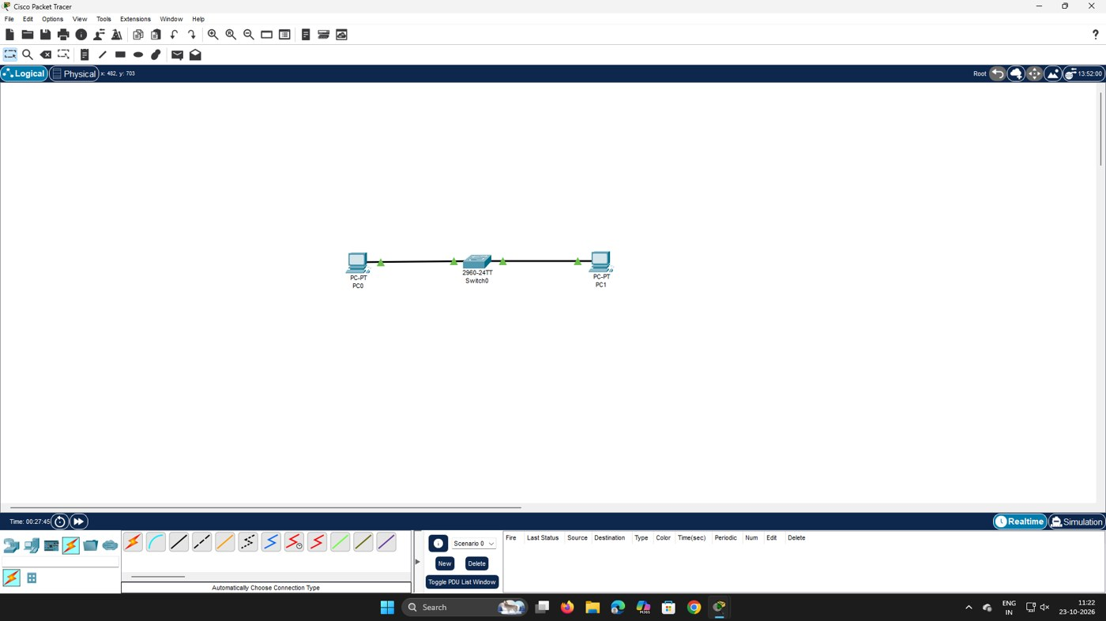
Figure 1.1: Topology – PC0 and PC1 connected through Switch0

IP Configuration
Device | IPv4 Address | Subnet Mask | Interface
PC0 | 192.168.1.1 | 255.255.255.0 | FastEthernet0
PC1 | 192.168.1.2 | 255.255.255.0 | FastEthernet0

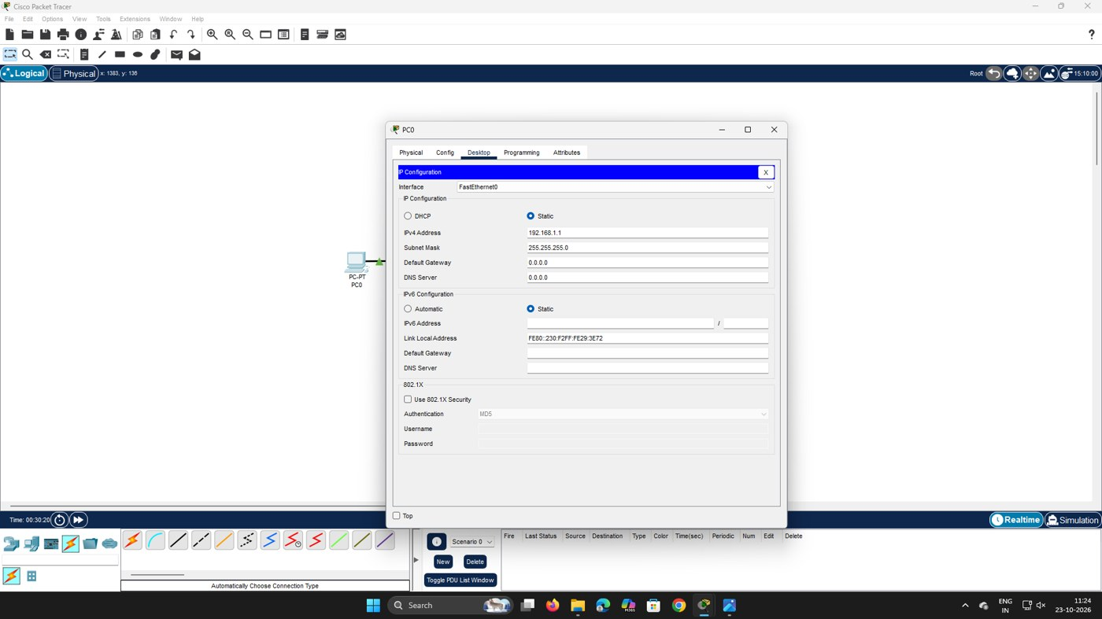
Figure 1.2: IP configuration of PC0 (192.168.1.1 / 255.255.255.0)
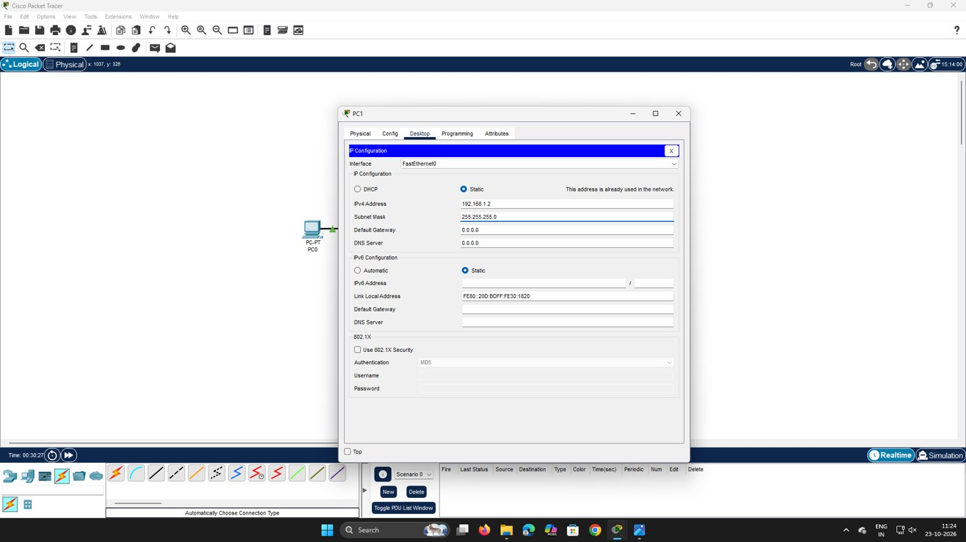
Figure 1.3: IP configuration of PC1 (192.168.1.2 / 255.255.255.0)

Connectivity Test (Ping)
Command executed on PC0:
C:\>ping 192.168.1.2

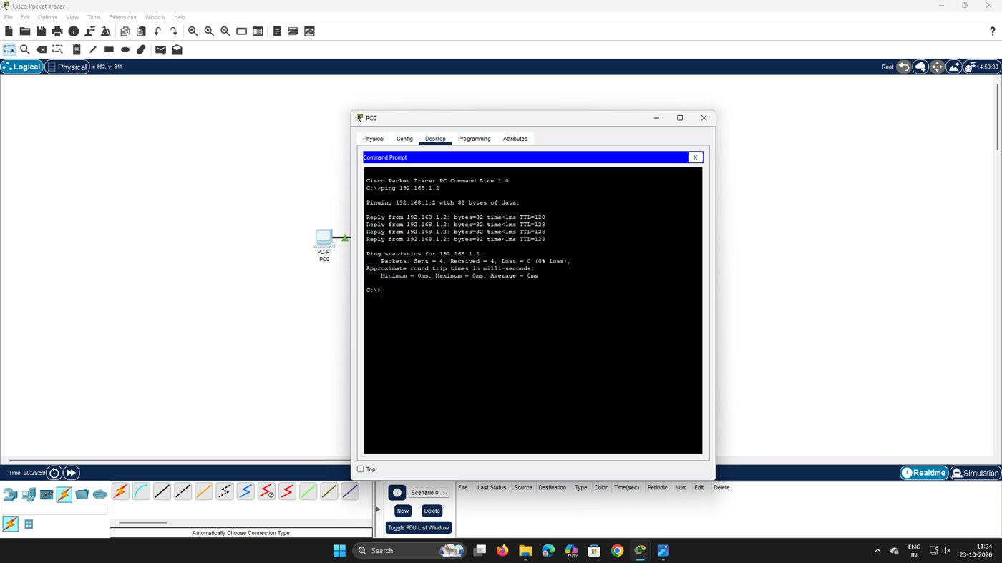
Figure 1.4: Ping from PC0 to PC1 – 4 sent, 4 received, 0% loss

Study of Cables and Colour Codes
Straight-through cable: used to connect unlike devices (e.g. computer to switch). Both ends use the same wiring standard (T568B).
Pin | Colour (T568B) | Used for
1 | White/Orange | Transmit +
2 | Orange | Transmit −
3 | White/Green | Receive +
4 | Blue | Unused
5 | White/Blue | Unused
6 | Green | Receive −
7 | White/Brown | Unused
8 | Brown | Unused

Crossover cable: used to connect like devices (e.g. computer to computer). One end is wired T568A and the other T568B, so the transmit pair (pins 1, 2) on one side connects to the receive pair (pins 3, 6) on the other.

Result
Two PCs were connected through a switch and configured with addresses in the 192.168.1.0/24 network. The ping from PC0 to PC1 (192.168.1.2) succeeded with 0% packet loss, confirming successful peer-to-peer communication. The cable types and colour codes were studied.

Lab 3: Router Configuration (Creating Passwords, Configuring Interfaces)

Aim
To build a simple network with a router, a switch and two computers, secure the router with console, enable and VTY passwords, assign IP addresses to the PCs, and verify connectivity.

Requirements
- Cisco Packet Tracer
- 1 router (ISR4331), 1 switch (2960-24TT), 2 PCs (PC-PT), copper straight-through cables

Procedure
- Open Packet Tracer and place a router, a switch and two PCs on the workspace.
- Connect the PCs to the switch and the switch to the router using straight-through Ethernet cables.
- Click the router and open the CLI tab.
- Enter privileged and global configuration mode using enable and configure terminal.
- Set the console password: line console 0, password cisco, login.
- Set the enable password: enable password cisco.
- Set the VTY password: line vty 0 4, password cisco, login.
- Configure the router interface with an IP address and enable it with no shutdown (as per the lab procedure: interface gig0/0, ip address 192.168.1.1 255.255.255.0).
- Assign IP addresses to the PCs with 192.168.1.1 as the default gateway.
- Use the ping command to test connectivity between the computers.

Network Topology
Router0 (ISR4331) is connected to Switch0 (2960-24TT), and PC0 and PC1 are connected to the switch. All links are up (green indicators).
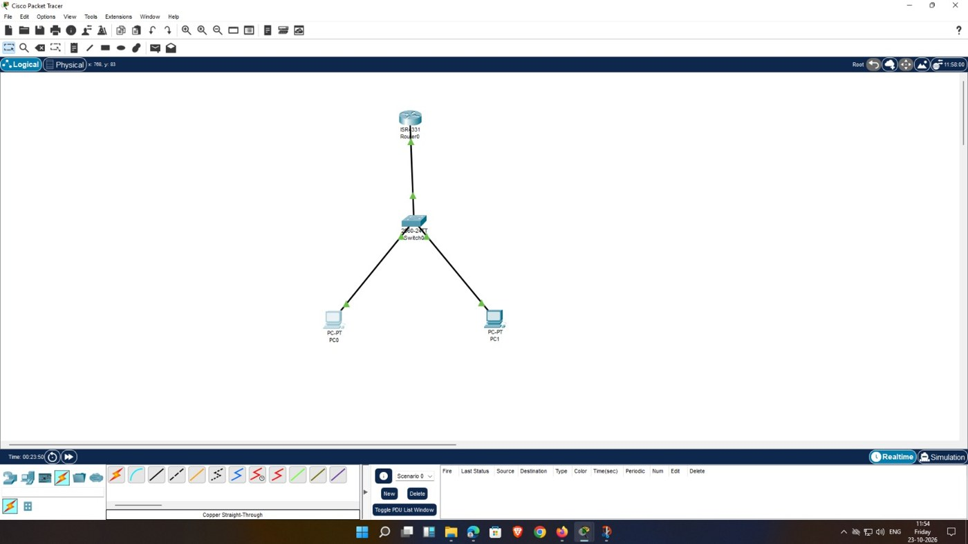
Figure 3.1: Topology – Router0, Switch0, PC0 and PC1

Router Password Configuration
Commands entered in the router CLI:
Router>enable
Router#configure terminal
Router(config)#line console 0
Router(config-line)#password cisco
Router(config-line)#login
Router(config-line)#exit
Router(config)#enable password cisco
Router(config)#line vty 0 4
Router(config-line)#password cisco
Router(config-line)#login
Router(config-line)#exit

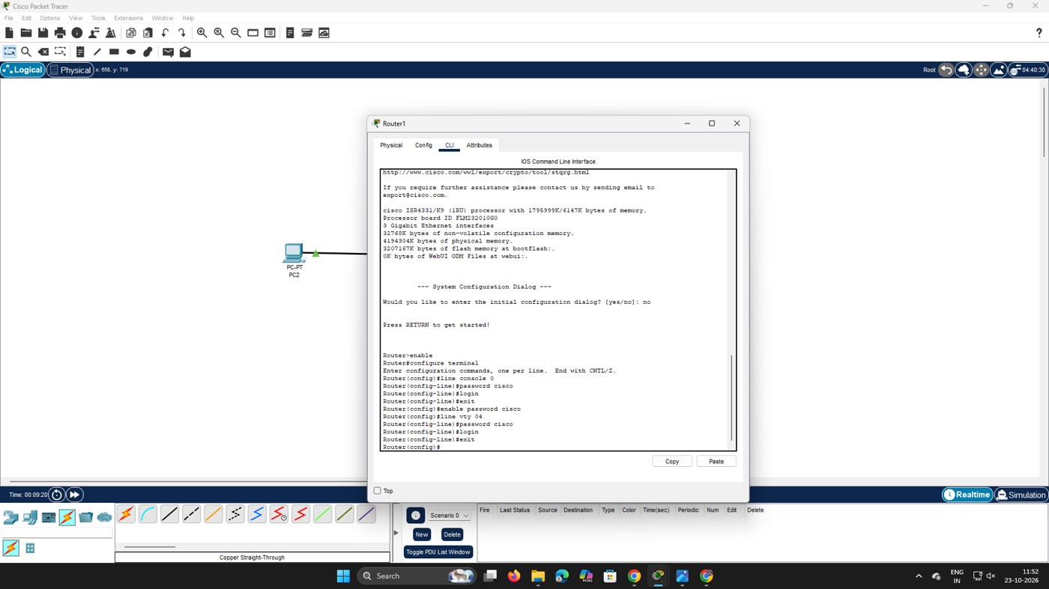
Figure 3.2: Router CLI – console, enable and VTY passwords configured

IP Configuration of PCs
Device | IPv4 Address | Subnet Mask | Default Gateway
PC0 | 192.168.1.2 | 255.255.255.0 | 192.168.1.1
PC1 | 192.168.1.3 | 255.255.255.0 | 192.168.1.1

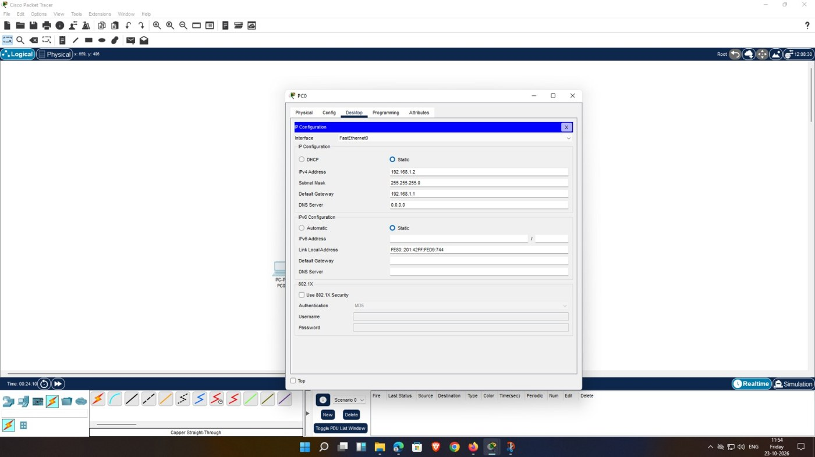
Figure 3.3: IP configuration of PC0 (192.168.1.2, gateway 192.168.1.1)
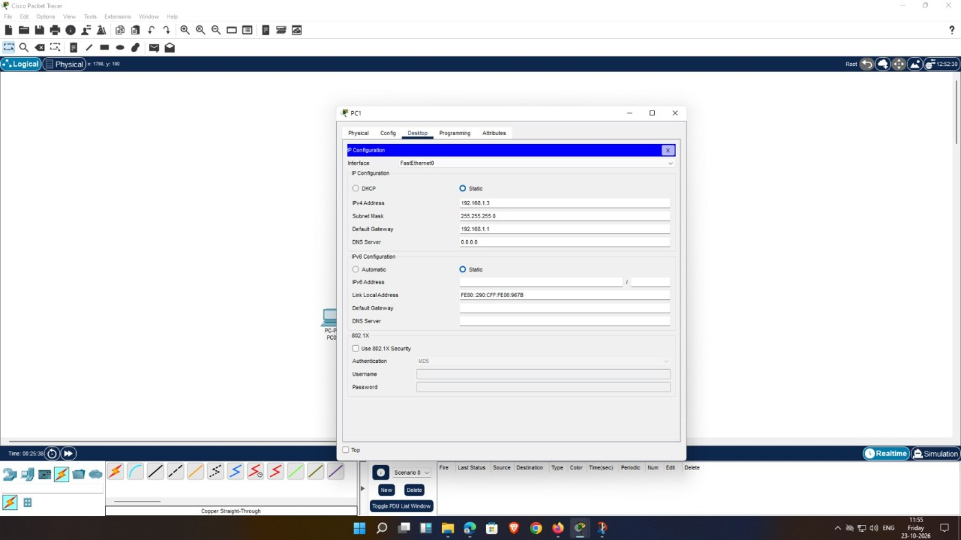
Figure 3.4: IP configuration of PC1 (192.168.1.3, gateway 192.168.1.1)

Connectivity Test (Ping)
Command executed from PC0 (to PC1, 192.168.1.3) and, in the second screenshot, from PC1:
C:\>ping 192.168.1.3

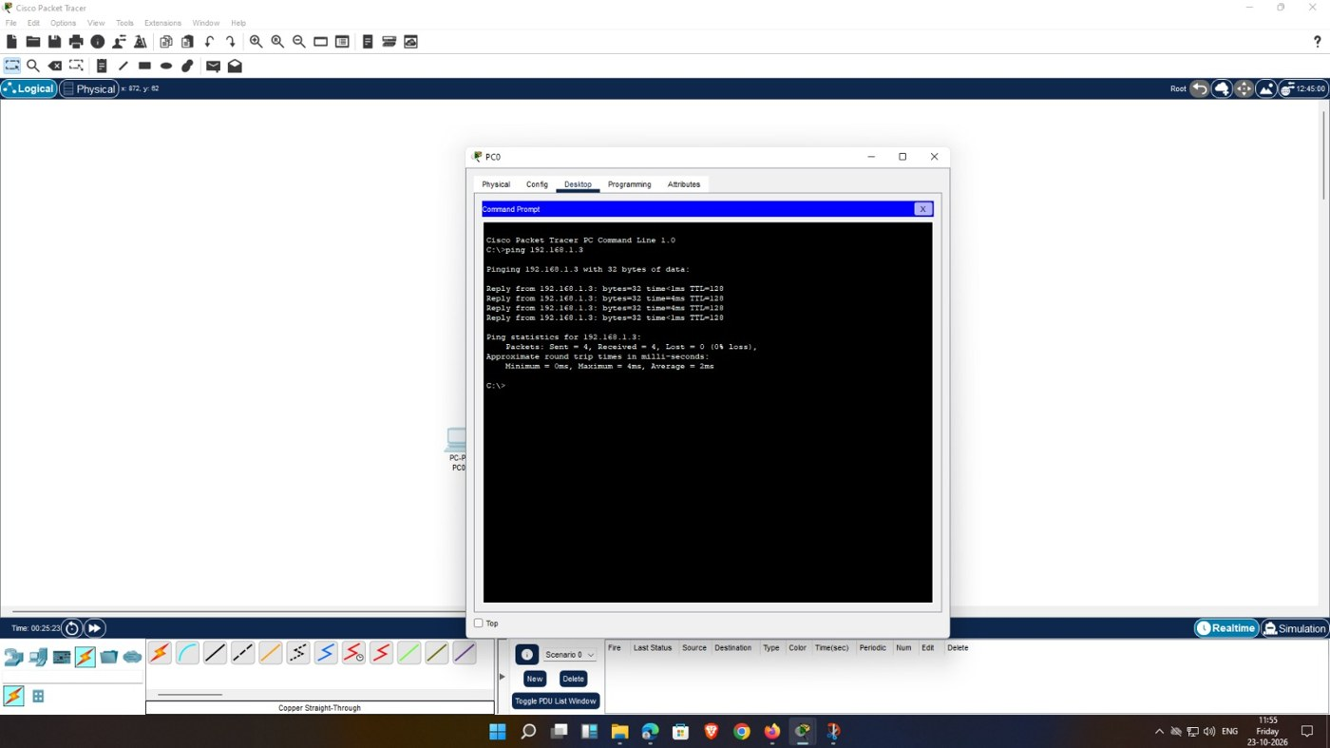
Figure 3.5: Ping from PC0 to PC1 (192.168.1.3) – 4 sent, 4 received, 0% loss
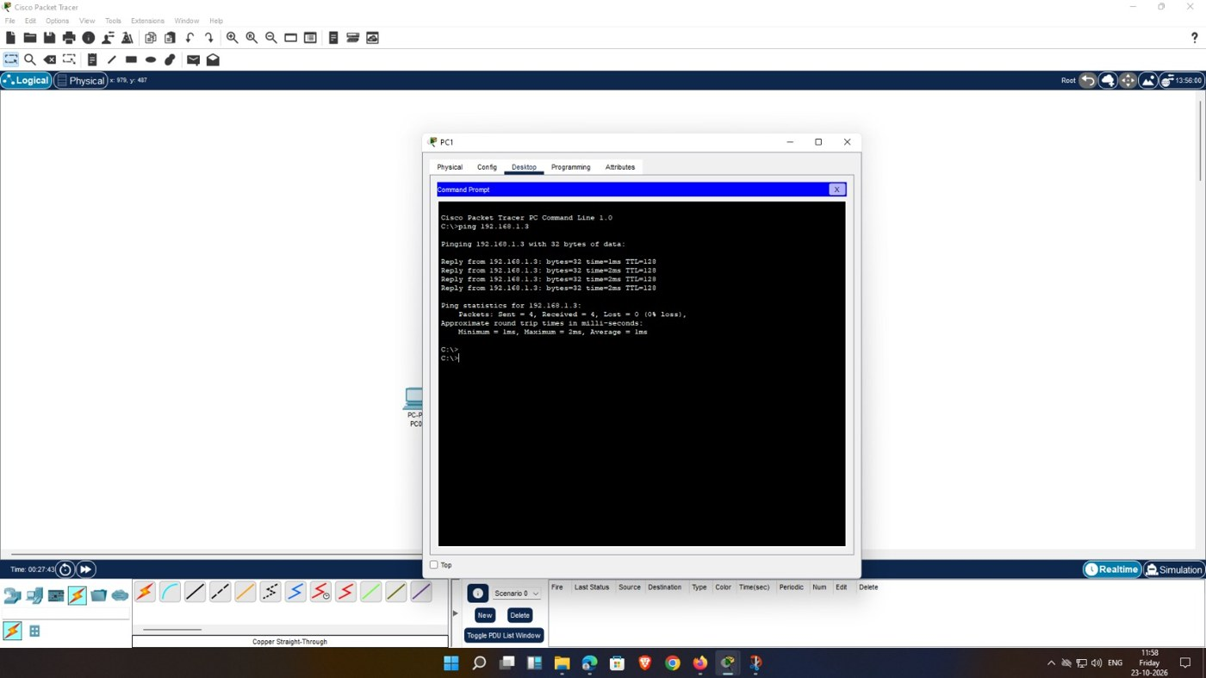
Figure 3.6: Ping test run from PC1 – 4 sent, 4 received, 0% loss

Result
The router was secured with console, enable and VTY passwords, the PCs were configured in the 192.168.1.0/24 network with 192.168.1.1 as the default gateway, and the ping from PC0 to PC1 (192.168.1.3) returned replies with 0% packet loss, confirming connectivity.

