**DECLARATION**

I hereby declare that all the work presented in this Industrial Training Report for the partial fulfilment of the requirements for the award of the degree of Bachelor of Technology in **Computer Science & Engineering**, Guru Tegh Bahadur Institute of Technology, affiliated to Guru Gobind Singh Indraprastha University, Delhi is an authentic record of my own work carried out with the help of Udemy from 15th July 2022 to 15th August 2022.

Submission Date:

*Kirti Gupta(029/CSE3/2020)*

[**CERTIFICATE**](http://ude.my/UC-77bc41ee-9a4f-4477-8e7a-94c4532cd331)

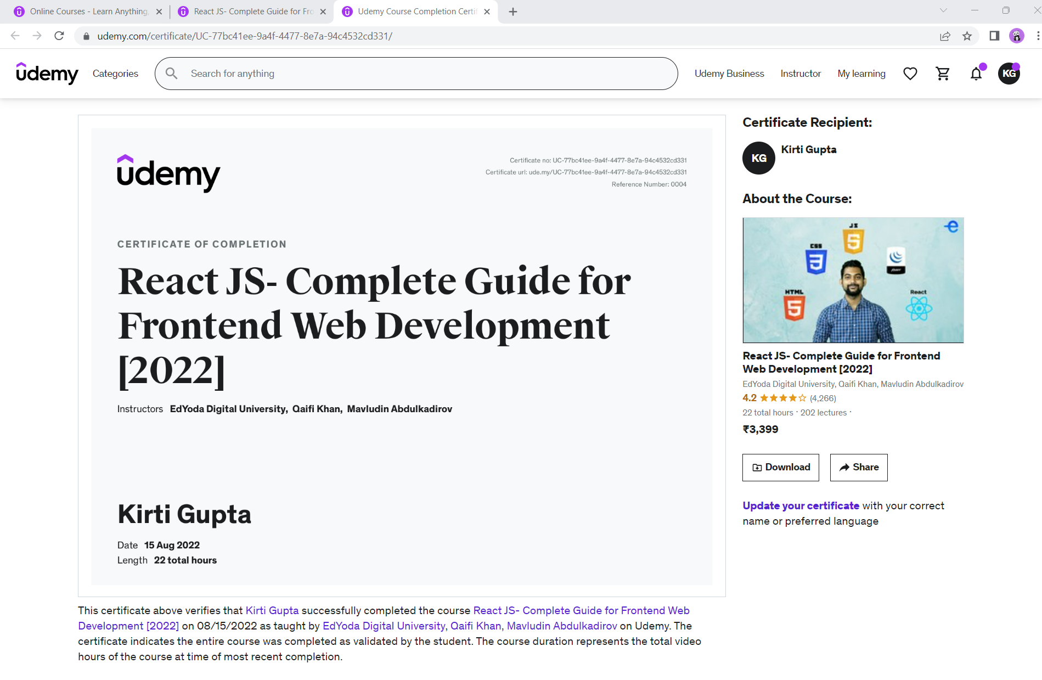

**ACKNOWLEDGEMENT**

Many people assisted me in successfully finishing this project. I would want to convey my heartfelt gratitude to *Dr. Aashish Bhardwaj*, my mentor, for his invaluable advice and assistance in completing my project. He was there to assist me every step of the way, and his motivation is what enabled me to accomplish my task effectively. I would also like to thank all of the other supporting personnel who assisted me by supplying the equipment that was essential and vital, without which I would not have been able to perform efficiently on this project.

I would also want to thank the college administration for accepting my project in my desired field of expertise. I’d also like to thank my friends and parents for their support and encouragement as I worked on this assignment.

***Kirti Gupta(029/CSE3/2020)*** Date:

kirtiigupta12@gmail.com

**ABSTRACT**

**Problem:**

kk

**Solution:**

ok