**Data Structure and Algorithm**

1. Array-

* The array insertion complexity = 0(n)

1. Linked List-

* It stores the elements in various different places in the memory. And are connected by the links
* Benefit- You don’t need to pre-allocate the space
* Insertion is easier
* Insert element at the beginning of the list=0(1)
* Delete element at the beginning of the list=0(1)
* Insert/Delete element at the end=0(n)
* Linked list Traversal =0(n)
* Accessing element by the value =0(n)
* Double linked list- where it is connected in both way

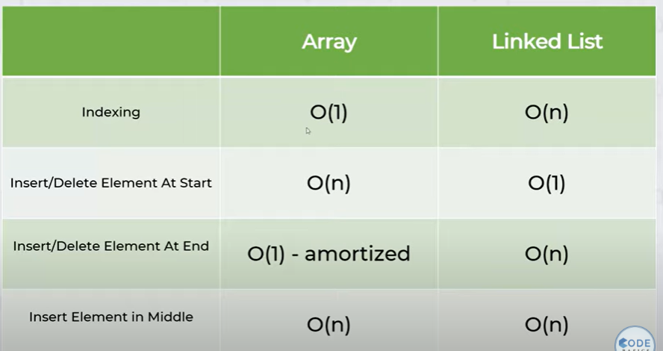

1. e