Basic Visualizations and basic questions on data.

**Q1.** **How many male candidates and female candidates contributed to the Election March 2009?**

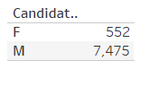

This tells the total no of female and male candidates for election in the March 2009. It is clearly visible that the no. of female candidates as compared to male candidates is very low.

It tells us that the female contribution is 6.87% whereas male contribution is around 93.13%.

**Q2. Check the total no. of candidates based on their category.**

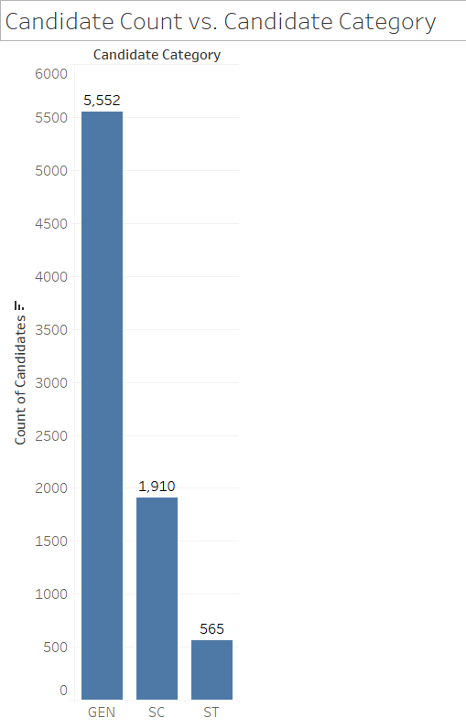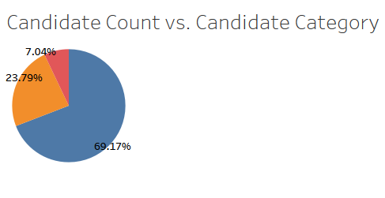

This tells the distribution of candidate count based on the Candidate Category. The graph displays that Count for GEN category is the highest and for ST Category it is lowest.

**Q3. Check the candidate count based on Sex, and differentiated by Candidate category.**

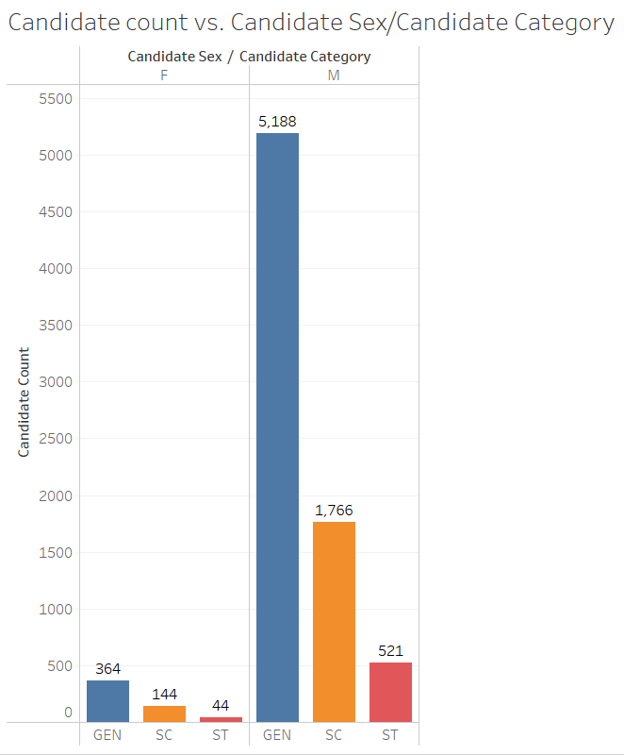

The distribution is the same for Female and Male gender, based on candidate category.

**Q4. Check the no. of candidates based on Age and display the average no. of candidates.**

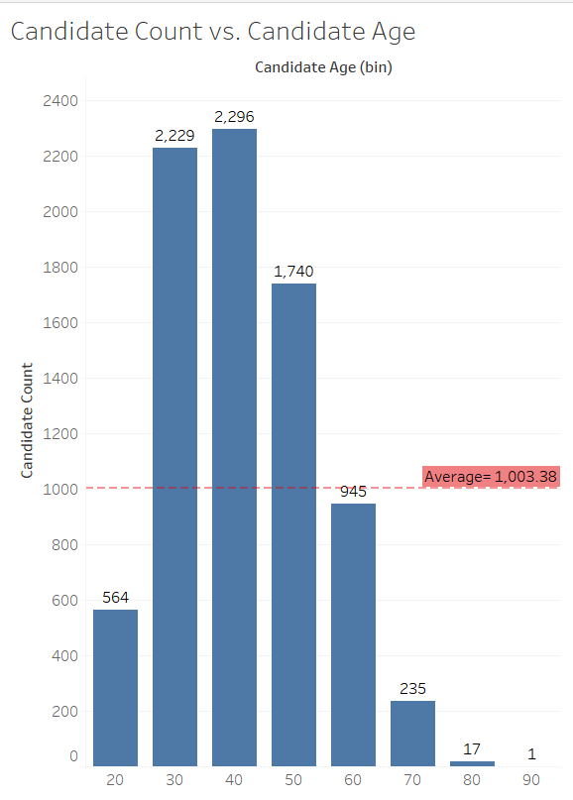

This graph displays the distribution of candidate count vs. Candidate Age. Here we can clearly see, the age range of 30 – 59 has the highest no. of candidates.

**Q5.What is the Candidate count based on Candidate sex for each range of Candidate Age.**

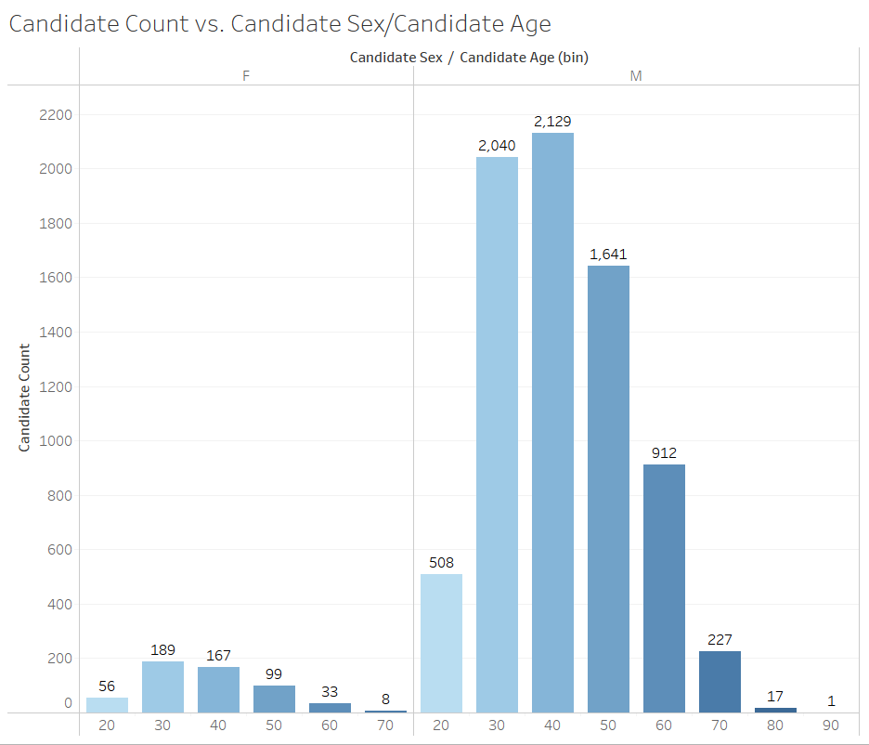

**Q6.What is the Candidate Count for each Candidate Category based on Age? Also display the average count for each category.**

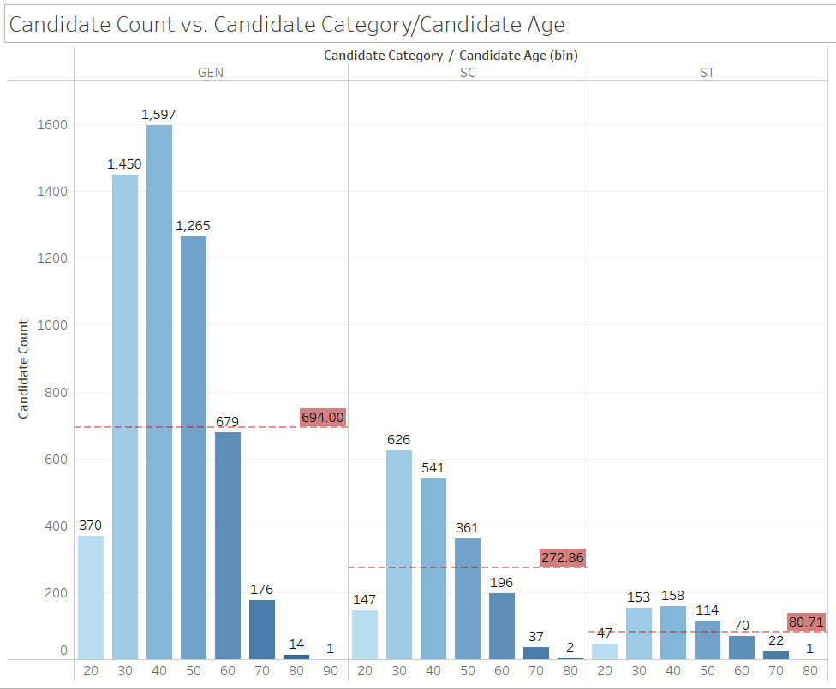

**Q7.What is the Candidate Count for each state? Display the average Candidate count.**

