**Prerequisite to run test case :**

1. Chrome version 75.0.3770.142(64-bit) should be installed in system
2. JAVA should be installed in system
3. Eclipse should be installed in system, scripted was created with Eclipse vesrion: Oxygen.3a Release(4.7.3a)

**Note:** For a different version of Chrome browser, a different chromedriver.exe version might be required.

**Project structure:**

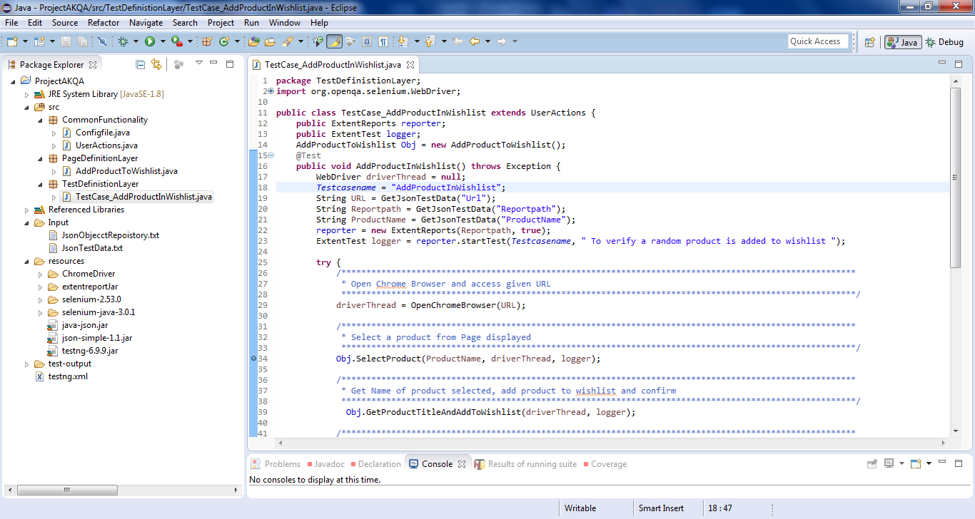

Project structure is based on Page Object Model. It has three packages under src folder.

1. **CommonFunctionality:** It has java clases for common functionality e.g. User actions click,get text etc.
2. **PagedefinitionLayer:**It has java class for page based functionality
3. **TestDefinitionLayer:** It contains Test Cases java class

**Input folder :** It contains two files one for JsonTestData.txt for test data and JsonObjectRepository.txt which contains all webelement locators and behaves like Object Repository.

**Resources folder:** This folder contains all JAR files along with chromedriver.exe

**Setp to run Test Cases:**

1. Download the project folder from given path
2. Open in project in eclipse

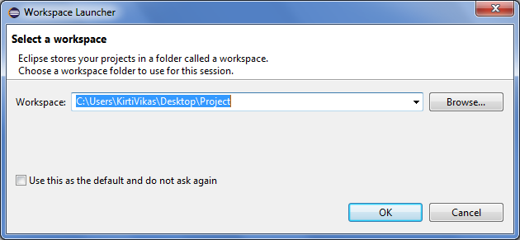

1. Once project is launched in eclispe, add jars from attached resources folders.
2. Right click on project and select properties
3. Select Java Build Path
4. Click on Libraries Tab and click on Add External Jars

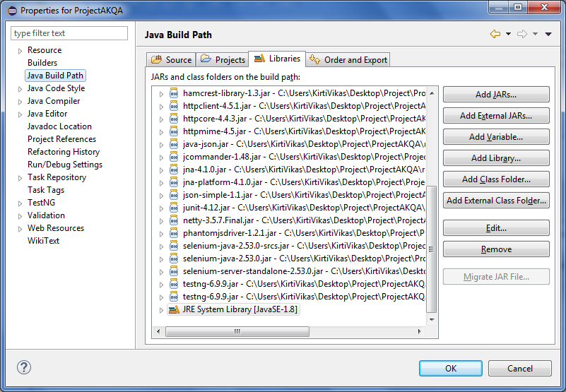

1. Add Jars from resources folder under project folder
2. ChromeDriver folder contains chromedriver.exe which is compatiable with Chrome version 75.0.3770.142(64-bit).
3. Right click on testng.xml, go to Run As and click on TestNG Suite

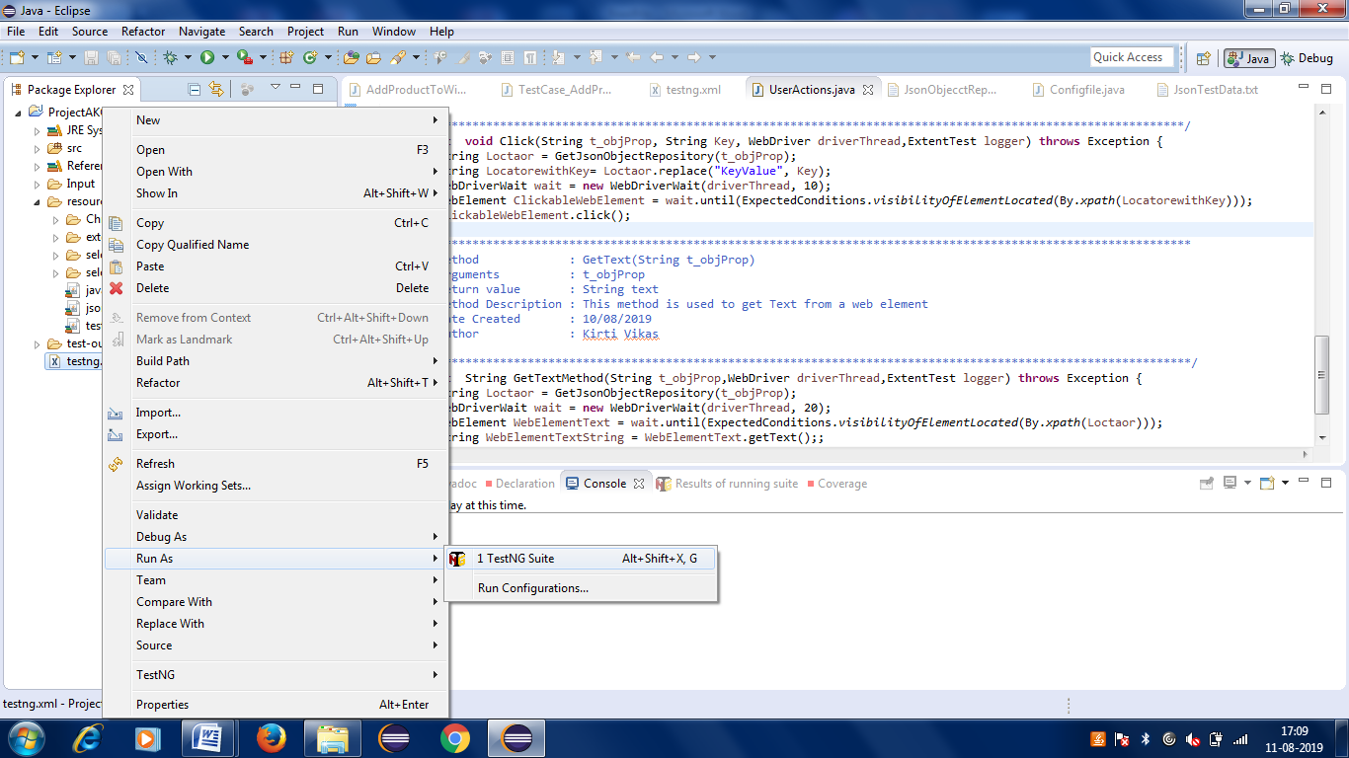

1. Test case will start running.
2. Test result can be seen in console whether it’s successful for failed.
3. At end, a html report “AddProductReport.html” will be generated under test-output folder, open this report in webbrowser.

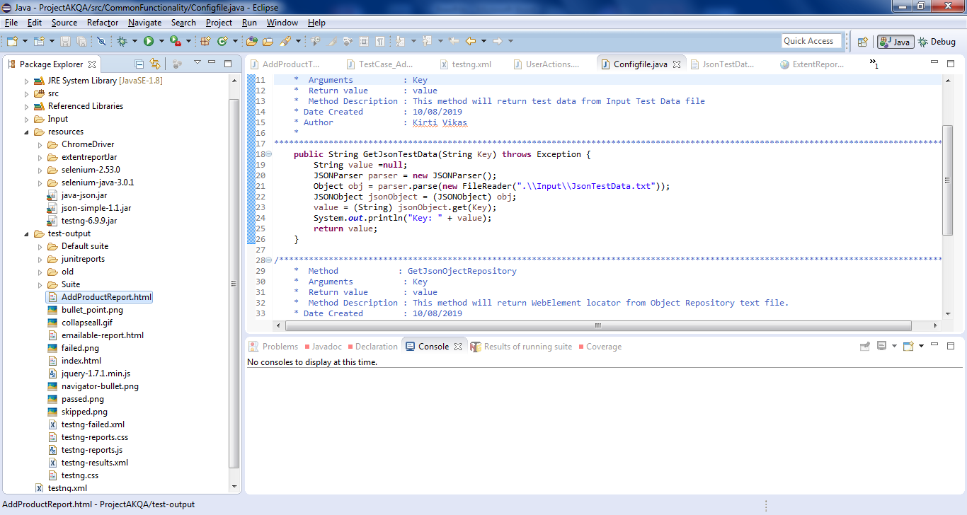

Report with Steps:

