1. GET ALL DOCUMETS
2. GET ALL DOCUMETS WITH WRITER SET TO “QUENTIN TARANTINO”

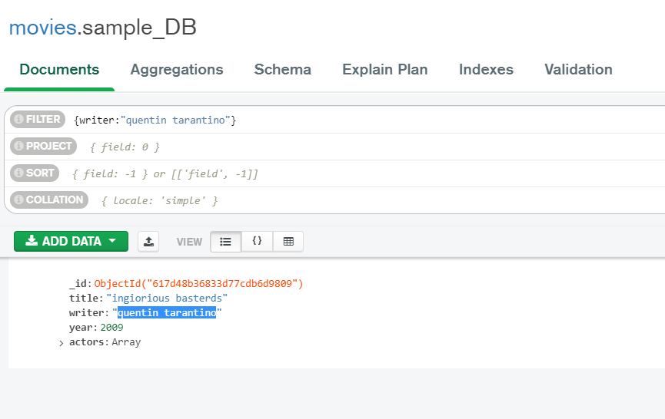

1. GET ALL DOCUMETS WHERE ACTORS INCLUDES “BRAD PITT”

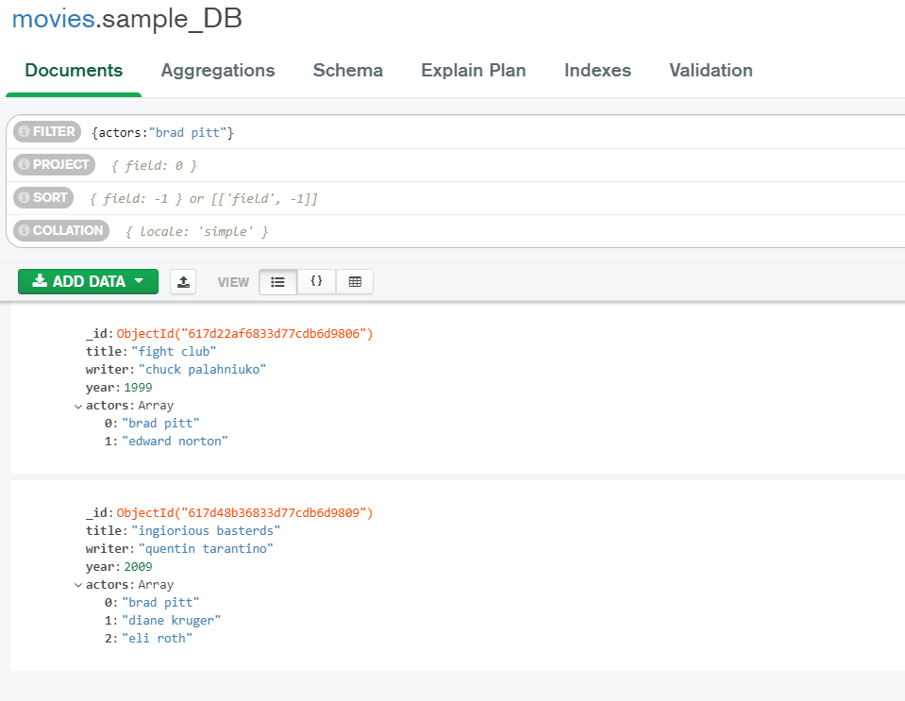

1. GET ALL DOCUMETS WHERE FRANCHISE SET TO HOBBIT

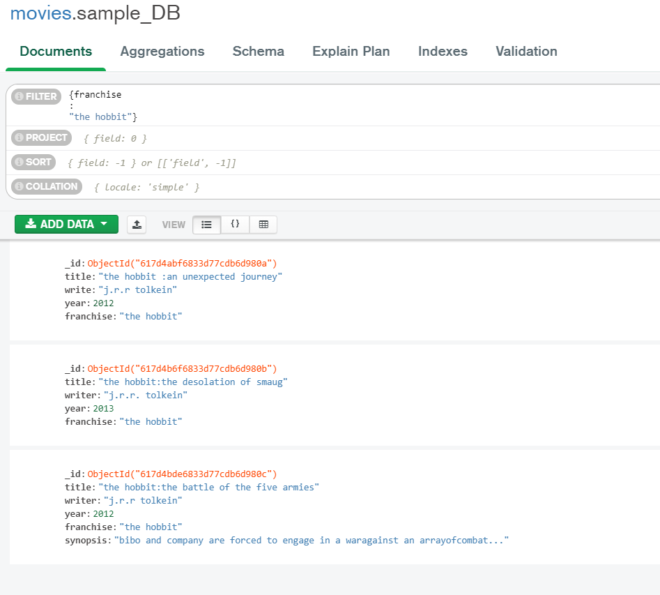

1. Get all movies released in 90’s

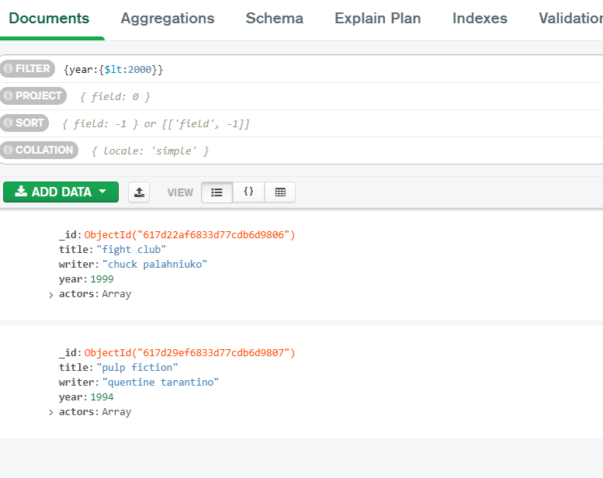

1. GET ALL MOVIES RELEASED BEFORE THE YEAR 2000 OR AFTER 2010

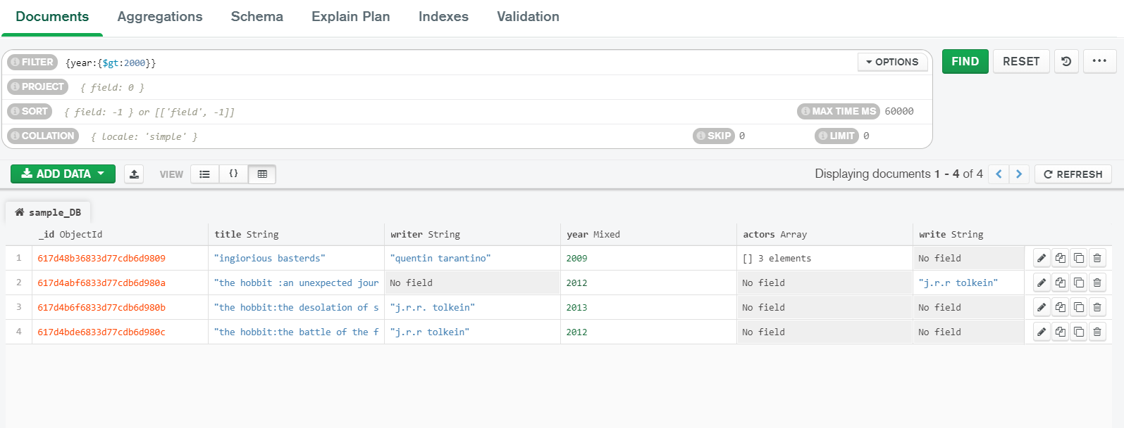

1. FIND ALL MOVIES THAT HAVE SYNOPSIS THAT CONTAINS THE WORD “BILBO”

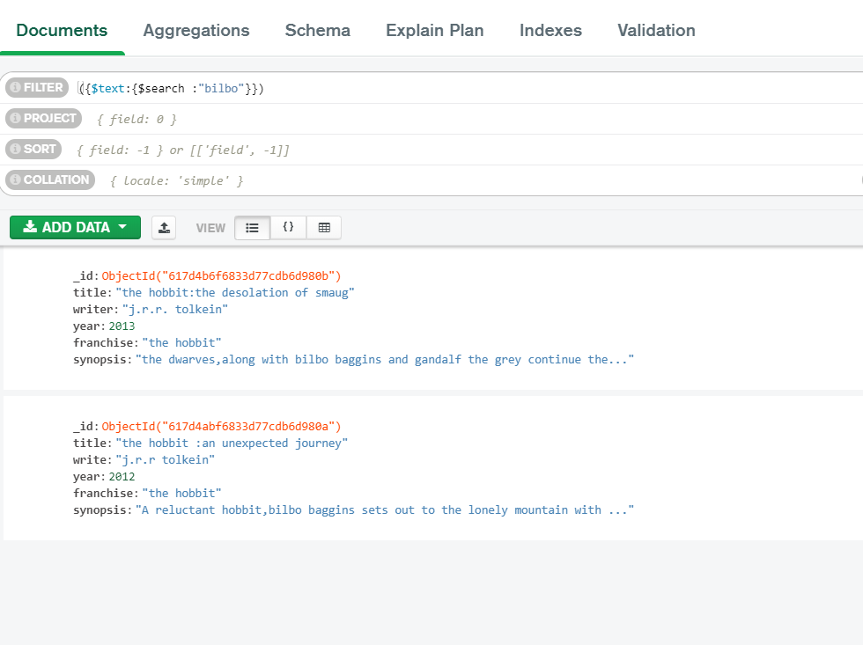

1. FIND ALL MOVIES THAT HAVE SYNOPSIS THAT CONTAINS THE WORD “GANDALF”

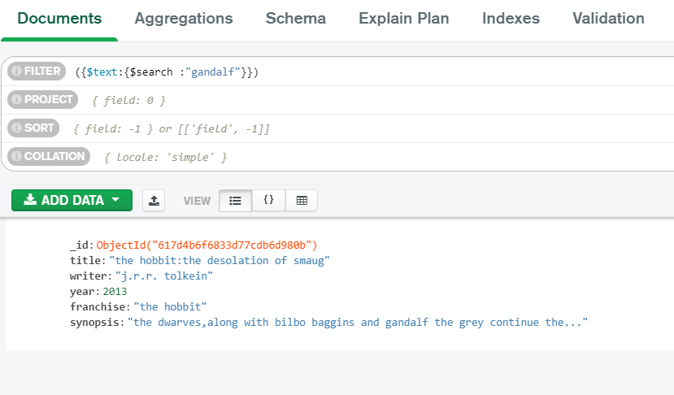

1. FIND ALL MOVIES THAT HAVE SYNOPSIS THAT CONTAINS THE WORD “BILBO” NOT THE “GANDALF”

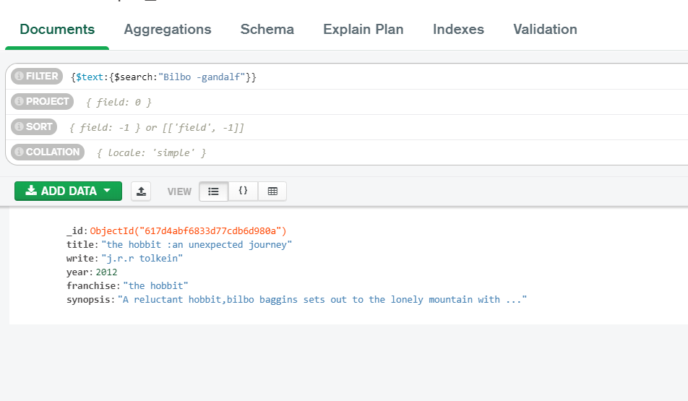

1. FIND ALL MOVIES THAT HAVE SYNOPSIS THAT CONTAINS THE WORD “DWARVES” NOT THE “HOBBIT”

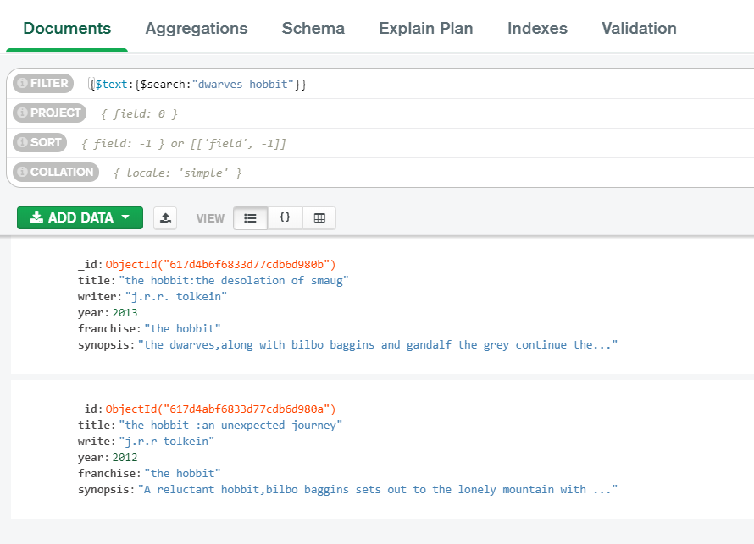

1. FIND ALL MOVIES THAT HAVE SYNOPSIS THAT CONTAINS THE WORD “GOLD” NOT THE “DRAGON”

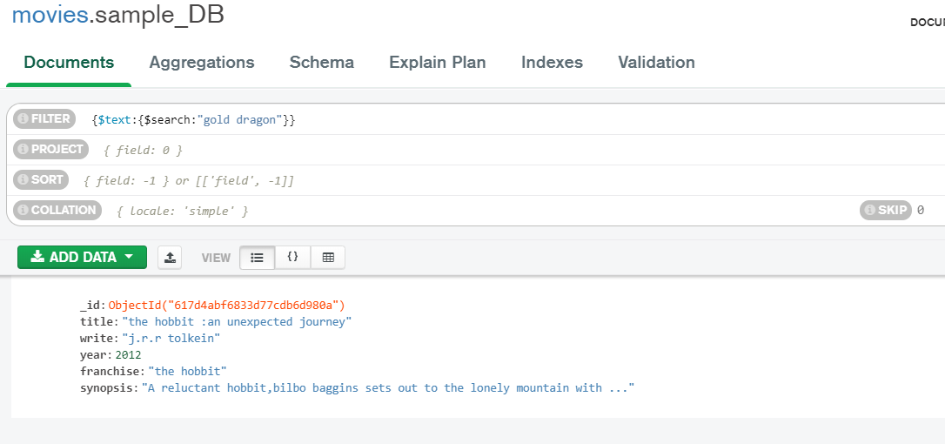

1. DELETE THE MOVIES “PEE WEE HERMAN'S BIG ADVENTURE”

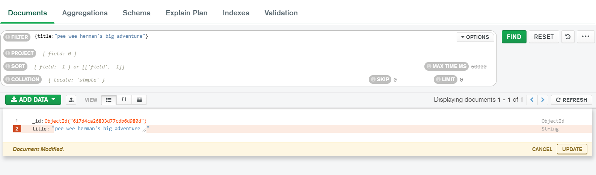

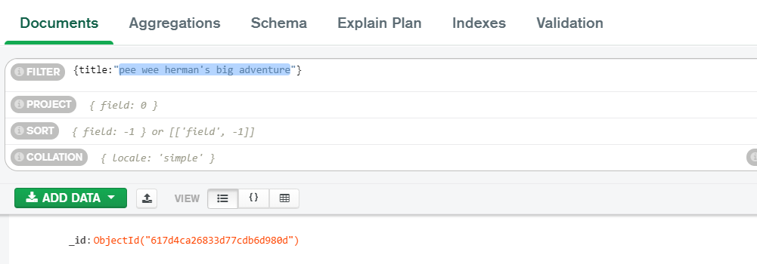

1. DELETE THE MOVIES “AVATAR”

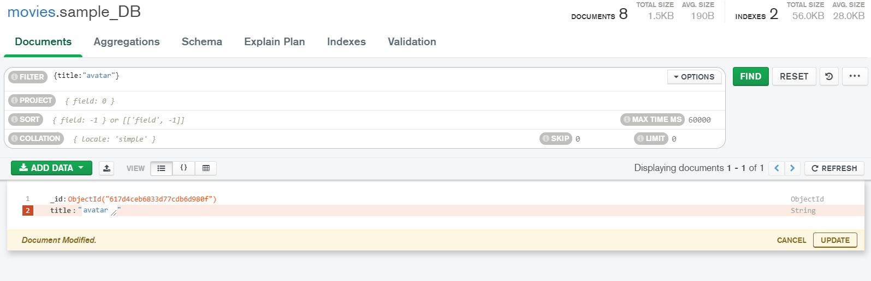

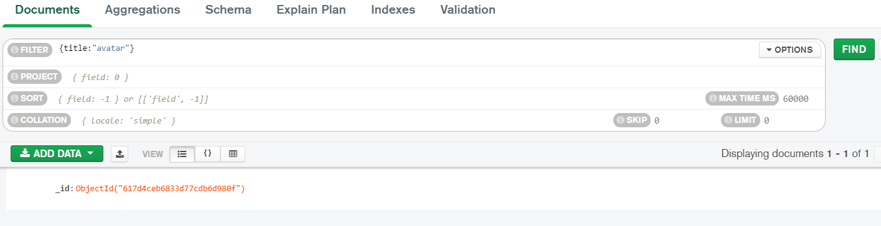

1. FIND ALL USERS.
2. FIND ALL POSTS.
3. FIND ALL POSTS THAT AUTHORIZED WITH “GOODGUYGREG”

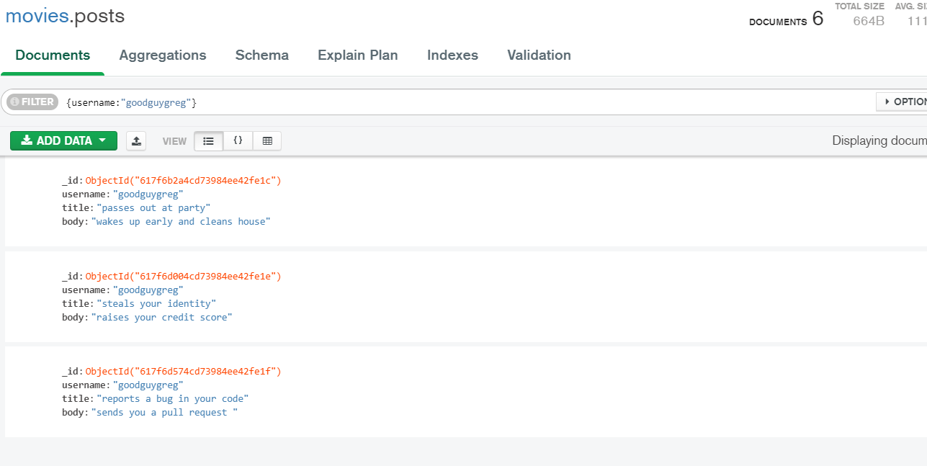

1. FIND ALL POSTS THAT AUTHORIZED WITH “SCUMBAGSTEVE”

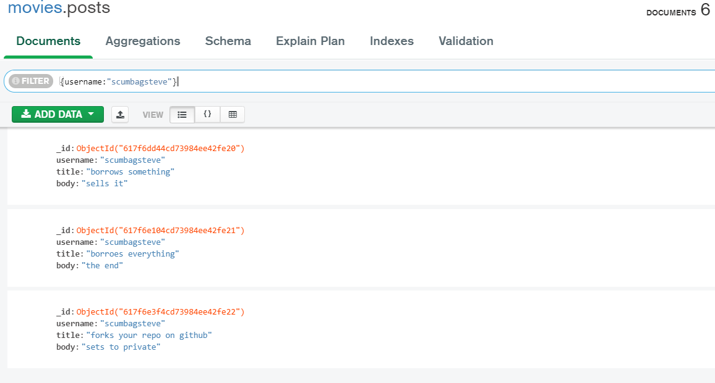

1. FIND ALL COMMENTS THAT AUTHORIZED WITH “GOODGUYGREG”

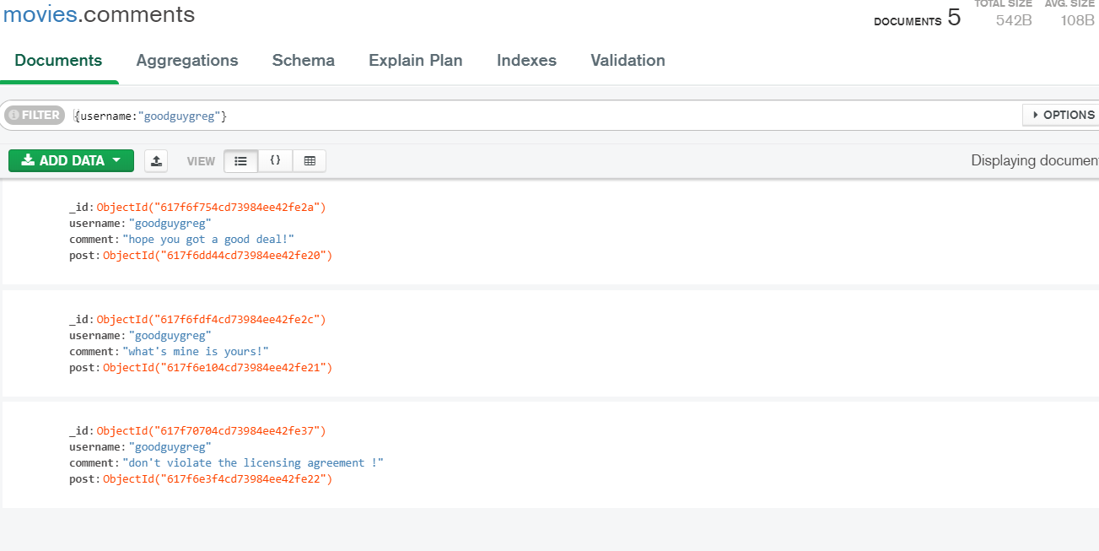

1. FIND ALL COMMENTS THAT AUTHORIZED WITH “SCUMBAGSTEVE”

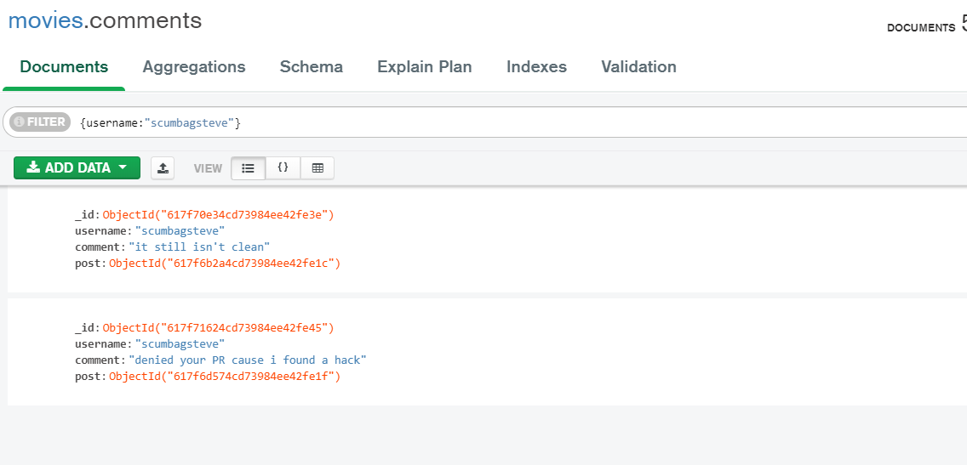

1. Find all comments belonging to the post “reports a bug in your code”

