1. Design and draw UML class diagram to represent an airline reservation system. The system enables the customer to search for airline flight on a specified date and choose a flight based on some details like availability. The customer can reserve a flight or cancel his reservation the system displays all the flight details such as flight number,name,price and duration of journey.

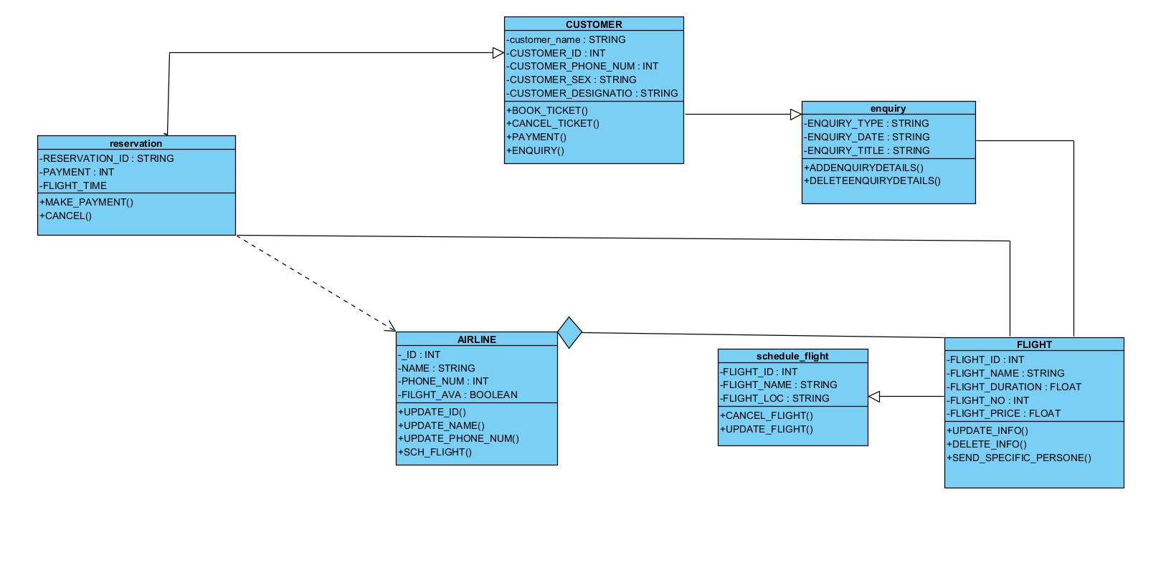

1. Design and draw UML class diagram with attributes,behaviour,and class relationship for the following scenario.

In a university there are various dept a dept has a name and is associated to classrooms and offices.an emp working at the university has a unique id,and can be a professor or an instructor .a professor can be a full professor, associate professor, or assistant professor and he/she belongs to a dept on the university offices and classrooms also have unique id’s and classrooms have fixed num of seats also every emp is assigned an office.

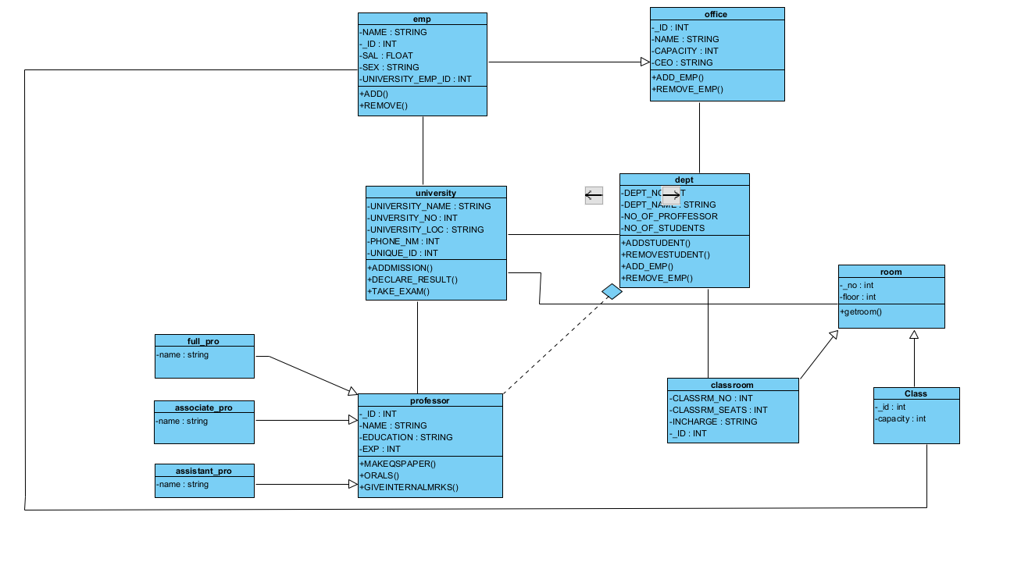

1. Draw an activity diagram for given scenario where a student needs to enroll with the university for the given course.

* An applicant wants to enroll in the university
* The applicants hand a filled-out-copy of enrolment form
* The register inspects the forms
* The register determines that the forms have been filled out properly
* The register informs student to attend in university overview ppt
* The registration helps the student to enroll in seminar
* The register asks the students to pay for the initial tuition.

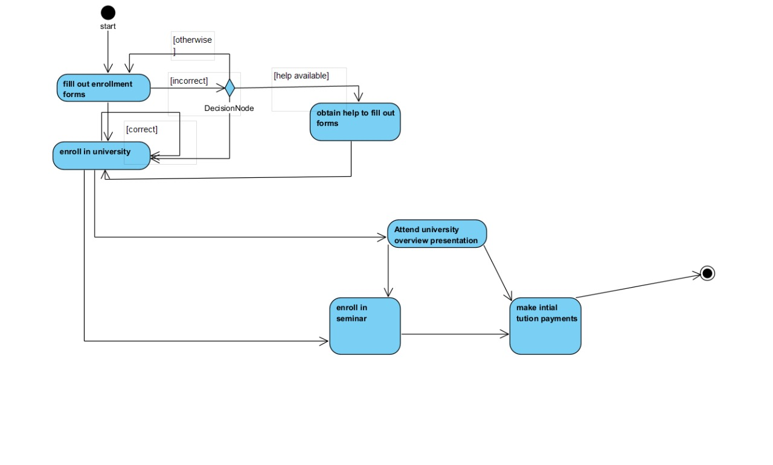

1. A scenario of online library management system sequence diagram

