Linux is Unix-like operating system like mac and ubantu is based on linux
1)Pwd: represents current directory we are currently at
2). è one folder back
3)Two folder back cd ../..
4)cd ~: any directory to comeback to home direactory
5) cd / : refering to root directory
6) ls -lh : tells which permission are allowed like read write,owener
total 100K
drwxr-xr-x 1 HP 197121 0 Nov 15 2023 CSS/
drwxr-xr-x 1 HP 197121 0 Jun 5 17:00 DSA/
drwxr-xr-x 1 HP 197121 0 Aug 24 2023 Deploymet/
drwxr-xr-x 1 HP 197121 0 Oct 20 2023 Expressjs/
drwxr-xr-x 1 HP 197121 0 Jul 22 13:55 FullStack/
drwxr-xr-x 1 HP 197121 0 Dec 18 2023 Javascript/
7)mkdir folder_name è create folder
7)touch file_name create file with name
8) $ cat demo.txt è read the content of file
good kirtikumar
9) rm demo.txt delete file
10) $ rmdir demo_folder è delete folder if that folder does not consist of any folder
11) rmdir demo èit will delete folder even if it has sub folder
12)rm -rf folder_nameè deletes folder forefully does not give warning so avoid it because if you do rm -rf / è it will delete operating also. Use in sub folder with care
Playing with vim
Note vim is one of that provide editable interface alternative is nano
- Vim text.txt if that file exists it will open that file otherwise it will create file with that name and opens
Existing from vimè
I)Ctrl + c + : + qa 2) esc+ : + q
instead of vim we can write vi text.txt
- Initially when we open any file inside vim then it is not inside editable mode we can not edit it. To enable edit we need to press “I”. I for insert. After editing inorder to save the file we will do
Ctrl + c + : + wq
To remember vim commands there is game called vim adventure

- Delete the line, stay in normal mode not insert and press dd(double d)
- gg: normal mode cursor will come on top left corner
- G(capital G): cursor will come to last line
- 6)w: normal mode jump one word
- 2w: jump 2 word and so on
- yy(double y): normal mode copy whole line
- p(single p): normal mode paste that copied line anywhere any time
- copy-pasteè we can copy from browser staying in readonly mode or normal mode and can paste in vim terminal using just p. then hit enter type ctrl+c and wq!
In insert mode you need to use mouse right click only
- Delete all lines from file :%d
- Undo: go in normal mode and press u
- vim ~/.vimrc è this is configuration file vim where we configure like theme tabing numbers etc
- printing last few lines
tail file_name
tail -n 3 code.txt here we are printing only last 3 lines.
Why tails is important than cat because suppose we are saving logs in one of the file
Then that file may have lakhs of line so searching in that is difficult so we can ask for last 100 lines of logs using this command
Same like tail there is head command is there also
13)printing on terminal
echo "kirtikumar"
kirtikumar
echo is like print command
14)dumming
For dumping we use >
echo “kirtikumar” > name.txt
here echo will not print whatever the result we get from left side of > it will dump in right
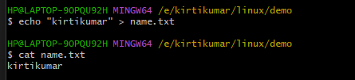
Another example
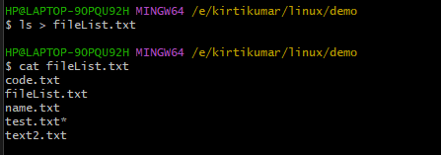
Here result of ls is not printed immediately we are dumping in new file
Suppose I want to dump the next things below of same file like append we can do it by >>
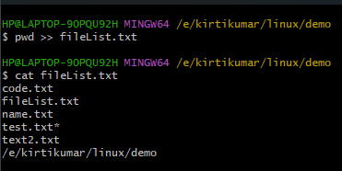
15)Searching in files and piping
Piping is denoted by “|”
X | Y whatever the result of X gives to Y and perform whtever the Y considering X as a input
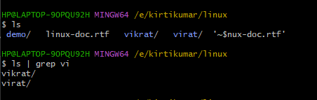
ls will give files or folder inside current folder. Then there is piping so this list of files acts as a input
grep: commonly used commands for text searching, filtering, and extracting in the terminal.
So serach in file which contains vi it is substring search
16)combing different commands : in order to combine different commands we can use && logical and operator
17)copy from one file to another
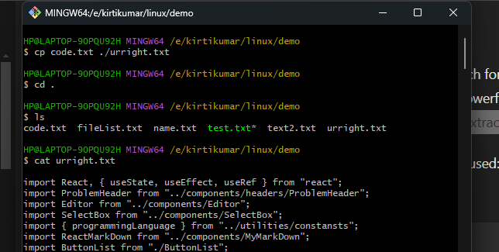

If there is same folder we direactly give path as
cp x.txt y.txt
18) for cut paste file you can use command mv

