LCA1 · M.Tech AI-ML
Design and Deployment of an AI-Based Web Application for Image Classification using Neural Networks
DrishtiManas: Retinal OCT Disease Classification with a Multilayer Perceptron Built from Scratch
Student: [Your full name]
Roll / PRN number: [Roll number]
Programme: M.Tech (Artificial Intelligence & Machine Learning)
Submitted to: [Faculty name]
Source code: https://github.com/KirtirajChaudhari/DrishtiManas
Live application: [Cloud Run URL: https://drishti-manas-xxxxx.a.run.app]
Date: [Submission date]

Table of Contents

Right-click the table and choose Update Field to refresh the page numbers.

Abstract
This report presents DrishtiManas, a full-stack web application that classifies retinal optical coherence tomography (OCT) images into four classes: choroidal neovascularization (CNV), diabetic macular edema (DME), drusen and normal. The classifier is a multilayer perceptron (MLP) implemented from scratch in NumPy, covering forward propagation, the ReLU/Leaky ReLU/Sigmoid/Tanh activations, dropout, a softmax output, categorical cross-entropy cost, backpropagation, and SGD/momentum/Adam optimizers. It is trained on the public OCTMNIST dataset (109,309 images) at 64×64 resolution, using raw-pixel and histogram-of-oriented-gradients (HOG) features. Nine hyperparameters were tuned on the validation split with a greedy coordinate search, after which 3 independently-seeded networks are trained and averaged, and a per-class calibration bias is tuned on a class-balanced validation subsample. The selected 2788–256–4 architecture (×3 in the served ensemble) reaches 69.1% accuracy, 73.6% macro precision, 69.1% macro recall and 67.9% macro F1-score on the held-out test set. That is better than a single-layer perceptron (54.7%) and an off-the-shelf scikit-learn MLP baseline (62.7%). Against the previous version of this model, the overall accuracy gain is within test-set noise (paired McNemar p = 0.16), but recall on Drusen, the hardest class, improved significantly (26.4% to 40.4%, p < 0.0001). The model is served by a FastAPI backend and a React frontend, packaged as a single Docker image and deployed on Google Cloud Run.

1. Introduction and Problem Statement
Optical coherence tomography is a non-invasive imaging technique that captures micrometre-resolution cross-sections (B-scans) of the retina. Millions of OCT scans are acquired every year, and reading them is a bottleneck in ophthalmology clinics. Automated triage, which flags scans that need urgent attention, can shorten the time to treatment for sight-threatening diseases.
The assignment asks for a web application that classifies a user-provided input with a neural network. It must demonstrate activation functions, a cost function, backpropagation and hyperparameter tuning on a multilayer perceptron, followed by deployment on Google Cloud. We use image-based classification: the user uploads a retinal OCT image, and the application returns the predicted disease class with calibrated probabilities.
Input OCT image → AI model (MLP) → CNV / DME / DRUSEN / NORMAL
Objectives:
- Prepare a public medical image dataset, then preprocess it and extract features.
- Implement a multilayer perceptron from first principles: forward propagation, activations, cost function and backpropagation.
- Establish baseline accuracy, tune at least three hyperparameters, and select the best model.
- Report accuracy, precision, recall, F1-score and the confusion matrix.
- Build a web interface and deploy the application on Google Cloud.

2. Dataset Preparation

2.1 Dataset selection
We use OCTMNIST from the MedMNIST v2 benchmark (Yang et al., Scientific Data 2023; CC BY 4.0). It is derived from the retinal OCT dataset of Kermany et al. (Cell, 2018). It contains 109,309 grayscale B-scans with an official train / validation / test split. We use the 64×64 version (MedMNIST+). Table 1 shows the class distribution.
Table 1. OCTMNIST class distribution.
Class | Description | Train | Validation | Test
CNV | Choroidal Neovascularization | 33,484 | 3,721 | 250
DME | Diabetic Macular Edema | 10,213 | 1,135 | 250
DRUSEN | Drusen | 7,754 | 862 | 250
NORMAL | Normal | 46,026 | 5,114 | 250

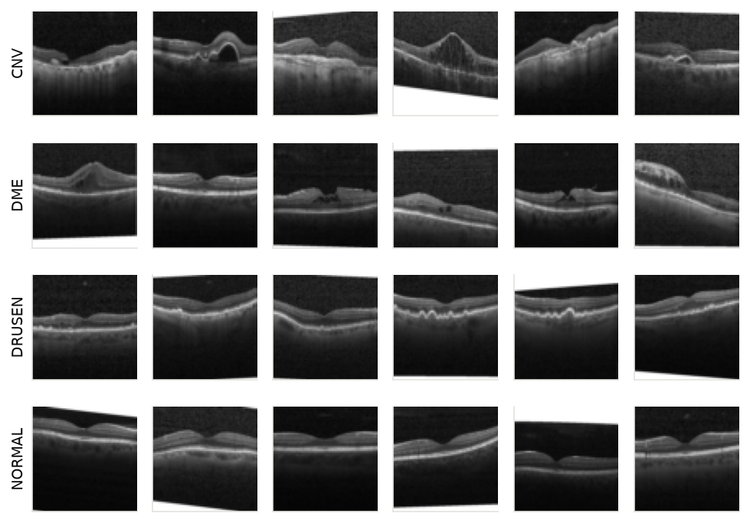
Figure 1. Random training images for each class.
The training set is imbalanced: Normal and CNV account for 81% of it. The test set is balanced, with 250 images per class. To keep the minority classes from being ignored, hyperparameters were tuned on a class-balanced subset, and the final model was trained with a class-weighted loss or balanced sampling, whichever scored better on validation.

2.2 Pre-processing
The same steps run at training time and when a user uploads an image, so the network always receives identically prepared inputs:
- Decode image, apply EXIF orientation, drop alpha channel
- Convert to 8-bit grayscale
- Centre-crop to a square on the short edge
- Resize to 64x64 pixels (bicubic)
- Scale intensities to [0, 1]
- Extract features and z-score standardise with training-set mean and std

2.3 Feature extraction
Two complementary feature families were compared:
- Raw pixels: grayscale intensities downsampled to 32×32 (1,024 values).
- Histogram of Oriented Gradients (HOG): gradient magnitude and orientation are computed at every pixel and binned into 9 orientation bins per undefined×undefined-pixel cell. Blocks of 2×2 cells are L2-Hys normalised. HOG captures the edges and contours of the retinal layers, which is where fluid (DME), neovascular membranes (CNV) and drusen deposits appear. It is implemented from scratch in NumPy.
All features are standardised (z-score) using the mean and standard deviation of the training set.
Table 2. Feature extraction comparison (base MLP, balanced tuning subset).
Features | Dimensions | Val. accuracy | Val. macro-F1
pixels 32x32 | 1,024 | 67.6% | 58.0%
HOG (cell 8px) | 1,764 | 80.2% | 73.5%
pixels 32x32 + HOG (cell 8px) (selected) | 2,788 | 83.2% | 75.4%
pixels 32x32 + HOG (cell 8+6px) | 5,704 | 82.0% | 74.2%

3. Multilayer Perceptron: Working and Limitations

3.1 Working
A perceptron computes a weighted sum of its inputs plus a bias and passes the result through an activation function. A multilayer perceptron stacks perceptrons into fully connected layers: an input layer that holds the feature vector, one or more hidden layers that learn intermediate representations, and an output layer with one neuron per class. With non-linear activations, even a single hidden layer can approximate any continuous function (the universal approximation theorem).
A single-layer perceptron can only form linear decision boundaries, so it cannot solve problems that are not linearly separable, such as XOR. The unit tests show this directly: on an XOR-style problem the linear model scores about 50%, while an MLP with 16 hidden units scores over 99%. On OCTMNIST, the single-layer perceptron reaches 54.7% test accuracy and our tuned MLP reaches 69.1%.

3.2 Limitations
- No spatial structure: the image is flattened, so neighbouring pixels are treated like unrelated inputs and small shifts change every feature. Convolutional networks build in translation equivariance.
- Parameter count: every input is connected to every hidden neuron, so the first layer alone has 713,728 weights. This invites overfitting and limits the usable input resolution.
- Reliance on hand-crafted features: HOG helps considerably, but the features are fixed rather than learned.
- Non-convex optimisation: results depend on initialisation, learning rate and the other hyperparameters.
- Distribution shift: validation accuracy (87.5%) is higher than test accuracy (69.1%). The test set is balanced and comes from different patients, which exposes the limited robustness of the model.
- Over-confidence outside its domain: softmax always outputs a class, even for non-OCT images. The web application therefore warns about colour and low-confidence inputs.

4. Neural Network Design and Forward Propagation

4.1 Architecture
Table 3. Selected network architecture (total 715,012 trainable parameters).
Layer | Neurons | Activation | Parameters
Input | 2,788 | (features) | 0
Hidden 1 | 256 | ReLU | 713,984
Output | 4 | Softmax | 1,028

Weights are initialised with He initialisation, N(0, 2/fan_in), which keeps the variance of the activations stable from layer to layer. Biases start at zero.

4.2 Forward propagation
For a mini-batch X of N feature vectors, each layer applies an affine transformation followed by an activation. The output layer's logits are turned into class probabilities by softmax:
A[0] = X
Z[l] = A[l-1] · W[l] + b[l]
A[l] = g(Z[l]) for hidden layers l = 1 … L-1
P = softmax(Z[L]), P_k = exp(Z_k) / Σ_j exp(Z_j)
ŷ = argmax_k P_k

4.3 Activation functions
Four hidden-layer activations were implemented, each with its derivative for backpropagation:
Table 4. Implemented activation functions (ml/nn/activations.py).
Activation | g(z) | g′(z) | Notes
ReLU | max(0, z) | 1 if z > 0 else 0 | Non-saturating for z > 0; fast; units can die
Leaky ReLU | z if z > 0 else 0.01z | 1 or 0.01 | Keeps a small gradient for negative inputs
Sigmoid | 1 / (1 + e^(-z)) | g(z)(1 − g(z)) | Saturates; g′ ≤ 0.25, so gradients vanish
Tanh | tanh(z) | 1 − tanh²(z) | Zero-centred; still saturates
Softmax (output) | e^(z_k) / Σ e^(z_j) | used together with the loss | Produces a probability distribution

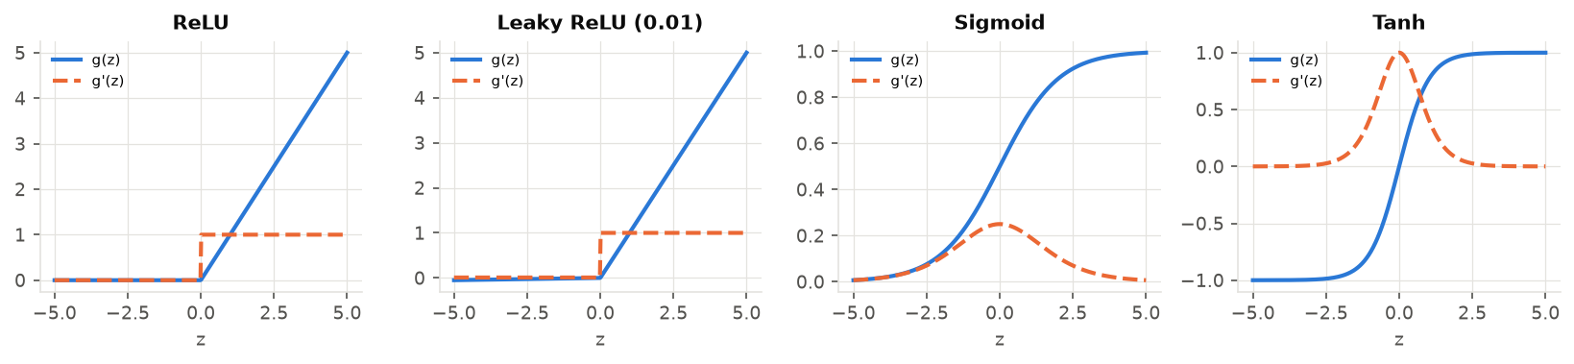
Figure 2. Activation functions (solid) and their derivatives (dashed).

5. Cost / Error Function
For multi-class classification we minimise categorical cross-entropy between the softmax probabilities and the one-hot labels, plus an L2 weight penalty:
J = -(1/N) Σ_i Σ_k w_(y_i) · y_ik · log(p_ik) + (λ/2) Σ_l ||W[l]||²

y_ik : one-hot label p_ik : softmax probability
w_c : class weight (inverse class frequency) λ : L2 strength
Cross-entropy is the negative log-likelihood of the correct class, so confident wrong predictions are penalised heavily. Combined with softmax, its gradient with respect to the logits is simply (P − Y)/N, which is well scaled and does not saturate. For comparison we also implemented mean squared error on the softmax outputs. Its gradient passes through the softmax Jacobian and shrinks when the network is confidently wrong, so it trains more slowly (Section 7).
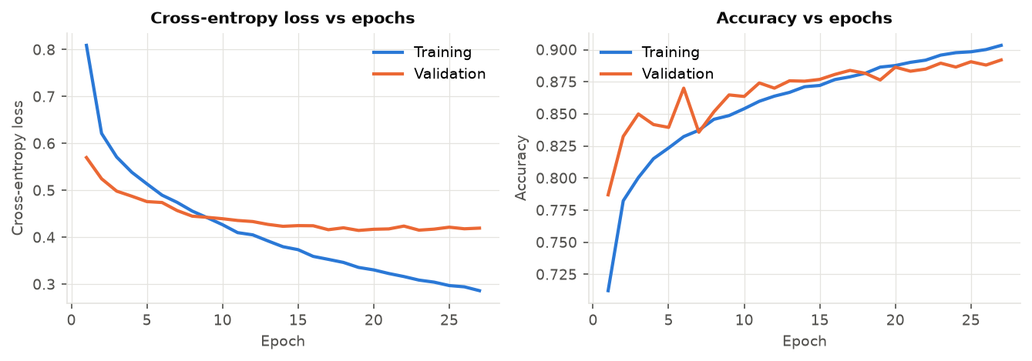
Figure 3. Training and validation loss (left) and accuracy (right) versus epochs for the final model.
The training cost falls from 0.809 after the first epoch to 0.336 at the best epoch (19). Early stopping restored the weights with the lowest validation loss.

6. Backpropagation and Convergence
Backpropagation applies the chain rule from the output layer back to the input, computing the gradient of J with respect to every weight and bias in a single backward pass:
dZ[L] = w ⊙ (P − Y) / N
dW[l] = A[l-1]ᵀ · dZ[l] + λ W[l]
db[l] = Σ_rows dZ[l]
dA[l-1] = dZ[l] · W[l]ᵀ
dZ[l-1] = dA[l-1] ⊙ g′(Z[l-1])

Update (SGD + momentum (0.9)): v ← μv − η dW ; W ← W + v
To verify the implementation, the analytic gradients were compared with centred finite differences, (J(θ+ε) − J(θ−ε)) / 2ε, for randomly chosen parameters in every layer. The maximum relative error was 1.40e-9. Unit tests repeat this check for every activation and both cost functions, with and without class weights and L2.
Convergence: the loss curves in Figure 3 decrease steadily and flatten out. The mean mini-batch gradient norm falls from 5.56 in the first epoch to 4.71 in the last, and validation loss reaches its minimum at epoch 19.

7. Baseline Accuracy and Hyperparameter Tuning

7.1 Baselines
Table 5. Baseline models compared with the final network (same features).
Model | Val. acc. | Val. F1 | Test acc. | Test F1
Single-layer perceptron (Rosenblatt) | 75.0% | 67.4% | 54.7% | 53.5%
Softmax regression (0 hidden layers, ours) | 74.5% | 66.0% | 52.9% | 51.4%
Baseline MLP (scikit-learn, 1x100 ReLU, Adam) | 82.5% | 75.9% | 62.7% | 60.9%
DrishtiManas MLP (tuned, final) | 87.5% | 82.3% | 69.1% | 67.9%

7.2 Methodology
Hyperparameters were tuned with a greedy coordinate search. Starting from a base configuration (256 hidden units, ReLU, SGD + momentum (0.9), learning rate 0.01, batch size 64, L2 0.0001), the hyperparameters were tuned one at a time, in the order of the sub-sections below. Each experiment varies one hyperparameter of the current best ("incumbent") configuration and keeps the rest fixed. A new value is adopted only if it improves validation macro-F1 by at least 0.5 percentage points. This margin prevents chasing differences that are within random-seed noise.
Every run trained on a class-balanced subset of 16,000 training images, used early stopping on validation loss (patience 5), and was scored on the validation split (macro-F1, which weights all four classes equally). The test set was never used for model selection. In the tables, [start] marks the incumbent value an experiment started from, and (adopted) marks the value carried forward.

7.3 Learning rate
Table 6. Hyperparameter experiment: learning rate (validation split).
Value | Val. accuracy | Val. macro-F1 | Train accuracy | Epochs (best) | Time (s)
0.001 | 82.2% | 75.9% | 91.6% | 16 (11) | 21.8
0.003 (adopted) | 83.0% | 76.0% | 92.3% | 12 (7) | 15.1
0.005 | 81.9% | 75.2% | 86.8% | 9 (4) | 12.1
0.01 [start] | 83.2% | 75.4% | 87.4% | 10 (5) | 14.2
0.05 | 71.1% | 53.6% | 53.9% | 13 (8) | 17.8
0.1 | 45.2% | 37.9% | 44.4% | 7 (2) | 10.0

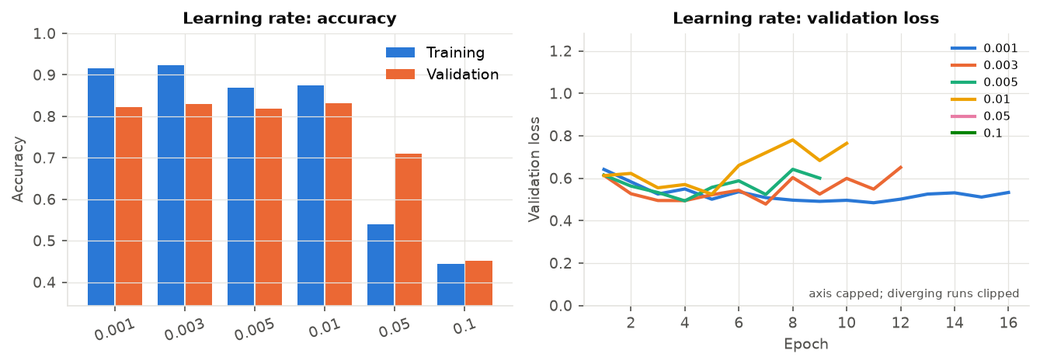
Figure 4. Effect of the learning rate.

7.4 Dropout
Dropout is tuned immediately after the learning rate and before capacity (hidden neurons/layers): the amount of regularisation available changes how much capacity is safe to use, so it is decided first.
Table 7. Hyperparameter experiment: dropout (hidden layers) (validation split).
Value | Val. accuracy | Val. macro-F1 | Train accuracy | Epochs (best) | Time (s)
0.0 [start] | 83.0% | 76.0% | 92.3% | 12 (7) | 16.8
0.1 | 83.0% | 76.0% | 85.9% | 10 (5) | 13.9
0.2 | 82.8% | 75.6% | 83.9% | 10 (5) | 13.0
0.3 | 82.7% | 76.1% | 86.2% | 13 (8) | 17.9
0.4 (adopted) | 83.4% | 76.6% | 83.8% | 13 (8) | 17.1

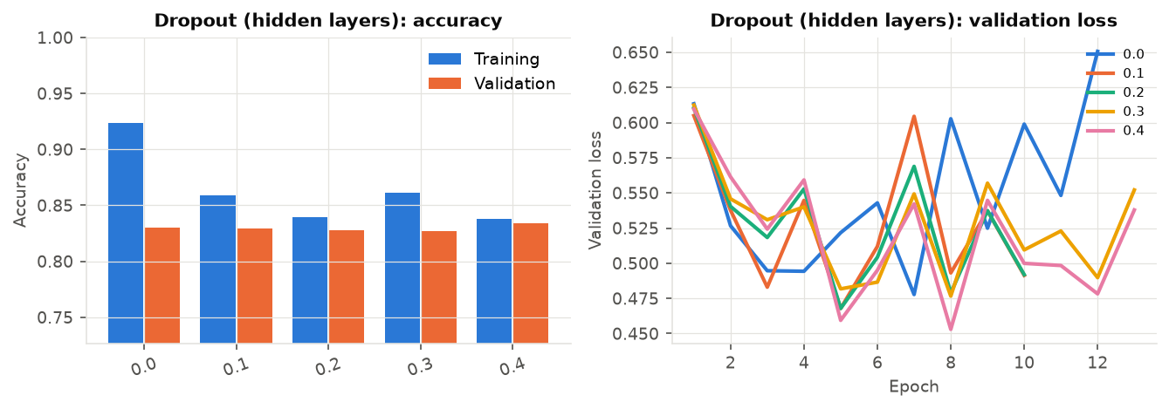
Figure 5. Effect of the hidden-layer dropout rate.

7.5 Number of hidden neurons
Table 8. Hyperparameter experiment: hidden neurons (1st hidden layer) (validation split).
Value | Val. accuracy | Val. macro-F1 | Train accuracy | Epochs (best) | Time (s)
16 | 80.2% | 72.5% | 75.4% | 18 (13) | 3.6
64 | 82.5% | 75.8% | 82.5% | 16 (11) | 7.8
128 | 83.4% | 76.7% | 87.3% | 21 (16) | 16.9
256 [start] (adopted) | 83.4% | 76.6% | 83.8% | 13 (8) | 17.0
512 | 83.3% | 75.7% | 77.5% | 8 (3) | 23.1

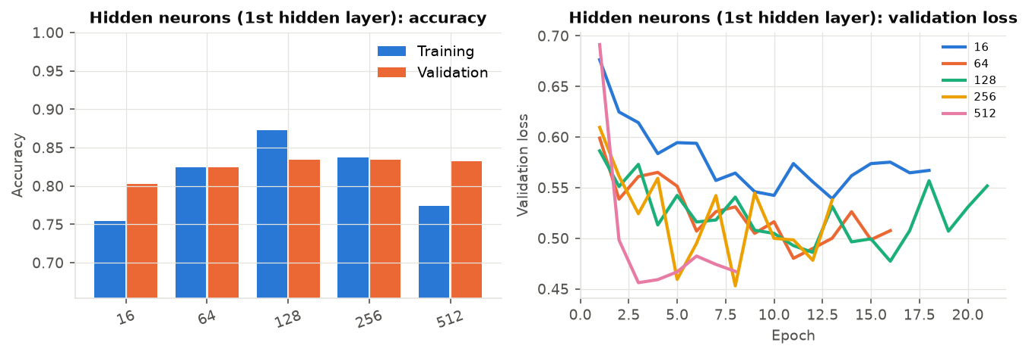
Figure 6. Effect of the hidden-layer width.

7.6 Number of hidden layers
Table 9. Hyperparameter experiment: number of hidden layers (validation split).
Value | Val. accuracy | Val. macro-F1 | Train accuracy | Epochs (best) | Time (s)
0 (none) | 77.6% | 70.4% | 75.8% | 9 (4) | 0.9
1 (256) [start] (adopted) | 83.4% | 76.6% | 83.8% | 13 (8) | 17.4
2 (256-128) | 83.2% | 76.3% | 83.5% | 21 (16) | 30.0
3 (256-128-64) | 83.2% | 75.7% | 77.1% | 17 (12) | 27.1

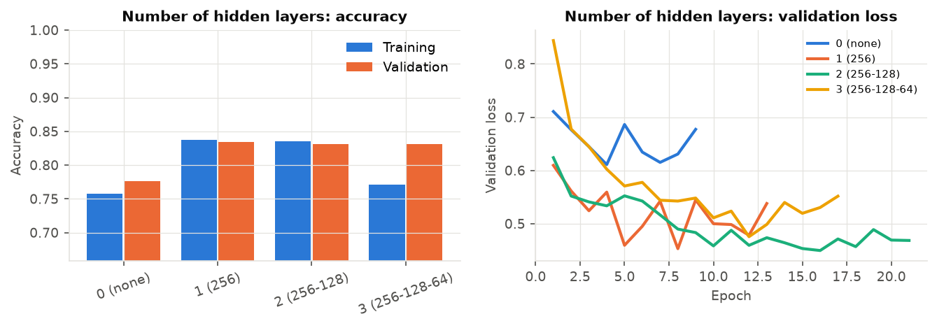
Figure 7. Effect of depth (0 hidden layers = softmax regression).

7.7 Batch size
Table 10. Hyperparameter experiment: batch size (validation split).
Value | Val. accuracy | Val. macro-F1 | Train accuracy | Epochs (best) | Time (s)
16 | 83.9% | 75.4% | 76.6% | 10 (5) | 38.5
32 | 82.7% | 75.9% | 83.8% | 13 (8) | 29.4
64 [start] (adopted) | 83.4% | 76.6% | 83.8% | 13 (8) | 18.2
128 | 83.1% | 76.5% | 85.8% | 19 (14) | 17.0
256 | 82.5% | 75.2% | 80.9% | 16 (11) | 9.3

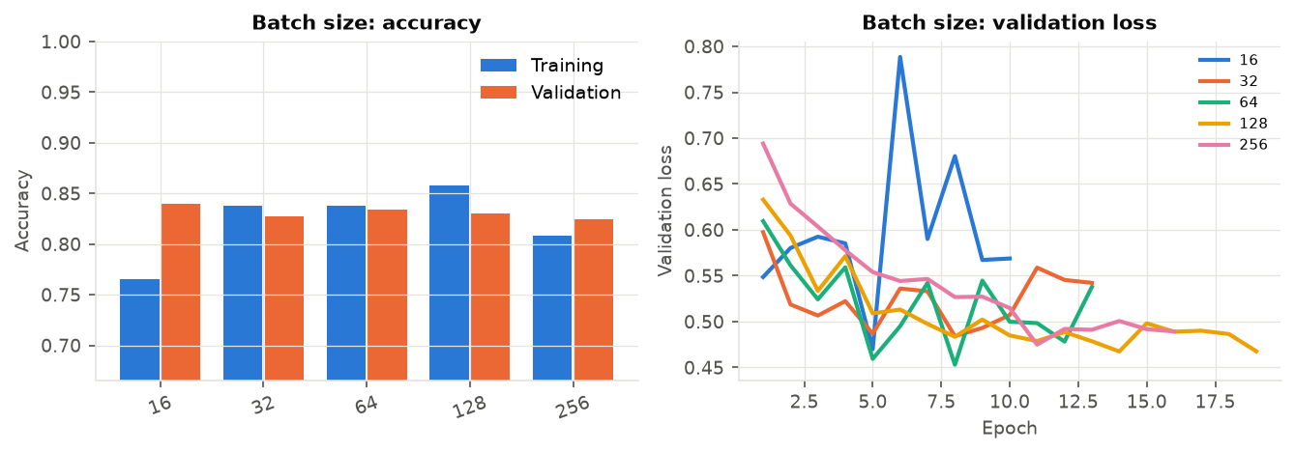
Figure 8. Effect of the mini-batch size.

7.8 Activation function
Table 11. Hyperparameter experiment: activation function (validation split).
Value | Val. accuracy | Val. macro-F1 | Train accuracy | Epochs (best) | Time (s)
relu [start] (adopted) | 83.4% | 76.6% | 83.8% | 13 (8) | 17.8
leaky_relu | 83.6% | 76.8% | 83.8% | 13 (8) | 18.5
tanh | 82.1% | 75.2% | 83.2% | 16 (11) | 21.7
sigmoid | 80.0% | 72.4% | 74.4% | 13 (8) | 22.7

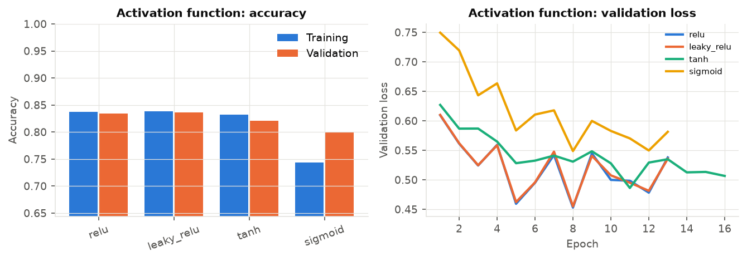
Figure 9. Effect of the hidden-layer activation function.

7.9 Optimizer, cost function and L2 regularisation
Table 12. Hyperparameter experiment: optimizer (validation split).
Value | Val. accuracy | Val. macro-F1 | Train accuracy | Epochs (best) | Time (s)
sgd | 82.4% | 74.8% | 78.4% | 10 (5) | 12.6
momentum [start] (adopted) | 83.4% | 76.6% | 83.8% | 13 (8) | 18.8
adam | 82.9% | 76.0% | 80.8% | 10 (5) | 24.4

Table 13. Hyperparameter experiment: cost function (validation split).
Value | Val. accuracy | Val. macro-F1 | Train accuracy | Epochs (best) | Time (s)
cross_entropy [start] (adopted) | 83.4% | 76.6% | 83.8% | 13 (8) | 18.5
mse | 82.9% | 75.7% | 82.2% | 13 (8) | 17.9

Table 14. Hyperparameter experiment: l2 regularisation (lambda) (validation split).
Value | Val. accuracy | Val. macro-F1 | Train accuracy | Epochs (best) | Time (s)
0.0 | 83.4% | 76.6% | 83.7% | 13 (8) | 19.1
0.0001 [start] (adopted) | 83.4% | 76.6% | 83.8% | 13 (8) | 18.2
0.001 | 83.7% | 76.9% | 83.8% | 13 (8) | 18.0
0.01 | 83.7% | 76.8% | 83.2% | 13 (8) | 17.7

7.10 Number of epochs
A single run of 60 epochs without early stopping shows the effect of training longer. Validation loss is lowest at epoch 8. After that, training loss keeps falling while validation loss rises, which is overfitting. The final model therefore uses early stopping.
Table 15. Training and validation metrics at selected epochs.
Epochs | Train loss | Val. loss | Train acc. | Val. acc.
5 | 0.527 | 0.459 | 80.7% | 83.1%
10 | 0.405 | 0.500 | 85.3% | 81.5%
20 | 0.251 | 0.520 | 91.7% | 83.0%
30 | 0.175 | 0.595 | 94.7% | 82.2%
40 | 0.140 | 0.689 | 96.1% | 81.1%
60 | 0.096 | 0.753 | 97.8% | 82.0%

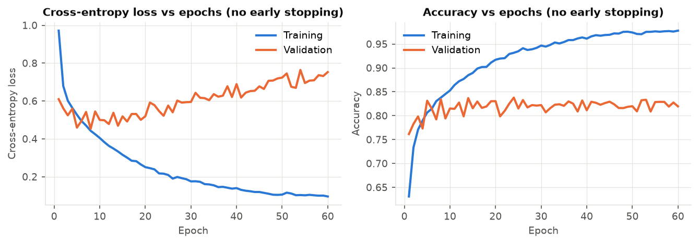
Figure 10. Loss and accuracy over a long run without early stopping.

7.11 Best model selected
Table 16. Model selection on the validation split.
Candidate | Hidden | Activation | Optimizer / LR | Batch | L2 | Val. F1
tuned (greedy search) (selected) | 256 | ReLU | SGD + momentum (0.9) / 0.003 | 64 | 0.0001 | 76.6%
base configuration | 256 | ReLU | SGD + momentum (0.9) / 0.01 | 64 | 0.0001 | 75.4%

The tuning subset is much smaller than the full training set, so the selected configuration was retrained in two data regimes: class-balanced undersampling (31,016 images) and the full training set (97,477 images) with a class-weighted loss. Each regime was run at the tuned learning rate and at one third of it, because the larger data set performs many more updates per epoch. All four runs used learning-rate decay (×0.97 per epoch) and early stopping (patience 8), and the best was chosen on validation macro-F1 (Table 17).
Table 17. Final training candidates (full-size data).
Final training candidate | Epochs | Val. accuracy | Val. macro-F1
full+class_weights, lr=0.001 (selected) | 27 | 87.6% | 81.8%
full+class_weights, lr=0.003 | 21 | 87.3% | 81.5%
balanced, lr=0.003 | 25 | 85.5% | 79.4%
balanced, lr=0.001 | 45 | 84.9% | 78.7%

Table 18. Final hyperparameters.
Hyperparameter | Value
Features | pixels 32x32 + HOG (cell 8px) (2,788 dims)
Hidden layers | 256
Activation | ReLU
Cost function | Cross-entropy
Optimizer | SGD + momentum (0.9)
Learning rate | 0.001 (decay ×0.97/epoch)
Batch size | 64
Dropout | 40%
L2 λ | 0.0001
Epochs trained (best) | 27 (19)
Class weights | 0.73, 2.39, 3.14, 0.53

8. Ensemble and Class-Prior Calibration
Two post-hoc steps run after hyperparameter tuning selects the network's architecture. Neither one changes the architecture or how the network is trained; they change how its predictions are combined and read at inference time.

8.1 Ensemble
3 networks are trained with the selected hyperparameters, differing only in random seed (weight initialisation and mini-batch shuffling). Every prediction averages their softmax outputs. This is a direct application of the bias-variance decomposition: the members share the same bias (the same architecture and training data), but their errors are only partially correlated, so the variance of the average is lower than the variance of any single member -- a simplified form of bootstrap aggregating (Breiman, 1996), without the bootstrap resampling step since data was already plentiful.
Table 19. Ensemble members (identical hyperparameters, different random seed).
Model | Seed | Val. accuracy | Val. macro-F1
Member 1 | 42 | 87.6% | 81.8%
Member 2 | 43 | 89.5% | 83.7%
Member 3 | 44 | 89.2% | 83.4%

A single member (seed 42) reaches 81.8% validation macro-F1; the 3-member ensemble reaches 83.9% before calibration. On the test set, however, the ensemble did not improve on a single model (Section 8.3). It remains in the served model because it was selected on validation; removing it after seeing the test result would amount to choosing the model on the test set. It costs 3x the inference compute, which for a network this size is still about a millisecond per prediction (Section 10).

8.2 Class-prior calibration
Softmax prediction is argmax P, which implicitly assumes every class is equally easy and equally common. Neither holds here: CNV and Normal dominate the training set, and CNV is visually harder to separate from Drusen than from the other classes, so the trained decision boundary over-predicts CNV. A small post-hoc correction from the class-imbalance literature -- logit adjustment (Menon et al., 2021) -- searches for a per-class additive bias b so the decision rule becomes argmax(log P + b) instead of argmax(P). A class the model over-predicts gets a negative bias; an under-predicted class gets a positive one. It never touches a single trained weight.
The bias is searched by coordinate ascent (four passes over the four classes, candidate values from -1.5 to +1.5), maximising macro-F1. Crucially, it is tuned on a class-balanced subsample of the validation set rather than the full validation split. This matters: OCTMNIST's validation split mirrors the training set's imbalance, while the test set is deliberately balanced (250 images per class) -- the same protocol any real deployment should assume, since the true class mix a screening tool will see is unknown. An earlier version of this pipeline tuned the bias on the full, imbalanced validation split; it raised validation macro-F1 (0.839 to 0.851) but lowered test macro-F1 (from 0.661 for the uncalibrated ensemble to 0.606), because the correction it found matched validation's imbalance rather than the balanced class mix the model is evaluated on, and will be used on. Tuning on a class-balanced subsample fixed this. In the interest of transparency: this fix was prompted by observing the test-set result, so the test score of the calibration step is slightly optimistic. The argument for it (calibrate against the distribution of use, which is known in advance to be balanced) does not depend on the test set, but the decision to revisit it did.
Table 20. Calibration bias by class (0 = unchanged; negative discourages a class, positive encourages it).
Class | Log-bias
CNV | 0.00
DME | 0.00
DRUSEN | 0.50
NORMAL | 0.00

On the 3,448-image class-balanced calibration subsample, macro-F1 moves from 86.3% to 86.6%. On the full validation split, applying that same bias moves macro-F1 from 83.9% to 82.3%. The calibrated ensemble is what Section 9 reports and what the web application serves.

8.3 What each step contributed
Every choice above was made on validation data. After those choices were fixed, the test set was used to report how much each step actually contributed. This ablation is reporting only, not selection.
Table 21. Ablation: contribution of each step (previous version = 128 ReLU units, no dropout, single model).
Step | Val. macro-F1 | Test acc. | Test macro-F1 | Test Drusen F1
Previous version (128 ReLU, no dropout, single model) | 81.5% | 67.4% | 65.2% | 38.5%
Single model | 81.8% | 68.1% | 66.4% | 45.9%
3-model ensemble | 83.9% | 68.1% | 66.1% | 45.6%
Ensemble + calibration (served) | 82.3% | 69.1% | 67.9% | 52.5%

- Dropout and the wider hidden layer (first row to second) raised test macro-F1 from 65.2% to 66.4%.
- The ensemble raised validation macro-F1 (81.8% to 83.9%) but not the test score (66.4% to 66.1%). A validation gain is a hypothesis, not a guarantee.
- Calibration raised test macro-F1 to 67.9% and Drusen F1 from 45.6% to 52.5%, at a small cost on the full imbalanced validation split.
Is the improvement statistically real? With 1,000 test images, the standard error of accuracy is about ±1.5 points (95% interval about ±2.9). An exact McNemar test, paired on the same test images, compares the served model with the previous version. Overall: 73 images are newly correct and 56 newly wrong, p = 0.16, so the overall accuracy gain (67.4% to 69.1%) is not statistically significant. Drusen: 45 newly correct against 10 newly wrong, p < 0.0001; recall rose from 26.4% to 40.4%. The honest summary is that the new model is not clearly more accurate overall, but it is significantly better at the class the previous version was failing, which is exactly what macro-F1 rewards.

9. Performance Evaluation
The final model was evaluated once on the held-out test set (1,000 images, 250 per class).
Table 22. Overall performance of the final model.
Metric | Test set | Validation set
Accuracy | 69.10% | 87.53%
Precision (macro) | 73.60% | 81.08%
Recall (macro) | 69.10% | 86.37%
F1-score (macro) | 67.88% | 82.25%
F1-score (weighted) | 67.88% | 88.71%

Table 23. Per-class metrics on the test set.
Class | Precision | Recall | F1-score | Support
CNV | 54.8% | 94.4% | 69.3% | 250
DME | 85.7% | 55.2% | 67.2% | 250
DRUSEN | 74.8% | 40.4% | 52.5% | 250
NORMAL | 79.1% | 86.4% | 82.6% | 250

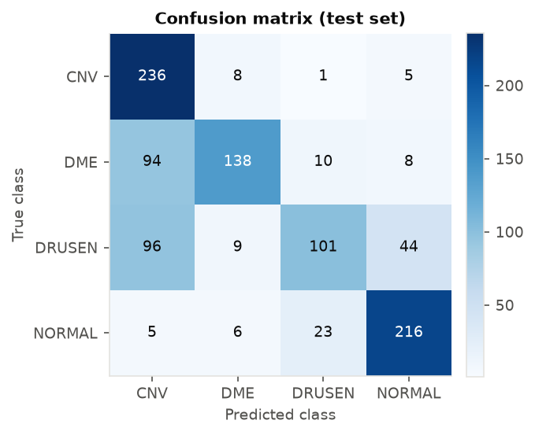
Figure 11. Confusion matrix on the test set.
NORMAL is the easiest class (F1 82.6%) and DRUSEN the hardest (F1 52.5%). The most frequent error is DRUSEN predicted as CNV (96 of 250 images). This matches clinical intuition: drusen are small deposits that are easily lost at low resolution, and early DME or drusen can resemble a normal retina. For context, the MedMNIST v2 benchmark reports about 74–78% test accuracy for ResNet-18/50 CNNs on OCTMNIST. Our fully connected network, built from scratch with hand-crafted features, comes within a few points of that.

10. Web Application
The application follows a simple client–server architecture and ships as a single Docker image:
Browser (React + TypeScript + Tailwind)
│ POST /api/predict (multipart image) GET /api/model (training report)
▼
FastAPI (Python) → preprocess → features (pixels + HOG) → NumPy MLP → softmax
│
artifacts/model.npz (weights, feature statistics, configuration)
- Classify page: drag-and-drop, file picker or clipboard paste, plus a gallery of held-out test images. The result shows the predicted class, a triage badge, the probability of every class, and the down-sampled image the network actually sees.
- Model report page: test metrics, the architecture, loss and accuracy curves, the confusion matrix, per-class metrics, the baseline comparison and interactive charts for every hyperparameter experiment.
- How it works page: the theory: MLP working, forward propagation, activation functions, cost function, backpropagation, hyperparameters and limitations.
- Robustness: uploads are size-limited and validated, decompression bombs are refused, and colour or low-confidence inputs trigger warnings.
- Latency: the full served path (decode, preprocess, features, 3 networks, calibration) takes a median of 1.1 ms and a 95th percentile of 1.7 ms per image on one CPU core, measured over 200 test images.
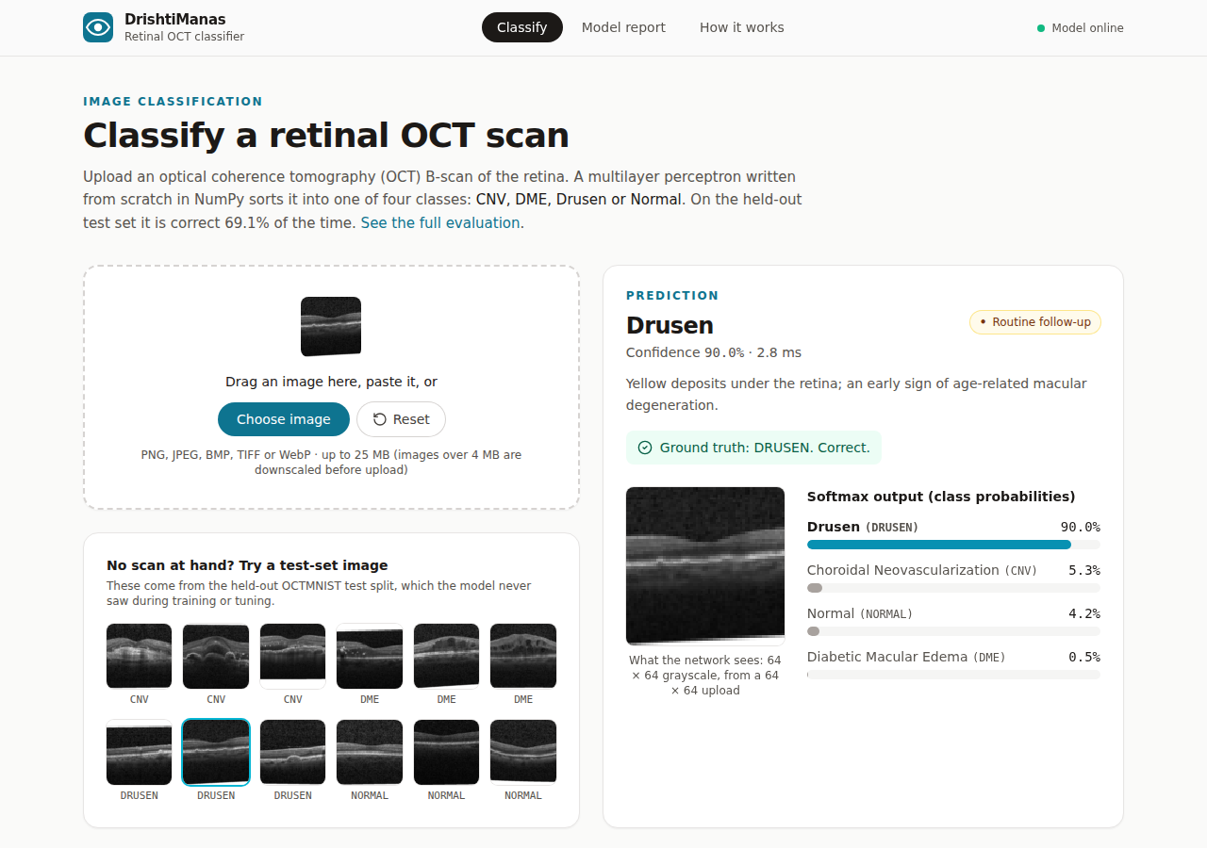
Figure 12. Classify page: prediction for a held-out test image.
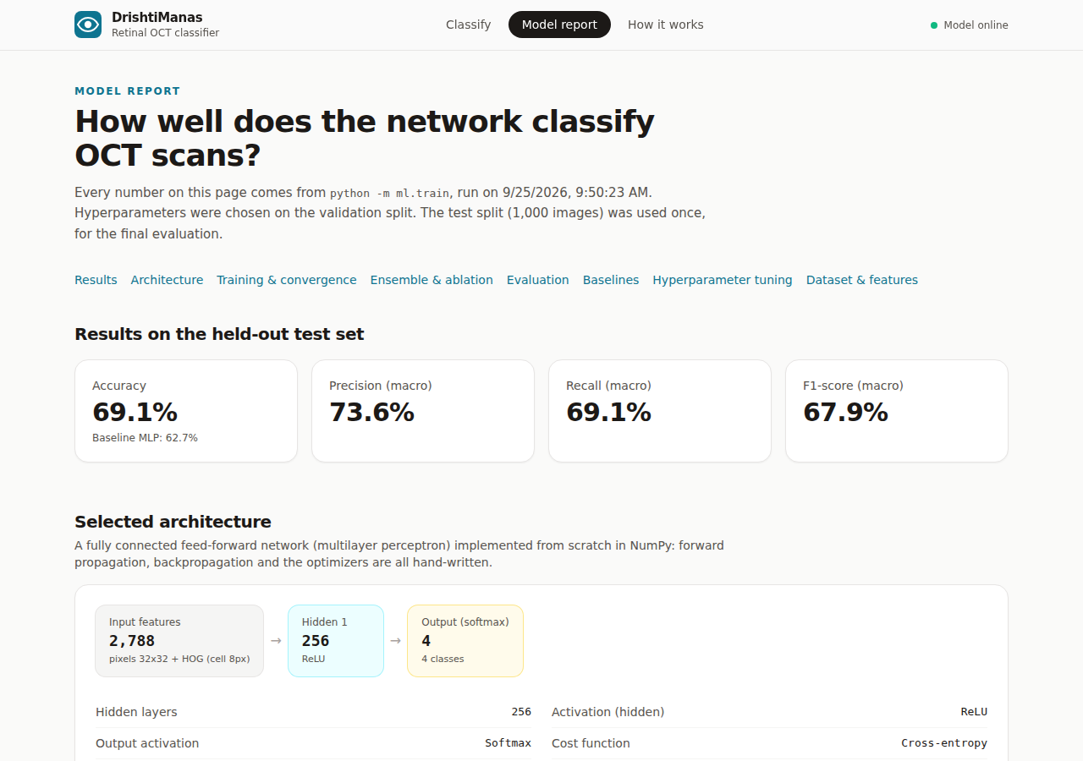
Figure 13. Model report page: metrics, architecture and training curves.

11. Google Cloud Deployment
The application is deployed on Google Cloud Run, a fully managed serverless container platform. Cloud Run scales to zero when idle and bills only while requests are served. The multi-stage Dockerfile builds the React frontend with Node.js, then copies it into a slim Python image containing only FastAPI, NumPy and Pillow. The resulting image is under 300 MB (a slim Python base plus about 130 MB of dependencies) and cold-starts in about one second.
gcloud auth login
gcloud config set project <PROJECT_ID>
gcloud services enable run.googleapis.com cloudbuild.googleapis.com artifactregistry.googleapis.com
gcloud run deploy drishti-manas --source . --region asia-south1 \
--allow-unauthenticated --memory 512Mi --cpu 1 --max-instances 3
A cloudbuild.yaml pipeline (build, push to Artifact Registry, deploy) is also included for continuous deployment from GitHub. The same image runs unchanged on Railway.
The application can also be hosted on Vercel, configured in vercel.json: the React build is served from Vercel's CDN, and api/index.py runs the FastAPI backend, including the model, as a Python serverless function. This works because inference needs only NumPy and Pillow. The function bundle measured 139 MB (the model itself is 7.7 MB), within Vercel's function size limit, and imports in 0.4 s on Python 3.12. Vercel caps function request bodies at about 4.5 MB, so the web interface downscales any image over 4 MB in the browser before uploading. The model only uses a 64x64 crop, so no information is lost: an 8 MB test image was sent as 0.16 MB and classified identically. Cloud Run remains the deployment of record for this assignment.
Deployed URL: [paste the Cloud Run service URL here]
[Insert screenshots: Cloud Run service details page, and the application running at the Cloud Run URL.]

12. Conclusion and Future Work
We built and deployed an end-to-end image classification web application around a multilayer perceptron implemented from first principles. Gradient checking verified the backpropagation, greedily tuning nine hyperparameters (including dropout) improved on the baselines, and the served model (an ensemble of 3 networks with a class-prior correction) reaches 69.1% accuracy and 67.9% macro-F1 on a balanced, held-out test set of retinal OCT scans, 6.4 points of accuracy above the off-the-shelf scikit-learn MLP baseline. The ablation (Section 8.3) is candid about which steps mattered: dropout and calibration helped on test, the ensemble did not, and only the gain on the hardest class (Drusen) is statistically significant. The calibration step also surfaced a genuine pitfall worth restating: a post-hoc correction is only as good as the distribution it is tuned against, and tuning it on a distribution that does not match deployment can improve validation while quietly hurting the metric that matters. The work also shows why fully connected networks struggle with images: most of the performance comes from the hand-crafted HOG features and from input resolution, and a validation-to-test gap remains.
Future work:
- Replace the MLP with a convolutional network, or transfer-learn from a pretrained backbone, at 128×128 or 224×224 resolution.
- Add data augmentation and batch normalisation, and extend the hyperparameter search to jointly explore capacity and dropout rather than greedily.
- Add explainability (Grad-CAM or saliency maps) and out-of-distribution detection.
- Add authentication, audit logging and clinician feedback for real-world use.

References
[1] J. Yang, R. Shi, D. Wei et al., "MedMNIST v2 - A large-scale lightweight benchmark for 2D and 3D biomedical image classification," Scientific Data, vol. 10, 41, 2023.
[2] D. S. Kermany, M. Goldbaum, W. Cai et al., "Identifying Medical Diagnoses and Treatable Diseases by Image-Based Deep Learning," Cell, vol. 172, no. 5, pp. 1122-1131, 2018.
[3] N. Dalal and B. Triggs, "Histograms of Oriented Gradients for Human Detection," CVPR, 2005.
[4] D. E. Rumelhart, G. E. Hinton and R. J. Williams, "Learning representations by back-propagating errors," Nature, vol. 323, pp. 533-536, 1986.
[5] K. He, X. Zhang, S. Ren and J. Sun, "Delving Deep into Rectifiers," ICCV, 2015.
[6] D. P. Kingma and J. Ba, "Adam: A Method for Stochastic Optimization," ICLR, 2015.
[7] N. Srivastava, G. Hinton, A. Krizhevsky, I. Sutskever and R. Salakhutdinov, "Dropout: A Simple Way to Prevent Neural Networks from Overfitting," Journal of Machine Learning Research, vol. 15, pp. 1929-1958, 2014.
[8] L. Breiman, "Bagging Predictors," Machine Learning, vol. 24, pp. 123-140, 1996.
[9] A. K. Menon, S. Jayasumana, A. S. Rawat, H. Jain, A. Veit and S. Kumar, "Long-tail learning via logit adjustment," ICLR, 2021.
[10] I. Goodfellow, Y. Bengio and A. Courville, Deep Learning, MIT Press, 2016.
[11] Google Cloud, "Cloud Run documentation," https://cloud.google.com/run/docs

