**TASK 1 REPORT**

**Task Description:**

Implement a custom aggregation function for use with `groupby` in pandas.

A) Created a custom dataframe named as “**employee_data”** having Employee_Name, Department, Daily_Sales, Date as its attributes. Now using ‘groupby’ and ‘apply’ we will create new table which will give us rank according to the performance of employees on a daily basis from different departments.

B) Working on a CSV file named “100_Sales.csv” applying the same functions and getting meaningful business insights for each and every region in dataset.

**Task Output (A):**

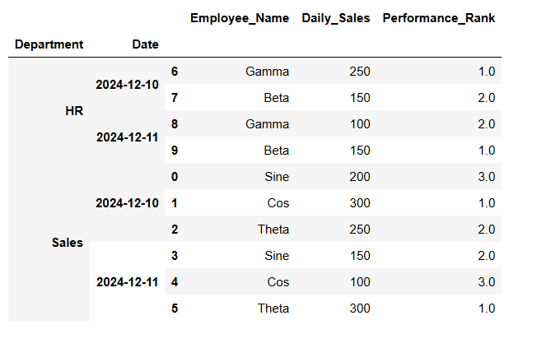

**Task Output (B):**

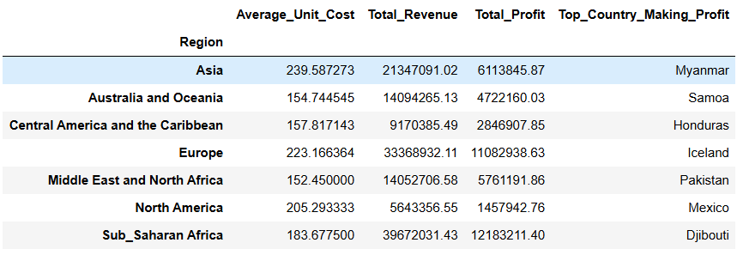

**Widget/Algorithm Used in Task:**

**groupby**: It is a function in pandas used to split data into groups based on values in one or more columns. After splitting, you can perform operations like sum, count, mean, or custom functions on each group.

**apply:** It is a function in pandas that allows you to apply a custom function to a column, row, or group of data. It can be used for complex or user-defined calculations. 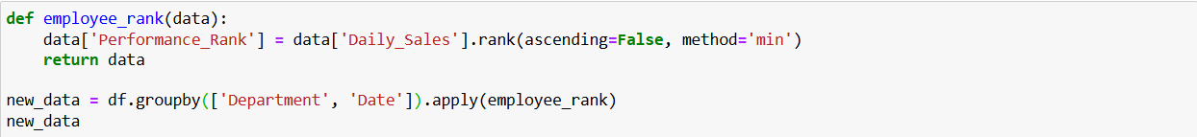

‘apply’ will apply the function ‘employee_rank’ on all grouped data

‘groupby’ will group the data first by ‘Department’ followed by ‘Date’.

