**TASK 2 REPORT**

**Task Description:**

Implement a custom DataFrame transformation function using `apply` and `groupby`.

A) Created a custom dataframe named as “**employee_data”** having Employee_Name, Department, Salary, Age and Experience as its attributes. Now using ‘groupby’ and custom aggregation functions we will create new table which will give us salary range, average age and average experience for each and every department.

B) Working on a CSV file named “100_Sales.csv” applying the same functions and getting meaningful business insights for each and every Region and Item-Type in dataset.

**Task Output (A):**

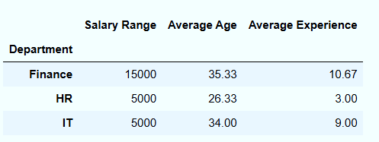

**Task Output (B): Region wise Insights**

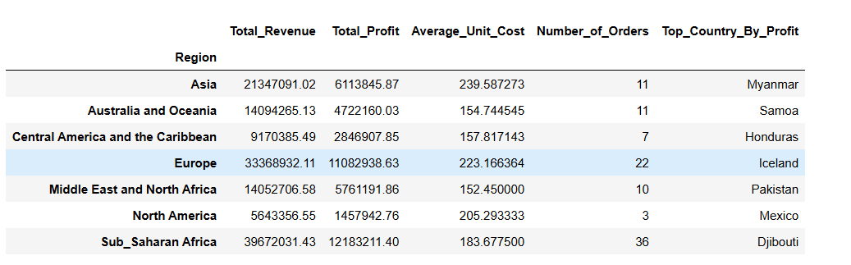

**Task Output (B): Item-Type wise Insights**

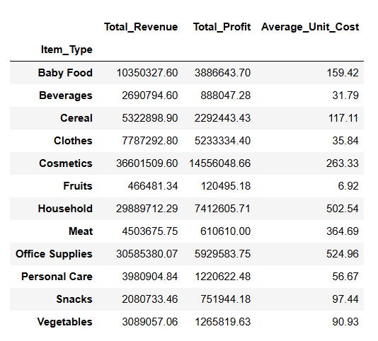

**Widget/Algorithm Used in Task:**

**groupby**: It is a function in pandas used to split data into groups based on values in one or more columns. After splitting, you can perform operations like sum, count, mean, or custom functions on each group.

**agg:**  An aggregate function is a function that performs a calculation on a set of values and returns a single summary value.

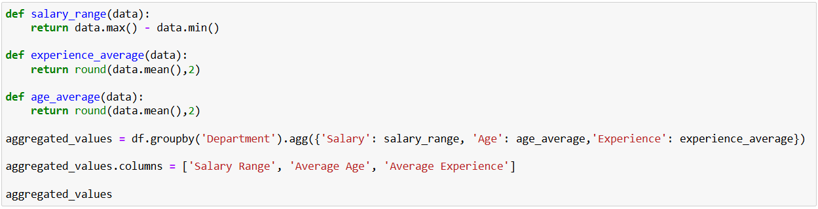

‘groupby’ will group the dataset according to the values in Department column.

‘agg’ will apply all the aggregate functions on the targeted columns

