**TASK 3 REPORT**

**Task Description:**

Apply Decision Tree and Random Forest and get good accuracy.

🡪We have a dataset **“100_Sales.csv”**.

**Task Output (Random Forest):**

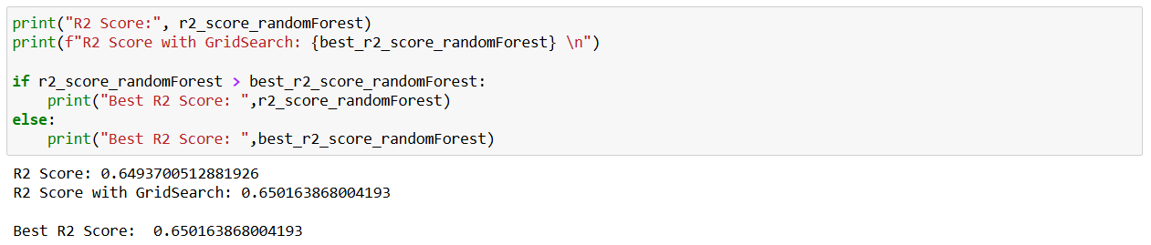



R2_Score getting improvised in Random Forest after making use of GridSearchCV.

**Task Output (Decision Tree):**

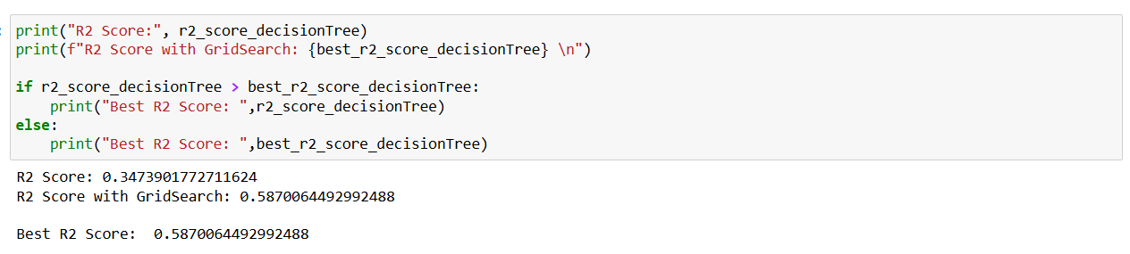

R2_Score getting improvised in Decision Tree after making use of GridSearchCV.



**Widgets/Algorithms Used in Task:**

**from** sklearn.model_selection **import** train_test_split

It is used to split a dataset into two parts: Training data and Testing data. This is important for training and evaluating machine learning models.

**from** sklearn.preprocessing **import** LabelEncoder

It is used to convert categorical values (text or labels) into numerical values (numbers) so that machine learning models can process them.

**from** sklearn.tree **import** DecisionTreeRegressor

It is a machine learning model used for regression tasks. It predicts a numerical output based on input data.

**from** sklearn.ensemble **import** RandomForestRegressor

It is a machine learning model used for regression tasks. It predicts a numerical value based on input data by combining the results of many Decision Trees.

**from** sklearn.metrics **import** mean_squared_error, r2_score

It imports two evaluation metrics: mean_squared_error (MSE) and r2_score (R-squared score). These metrics are used to measure the performance of a regression model (models that predict numerical values).

**from** sklearn.model_selection **import** GridSearchCV

It imports GridSearchCV, which is used to find the best combination of parameters for a machine learning model.