**TASK 4 REPORT**

**Task Description:**

Customize Matplotlib plots with interactive widgets (e.g., sliders, buttons) using libraries like ipywidgets.

1. Displaying the filtered data (Select Item-Type, Region and Channel)
2. Profit v/s Region Bar graph (Select Region)
3. Profit v/s Revenue Scatter plot (Select Cost Range)

**Task Outcomes (A):**

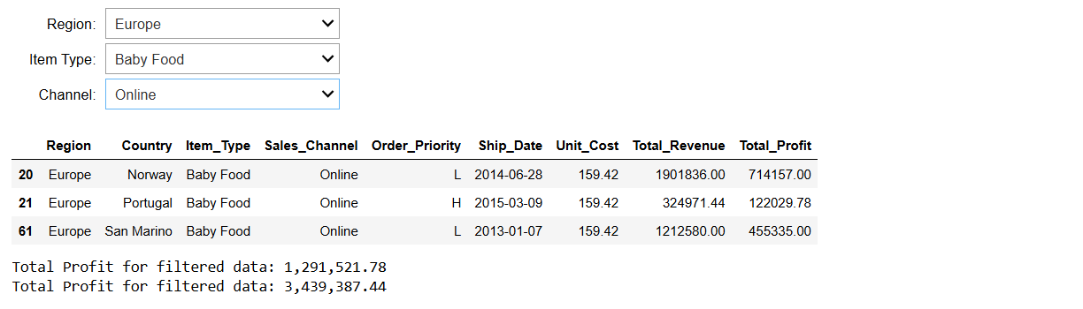

Select your desired Region, Item-Type and Channel to get the insights

**Task Outcomes (B):**

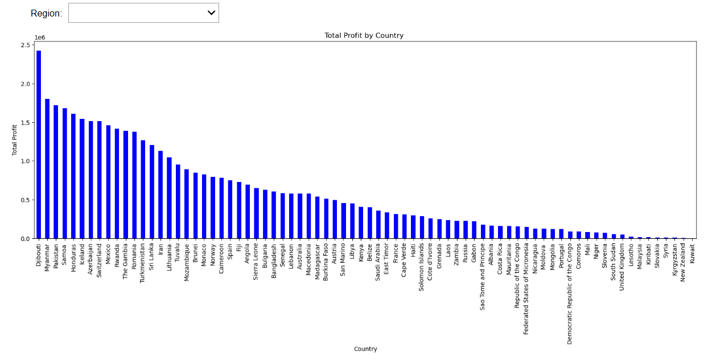

No region selected. So will show you bar graph for all Countries (Default).

**Task Outcomes (C):**

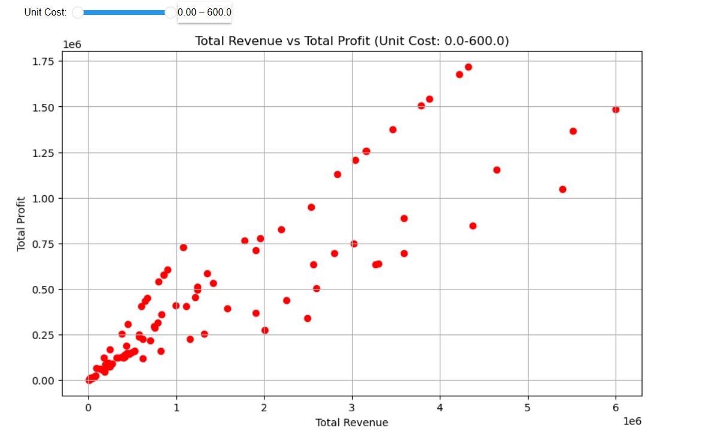

Range of Cost (Default 0-600). Create a scatter plot.

**Widgets/Algorithms Used in Task:**

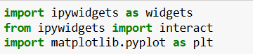



Here **matplotlib** and **ipywidgets** are libraries provided by python for data visualisation.

**Interact:** It is a function in ipywidgets is used to create interactive controls for functions in Jupyter Notebook. It automatically generates widgets like sliders, checkboxes, text boxes, dropdowns, etc., based on the arguments passed to the function.

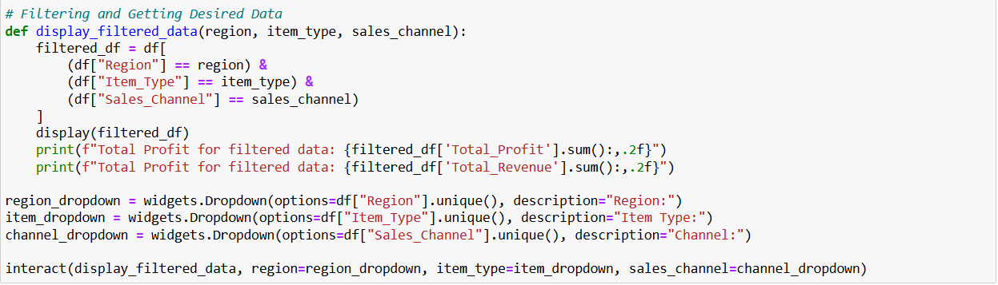

Interact here creating three dropdowns based on display_filtered_data function.

