**TASK 5 REPORT**

**Task Description:**

Implemjent matrix exponentiation for a square matrix using numpy.

**Task Output:**

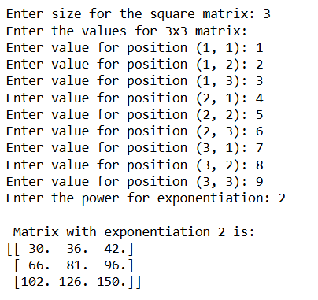

**Widget/Algorithm Used in Task:**

Here in this task, we use a simple concept of matrix multiplication. Explained by a small example. We are given a matrix A and told to exponentiate it by power 3.

