Kirti shukla BCA 1C **INDEX**

|  |  |  |  |  |  |
| --- | --- | --- | --- | --- | --- |
| **S.NO.** | **Task** | | **Page No.** | **Date** | **Signature** |
| **1** | To explore Windows Explorer functionalities like Create,  Rename, Move, Delete folder and files etc. | | 1-3 | 15/12/2021 |  |
|  | |
|  | |
|  | |
|  | |
|  | |
|  | |
|  | |

**Q1. To explore Windows Explorer functionalities like create, rename, move, delete folder and files etc.**

default name “New folder”. 

**A1.**

**1**

**. Create**

**folder**

•

Navigate

to the

location

where

you

where you want to place the new

folder.

 

•

Right

-

click

and

select

**New.**

** **

•

Select

**Folder.**

** **

•

The

folder

will

be

displayed,

with

the

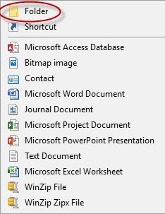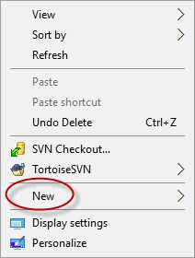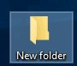

**2. Rename Folders/Files**

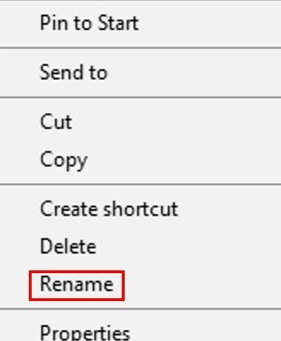

* Click **File Explorer** icon.  
* Go to the location where stores your file or folder. 
* Right click the name of the file or folder you wish to rename. 
* Click **Rename** (on the menu that opens up). 
* Type a new name for the file and press Enter. 

**3.Move Folders/Files**

* 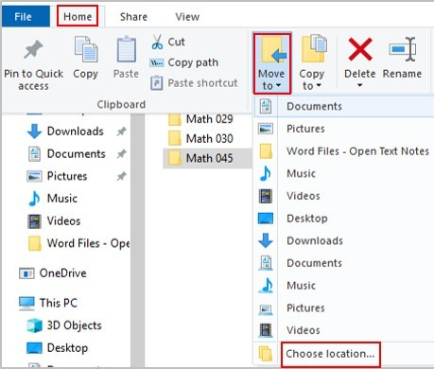Click **File Explorer** icon.  
* Go to the location where stores your file or folder (hard drive, USB, etc.). 
* Click the name of the file or folder you wish to move. 
* Click the **Home** tab at the top (on the 

ribbon).

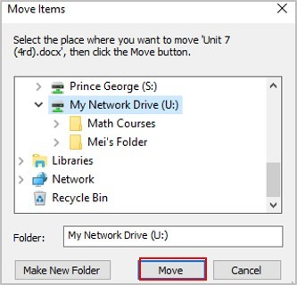**3.** Click the **Move to** button.

* 1. Click **Choose Location** (if you don!t find the right spot on the drop-down menu).
  2. Go to the location you want to move for this folder.
  3. Click **Move**.

**4.Delete Folders/Files**

* Click **File Explorer** icon.  
* Go to the location where stores your file or folder. 
* Click the name of the file or folder you wish to delete. 
* Press the **delete** key (on the keyboard) or right click the file or folder and click  **Delete**. 