Instructions

­

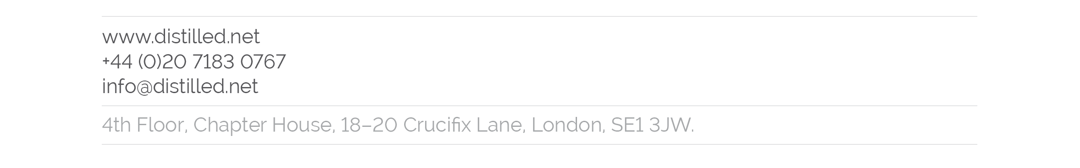

Here is your finished interactive!

Before we launch it, there are just a few minor tweaks to make to the code. Don't worry, they're not complicated: If you have a basic understanding of HTML (particularly comment tags) then you'll be fine. These tweaks are required because we don't yet know what URL the piece will have when it's launched. However, various social media sites and their widgets require this information to be included in order to run properly. Hence you'll need to open up one of the files and add this information on certain lines in the code.

1. Open the index.html file in a plain-text editor and run a text search for the word 'NBED'. This is a red flag that we use: Any time you see it, it means that something needs to be changed on that line or the following line/lines. Most times, it's a URL. Accompanying the 'NBED' will be an HTML comment with specific instructions. In most cases, you should add the URL where the instructions say then remove the opening and closing HTML comments (the <!--- and -->) around that line/lines. Delete the instructions once you're done. Where the content to be changed is a link, be very careful to ensure that the correct number of slashes are included.
2. The Facebook OpenGraph ("OG") tags have been commented out, because you're better off not having these tags included than having them included with the wrong URL. These tags tell Facebook what URL and image to supply when the page URL is posted/liked. If it's wrong then the information will be cached by Facebook and could take a week or two to be updated, so make sure it's correct before launching. Check whether the URL is correct - it probably isn't, so change it if not. The remove the comment tags.
3. The CSS file has several font-face declarations starting around line 100. There is a double-up because for each set, the latter font-family declaration is for testing and the former one is the one used on the Rasmussen site. Remove the latter one when switching to Rasmussen hosting.
4. There is a textarea containing an embed code, which has HTML entity encoding on its special characters to ensure that it's displayed correctly. There are a couple of URLs in there: Double-check that they're correct. It'll look something like this:  
   <textarea onClick="this.select();">&lt;a href=&quot;http://www.YOURSITENAME.com/PATH/TO/FOLDER/&quot; target=&quot;_blank&quot;&gt;&lt;img src=&quot;http://www.YOURSITENAME.com/PATH/TO/FOLDER/preview.png&quot; border=&quot;0&quot; width=&quot;550&quot; height=&quot;1007&quot; /&gt;&lt;/a&gt;&lt;br /&gt;&lt;span style=&quot;font-size: 12px;&quot;&gt;Click image to open interactive version (via &lt;a href=&quot;http://www.YOURSITENAME.com/&quot;&gt;YOUR COMPANY NAME&lt;/a&gt;).&lt;/span&gt;</textarea>

That should be it! Make a final sweep to check that you haven’t missed any NBED tags, and then we’re ready for launch.