**VOICE CONTROLLED BOT USING ARDUINO**

**A PROJECT REPORT**

***Submitted by***

**KIRUTHIKA V (210620104029)**

**SAHITHYA A (210620104044)**

***in partial fulfillment for the award of the degree***

***of***

**BACHELOR OF ENGINEERING**

**IN**

**COMPUTER SCIENCE AND ENGINEERING**



**JEPPIAAR INSTITUTE OF TECHNOLOGY**

**ANNA UNIVERSITY : CHENNAI 600 025**

**MAY 2024**

**ANNA UNIVERSITY : CHENNAI 600 025**

**BONAFIDE CERTIFICATE**

Certified that this project report **“VOICE CONTROLLED BOT USING ARDUINO”** is the bonafide work of “**KIRUTHIKA V (210620104029), SAHITHYA A (210620104044)”** who carried out the project work under my supervision.

**SIGNATURE**

**Dr.K.TAMILARASI ,M.E.,Ph.D**

**HEAD OF THE DEPARTMENT**

Professor,

Computer Science and Engineering

Jeppiaar Institute of Technology,

Sriperumbudur, Chennai

**SIGNATURE**

**Ms.V.DHANALAKSHMI M.E.,**

**SUPERVISOR,**

Assistant Professor,

Computer Science and Engineering

Jeppiaar Institute of Technology,

Sriperumbudur, Chennai

This project report is submitted for viva voce examination to be held on ________________

**INTERNAL EXAMINER EXTERNAL EXAMINER**

**JEPPIAAR INSTITUTE OF TECHNOLOGY,**

**SRIPERUMBUDUR, CHENNAI - 631 604.**

**ACKNOWLEDGEMENT**

We express our deep sense of gratitude to Lord Almighty for the blessings to complete this project work successfully.

We would like to express our deepest gratitude and respect to honourable **Chairman** **Col. Dr. JEPPIAAR, M.A., B.L., Ph.D.,** for having given the opportunity to pursue the education in this premier institution.

We take this opportunity to express our deepest and special thanks to our **Managing Director Dr. N. MARIE WILSON, B.Tech. MBA, Ph.D.**, for providing all the facilities and continuous encouragement for carrying out this project work.

We express our gratitude to our **Principal Dr. G. R. SURESH, Ph.D**., and the Head of the Department of CSE, **Dr. K. TAMILARASI, Ph.D**., for their guidance and advice all through the project.

We convey our sincere and in-depth gratitude to our Internal guide **Ms.V.DHANALAKSHMI M.E.,** for her valuable guidance throughout the duration of this project.

We would also like to thank our parents and friends for the support they extended during this course of the project.

ABSTRACT

Voice signal plays a major role in the communication among human beings. Robots reduce the human efforts in their day-to-day tasks. In this project, a voice-controlled robotic vehicle is developed. The human voice commands are taken by the robotic vehicle through an android application with a micro controller. The voice signal commands are directly communicated to the robotic vehicle using Bluetooth. The robotic vehicle is controlled by voice commands received from the user. The development of the robotic vehicle is carried out using two DC gear motors associated with micro-controller at the collector side. The commands from the application are changed over in to computerized signals by the Bluetooth RF transmitter for a fitting reach (around 100 meters) to the robot. At the receiver end the information gets decoded by the receiver and is taken care of to the micro-controller which drives the DC motors for the fundamental work. The voice-controlled robot is designed and implemented to reach out the necessary undertaking by paying attention to the commands of the user. An earlier preliminary meeting is required for the smooth activity of the robot by the user. A code is utilized for offering guidance to the user. Performance valuation is carried out with appreciable results of the initial experiments.

**Keywords:** Robot, Plan, Voice control, Micro controller, Bluetooth, Computerization and Performance.

**TABLE OF CONTENTS**

|  |  |  |
| --- | --- | --- |
| **CHAPTER NO** | **TITLE** | **PAGE NO** |

ABSTRACT iv

LIST OF FIGURES viii

LIST OF TABLES ix

1. INTRODUCTION 1

1.1 INTRODUCTION: THE GLOBAL IMPACT OF THE COVID-19 1

1.2 PROBLEM STATEMENT 2

1.3 OBJECTIVE OF THE PROJECT 2

1. LITERATURE SURVEY 3

2.1 LITERATURE REVIEW 3

1. SYSTEM ANALYSIS 7

3.1EXISTING SYSTEM 7

3.1.1.DISADVANTAGES IN EXISTING SYSTEM 7

3.2 PROPOSED SYSTEM 10

3.2.1 ADVANTAGES OF PROPOSED SYSTEM 12

1. REQUIREMENTS SPECIFICATION 13

4.1. INTRODUCTION 13

4.2. HARDWARE REQUIREMENTS 13

4.2.1 ARDUINO UNO 14

4.2.2 GEAR MOTOR 14

4.2.3 L293D MOTOR DRIVER: - 15

4.2.4 BLUETOOTH MODULE HC – 05 15

4.3. SOFTWARE REQUIREMENTS 17

1. SYSTEM DESIGN 20

5.1 INTRODUCTION 20

5.2 ARCHITECTURE DIAGRAM 20

5.3 FLOWCHART FOR WORKING OF THE BOT 21

1. SYSTEM DESIGN – IMPLEMENTATION AND RESULTS 23

6.1 MODULES 23

6.2 MODULE EXPLANATION 23

1. RESULT AND ANALYSIS 29

7.1 Result Overview: 29

1. CONCLUSION AND FUTURE ENHANCEMENTS 32

CONCLUSION 32

FUTURE ENHANCEMENTS 32

APPENDIX A 33

CODING 33

APPENDIX B 37

SNAPSHOTS 37

REFERENCES 38

PUBLICATION 40

CERTIFICATIONS 41

# LIST OF FIGURES

|  |  |  |
| --- | --- | --- |
| **FIG. NO** | **FIGURE NAME** | **PAGE NO** |
| 4.1 | Arduino Uno | 16 |
| 4.2 | Gear Motor | 16 |
| 4.3 | L293D motor driver | 17 |
| 4.4 | Bluetooth module HC-05 | 17 |
| 5.1 | Architecture Diagram | 22 |
| 5.2 | Flowchart of the working of Bot | 24 |
| 6.1 | Arduino Uno | 26 |
| 6.2 | l293d Motor Shield | 27 |
| 6.3 | Ultrasonic sensor | 28 |
| 6.4 | HC-06 Bluetooth module | 29 |
| 7.1 | Circuit Diagram of Voice Controlled Bot | 31 |
| 7.3 | Top view of Voice Controlled Bot. | 32 |
| 7.4 | Side View of voice controlled Bot | 32 |
| 7.5 | Front View of voice controlled Bot | 33 |

# LIST OF TABLES

|  |  |  |
| --- | --- | --- |
| **TABLE**  **NO** | **NAME OF THE TABLES** | **PAGE NO** |
|  | Table I Software Specifications | 19 |

CHAPTER 1

# INTRODUCTION

## 1.1 INTRODUCTION: THE GLOBAL IMPACT OF THE COVID-19

Introducing a voice-controlled robot powered by Arduino opens up a world of interactive possibilities. By leveraging the Arduino platform's flexibility and simplicity, combined with voice recognition technology, this project enables users to command a robot using their voice. Imagine being able to speak simple instructions like "move forward," "turn left," or "stop," and watching your robot respond accordingly. This project not only showcases the fusion of hardware and software but also introduces users to the exciting field of robotics and human-computer interaction.

With Arduino as the brain of the operation, users can customize their robot's behavior, add new voice commands, and even integrate additional features like obstacle avoidance or object detection. By breaking down complex concepts into manageable steps, this project serves as an excellent entry point for beginners to learn about electronics, programming, and robotics in a hands-on and engaging way.Overall, the voice-controlled robot using Arduino embodies the spirit of innovation and exploration, empowering enthusiasts to bring their ideas to life and interact with technology in a more intuitive and natural manner.

It has yield to the developments and inventions of modern equipment and machineries. Many amputate people usually depend on others in their daily life. Nowadays, many kinds of bots have implemented utilizes the analogue joysticks, touch activated switches, chin-controlled switches and head-controlled switches. They also implemented the GUI system to control the bot. In this project, we will develop control system of the bot movement will be employed by the voice and the robot will response the commanding persons.

## 1.2 PROBLEM STATEMENT

* People who are disabled and handicapped and cannot drive their own vehicle.
* Amputated and handicapped people dependent to the other person.
* People who cannot use the GUI and Joystick .

## 1.3 OBJECTIVE OF THE PROJECT

The objective of creating a voice-controlled bot using Arduino can vary depending on the specific project goals and applications. However, here are some common objective

**Hands-Free Interaction**: Enable users to interact with devices or robots without the need for physical input devices like buttons or joysticks, enhancing convenience and accessibility.

**Home Automation**: Control various home appliances or devices through voice commands, providing a more intuitive and futuristic way of managing household tasks.

**Assistive Technology**: Develop assistive devices for individuals with disabilities to help them operate electronic devices or perform tasks using voice commands, empowering them with greater independence.

**Integration with IoT**: Integrate voice control functionality with Internet of Things (IoT) devices to enable remote control and monitoring of connected devices using voice commands.

**Research and Development**: Explore the possibilities of voice recognition technology and its integration with hardware platforms like Arduino for research purposes, such as studying human-computer interaction or natural language processing. The project aims to achieve the following

* To integrate mobile application, actuators, and controllers along with wireless communication to gain good experience at training.
* The Interface between the mobile application and bot is done through via Bluetooth technology.

CHAPTER 2

# LITERATURE SURVEY

## 2.1 LITERATURE REVIEW

In this chapter we are discussing about the previous researches which are focused on designing and developing of voice-controlled bot. There are many types of voice control techniques in bot which has been implemented. The sources of this information are mainly from journals and conference papers.

**2.2 REVIEW OF LITERATURE SURVEY**

**Title : Single-Equipment with Multiple-Application for an Automated Robot Car Control System**

**Authors:** Saleem Ullah, Zain Mumtaz, Shuo Liu, Mohammad Abubaqr, Athar Mahboob and Hamza Ahmad Madni

**Year**: 2019.

**Description**: This paper is deals about the innovative element of the proposed work in this paper the integration of greater functionalities into vehicles increase the complexity of car-controlling. The proposed system has capability to identity voice commands and makes them to move using Bluetooth technology. They have used two modes of transmission and controlling of the robot car. The first mode is to control a robot car with an android mobile application when the user presses the corresponding touch button in mobile application , a signal is transferred to the micro-controller that is attached to the car through the built-in mobile Bluetooth device motor module to move the wheels of the robot car accordingly to the received signal .The second mode is the hand-gesture system in that accelerometer first senses the acceleration forces from the direction of the hand and sends them to the micro-controller that is attached to the hand. After receiving the data, micro-controller converts it into different angles, between 0– 450°, and sends it to the RF receiver of the Arduino Uno that is attached to the robot car through the RF sender. After receiving the signal, it will process the data and sends the signal to motor module to move the wheels of the robot car accordingly to the angles.

**Title - Voice-Controlled Autonomous Vehicle Using IoT (2019)**

**Author-** Sumeet Sachdeva, Joel Macwana, Chintan Patela, Nishant Doshia**.**

**Year -** 2019

**Description** : This paper deliberates about the concept of Internet of things which can be accessed by any others part of the world. In this project, the motor will be controlled using voice commands through google assistant in smartphones. To use the google assistant, they use the software called “IFTTT”. In this “IFTTT”, we can create the simple programs to control the devices. They also used the Adafruit.io for storing the data, viewing the data and control devices.

**Title : Design of Voice Controlled Smart Wheelchair**

**Author:** Ali A. Abed

**Year:** 2020

**Description** :The motivation behind the project to help the handicapped people and patients to control the wheelchair using voice commands. In this project, they use new component called “voice recognition board with HM2007”. This will enable the system to recognize different voices, inflections and enunciations of the target word so that it will recognize the different languages .More interesting part in this project , in order to not respond to some similar words spoken randomly in an environment, secret voice key is preferred to be a word with complex pronunciation in order to not pick up by others and also by utter the words twice in order to respond the system The direction and velocity of the chair are controlled by pre-defined Arabic voice commands. They have controlled the direction and velocity of the chair by pre- defined Arabic voice commands. They have tested and successfully demonstrated with patients for utterance of Arabic words.

**Title: Design and Fabrication of a Voice Controlled Wheelchair for Physically Disabled People**

**Author:** G Azam and M T Islam

**Year: 2021**

**Description:** The authors have used CAD/CAE tools to eliminate the early flaws and to improve the quality of the Wheels and their mechanism. With the combination of these mechanical and electrical parts, the manual wheelchair is turned to be an electrical wheelchair. They have utilized a PIC controller manufactured by Microchip Technology to control the system operations. They have programmed the assembly level code and stored in controller’s memory. In this project, they have developed a cost effective and efficient movable and easily controllable Wheelchair that can be controlled via voice commands. By using PIC, they are controlling the motors and using voice recognition board to identify the voice commands. It was allowed to move in a straight line. In voice recognition board, we have to train the board to recognize the voice. There is no further add upon to their project, they have calculated the velocity that wheelchair with and without the load.

**Title: Obstacle Avoidance and Voice Control Unit for Autonomous Car**

**Author:** MA Bhikule, MS Mankame, MS Khot, MY Nhawkar

**Year:** 2021

**Description:** In this paper, the authors have done new approach in methodology they have included the obstacle avoidance to their project. when the user is commands move forward to the robot. But at the same time some objects are in front of robot. The robot can avoid the way and search another way to move on. They are using the ultrasonic sensor for detection of obstacle. The ability of the machine to receive and interpret the human voice or to understand and carry out spoken commands can be concluded as speech recognition.

CHAPTER 3

# SYSTEM ANALYSIS

## 3.1EXISTING SYSTEM

* The existing system being discussed is a conventional joystick-controlled wheelchair, which is a common mobility aid for individuals with disabilities. This type of wheelchair allows users to control the direction and speed of movement by manipulating a joystick typically located on one of the wheelchair's armrests.
* The joystick interface is designed to be intuitive and easy to use, making it accessible for individuals with various levels of mobility and dexterity. By simply moving the joystick in different directions or pushing it forward or backward, users can command the wheelchair to move accordingly.
* These joystick-controlled wheelchairs are highly customizable to accommodate the specific needs and preferences of users. For example, sensitivity settings can be adjusted to match the user's level of control, and additional features such as tilt or recline functions may be available to enhance comfort and functionality.
* Overall, while joystick-controlled wheelchairs provide effective mobility solutions for many individuals with disabilities, ongoing advancements in technology continue to drive innovation in this field, offering new possibilities for improved accessibility and user experience.

### 3.1.1.DISADVANTAGES IN EXISTING SYSTEM

The Arduino programming language also has some disadvantages that aspiring programmers should be aware of:

1**. Limited Memory and Processing Power:**

Arduino boards have limited memory and processing power compared to larger microcontroller boards or full-fledged computers. This can limit the complexity and size of projects built with Arduino.

2**. Limited Support for Some Communication Protocols**:

Arduino boards have built-in support for some communication protocols, such as USB, Ethernet, and Wi-Fi, but lack support for other protocols like Zigbee, Z-wave, Thread, or LoRa.

3. **Limited Real-Time Performance:**

Arduino boards are not designed for real-time applications that require a high degree of accuracy in timing and responsiveness.

4. **Limited Security Features:**

Moreover, Arduino boards have limited security features that could make them vulnerable to hacking or other types of cyberattacks.

5. **Limited Precision:**

However, some Arduino boards have limited precision for analog to digital conversion; this could affect the accuracy of certain applications.

6. Limited Scalability:

Arduino boards are not suitable for large-scale projects. They are neither recommended for professional or industrial applications.

## 

## 3.2 PROPOSED SYSTEM

Certainly, while joystick-controlled wheelchairs offer significant benefits in terms of mobility and independence for individuals with disabilities, there are also some disadvantages associated with this type of system:

* **Limited Accessibility**: Joystick-controlled wheelchairs may not be suitable for individuals with severe physical disabilities or limited hand dexterity. Users must have sufficient upper body strength and coordination to manipulate the joystick effectively.
* **Learning Curve:** Using a joystick to control a wheelchair requires some degree of training and practice. Users may need time to become proficient in operating the wheelchair smoothly and safely, especially when navigating through crowded or complex environments.
* **Physical Fatigue**: Continuous use of the joystick over extended periods can lead to physical fatigue, particularly for individuals with limited strength or endurance. Prolonged operation of the wheelchair may strain muscles and joints, affecting comfort and mobility.
* **Space Limitations:** Maneuvering a joystick-controlled wheelchair in tight or confined spaces, such as narrow hallways or crowded rooms, can be challenging. Users may encounter difficulty in making precise movements or negotiating obstacles, leading to frustration or inconvenience.
* **Maintenance Issues:** Like any mechanical device, joystick-controlled wheelchairs require regular maintenance to ensure optimal performance. Components such as the joystick mechanism, motor, and batteries may require servicing or replacement over time, leading to potential downtime and repair costs.
* **Dependency on Power Source:** Most joystick-controlled wheelchairs are powered by batteries, which need to be recharged regularly. Users may face limitations in mobility if the wheelchair's battery runs out unexpectedly, particularly if they are unable to access a power source for recharging.
* **Vulnerability to Malfunctions**: Joystick-controlled wheelchairs are susceptible to malfunctions or technical issues, such as electronic failures or sensor errors. These issues can disrupt normal operation and may require professional assistance to resolve, causing inconvenience and potential downtime for the user.

### ADVANTAGES OF PROPOSED SYSTEM

* **Accessibility**: The voice-controlled interface eliminates the need for manual manipulation of joysticks, making the mobility solution accessible to individuals with hand disabilities or limited dexterity.
* **Affordability**: By utilizing readily available components such as Arduino Uno microcontrollers and mobile devices, the proposed system offers a cost-effective alternative to commercial powered wheelchairs.
* **Customizability**: The mobile application allows users to define and customize their voice commands, tailoring the control interface to their specific needs and preferences.
* **User-Friendly Interface**: The intuitive mobile application interface simplifies the interaction between the user and the mobility system, enhancing usability and user experience.
* **Real-Time Feedback and Control**: The system provides real-time feedback to the user, ensuring prompt execution of commands and facilitating seamless navigation.
* **Scalability and Upgradability**: The modular design of the system allows for scalability and upgradability, enabling future enhancements and additions to improve functionality and performance

CHAPTER 4

# REQUIREMENTS SPECIFICATION

## INTRODUCTION

The requirements specification is a technical specification of requirements for the software products. It is the first step in the requirements analysis process it lists the requirements of a software system including functional, performance and security requirements. The requirements also provide usage scenarios from a user, an operational and an administrative perspective. The purpose of software requirements specification is to provide a detailed overview of the software project, its parameters and goals. This describes the project target audience and its user interface, hardware and software requirements. It defines how the client, team and audience see the project and its functionality.

## HARDWARE REQUIREMENTS

Components of the Voice Controlled Bot are chosen to get an efficient output with a greater accuracy.

* Arduino Uno microcontroller,
* L293D Motor Driver,
* Gear motor,
* Bluetooth module HC-05

**COMPONENT DESCRIPTION**

### 4.2.1 ARDUINO UNO

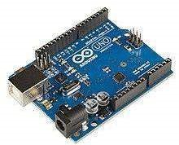

Fig.4.1 Arduino Uno

Arduino Uno is a microcontroller board and it having 14 output and input pins, in this 6 pins used as PWM output,6 analog input,1 UARTs 16 having usb, power jack icsp button and reset button, Vin, Gnd, serial communication, external interrupts, led can simply connect to a computer and the supply AC to DC adapter or battery, operating voltage of this boards is 5 volt and the range of the input will 7 to 12 volts, length of the board is about 68.6 mm and the width is 53.4, the weight of this is 25 g, comparing to the Arduino Nano it having more space and more processing, programming of the Arduino Uno can be done in pc with the c programming language and it can transfer to the Arduino by using USB cables.

### 4.2.2 GEAR MOTOR

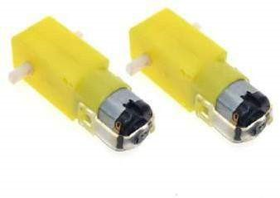

4.2. Gear Motor

A gear motor is an all-in-one combination of an electric motor and a gearbox. This makes it a simple, cost-effective solution for high-torque, low-speed applications because it combines a motor with a gear reducer system.

### 4.2.3 L293D MOTOR DRIVER: -

L293D motor driver IC is very simple is to drive the two DC motors simultaneously. This IC works on the principle of Half H-Bridge. It controls the speed of the motor microcontroller sends the pulse signals to it accordingly. An L293D has four input pins, four output pins, 2 enable pins, Vss, Vcc and GND.

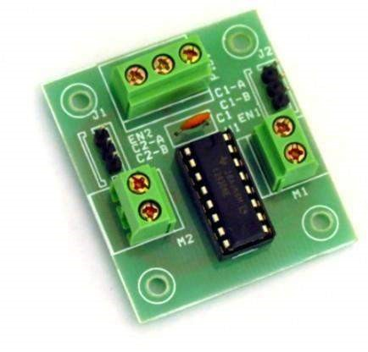

Fig.4.3. L293D motor driver

### 4.2.4 BLUETOOTH MODULE HC – 05

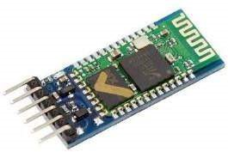

Fig.4.4. Bluetooth module HC-05

The HC-05 is a commonly used Bluetooth module for wireless communication. It's widely used in hobbyist electronics projects, as well as in industrial applications where short-range wireless communication is needed. The module is quite versatile and relatively easy to use, making it popular among both beginners and experienced electronics enthusiasts.

Some key features of the HC-05 module include:

**Bluetooth Version**: The HC-05 typically supports Bluetooth 2.0, but there are also variants that support Bluetooth 3.0 and 4.0.

**Communication Range**: It has a typical communication range of around 10 meters, although this can vary depending on factors such as antenna design and environmental conditions.

**Serial Interface**: The module communicates with microcontrollers or other devices using a serial interface (UART). This makes it easy to integrate into projects using a wide range of microcontrollers, such as Arduino, Raspberry Pi, or PIC.

**AT Commands**: The module can be configured using AT commands, which allow you to customize its behavior and settings. This includes things like changing the baud rate, setting the device name, and configuring security settings.

**Cost:** It's relatively inexpensive compared to other Bluetooth modules, which makes it a cost-effective option for many projects..

## SOFTWARE REQUIREMENTS

Table I. Software Specifications

|  |  |  |
| --- | --- | --- |
| **Software Name** | **Version** | **Source** |
| Arduino IDE | 1.8.13 | Arduino site |
| Arduino Uno Library | Latest | Already included in Arduino IDE |
| Mobile Application (iOS) | Latest | [App Store](https://www.apple.com/app-store/) |
| Mobile Application (Android) | Latest | Google Play Store |
| Speech Recognition Module | - | Pre-installed on mobile devices |
| Proteus | Latest | Official site |

1. **Arduino IDE (Integrated Development Environment)**:
   * **Version**: 1.8.13
   * **URL**: Download
   * **Explanation**: The Arduino IDE is a software development environment used for writing, compiling, and uploading code to Arduino microcontroller boards. It provides a user-friendly interface for programming Arduino devices, including the Arduino Uno microcontroller used in the proposed mobility system. With the Arduino IDE, developers can write code in the Arduino programming language (based on C/C++) and upload it to the Arduino Uno to control the behavior of the mobility system.
2. **Arduino Uno Library**:
   * **Version**: Latest
   * **Explanation**: The Arduino Uno Library contains the necessary software libraries and drivers required to interface with the Arduino Uno microcontroller. These libraries provide pre-written code and functions that simplify the process of programming the Arduino Uno for various tasks, including controlling motors, reading sensors, and communicating with external devices. The Arduino Uno Library is typically included and automatically installed with the Arduino IDE.
3. **Mobile Application (iOS)**:
   * **Version**: Latest
   * **URL**: [App Store](https://www.apple.com/app-store/)
   * **Explanation**: The mobile application for iOS devices serves as the user interface for controlling the voice-controlled mobility system. Users can install the mobile application from the Apple App Store on their iPhones or iPads. The application allows users to input voice commands, which are then transmitted to the Arduino Uno microcontroller via Bluetooth or Wi-Fi to control the movement and orientation of the mobility bot.
4. **Mobile Application (Android)**:
   * **Version**: Latest
   * **URL**: Google Play Store
   * **Explanation**: Similar to the iOS version, the mobile application for Android devices serves as the user interface for controlling the voice-controlled mobility system. Users can install the mobile application from the Google Play Store on their Android smartphones or tablets. The application provides a user-friendly interface for inputting voice commands and controlling the mobility bot's movements in real-time.
5. **Speech Recognition Module**:
   * **Explanation**: The speech recognition module is a software component that enables the mobile device to recognize and interpret spoken voice commands. This module is typically pre-installed on most modern smartphones and tablets, allowing users to interact with voice-controlled applications and services. The speech recognition module converts spoken words into text, which is then processed by the mobile application to generate corresponding control signals for the mobility bot.

CHAPTER 5

# SYSTEM DESIGN

## 5.1 INTRODUCTION

The Voice Controlled bot is designed to provide a mobility to the disability. The whole process is controlled by the Arduino Uno microcontroller. The user will control the bot with the mobile application. The mobile application will provide the user to input their voice to recognize. For adjusting the orientation, they can use various commands to control the bot

## 5.2 ARCHITECTURE DIAGRAM

The aim of the project is to build a bot with voice controlled and of low cost.

The hardware’s implementation has been structured is been selected accordingly to achievethegoal.

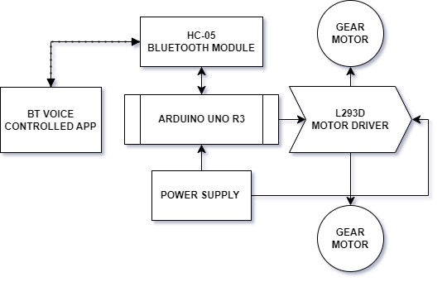

Fig 5.1 Architecture Diagram

1. **Arduino Uno:** Arduino Uno is the brain of the bot. The microcontroller board “Arduino at Mega” depends on the Atmega328P microcontroller. It includes 14 digital input/output pins, where 6 pins are Analog inputs, 6 are used like PWM outputs, hardware serial ports (UARTs) – 1, a crystal oscillator of 16 MHz, a power jack, a USB connection, as well as an RST button. This board will control the motor drivers and Bluetooth module.

1. **L293D Motor Driver:** L293D motor driver IC is very simple is to drive the two DC motors simultaneously. This IC works on the principle of Half HBridge. It controls the speed of the motor microcontroller sends the pulse signals to it accordingly. An L293D has four input pins, four output pins, 2 enable pins, Vss, Vcc and GND.

1. **Gear Motor:** A gearmotor is an all-in-one combination of an electric motor and a gearbox. This makes it a simple, cost-effective solution for hightorque, low-speed applications because it combines a motor with a gear reducer system.

1. **HC-05 Bluetooth module:** HC-05 Bluetooth Module is a smooth to use Bluetooth SPP (Serial Port Protocol) module, designed for obvious wireless serial connection setup. Its communication is through serial communication which makes an easy manner to interface with controller or PC. HC-05 Bluetooth module gives switching mode among master and slave mode which means it capable of use neither receiving nor transmitting records.

1. **Power supply:** The power supply for the bot will be provided with two switch mode power supply (SMPS) and a separate small adapter for Arduino mega. A 3.7V 2000mAh lion battery is used for motor drivers.

## 5.3 FLOWCHART FOR WORKING OF THE BOT

The Voice Controlled bot is designed to get controlled wirelessly by an android application. The flow of working of the machine is described below,

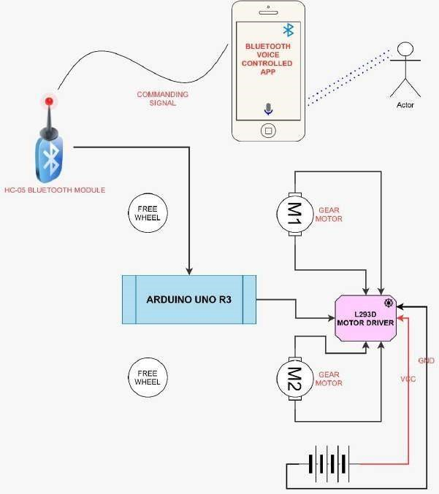

Fig 5.2 Flowchart of the working of Bot

When the voice-controlled bot is connected to the power supply, the bot gets initialized. At the initial stage we have connect the Bluetooth module with mobile application. Once it connected, we will start the commanding the bot by voice. We have four basic commands which send to microcontroller through Bluetooth which uses mobile application. Mobile application will process the input data converted into commanding signal. This signal is processed by Arduino UNO then signals the motor driver. Gear motors will start rotates according to signal received from motor driver.



CHAPTER 6

# SYSTEM DESIGN – IMPLEMENTATION



## 6.1 MODULES

1. Setting Up Arduino Uno

2. Fixing L293D Motor Shield

3. Wiring Motors

4.Using Ultrasonic Sensor for Obstacle Detection

5. Configuring Bluetooth Module

6. Developing Arduino Code for Motor Control

7. Developing Mobile Application for Voice Control

8. Integrating Speech Recognition Functionality

9. Testing and Debugging

## 6.2 MODULE EXPLANATION

1. **Setting Up Arduino Uno**:

In this module, you'll start by downloading and installing the Arduino IDE (Integrated Development Environment) on your computer. The IDE is a software tool that allows you to write, compile, and upload code to the Arduino Uno microcontroller. Once the IDE is installed, you'll connect the Arduino Uno to your computer using a USB cable. This establishes a communication link between the Arduino Uno and the computer, enabling you to upload code and communicate with the microcontroller.

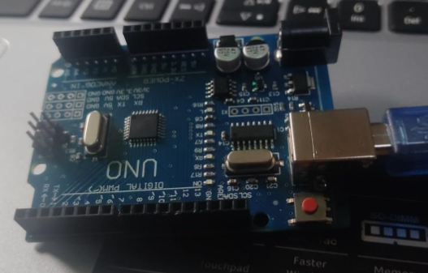

Figure 6.1 : Arduino Uno

1. **Fixing L293D Motor Shield**:

The L293D motor shield is a convenient way to control DC motors with the Arduino Uno. In this module, you'll attach the motor shield securely onto the Arduino Uno board. This typically involves aligning the pins on the motor shield with the headers on the Arduino Uno and gently pressing them together to ensure a firm connection. Properly fixing the motor shield ensures reliable communication between the Arduino Uno and the motors.

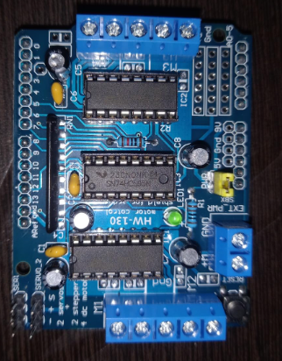

Figure 6.2 : l293d Motor Shield

1. **Wiring Motors**:

Now that the motor shield is fixed to the Arduino Uno, you'll wire the DC motors to the motor shield. The motor shield provides screw terminals or pin headers for connecting the motors. You'll connect the motor terminals to the appropriate pins on the motor shield, typically labeled "M1," "M2," etc. This wiring setup allows the Arduino Uno to control the direction and speed of the motors, enabling movement of the wheelchair platform.

1. **Using Ultrasonic Sensor for Obstacle Detection**:

An ultrasonic sensor, such as the HC-SR04, can be used to detect obstacles in the path of the wheelchair and prevent collisions. In this module, you'll wire the ultrasonic sensor to the Arduino Uno according to its datasheet. Once wired, you'll write code to read data from the sensor and interpret it to determine the distance to nearby objects. Based on this distance data, you can implement logic to stop or change the direction of the wheelchair to avoid collisions.

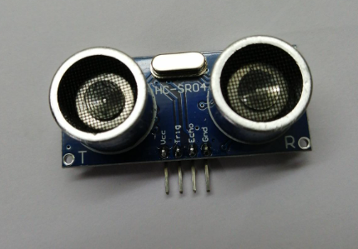

Figure 6.3 : Ultrasonic sensor

1. **Configuring Bluetooth Module**:

The Bluetooth module (e.g., HC-05 or HC-06) enables wireless communication between the Arduino Uno and the mobile application. In this module, you'll pair the Bluetooth module with your mobile device and establish a serial communication link. You'll configure the Bluetooth module to communicate using a specific baud rate and protocol compatible with the Arduino Uno. This module sets up the foundation for transmitting voice commands from the mobile application to the Arduino Uno.

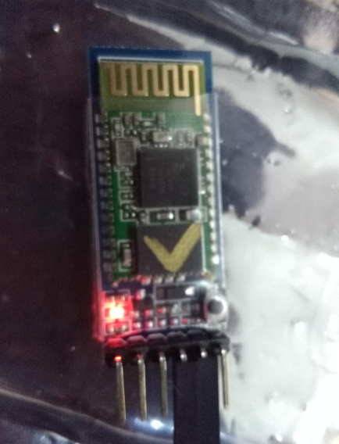

Figure 6.4 : HC-06 Bluetooth module

1. **Developing Arduino Code for Motor Control**:

With the hardware set up, you'll now write Arduino code to control the movement and orientation of the wheelchair platform. This code will include functions to drive the DC motors connected to the motor shield. You'll implement logic to interpret commands received from the mobile application via Bluetooth and translate them into motor control actions, such as moving forward, backward, turning, or stopping.

1. **Developing Mobile Application for Voice Control**:

In this module, you'll develop a mobile application for both iOS and Android platforms to provide a user interface for voice control of the wheelchair. The application will capture voice commands from the user and transmit them to the Arduino Uno via Bluetooth. You'll design the user interface (UI) to be intuitive and user-friendly, allowing users to input voice commands easily. Additionally, you'll integrate speech recognition functionality into the application to interpret spoken voice commands accurately.

1. **Integrating Speech Recognition Functionality**:

This module focuses on integrating speech recognition capabilities into the mobile application. You'll utilize built-in speech recognition APIs or third-party libraries to capture and process spoken voice commands inputted by the user. The application will analyze the audio input, recognize keywords or phrases, and generate corresponding control signals for the wheelchair platform. Integration of speech recognition ensures seamless interaction between the user and the mobility system.

1. **Testing and Debugging**:

Testing and debugging are crucial steps to ensure the functionality and reliability of the entire system. In this module, you'll thoroughly test each component of the system, including hardware components, Arduino code, mobile application, and speech recognition integration. You'll verify the accuracy and responsiveness of voice commands, test sensor functionality for obstacle detection, and identify and fix any bugs or issues encountered during testing. This iterative process helps refine the system and ensures it meets the requirements of users with disabilities

Chapter-7

# RESULT AND ANALYSIS

## 7.1 Result Overview:

* The **“Voice Controlled Bot”** is designed in Proteus Software. The circuit simulation is designed in Proteus software.

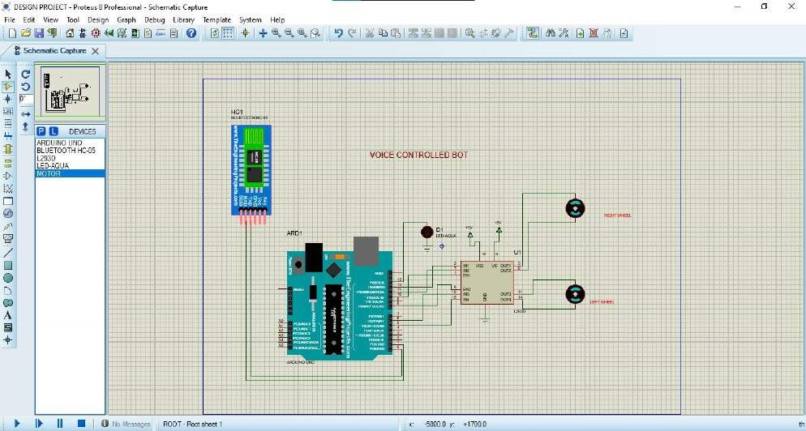

Fig.7.1 Circuit Diagram of Voice Controlled Bot

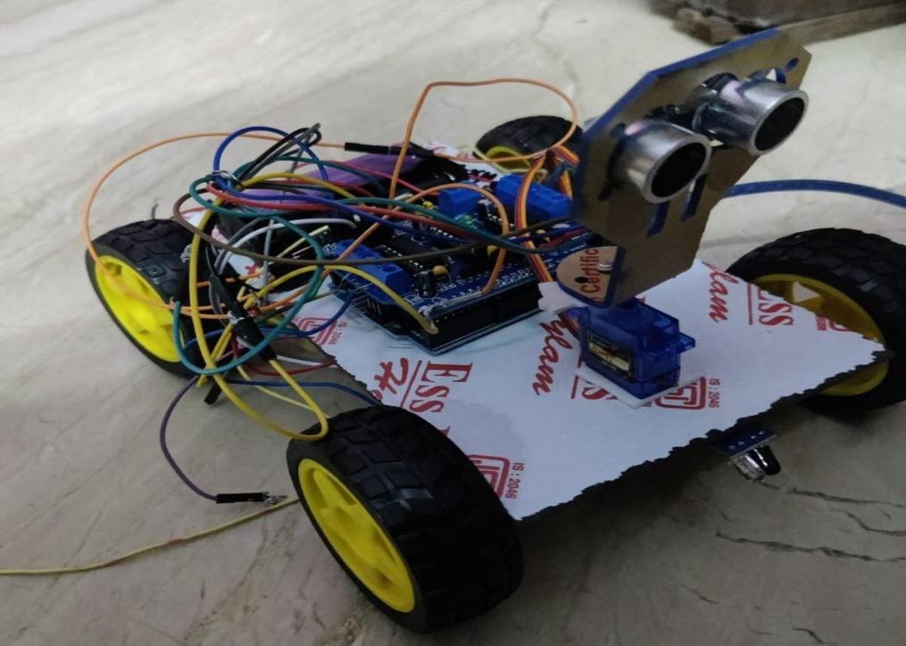

Fig.7.3 Top view of Voice Controlled Bot.

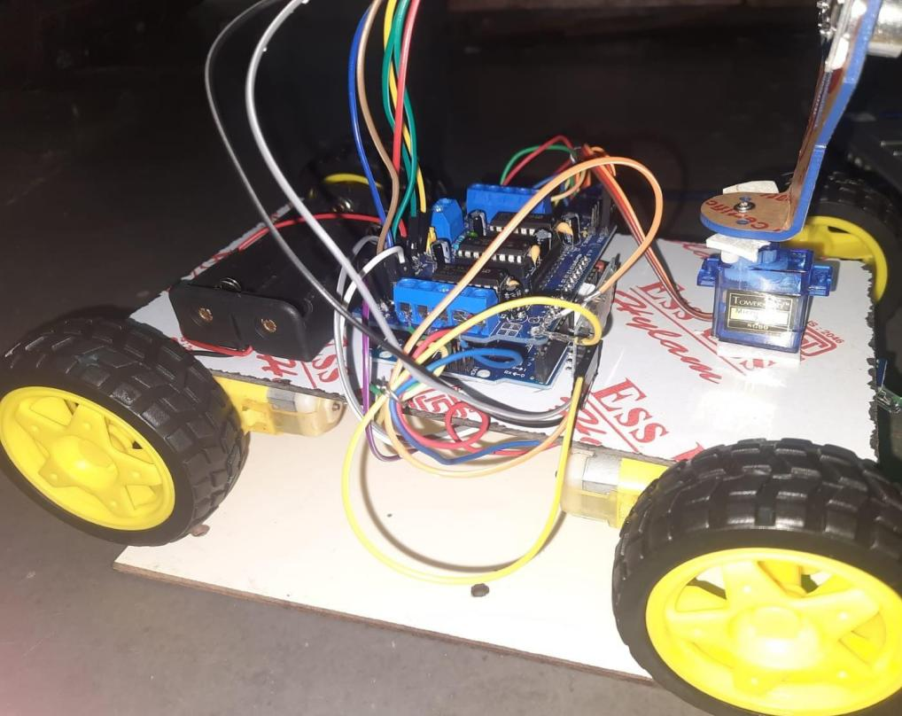

Fig. 7.4 Side View of voice controlled Bot

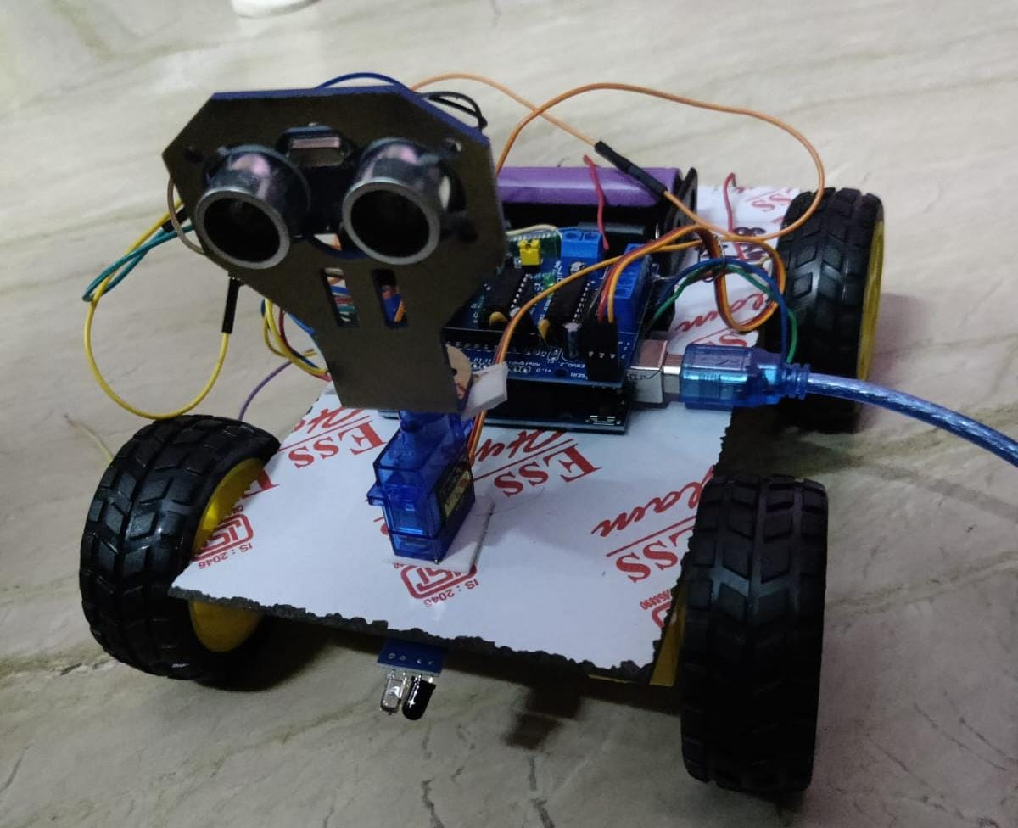

Fig.7.5 Front view of voice controlled Bot

* When the voice-controlled bot is connected to the power supply, the bot gets initialized. At the initial stage we have connect the Bluetooth module with mobile application. Once it connected, we will start the commanding the bot by voice. We have four basic commands which send to microcontroller through Bluetooth
* which uses mobile application. Mobile application will process the input data converted into commanding signal. This signal is processed by Arduino UNO then signals the motor driver. Gear motors will start rotates according to signal received from motor drive.

Chapter 8

# CONCLUSION AND FUTURE ENHANCEMENTS



## CONCLUSION

Human voice is identified the use of a microphone inside the android clever smartphone. This voice is analyzed and transformed into English phrases using the android app. Speech reputation is the inter-disciplinary sub-subject of computational linguistics that develops methodologies and technologies that permits the recognition and translation of spoken language into text by way of computers. It is also called computerized speech popularity (ASR) or speech to textual content (STT). It incorporates expertise and research in the linguistics, computer technology, and electrical engineering fields. speech recognition has an extended history with numerous waves of primary innovations. Most lately, the sphere has benefited from advances in deep getting to know and massive statistics. The advances are evidenced no longer handiest by using the surge of instructional papers posted in the discipline, but more importantly by means of the global enterprise adoption of a variety of deep studying strategies in designing and deploying speech recognition systems.

## FUTURE ENHANCEMENTS

The future prospects for a voice-controlled bot employing Arduino technology are highly promising, aligning seamlessly with the evolving trends in voice recognition, home automation, and the Internet of Things (IoT). Potential avenues for future development include seamless integration with smart home devices, accessibility solutions catering to individuals with disabilities, educational applications for interactive learning experiences, and healthcare applications for monitoring and assistance. Customization features, integration with emerging technologies like augmented reality, and a focus on security and privacy are crucial aspects to consider.

# APPENDIX A

## CODING

#include <AFMotor.h>

#include <SoftwareSerial.h>

#define trigPin A1

#define echoPin A0

#define MAX_DISTANCE 5

AF_DCMotor motor1(1, MOTOR12_1KHZ);

AF_DCMotor motor2(2, MOTOR12_1KHZ);

AF_DCMotor motor3(3, MOTOR34_1KHZ);

AF_DCMotor motor4(4, MOTOR34_1KHZ);

char command;

void setup() {

Serial.begin(9600);

pinMode(trigPin, OUTPUT);

pinMode(echoPin, INPUT);

}

void loop() {

if (Serial.available()) {

command = Serial.read();

executeCommand(command);

}

int distance = checkObstacle();

Serial.print("Distance: ");

Serial.print(distance);

Serial.println(" cm");

if (distance < MAX_DISTANCE) {

Stop();

}

}

void executeCommand(char cmd) {

Stop();

switch (cmd) {

case 'F':

forward();

break;

case 'B':

back();

break;

case 'L':

left();

break;

case 'R':

right();

break;

case 'S':

Stop();

break;

}

}

void forward() {

setMotorsSpeed(255, 255, 255, 255, FORWARD);

}

void back() {

setMotorsSpeed(255, 255, 255, 255, BACKWARD);

}

void left() {

setMotorsSpeed(255, 255, 255, 255, BACKWARD);

delay(100); // Delay to allow the turn to complete

}

void right() {

setMotorsSpeed(255, 255, 255, 255, FORWARD);

delay(100); // Delay to allow the turn to complete

}

void Stop() {

setMotorsSpeed(0, 0, 0, 0, RELEASE);

}

void setMotorsSpeed(int speed1, int speed2, int speed3, int speed4, uint8_t direction) {

motor1.setSpeed(speed1);

motor1.run(direction);

motor2.setSpeed(speed2);

motor2.run(direction);

motor3.setSpeed(speed3);

motor3.run(direction);

motor4.setSpeed(speed4);

motor4.run(direction);

}

int checkObstacle() {

digitalWrite(trigPin, LOW);

delayMicroseconds(2);

digitalWrite(trigPin, HIGH);

delayMicroseconds(10);

digitalWrite(trigPin, LOW);

return pulseIn(echoPin, HIGH) * 0.0344 / 2;

}



# APPENDIX B

## SNAPSHOTS

**FINAL OUTPUT**



# REFERENCES

1. A Hussain, S. U. Amin, H. Lee, A. Khan, N. F. Khan and S. Seo, "An Automated Chest X-Ray Image Analysis for Covid-19 and Pneumonia Diagnosis Using Deep Ensemble Strategy," in *IEEE Access*, vol. 11, pp. 97207-97220, 2023, doi: 10.1109/ACCESS.2023.3312533.
2. Saleem Ullah, Zain Mumtaz, Shuo Liu, Mohammad Abu-Bakr, Athar

Mahboob and Hamza Ahmad Madni, “Single-Equipment with Multiple- Application for an Automated Robot-Car Control System” Feb-2019.

1. Sumeet Sachdeva, Joel Macwana, Chintan Patela, Nishant Doshia. “VoiceControlled Autonomous Vehicle Using IoT” (2019).
2. Ali A. Abed, “Design of Voice Controlled Smart Wheelchair” (2015)
3. M Saravanan et al 2020, “Arduino Based Voice Controlled Robot Vehicle”. [5] G Azam and M T Islam, “Design and Fabrication of a Voice Controlled Wheelchair for Physically Disabled People” (2019).
4. MA Bhikule, MS Mankame, MS Khot, MY Nhawkar, “Obstacle Avoidance and Voice Control Unit for Autonomous Car” (2021).
5. M. Meghana et al,2020, Hand gesture recognition and voice-controlled robot .
6. Abikshit Timsina, Dev Chandra Sharma, Nirmala Sharma, Allen Bhutia,

Sujala Pardhan Voice Command Robotics Car, (2020)

1. Megalingam R.K., Vadivel S.R.R., Yadav P.K., Nigam K., Geesala R.T., Chandra R. (2020), Implementation of Low-Cost Mobile Robot for Rescuing Challenge. In: In Ranganathan G., Chen J., Rocha Á. (eds) Inventive Communication and Computational Technologies. Lecture Notes in Networks and Systems.

# PUBLICATION

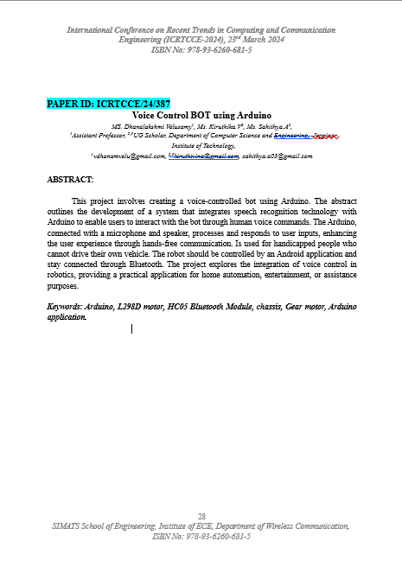

# CERTIFICATIONS

