Introduction
The Hospital Management System (HMS) developed in this project is a modular, file-based software application designed to streamline and digitize essential operations within a healthcare environment. The system integrates multiple user role namely Director, Administrator, Patient, Doctor, and Nurse, each with specific functionalities that collectively support efficient hospital workflow management. The primary aim of this project is to replace traditional manual processes with a structured, computerized system that enhances accuracy, accessibility, and overall service quality.
In many healthcare institutions, manual record-keeping often led to inefficiencies such as data redundancy, scheduling conflicts, and delayed service delivery. This project addresses these challenges by providing a centralized role-based system where users can interact with relevant modules according to their responsibilities. The Administrator manages core data such as patient registration, doctor and nurse records, and inventory tracking. The Director oversees high-level operations including staff reporting and administrative management. Doctors and nurses are responsible for clinical and operational tasks, such as managing appointments, viewing schedules, and maintaining medical records.
A significant component of the system is the patient module, which allows users to book, view, reschedule, and cancel appointments using predefined time slots. This ensures that scheduling conflicts are minimized and that doctor availability is efficiently utilized. The system enforces validation mechanisms such as preventing duplicate bookings and restricting appointments to future dates only. Additionally, a billing and payment subsystem is integrated, enabling automatic bill generation upon appointment booking and supporting multiple payment methods including card, online banking, and cash.
The system is implemented using the C programming language and relies on structured programming principles and file handling techniques to manage the data. Text files such as admin.txt, director.txt, patients.txt, doctors.txt, appointments.txt, medicalrecords.txt, nurse.txt, inventory.txt, and billing.txt act as simple databases, ensuring that the system remains lightweight and easy to deploy without requiring complex database management systems. Despite its simplicity, the system demonstrates key concepts such as modular design, data consistency, input validation, and user authentication.
Overall, this Hospital Management System serves as a comprehensive academic project that models real-world healthcare operations. It highlights the importance of system integration, user role management, and process automation in improving organizational efficiency.

Pseudocode
{MAIN}
BEGIN Main
REPEAT
DISPLAY "===================================="
DISPLAY " HOSPITAL MANAGEMENT SYSTEM"
DISPLAY "===================================="
DISPLAY "1. Director Login"
DISPLAY "2. Administrator Login"
DISPLAY "3. Patient Login"
DISPLAY "4. Doctor Login"
DISPLAY "5. Nurse Login"
DISPLAY "6. Exit"
PROMPT "Enter your choice: "
READ choice
SWITCH choice
CASE 1:
CALL directorLogin()
CASE 2:
CALL adminLogin()
CASE 3:
CALL patientLogin()
CASE 4:
CALL doctorLogin()
CASE 5:
CALL nurseLogin()
CASE 6:
DISPLAY "Exiting system..."
DEFAULT:
DISPLAY "Invalid choice. Try again."
END SWITCH
UNTIL choice = 6
END Main

{DIRECTOR}
[DIRECTOR LOGIN]
BEGIN DirectorLogin
OPEN "director.txt" for READ
IF file is NULL THEN
DISPLAY "Error opening director file"
RETURN
ENDIF
INPUT ID, password
SET found ← FALSE
WHILE reading records from file DO
IF inputID = recordID AND inputPassword = recordPassword THEN
SET found ← TRUE
BREAK
ENDIF
ENDWHILE
IF found = TRUE THEN
DISPLAY "Login successful!"
CALL DirectorMenu
ELSE
DISPLAY "Invalid login."
ENDIF
CLOSE file
END DirectorLogin

[DIRECTOR MENU]
BEGIN DirectorMenu
REPEAT
DISPLAY options:
1. Add Admin
2. View Admins
3. Staff Report
4. Appointment Summary
5. Logout
INPUT choice
SWITCH(choice)
CASE 1:
CALL AddAdmin
CASE 2:
CALL ViewAdmin
CASE 3:
CALL ViewStaffReport
CASE 4:
CALL ViewAppointmentSummary
CASE 5:
DISPLAY "Logging out..."
EXIT
DEFAULT:
DISPLAY "Invalid Option"
ENDSWITCH
UNTIL choice = 5
END DirectorMenu

[ADD ADMIN]
BEGIN AddAdmin
OPEN "admin.txt" in APPEND mode
INPUT AdminID, Username, Password
SAVE AdminID, Username, Password to admin.txt
DISPLAY "Admin added successfully"
CLOSE file
END AddAdmin

[VIEW ADMIN]
BEGIN ViewAdmin
OPEN "admin.txt" for READ
IF file is NULL THEN
DISPLAY "No admin file"
RETURN
ENDIF
DISPLAY "ADMIN LIST"
WHILE reading records from admin.txt DO
DISPLAY AdminID, Username
ENDWHILE
CLOSE file
END ViewAdmin

[VIEW STAFF REPORT]
BEGIN ViewStaffReport
DISPLAY "Role | ID | Name"
OPEN "admin.txt" for READ
IF file exists THEN
WHILE reading records DO
DISPLAY "Admin", ID, Name
ENDWHILE
CLOSE file
ENDIF
OPEN "doctors.txt" for READ
IF file exists THEN
WHILE reading records DO
DISPLAY "Doctor", ID, Name
ENDWHILE
CLOSE file
ENDIF
OPEN "nurses.txt" for READ
IF file exists THEN
WHILE reading records DO
DISPLAY "Nurse", ID, Name
ENDWHILE
CLOSE file
ENDIF
END ViewStaffReport

[VIEW APPOINTMENT SUMMARY]
BEGIN ViewAppointmentSummary
SET total ← 0
OPEN "appointments.txt" for READ
IF file is NULL THEN
DISPLAY "No appointment file"
RETURN
ENDIF
WHILE reading appointment records DO
INCREMENT total
ENDWHILE
DISPLAY "Total Appointments: " + total
CLOSE file
END ViewAppointmentSummary

{ADMIN}
[ADMIN LOGIN]
BEGIN AdminLogin
INPUT ID, password
IF credentials match admin.txt THEN
DISPLAY Admin Menu
ELSE
DISPLAY "Invalid Login"
ENDIF
END AdminLogin

[ADMIN MENU]
BEGIN AdminMenu
REPEAT
DISPLAY options:
1. Register Patient
2. Register Doctor
3. Register Nurse
4. View All Patients
5. Search Patient
6. View Inventory
7. Search Inventory
8. Logout
INPUT choice
SWITCH(choice)
CASE 1:
CALL RegisterPatient
CASE 2:
CALL RegisterDoctor
CASE 3:
CALL RegisterNurse
CASE 4:
CALL ViewAllPatients
CASE 5:
CALL SearchPatient
CASE 6:
CALL ViewInventory
CASE 7:
CALL SearchInventory
CASE 8:
EXIT
DEFAULT:
DISPLAY "Invalid Option"
ENDSWITCH
UNTIL choice = 8
END AdminMenu

[PATIENT REGISTER]
BEGIN RegisterPatient
GENERATE PatientID, PatientEmail
INPUT Name, Age, Gender, Password
SAVE details to patients.txt
DISPLAY "Patient registered successfully"
END RegisterPatient

[DOCTOR REGISTER]
BEGIN RegisterDoctor
GENERATE DoctorID, DoctorEmail
INPUT Name, Specialism, Password
SAVE details to doctors.txt
DISPLAY "Doctor registered successfully"
END RegisterDoctor

[NURSE REGISTER]
BEGIN RegisterNurse
GENERATE NurseID, NurseEmail
INPUT Name, Ward, Password
SAVE details to nurses.txt
DISPLAY "Nurse registered successfully"
END RegisterNurse

[VIEW ALL PATIENTS]
BEGIN ViewAllPatients
OPEN patients.txt
READ each record
DISPLAY all patient details
CLOSE file
END ViewAllPatients

[SEARCH PATIENT]
BEGIN SearchPatient
INPUT PatientID
SEARCH in patients.txt
IF found THEN
DISPLAY details
ELSE
DISPLAY "Not found"
ENDIF
END SearchPatient

[VIEW INVENTORY]
BEGIN ViewInventory
OPEN inventory.txt
READ each record
DISPLAY all inventory items
CLOSE file
END ViewInventory

[SEARCH INVENTORY]
BEGIN SearchInventory
INPUT ItemID or ItemName
OPEN inventory.txt
SEARCH for matching record
IF found THEN
DISPLAY item details
ELSE
DISPLAY "Item not found"
ENDIF
CLOSE file
END SearchInventory

{DOCTOR}
[DOCTOR LOGIN]
BEGIN doctorLogin
Open "doctors.txt" for reading
IF file not found THEN
Print "Error: doctors.txt not found"
EXIT
END IF
Print "=== DOCTOR LOGIN ==="
Input inputID, inputPass
SET found = 0
WHILE not end of file DO
Read doctor record (id, name, specialism, email, password)
IF inputID == doctor.id AND inputPass == doctor.password THEN
SET loggedID = doctor.id
SET found = 1
BREAK
END IF
END WHILE
Close file
IF found == 1 THEN
Print "Login successful! Welcome Doctor [loggedID]"
CALL doctorMenu(loggedID)
ELSE
Print "Invalid login credentials"
END IF
END doctorLogin

[DOCTOR MENU]
BEGIN doctorMenu(loggedID)
REPEAT
Print "=== DOCTOR MENU ==="
Print "1. View My Appointments"
Print "2. Add Medical Record"
Print "3. View Patient History"
Print "4. Logout"
Input choice
CASE choice OF
1 : CALL viewMyAppointments(loggedID)
2 : CALL addMedicalRecord(loggedID)
3 : CALL viewPatientHistory()
4 : Print "Logging out..."
DEFAULT : Print "Invalid choice"
END CASE
UNTIL choice == 4
END doctorMenu

[VIEW APPOINTMENTS]
BEGIN viewMyAppointments(loggedID)
Open "appointments.txt" for reading
IF file not found THEN
Print "No appointments found"
EXIT
END IF
Print table header (AppID, PatientID, Date, Time)
WHILE not end of file DO
Read appointment record
(appointmentID, patientID, doctorID, date, time, period)
IF appointment.doctorID == loggedID THEN
Print appointmentID, patientID, date, time, period
END IF
END WHILE
Close file
END viewMyAppointments

[ADD MEDICAL RECORDS]
BEGIN addMedicalRecord(loggedID)
Open "medical_records.txt" for appending
IF file cannot be opened THEN
Print "Error opening file"
EXIT
END IF
Print "=== ADD MEDICAL RECORD ==="
Input recordID
Input patientID
Input diagnosis
Input prescription
Input notes
Input date (DD/MM/YYYY)
SET mr.doctorID = loggedID
Write to file:
recordID, patientID, doctorID, diagnosis,
prescription, notes, date
Close file
Print "Medical record added successfully"
END addMedicalRecord
[VIEW PATIENT HISTORY]
BEGIN viewPatientHistory()
Input searchID
Open "medical_records.txt" for reading
IF file not found THEN
Print "No records found"
EXIT
END IF
SET found = 0
WHILE not end of file DO
Read record
(recordID, patientID, doctorID,
diagnosis, prescription, notes, date)
IF record.patientID == searchID THEN
Print recordID, doctorID, date
Print diagnosis, prescription, notes
SET found = 1
END IF
END WHILE
IF found == 0 THEN
Print "No records found for this patient"
END IF
Close file
END viewPatientHistory

{NURSE}
[NURSE LOGIN]
BEGIN NurseLogin
INPUT NurseID, Password
OPEN "nurses.txt" for READ
IF credentials match THEN
CALL NurseMenu
ELSE
DISPLAY "Invalid Login Credentials"
ENDIF
CLOSE file
END NurseLogin

[NURSE MENU]
BEGIN NurseMenu
REPEAT
DISPLAY options:
1. View Doctor Schedule
2. Add Inventory
3. View Inventory
4. Search Inventory
5. Generate Report
6. Logout
INPUT choice
SWITCH(choice)
CASE 1:
CALL ViewDoctorSchedule
CASE 2:
CALL AddInventory
CASE 3:
CALL ViewInventory
CASE 4:
CALL SearchInventory
CASE 5:
CALL GenerateReport
CASE 6:
EXIT
DEFAULT:
DISPLAY "Invalid Option"
ENDSWITCH
UNTIL choice = 6
END NurseMenu

[VIEW DOCTOR SCHEDULE]
BEGIN ViewDoctorSchedule
OPEN "appointments.txt" for READ
WHILE reading records DO
DISPLAY AppointmentID, PatientID, DoctorID, Date, Time
ENDWHILE
CLOSE file
END ViewDoctorSchedule

[ADD INVENTORY]
BEGIN AddInventory
INPUT ItemID, ItemName, Category, Quantity
OPEN "inventory.txt" in APPEND mode
WRITE ItemID, ItemName, Category, Quantity to file
CLOSE file
DISPLAY "Inventory item added successfully"
END AddInventory

[VIEW INVENTORY]
BEGIN ViewInventory
OPEN "inventory.txt" for READ
IF file is NULL THEN
DISPLAY "No inventory records found"
RETURN
ENDIF
WHILE reading records DO
DISPLAY ItemID, ItemName, Category, Quantity
ENDWHILE
CLOSE file
END ViewInventory

[SEARCH INVENTORY]
BEGIN SearchInventory
INPUT ItemID or ItemName
OPEN "inventory.txt" for READ
SEARCH for matching record
IF found THEN
DISPLAY Item details and stock level
ELSE
DISPLAY "Item not found in system"
ENDIF
CLOSE file
END SearchInventory

[GENERATE REPORT]
BEGIN GenerateReport
DISPLAY "Generating Staff and Inventory Report..."
CALL ViewDoctorSchedule
CALL ViewInventory
DISPLAY "Report generated successfully"
END GenerateReport

{PATIENT}
[Patient Login]
BEGIN PatientLogin
OPEN patients.txt
PROMPT "Email: "
READ inputEmail
PROMPT "Password: "
READ inputPass
WHILE records exist in patients.txt DO
IF email = inputEmail AND password = inputPass THEN
DISPLAY "Login successful"
CALL PatientMenu(patientID)
RETURN
ENDIF
ENDWHILE
DISPLAY "Invalid login"
CLOSE file
END PatientLogin

[Patient Menu]
BEGIN PatientMenu(patientID)
REPEAT
DISPLAY options:
1. Book Appointment
2. View Appointments
3. Reschedule Appointment
4. Cancel Appointment
5. View Billing
6. Logout
PROMPT "Choice: "
READ choice
SWITCH(choice)
CASE 1:
CALL BookAppointment(patientID)
CASE 2:
CALL ViewAppointments(patientID)
CASE 3:
CALL RescheduleAppointment(patientID)
CASE 4:
CALL CancelAppointment(patientID)
CASE 5:
CALL ViewBilling(patientID)
CASE 6:
DISPLAY "Logging Out..."
DEFAULT:
DISPLAY "Please choose a valid option"
ENDSWITCH
UNTIL choice = 6
END PatientMenu

[Generate Appointment ID]
BEGIN GenerateAppointmentID(newID)
OPEN appointments.txt
last ← 0
WHILE records exist DO
EXTRACT appointmentID
CONVERT appointmentID to number
IF number > last THEN
last ← number
ENDIF
ENDWHILE
CLOSE file
newID ← "A" + (last+1 formatted as 4 digits)
END GenerateAppointmentID
[Book Appointment]
BEGIN BookAppointment(patientID)
GENERATE appointmentID
SET patientID
DISPLAY list of doctors from doctors.txt
PROMPT "Enter Doctor ID: "
READ doctorID
PROMPT "Enter Date (DD/MM/YYYY): "
READ date
IF NOT isFutureDate(date) THEN
DISPLAY "Invalid date"
RETURN
ENDIF
DISPLAY available time slots
PROMPT "Enter choice (1-5): "
READ slot
ASSIGN time and period based on slot
OPEN appointments.txt
CHECK for conflicts (same doctor, date, time)
IF conflict THEN
DISPLAY "Doctor not available"
RETURN
ENDIF
SAVE appointment record to appointments.txt
CALL Payment(patientID, appointmentID)
DISPLAY "Appointment booked! ID: " + appointmentID
END BookAppointment
[View Appointments]
BEGIN ViewAppointments(patientID)
OPEN appointments.txt
WHILE records exist DO
IF patientID matches THEN
DISPLAY appointmentID, date, time, period
ENDIF
ENDWHILE
CLOSE file
END ViewAppointments

[Reschedule Appointment]
BEGIN RescheduleAppointment(patientID)
OPEN appointments.txt
CREATE temp.txt
PROMPT "Enter Appointment ID: "
READ id
WHILE records exist DO
IF appointmentID = id AND patientID matches THEN
PROMPT "New Date (DD/MM/YYYY): "
READ date
DISPLAY available time slots
PROMPT "Enter choice (1-5): "
READ slot
UPDATE time and period
ENDIF
WRITE record to temp.txt
ENDWHILE
CLOSE files
REPLACE appointments.txt with temp.txt
DISPLAY "Rescheduled"
END RescheduleAppointment

[Cancel Appointment]
BEGIN CancelAppointment(patientID)
OPEN appointments.txt
CREATE temp.txt
PROMPT "Enter Appointment ID: "
READ id
WHILE records exist DO
IF appointmentID = id AND patientID matches THEN
SKIP record
ELSE
WRITE record to temp.txt
ENDIF
ENDWHILE
CLOSE files
REPLACE appointments.txt with temp.txt
DISPLAY "Cancelled"
END CancelAppointment

[View Billing]
BEGIN ViewBilling(patientID)
OPEN billing.txt
IF file empty THEN
DISPLAY "No billing records found"
RETURN
ENDIF
DISPLAY "=== BILLING ==="
WHILE records exist DO
IF patientID matches THEN
DISPLAY billing details
ENDIF
ENDWHILE
CLOSE file
END ViewBilling

[Payment]
BEGIN Payment(patientID, appointmentID)
SET paysuccess ← 0
SET amount ← 100
DISPLAY "You need to Pay : RM " + amount
FOR j = 1 TO 3 DO
DISPLAY "Payment Methods: 1.Card 2.Online Banking"
PROMPT "Choose Payment Method: "
READ pmoption
SWITCH(pmoption)
CASE 1:
paysuccess ← Card(amount, patientID, appointmentID)
CASE 2:
paysuccess ← OnlineBanking(amount, patientID, appointmentID)
DEFAULT:
DISPLAY "Please Enter a Valid Option"
ENDSWITCH
IF paysuccess = 1 THEN
RETURN
ENDIF
ENDFOR
DISPLAY "Too Many Tries, Please Try Again Later"
END Payment

[Card Payment]
BEGIN Card(amount, patientID, appointmentID)
SET paysuccess ← 0
FOR j = 1 TO 3 DO
PROMPT "Enter Card Number: "
READ cardNumber
IF length(cardNumber) = 16 THEN
PROMPT "Enter Name on Card: "
READ cardName
PROMPT "Enter Card Validity: "
READ validity
PROMPT "Enter CVV Code: "
READ CVV
PROMPT "Type 'Pay Now' to confirm payment: "
READ confirm
IF confirm = "Pay Now" THEN
SET paysuccess ← 1
DISPLAY "Payment Success"
APPEND billing record (patientID, Card, amount, appointmentID) to billing.txt
DISPLAY payment details
RETURN paysuccess
ELSE
DISPLAY "Payment Failed"
RETURN paysuccess
ENDIF
ELSE
DISPLAY "Invalid Card Number! Please Try Again"
ENDIF
IF j = 3 THEN
DISPLAY "Too Many Failed Attempts, Please Try Again Later"
RETURN paysuccess
ENDIF
ENDFOR
END Card

[Online Banking Payment]
BEGIN OnlineBanking(amount, patientID, appointmentID)
SET paysuccess ← 0
PROMPT "Enter Bank Name: "
READ bankName
DISPLAY "Redirecting to Online Banking..."
PROMPT "Enter Username: "
READ username
PROMPT "Enter Password: "
READ password
PROMPT "Type 'Pay Now' to confirm payment: "
READ confirm
IF confirm = "Pay Now" THEN
SET paysuccess ← 1
DISPLAY "Payment Success"
APPEND billing record (patientID, Online_Banking, amount, appointmentID) to billing.txt
DISPLAY payment details
RETURN paysuccess
ELSE
DISPLAY "Payment Failed"
RETURN paysuccess
ENDIF
END OnlineBanking

[Future Date Validation]
BEGIN isFutureDate(inputDate)
EXTRACT day, month, year from inputDate
GET current system date
IF year < currentYear THEN
RETURN 0
ELSE IF year = currentYear AND month < currentMonth THEN
RETURN 0
ELSE IF year = currentYear AND month = currentMonth AND day < currentDay THEN
RETURN 0
ELSE
RETURN 1
ENDIF
END isFutureDate

Data Structures
Director
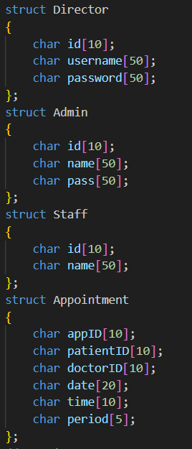
Figure 1 : Structures for Director
The Director module uses structured data types to organize and store information related to the management of the hospital. Each structure represents a specific entity and contains attributes necessary for authentication and reporting.
For example, the Director structure includes fields for the ID, username, and password used for secure login.
These structures improve data organization and allow the system to handle complex management records efficiently when interacting with the file-based database.

Admin
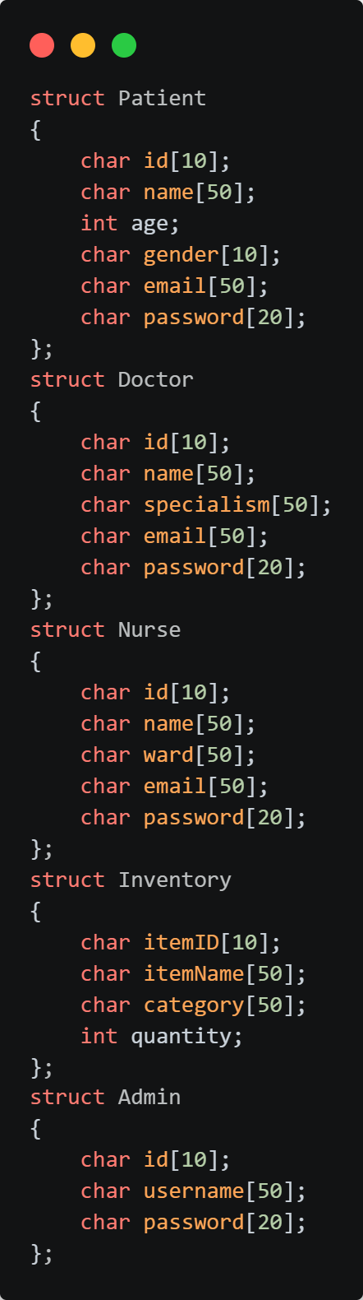
Figure 2 : Structures for Admin
The admin file uses structured data types to organize and store information related to patients, doctors, nurses, and inventory. Each structure represents a real-world entity and contains relevant attributes.
For example, the Patient structure includes fields such as patient ID, name, age, gender, email, and password. Similarly, the Doctor structure stores Doctor ID, name, specialism, email, and password. The Nurse structure includes nurse ID, name, assigned ward, email, and password. The Inventory structure stores item ID, item name, type, and quantity. These structures improve data organization and allow the system to handle records efficiently when reading from or writing to text files.

Doctor
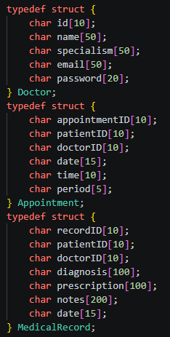
Figure 3 : Structures for Doctor
The doctor file uses structured data types to organize and store information related to doctors, appointments, and medical records. Each structure represents a real-world entity and contains relevant attributes.
For example, the Doctor structure includes fields such as doctor ID, name, specialism, email, and password. This allows the system to authenticate doctors and link them to patients and medical records. Similarly, the Appointment structure stores appointment ID, patient ID, doctor ID, date, time, and period (AM/PM). These attributes ensure that appointments are uniquely identified, properly scheduled, and checked for conflicts. The MedicalRecord structure captures details of a patient’s consultation, including record ID, patient ID, doctor ID, diagnosis, prescription, notes, and date. This ensures that each patient’s medical history is securely maintained and linked to both the patient and the doctor who created the record.
These structures improve data organization and allow the system to handle records efficiently when reading or writing text files, ensuring continuity of care and accurate hospital management.
Nurse
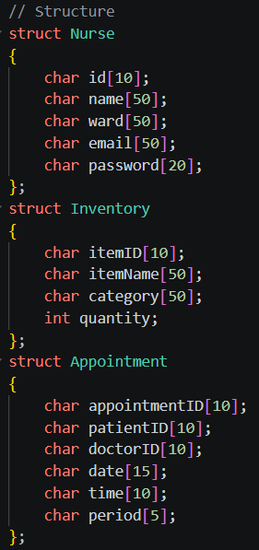
Figure 4 : Structures for Nurse
There are three main data structures in the Nurse module that organize the hospital's clinical and operational data. The Nurse struct keeps track of important staff information, such as a unique ID, name, ward assignment, and contact information. This makes sure that every action taken in the system is linked to a specific staff member. The Inventory struct is meant to keep track of medical supplies by storing the Item ID, name, category, and current stock quantity. This is very important for keeping the ward ready. The Appointment struct stores the appointment ID, patient and doctor identifiers, and the exact date and time slot. It is responsible for managing the scheduling link between patients and doctors.

Patient
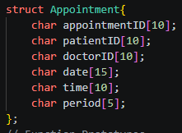
Figure 5 : Structures for Patient
The patient module uses structured data types to organize and store information related to hospital patients. Each structure represents a real-world entity and contains relevant attributes that allow the system to manage patient records efficiently.
For example, the Patient structure includes fields such as patient ID, name, age, gender, email, and password. These attributes ensure that each patient can be uniquely identified, authenticated during login, and linked to appointments, billing, and medical records. By storing this information in a structured format, the system can easily read and write patient details to text files, improving data organization and supporting secure record management.

Function Explanation
Director Login Function
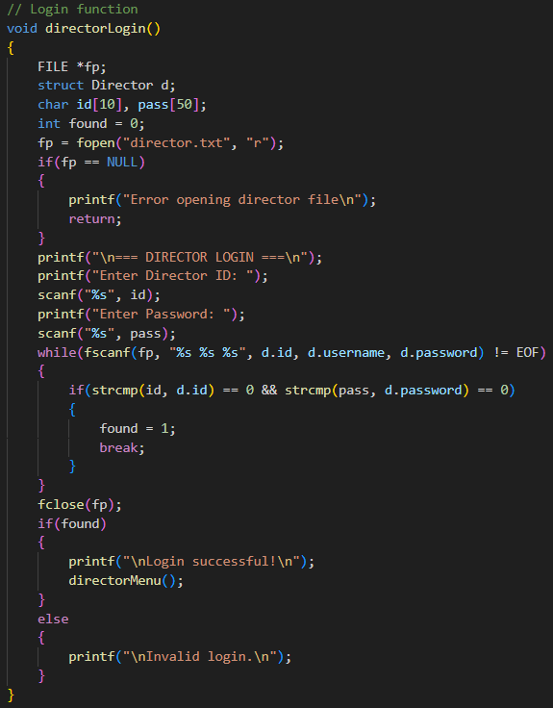
Figure 6 : Director Login Function
The Director login function is responsible for authenticating the executive user before granting access to the high-level management system. To ensure security, the Director is required to enter a valid Director ID and matching password. The system retrieves stored credentials from the director.txt file and performs a comparison with the values provided during the input stage.
If the credentials match a record within the file, the login is successful, and the Director is redirected to the main Director Menu. Otherwise, the system displays an error message indicating an invalid login attempt and denies access. This function serves as the primary security gateway, ensuring that only authorized individuals can access staff reports, administrative registration, and hospital summaries.

Director Menu Function
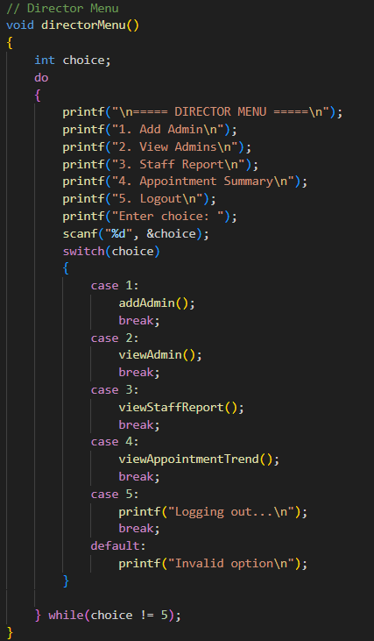
Figure 7 : Director Menu Function
After successful authentication, the Director menu function is displayed. This function presents a specialized list of available operations, including registering new administrators, viewing current administrator records, generating hospital-wide staff reports, and analyzing appointment trends. The Director selects an option using a numeric choice, and the system calls the corresponding function to execute the requested task.
The menu is implemented using a loop structure, allowing the Director to perform multiple oversight operations sequentially until they choose to exit or log out. This ensures smooth navigation and continuous interaction with the hospital's high-level data management system without needing to re-authenticate every task.

Add Admin Function
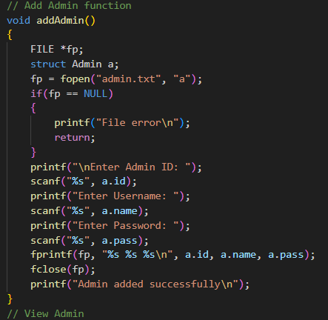
Figure 8 : Add Admin Function
The Add Admin function is responsible for registering new administrative users into the system. The Director is prompted to enter a unique Admin ID, a username, and a secure password for the new staff member. The system utilizes file handling techniques to open the admin.txt file in append mode, allowing the new credentials to be permanently stored without overwriting existing data.
Upon receiving the input, the function formats the information into a single record and writes it to the text file. If the file is successfully accessed and the data is written, a confirmation message is displayed to the Director. This function is vital for expanding the hospital's administrative team and ensures that the system's management hierarchy is maintained through controlled account creation.

View Admin Function
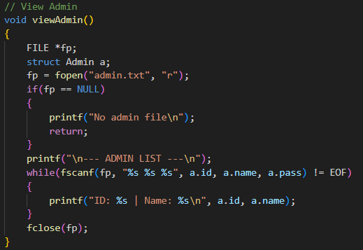
Figure 9 : View Admin Function
The View Admin function allows the Director to retrieve and display a list of all registered administrators currently stored in the system. This function opens the admin.txt file in read mode and utilizes a loop to scan each entry, extracting the Admin ID and Name for presentation. If the file is missing or cannot be opened, an appropriate error message is shown to inform the user.
By outputting the IDs and usernames of the administrative staff, this function provides the Director with a quick oversight of the personnel authorized to manage hospital data. The use of structured reading ensures that only the relevant identifying information is displayed, maintaining a clean and professional interface. This capability is essential for monitoring administrative accounts and ensuring that the list of authorized users remains accurate.

View Staff Report Function
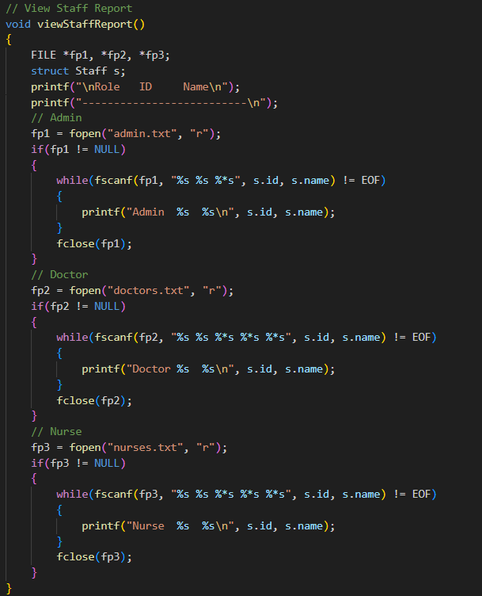
Figure 10 : View Staff Report Function
The View Staff Report function is a comprehensive monitoring tool that allows the Director to see a complete roster of all hospital personnel, including Administrators, Doctors, and Nurses. This function operates by sequentially opening the admin.txt, doctors.txt, and nurses.txt files and reading the ID and Name fields for each role. By aggregating data from multiple sources into a single unified report, the function provides a holistic view of the hospital's human resources.
The report is presented in a tabular format, clearly labeling the role of each staff member alongside their unique identification details. The system includes built-in checks to ensure that if a specific file is missing, the function skips it without crashing, ensuring operational stability. This reporting capability is crucial for the Director to verify staffing levels across different departments and maintain organized oversight of the hospital’s workforce.

View Appointment Trend Function
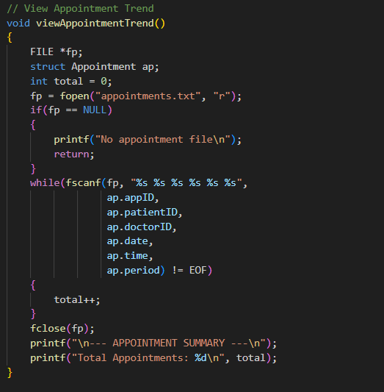
Figure 11 : View Appointment Trend Function
The View Appointment Trend function is designed to provide the Director with high-level quantitative data regarding the hospital's operational volume. This function accesses the appointments.txt file in read mode and utilizes counter-based logic to iterate through every recorded appointment entry. By parsing the structured data, the function calculates the total number of bookings processed by the system across all medical departments.
Once the entire file has been processed, the system generates a summary display showing the total count of appointments. This data allows the Director to assess the hospital's current workload and identify trends in patient traffic without needing to review individual medical records. This analytical feature is a key component of the Director's oversight role, facilitating data-driven insights into the efficiency of the hospital's scheduling system.
Admin Login Function
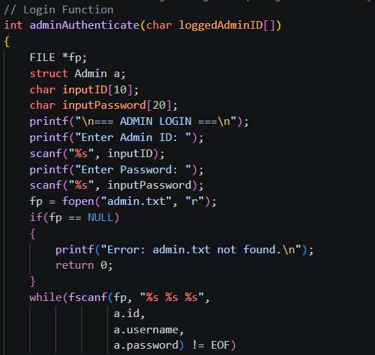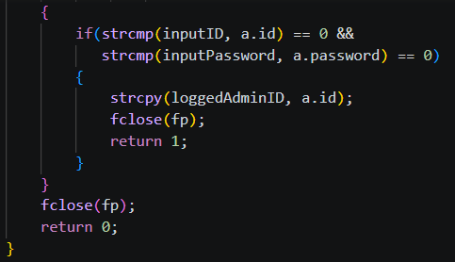
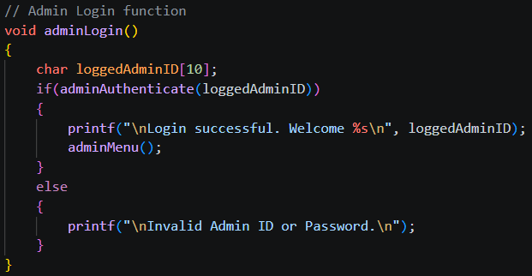
Figure 12 : Admin Login Function
The admin login function is responsible for authenticating the administrator before granting access to the system. The admin is required to enter a valid ID and password. The system reads and stores credentials from the file and compares them with the input values.
If the credentials match, the login is successful and the admin menu is displayed. Otherwise, an error message is shown indicating invalid login. This function ensures that only authorized users can access administrative functionalities.

Admin Menu Function
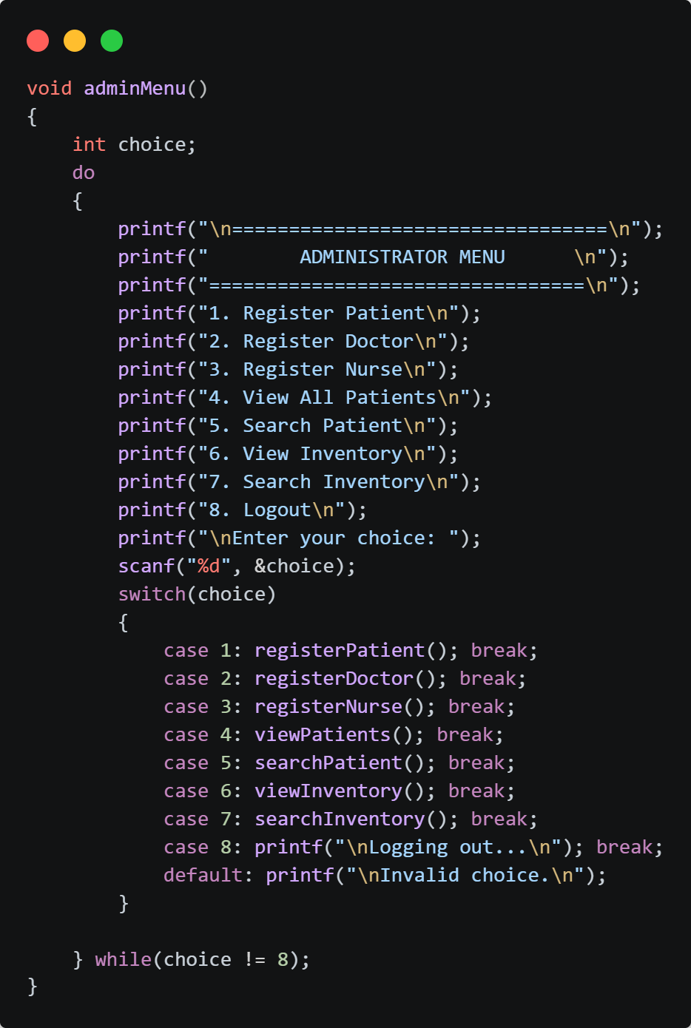
Figure 13 : Admin Menu Function
After successful authentication, the admin menu function is displayed. This function presents a list of available operations such as registering patients, managing doctors and nurses, and handling inventory. The admin selects an option using a numeric choice, and the system calls the corresponding function.
The menu is implemented using a loop structure, allowing the administrator to perform multiple operations until they choose to exit. This ensures smooth navigation and continuous system interaction.
Generate Patient ID Function
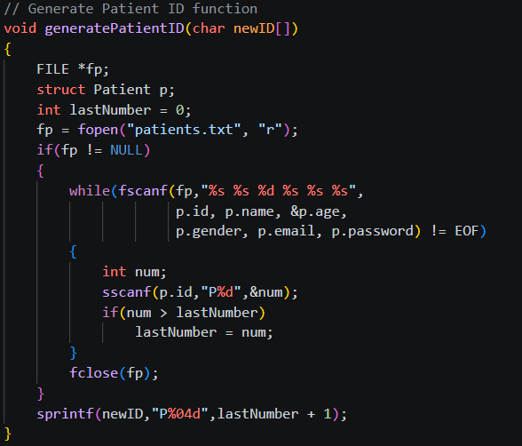
Figure 14 : Generate Patient ID Function
The generatePatientID function is used to automatically assign a unique Patient ID to each new patient record. It reads existing entries from the patients.txt file and extracts the numeric portion of each Patient ID to determine the highest value currently stored. The function then increments this value and formats it into a standardized ID (e.g., P0002, P0003). If no records are found, the numbering starts from P0001. This ensures that all patient IDs are unique, sequential, and consistently formatted within the system.

Register Patient Function
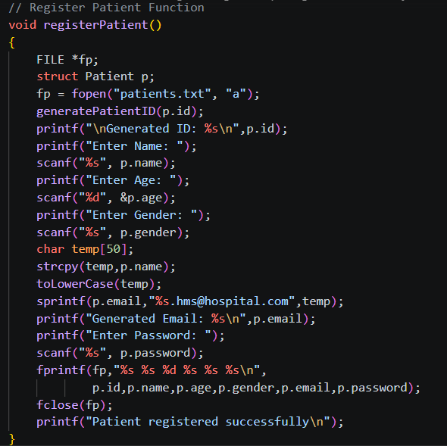
Figure 15 : Register Patient Function
The Register Patient function allows the administrator to add new patient records into the system. The admin is required to input details such as name, age, gender, and password. The system automatically generates a unique patient ID and a corresponding email address based on the patient’s name.
Once all details are entered, the system stores the information in the patients.txt file. A confirmation message is displayed to indicate successful registration. This function ensures consistent and accurate storage of patient data.

View Patients Function
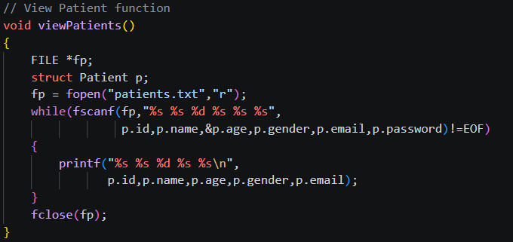
Figure 16 : View Patients Function
The View All Patients function retrieves and displays all patient records stored in the system. The system reads data from the patients.txt file and prints each record in a structured format.
This function allows the administrator to verify stored data and monitor all registered patients. It improves transparency and helps ensure that records are properly maintained.

Search Patient Function
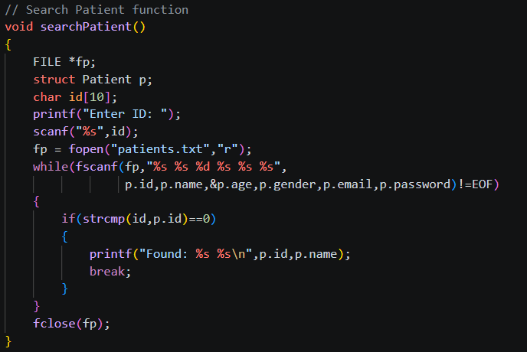
Figure 17 : Search Patient Function
The Search Patient function enables the administrator to locate a specific patient using their unique Patient ID. The system scans through the patients.txt file and compares each record with the input ID.
If a match is found, the corresponding patient details are displayed. If no match is found, the system displays a “Not found” message. This function provides efficient access to individual records.

Generate Doctor ID Function
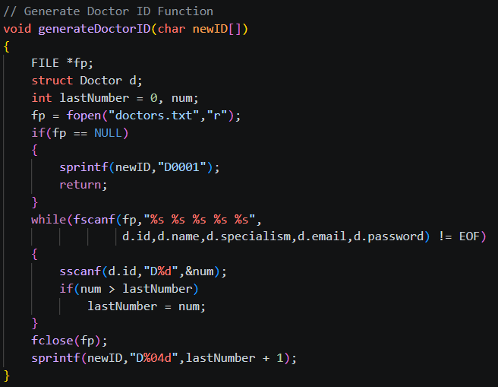
Figure 18 : Generate Doctor ID Function
The generateDoctorID function is responsible for automatically generating a unique Doctor ID for each new doctor record. It reads existing entries from the doctors.txt file and extracts the numeric portion of each Doctor ID to identify the highest value currently stored. If the file does not exist, the function assigns the default ID D0001. Otherwise, it increments the highest value and formats it into a standardized ID (e.g., D0002, D0003). This approach ensures that all doctor records have unique and sequential identifiers within the system.

Register Doctor Function
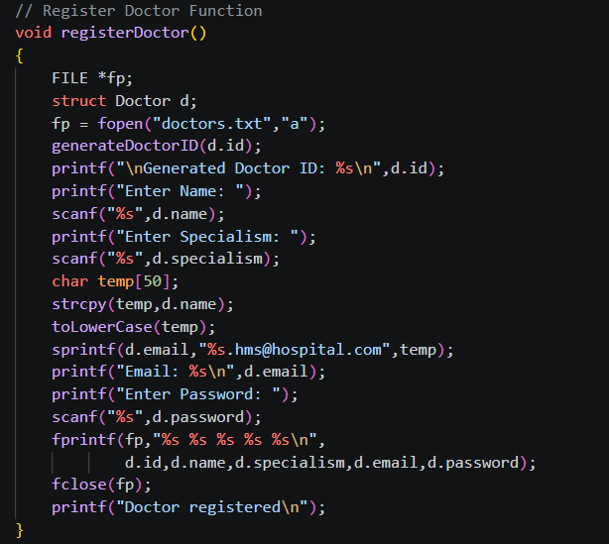
Figure 19 : Register Doctor Function
The Register Doctor function allows the administrator to add new doctors to the system. The admin enters details such as doctor name, specialism, and password. The system generates a unique doctor ID and email address.
The information is then stored in the doctors.txt file. This function ensures that doctor records are properly maintained and easily accessible.

Generate Nurse ID Function
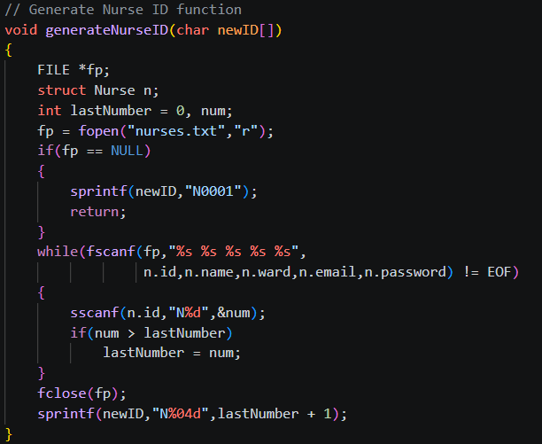
Figure 20 : Generate Nurse ID Function
The generateNurseID function is used to automatically create a unique Nurse ID for each new nurse record. It reads existing data from the nurses.txt file and extracts the numeric part of each Nurse ID to determine the highest value currently stored. If the file does not exist, the system assigns the default ID N0001. Otherwise, it increases the highest ID value and formats it into a standardized form (e.g., N0002, N0003). This ensures that each nurse is assigned a unique and sequential identifier within the system.

Register Nurse Function
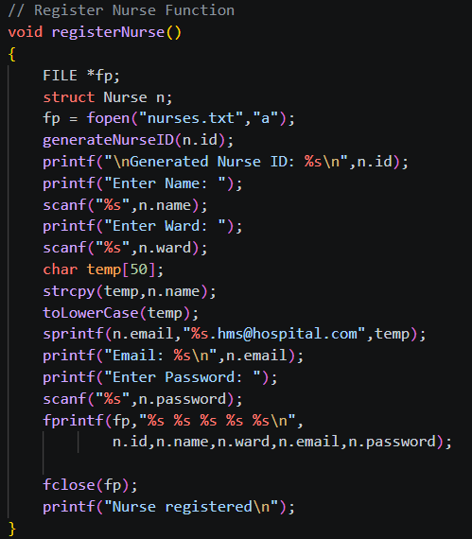
Figure 21 : Register Nurse Function
The Register Nurse function is used to add nurse details into the system. The administrator inputs the nurse’s name, assigned ward, and password. The system generates a unique nurse ID and email address.
The details are saved in the nurses.txt file, and a confirmation message is displayed. This function helps in managing nursing staff efficiently.

View Inventory Function
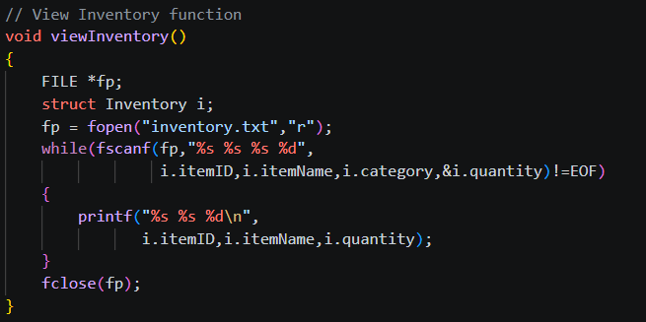
Figure 22 : View Inventory Function
The View Inventory function allows the administrator to view all available medical items in the system. The system reads data from the inventory.txt file and displays each item along with its details such as item ID, name, type, and quantity.
This function helps the administrator monitor available resources and ensures that inventory records are up to date.

Search Inventory Function
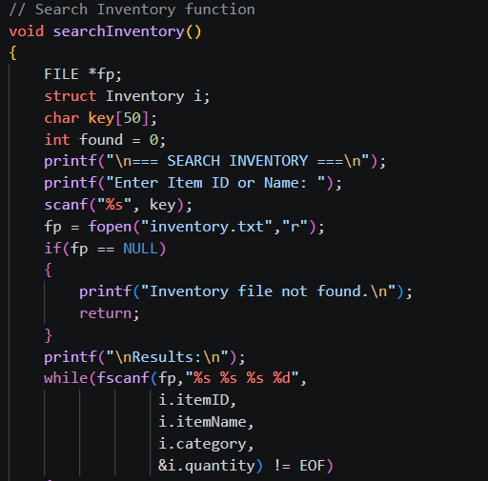
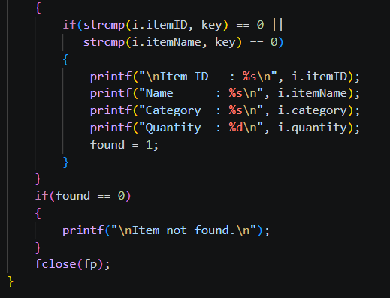
Figure 23 : Search Inventory Function
The Search Inventory function enables the administrator to search for a specific item using its ID or name. The system scans the inventory.txt file and compares each record with the input.
If a matching item is found, its details are displayed. Otherwise, a message indicating that the item is not found is shown. This function improves efficiency in locating required medical supplies.

Doctor Login Function
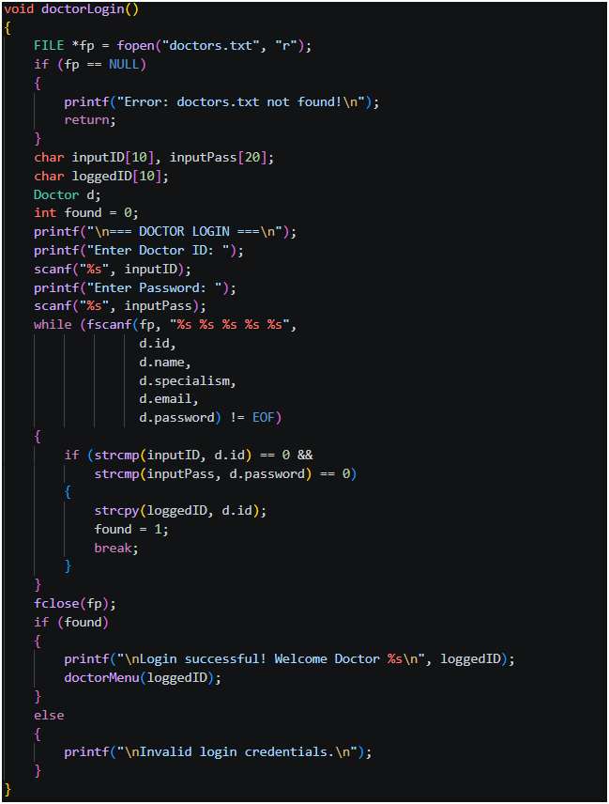
Figure 24 : Doctor Login Function
This function handles the login process for the doctor.
Opens doctors.txt for reading
Prompts the doctor to enter their doctor ID and password
Loops through every record in the file comparing the input against stored credentials
If a match is found, it stores the doctor’s ID into loggedID and calls doctorMenu()
If no match is found, it prints “Invalid login credentials”
The loggedID is important because it is passed into other functions to ensure the doctor only sees their own data.
Doctor Menu Function
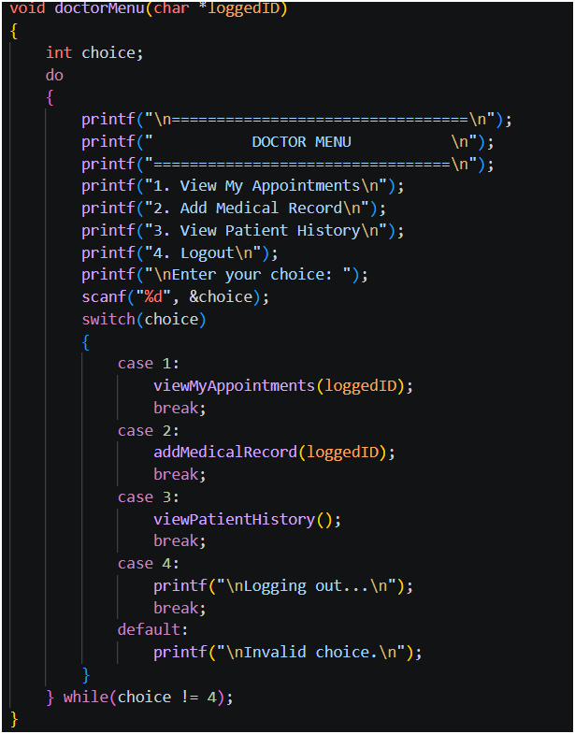
Figure 25 : Doctor Menu Function
This function displays the main navigation menu for the doctor.
Takes loggedID as a parameter so it can pass it to other functions
Uses a do-while loop so the menu keeps showing until the doctor chooses to logout
Uses a switch statement to direct the doctor to the correct function based on their choice
Option 4 breaks the loop and logs the doctor out.

View My Appointments Function
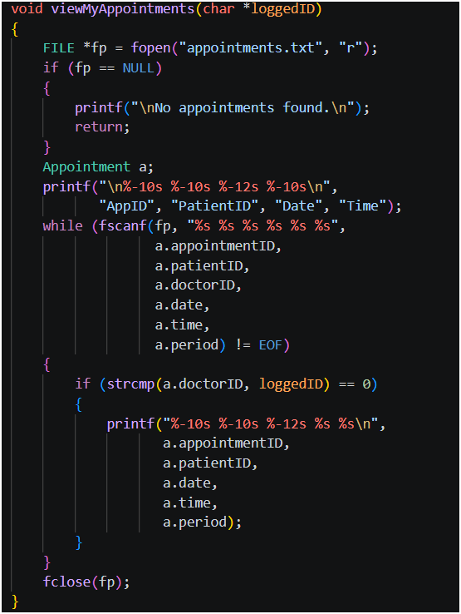
Figure 26 : View My Appointments Function
This function displays only the appointments belonging to the logged-in doctor.
Opens appointments.txt for reading
Reads every appointment record one by one
Compares each record’s doctorID field against loggedID
Only prints the appointment if they match, ensuring doctors cannot see other doctors’ appointments
Shows: Appointment and Patient IDs, Time, Date, and Period
Add Medical Record Function
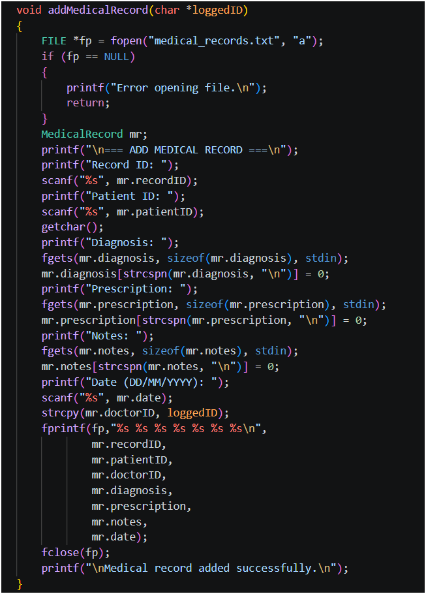
Figure 27 : Add Medical Record Function
The function makes possible for the doctor to add a new medical record for the patient after a consultation.
Opens the text file medical_records.txt, to not overwrite anything it's done in append mode.
Prompts the doctor to input: Record ID, Patient ID, Diagnosis, Prescription, Notes, and Date
Uses fgets() for diagnosis, prescription, and notes to allow spaces in the input
Uses strcspn() to remove the newline character from fgets() input
Automatically sets doctorID to loggedID so the record is linked to the correct doctor
Writes all fields to the file in a single line.
View Patient History Function
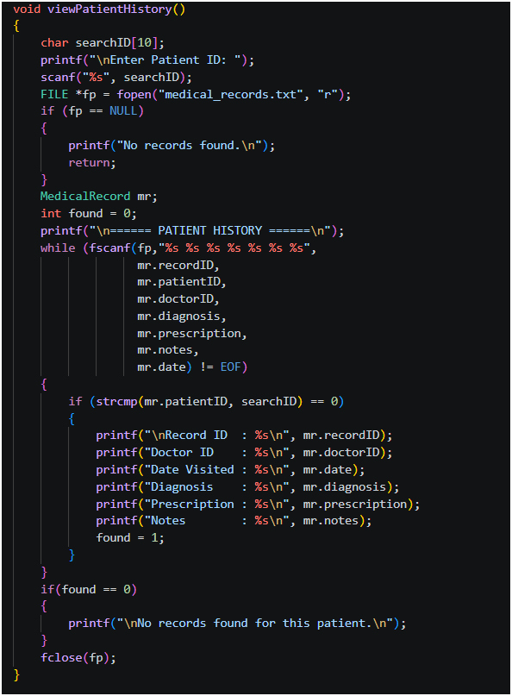
Figure 28 : View Patient History Function
This function allows the doctor to search and view a patient’s full medical history.
Prompts the doctor to enter a Patient ID to search for
Opens medical_records.txt for reading
Loops through every record and compares patientID against the search input
In case a match is found, all details are printed: Record ID, Doctor ID, Date, Diagnosis, Prescription, and Notes
Uses a found flag to detect if no records exist for the entered patient ID and displays an appropriate message one time kill.
Nurse Login Function
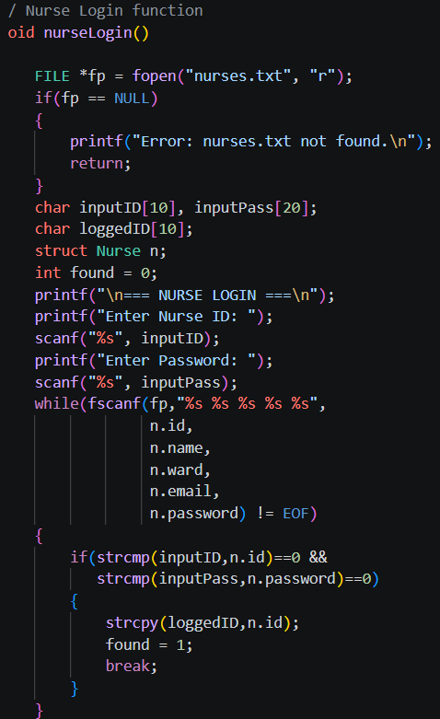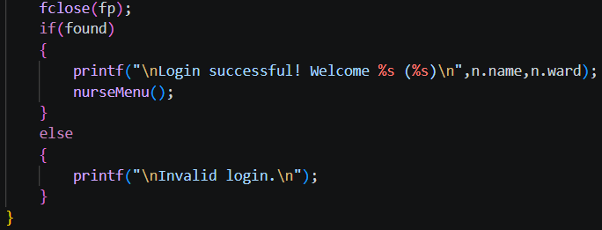
Figure 29 : Nurse Login Function
The nurseLogin function is the module's security gateway. It makes sure that only people who are allowed to see sensitive medical schedules and inventory data can do so. When a nurse tries to log in, the system asks for a unique Nurse ID and password. The program then opens the nurses.txt file in read mode and searches through it in order, using string comparison functions to compare the user's input to the records that are already there. The system calls the main menu to let someone in if a match is found. If not, it shows an error message and takes the user back to the main system portal to stop unauthorised access.
Nurse Menu Function
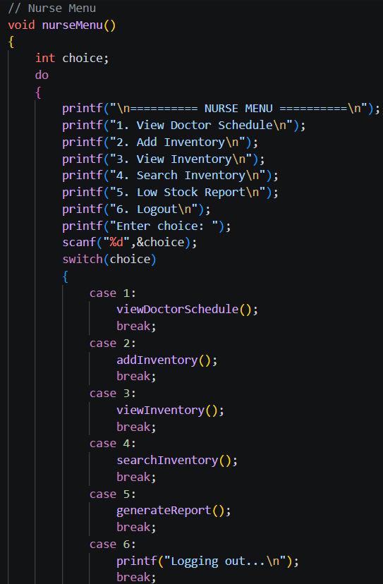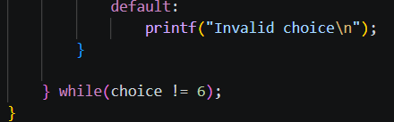
Figure 30 : Nurse Menu Function
Upon authentication, the user is given access to a central Nurse Menu that serves as a command center for all their duties. The use of the Nurse Menu involves the use of a do-while loop alongside a switch-case control construct. It allows the user to transition between operations in a seamless manner without having the application shut down. Through this interface, the nurse can opt to browse through the doctors’ schedules to facilitate the flow of patients or look up an item within the inventory or create a report on the entire inventory. The loop runs until the user decides to log out of the system.

View Doctor Schedule Function
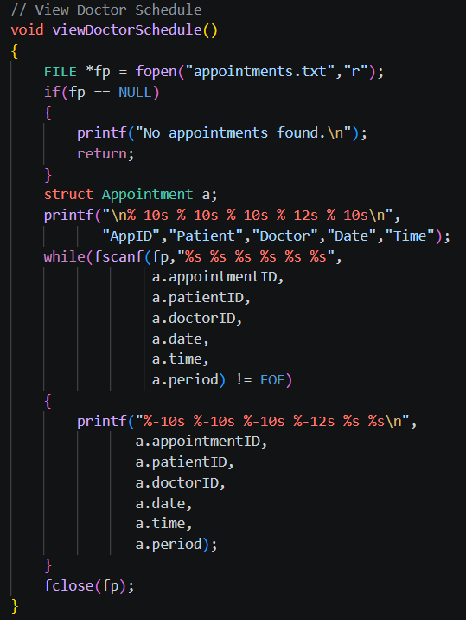
Figure 31 : View Doctor Schedule Function
The function `viewDoctorSchedule()` is responsible for reading and displaying the appointments data from a file called `"appointments.txt"`. First, it tries to open the file in read-only mode, and if it fails to open the file (or if it doesn't exist), an error message is displayed and the function ends. In case the file exists and can be successfully opened, a structure variable `a` is declared of the type `Appointment` which will hold each record temporarily. Then, a header for the appointment details such as `AppID`, `Patient`, `Doctor`, `Date`, and `Time` is printed on screen. With the help of `fscanf` and `while` loops, each record from the file is read into the fields of the structure. The record details are printed on screen in a nicely formatted way using `printf`.

Add Inventory Function
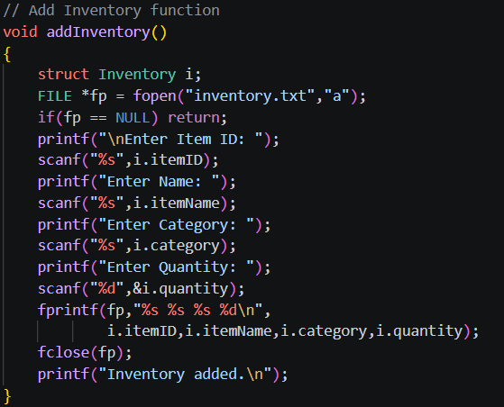
Figure 32 : Add Inventory Function
The function `addInventory()` is intended to obtain inventory information from the user and save it in a file "inventory.txt". First, the function declares the variable i of structure Inventory and attempts to open the file "inventory.txt" in append mode ("a"), where it can add new data to the file while not deleting any of the data inside; if the file opening fails, the function terminates at once. Then the user is prompted for entering the details of the items – Item ID, Name, Category, and Quantity. Each of the entered values is obtained with the use of `scanf` and saved into the appropriate members of the structure. After that, the obtained values are written in the file with the use of `fprintf` and placed on a new line in the file.

Generate Report Function
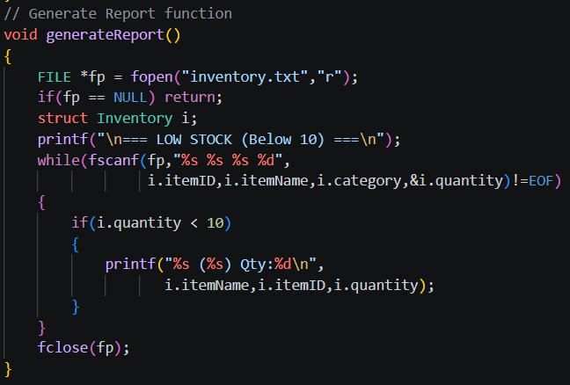
Figure 33 : Generate Report Function
The purpose of this function is to read records of inventories from a file "inventory.txt" and generate a list of those products whose stocks have fallen below 10. Firstly, the file is opened in read mode using `fopen()`, and in case, if it fails to do so `fp = NULL`, then the function is terminated. A variable `i` of structure `Inventory` is declared, which holds each record at a time. Next, it outputs the heading of the listing showing that only those products having stocks below 10 would be listed down. A `while` loop using `fscanf()` function is called to read records one by one from the file. Each product's details including its name, ID, and category are read from the file, and if the value of `quantity` for any record is less than 10, then the product's name and other details are printed on the screen.

Patient Login Function
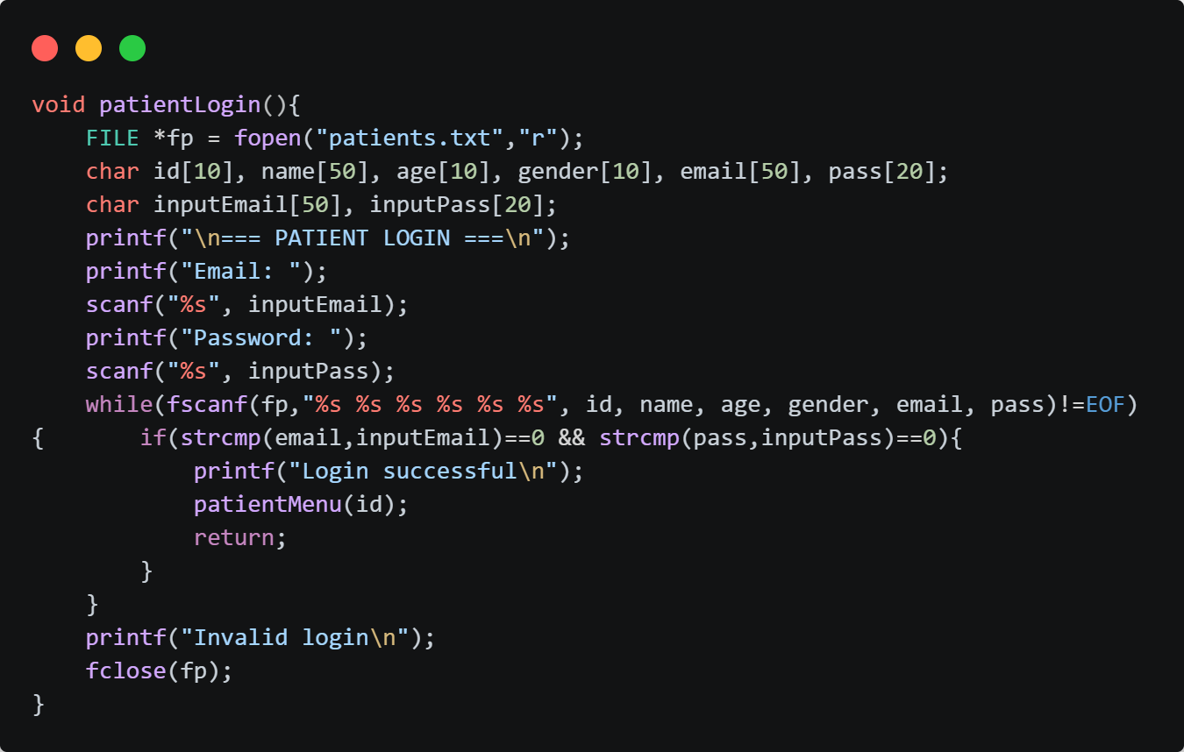
Figure 34 : Patient Login Function
The patientLogin() function authenticates a patient by checking that the login credentials match those saved in the text file named patients.txt. When executed, the function opens the patients.txt file in read mode. The values from the file are assigned to variables and compared with the values entered by the user. If a match is found, it prints “Login Successful” and then calls the patientMenu() function and passes the patient id into it. If no values match with the patient credentials (like incorrect password or patient not registered yet) in the patient.txt text file, it says “Invalid Login” closes.

Patient Menu Function
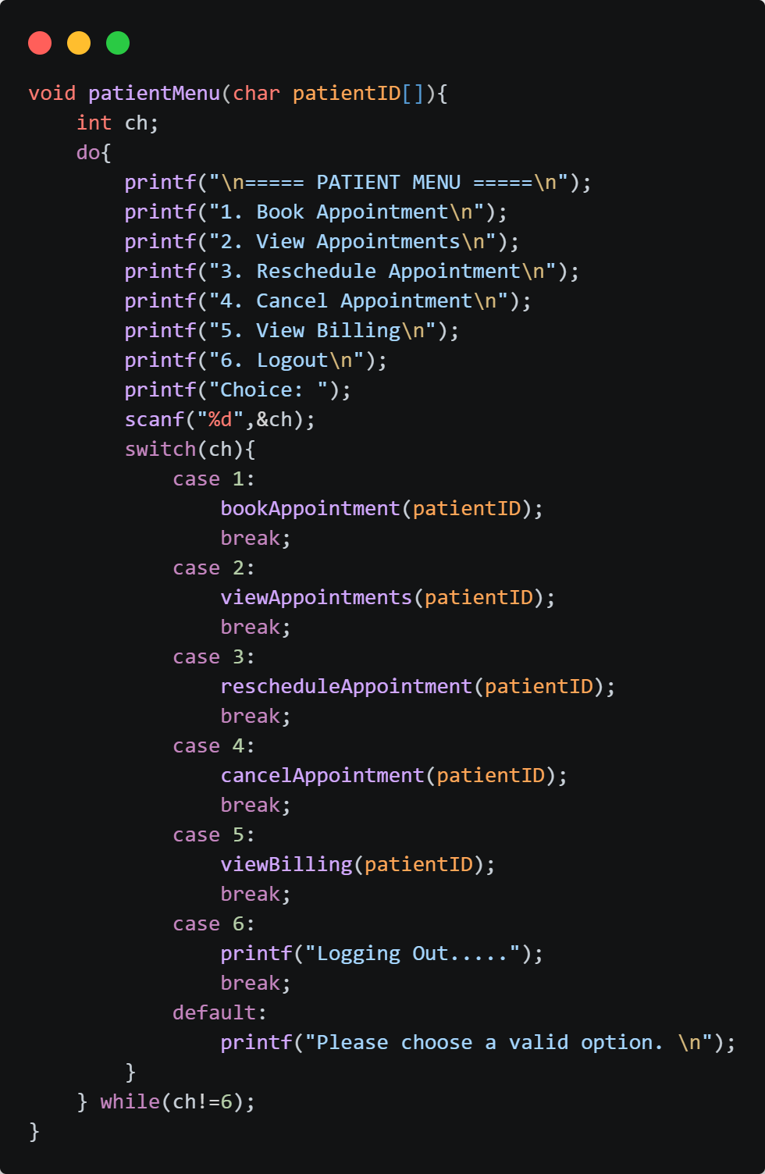
Figure 35 : Patient Menu Function
The patientMenu() function displays a menu to the user, who selects an option by entering a number. A switch statement processes the user’s choice, with valid options ranging from 1 to 6. If the input is invalid, the default case prints “Please choose a valid option” and the menu is shown again. Case 1 calls the bookAppointment() function, Case 2 displays all appointments for the patient, Case 3 allows rescheduling of appointments, Case 4 cancels appointments, and Case 5 shows billing information. If the user enters 6, the function prints “Logging Out” and terminates the menu loop.
Book Appointments Function
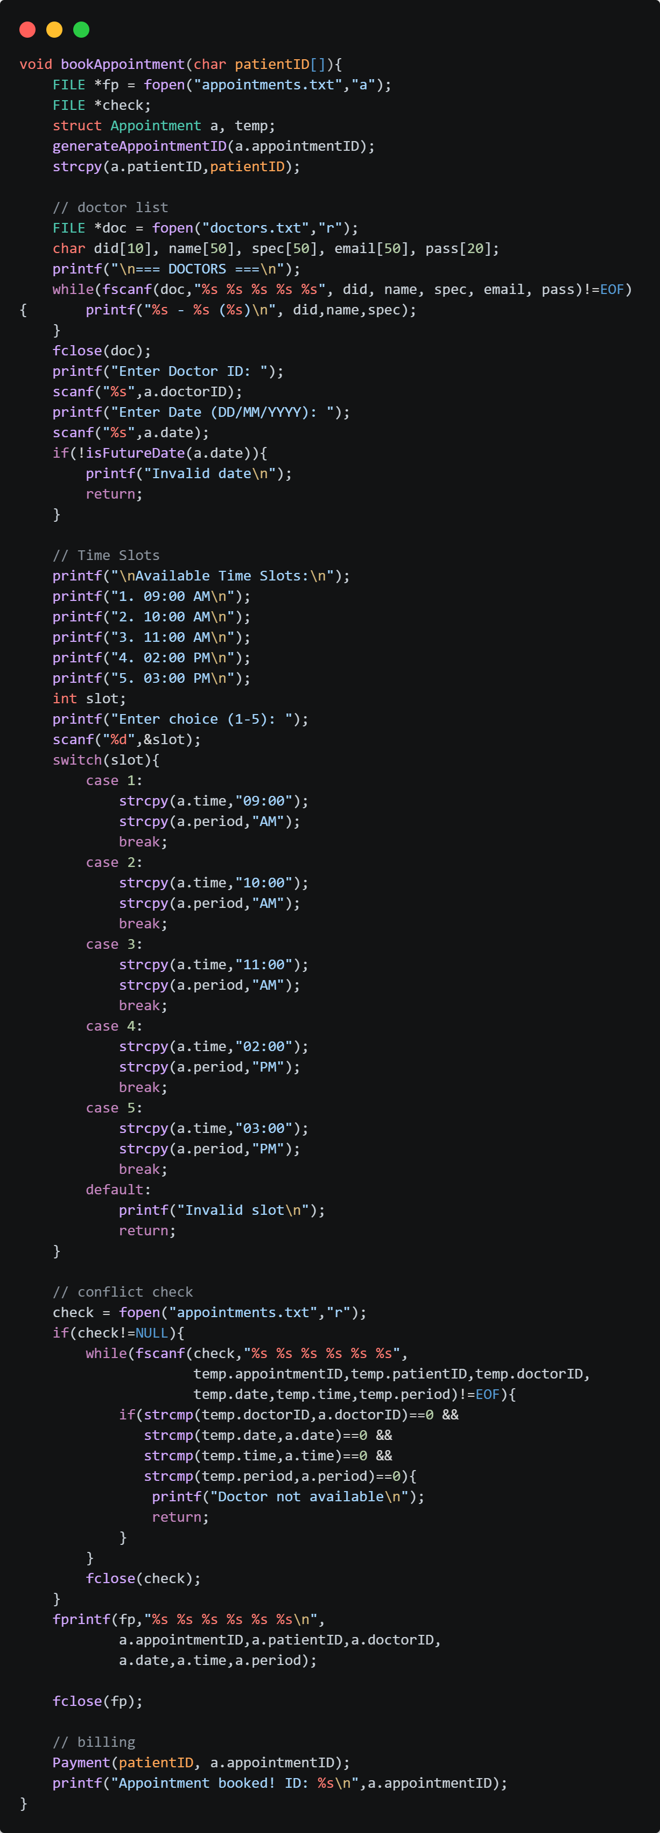

Figure 36 : Book Appointments Function
The bookAppointment() function manages the process of scheduling a patient’s appointment with a doctor. It begins by generating a unique appointment ID and linking it to the patient’s ID. The function then reads doctor information from the doctors.txt file and displays the available doctors. The patient is prompted to enter a doctor ID and an appointment date, which is validated to ensure it is a future date. Afterward, the function presents a list of available time slots, and the user selects one by entering a number between 1 and 5. The chosen time and period (AM/PM) are stored in the appointment structure.
Before confirming the booking, the function checks the appointments.txt file to verify that the selected doctor is available at the chosen date and time. If a conflict is detected, it prints “Doctor not available” and terminates without saving the appointment. Otherwise, the appointment details are written to appointments.txt, and the Payment() function is called to handle billing. Finally, the function prints a confirmation message along with the generated appointment ID.

View Appointment Function
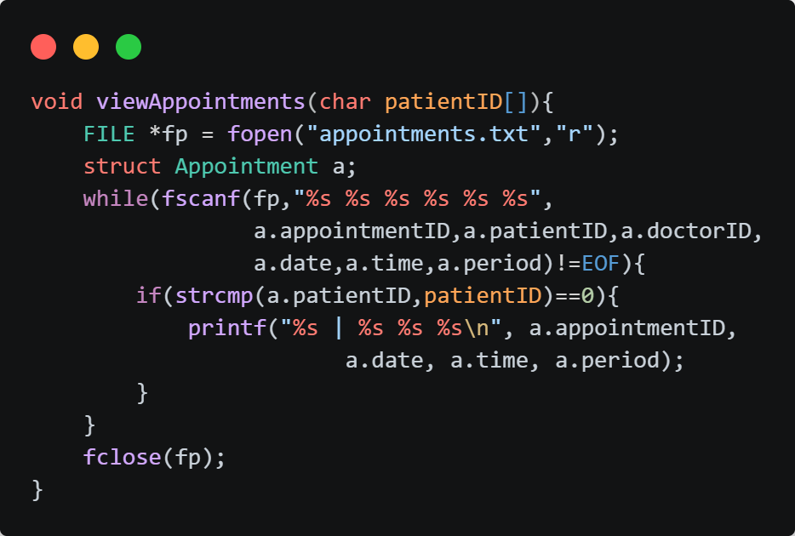
Figure 37 : View Appointment Function
The viewAppointments() function displays all appointments associated with a specific patient. It opens the appointments.txt file in read mode and uses a loop to read each appointment record line by line into an Appointment structure. For every record, the function compares the stored patient ID with the patient ID provided as input. If the IDs match, the function prints the appointment details, including the appointment ID, date, time, and period. Once all records have been processed, the file is closed. This function provides patients with a simple way of viewing their scheduled appointments directly from the stored data.

Reschedule Appointments Function
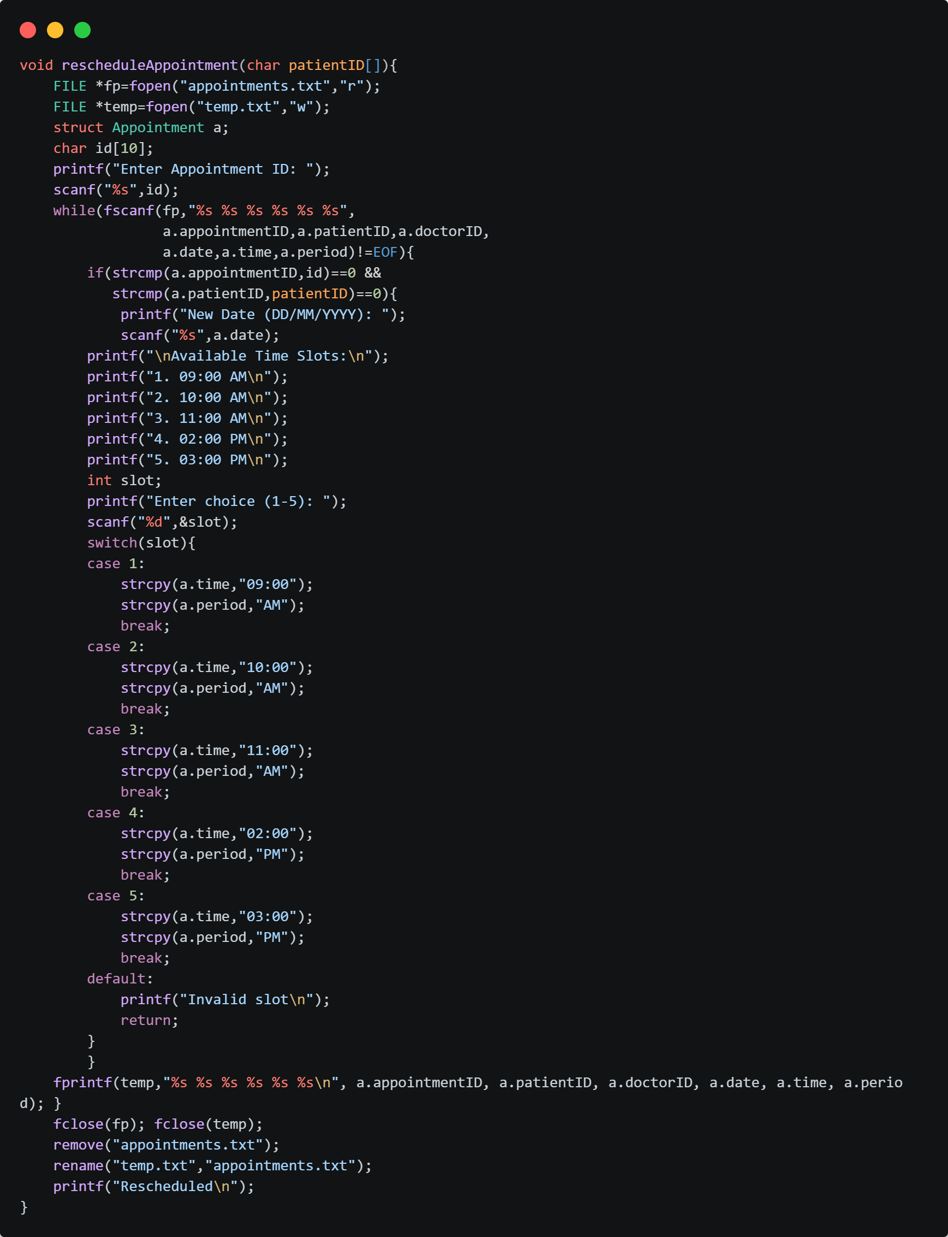Figure 38 : Reschedule Appointments Function
The rescheduleAppointment() function allows patients to update the date and time of an existing appointment. It opens the appointments.txt file in read mode and a temporary file temp.txt in write mode. The patient is prompted to enter the appointment ID they wish to modify. Each appointment record is then read line by line, and if the appointment ID and patient ID match, the user is asked to provide a new date and select a time slot from the available options. The updated details are stored in the appointment structure.
All records, including the modified one, are written into temp.txt. Once processing is complete, the original appointments.txt file is deleted and replaced with the updated temp.txt file. Finally, the function prints “Rescheduled” to confirm the update. This method ensures safe modification of appointment data by using a temporary file rather than directly overwriting the original file.

Cancel Appointments Function
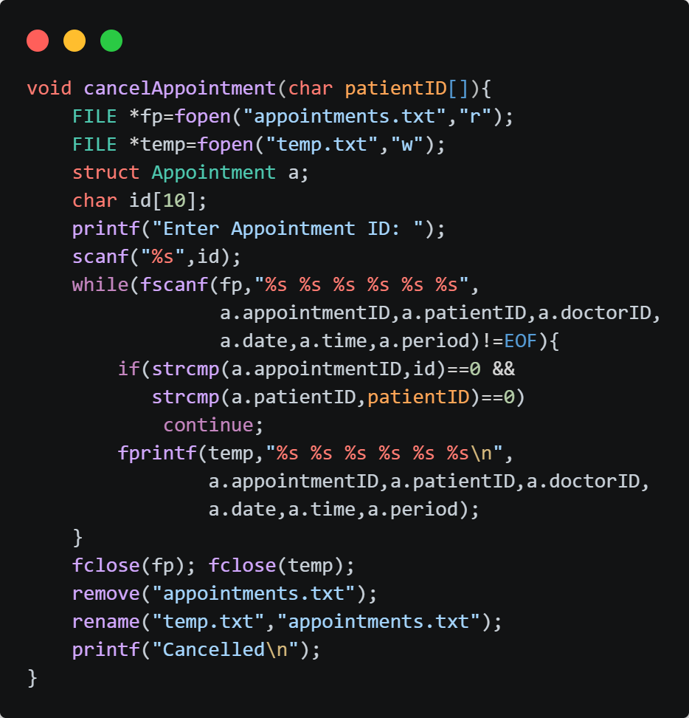
Figure 39 : Cancel Appointments Function
The cancelAppointment() function enables a patient to remove an existing appointment from the system. It opens the appointments.txt file in read mode and a temporary file temp.txt in write mode. The patient is prompted to enter the appointment ID they wish to cancel. The function then reads each appointment record line by line. If the appointment ID and patient ID match the input, that record is skipped; otherwise, the record is written into temp.txt.
After processing all records, the original appointments.txt file is deleted and replaced with the updated temp.txt file, ensuring that the cancelled appointment is removed from the system. Finally, the function prints “Cancelled” to confirm the operation. This approach ensures safe modification of appointment data by using a temporary file instead of directly overwriting the original file.

View Billing Function
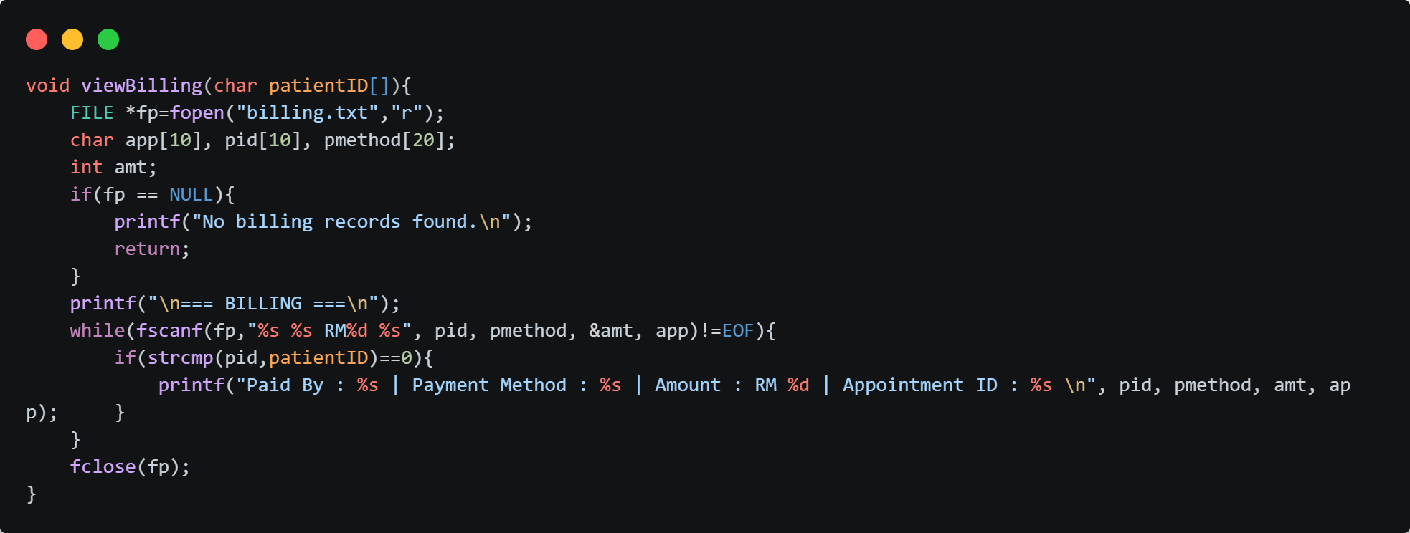
Figure 40 : View Billing Function
The viewBilling() function displays billing information for a specific patient. It opens the billing.txt file in read mode and checks whether any billing records exist. If the file cannot be opened, the function prints “No billing records found” and terminates. Otherwise, it reads each billing record line by line, extracting the patient’s ID, payment method, amount, and appointment ID. For every record, the function compares the stored patient ID with the input patient ID. If they match, the billing details are printed in a formatted output showing the payment method, amount, and appointment ID. After processing all records, the file is closed. This function provides patients with a straightforward way to review their billing history stored in the system.

Payment Function
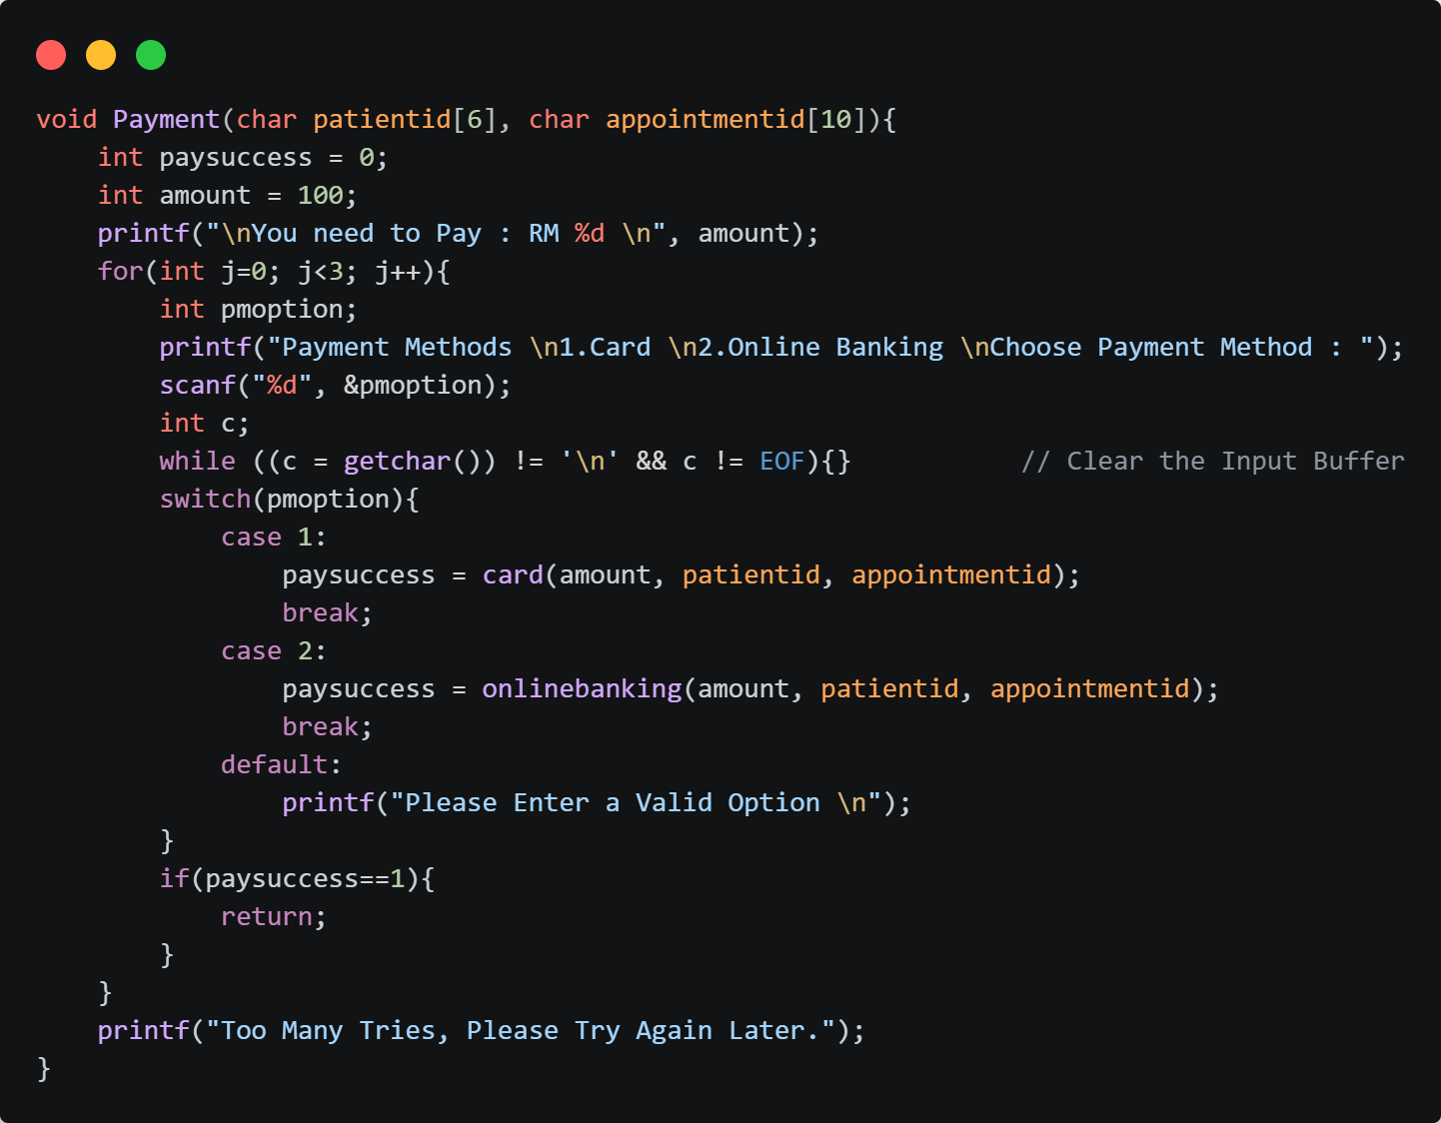
Figure 41 : Payment Function
The Payment() function is used for the payment processing for an appointment. It shows the fixed amount due and asks the user to choose a payment method, 1 for Card or 2 for Online Banking. Before the user enters the option, the input buffer is cleared to prevent errors. The user enters their option, and it goes through the switch case to check if the user selected a valid option. For option 1, card() function is called for payment. For option 2 is chosen, onlinebanking() function is called for payment. For any other input, the function prints “Please Enter a Valid Option” and allows the user up to 3 attempts, if all 3 attempts fail, it will print “Too many tries, please try again later.” and stops.

Card (Payment) Function
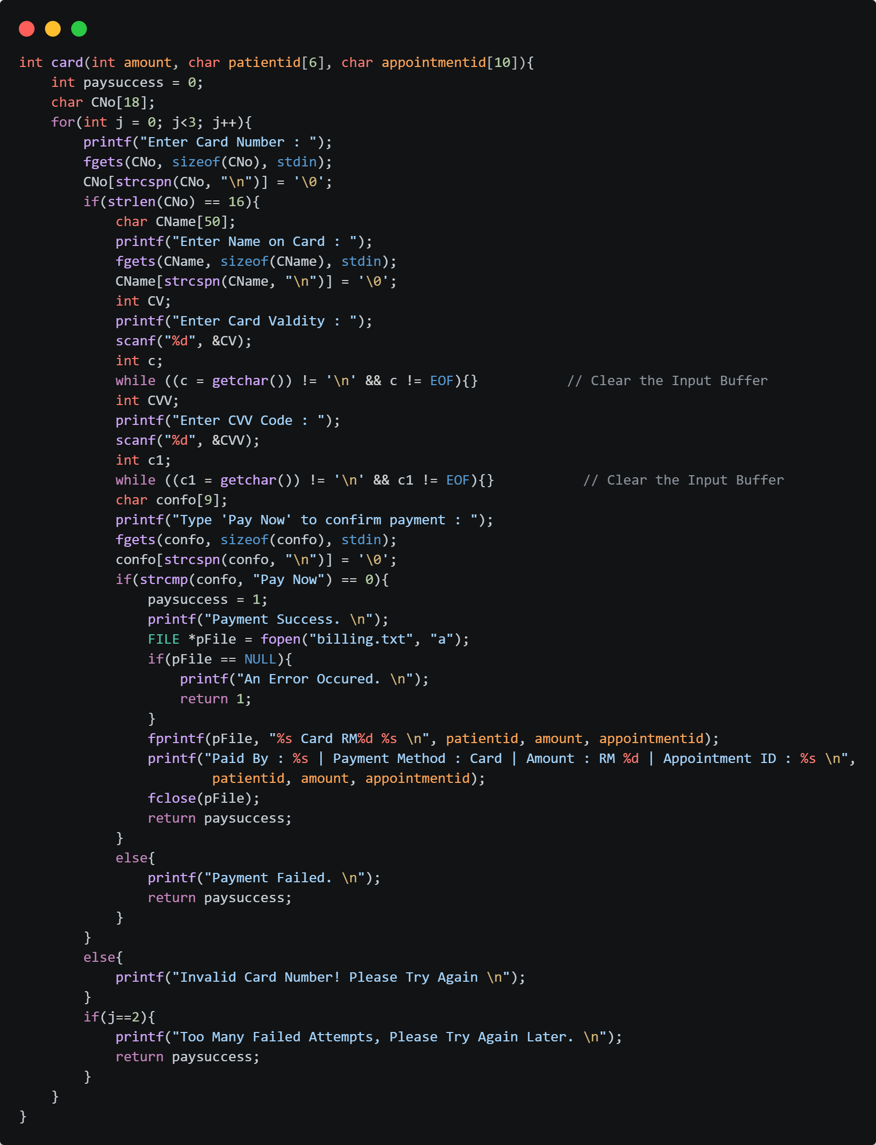
Figure 42 : Card (Payment) Function
The card() function is used for card payments. It takes 3 parameters like amount, patient id, appointment id from the Payment() function. When executed, the function prompts the user to enter their card number and validates that it contains exactly 16 digits. If the card number is invalid, the user is asked to try again, with a maximum of three attempts allowed before the process is terminated. Once a valid card number is entered, the function collects additional details such as the name on the card, the card’s validity period, and the CVV code. Input buffers are cleared after each scanf() call to prevent errors when mixing different input functions.
After the card details are entered, the user must type “Pay Now” to confirm the payment. If the confirmation is successful, the system prints a success message and records the transaction in the billing.txt file, storing the patient ID, payment method, amount, and appointment ID. This ensures that billing records are properly maintained for auditing and reporting purposes. If the user fails to confirm or enters incorrect details, the payment is marked as failed. Additionally, if the billing file cannot be opened, an error message is displayed. The function also limits the number of failed attempts to three, after which it terminates with a message indicating too many failed attempts.

Online Banking (Payment) Function
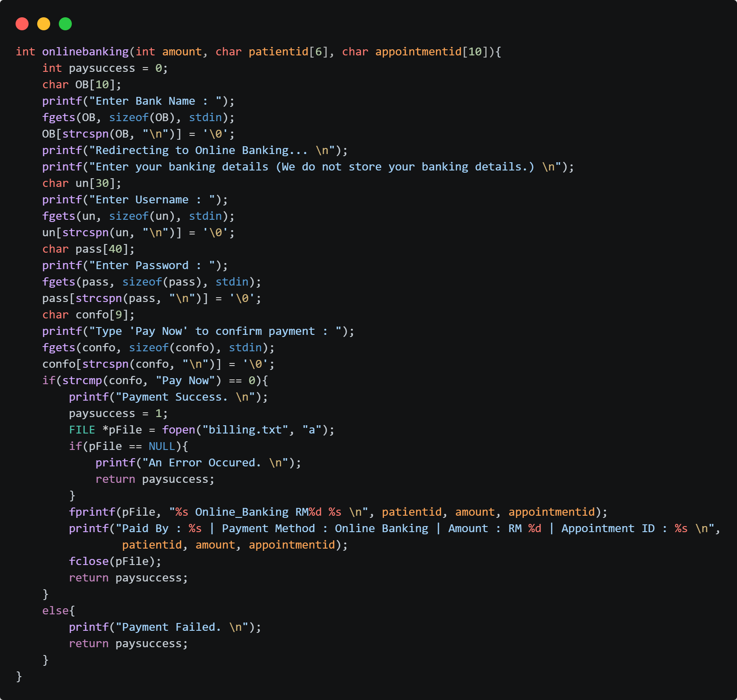
Figure 43 : Online Banking (Payment) Function
The onlinebanking() function is responsible for handling payments made through online banking. It begins by prompting the user to enter their bank name, then simulates a redirection to the online banking portal. The user is asked to provide their banking credentials, including a username and password, though the system explicitly notes that these details are not stored. After entering the credentials, the user must type “Pay Now” to confirm the transaction. If the confirmation is successful, the function prints a success message, sets the payment status to success, and records the transaction in the billing.txt file. The billing record includes the patient ID, payment method (Online Banking), the amount paid, and the appointment ID, ensuring that the payment is properly logged for auditing and reporting purposes. A confirmation message is also displayed to the user with the payment details. If the user fails to confirm by typing “Pay Now,” the payment is marked as failed, and the system outputs a failure message. Additionally, if the billing file cannot be opened, an error message is displayed. Overall, this function provides a structured way to process online banking payments, ensures user confirmation before recording transactions, and maintains an audit trail by storing billing records securely.

Is Future Date Function
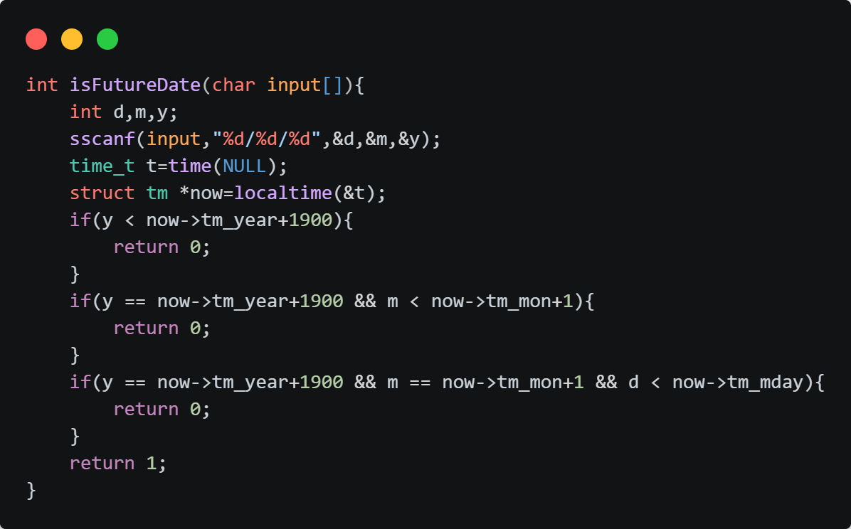
Figure 44 : Is Future Date Function
The isFutureDate() function is used to validate whether a given date string represents a future date compared to the current system date. It accepts a date in the format DD/MM/YYYY as input and extracts the day, month, and year using sscanf(). The function then retrieves the current date and time using the time() function and the localtime() structure. It performs a series of comparisons: first checking if the input year is less than the current year, then if the year is equal but the month is earlier, and finally if both year and month are equal, but the day is earlier. In any of these cases, the function returns 0, indicating that the date is not valid as a future date. If none of these conditions are met, the function returns 1, confirming that the input date is indeed in the future. This validation ensures that appointments or scheduled events cannot be set to past dates, thereby maintaining logical consistency in the system’s scheduling process.

Text files
Director Text File
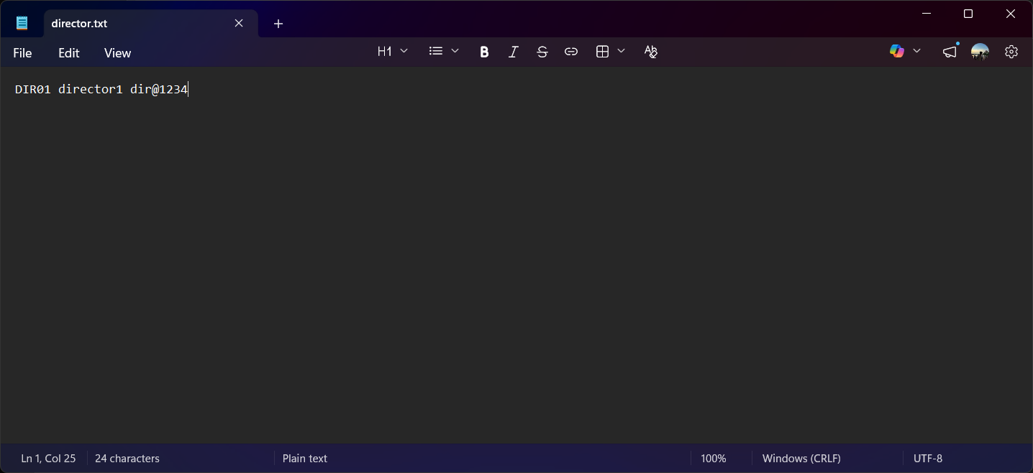
Figure 45 : Director Text File

Admin Text File
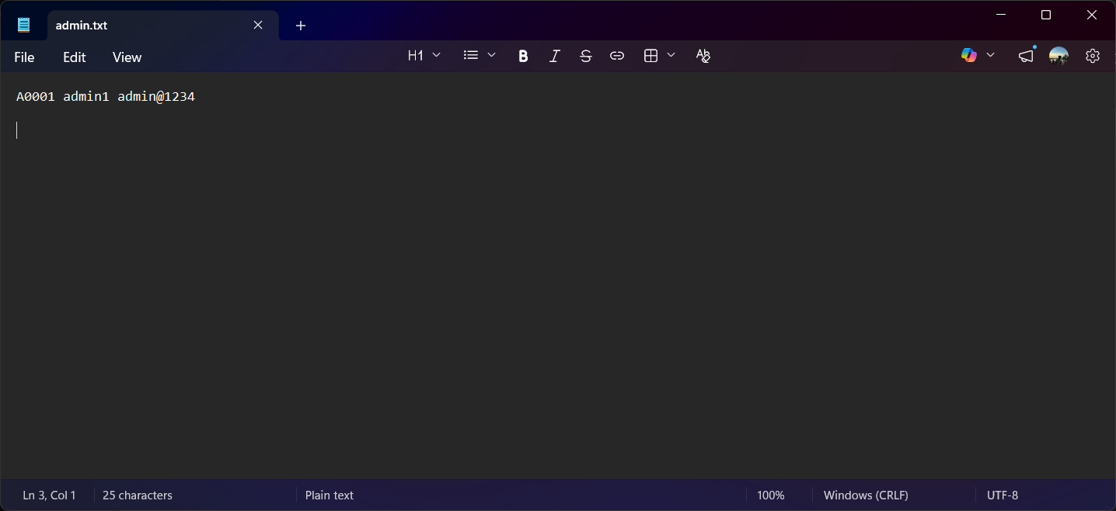
Figure 46 : Admin Text File

Doctor Text File
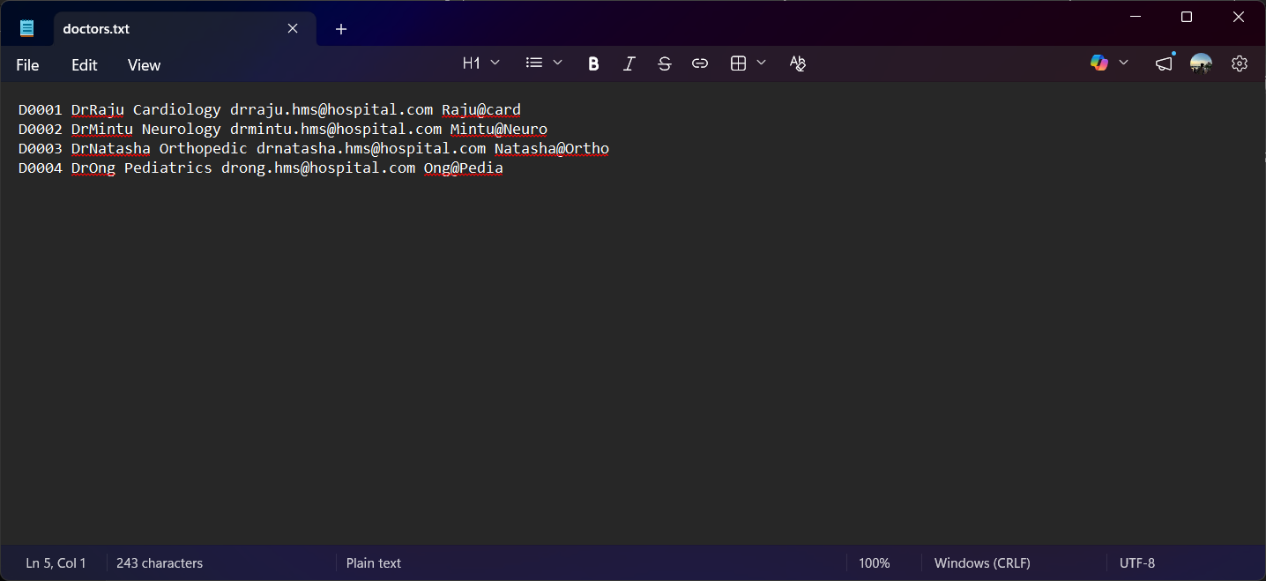
Figure 47 : Doctors Text File

Patients Text File
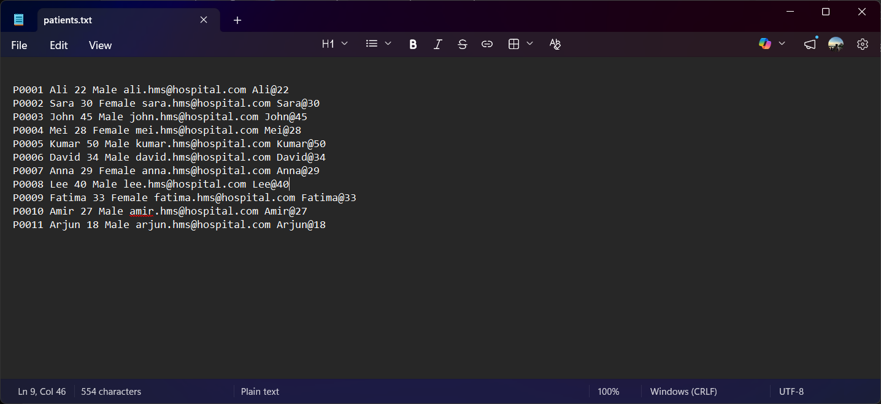
Figure 48 : Patients Text File

Nurse Text File
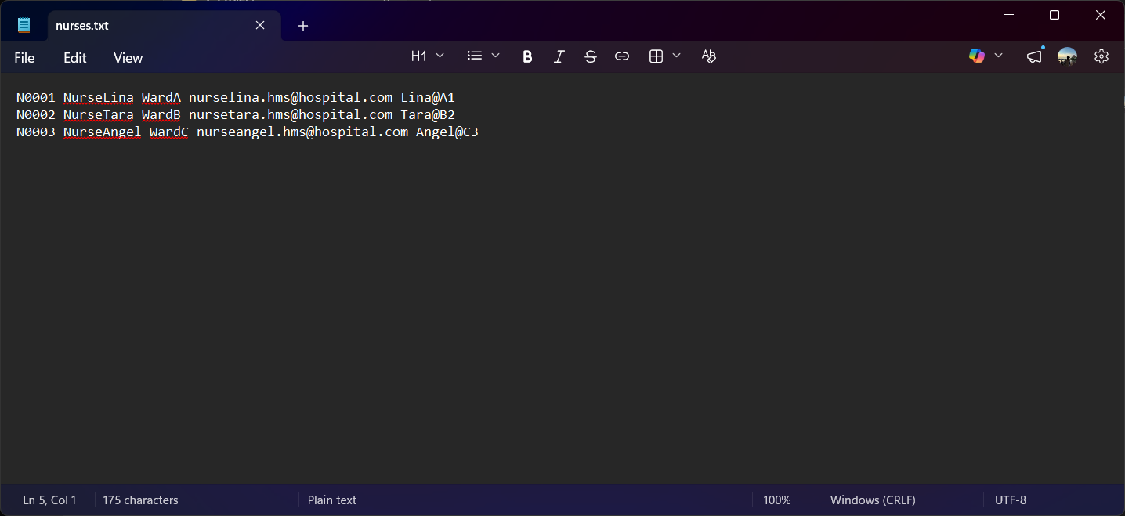
Figure 49 : Nurses Text File

Appointments Text File
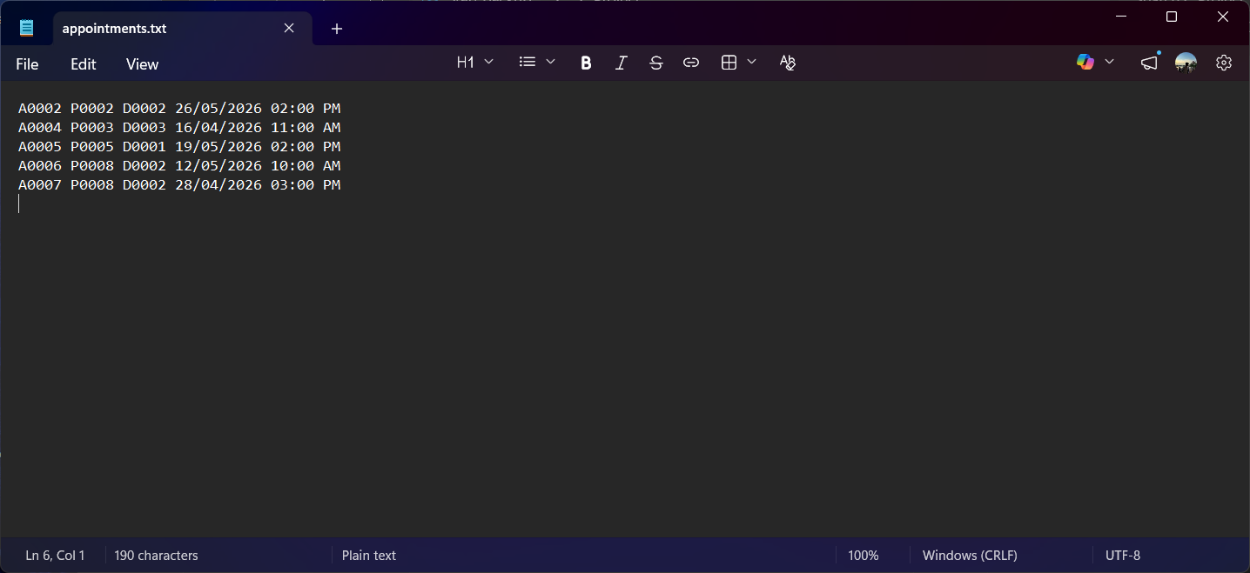
Figure 50 : Appointment Text File

Inventory Text File
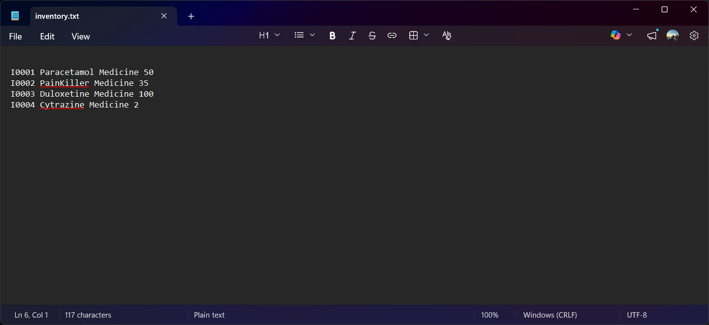
Figure 51 : Inventory Text File

Medical Records Text File
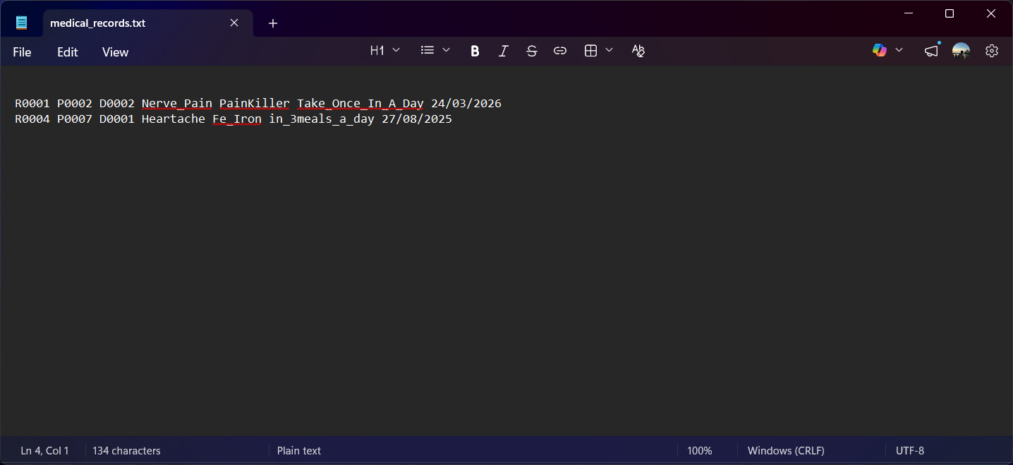
Figure 52 : Medical Records Text File

Billing Text File
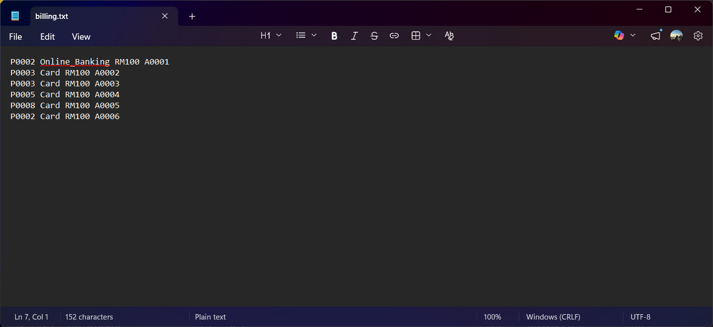
Figure 53 : Billing Text File

Runtime Operation
Director login
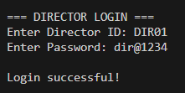
Figure 54 : Director Login

Director menu
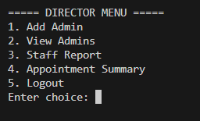
Figure 55 : Director Menu

Add Admin
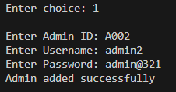
Figure 56 : Add Admin

View Admin
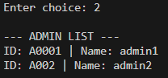
Figure 57 : View Admin

Staff Report
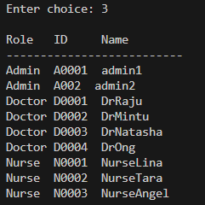
Figure 58 : Staff Report

Appointment Summary
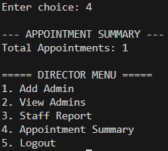
Figure 59 : Appointment Summary
Logout:
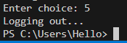
Figure 60 : Director Logout

Admin Login
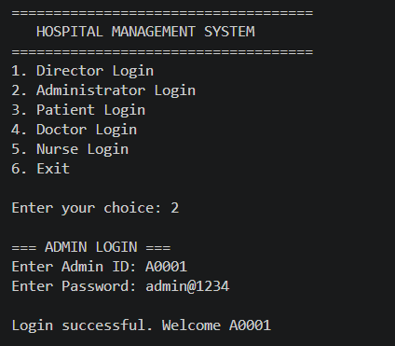
Figure 61 : Admin Login

Patient Registered
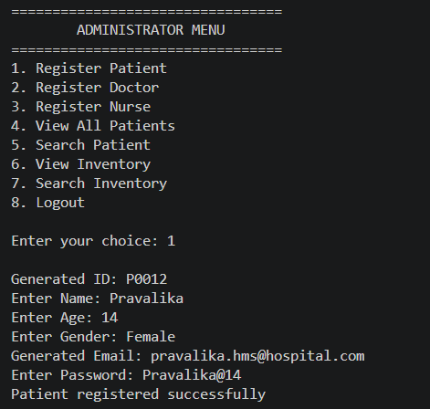
Figure 62 : Patient Registered

Doctor Registered
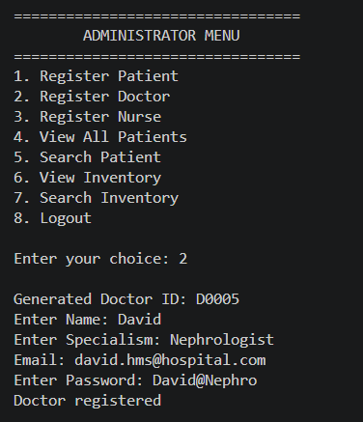
Figure 63 : Doctor Registered
Nurse Registered
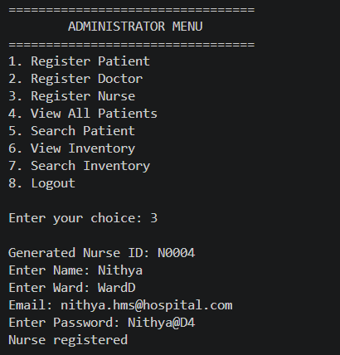
Figure 64 : Nurse Registered

View All Patients
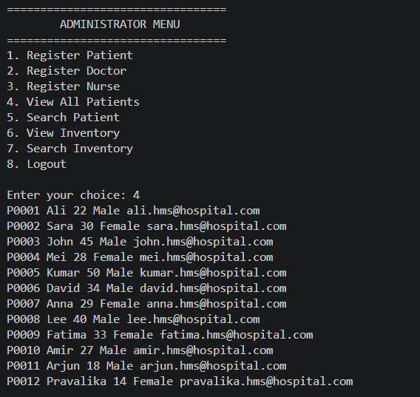
Figure 65 : View All Patients
Search Patient
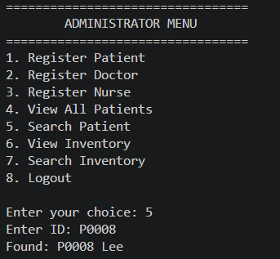
Figure 66 : Search Patient

View Inventory
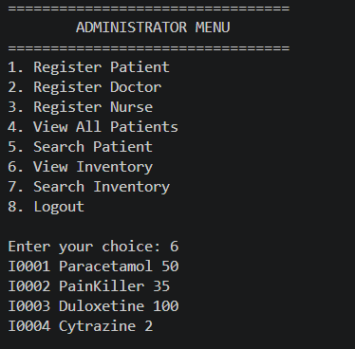
Figure 67 : View Inventory

Search Inventory
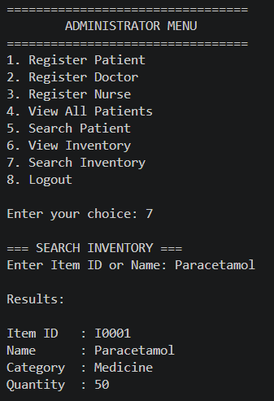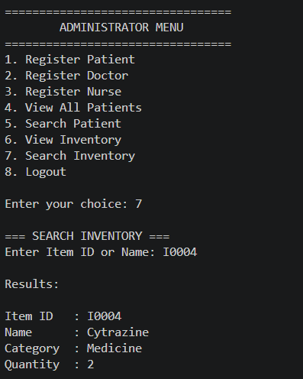
Figure 68 : Search Inventory

Logging out of the system
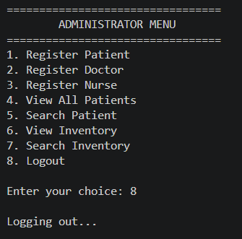
Figure 69 : Logging out of the system

Exiting System
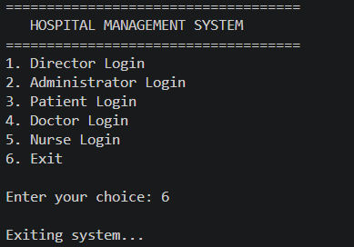
Figure 70 : Exiting System

Doctor login
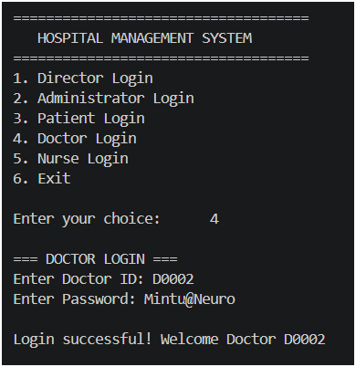
Figure 71 : Doctor login

Doctor Menu
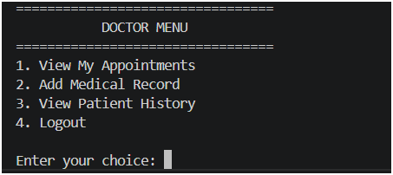
Figure 72 : Doctor Menu

Add medical records
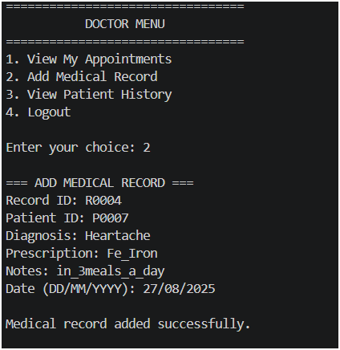
Figure 73 : Add medical records

View Appointments
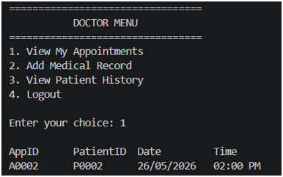
Figure 74 : View Appointments

View Patient History
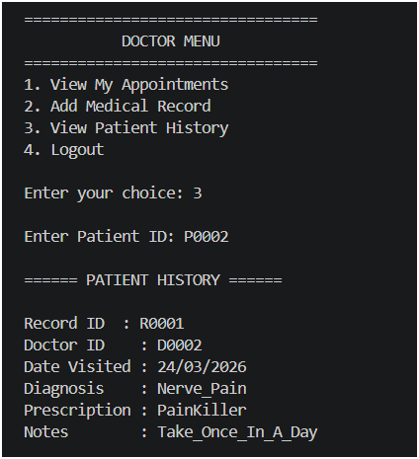
Figure 75 : View Patient History
Nurse Login
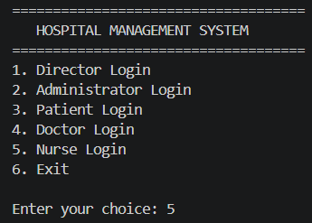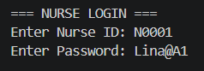
Figure 76 : Nurse Login

View Doctor Schedule
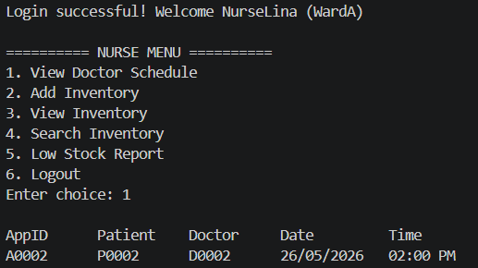
Figure 77 : View Doctor Schedule

Add Inventory
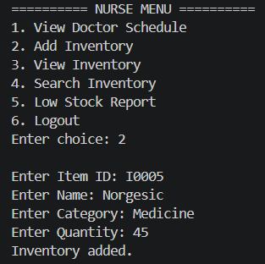
Figure 78 : Add Inventory

View Inventory
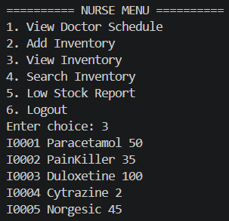
Figure 79 : View Inventory

Search Inventory
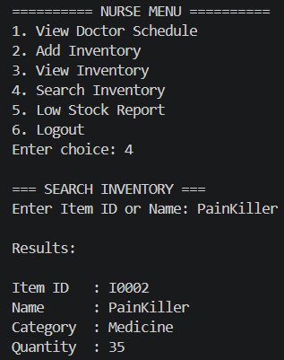
Figure 80 : Search Inventory

Low Stock Report
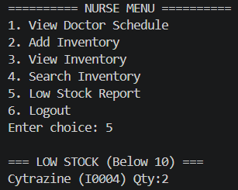
Figure 81 : Low Stock Report

Logging Out Nurse Menu
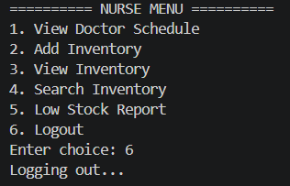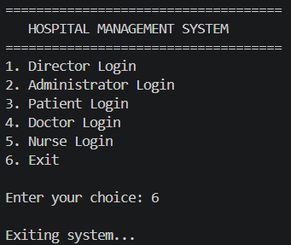
Figure 82 : Logging Out Nurse Menu

Patient Login
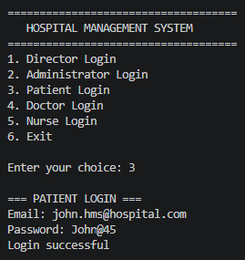
Figure 83 : Patient Login

Booking Appointments
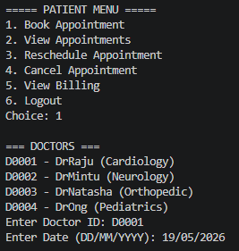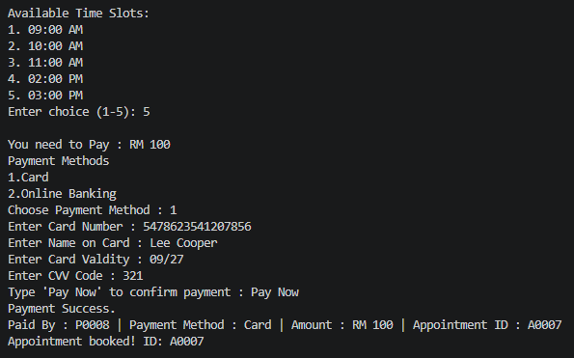
Figure 84 : Booking Appointments

View Appointments
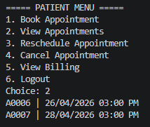
Figure 85 : View Appointments

Reschedule Appointments
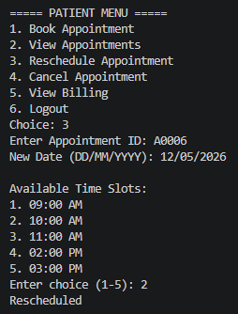
Figure 86 : Reschedule Appointments

Cancel Appointments
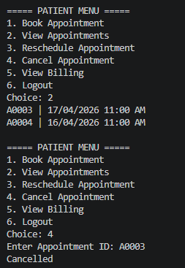
Figure 87 : Cancel Appointments

View Billing
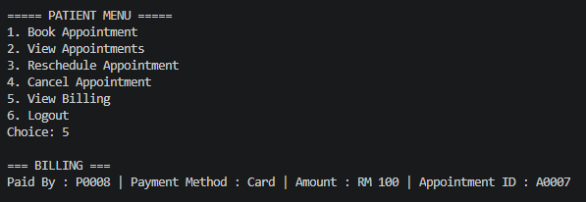
Figure 88 : View Billing

Patient Logout
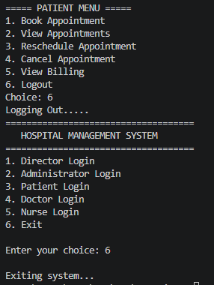
Figure 89 : Patient Logout

Assumptions of System Developed
User Roles Are Predefined
- The system supports five distinct roles: Director, Administrator, Doctor, Nurse, and Patient.
- Each role has its own login credentials stored in text files.
- Role-specific menus ensure separation of responsibilities and controlled access.
File-Based Data Storage
- All records (users, appointments, billing, inventory, medical records) are stored in plain text files (.txt).
- Temporary files are used for safe updates during rescheduling or cancellations.
- No external database or cloud storage is assumed, as per QP requirements.
Unique Identifiers
- Each role has a unique ID (di_id, a_id, do_id, n_id, p_id).
- Appointment IDs (appID) and Medical Record IDs (recordID) are auto generated and unique.
- Patient login is based on generated email addresses, while staff logins use assigned IDs.
Authentication and Access
- Login validation is performed against stored IDs and passwords in text files.
- Patients can only access their own appointments, billing, and medical history.
- Doctors and nurses can only access records relevant to their role.
Appointment Scheduling
- Dates must follow the DD/MM/YYYY format and are validated as future dates.
- Time slots are fixed (09:00 AM, 10:00 AM, 11:00 AM, 02:00 PM, 03:00 PM).
- A doctor cannot have overlapping appointments at the same date and time.
- Patients can book, view, reschedule, and cancel appointments independently.
Billing and Payment
- Each appointment has a fixed fee (RM 100).
- Payment methods are limited to Card and Online Banking.
- Payment retries are limited to three attempts before termination.
- Billing records are cumulative and linked to appointment IDs.
Medical Records (EHR)
- Doctors can add medical records after consultations, including diagnosis, prescription, notes, and date.
- Patients can view their medical history but cannot modify it.
- Records are stored in medical_records.txt and linked to patient IDs.
Inventory Management
- Nurses add inventory items (ID, name, category, quantity).
- Administrators can view and search inventory but cannot add items.
- Low stock reports are generated for items below a threshold (e.g., <10).
Error Handling and Validation
- Invalid inputs (wrong slot, wrong option, invalid ID) trigger error messages.
- Missing files (e.g., appointments.txt, doctors.txt) are handled gracefully with error prompts.
- Payment attempts are limited to three before the system terminates the process.
System Scope
- The system is console-based, menu-driven, and operates in a single-user environment.
- No real-time concurrency or multi-user sessions are supported.
- Input/output is text-based with no graphical interface, as per QP requirements.
Audit and Reporting
- Directors can view staff reports and appointment trends.
- Nurses can generate low-stock inventory reports.
- Appointment and billing records are cumulative, with cancellations removing associated entries.

Advantages of System Developed
Multi-Role Access Control
- The system supports five distinct roles: Director, Administrator, Doctor, Nurse, and Patient.
- Each role has its own login function and menu, ensuring clear separation of responsibilities and secure access.
Automated ID Generation
- Patients, doctors, nurses, and appointments are assigned auto-generated unique IDs (P0001, D0001, N0001, A0001).
- This prevents duplication and ensures traceability across records.
Patient-Centered Features
- Patients can book, view, reschedule, and cancel appointments.
- Billing is integrated directly into appointment booking, with payment options (Card or Online Banking).
- Patients log in using generated hospital emails, adding realism to the system.
Nurse and Inventory Management
- Nurses can add inventory items (supplies, medications) and generate low stock reports.
- They can view doctor schedules to assist patients.
- Inventory search and view functions improve resource tracking.
Administrative Oversight
- Administrators can register patients, doctors, and nurses.
- They can view and search patient records and monitor inventory.
- Directors can add admins, view staff reports, and track appointment trends.
File-Based Storage and Reporting
- All data (users, appointments, billing, inventory, medical records) is stored in text files, making the system lightweight and portable.
- Reports (staff lists, appointment summaries, low-stock inventory) are generated directly from stored data.

Error Handling and Validation
- Input buffer clearing prevents errors during payment option selection.
- Appointment booking validates future dates and checks for doctor availability to avoid conflicts.
- Payment attempts are limited to three retries, reducing misuse.
Modular and Scalable Design
- Functions are modular (bookAppointment(), viewBilling(), addMedicalRecord(), etc.), making the system easy to maintain and extend.
- Additional features (new payment methods, advanced reporting) can be integrated without major redesign.
User-Friendly Console Interface
- Menu-driven navigation for each role simplifies usage.
- Clear prompts and structured outputs make the system accessible to non-technical users.

Discussion and Conclusion
The Hospital Management System developed in this project demonstrates the practical implementation of a multi-role, file-based application designed to support essential healthcare operations. The system effectively integrates different user roles, allowing each module to perform specific tasks while contributing to the overall workflow. This structured approach improves clarity in system design and ensures that responsibilities are clearly distributed.
However, the system has certain limitations. The reliance on text files for data storage may not be suitable for large-scale applications. Additionally, the lack of a graphical user interface may limit usability for non-technical users. Advanced functionalities such as real-time scheduling, database integration, and enhanced security mechanisms are not included in the current implementation.
In conclusion, the system successfully demonstrates how a structured and modular approach can be used to manage hospital operations efficiently. It provides a functional solution that improves organization, reduces errors, and supports better data management. Although there are areas for improvement, the project establishes a strong foundation for further development and highlights the potential of software solutions in enhancing healthcare management systems.

