**Questsion:1**

**CODE:**

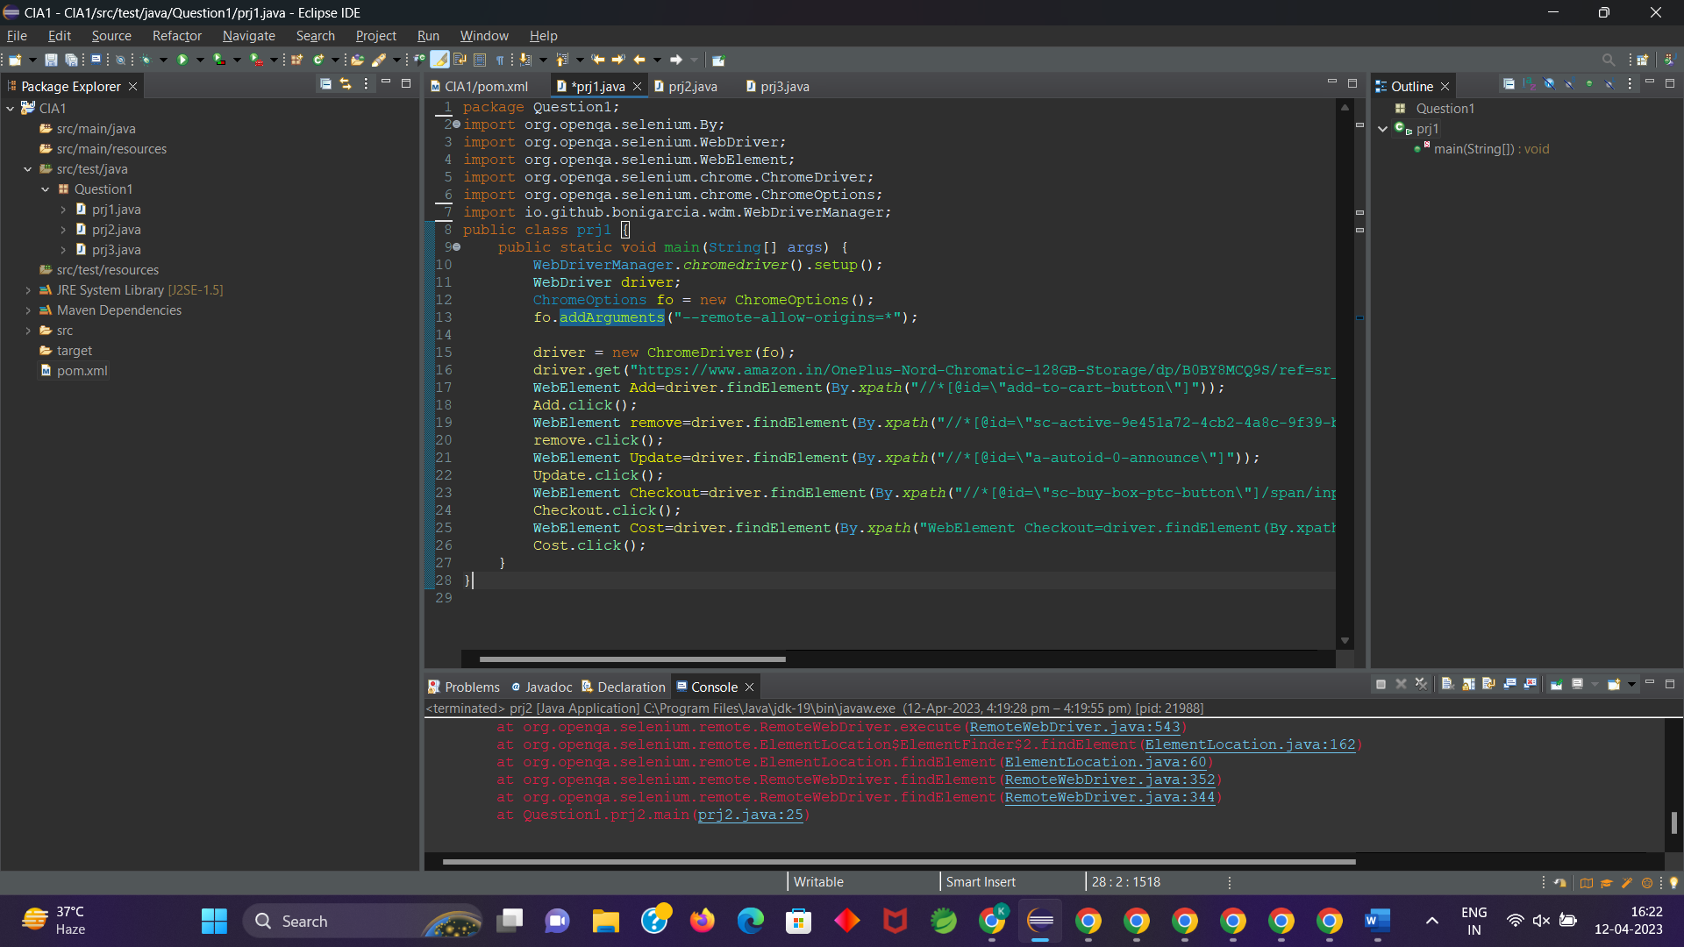

**OUTPUT:**

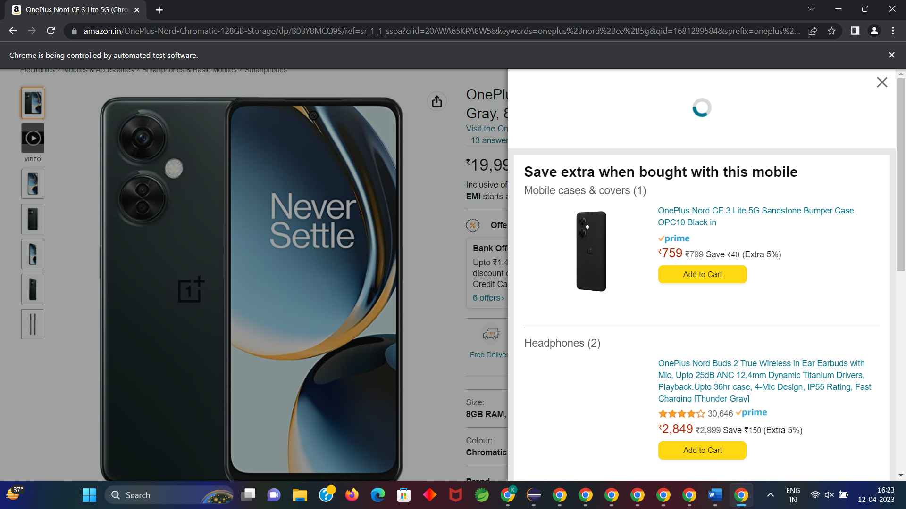

**Question:2:**

**CODE:**

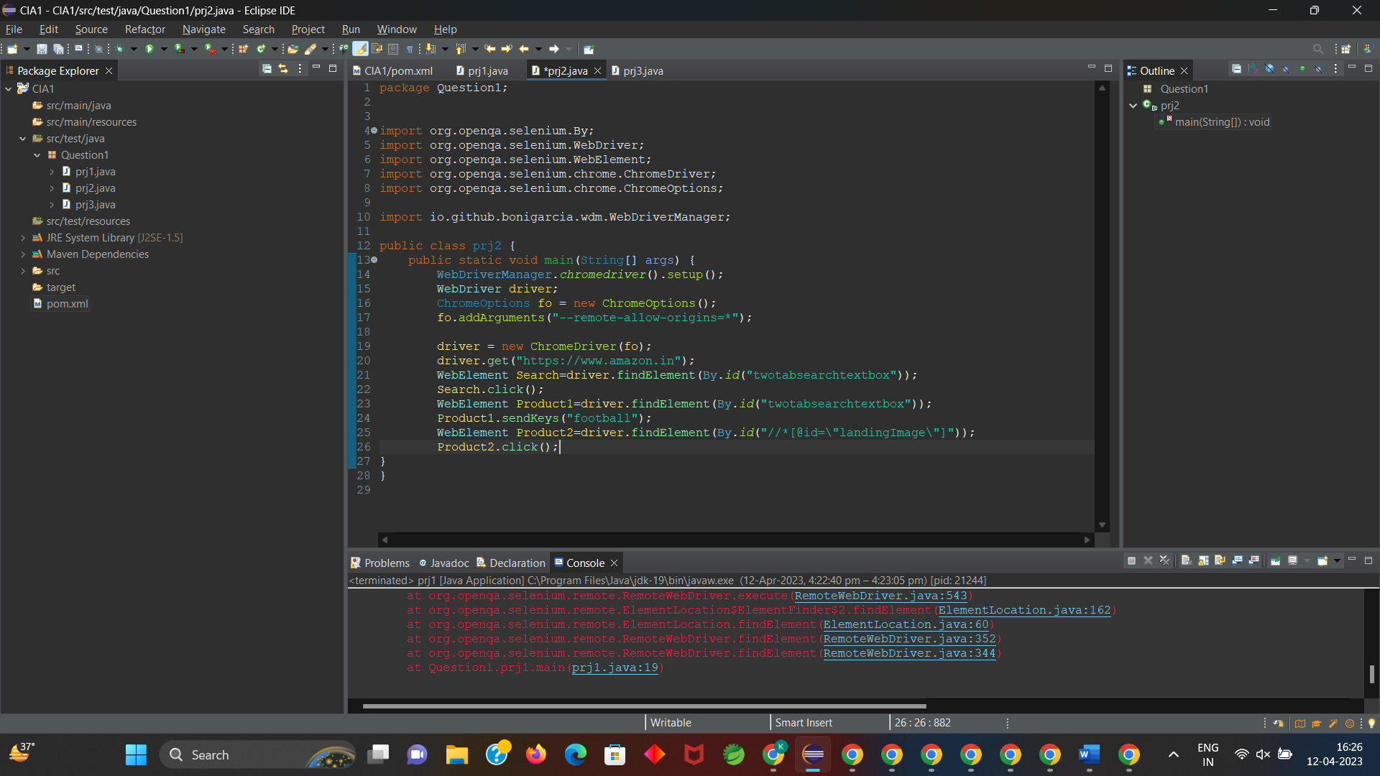

**OUTPUT:**

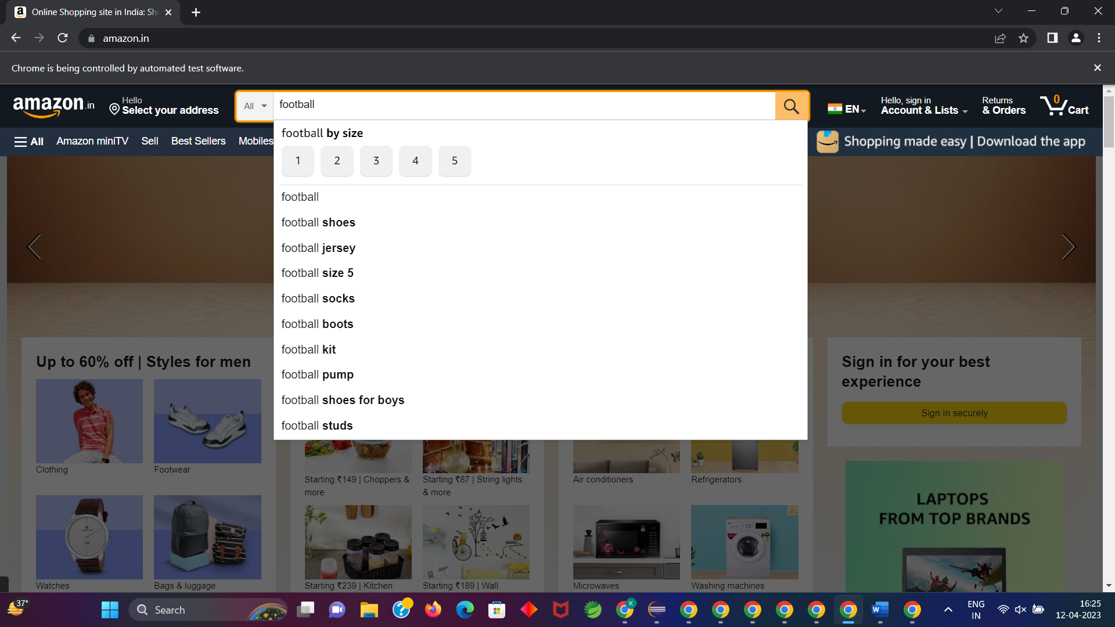

**QUESTION:3**

**CODE:**

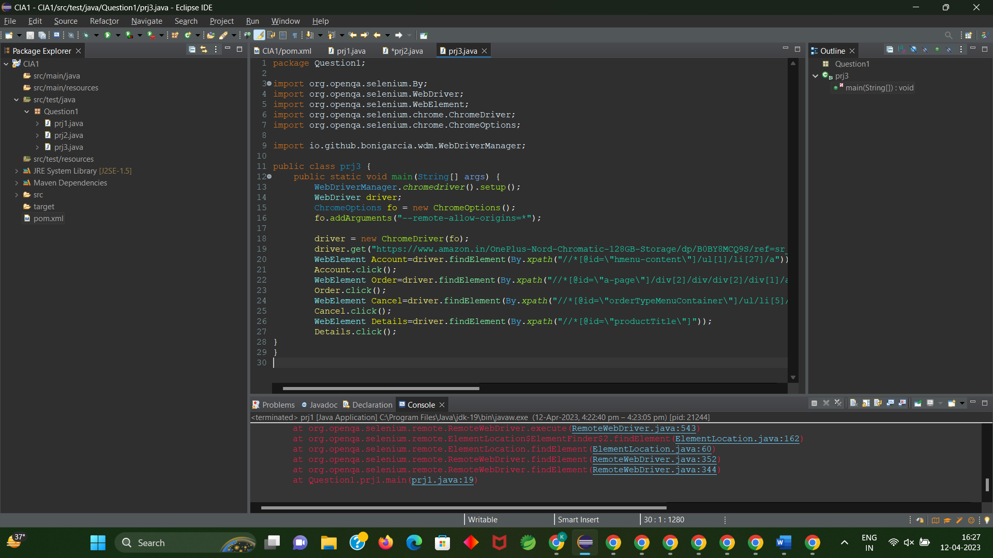

**OUTPUT:**

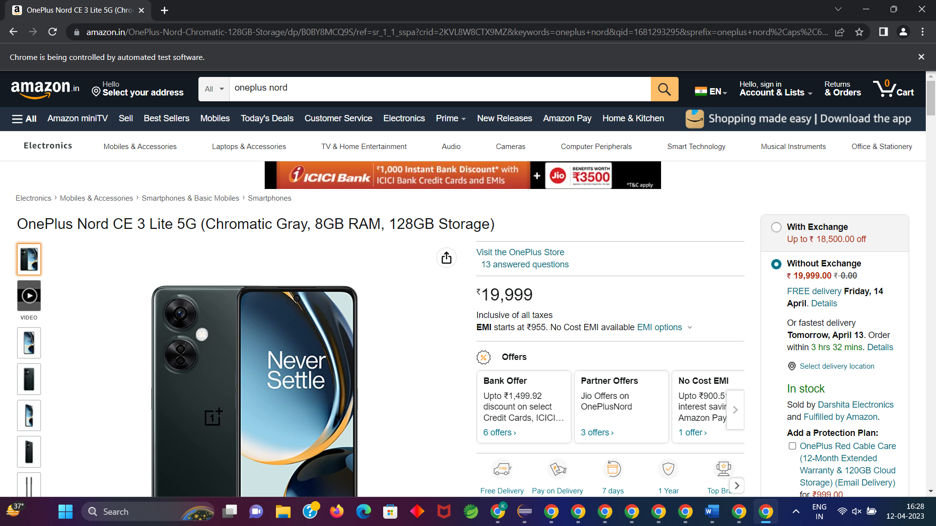

CC1:

OUESTION1:

CODE:

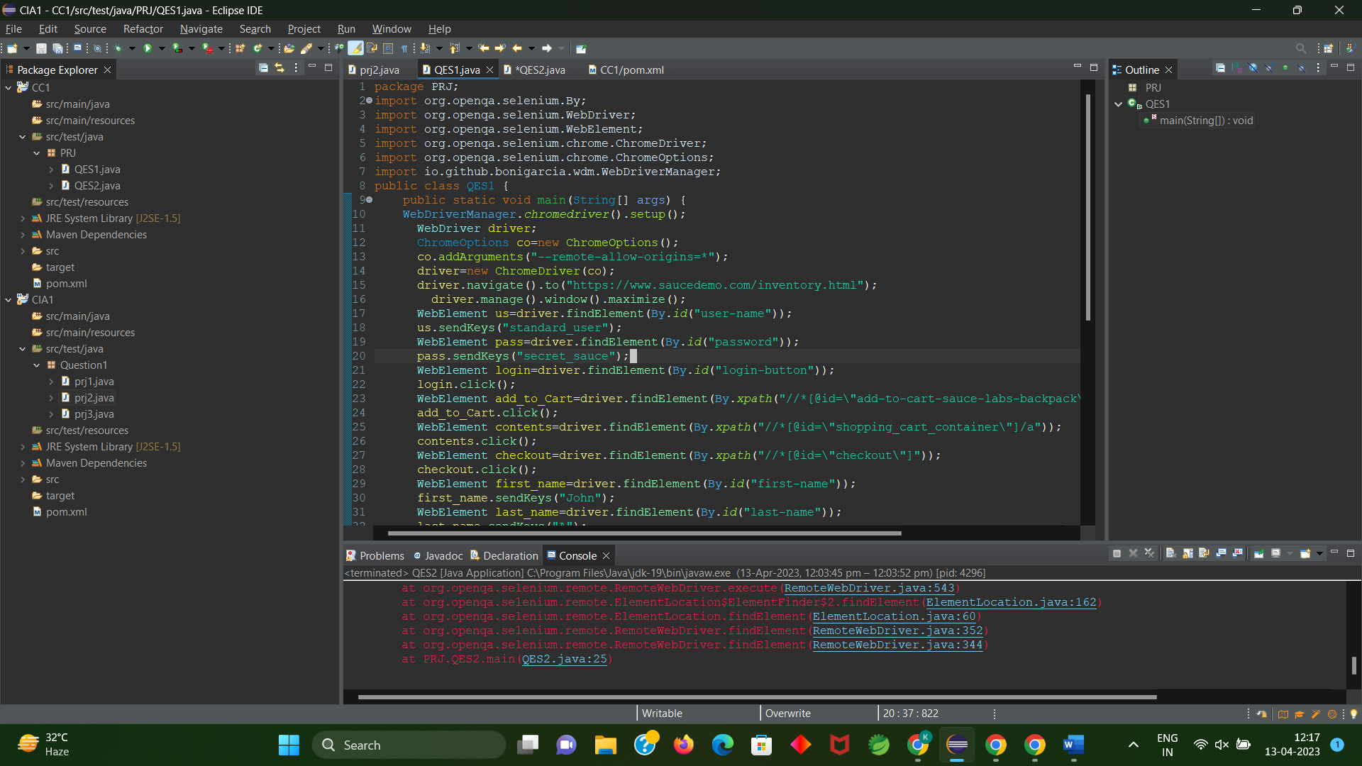

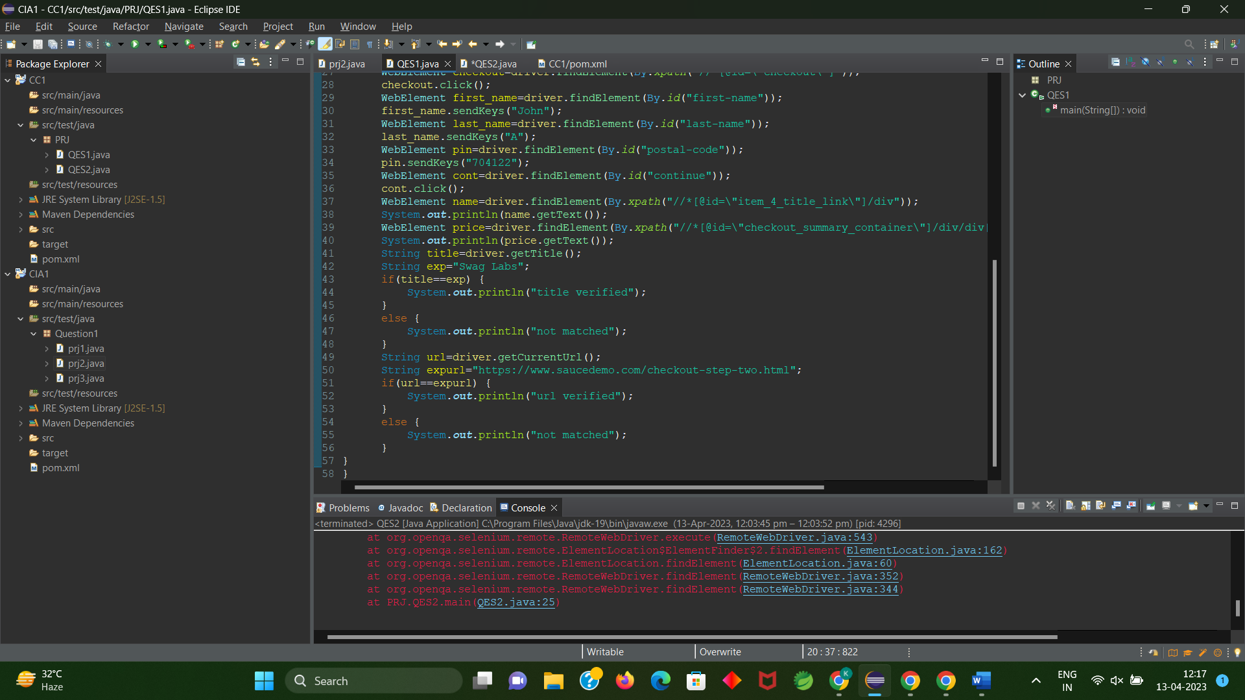

OUTPUT:

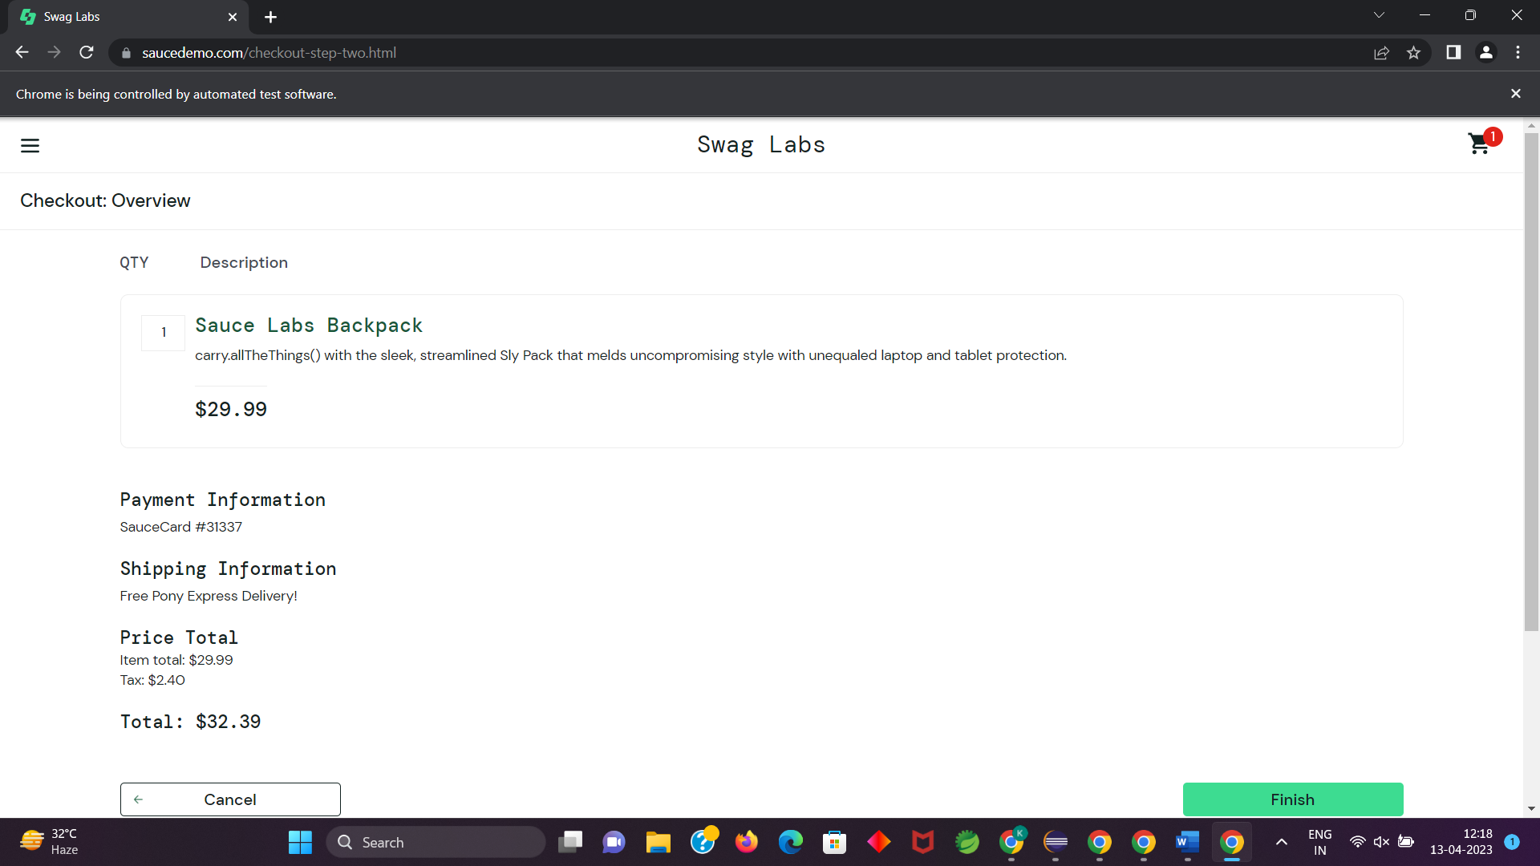

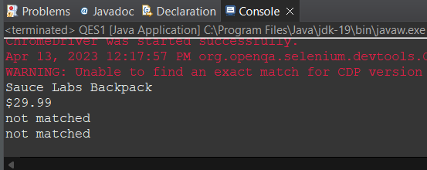

QUESTION2:

CODE:

package com.demo.Demo;

import org.openqa.selenium.By;

import org.openqa.selenium.WebDriver;

import org.openqa.selenium.WebElement;

import org.openqa.selenium.firefox.FirefoxDriver;

import org.openqa.selenium.support.ui.Select;

import io.github.bonigarcia.wdm.WebDriverManager;

public class task2 {

public static void main( String[] args ) throws InterruptedException

{

WebDriverManager.*firefoxdriver*().setup();

WebDriver driver = new FirefoxDriver();

driver.manage().window().maximize();

driver.navigate().to("https://www.saucedemo.com/");

driver.manage().window().maximize();

WebElement txtBoxl=driver.findElement(By.*xpath*("//*[@id=\"user-name\"]"));

txtBoxl.sendKeys("standard_user");

WebElement txtBox2=driver.findElement(By.*xpath*("//*[@id=\"password\"]"));

txtBox2.sendKeys("secret_sauce");

driver.findElement(By.*xpath*("//*[@id=\"login-button\"]")).click();

String txt1=driver.findElement(By.*xpath*("//*[@id=\"item_4_title_link\"]/div")).getText();

System.***out***.println(txt1);

driver.findElement(By.*xpath*("//*[@id=\"header_container\"]/div[2]/div/span/select")).click();

driver.findElement(By.*xpath*("//*[@id=\"header_container\"]/div[2]/div/span/select/option[2]")).click();

String txt2=driver.findElement(By.*xpath*("//*[@id=\"item_3_title_link\"]/div")).getText();

System.***out***.println(txt2);

driver.findElement(By.*xpath*("//*[@id=\"header_container\"]/div[2]/div/span/select")).click();

driver.findElement(By.*xpath*("//*[@id=\"header_container\"]/div[2]/div/span/select/option[3]")).click();

String txt3=driver.findElement(By.*xpath*("//*[@id=\"item_2_title_link\"]/div")).getText();

System.***out***.println(txt3);

driver.findElement(By.*xpath*("//*[@id=\"header_container\"]/div[2]/div/span/select")).click();

driver.findElement(By.*xpath*("//*[@id=\"header_container\"]/div[2]/div/span/select/option[4]")).click();

String txt4=driver.findElement(By.*xpath*("//*[@id=\"item_5_title_link\"]/div")).getText();

System.***out***.println(txt4);

Thread.*sleep*(5000);

}

}

OUTPUT:

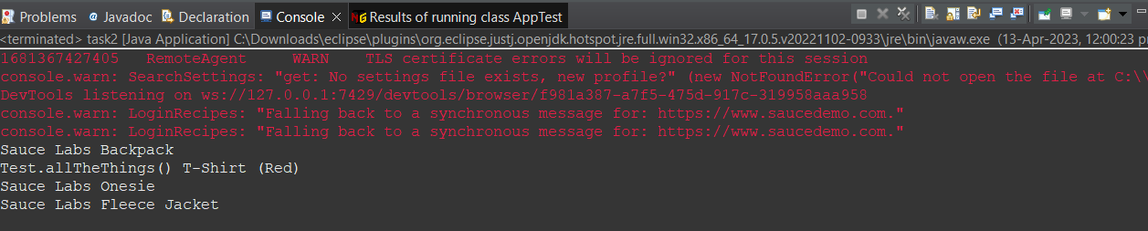

**Questsion:1**

**CODE:**



**OUTPUT:**



**Question:2:**

**CODE:**



**OUTPUT:**



**QUESTION:3**

**CODE:**



**OUTPUT:**



CC2:

QES1:

PROGRAM:

package SP1;

import org.openqa.selenium.By;

import org.openqa.selenium.WebDriver;

import org.openqa.selenium.chrome.ChromeDriver;

import org.openqa.selenium.chrome.ChromeOptions;

import org.testng.annotations.Test;

import io.github.bonigarcia.wdm.WebDriverManager;

public class EX1 {

WebDriver d;

@Test

public void f() throws InterruptedException {

ChromeOptions co=new ChromeOptions();

co.addArguments("--remote-allow-origins=*");

WebDriverManager.chromedriver().setup();

d=new ChromeDriver(co);

d.get("https://www.yatra.com/flights");

d.manage().window().maximize();

Thread.sleep(4000);

d.findElement(By.xpath("//*[@id=\"booking_engine_flights\"]")).click();

Thread.sleep(2000);

d.findElement(By.xpath("//*[@id=\"BE_flight_form_wrapper\"]/div[1]/div[1]/ul[1]/li[2]/a")).click();

Thread.sleep(2000);

d.findElement(By.xpath("//*[@id=\"BE_flight_origin_city\"]")).click();

Thread.sleep(2000);

d.findElement(By.xpath("//*[@id=\"BE_flight_form_wrapper\"]/div[1]/div[2]/ul/li[1]/ul/li[1]/div/div/ul/div/div/div/li[3]")).click();

Thread.sleep(2000);

d.findElement(By.xpath("//*[@id=\"BE_flight_form_wrapper\"]/div[1]/div[2]/ul/li[1]/ul/li[3]/div/div/ul/div/div/div/li[4]")).click();

Thread.sleep(2000);

d.findElement(By.xpath("//*[@id=\"BE_flight_origin_date\"]")).click();

Thread.sleep(2000);

d.findElement(By.xpath("//*[@id=\"20/04/2023\"]")).click();

Thread.sleep(2000);

d.findElement(By.xpath("//*[@id=\"BE_flight_arrival_date\"]")).click();

Thread.sleep(2000);

d.findElement(By.xpath("//*[@id=\"24/04/2023\"]")).click();

Thread.sleep(2000);

d.findElement(By.xpath("//*[@id=\"BE_flight_paxInfoBox\"]/i")).click();

Thread.sleep(2000);

d.findElement(By.xpath("//*[@id=\"BE_flight_passengerBox\"]/div[1]/div[1]/div/div/span[2]")).click();

Thread.sleep(2000);

d.findElement(By.xpath("//*[@id=\"flight_class_select_child\"]/ul/li[3]")).click();

Thread.sleep(2000);

d.findElement(By.xpath("//*[@id=\"BE_flight_form_wrapper\"]/div[3]/div[1]/div[1]/a/i")).click();

Thread.sleep(2000);

d.findElement(By.xpath("//*[@id=\"BE_flight_flsearch_btn\"]")).click();

}

}

OUTPUT:

