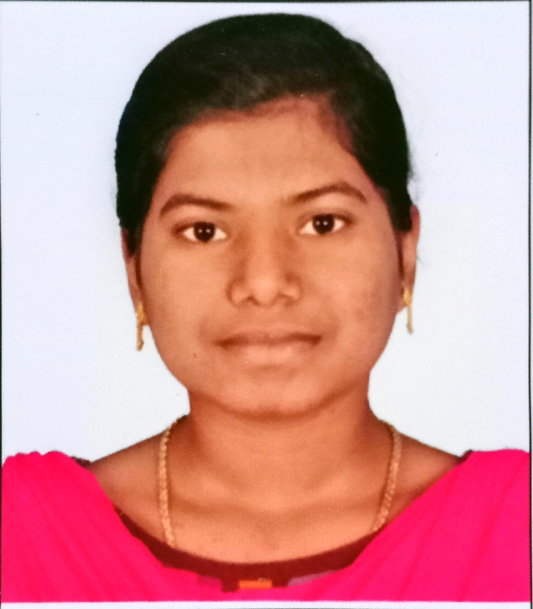 **RESUME**

**S. KIRUBA ANUSHYA**

D/O P. SELVARAJ,

12/17 , C.S.I. Church Street,

Alwanthulukkapatti,

Alangulam (TK),

Tenkasi (DT) – 627851.

EMAIL ID : [kirubaanushyas@gmail.com](mailto:kirubaanushyas@gmail.com)

MOBILE NO : 7010382061 / 9597949488

**OBJECTIVE :**

Seeking a challenging position in a reputed organization where I can learn new skills, expand my knowledge ,and leverage my Learnings.

**EDUCATIONAL CREDENTIALS :**

* SSLC 75.8% (2019)
* HSC 79.8% (2021)
* Bachelor of Computer science (2nd year)

(Government Arts and Science College for Women, Alangulam

* Hindi : PRATHAMIC
* Course : PGDCA

**KEY STRENGTH :**

* Improving own learning and performance.
* Good Communication Skill.
* Flexibility in Adapting New Things.
* Good creative skill.

**PERSONAL DETAILS. :**

Father’s Name : P.Selvaraj

Date of Birth : 3rd September 2003

Gender : Female

Marital Status : Unmarried

Nationality : Indian

Religion : Christian

Languages Known : Tamil & English

Extra curricular activities : Reading, Coding, Yoga , Writing

**DECLARATION :**

I hereby declare that all the details given below are true to the best of my knowledge and belief.

Place : Alwanthulukkapatti Signature

Date : 17 Mar 2023 ( S.Kiruba Anushya )