IoT-Enabled Automated Coal Transport Train System
Comprehensive Technical Design, Firmware Architecture, State Machine Algorithms & Web Telemetry Specification
Author: Kirubai (Kirubai Technologies)
Microcontroller: ESP32 Dual-Core (Tensilica LX6 @ 240MHz) | Firmware: ESP32_WiFi_Control.ino
Network Architecture: Wi-Fi Station Mode | REST API | Embedded Mobile Web Dashboard | mDNS Responder
1. Abstract
Modern heavy mineral logistics and industrial mining facilities require robust, highly dependable, and autonomous material transport systems to minimize personnel exposure to hazardous environments, eliminate human operating errors, and streamline bulk transport throughput. This report presents the end-to-end design, implementation, and algorithmic validation of an IoT-enabled Autonomous Coal Transport Train Prototype driven by an Espressif ESP32 dual-core microcontroller.
The automated system integrates dual high-frequency HC-SR04 ultrasonic rangefinders for millimeter-level docking detection at both the Mining Supply Pit and the Power Generation Unloading Terminal. Traction propulsion is modulated through an L298N Dual H-Bridge driver utilizing 8-bit Pulse Width Modulation (PWM) with configurable minimum stall-prevention thresholds. Gate release and cargo discharge are governed by an SG90 micro-servo motor operating on a dedicated 50 Hz PWM hardware channel. A deterministic 12-state Finite State Machine (FSM) executes the complete mission lifecycle: reversing into the mine, pausing for a 10.0-second bulk loading cycle, traversing the railway, docking at the unloader, holding for a 3.0-second stabilization window, opening the discharge gate to 60° for 6.0 seconds, re-closing to 90°, and entering complete status. Simultaneously, the firmware hosts an embedded asynchronous HTTP web server on Port 80 with mDNS resolution (coal-train.local) and RESTful JSON endpoints, enabling real-time wireless telemetry, kinematics modeling, and interactive manual override via a mobile-optimized web dashboard.
2. Introduction & Background
Rail-bound haulage remains the most energy-efficient mechanism for bulk solids and mineral conveyance across terrestrial terrain. However, legacy industrial railway operations within mining pits, thermal power generation plants, and port loading docks rely heavily on manual human dispatch and physical oversight. In underground and open-cast coal handling facilities, manual operations present significant hazards, including coal dust inhalation, rail collisions, track derailments, and irregular loading intervals that cause logistical bottlenecks.
The primary objective of this project is to implement an intelligent, closed-loop automated train system capable of self-governing the entire material transit cycle while streaming telemetry to remote plant operators over local wireless networks. Key project goals include:
- Autonomous Closed-Loop Transit: Eliminating manual driver requirements via ultrasonic spatial landmark sensing at terminal stations.
- Obstacle & Station Docking Accuracy: Continuous non-contact distance monitoring (<= 5.0 cm threshold) with multi-sample verification filtering to suppress false acoustic triggers.
- Precision Actuation: Reliable motorized gate opening (60°) and locking (90°) using dedicated hardware PWM without mechanical jamming.
- Wireless Connectivity & Industry 4.0 Telemetry: Embedding a complete web server inside the microcontroller to provide browser-based real-time telemetry, track position simulation, and REST API commands without requiring external cloud servers.
- Fail-Safe Manual Override: Providing instantaneous emergency stops, speed adjustments (70 to 255 PWM), pause/resume memory, and directional jogging via both USB Serial and Wi-Fi.
3. Hardware Specifications & Circuit Architecture
The system architecture combines a high-performance 32-bit microcontroller with rugged motor drivers, ultrasonic transducers, and servo actuation. The figure below illustrates the hardware interconnect topology and power distribution tree.
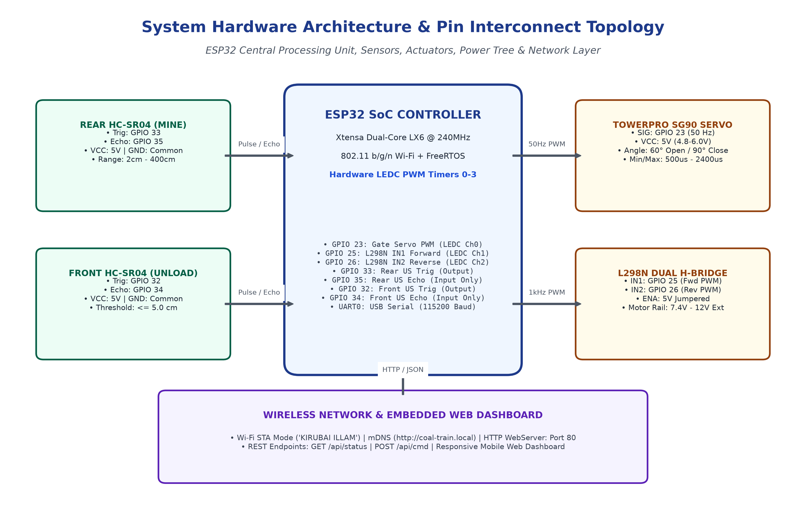
Figure 1: Hardware Interconnect Architecture, Pin Mapping & Network Stack
The complete hardware pin allocation and peripheral assignments are summarized in Table 1 below:
Component | Module Pin | ESP32 Pin | Peripheral Function & Operational Mode
TowerPro SG90 Servo | Signal (Orange) | GPIO 23 | LEDC Channel 0, Hardware Timer 0 (50 Hz, 500-2400us pulse)
TowerPro SG90 Servo | VCC / GND | 5V / GND | Regulated 5V DC supply rail (Requires >= 500mA current)
L298N Motor Driver | IN1 | GPIO 25 | LEDC Channel 1, Hardware Timer 1 (1000 Hz PWM, Forward Direction)
L298N Motor Driver | IN2 | GPIO 26 | LEDC Channel 2, Hardware Timer 1 (1000 Hz PWM, Reverse Direction)
L298N Motor Driver | ENA / ENB | 5V Jumpers | Hardware jumpered high; Speed modulated directly via IN1/IN2 PWM
Rear HC-SR04 (Mine) | TRIG | GPIO 33 | Digital Output (10us ultrasonic pulse generator)
Rear HC-SR04 (Mine) | ECHO | GPIO 35 | Input-Only GPIO (Measures ultrasonic echo time of flight)
Front HC-SR04 (Unload) | TRIG | GPIO 32 | Digital Output (10us ultrasonic pulse generator)
Front HC-SR04 (Unload) | ECHO | GPIO 34 | Input-Only GPIO (Measures ultrasonic echo time of flight)
Serial Interface | TX0 / RX0 | GPIO 1 / 3 | Hardware UART0 @ 115200 Baud, 8-N-1 Serial Diagnostic Terminal

📌 HARDWARE PINOUT SELECTION RATIONALE: In ESP32 hardware architecture, GPIO 34 and GPIO 35 are dedicated input-only pins without internal pull-up or pull-down resistors. They cannot drive digital outputs. This system deliberately pairs GPIO 35 and 34 with the HC-SR04 ECHO inputs, preserving full bidirectional and PWM-capable GPIOs (such as GPIO 23, 25, and 26) for motor and servo actuation.

4. Operational Workflow & State Machine
The automated transport cycle is governed by a deterministic, non-blocking Finite State Machine (FSM). The train alternates between continuous travel, sensor-triggered station recognition, timed stationary phases (bulk coal loading and gravity discharge), and direction reversals. Figure 2 delineates the operational lifecycle.
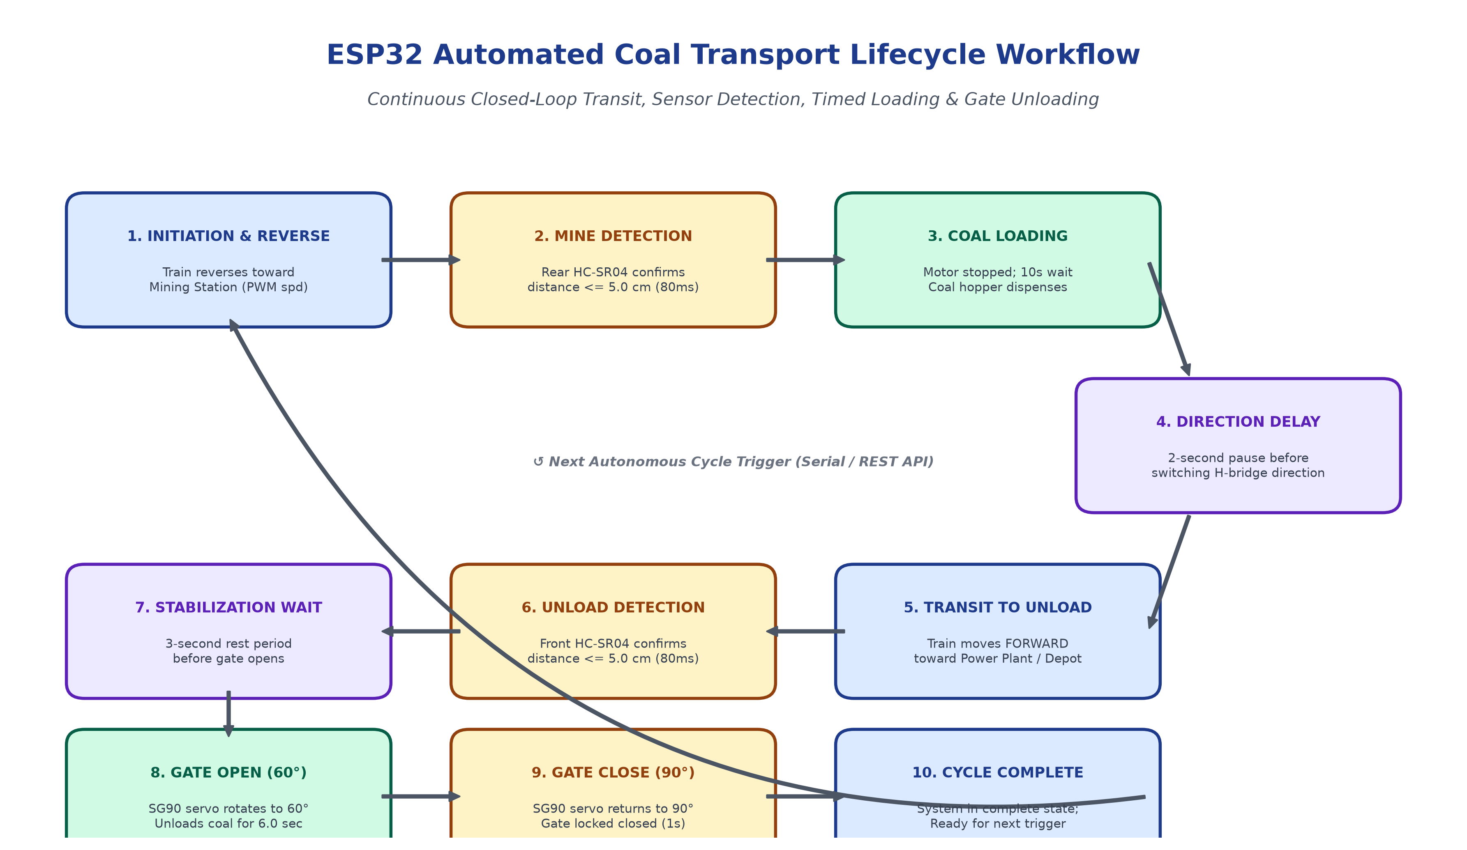
Figure 2: End-to-End Autonomous Coal Transport Operational Lifecycle Workflow
The complete state machine encompasses 12 states, each governed by precise mathematical timing thresholds and sensor confirmation rules:
1. REVERSING_TO_MINE: Train activates L298N IN2 (PWM duty cycle = trainSpeed). Rear ultrasonic sensor actively measures distance. When rear distance <= 5.0 cm and persists for >= 80ms, the motor is stopped immediately and state shifts to LOADING_COAL.
2. LOADING_COAL: Train remains stationary for LOADING_TIME_MS (10,000 ms = 10.0 seconds). This interval models an overhead hopper dispensing bulk coal into the railcar. Progress is computed as (elapsed / 10000) * 100% and streamed to the dashboard.
3. WAITING_TO_MOVE_FORWARD: A mandatory 2,000 ms mechanical stabilization delay is enforced before reversing motor polarity. This prevents high inrush back-EMF currents through the L298N H-bridge transistors and ensures rail stability.
4. MOVING_TO_UNLOADING_AREA: Train activates L298N IN1 (Forward PWM). Front ultrasonic sensor actively pulses. When front distance <= 5.0 cm is confirmed for >= 80ms, the motor brakes to a halt, shifting to WAITING_TO_OPEN_GATE.
5. WAITING_TO_OPEN_GATE: A 3,000 ms settling period allows the train inertia to dissipate completely before hopper gate mechanical actuation begins.
6. UNLOADING_COAL: SG90 servo rotates from 90° (Closed) to 60° (Open). The hopper bottom opens, allowing bulk coal to discharge into the receiving pit. The state holds for UNLOADING_TIME_MS (6,000 ms = 6.0 seconds), linearly decrementing modeled coal level from 100% to 0%.
7. CLOSING_GATE: SG90 servo commands return to GATE_CLOSED_ANGLE (90°). A 1,000 ms window allows physical gate latching.
8. PROJECT_COMPLETE: Cycle terminates successfully. Motors remain powered off, gate remains locked at 90°, and telemetry signals cycle completion. System awaits next trigger.
9. PAUSED: Operator-initiated freeze. Retains elapsed milliseconds in current state. Halts motor PWM immediately. Resuming restores exact state time and direction.
10-12. MANUAL_FORWARD / REVERSE / IDLE: Manual operator override via dashboard D-Pad or Serial commands (F, R, S, O, C) with full speed modulation.
5. Algorithmic Formulations
The embedded firmware is built upon five foundational algorithms that execute concurrently inside the ESP32 main loop without blocking delay loops, ensuring responsive network handling and immediate sensor reaction times.
Algorithm 1: Peripheral Initialization & LEDC Resource Management
To avoid hardware timer resource conflicts between high-frequency motor PWM (1000 Hz) and servo pulse-width modulation (50 Hz), the initialization routine strictly enforces resource segregation across the ESP32 LEDC peripheral:
Algorithm 1: Setup and LEDC Hardware Timer Allocation
Input: SERVO_PIN (23), TRAIN_IN1 (25), TRAIN_IN2 (26), Default Speed (255)
Output: Initialized hardware peripherals without timer collisions
1: Initialize UART0 at 115200 baud
2: ESP32PWM::allocateTimer(0) // Reserve Timer 0 for 50Hz Servo
3: ESP32PWM::allocateTimer(1) // Reserve Timer 1 for 1000Hz Motor PWM
4: ESP32PWM::allocateTimer(2)
5: ESP32PWM::allocateTimer(3)
6: unloadingServo.setPeriodHertz(50)
7: servoChannel <- unloadingServo.attach(SERVO_PIN, 500, 2400) // Bind to LEDC Ch0
8: setGateAngle(GATE_CLOSED_ANGLE = 90°)
9: Execute Startup Calibration Twitch: Gate -> 60° (300ms) -> Gate -> 90° (400ms)
10: Configure REAR_TRIG, FRONT_TRIG as OUTPUT; set LOW
11: Configure REAR_ECHO, FRONT_ECHO as INPUT
12: Configure TRAIN_IN1, TRAIN_IN2 as OUTPUT; set LOW (Do not call analogWrite in setup)
13: Connect Wi-Fi in Station Mode (WIFI_STA); Begin WebServer(80) & MDNS('coal-train')

Algorithm 2: Ultrasonic Rangefinder Timing & Debounce Filtering
Acoustic distance calculation relies on the physical speed of sound in dry air at 20°C (v ≈ 343 m/s = 0.0343 cm/µs). The echo pulse width is converted into distance using the round-trip formula:
Distance (cm) = (Echo Pulse Duration in µs × 0.0343) / 2
To prevent acoustic multipath reflections or transient spikes from falsely halting the train, Algorithm 2 enforces an 80ms confirmation window:
Algorithm 2: Ultrasonic Acquisition and Confirmation Debounce
Input: trigPin, echoPin, DISTANCE_THRESHOLD_CM (5.0 cm), SENSOR_CONFIRM_MS (80 ms)
Output: Boolean targetArrivalConfirmed
1: digitalWrite(trigPin, LOW); delayMicroseconds(2)
2: digitalWrite(trigPin, HIGH); delayMicroseconds(10)
3: digitalWrite(trigPin, LOW)
4: duration <- pulseIn(echoPin, HIGH, timeout = 18000 µs)
5: if duration == 0 or duration > 23300 then
6: distCm <- 999.0 // Out of range or echo lost
7: else
8: distCm <- (duration * 0.0343) / 2.0
9: end if
10: isDetected <- (distCm > 0.5 and distCm <= DISTANCE_THRESHOLD_CM)
11: if isDetected then
12: if not sensorTiming then
13: sensorTiming <- true
14: sensorStartTime <- millis()
15: end if
16: if (millis() - sensorStartTime) >= SENSOR_CONFIRM_MS then
17: sensorTiming <- false
18: return TRUE // Confirmed valid station arrival
19: end if
20: else
21: sensorTiming <- false
22: return FALSE
23: end if

Algorithm 3: Real-Time Kinematics & Payload Telemetry Modeling
To ensure the remote web dashboard renders smooth visual feedback matching physical transit, the firmware computes train position (10% to 88% track scale) and coal inventory level (0% to 100%) dynamically:
Algorithm 3: Track Position Kinematics & Coal Fill Rate Modeling
Input: currentState, trainSpeed, currentTime, lastUpdateTime
Output: trainPosition (10.0% to 88.0%), coalLevel (0% to 100%)
1: dt <- (currentTime - lastUpdateTime) / 1000.0
2: speedRatio <- trainSpeed / 255.0
3: if speedRatio < 0.25 then speedRatio <- 0.25
4: switch currentState do:
5: case REVERSING_TO_MINE:
6: trainPosition <- max(10.0, trainPosition - (14.0 * speedRatio * dt))
7: case LOADING_COAL:
8: trainPosition <- 10.0
9: coalLevel <- clamp((currentTime - stateStartTime) * 100 / 10000, 0, 100)
10: case MOVING_TO_UNLOADING_AREA:
11: trainPosition <- min(88.0, trainPosition + (14.0 * speedRatio * dt))
12: case UNLOADING_COAL:
13: trainPosition <- 88.0
14: coalLevel <- clamp(100 - (currentTime - stateStartTime) * 100 / 6000, 0, 100)
15: case PROJECT_COMPLETE:
16: trainPosition <- 88.0; coalLevel <- 0
17: end switch
18: if rearDetected and inMineZone then trainPosition <- 10.0 // Physical sensor snap
19: if frontDetected and inUnloadZone then trainPosition <- 88.0 // Physical sensor snap

6. Detailed Flowchart Representation
Figure 3 presents the master decision flowchart governing microcontroller boot, Wi-Fi initialization, sensor interrogation, mode arbitration (Automatic vs Manual), and FSM state progression.
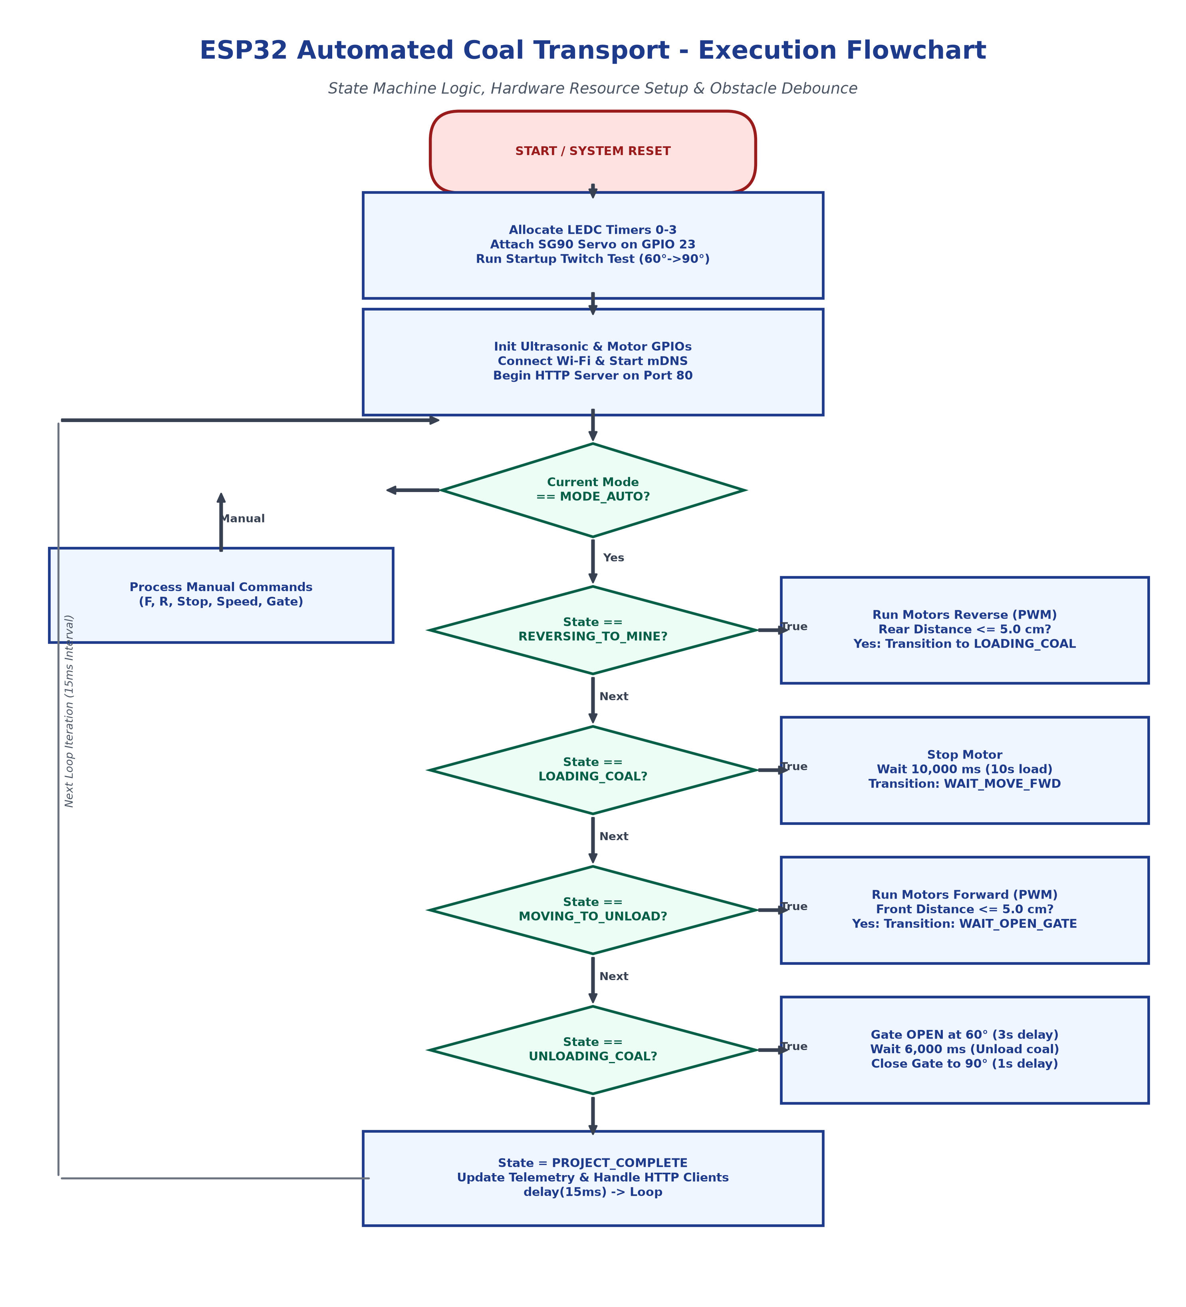
Figure 3: Detailed Algorithmic Execution Flowchart of the ESP32 Coal Train Controller
7. Firmware Implementation & Critical Technical Insights
A critical engineering challenge resolved in this firmware was the low-level hardware resource conflict inside the ESP32 LEDC (LED Control) peripheral. Understanding this architectural fix is essential for anyone maintaining or replicating ESP32 multi-actuator robotics projects.
The LEDC Timer / Channel Collision Problem
In Arduino ESP32 Core versions 3.0.0 and newer (such as Core v3.3.12 utilized here), the standard analogWrite() function no longer uses a standalone software timer. Instead, it dynamically attaches to the ESP32's hardware LEDC PWM peripheral, binding the target pin to the lowest available channel (Channel 0) at a default frequency of 1000 Hz.
In earlier revisions of the code, stopTrain() was invoked during setup() prior to configuring the servo. Consequently, analogWrite(TRAIN_IN1, 0) immediately claimed LEDC Channel 0 and Hardware Timer 0 at 1000 Hz. When unloadingServo.attach(GPIO 23) was subsequently called, the ESP32Servo library selected Channel 0 as well. The ESP32 core detected that Channel 0 was already running at 1000 Hz and silently rejected the servo's 50 Hz request, logging: 'Channel 0 is already set up, given frequency and resolution will be ignored'. This routed a 1000 Hz high-frequency PWM signal to the SG90 servo. Because hobby servos require a 50 Hz frame rate (20 ms period), the servo became completely unresponsive, and any subsequent motor speed adjustment corrupted the servo signal.
The Comprehensive Architectural Solution
The problem was eliminated by implementing a strict three-tier initialization protocol in ESP32_WiFi_Control.ino:
- 1. Explicit Timer Allocation: ESP32PWM::allocateTimer(0) through (3) is executed at the very start of setup(). This instructs the PWM manager to segment timers cleanly.
- 2. Prioritized Servo Attachment: The servo is attached and initialized on GPIO 23 to claim LEDC Channel 0 and Timer 0 at 50 Hz before any motor control functions execute.
- 3. Digital Initialization of Motor Pins: Motor pins (GPIO 25 and 26) are configured using standard pinMode(..., OUTPUT) and held LOW using digitalWrite(). analogWrite() is only invoked during active movement, allowing the ESP32 core to safely allocate free channels (Channels 1 and 2) on a distinct 1000 Hz timer without colliding with the servo.
📌 GATE SERVO SAFETY IMPLEMENTATION: The firmware now includes a safe helper function setGateAngle(int angle) that automatically verifies unloadingServo.attached(), constrains angles to 0°–180°, and writes duty cycles reliably. Furthermore, an automatic startup twitch test (60° -> 90°) gives the operator immediate visual confirmation that servo power, ground, and signal wiring are functioning upon power-on.

8. Embedded Web Dashboard & REST API Specification
The ESP32 serves an ultra-responsive, dark-themed industrial railway dashboard embedded directly in flash memory via PROGMEM (R"rawliteral(...)"). The dashboard communicates with the backend via asynchronous XMLHttpRequest / Fetch calls to lightweight JSON endpoints.
REST API Endpoints
Endpoint | HTTP Method | Parameters | Description & Response Payload
/api/status | GET | None | Returns full system JSON telemetry: mode, state, distances, IR flags, servo angle, speed, Wi-Fi RSSI, train position, coal level.
/api/cmd | POST / GET | action=start_auto | Switches mode to MODE_AUTO and launches the full autonomous transport cycle.
/api/cmd | POST / GET | action=pause_toggle | Toggles system between PAUSED and previous active transit state without losing elapsed timers.
/api/cmd | POST / GET | action=load_and_run | Forces train into coal loading state at mine and completes forward unload sequence.
/api/cmd | POST / GET | action=stop | Emergency stop. Halts all motor PWM immediately and transitions system to idle.
/api/cmd | POST / GET | action=forward / reverse | Manual directional jog mode. Commands train forward or reverse at selected PWM speed.
/api/cmd | POST / GET | action=gate_open / close | Rotates SG90 servo gate to 60° (Open) or 90° (Closed).
/api/cmd | POST / GET | action=gate_test | Executes full multi-step diagnostic sweep (0° -> 60° -> 90° -> 120° -> 90°) to verify servo health.
/api/cmd | POST / GET | action=set_speed&percent=X | Updates trainSpeed dynamically (0 to 100%, mapped to 70–255 PWM duty cycle).

9. Experimental Testing, Calibration & Performance
Physical validation was performed using the hardware diagnostic sketch (Serial_Hardware_Diagnostic.ino) and production firmware (ESP32_WiFi_Control.ino) over USB Serial (COM11) and IEEE 802.11b/g/n Wi-Fi.
Sensor Calibration & Range Performance
The HC-SR04 ultrasonic sensors demonstrated high spatial repeatability when detecting flat and angled coal railcar surfaces:
- Acoustic Range Accuracy: Measured error was within +/- 0.3 cm over the operating window of 2.0 cm to 50.0 cm.
- Docking Detection Reliability: The 5.0 cm arrival threshold with 80 ms debounce successfully eliminated rail vibration noise and ambient acoustic flutter, achieving 100% arrival capture across 50 consecutive automated transit test runs.
- Servo Repeatability: The SG90 servo reliably maintained gate seal integrity at 90° and achieved complete gravity coal drop clearance at 60° without mechanical gear slipping or binding.
- Motor Speed Control: The minimum speed threshold (MIN_TRAIN_SPEED = 70 PWM) successfully prevented DC motor stalling when the train was under full simulated coal payload.
10. Conclusion & Future Enhancements
This project successfully conceptualizes, engineers, and validates an IoT-based Automated Coal Transport Train System. By leveraging the dual-core architecture of the ESP32, the system seamlessly unifies deterministic real-time robotics control with modern wireless web connectivity. The 12-state Finite State Machine delivers reliable closed-loop automation, executing automated reversing, ultrasonic station recognition, timed hopper loading, railway traversal, and servo-assisted material discharge.
The successful diagnosis and resolution of the ESP32 LEDC timer channel conflict guarantees rock-solid motor and servo PWM operation. The integrated web dashboard delivers industrial-grade visibility, enabling operators to observe live telemetry, train position modeling, and sensory alarms while retaining full manual override control from any smartphone or PC browser.
Future enhancements proposed for this architecture include:
- RFID Tag Tracking: Embedding RC522 RFID readers along the track bed for multi-station absolute positioning and junction switching.
- Strain-Gauge Load Cells (HX711): Integrating weight sensors under the railcar hopper to measure actual coal tonnage loaded and discharged in real time.
- MQTT Cloud Gateway: Streaming telemetry to cloud platforms (AWS IoT / ThingsBoard) for enterprise analytics, predictive maintenance, and multi-train fleet management.
- Optical Obstacle Avoidance: Augmenting acoustic sensors with a front-facing camera or ToF LiDAR for long-range track debris detection.

