DevOps Day 2 – Automation using Jenkins push image from github to docker hub using jenkins automation

docker

___

# sudo apt install docker.io -y

# sudo service docker restart

# sudo service docker status

# sudo usermod -aG docker $USER

docker images

docker ps

# sudo chmod 666 /var/run/docker.sock

curl -LO <https://dl.k8s.io/release/v1.32.0/bin/linux/amd64/kubectl>

sudo install -o root -g root -m 0755 kubectl /usr/local/bin/kubectl

chmod +x kubectl

mkdir -p ~/.local/bin

mv ./kubectl ~/.local/bin/kubectl

kubectl version –client

udo install -o root -g root -m 0755 kubectl /usr/local/bin/kubectl

chmod +x kubectl

mkdir -p ~/.local/bin

mv ./kubectl ~/.local/bin/kubectl

kubectl version –client

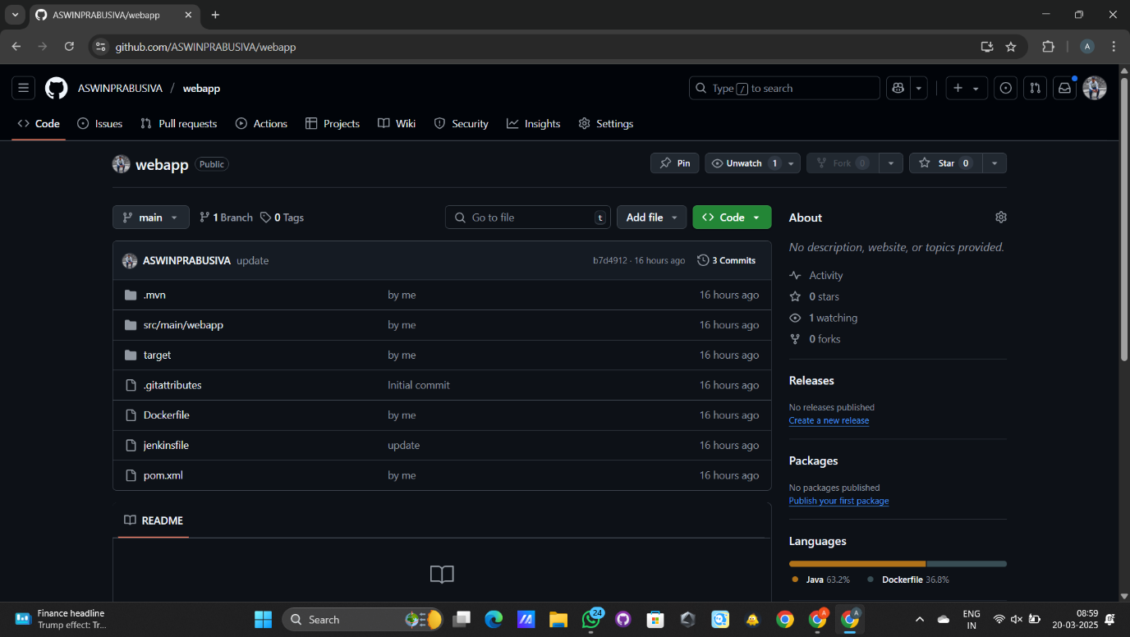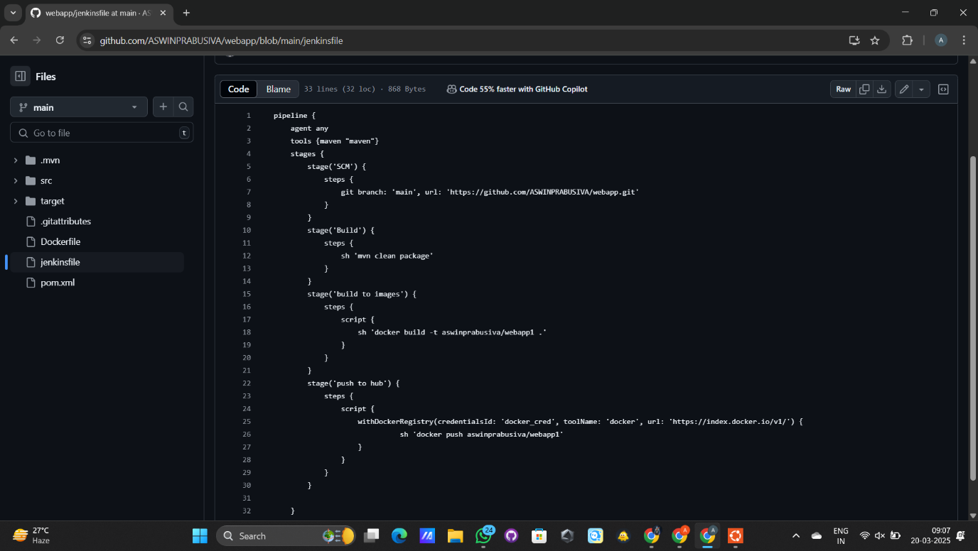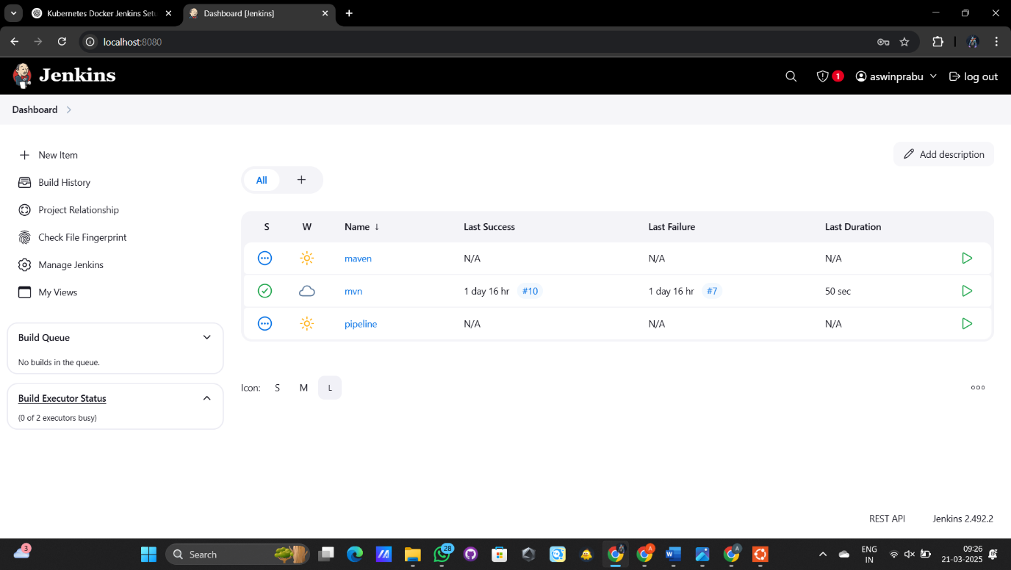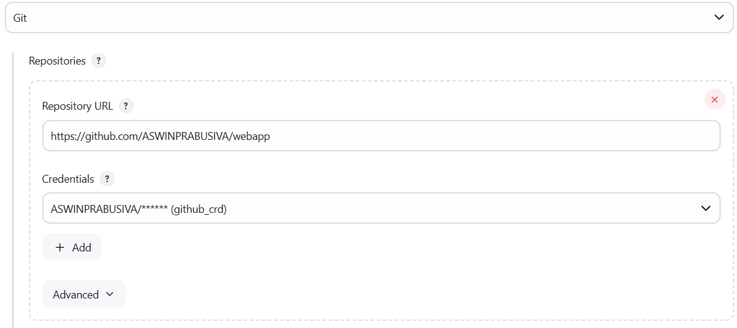

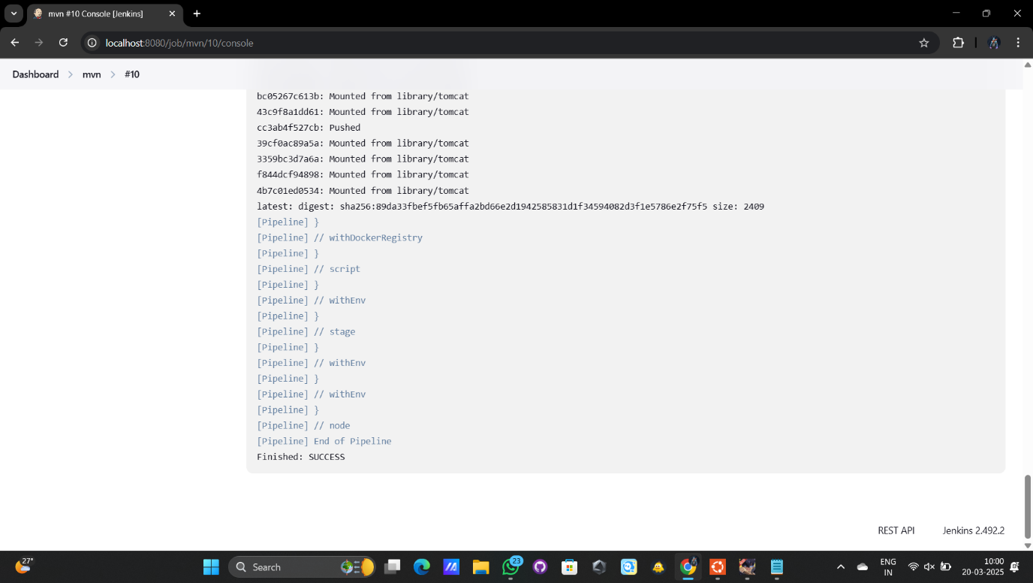

Pipeline code

pipeline {

agent any

tools {maven "maven"}

stages {

stage('SCM') {

steps {

git branch: 'master', url: 'https://github.com/Saran-Avinash/DevOps.git'

}

}

stage('Build') {

steps {

sh 'mvn clean package'

}

}

stage('build to images') {

steps {

script {

sh 'docker build -t saranavinashb/webapp1 .'

}

}

}

stage('push to hub') {

steps {

script {

withDockerRegistry(credentialsId: 'docker_cred', toolName: 'docker', url: 'https://index.docker.io/v1/') {

sh 'docker push saranavinashb/webapp1'

}

}

}

}

}

}

