Task 1: Amazon RDS Setup and Basic Operations

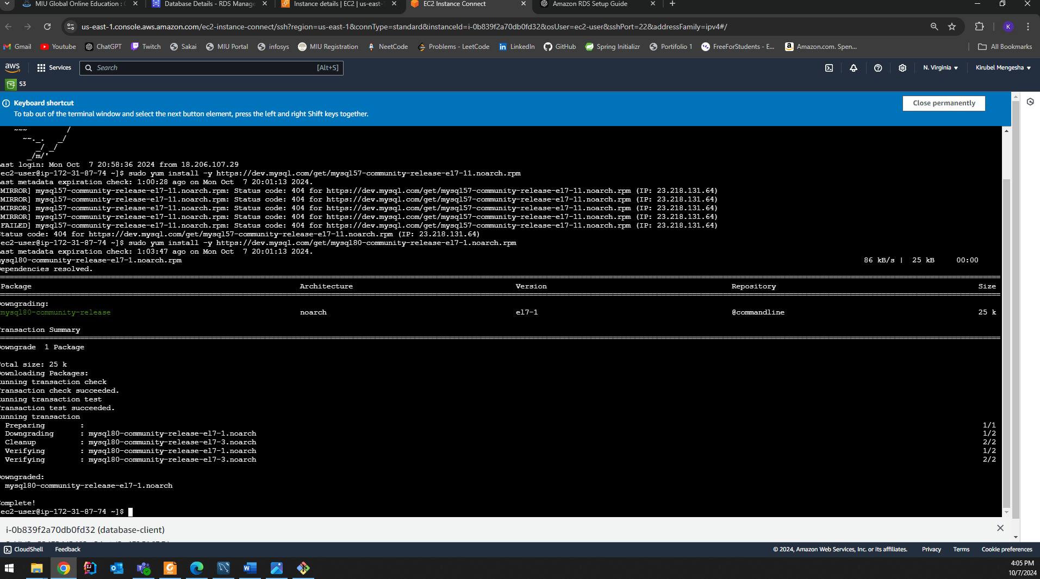

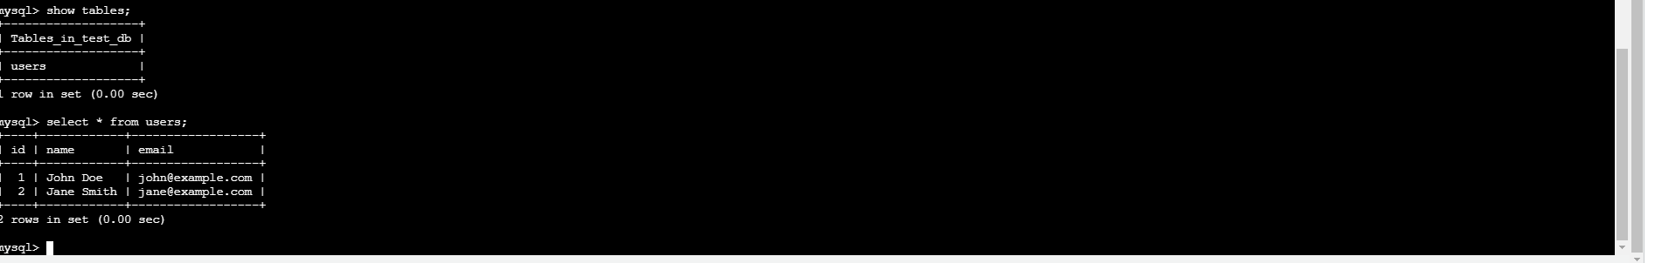

Task 2: Amazon Aurora Exploration

Failover observations

18 second downtime during failover in Amazon Aurora

