## Task 1: Amazon DynamoDB - Setup and Data Manipulation

* Create a DynamoDB table named "UserActivity" with a primary key "UserID" (partition key) and "ActivityTime" (sort key).

* Use the AWS Management Console to insert at least 5 items, representing user activities with attributes such as activity type and duration.

* Perform a query to retrieve all activities for a specific user

* Create Lambda function to insert and query data from this table.

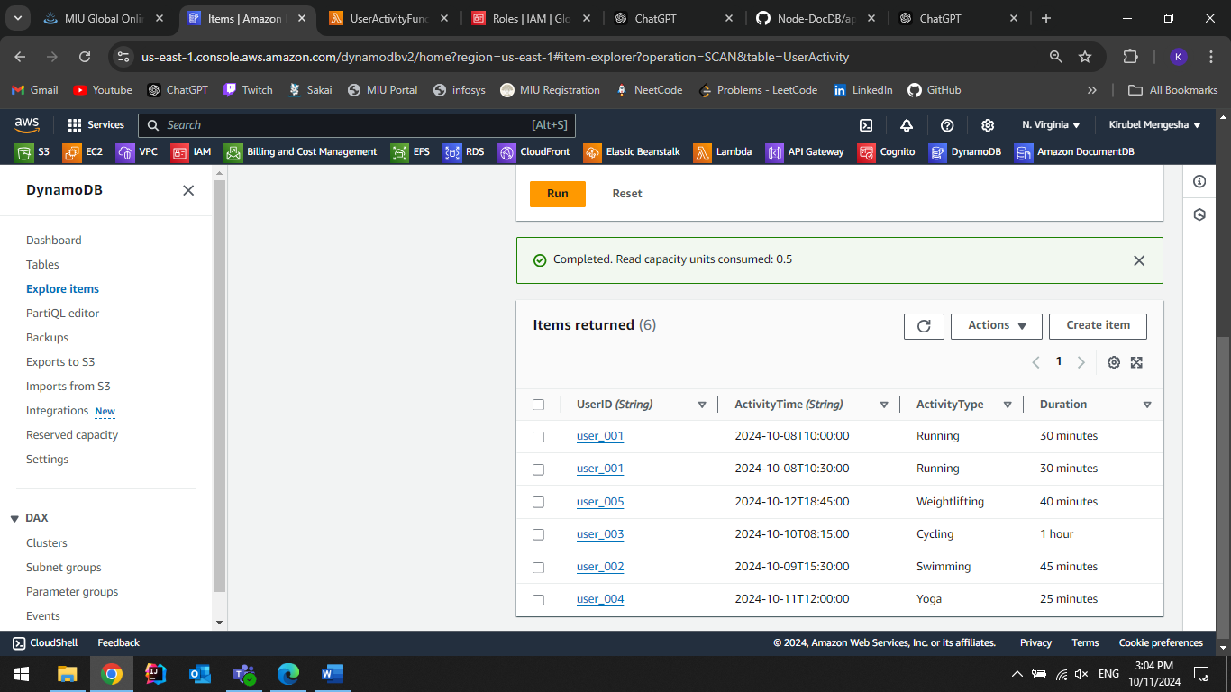

## Task 2: Amazon DocumentDB with EC2

* Create an EC2 that allows SSH

* Create a DocumentDB Cluster:

- In the same VPC with the above EC2

- Include the connection to the above EC2

* Connect to the above EC2

- Install Git: sudo yum install git -y

- Download NodeJS: curl -sL https://rpm.nodesource.com/setup_20.x | sudo bash -

- Install NodeJS: sudo yum install nodejs -y

- Clone the application: git clone https://github.com/Thao-V/Node-DocDB

- Download the CA for DocumentDB: curl -O https://truststore.pki.rds.amazonaws.com/global/global-bundle.pem

- Copy the above file to the Node-DocDB: cp global-bundle.pem Node-DocDB

- Change the directory to Node-DocDB

- Install dependencies: npm i

- Config .env: URI=<your-connection-string>

- Run the app: node app.js