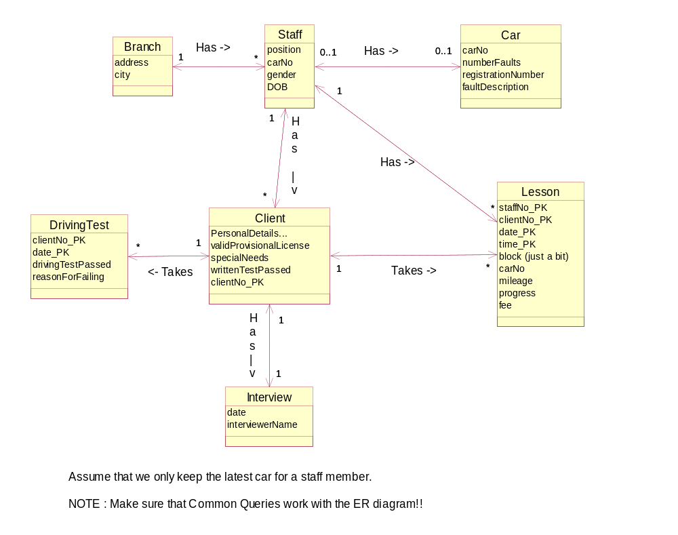
NOTE : We also need an entity called ‘Inspection’ for when a car gets inspected!

