StockPilot
Software Architecture Document
Agentic AI-Powered Inventory and Procurement Management System
SE3090 Assignment 1 - Architecture Baseline v1.0

Document Item | Value
Project | StockPilot - Right Stock. Right Supplier. Right Time.
Team | 4 students (replace placeholders with names / IDs)
Architecture style | Layered modular monolith + internal agentic AI subsystem
Mandatory stack | ASP.NET Core Web API, PostgreSQL + EF Core, React, Flutter/Dart, Agentic AI
Purpose | Shared technical baseline for implementation, Git workflow, documentation, demo and viva
Status | Initial architecture; update through ADRs as decisions are finalized

1. Executive Summary
StockPilot is a single integrated inventory and procurement platform for multi-branch businesses. It combines a React management portal, a Flutter operational mobile app, one ASP.NET Core Web API, one PostgreSQL database, and a controlled four-agent AI workflow. The architecture deliberately keeps the ASP.NET Core API as the only public backend so authentication, authorization, business rules, audit logging, integrations, and AI orchestration remain consistent across both clients.
The architecture supports four student-owned business components: Inventory Management; Sales & Demand; Supplier Management; and Procurement Management. Each student should implement backend endpoints, database work, React screens, Flutter screens, automated tests, and one distinct Agentic AI contribution for the component they own.

2. Architecture Drivers and Constraints
Driver / Constraint | Architecture Response
One coherent shared system | React and Flutter use the same ASP.NET Core API, database, identities, permissions and business rules.
Four student-owned components | Modular feature boundaries in backend, web and mobile make individual ownership visible while preserving integration.
Agentic AI must be multi-step and auditable | Four distinct agents, structured workflow state, allow-listed tools, deterministic validation, human approval and execution summaries.
Human authority over purchasing | AI produces proposals only. Purchase-order creation is gated by authorized approve/reject/revise decisions.
Cross-platform workflow | Mobile stock/sales/receiving events can trigger backend rules and AI proposals; staff review occurs in React; final status is visible to mobile.
Security | JWT authentication, role authorization, protected endpoints, secure token handling, environment variables, input/output validation and least-privilege agent tools.
Process evidence | Feature branches, pull requests, code reviews, issues/project board, CI, regular commits and per-student documentation/testing evidence.

3. System Context and Boundaries
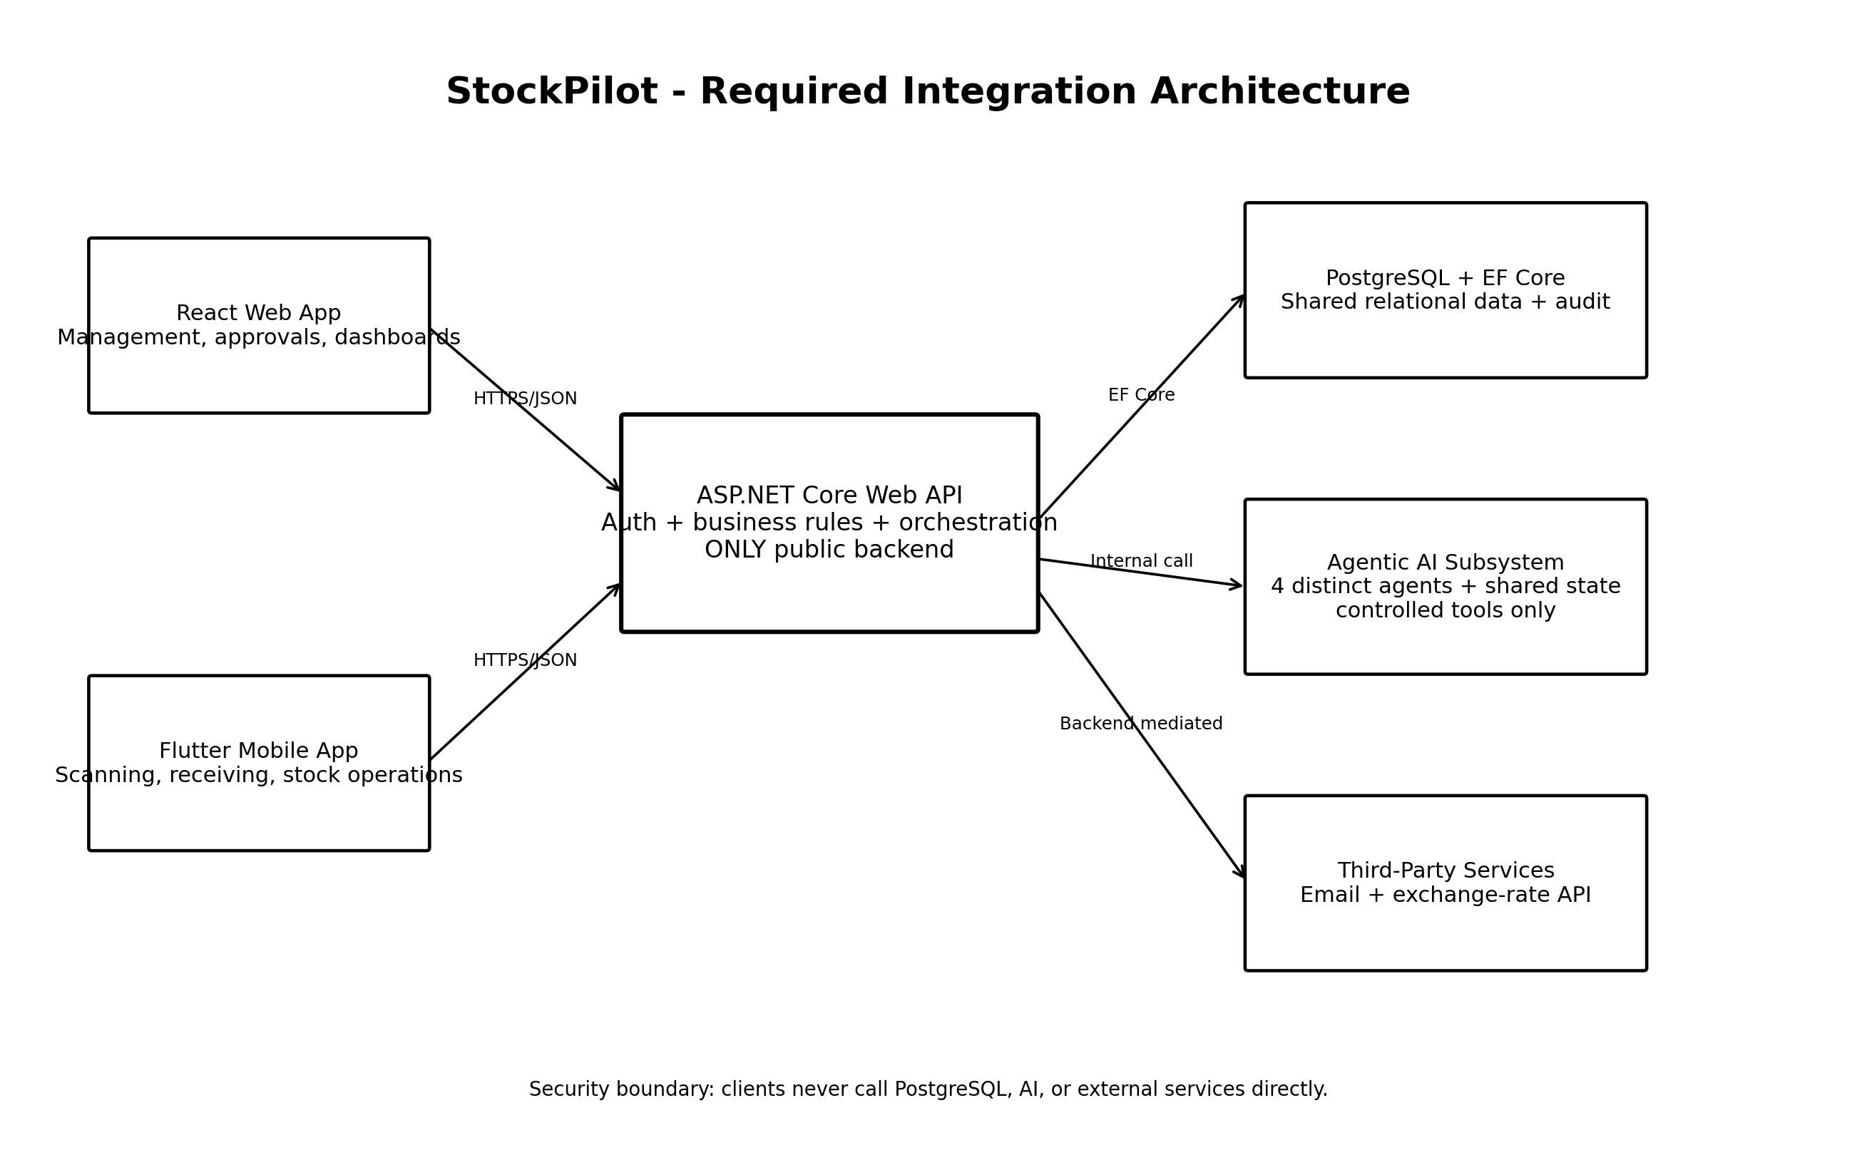
Figure 1. Required integration architecture adapted for StockPilot.
- React is primarily the management, dashboard, reporting, supplier, quotation, AI-monitoring and approval interface.
- Flutter is primarily the operational mobile interface for barcode/QR scanning, physical counts, receiving, damage/expiry reports, replenishment requests, transfers, notifications and status tracking.
- ASP.NET Core is the only public backend. Both clients use HTTPS/JSON to communicate with it.
- PostgreSQL stores shared business data, audit information and the minimum durable agent workflow state needed for observability.
- The Agentic AI subsystem is invoked internally by ASP.NET Core; clients do not call it directly.
- Third-party services such as email and exchange-rate APIs are called through ASP.NET Core so credentials and failure handling stay server-side.

4. Logical Architecture

4.1 Backend layers
Layer | Responsibilities | Examples
API / Presentation | HTTP routes, DTO binding, auth policies, status codes, Swagger | Controllers, request/response DTOs
Application / Services | Use cases, orchestration, transactions, permissions, business rules | InventoryService, ProcurementService, ApprovalService
Domain | Core entities, enums, domain rules/value objects | Product, StockBatch, Quotation, ProcurementProposal
Infrastructure | EF Core, repositories/data access, external APIs, email, AI adapter, logging | AppDbContext, EmailClient, AgentWorkflowClient
Agentic AI | Planning/delegation, domain agents, controlled tools, shared workflow state | Forecast, optimization, supplier evaluation, coordinator

4.2 Feature modules / student ownership
Component | Core responsibility | Representative backend operations | AI contribution
1. Inventory Management | Products, batches, stock movements, transfers, expiry | Receive stock; adjust/count stock; transfer between branches; view low/expiring stock | Inventory Optimization Agent
2. Sales & Demand | Sales history, forecasting, reorder calculations | Record/query sales; demand history; forecast request; reorder calculation | Demand Forecast Agent
3. Supplier Management | Suppliers, quotations, ratings, comparison | Supplier CRUD; quotation CRUD; compare quotations; supplier performance | Supplier Evaluation Agent
4. Procurement Management | Proposals, approvals, purchase orders, budgets | Create/review proposal; approve/reject/revise; create PO after approval; budget status | Procurement Coordinator Agent

5. Key End-to-End Workflow
Recommended demonstrable workflow: a mobile stock operation exposes a potential shortage; the API validates and stores the transaction; AI analyzes demand, inventory and supplier options; a procurement proposal is produced; a manager reviews it in React; the decision is audited; and the resulting status is visible across the system.
Step | Platform / Layer | Action
1 | Flutter | Employee scans barcode or records a stock count/receiving event.
2 | ASP.NET Core | JWT + role check, DTO validation, business-rule validation.
3 | PostgreSQL | Persist stock movement, updated balance and audit fields in a transaction.
4 | Application service | Evaluate reorder trigger and start an agent workflow when justified.
5 | Agentic AI | Forecast demand -> optimize inventory -> evaluate suppliers -> coordinate procurement proposal.
6 | Deterministic validators | Validate product/supplier existence, positive quantity, quotation validity, budget, pending POs, approval limit and possible stock transfer.
7 | React | Authorized manager sees proposal and execution summary; approve, reject or request revision.
8 | ASP.NET Core + PostgreSQL | On approval, create purchase order inside a controlled service transaction; record decision and audit trail.
9 | Flutter / React | Both clients fetch the shared updated status.

6. Agentic AI Architecture
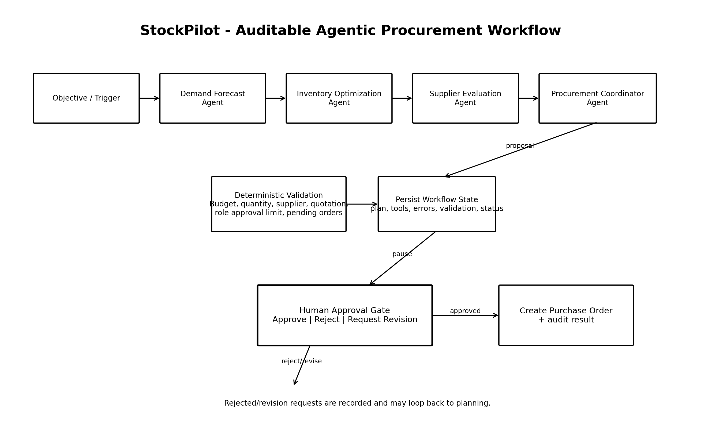
Figure 2. Proposed four-agent procurement workflow with deterministic validation and approval gate.
Agent | Input contract | Allowed tools / data | Structured output
Demand Forecast Agent | productId, branchId, sales window, horizon | Read sales history; read stock; forecasting function/model | forecast quantities, confidence/metrics, suggested reorder date
Inventory Optimization Agent | forecast + current stock/batches/branches | Read stock/batches; read transfer candidates | shortage/overstock/expiry findings, transfer recommendation, purchase need
Supplier Evaluation Agent | product requirement + valid quotations | Read supplier, quotation and delivery/performance data; optional exchange-rate lookup through backend | ranked eligible suppliers with normalized comparison
Procurement Coordinator Agent | validated recommendations + budget + approval policy | Read budget, pending orders and approval rules; create proposal draft only | purchase plan/proposal, rationale summary, required approver, status=PendingApproval

6.1 Shared workflow state
Persist only auditable state needed to reproduce the workflow outcome; never store hidden chain-of-thought. Recommended fields: WorkflowId, Objective, InitiatedBy, CurrentStep, PlanJson, ToolExecutions, ValidationResults, Errors, RetryCount, ApprovalStatus, ApprovalDecision, FinalOutcome, StartedAt, CompletedAt.

6.2 Human approval rule
The AI subsystem must not directly create a purchase order. It may create a procurement proposal. The workflow pauses at PendingApproval. Only an authorized backend command can transition it after Approve / Reject / RequestRevision. Every decision should record actor, time, comment and previous/new status.

7. Data Architecture
Area | Suggested entities
Identity | User, Role, UserRole
Organization | Branch, Warehouse
Catalog | Product, Category
Inventory | StockBatch, InventoryBalance, StockMovement, StockTransfer, StockTransferItem
Sales & Demand | Sale, SaleItem, DemandForecast
Supplier | Supplier, SupplierRating, Quotation, QuotationItem
Procurement | Budget, ProcurementProposal, ProcurementProposalItem, ApprovalDecision, PurchaseOrder, PurchaseOrderItem
Agent / Audit | AgentWorkflow, AgentStep, ToolExecution, ValidationResult, AuditLog

7.1 Important data rules
- Use database foreign keys and unique constraints for integrity, not only UI validation.
- Use decimal/numeric types for money and quantities where precision matters; do not use floating point for currency.
- Add CreatedAt/UpdatedAt and actor identifiers to auditable records.
- Use indexes for frequent filters such as ProductId, BranchId, SupplierId, status, CreatedAt, expiry date and proposal workflow IDs.
- Use explicit transactions for receiving stock, transfers, approval transitions and purchase-order creation.
- Use EF Core migrations committed to Git; keep development seed data meaningful and non-sensitive.

8. API Design Baseline
Area | Example routes (baseline) | Notes
Auth | POST /api/auth/login; GET /api/auth/me | JWT and role claims
Inventory | GET/POST /api/products; GET /api/inventory; POST /api/stock-movements; POST /api/transfers | Search/filter/sort/page on list endpoints
Sales | POST /api/sales; GET /api/sales; POST /api/demand/forecast | Forecast endpoint can trigger or retrieve AI-backed structured result
Suppliers | GET/POST /api/suppliers; GET/POST /api/quotations; POST /api/quotations/compare | Comparison must validate quotation validity/eligibility
Procurement | GET /api/procurement/proposals; POST /api/procurement/proposals/{id}/approve|reject|revise; GET /api/purchase-orders | PO creation is server-controlled after approval
Agent workflows | POST /api/agent-workflows; GET /api/agent-workflows/{id}; GET /api/agent-workflows/{id}/executions | Expose summaries/status, not hidden reasoning
Each student-owned component should have at least four meaningful API endpoints plus at least one domain-specific operation beyond basic CRUD. Use async operations, consistent problem-details errors, server-side validation, Swagger/OpenAPI and structured logging.

9. Security and Safety
Control | Implementation baseline
Authentication | ASP.NET Core Identity or equivalent user store + strong password hashing; JWT access tokens.
Authorization | Policies/roles for Owner, ProcurementManager, BranchManager and StoreEmployee; resource/branch checks where needed.
Client tokens | React memory/secure strategy; Flutter secure storage; never commit tokens.
Secrets | Environment variables / secret store; provide .env.example with names only.
Validation | DTO validation + deterministic business validators + database constraints.
AI safety | Allow-listed tools, schema validation, least privilege, timeouts, retry limits, output validation and safe failures.
Audit | Record approvals, status changes, important stock changes, workflow/tool summaries and errors.
External services | All calls server-side; validate response, enforce timeout, handle failure/rate limits and minimize shared data.

10. Deployment Architecture
- React: static web deployment (for example a no-cost hosting platform) configured with the deployed API base URL.
- ASP.NET Core API: cloud service/container with HTTPS, health endpoint, Swagger URL and environment-variable configuration.
- PostgreSQL: managed/no-cost PostgreSQL where available, restricted credentials, migrations executed in a controlled step.
- Flutter: source plus runnable Android APK (or approved equivalent), configured for the deployed API.
- Agentic AI: preferably hosted inside the ASP.NET Core process or as a private/internal service called only by the API. If a separate Python service is used, it must not be public to React/Flutter.
- GitHub Actions: on push/PR, restore/build backend and run backend tests at minimum; add React build/lint and Flutter analyze/test where runners allow.

11. Repository Structure
StockPilot/
├─ backend/
│ ├─ src/StockPilot.Api/
│ ├─ src/StockPilot.Application/
│ ├─ src/StockPilot.Domain/
│ ├─ src/StockPilot.Infrastructure/
│ └─ tests/
├─ web/ # React
├─ mobile/ # Flutter
├─ agentic-ai/ # prompts/contracts/evaluation or internal service
├─ docs/
│ ├─ architecture/
│ ├─ adr/
│ ├─ api/
│ ├─ database/
│ └─ testing/
├─ scripts/
├─ .github/workflows/
├─ .env.example
├─ .gitignore
├─ CONTRIBUTING.md
└─ README.md
Recommended approach: one monorepo for the whole group. This makes cross-platform integration, shared issues/PRs, CI and contribution evidence easier to review. Keep student ownership visible through module/component issues, labels, branches, PR descriptions and CODEOWNERS-style review practice rather than separate repositories.

12. GitHub Collaboration Workflow
Item | Team convention
Main branch | main is always buildable; protect it; no direct feature commits.
Branches | feature/inventory-stock-count, feature/demand-forecast, fix/proposal-validation, docs/architecture-v2
Issues | Every meaningful task gets an issue with owner, acceptance criteria and component label.
Pull requests | Small PRs; link issue; explain what changed, tests run and screenshots/API evidence where relevant.
Review | At least one teammate review before merge; author does not self-approve.
Commits | Frequent meaningful commits: feat:, fix:, test:, docs:, refactor:, chore:.
Project board | Backlog -> Ready -> In Progress -> Review -> Done.
Evidence | Do not back-fill commits. Keep regular contributions for each student through the full timeline.

13. CI/CD Baseline
The initial GitHub Actions workflow in the repository base is intentionally a safe skeleton. Once the actual .NET solution, React package and Flutter project exist, replace placeholder checks with real restore/build/test commands. Minimum target: backend restore/build/tests on every push and pull request to main. Recommended additions: React npm ci + lint/test/build; Flutter analyze + test; optional deployment jobs after main passes.

14. Architecture Decision Records (ADRs) to Create
ADR | Decision to record | Suggested initial options
ADR-001 React state management | Choose app-wide state strategy | Context + TanStack Query vs Redux Toolkit vs Zustand
ADR-002 Flutter state management | Choose state strategy | Riverpod vs Bloc vs Provider
ADR-003 Agent orchestration | Choose agentic framework / hosting | Microsoft Agent Framework vs LangGraph/internal service vs custom orchestration
ADR-004 Agent workflow persistence | How to store state/audit | Normalized tables + JSONB summaries vs hybrid schema
ADR-005 Deployment platform | No-cost platform selection and constraints | Compare available free/institution options near implementation time
Each ADR should record Context, Options Considered, Decision, Consequences and Status. The team should be able to defend the decision during the viva.

15. Implementation Baseline - First 7 Days
Day / checkpoint | Group action
1 | Create GitHub monorepo, invite all four members, enable issues/project, protect main, add README/CONTRIBUTING/.gitignore and initial CI.
1-2 | Confirm student ownership for the four components and four agents. Create labels and epics/issues.
2 | Create backend solution/projects and PostgreSQL connection; first migration; health endpoint.
3 | Implement JWT/roles and seed test users/roles; add Swagger and global error handling.
3-4 | Create React and Flutter shells with login/routing/API client configuration.
4-5 | Define core ER diagram and entity contracts; create first CRUD vertical slice per component.
5-6 | Define AgentWorkflow state schema, agent input/output contracts, tool allow-list and deterministic validators.
7 | Merge only reviewed passing PRs; run a thin end-to-end slice from one client -> API -> DB and document setup.

16. Definition of Done for a Feature
- Issue has clear acceptance criteria and owner.
- Backend endpoint/service/database work is implemented with validation and authorization.
- React and/or Flutter surface required by the component is integrated with the shared API.
- Happy path and important failure paths have automated tests.
- API error/loading/empty states are handled.
- Security and audit implications are considered.
- Documentation/Swagger is updated.
- PR links the issue, contains evidence, passes CI and receives review.
- Author can explain and modify the implementation without AI assistance during the viva.

17. Assignment Traceability Summary
Requirement | StockPilot architecture coverage
3+ roles | Four roles: Business Owner, Procurement Manager, Branch Manager, Store Employee.
4 components | Inventory; Sales & Demand; Supplier; Procurement.
4 distinct agents | Demand Forecast; Inventory Optimization; Supplier Evaluation; Procurement Coordinator.
React + Flutter different purposes | Management/approval vs operational mobile stock activities.
Single backend/shared DB | Both clients use ASP.NET Core; PostgreSQL via EF Core.
Third-party integration | Email and/or exchange-rate API routed through backend.
Human approval | Procurement proposal pauses before purchase-order creation.
Deterministic checks | Supplier/product/quantity/quotation/budget/pending order/approval/transfer rules.
Auditable AI | Workflow state, tool executions, validation results, errors, approvals, final outcome.
Git/CI evidence | Monorepo, branches, issues, PR review, project board, GitHub Actions.

18. Open Decisions Before Heavy Coding
- Confirm exact member-to-component and member-to-agent ownership.
- Choose React state-management strategy and record ADR.
- Choose Flutter state-management strategy and record ADR.
- Choose Agentic AI framework/hosting arrangement after a small proof-of-concept; record ADR.
- Finalize database ER diagram and transaction boundaries.
- Choose the first third-party service and define failure behaviour.
- Choose deployment platforms only after confirming current free/institution options and deployment constraints.
- Agree coding conventions, branch/PR rules, reviewer rotation and Definition of Done.

19. Source Basis
This architecture baseline is grounded in the uploaded StockPilot Project Proposal and the uploaded SE3090 Assignment 1 Study & Action Guide. The assignment guide itself states that the official assignment PDF and Course Web announcements remain authoritative for exact wording and updates. The team should update this architecture document and ADRs when the official specification or lecturer guidance changes.
Version history: v1.0 - initial architecture baseline generated from the project idea and assignment criteria provided by the team.

