SIMATS ENGINEERING
ASSESSMENT TOOL 1

COURSE NAME: Artificial Intelligence COURSE CODE: CSA17

COURSE OUTCOME COVERED

CO1: Apply AI basics such as intelligent agents and uninformed search methods to solve problems effectively. (BL3)

Assessment Tool Weightage: 50%

QUESTIONS: 5 Duration : 1 Hour
Total Marks:50

Annexure A

Analytical Problem Solving

Code of Conduct:

I ___Kiruthika M (192421239)____ certify that this submission is my original work and that I have adhered to the guidelines specified for this assessment.
I understand that any violation of academic integrity rules will result in disciplinary action.

Signature of the student: kiruthika M

Annexure A

Analytical Problem Solving

- Solve the Water Jug problem: you are given 2 jugs, a 4-gallon one and 3-gallon one. Neither has any measuring maker on it. There is a pump that can be used to fill the jugs with water. How can you get exactly 2 gallons of water into 4-gallon jug? Explicit assumptions: A jug can be filled from the pump, water can be poured out of a jug onto the ground, water can be poured from one jug to another and that there are no other measuring devices available.

Problem Formulation:
State Representation: (x, y), where x represents the amount of water in the 4-gallon jug (0 \le x \le 4), and y represents the amount of water in the 3-gallon jug (0 \le y \le 3).
Initial State: (0, 0)
Goal State: (2, y) where y \in \{0, 1, 2, 3\} (specifically reaching 2 gallons in the 4-gallon jug).
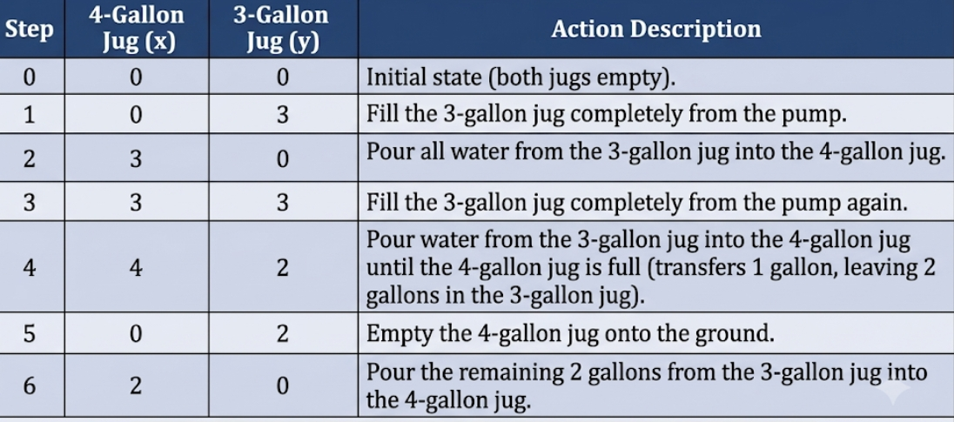
Result: The 4-gallon jug contains exactly 2 gallons of water.

- Find out how Mars Rover, analyse and explore the samples on Mars by answering the following questions.
- What are the percept’s for this agent?
- Characterize the operating environment.
- What are the actions the agent can take?
- How can one evaluate the performance of the agent?
- What sort of agent architecture do you think is most suitable for this agent? Why?
​i. Percepts for this Agent
- ​Visual Data: Panoramic, stereo, and microscopic camera imagery.
- ​Proximity and Obstacle Detection: LiDAR, radar, and ultrasonic range sensors.
- ​Navigation and Orientation: IMU (Inertial Measurement Unit), gyroscopes, accelerometers, wheel encoders (odometry), sun sensors.
- ​Scientific Sensor Readings: Spectrometers (Alpha Particle X-Ray, Raman, APXS), temperature, atmospheric pressure, wind sensors.
- ​Internal Diagnostics: Battery charge levels, motor temperatures, drill torque, communication signal strength.
​ii. Operating Environment Characteristics
- ​Partially Observable: Cameras and sensors only reveal the immediate local surroundings; underground or distant terrain remains hidden.
- ​Stochastic: Terrain can slip unexpectedly under wheels; dust storms, wind, and radiation introduce unpredictable disturbances.
- ​Sequential: Every movement or drilling action alters future position, battery power, and safety.
- ​Dynamic: Environmental conditions (solar illumination, dust accumulation, thermal swings) change while the rover is deciding its next step.
- ​Continuous: Spatial coordinates, speed, steering angles, sensor measurements, and time are continuous.
- ​Single-agent (with external supervisors): The rover acts alone on Mars, receiving high-level delayed goals from Earth controllers.
​iii. Actions the Agent Can Take
- ​Mobility: Move forward/backward, turn/steer, adjust suspension, brake.
- ​Manipulation & Sampling: Deploy robotic arm, rotate turret, drill rock/soil, scoop regolith, drop sample into analysis chambers.
- ​Science Analysis: Fire laser spectrometer, take multispectral/microscopic images.
- ​Communication & Housekeeping: Align high-gain antenna toward Earth/orbiters, transmit telemetry/data, enter sleep/power-saving mode.
​iv. Performance Evaluation Criteria
- ​Scientific Value: Number, purity, and diversity of rock/soil samples collected and analyzed.
- ​Mission Safety: Avoidance of rollovers, wheel entrapment, or critical thermal/mechanical failures.
- ​Energy Efficiency: Optimum battery utilization relative to distance traversed and tasks completed.
- ​Operational Autonomy: Minimization of idle time spent waiting for Earth commands (overcoming the 4–24 minute communication delay).
- ​Data Transmission Yield: Successfully transmitted scientific observations and imagery within communication windows.
​v. Agent Architecture and Justification
- ​Recommended Architecture: Hybrid (Hierarchical / Deliberative-Reactive) Architecture (such as a 3-layer architecture: Deliberative Planner, Executive/Sequencer, and Reactive Controller).
- ​Justification:
  - ​Mars experiences high transmission latency (up to 20+ minutes one-way), making direct real-time teleoperation impossible.
  - ​A purely reactive agent cannot plan multi-step paths, schedule complex science experiments, or manage daily power budgets.
  - ​A purely goal-based deliberative agent cannot react fast enough to immediate hazards like wheel slippage or sudden cliff edges.
  - ​A hybrid architecture allows high-level deliberate planning for path and sample scheduling while low-level reactive modules continuously ensure hazard avoidance and rover safety.

- Explore the search space using search strategies and formulate the problem components for the 8-Queens problem using the following information: Place 8 queens on a chessboard such that none of the queen’s attack any of the others. A configuration of 8 queens on the board as shown in the figure below, but this does not represent a solution as the queen in the first column is on the same diagonal as the queen in the last column.
Problem Formulation Components
State Representation:
Efficient formulation: An 8-element list or tuple S = [q_1, q_2, \dots, q_8], where index i \in \{1, \dots, 8\} denotes the column and value q_i \in \{1, \dots, 8\} denotes the row of the queen in column i. This implicitly enforces that no two queens share the same column.

Initial State:
Standard Incremental formulation: An empty board (0 queens placed).
Complete-state formulation: 8 queens placed randomly on the board (one per column).

Actions / Successor Function:
Incremental: Place a queen in the next empty column k in any row r \in \{1, \dots, 8\} such that it is not attacked by previously placed queens.
Complete-state (Local Search): Move a single queen in column k to a different row in the same column

Search Strategies Exploration
Depth-First Search (DFS) with Backtracking: Explores queen placements column-by-column. Backtracks immediately as soon as a queen conflicts with an existing one. Prunes large invalid subtrees efficiently.
Local Search (Hill Climbing / Min-Conflicts Heuristic): Starts with all 8 queens on the board. In each step, chooses a queen with conflicts and moves it to the row within its column that minimizes the total number of attacking pairs (h).
Constraint Satisfaction Problem (CSP) Formulation: Solved using Forward Checking or AC-3 (Arc Consistency) along with the Minimum Remaining Values (MRV) heuristic to assign variables (columns) to values (rows).

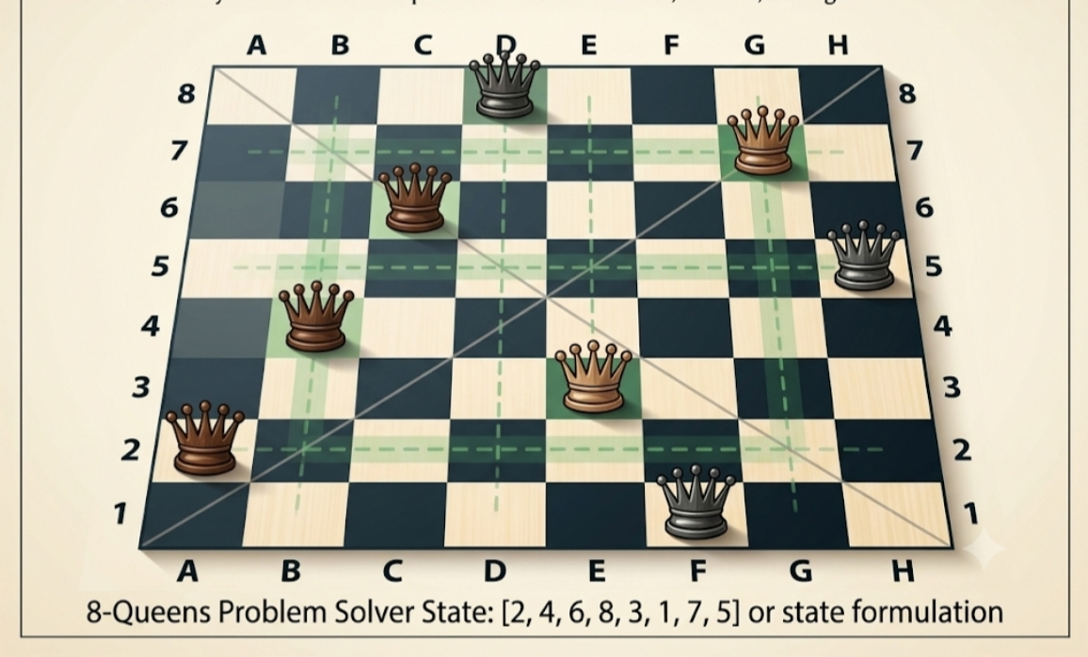

- A customer wants to travel from the one location to another location using OLA Cab booking mobile application. The customer can select the any of the cab type as mini, micro, sedan, shared, prime and so on based on his comfort to reach the destination. Identify what type of problem-solving agent can be used and write the pseudocode for the above problem.
- Agent Type: Goal-Based, Utility-Based Search Agent.
- ​Reasoning: The user wants to reach a specific destination (Goal) while trading off multiple criteria (comfort, cab category, price, and estimated arrival time), which requires maximizing an overall utility function.
Pseudocode:
Algorithm: OLACabBookingAgent

Input:
Pickup_Location, Destination_Location, Customer_Preferences (Budget, Preferred_Type, Urgency)

Output:
Confirmed_Booking (Cab_ID, Driver_Details, Route, Estimated_Cost, ETA)

Procedure Solve_Cab_Booking():
1. Validate Pickup_Location and Destination_Location.
2. Available_Drivers ← QueryNearbyDrivers(Pickup_Location, search_radius=5 km)

3. If Available_Drivers is empty:
Return “No cabs currently available near your location.”

Candidate_Options ← Empty List

For each Driver in Available_Drivers:

Cab_Category ← Driver.category // Mini, Sedan, Prime, Shared
Route ← ComputeShortestPath(Pickup_Location, Destination_Location, TrafficData)
Base_Distance ← Route.total_distance
ETA ← EstimateArrivalTime(Driver.current_location, Pickup_Location) + Route.duration
Trip_Cost ← CalculateFare(Cab_Category, Base_Distance, SurgeFactor)

// Calculate Utility based on user comfort, time, and budget preferences
Utility_Score ← ComputeUtility(Cab_Category, Trip_Cost, ETA, Customer_Preferences)

Append (Driver, Cab_Category, Route, Trip_Cost, ETA, Utility_Score) to Candidate_Options

6. Filter Candidate_Options by Customer_Preferences.Selected_Category (if explicitly chosen).
7. Best_Option ← Candidate with maximum Utility_Score.

Send Booking_Request to Best_Option.Driver:
Wait for Driver_Response (timeout = 30 seconds)
If Accepted:
Return ConfirmBookingDetails(Best_Option)
Else:
Remove Best_Option from Candidate_Options
Repeat step 7 for next best candidate until accepted or list exhausted.

Return “Booking could not be confirmed. Please try again.”

- A logistics company operates a delivery network where packages must be transported between warehouses at minimum cost. Each route between warehouses has an associated travel cost (fuel + time). The company wants to determine the least-cost path from the starting warehouse S to the destination warehouse G using the Uniform Cost Search (UCS) algorithm.
The delivery network is represented as a weighted graph:
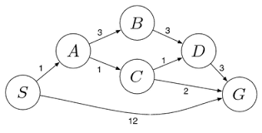

Graph Definition (from diagram):
- ​Nodes: S (Start), A, B, C, D, G (Goal)
- ​Directed Weighted Edges:
  - ​S \to A (cost 1)
  - ​S \to G (cost 12)
  - ​A \to B (cost 2)
  - ​A \to C (cost 1)
  - ​B \to D (cost 3)
  - ​C \to D (cost 1)
  - ​C \to G (cost 2)
  - ​D \to G (cost 3)
​Execution Trace (Priority Queue ordered by path cost g(n)):
- ​Initialization:
  - ​Priority Queue (PQ): \{ [S], g = 0 \}
  - ​Explored Set: \emptyset
- ​Iteration 1:
  - ​Dequeue lowest-cost node: S (g = 0)
  - ​Add S to Explored.
  - ​Expand S:
    - ​S \to A with cost 0 + 1 = 1
    - ​S \to G with cost 0 + 12 = 12
  - ​PQ: \{ [S \to A, g=1], [S \to G, g=12] \}
- ​Iteration 2:
  - ​Dequeue lowest-cost node: A (g = 1)
  - ​Add A to Explored.
  - ​Expand A:
    - ​A \to B with cost 1 + 2 = 3
    - ​A \to C with cost 1 + 1 = 2
  - ​PQ: \{ [S \to A \to C, g=2], [S \to A \to B, g=3], [S \to G, g=12] \}
- ​Iteration 3:
  - ​Dequeue lowest-cost node: C (g = 2)
  - ​Add C to Explored.
  - ​Expand C:
    - ​C \to D with cost 2 + 1 = 3
    - ​C \to G with cost 2 + 2 = 4
  - ​PQ: \{ [S \to A \to B, g=3], [S \to A \to C \to D, g=3], [S \to A \to C \to G, g=4], [S \to G, g=12] \}
- ​Iteration 4:
  - ​Dequeue lowest-cost node: B (g = 3)
  - ​Add B to Explored.
  - ​Expand B:
    - ​B \to D with cost 3 + 3 = 6 (A cheaper path to D with cost 3 already exists in PQ, so ignore/discard this path).
  - ​Dequeue lowest-cost node: G via path S \to A \to C \to G (g = 4)
  - Goal test succeeds. Search terminates
RUBRICS FOR CALCULATION:
Criteria | Weightage | Level 4 (Exemplary) | Level 3 (Proficient) | Level 2 (Developing) | Level 1 (Beginning)
Problem Understanding | 20% | Clearly interprets problem, identifies all parameters and requirements accurately | Understands problem with minor gaps | Partial understanding; misses key elements | Misinterprets or unable to understand problem
Method Selection | 20% | Selects most appropriate method/formula with strong justification | Selects correct method with minor errors | Inappropriate or partially correct method | Unable to select method
Solution Process | 25% | Logical, systematic steps with correct approach throughout | Mostly correct steps with minor mistakes | Disorganized steps; multiple errors | No clear process
Accuracy of Calculation | 20% | All calculations accurate; correct final answer | Minor calculation errors | Frequent errors; incorrect final answer | No valid calculations
Interpretation of Results | 15% | Clearly interprets results with units and engineering relevance | Basic interpretation with minor omissions | Limited or unclear interpretation | No interpretation
Problem Understanding | 20% | Clearly interprets problem, identifies all parameters and requirements accurately | Understands problem with minor gaps | Partial understanding; misses key elements | Misinterprets or unable to understand problem

