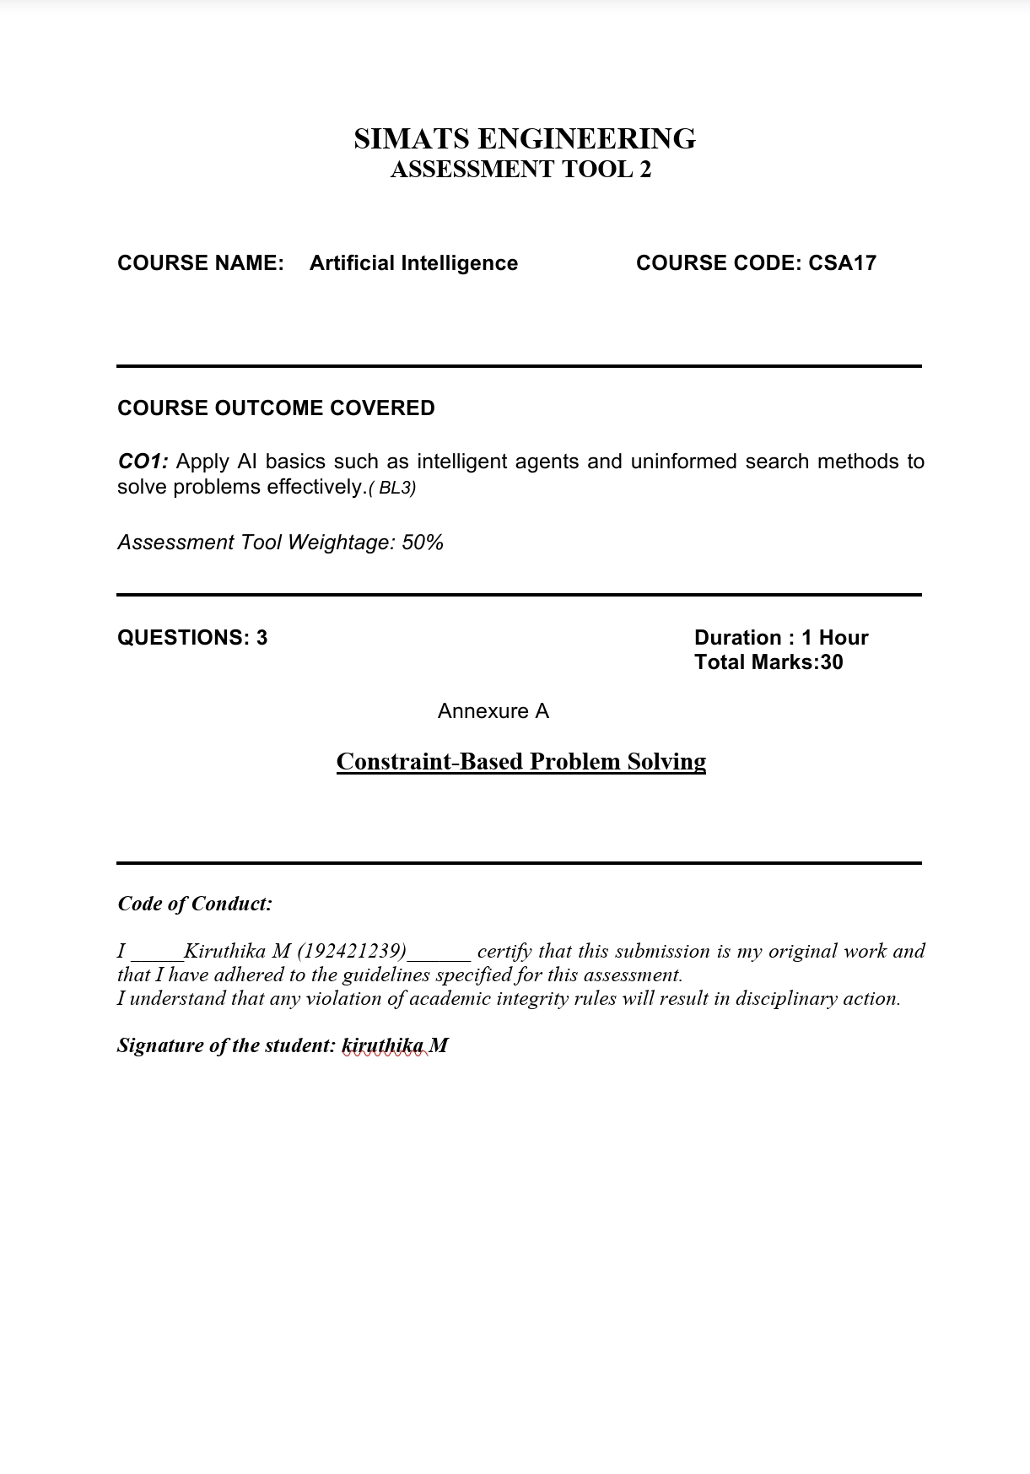

QUESTION 1 — Doctor–Shift Assignment Using Backtracking
Problem statement: Assign doctors D1, D2 and D3 to Morning, Afternoon and Night shifts. Each doctor must receive exactly one shift, each shift must have exactly one doctor, D1 cannot work Night, D3 cannot work Morning, and D2 must work earlier than D3.

1. Representing the problem
- Variables: D1, D2 and D3. Each variable represents the shift assigned to that doctor.
- Domain: {Morning, Afternoon, Night} for each doctor.
- All-different constraint: no two doctors may be assigned the same shift.
- Ordering constraint: the shift of D2 must come before the shift of D3, where Morning < Afternoon < Night.
- Unary constraints: D1 ≠ Night and D3 ≠ Morning.

2. Backtracking search method
Backtracking builds a solution one assignment at a time. After every assignment, the algorithm checks whether the partial schedule violates any constraint. If it does, that choice is rejected and the algorithm returns to the previous decision to try another value. A branch is accepted only when all three doctors are assigned and every constraint is satisfied.
- Start with all doctors unassigned.
- Choose an unassigned doctor and try an available shift.
- Check whether the choice duplicates a shift, assigns Night to D1, assigns Morning to D3, or breaks the D2-before-D3 rule.
- If the partial assignment is valid, continue to the next doctor.
- If no shift works, undo the latest assignment and try another shift (backtrack).
- When all doctors are assigned, verify the complete schedule and report it as a solution.
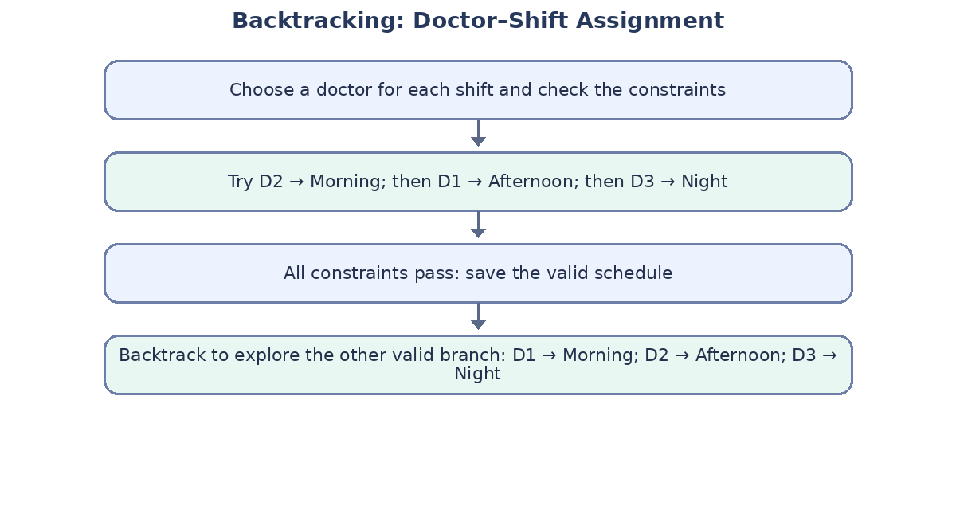
Figure 1. Conceptual flow of backtracking and a valid branch.

3. Intermediate steps and constraint checks
Step | Trial assignment | Constraint check | Decision
1 | D2 = Morning | No conflict yet; Morning is an allowed shift for D2. | Accept
2 | D1 = Afternoon | D1 is not assigned Night; shift is unique. | Accept
3 | D3 = Night | D3 is not Morning; D2 (Morning) is before D3 (Night). | Accept
4 | Complete schedule | All shifts used once; every doctor has exactly one shift. | Valid solution
5 | Alternative branch: D1 = Morning, D2 = Afternoon, D3 = Night | D2 (Afternoon) is before D3 (Night); D1 is not Night; D3 is not Morning. | Valid solution
6 | Rejected example: D3 = Morning | Violates the restriction that D3 cannot work Morning. | Backtrack
7 | Rejected example: D1 = Night | Violates the restriction that D1 cannot work Night. | Backtrack
8 | Rejected example: D2 = Night, D3 = Afternoon | D2 is later than D3, so the ordering constraint fails. | Backtrack

4. Final valid schedules
The constraints permit two valid schedules:
Solution | Morning | Afternoon | Night
A | D2 | D1 | D3
B | D1 | D2 | D3
If only one final schedule is required, Solution A is a valid answer: Morning—D2; Afternoon—D1; Night—D3. Backtracking may find either valid schedule depending on the order in which variables and shift values are tried.

5. Conclusion
Backtracking is suitable because it systematically explores possible assignments while pruning invalid choices early. It avoids checking every complete permutation unnecessarily and guarantees that any reported schedule satisfies all stated constraints.

QUESTION 2 — Robot Navigation in a 5 × 5 Grid
The robot must travel from Start (S) to Goal (G). It may move up, down, left or right, each move costs 1, and blocked cells cannot be entered. The question also requests Manhattan distance and priority-queue updates.

Important note about the missing grid
The question does not specify the exact coordinates of S, G or the obstacles. Therefore, the worked example below explicitly assumes S = (0,0), G = (4,4), and blocked cells (1,1), (1,2), and (3,2). These are illustrative assumptions, not details provided in the question. The method can be applied to the actual grid if its obstacle layout is supplied.
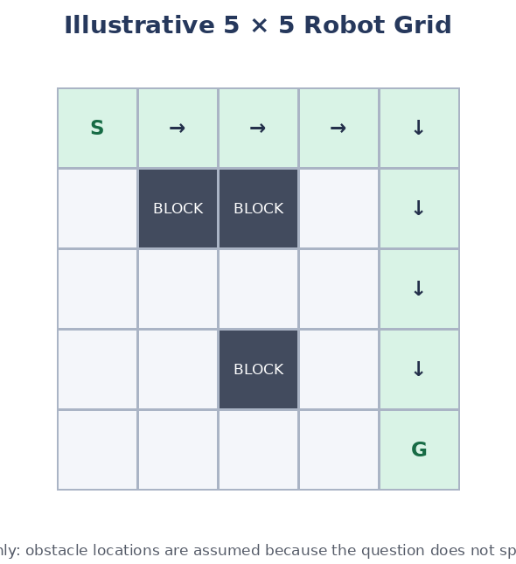
Figure 2. Example grid. Green cells indicate one valid route; dark cells are blocked.

1. Search concepts
- Breadth-First Search (BFS): uses a first-in, first-out queue and explores nodes level by level. Since every move costs 1, BFS finds a path with the minimum number of moves.
- Manhattan distance: h(r,c) = |r − rG| + |c − cG|. It estimates the minimum number of horizontal and vertical moves to the goal, ignoring obstacles.
- Priority queue: BFS itself uses a normal queue, not a priority queue. Because the question asks for Manhattan distance and priority-queue updates, A* is the most consistent algorithm for the detailed priority-queue demonstration. A* ranks a node by f(n) = g(n) + h(n), where g is the cost so far and h is Manhattan distance.
- Optimality: with unit-cost moves and a Manhattan heuristic, A* is optimal; BFS is also optimal for this unit-cost grid.

2. Step-by-step route and cost
Using the illustrative grid, one shortest safe route is:
(0,0) → (0,1) → (0,2) → (0,3) → (0,4) → (1,4) → (2,4) → (3,4) → (4,4)
This route moves right four times and down four times. It avoids every assumed obstacle and reaches the goal in 8 moves. Since the Manhattan distance from (0,0) to (4,4) is |0−4| + |0−4| = 8, no route can use fewer than 8 moves. Therefore, the route is optimal and its total cost is 8 × 1 = 8.

3. Manhattan heuristic and priority queue
For each cell, calculate h = |row − 4| + |column − 4|. At the start, g(S)=0 and h(S)=8, so f(S)=8. Each legal neighbor is evaluated by its tentative g-cost and heuristic. The priority queue removes the cell with the smallest f-value first. If a shorter route to a cell is found, its g-value and parent are updated and its priority is refreshed.
Expansion | Current cell | g (cost so far) | h (to goal) | f = g + h
1 | (0,0) | 0 | 8 | 8
2 | (0,1) | 1 | 7 | 8
3 | (0,2) | 2 | 6 | 8
4 | (0,3) | 3 | 5 | 8
5 | (0,4) | 4 | 4 | 8
6 | (1,4) | 5 | 3 | 8
7 | (2,4) | 6 | 2 | 8
8 | (3,4) | 7 | 1 | 8
9 | (4,4) Goal | 8 | 0 | 8
These rows show the cells along one optimal route. In a real A* execution, other neighboring cells may also enter the priority queue. Cells with equal f-values may be expanded in different orders depending on the tie-breaking rule; this does not change the optimal cost.

4. BFS procedure
- Put S into the queue and mark it visited; set its distance to 0.
- Remove the front cell from the queue. If it is G, stop and reconstruct the path using parent pointers.
- Otherwise inspect its neighbors in a fixed order (for example, Up, Down, Left, Right).
- Ignore a neighbor if it is outside the grid, blocked, or already visited. For each legal new neighbor, mark it visited, set its distance to the current distance plus 1, record its parent, and enqueue it.
- Repeat until G is found or the queue becomes empty. If the queue empties first, no route exists.

5. Final answer
Under the stated illustrative assumptions, an optimal path contains 8 moves and has total cost 8. BFS establishes shortest-path optimality for equal step costs; A* uses the requested Manhattan heuristic and priority queue to guide exploration toward the goal. Exact node expansion order depends on the actual obstacle layout and the tie-breaking rule.

QUESTION 3 — Autonomous Rescue Robot in a Partially Observable Building
A rescue robot must reach a survivor at goal G in a building represented as a grid of rooms. Some rooms or paths are blocked, the robot can sense only adjacent cells, movement costs 1, and entering a risky zone adds 2. The robot must minimize cost, remain safe, and update its knowledge as it explores.

(a) How the constraints affect decision-making
Constraint | Effect on the robot | Decision-making response
Four-direction movement | Only adjacent vertical or horizontal rooms are reachable in one action. | Generate only up, down, left and right successors.
Blocked cells | Some routes cannot be traversed. | Mark known blocked cells as forbidden; do not plan through them.
Limited sensing | The robot cannot see the entire building at once. | Maintain an internal map and treat unseen cells as unknown until observed.
Base movement cost = 1 | Every ordinary move contributes one cost unit. | Track cumulative path cost g(n).
Risk-zone penalty = +2 | A risky cell makes a route more expensive; entering it costs 1 + 2 = 3 under this interpretation. | Prefer a safe route when its total cost is lower; accept a risky route only if justified by the overall cost and mission needs.
Dynamic knowledge | New observations can reveal a blocked passage or a safer route. | Update the map and re-plan whenever new information changes the best route.
Reach survivor safely | A short route may not be the safest or cheapest route. | Compare total cost, obstacle feasibility and risk before selecting an action.
The key trade-off is between distance and risk. The robot should not simply choose the route with the fewest steps. It should minimize total accumulated cost while avoiding blocked cells and using its limited observations responsibly.

(b) Proposed solution using Uniform Cost Search and an online agent
Uniform Cost Search (UCS) is appropriate when action costs differ. It expands the frontier node with the smallest cumulative path cost g(n), using a priority queue. Ordinary moves add 1; entering a risky zone adds 3 in total if the additional risk penalty of 2 is charged on top of the normal movement cost.
- Initialize the robot at S with cost 0. Create an internal map and a priority queue containing S with priority 0.
- Sense the current room and its adjacent cells. Record whether each observed cell is free, blocked or risky. Unobserved cells remain unknown.
- Generate legal neighboring cells. Exclude known blocked cells. Calculate each transition cost: 1 for a normal cell, or 3 for entering a risky cell.
- For every neighbor, calculate new_cost = current_cost + transition_cost. If this is cheaper than the best known cost, update its cost and parent and insert or update it in the priority queue.
- Select the lowest-cost reachable frontier target and move one action at a time, rather than assuming the entire map is known.
- After moving, sense again and update the map. If a newly discovered obstacle invalidates the planned route, remove that route from consideration and plan again from the current location.
- When G is reached, reconstruct the route from parent links and report the total movement plus risk cost.
Why UCS? Unlike ordinary BFS, UCS correctly compares paths when some moves have additional penalties. It finds the lowest-cost path on a known map when edge costs are non-negative. Because the real map is only partly known, the robot uses UCS repeatedly as an online replanning strategy as observations arrive.

(c) AI concepts demonstrated by the robot

1. Intelligent agent
An intelligent agent perceives its environment through sensors and acts through actuators to achieve a goal. Here, the robot senses neighboring rooms, updates its internal map, selects a movement action and physically moves. Its performance measure is reaching the survivor safely while minimizing total cost.

2. Rationality
A rational agent chooses the action expected to produce the best result according to its performance measure and the information currently available. The robot cannot guarantee that it knows the whole building, but it can act rationally by using observed evidence, avoiding known hazards, comparing route costs and replanning when new facts are discovered. Rationality means making the best decision with current information, not having perfect knowledge.

3. Environment type
Environment property | Classification and reason
Partially observable | The robot senses adjacent cells only; the complete building map is not initially visible.
Sequential | Each movement affects the robot's later location, options and accumulated cost.
Dynamic / changing knowledge | The environment or the robot's information can change during exploration; the internal map is updated online.
Discrete | Rooms/cells and the four allowed actions are represented as distinct states and actions.
Single-agent | The robot is the decision-making agent; no competing agent is specified in the problem.
Deterministic movement, uncertain map | The rules for moving to an adjacent cell are predictable, but unknown obstacles and risks make the route initially uncertain.
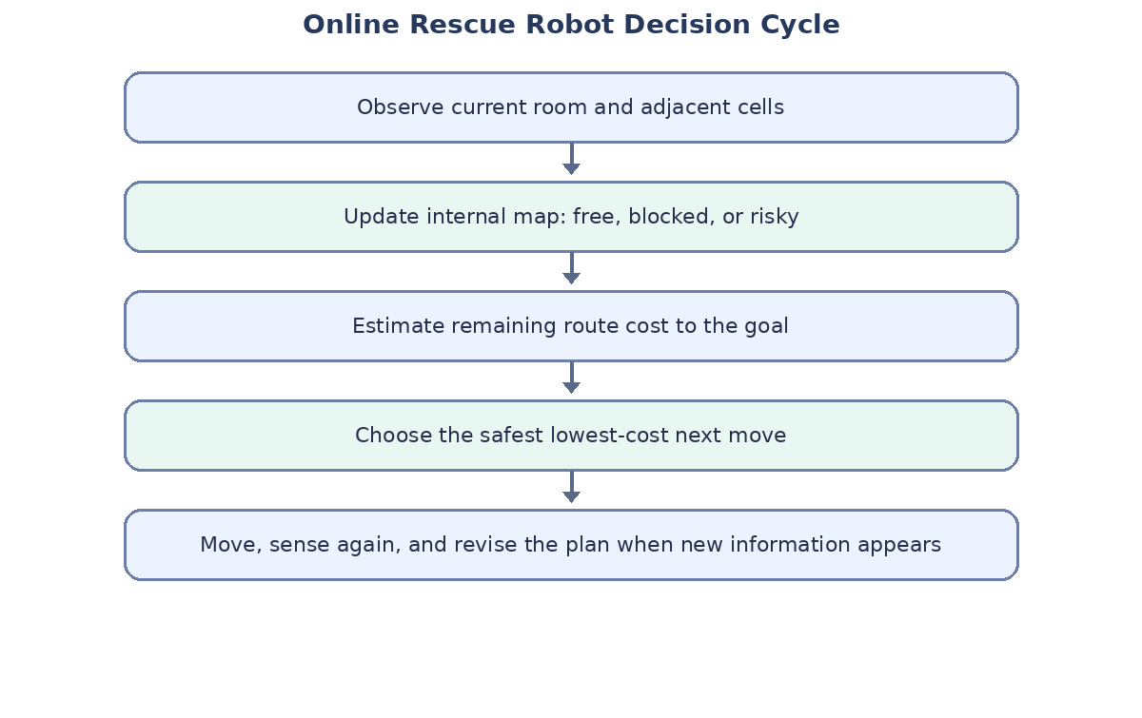
Figure 3. Online perception, map update, cost evaluation and replanning loop.

(d) Why this approach is suitable
- It handles different costs: UCS considers both normal movement cost and extra risk penalties instead of treating every step as equal.
- It avoids known obstacles: blocked cells are excluded from successor generation, preventing invalid planned routes.
- It supports limited information: the robot builds its map from local observations instead of assuming full visibility.
- It adapts online: repeated sensing and replanning allow the robot to respond when a passage is discovered to be blocked or risky.
- It supports cost minimization: on the currently known graph, UCS expands the lowest accumulated-cost frontier first and returns a least-cost path when the goal is reached.
- It makes the assumptions transparent: the robot must distinguish confirmed safe, confirmed blocked, risky and unknown cells, and should not label an unknown cell as safe without evidence.
A practical safety improvement is to assign a conservative cost to unknown cells until they are inspected. If a risk is detected, the robot should update the map and recalculate the route. This is safer than blindly following a fixed path calculated before exploration.

Overall conclusion
The three problems illustrate different AI search techniques. Backtracking solves a constraint-satisfaction problem by testing assignments and undoing invalid choices. BFS finds a shortest path when every move has equal cost, while A* combines path cost with Manhattan distance to guide search. For the rescue robot, Uniform Cost Search is suitable because risk penalties create unequal transition costs, and an online agent can repeatedly sense, update its map and re-plan as new information becomes available.

