EVENTFORCE MANAGEMENT SYSTEM
Salesforce Implementation Project Documentation

Program: Salesforce Developer
Team Leader: Kiruthika.K
Team Members: Madhumitha.M, Janani.S, Kalki.K
Registered Mail ID: kiruthikakannan061@gmail.com
Team ID: SWTID-2026-4043
College: Arasu Engineering College
Platform: Salesforce Developer Edition Org (Lightning Experience)
Submission Date: 3rd October 2026

Contents
1. Project Overview
2. Objectives
3. Ideation Phase
4. Requirement Analysis
5. Project Design
6. Project Planning
7. Phase 1: Functional Scope and Execution Roadmap
8. Phase 2: Backend Development and Configurations
9. Phase 3: UI/UX Development and Customization
10. Phase 4: Data Migration, Testing and Security
11. Phase 5: Deployment, Documentation and Maintenance
12. Challenges Faced and Fixes
13. Conclusion
Appendix A: Apex Source Code

1. Project Overview
EventForce Management System is a CRM application built on the Salesforce platform for an event planning company. Without such a system, details about clients, bookings, venues, vendors and feedback are usually scattered across spreadsheets, phone calls and messages. This project brings all of that into one Salesforce org so that every team member works from the same up-to-date record.
The application is made up of six custom objects (Event, Client, Vendor, Venue, Feedback and Event Vendor), relationships that link them, a validation rule that protects data quality, a formula field that calculates the event budget, an approval process for event cancellations, a record-triggered Flow that sends reminders, and Apex code that keeps venue availability correct, blocks double bookings and completes past events every night. A Lightning App, a report and a dashboard give a clear view of upcoming events. Access is controlled with roles, profiles, a permission set, organization-wide defaults and a sharing rule.
The whole solution was configured and tested in a Salesforce Developer Edition org, following the order a real consultant would follow: gather requirements, model the data, automate the process, design the interface, secure access, test and document.

2. Objectives
- Keep client, event, venue, vendor and feedback information in one well-structured place.
- Reduce manual work in booking events and reserving venues.
- Stop two events from being booked at the same venue on the same date.
- Send clients an automatic reminder before their event.
- Route event cancellation requests through a controlled approval process.
- Give each type of user access only to what they need.
- Give management clear visibility of upcoming events through a report and a dashboard.

3. Ideation Phase

3.1 Problem Statement
Event planning companies handle many clients, venues and vendors at the same time. When this information lives in spreadsheets and chats, bookings are missed, venues get double-booked and clients are not kept informed. The table below describes the problem from the point of view of two users.
Item | Event Coordinator | Client
I am | An event coordinator at an event planning company | A customer who books an event
I am trying to | Book events, reserve venues and track every booking in one place | Book an event and know that everything is confirmed
But | Records are scattered and I can book the same venue twice by mistake | I do not get reminders or updates about my event
Because | There is no central system with rules and automation | Communication is manual and depends on the coordinator
Which makes me feel | Stressed and worried about mistakes | Uncertain and unimportant

3.2 Empathy Map
The empathy map describes the main user, the Event Coordinator, so that the solution is built around what this person actually experiences.
Quadrant | Event Coordinator
Says | "I need to know which venues are free." "Did we send the reminder to the client?" "Can I cancel this booking quickly?"
Thinks | Double booking will damage the company's reputation. Too much time is lost in manual follow-ups.
Does | Maintains spreadsheets, calls vendors and venues, sends reminders by hand, asks managers to approve cancellations.
Feels | Pressure to avoid mistakes, frustrated with repeated work, relieved when everything is confirmed.
Pains | Double bookings, missed reminders, no single view of upcoming events, slow approvals.
Gains | Automatic checks, automatic reminders, a clear dashboard and a controlled approval process.

3.3 Brainstorming and Idea Prioritization
The team listed possible features and ranked them by business impact and effort. Features with high impact and low to medium effort were selected for the project.
Idea | Impact | Effort | Decision
Central objects for events, clients, venues, vendors and feedback | High | Low | Selected
Prevent double booking of a venue on the same date | High | Medium | Selected
Automatic email reminder before the event | High | Low | Selected
Approval process for event cancellation | High | Medium | Selected
Automatic event budget from the event type | Medium | Low | Selected
Nightly job that marks past events as completed | Medium | Medium | Selected
Report and dashboard of upcoming events | High | Low | Selected
Role-based access for coordinators, vendor managers and clients | High | Medium | Selected
Online payment integration | Medium | High | Future scope
Mobile app for clients | Medium | High | Future scope

4. Requirement Analysis

4.1 Customer Journey
Stage | What the user does | Pain point | How EventForce helps
Enquiry | Client contacts the company about an event | Details are noted on paper or chat | Client and event records are created in Salesforce
Planning | Coordinator selects a venue and date | Venue may already be booked | Double-booking trigger blocks the save and shows an error
Confirmation | Event is confirmed | Venue status is updated manually | Venue becomes Reserved automatically
Before the event | Client must be reminded | Reminders are forgotten | Flow sends an email three days before the event
Cancellation | Client or coordinator asks to cancel | No control over who approves | Approval process with email alerts
After the event | Event is closed and feedback is collected | Past events stay open | Nightly batch marks them Completed; Feedback object stores ratings

4.2 Solution Requirements

Functional requirements
ID | Requirement
FR-1 | Store clients, events, venues, vendors and feedback as separate records with relationships.
FR-2 | Validate the client email address before saving.
FR-3 | Calculate the event budget automatically from the event type.
FR-4 | Prevent two events from being booked at the same venue on the same date.
FR-5 | Update the venue availability when an event is confirmed or canceled.
FR-6 | Send an automatic reminder email to the client before the event.
FR-7 | Route cancellation requests through an approval process.
FR-8 | Mark past events as Completed every night.
FR-9 | Provide a report and a dashboard of upcoming events.
FR-10 | Restrict access by role, profile, permission set and sharing rules.

Non-functional requirements
- Usability: a simple Lightning App with one tab for each object.
- Security: private organization-wide default on events with controlled sharing.
- Reliability: automation runs on the platform without manual steps.
- Maintainability: declarative tools first, Apex only where needed, with clear naming.

4.3 Data Flow
Step | Input | Process | Output / data store
1 | Client details | Email validation rule | Client record
2 | Event details, client, venue | Double-booking trigger, budget formula | Event record
3 | Confirmed event | Venue helper trigger | Venue status set to Reserved
4 | Confirmed event date | Scheduled path in the Flow | Reminder email to the client
5 | Status Pending Cancellation | Approval process | Status Canceled or Rejected, email alert
6 | Past events | Nightly batch Apex | Status Completed
7 | Event records | Report and dashboard | Upcoming events by month

4.4 Technology Stack
Layer | Technology
Platform | Salesforce Developer Edition, Lightning Experience
Data model | Custom objects, fields, lookup and master-detail relationships
Declarative automation | Validation rule, formula field, record-triggered Flow, approval process
Programmatic | Apex classes and triggers, Batch Apex and Schedulable Apex
User interface | Lightning App, report, dashboard
Security | Roles, profiles, permission set, organization-wide defaults, sharing rule
Tools | Setup, Developer Console, Flow Builder, GitHub

5. Project Design

5.1 Problem-Solution Fit
Problem | Solution in EventForce
Scattered information | One org with linked objects for clients, events, venues, vendors and feedback
Wrong data entry | Email validation rule and an automatic budget formula
Double booking | Apex trigger that blocks the same venue on the same date
Forgotten reminders | Record-triggered Flow with a scheduled path
Uncontrolled cancellations | Approval process with record lock and email alerts
No visibility | Report and dashboard for upcoming events

5.2 Proposed Solution
Item | Description
Solution | A Salesforce application, EventForce, that manages the complete life cycle of an event: booking, venue reservation, reminders, cancellation approval, completion and feedback.
Novelty | Business rules (double booking, venue status, nightly completion) run automatically, so coordinators do not have to remember them.
Business value | Fewer booking errors, less manual follow-up and clearer visibility for managers.
Scalability | New object types, flows and reports can be added without redesign; the batch job already processes records in chunks of 200.

5.3 Solution Architecture
The solution has three layers. The user layer is the Event Planner Lightning App with tabs, a report and a dashboard. The logic layer holds the validation rule, formula field, approval process, Flow, Apex triggers and the scheduled batch job. The data layer holds the six custom objects. Security (roles, profiles, permission set and sharing) controls what each user sees at every layer.
Layer | Components
User layer | Event Planner app, Events, Clients, Vendors, Venues, Feedbacks, Reports, Dashboards
Logic layer | Email_Valid_Address rule, Event Budget formula, Event_Cancellation_Process, Event_Reminder_Flow, EventTrigger13, PreventDoubleBooking, BatchCompleteEvents, ScheduleCompleteEvents
Data layer | Event__c, Client__c, Vendor__c, Venue__c, Feedback__c, Event_Vendor__c
Security layer | Roles, profiles, Feedback Manager permission set, organization-wide defaults, Event sharing rule

6. Project Planning
The work was planned in sprints. The table lists each user story with its story points, priority, the team member who worked on it and the dates.
Sprint | User story | Points | Priority | Team member | Start | End
1 | As an admin, I create the objects, tabs, fields and relationships | 5 | High | Kiruthika K | 29 Sep 2026 | 29 Sep 2026
1 | As a coordinator, I get email validation and an automatic budget | 3 | High | Kiruthika K | 29 Sep 2026 | 29 Sep 2026
2 | As a manager, I approve or reject cancellations | 5 | High | Kiruthika K | 29 Sep 2026 | 30 Sep 2026
2 | As a client, I receive a reminder before my event | 3 | High | Kiruthika K | 29 Sep 2026 | 30 Sep 2026
2 | As a coordinator, I cannot double-book a venue | 5 | High | Kiruthika K | 29 Sep 2026 | 30 Sep 2026
2 | As a system, I complete past events every night | 3 | Medium | Kiruthika K | 29 Sep 2026 | 2 Oct 2026
3 | As a manager, I see upcoming events in a report and dashboard | 5 | Medium | Madhumitha M | 29 Sep 2026 | 29 Sep 2026
3 | As a user, I work in a Lightning App | 2 | Medium | Madhumitha M | 29 Sep 2026 | 29 Sep 2026
4 | As an admin, I secure access with roles, profiles, permission set and sharing | 5 | High | Janani S | 2 Oct 2026 | 2 Oct 2026
4 | As a tester, I verify every feature in the user interface | 3 | High | Janani S | 2 Oct 2026 | 2 Oct 2026
5 | As a team, we prepare documentation and the demo video | 3 | High | Kalki K | 2 Oct 2026 | 3 Oct 2026

Total planned story points: 42 across 5 sprints. All sprints were completed by 3 October 2026.

7. Phase 1: Functional Scope and Execution Roadmap
This phase defined what the system must do, who will use it and in what order it would be built.

7.1 Functional Scope
- Data model: custom objects Event, Client, Vendor, Venue, Feedback and Event Vendor.
- Relationships: lookup and master-detail relationships between the objects.
- Automation: a Flow for client reminders, an approval process for cancellations, and Apex for venue logic and nightly processing.
- Data quality: a validation rule, a formula field for the event budget and a lookup filter on Feedback.
- Security: roles, profiles, a permission set, organization-wide defaults and sharing rules.
- Analytics: a report and a dashboard for upcoming events.

7.2 Stakeholder Mapping
Stakeholder | Responsibility in the system
Client | Requests event services, receives reminders and gives feedback.
Event Coordinator | Creates and manages events, communicates with clients and takes part in cancellation approvals.
Vendor Manager | Coordinates vendors such as catering, decor and photography for events.
Venue Manager | Tracks venue availability and reservations.
Event Administrator | Owns the system: security, configuration, approvals and monitoring.

7.3 Execution Roadmap
- Create the objects, fields and relationships.
- Add the validation rule and the formula field.
- Build the approval process for event cancellation.
- Build the reminder Flow.
- Write Apex classes and triggers for venue availability, double-booking prevention and nightly event completion.
- Create the Lightning App, report and dashboard.
- Create roles, profiles, users, permission set and sharing settings.
- Test every feature and prepare the documentation and demo.

8. Phase 2: Backend Development and Configurations
This phase built the working core of the application: the data model, the rules that protect it and the automation that runs on it.

8.1 Salesforce Developer Org
A free Developer Edition org was created from developer.salesforce.com, the account was activated through the verification email and a password was set. All configuration in this project was done inside this org.
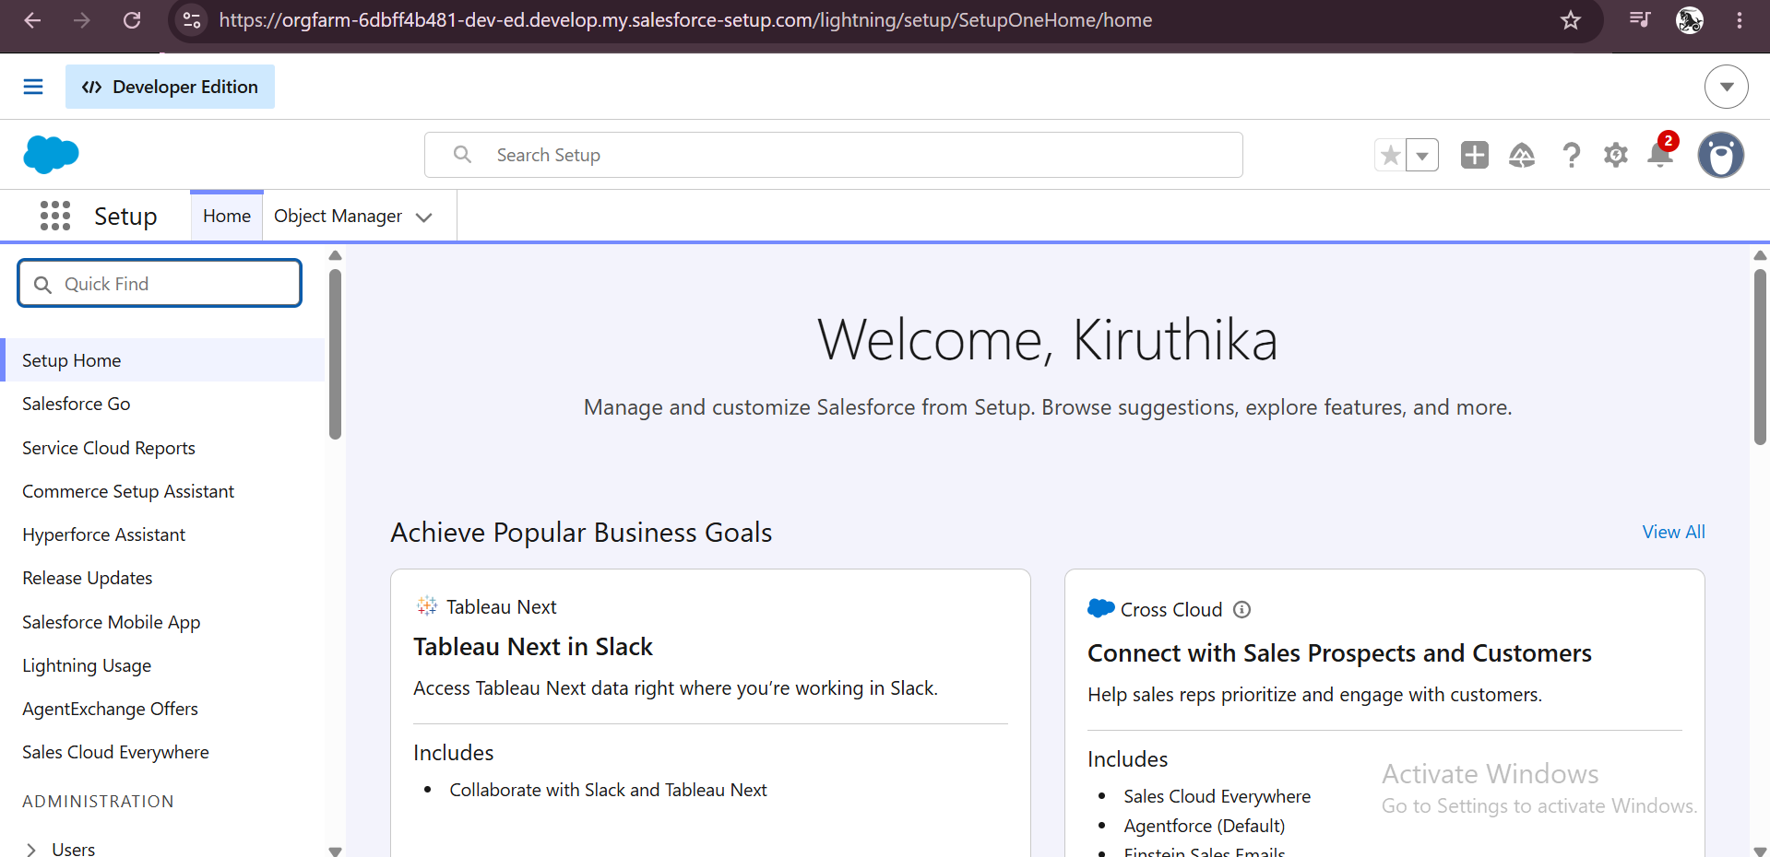
Figure 1: Setup home page of the Developer Edition org

8.2 Data Model
Six custom objects hold the data of the application.
Object | Purpose | Key fields
Event (Event__c) | One record per booked event. | Event Name, Event Date, Event Type, Event Status, Event Budget, Client, Venue
Client (Client__c) | The customer who books the event. | Client Name, Email, Phone, Address, Country, City
Vendor (Vendor__c) | Service providers used in events. | Vendor Name, Email, Phone, Service Type, Status
Venue (Venue__c) | Places where events are held. | Venue Name, Address, Location, Capacity, Availability Status
Feedback (Feedback__c) | Client feedback on an event. | Feedback Name (auto number), Rating, Comments, Event, Client
Event Vendor (Event_Vendor__c) | Records the vendor services linked to an event. | Event Vendor Name, Event (master-detail)

Relationships
From | To | Type
Event | Client | Lookup
Event | Venue | Lookup
Feedback | Event | Lookup
Feedback | Client | Lookup
Event Vendor | Event | Master-Detail

8.3 Creating the Objects
Each object was created from Setup, Object Manager, Create, Custom Object. The label, plural label and record name were entered for every object, and the deployment status was kept as Deployed. For Event, Client, Vendor, Venue and Event Vendor, the options Allow Reports, Track Activities and Track Field History were enabled. Feedback uses an auto-number record name and has Allow Reports enabled.
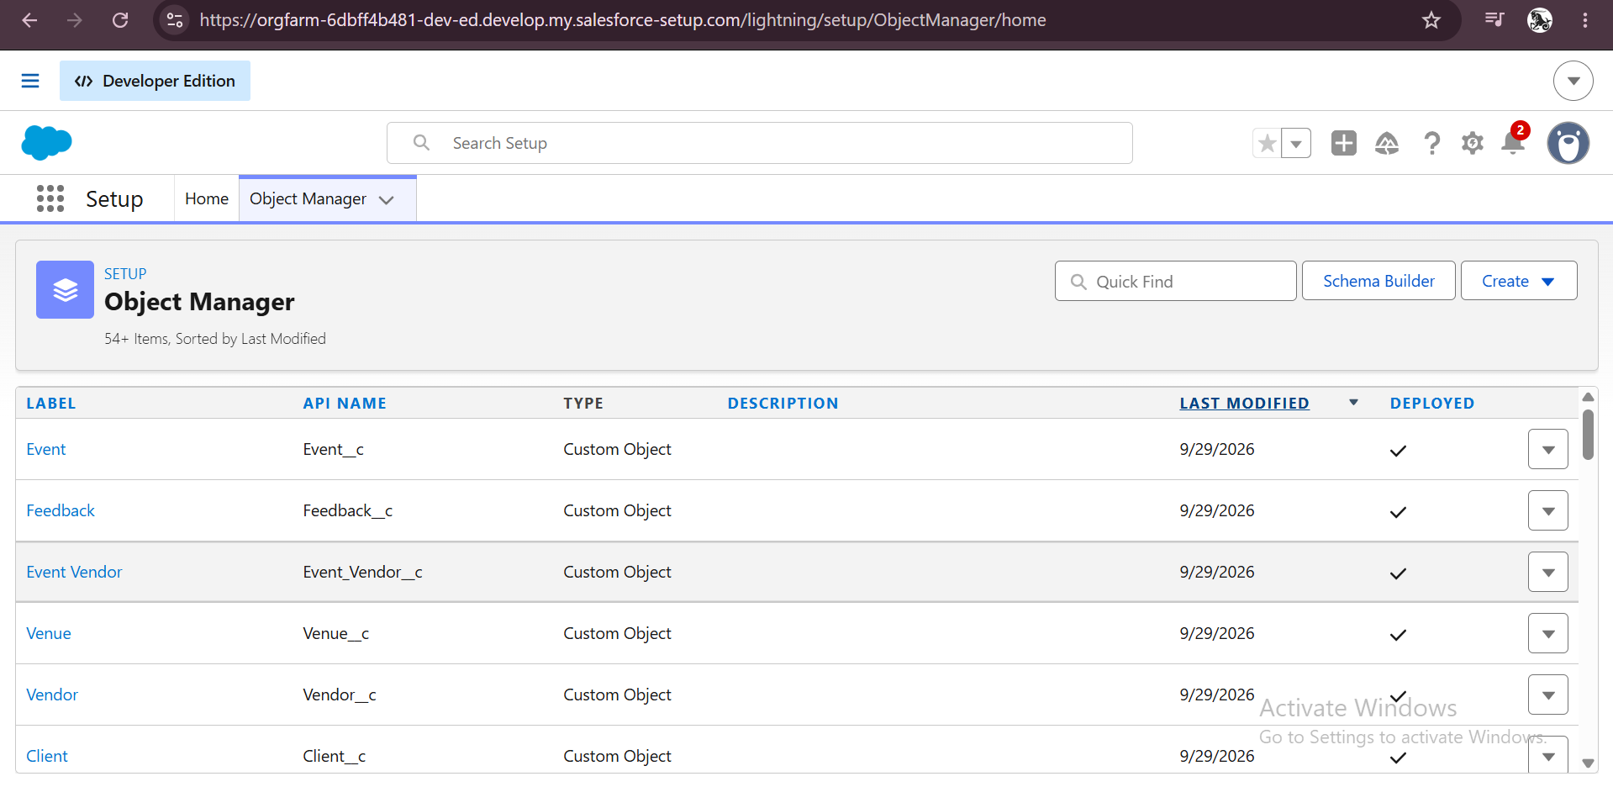
Figure 2: Object Manager showing the six custom objects
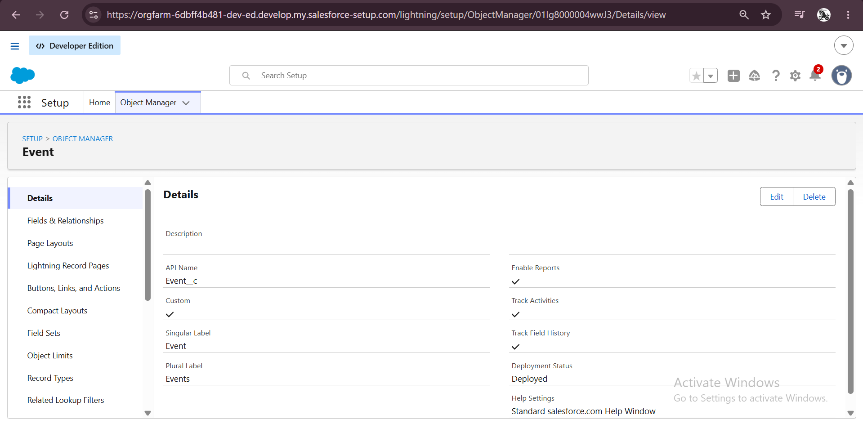
Figure 3: Event object details
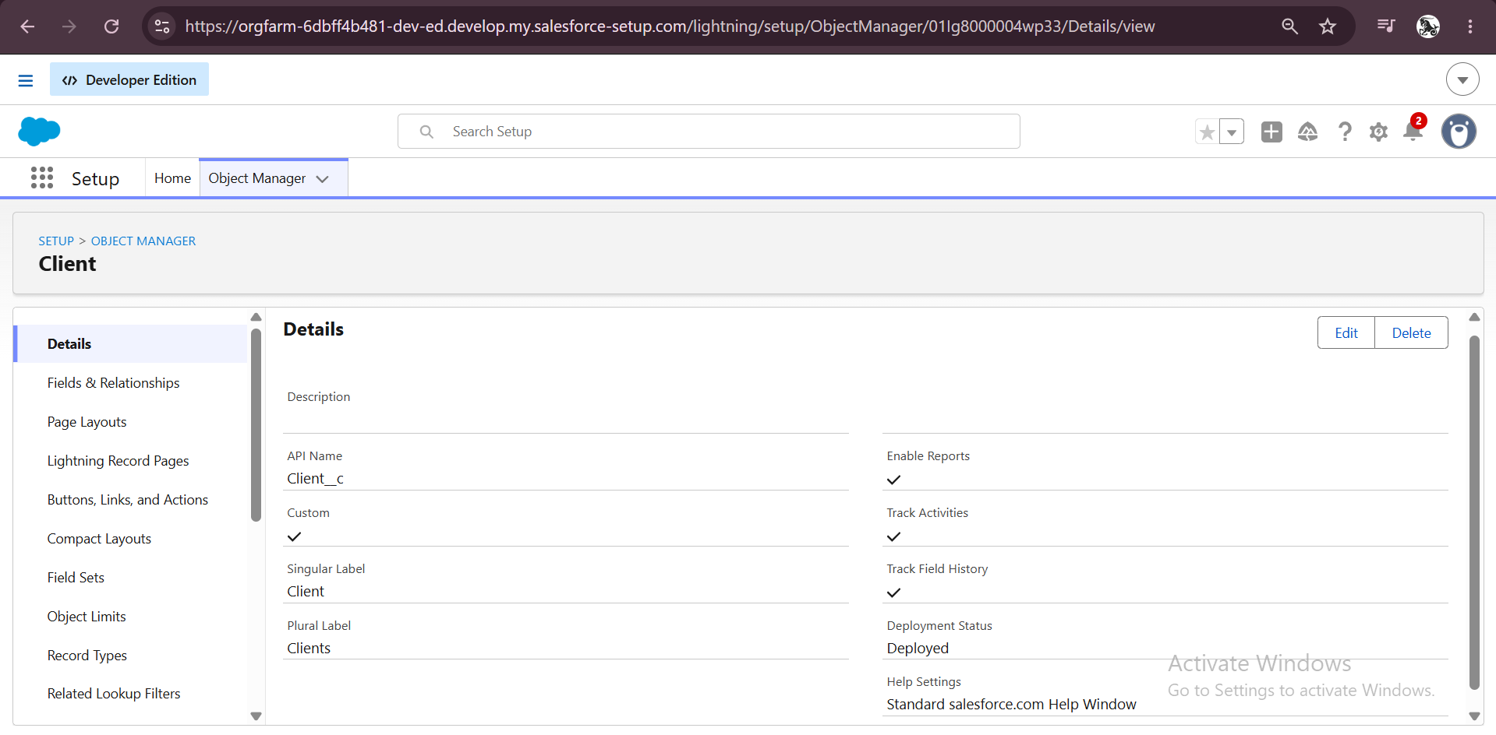
Figure 4: Client object details
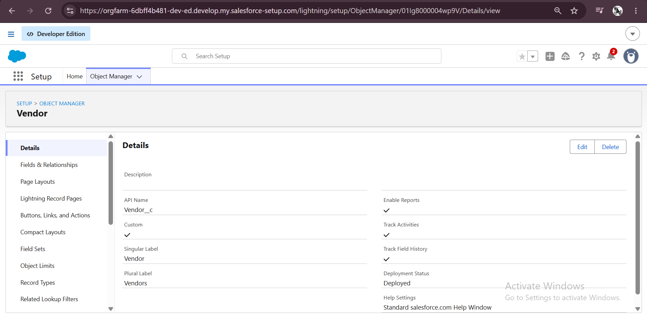
Figure 5: Vendor object details
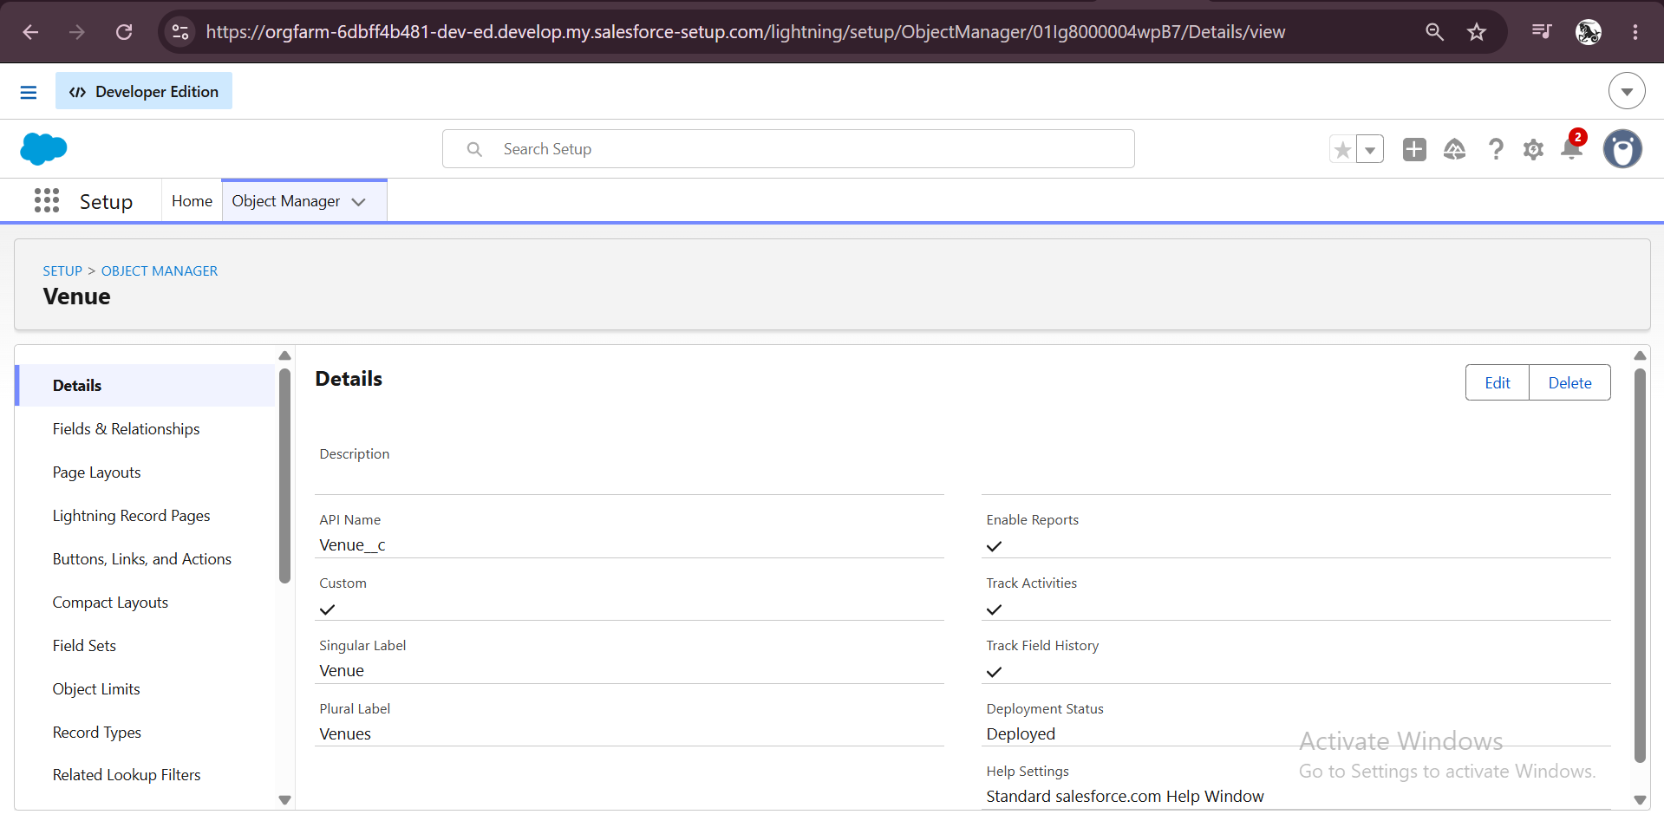
Figure 6: Venue object details
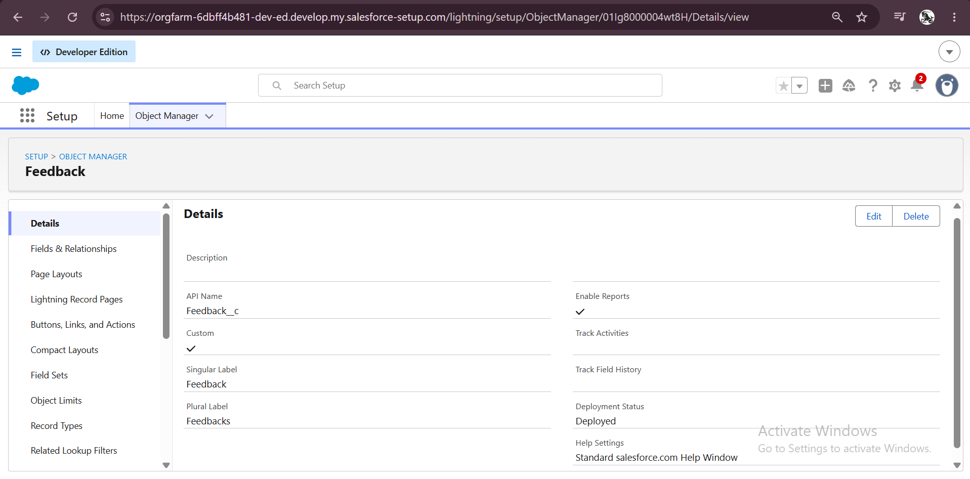
Figure 7: Feedback object details
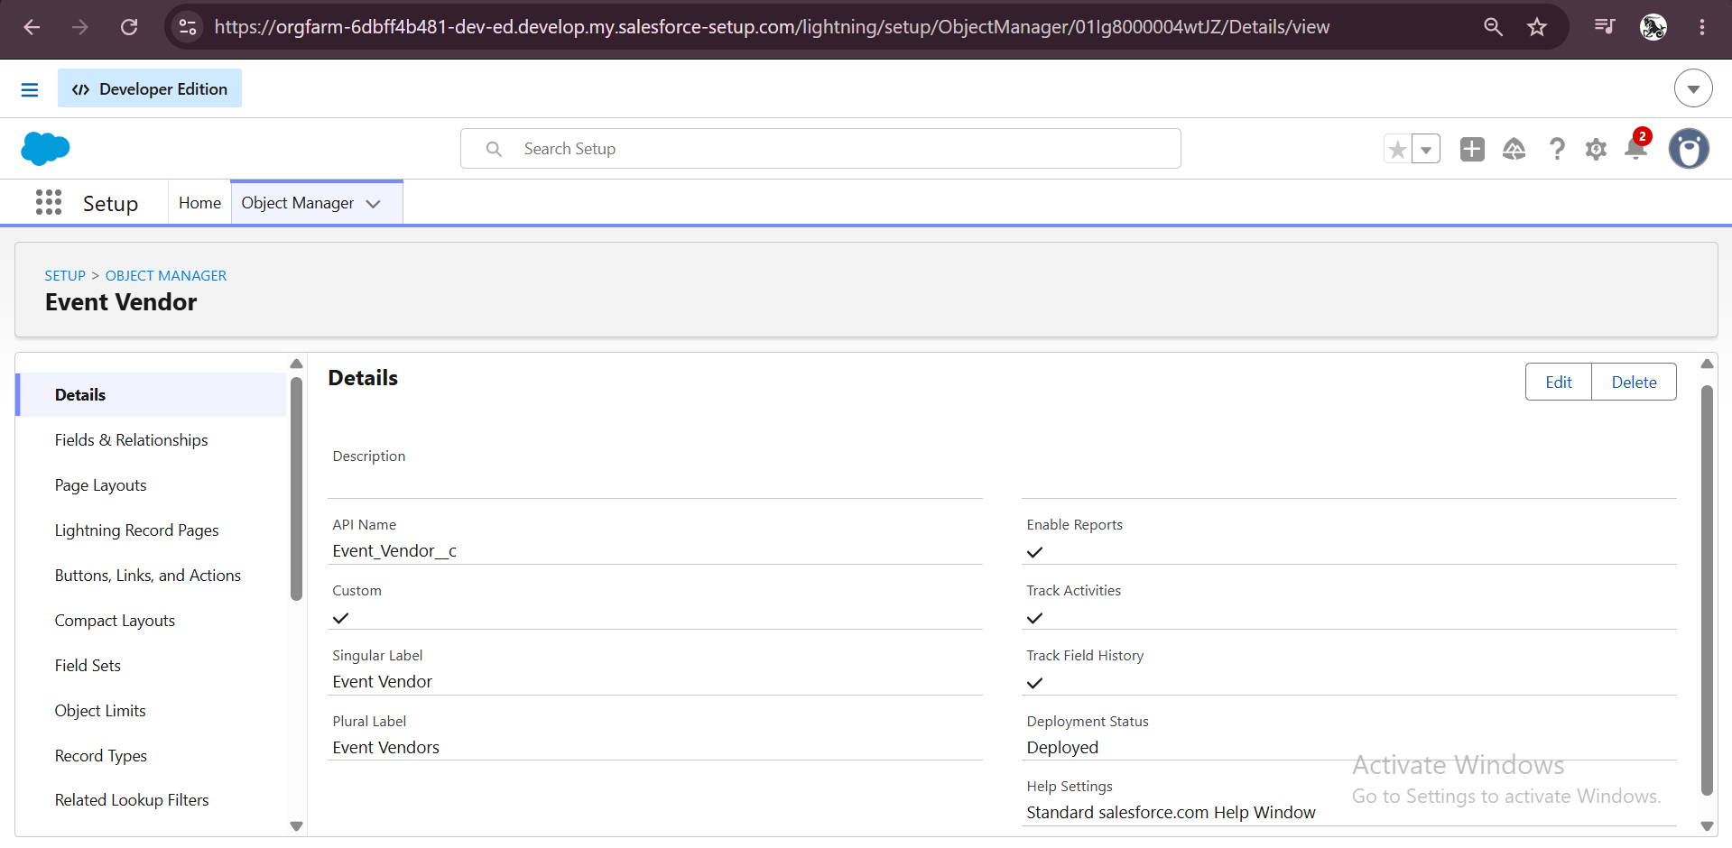
Figure 8: Event Vendor object details

8.4 Custom Tabs
A custom tab was created for every custom object (Clients, Events, Event Vendors, Feedbacks, Vendors and Venues) so that users can open each object from the navigation bar.
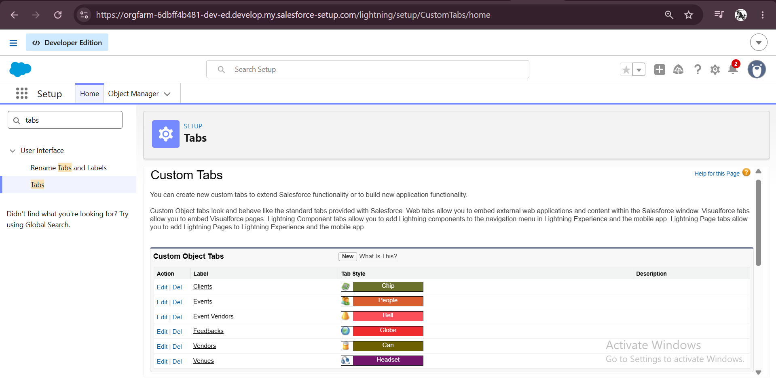
Figure 9: Custom Object Tabs in Setup

8.5 Fields
Object | Field | Data type / values
Event | Event Date | Date
Event | Event Type | Picklist: Wedding, Corporate, Birthday, Anniversary, Festival, Concert, Other
Event | Event Status | Picklist: Planned, Confirmed, Completed, Pending Cancellation, Canceled, Rejected
Event | Event Budget | Formula (Currency), based on the event type
Event | Client, Venue | Lookup relationships
Client | Email, Phone, Address | Email, Phone, Text Area
Client | Country, City | Picklists
Vendor | Service Type | Picklist (Multi-Select): Catering, Decor, Photography, Videography, Lighting, Stage Setup, Makeup Artist, DJ/Music, Transportation, Hosting/Anchor
Vendor | Email, Phone, Status | Email, Phone, Picklist: Available, Booked, Cancelled
Venue | Address, Location, Capacity | Text Area, URL, Number
Venue | Availability Status | Picklist: Available, Reserved, Not Available
Feedback | Rating, Comments | Picklist 1 to 5, Long Text Area
Feedback | Event, Client | Lookup relationships

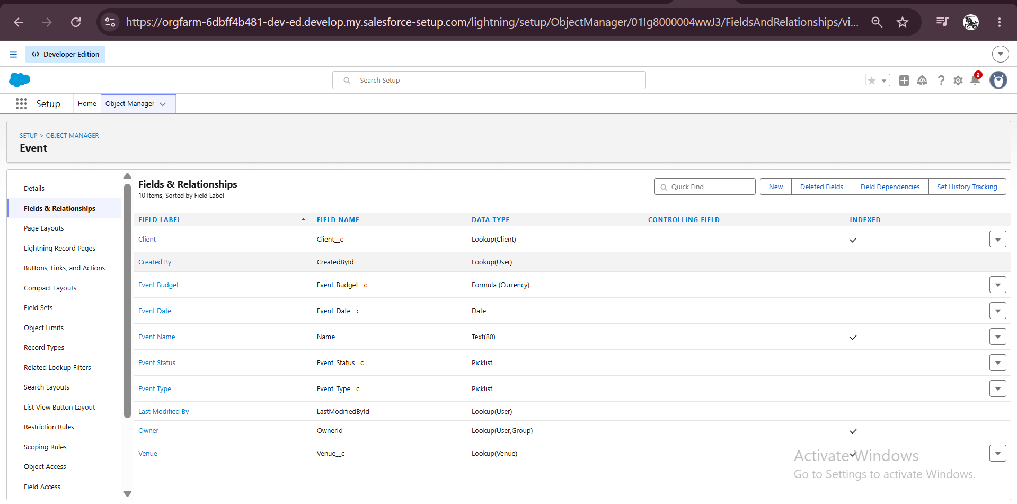
Figure 10: Fields and relationships of the Event object
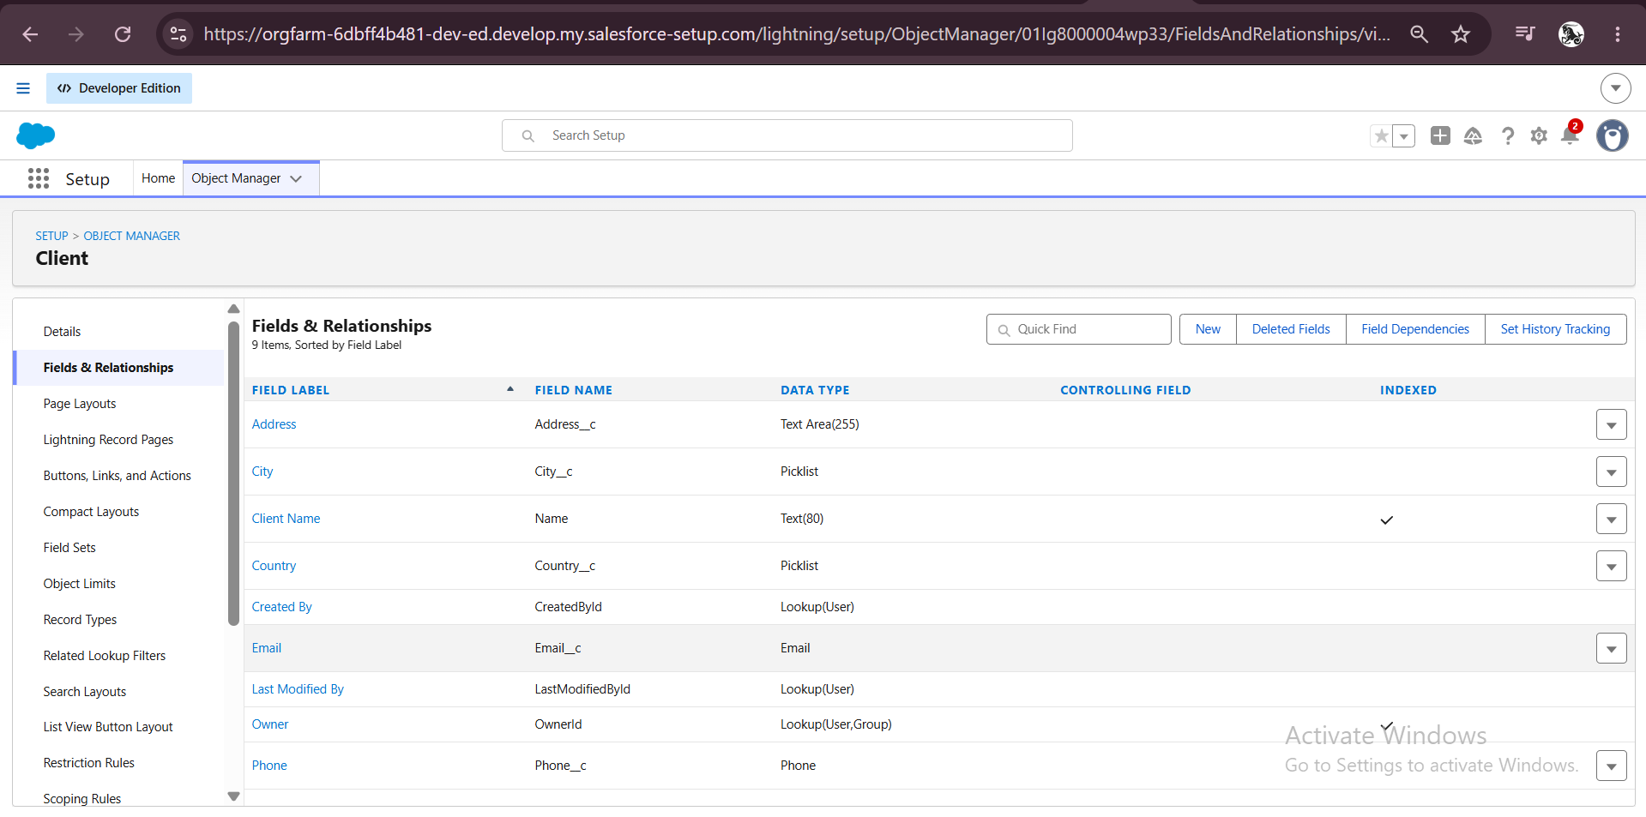
Figure 11: Fields of the Client object
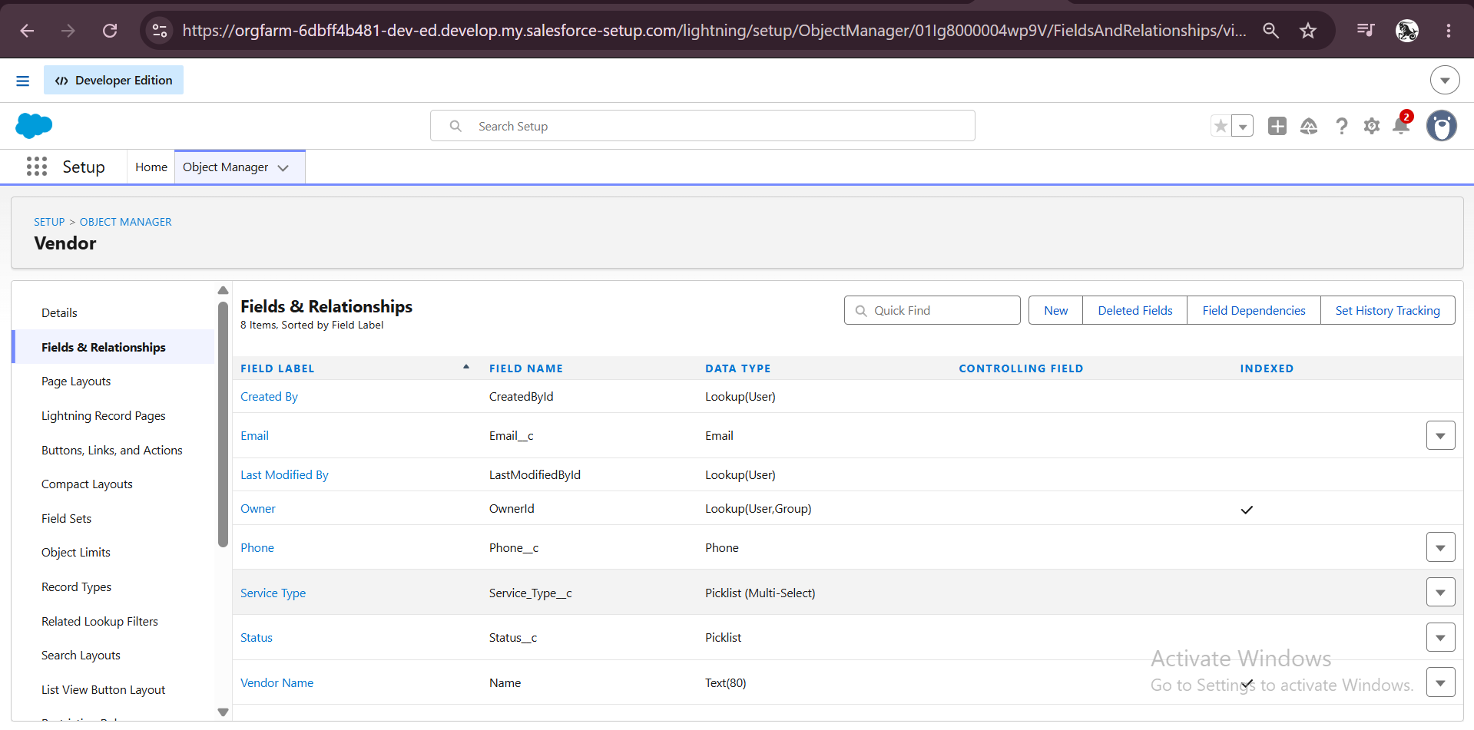
Figure 12: Fields of the Vendor object
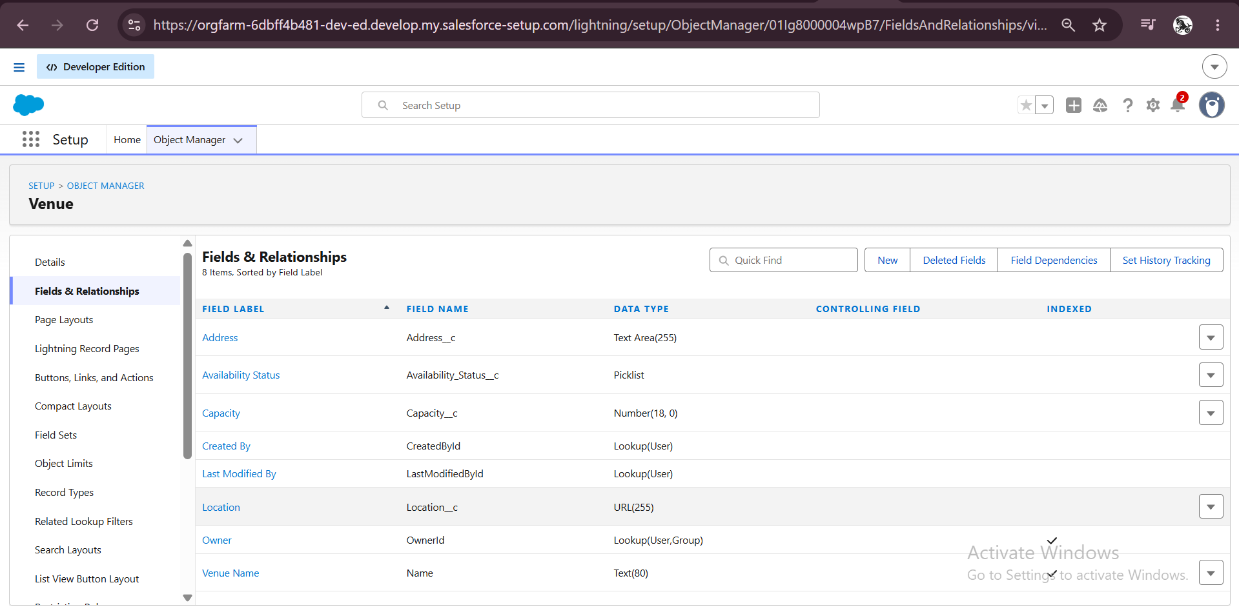
Figure 13: Fields of the Venue object
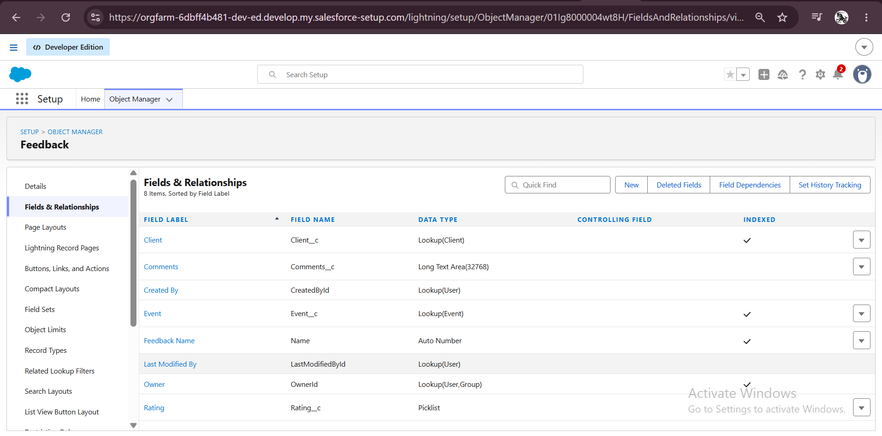
Figure 14: Fields of the Feedback object

Event Budget formula field
The Event Budget is not typed in by the user. A formula field calculates it from the event type: Wedding 50,000; Corporate 30,000; Birthday 10,000; Anniversary 20,000; Festival 60,000; Concert 40,000; Other 15,000; and 0 when no type is chosen.
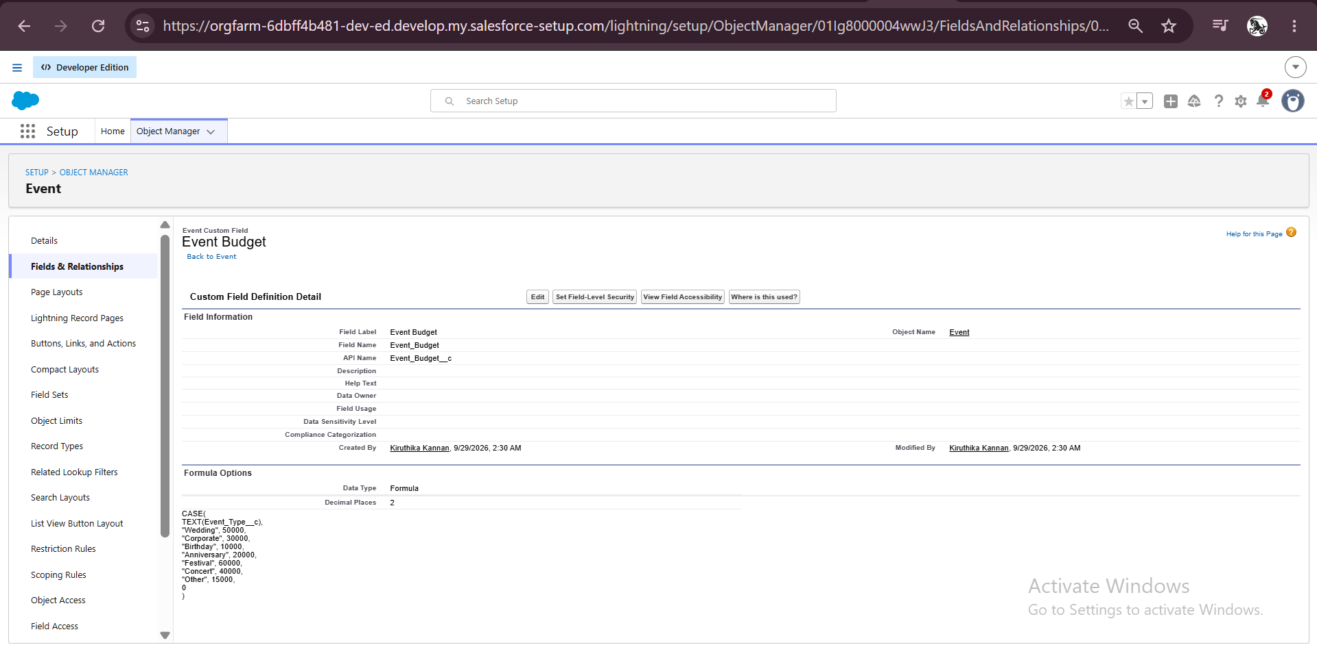
Figure 15: Event Budget formula field definition

8.6 Lookup Filter
On the Feedback object, the Event lookup was filtered so that only the events of the selected client can be chosen. The filter compares the Client on the Event record with the Client on the Feedback record, is marked Required and is enabled.
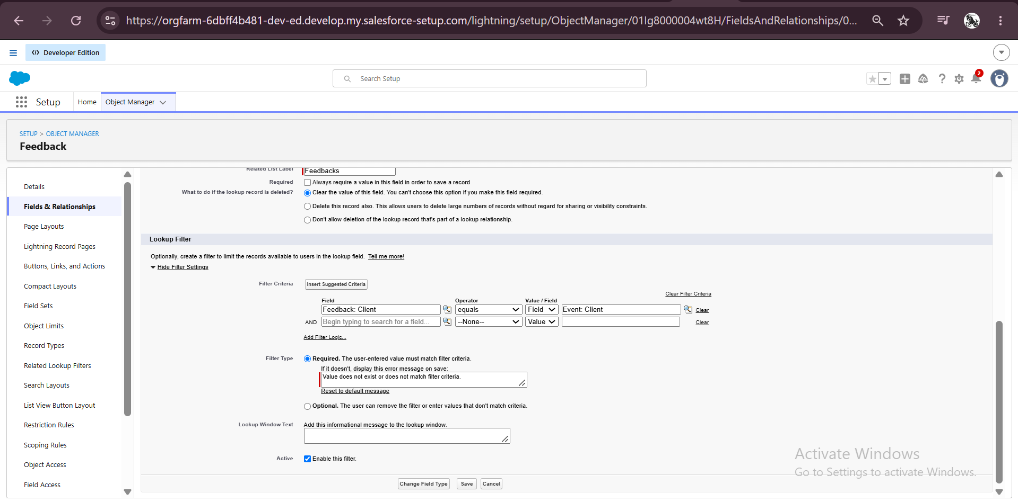
Figure 16: Lookup filter on the Feedback > Event field

8.7 Validation Rule
A validation rule named Email_Valid_Address was created on the Client object. It checks the email with a regular expression and blocks the save if the format is wrong. The error message "Please Enter Valid Email Address" is shown on the Email field.
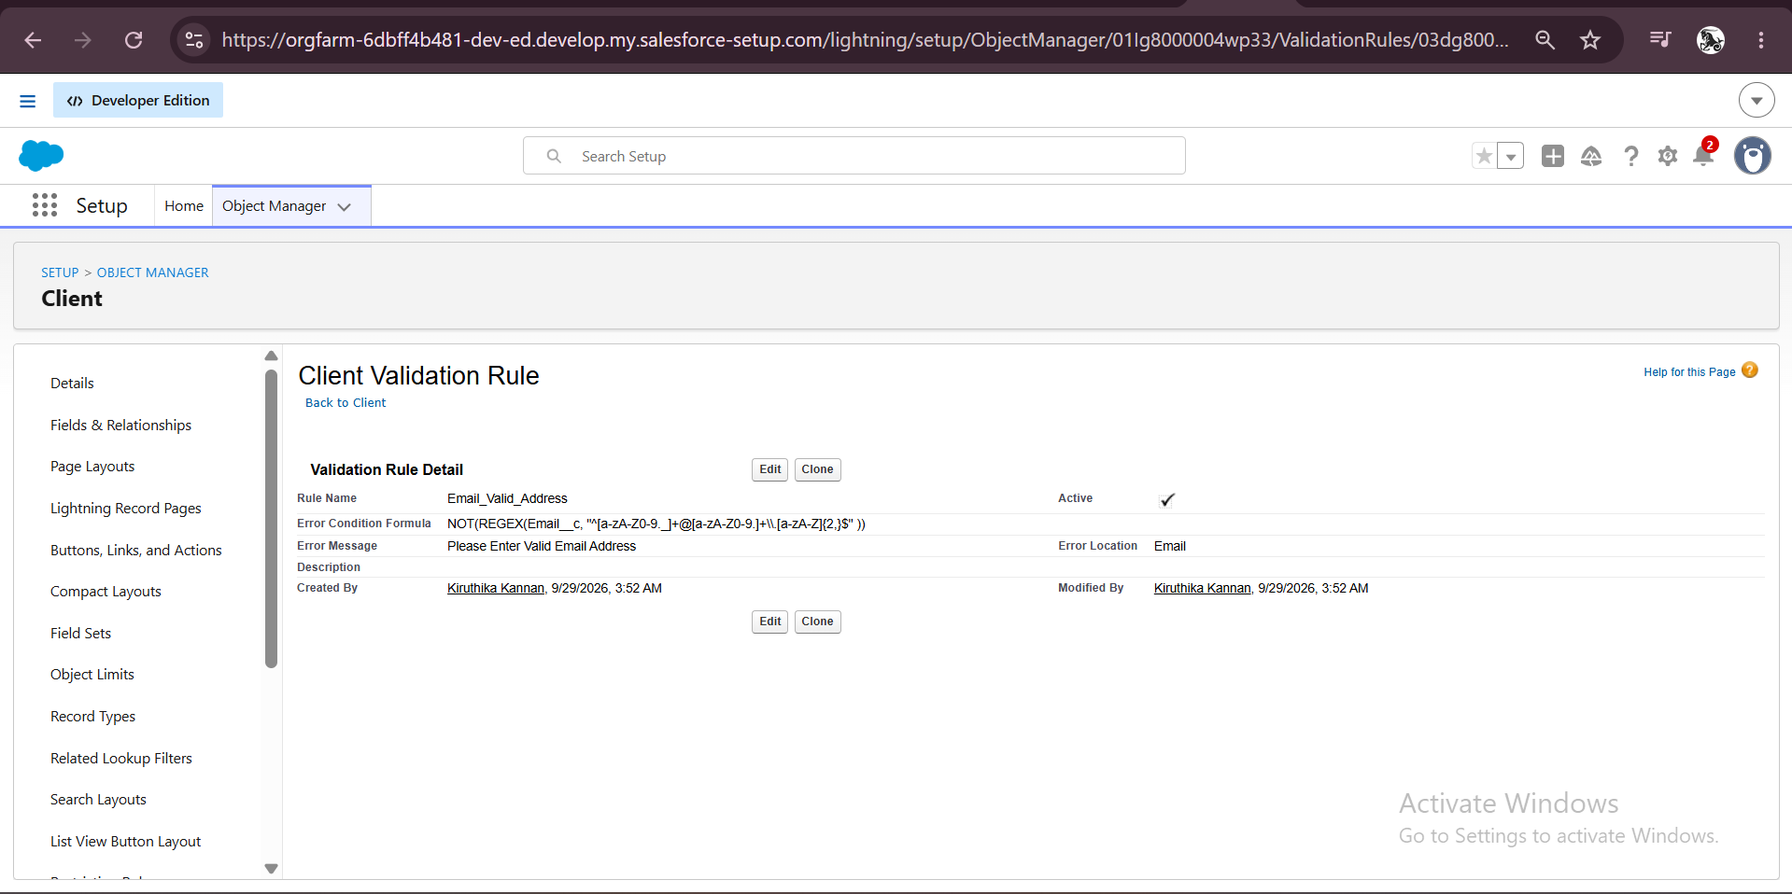
Figure 17: Validation rule Email_Valid_Address on the Client object
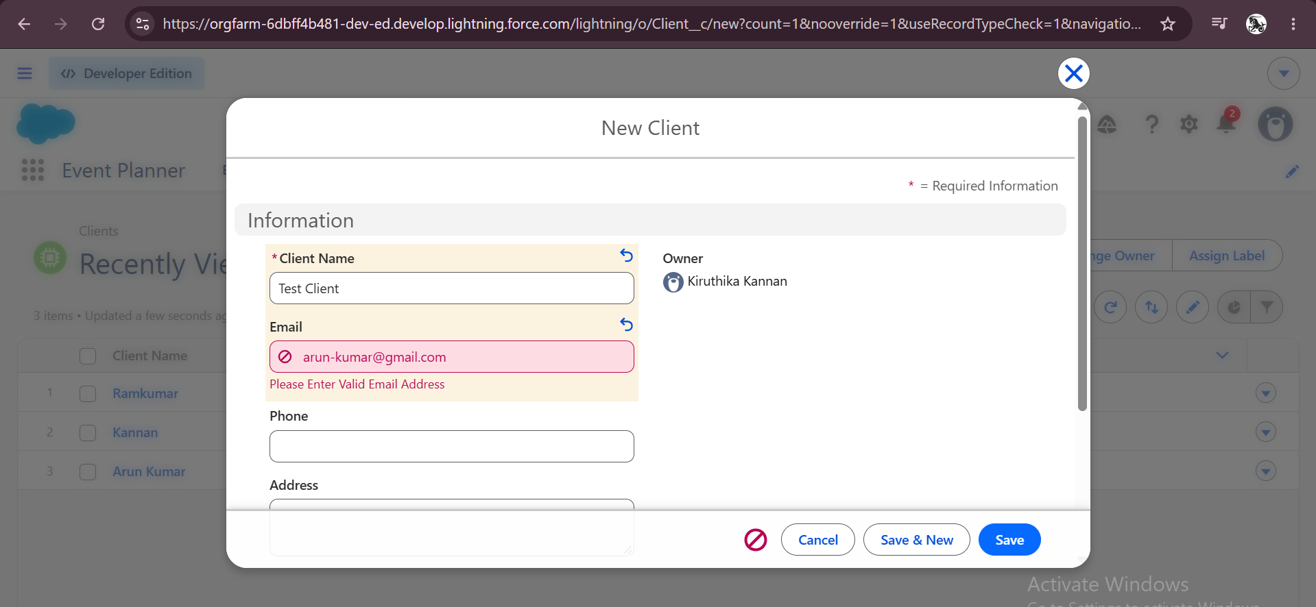
Figure 18: Error shown when an invalid email is entered

8.8 Approval Process for Event Cancellation
When a cancellation is requested, the request is sent to an approver instead of being accepted automatically. Email templates were created for the request, approval and rejection messages, and the approval process Event_Cancellation_Process was built on the Event object.
Setting | Value
Name | Event_Cancellation_Process
Object | Event
Entry criteria | Event Status equals Pending Cancellation
Record editability | Administrator only
Approval assignment email template | Event Cancellation Request Notification
Initial submitter | Event Owner
Initial submission actions | Record lock; email alert "Alert - Event Cancellation Request"
Approval steps | Step 1 (manager of the submitter) and Step 2 "Manager Review" (assigned to a specific user)
Final approval actions | Record lock; field update Event Status = Canceled; email alert "Alert - Cancellation Approved"
Final rejection actions | Unlock the record; field update Event Status = Rejected

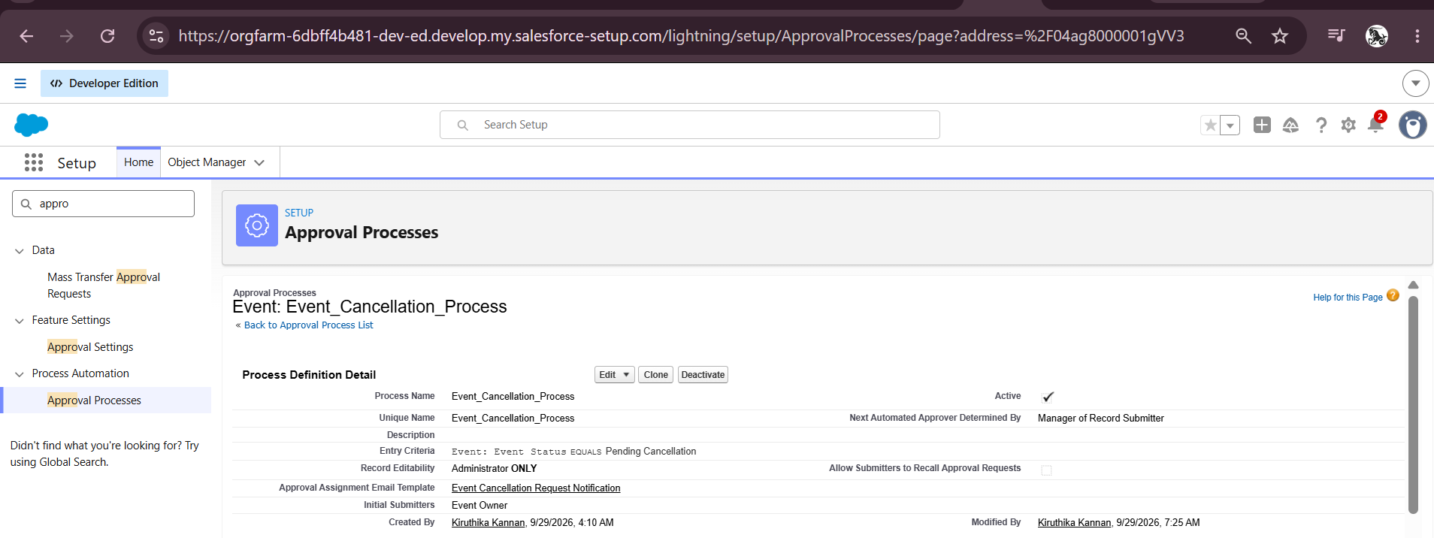
Figure 19: Approval process definition detail
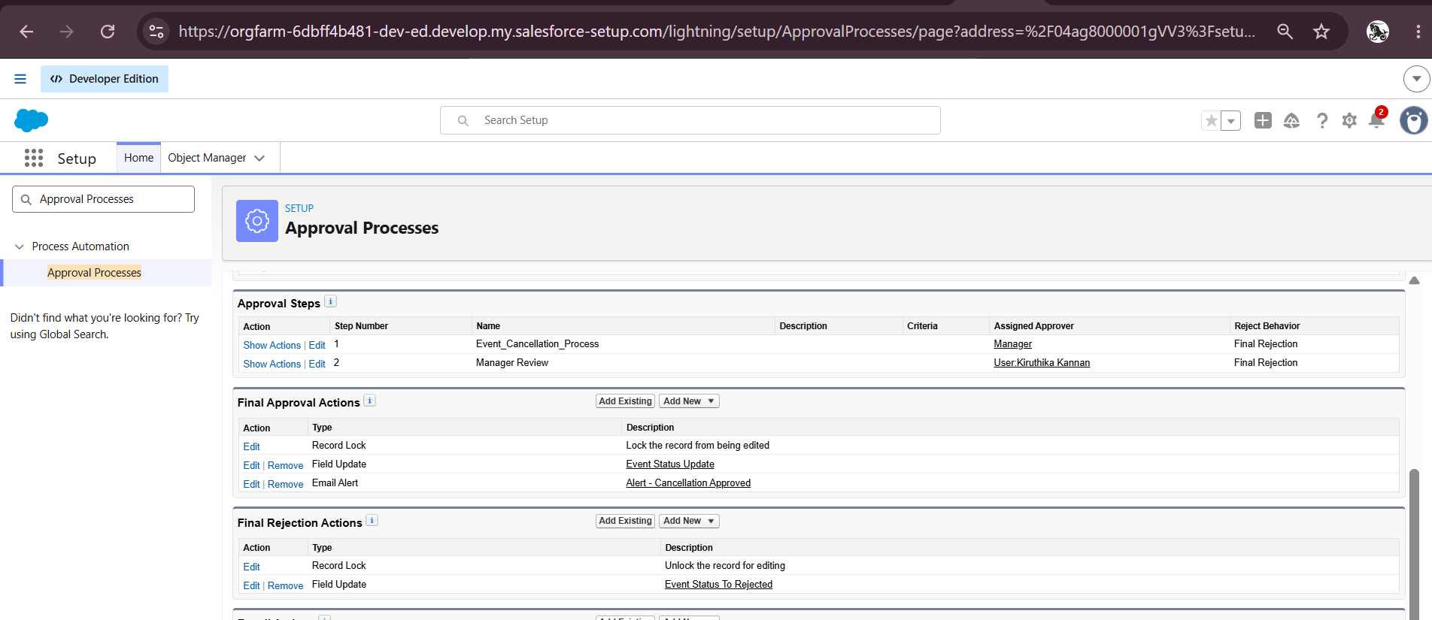
Figure 20: Approval steps, final approval actions and final rejection actions

8.9 Flow: Three-Day Client Reminder
A record-triggered Flow named Event_Reminder_Flow sends the client an email three days before an event.
- Object: Event. Trigger: a record is created or updated. Condition: Event Status equals Confirmed.
- A scheduled path named 3_Days_Before was added with the time source Event Date and an offset of 3 days before.
- Text template resources named Subject and Body were created. The body greets the client by name and lists the event name, date, venue and type.
- A Send Email action named Alert_Client_3Day_Reminder was added on the scheduled path. The recipient is the Client's email through the triggering Event record, and the event owner's email is in CC.
- The Flow was saved and activated.
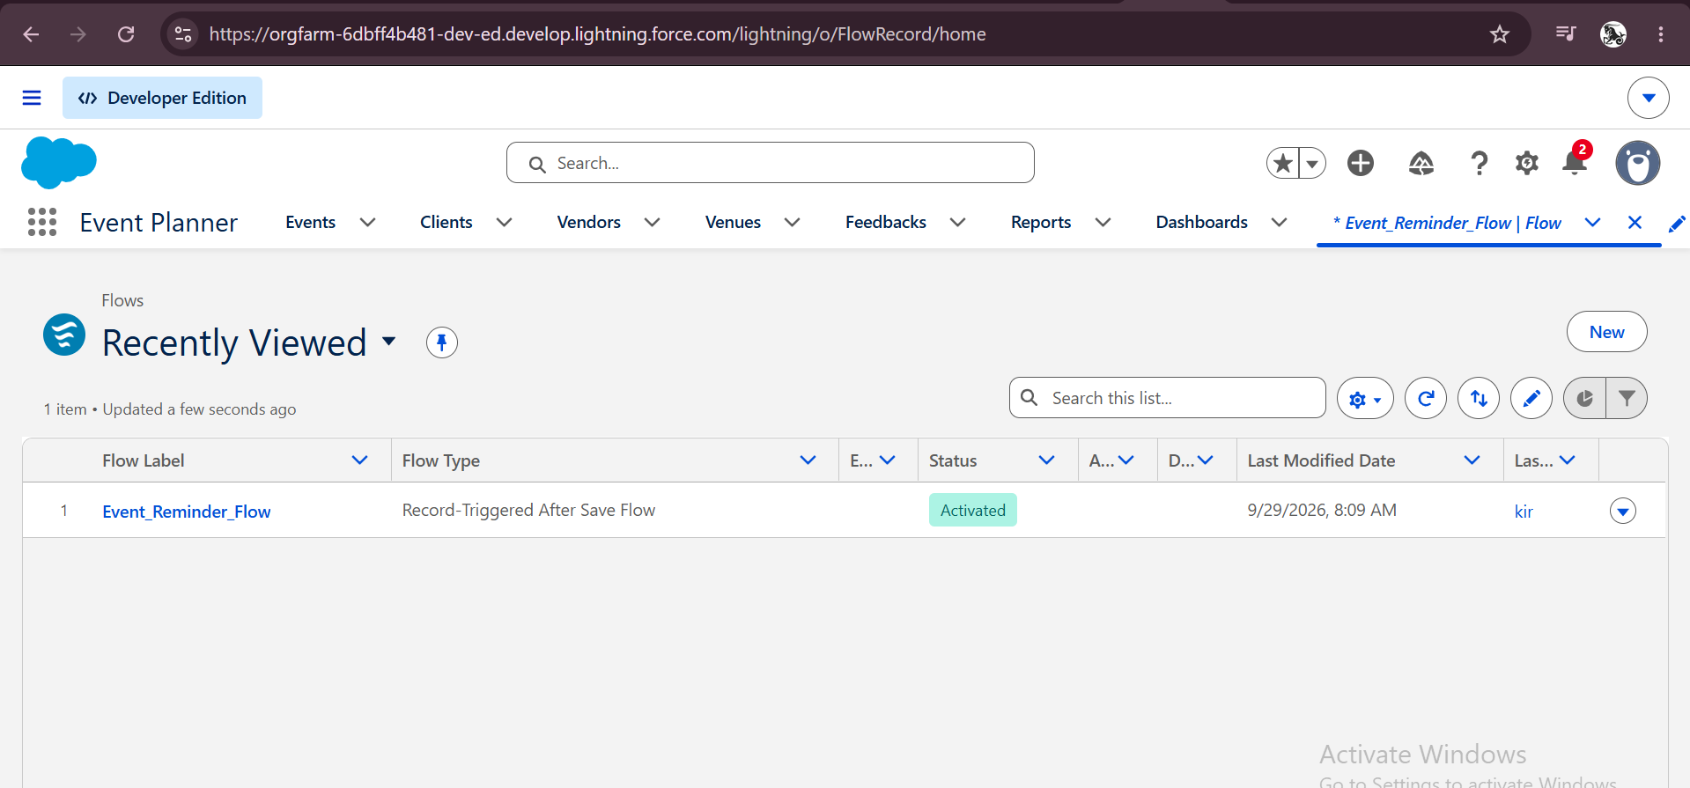
Figure 21: Event_Reminder_Flow shown as Activated

8.10 Apex Classes and Triggers
Apex was used where clicks were not enough. The complete code is available in Appendix A.

Venue availability (VenueStatusHelper and EventTrigger13)
When an event with a venue is saved as Confirmed, the venue's Availability Status becomes Reserved. When the event is Canceled, the venue becomes Available again. The helper class holds the logic and the trigger EventTrigger13 (after insert, after update) calls it.
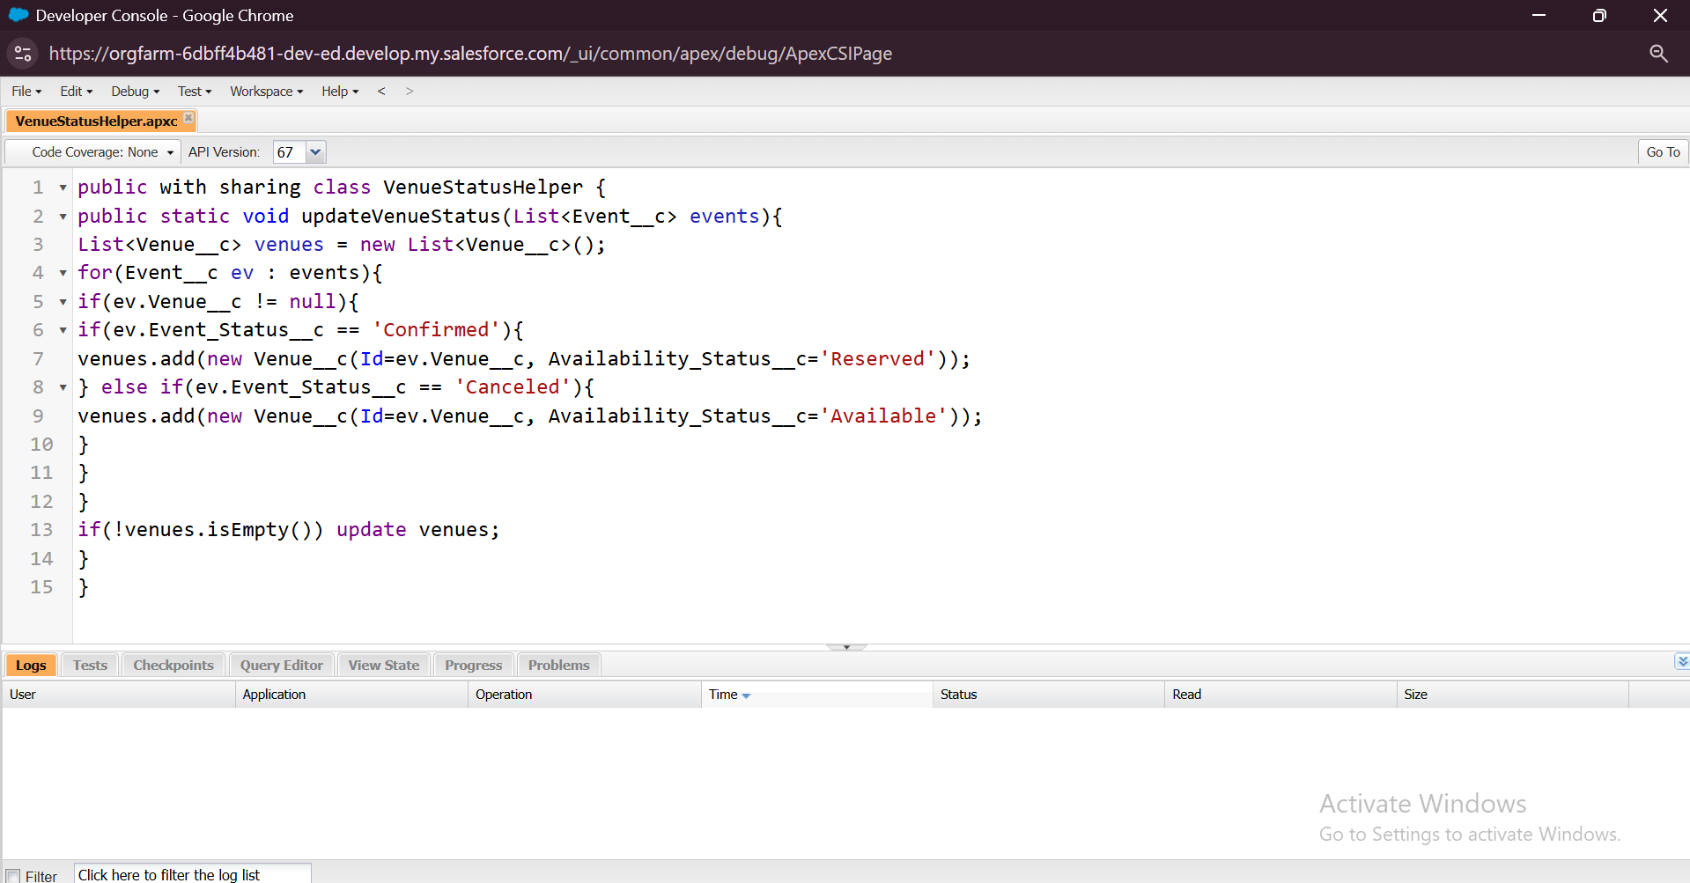
Figure 22: VenueStatusHelper class in Developer Console
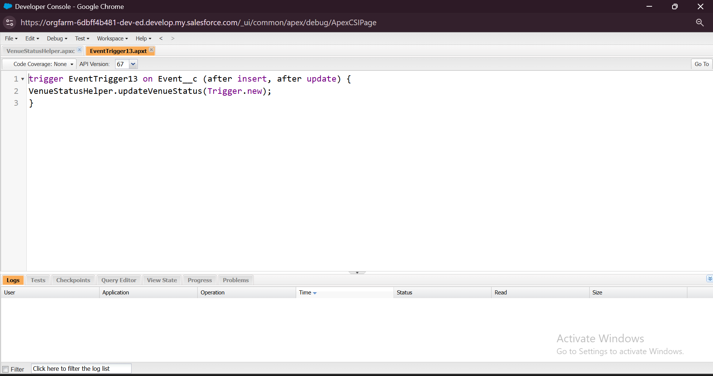
Figure 23: EventTrigger13 trigger in Developer Console

Double-booking prevention (PreventDoubleBooking)
This trigger runs before insert and before update. It collects the venues of the incoming events, reads other events at those venues and stops the save with the error "This Venue is already booked on this date." if another event exists on the same venue and date.
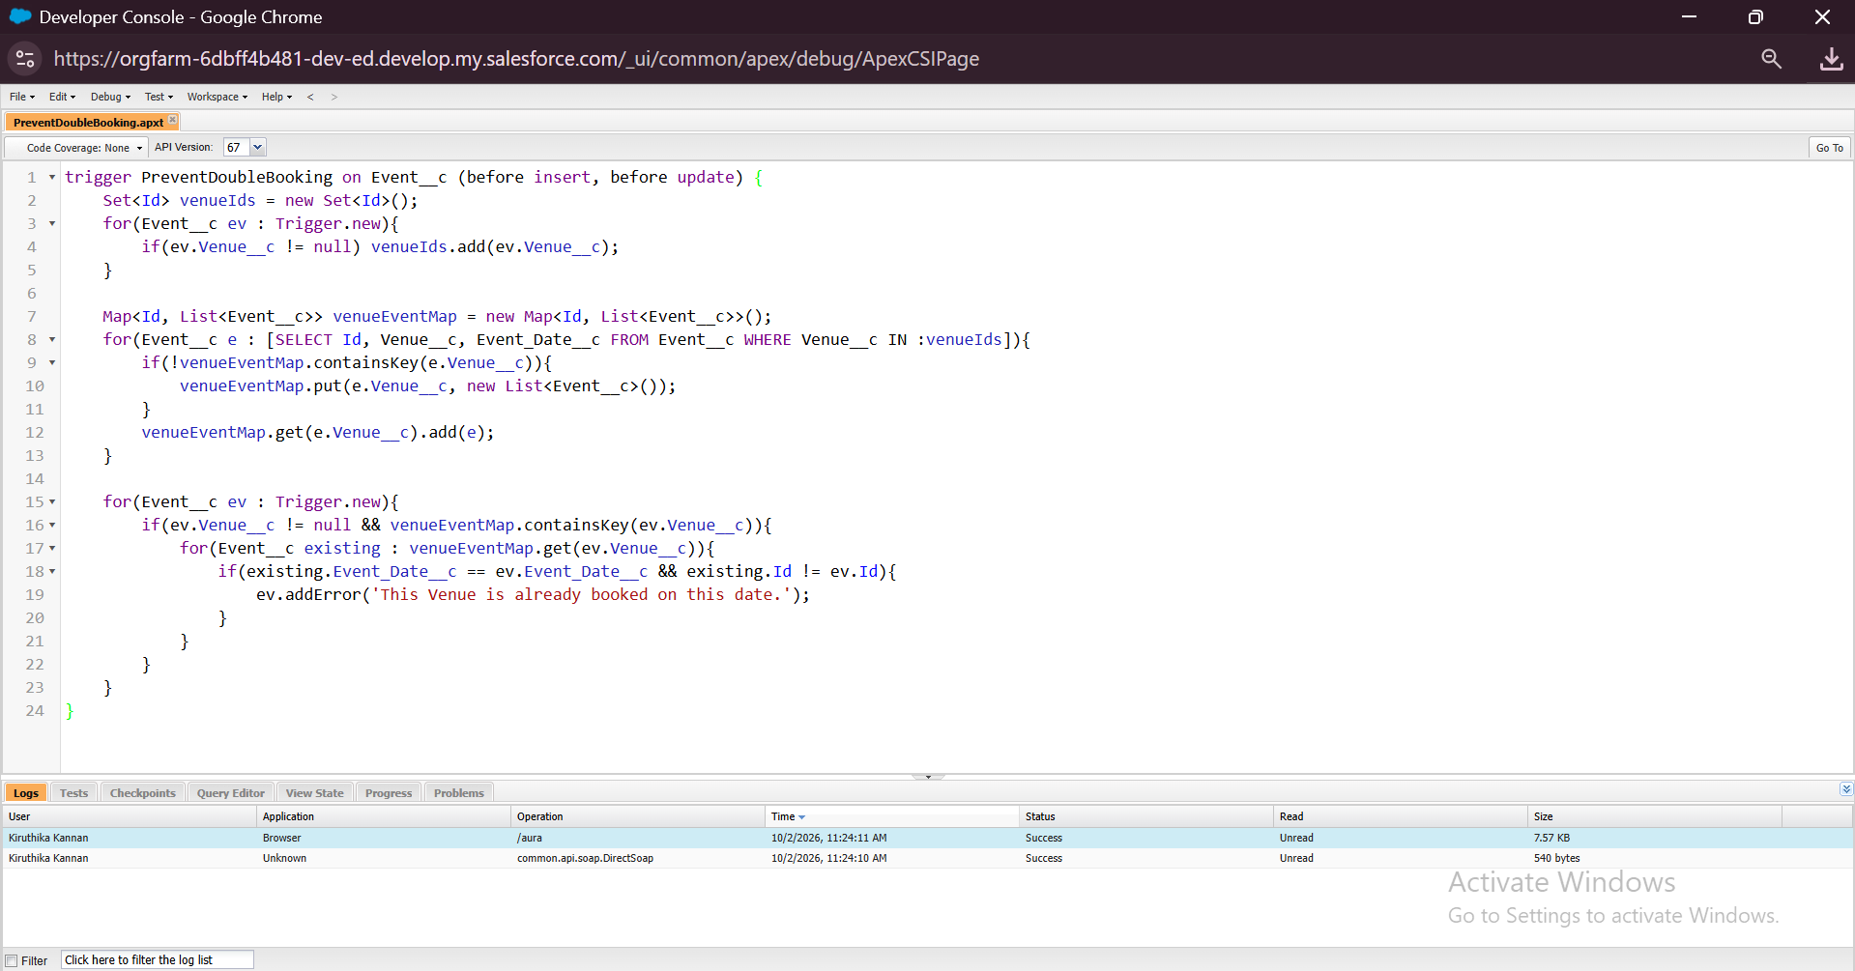
Figure 24: PreventDoubleBooking trigger
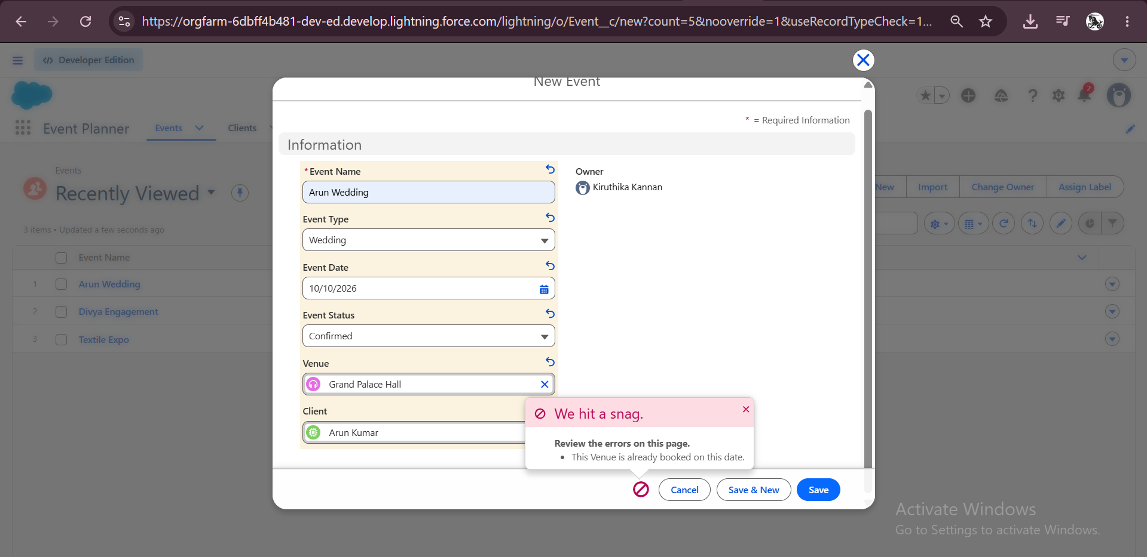
Figure 25: Error shown when the same venue is booked on the same date

Nightly completion of past events (Batch and Schedulable Apex)
BatchCompleteEvents selects events whose date is before today and whose status is not Completed, and sets their status to Completed. ScheduleCompleteEvents runs the batch in chunks of 200 records. The job Daily Event Completion was scheduled from Setup, Apex Classes, Schedule Apex, to run every day at 8:00 PM.
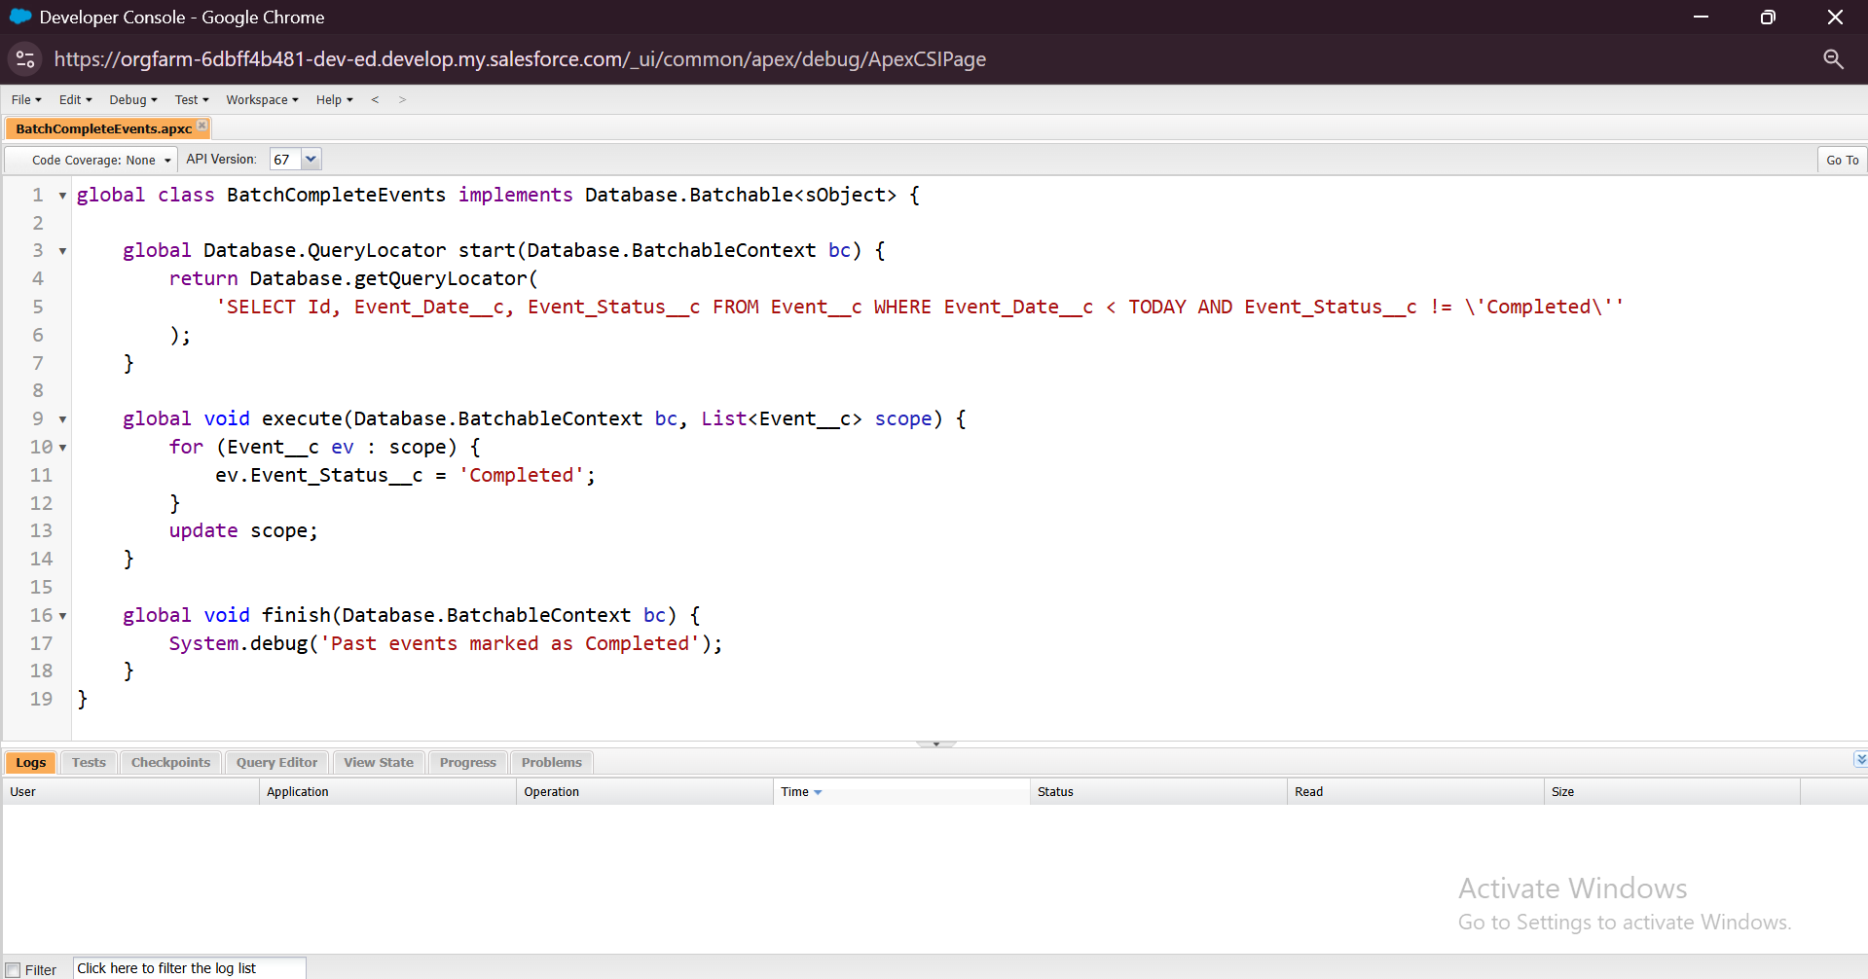
Figure 26: BatchCompleteEvents class in Developer Console
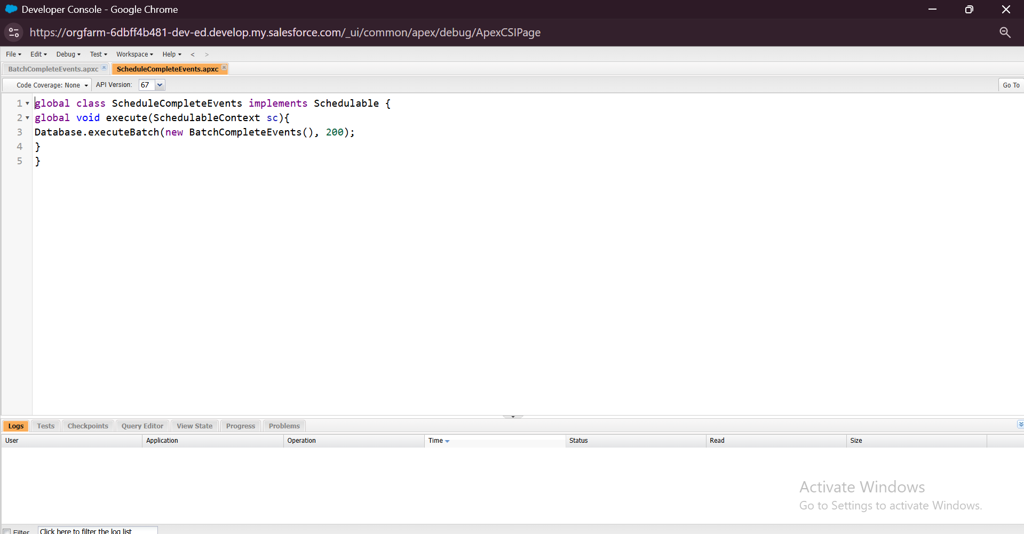
Figure 27: ScheduleCompleteEvents class in Developer Console
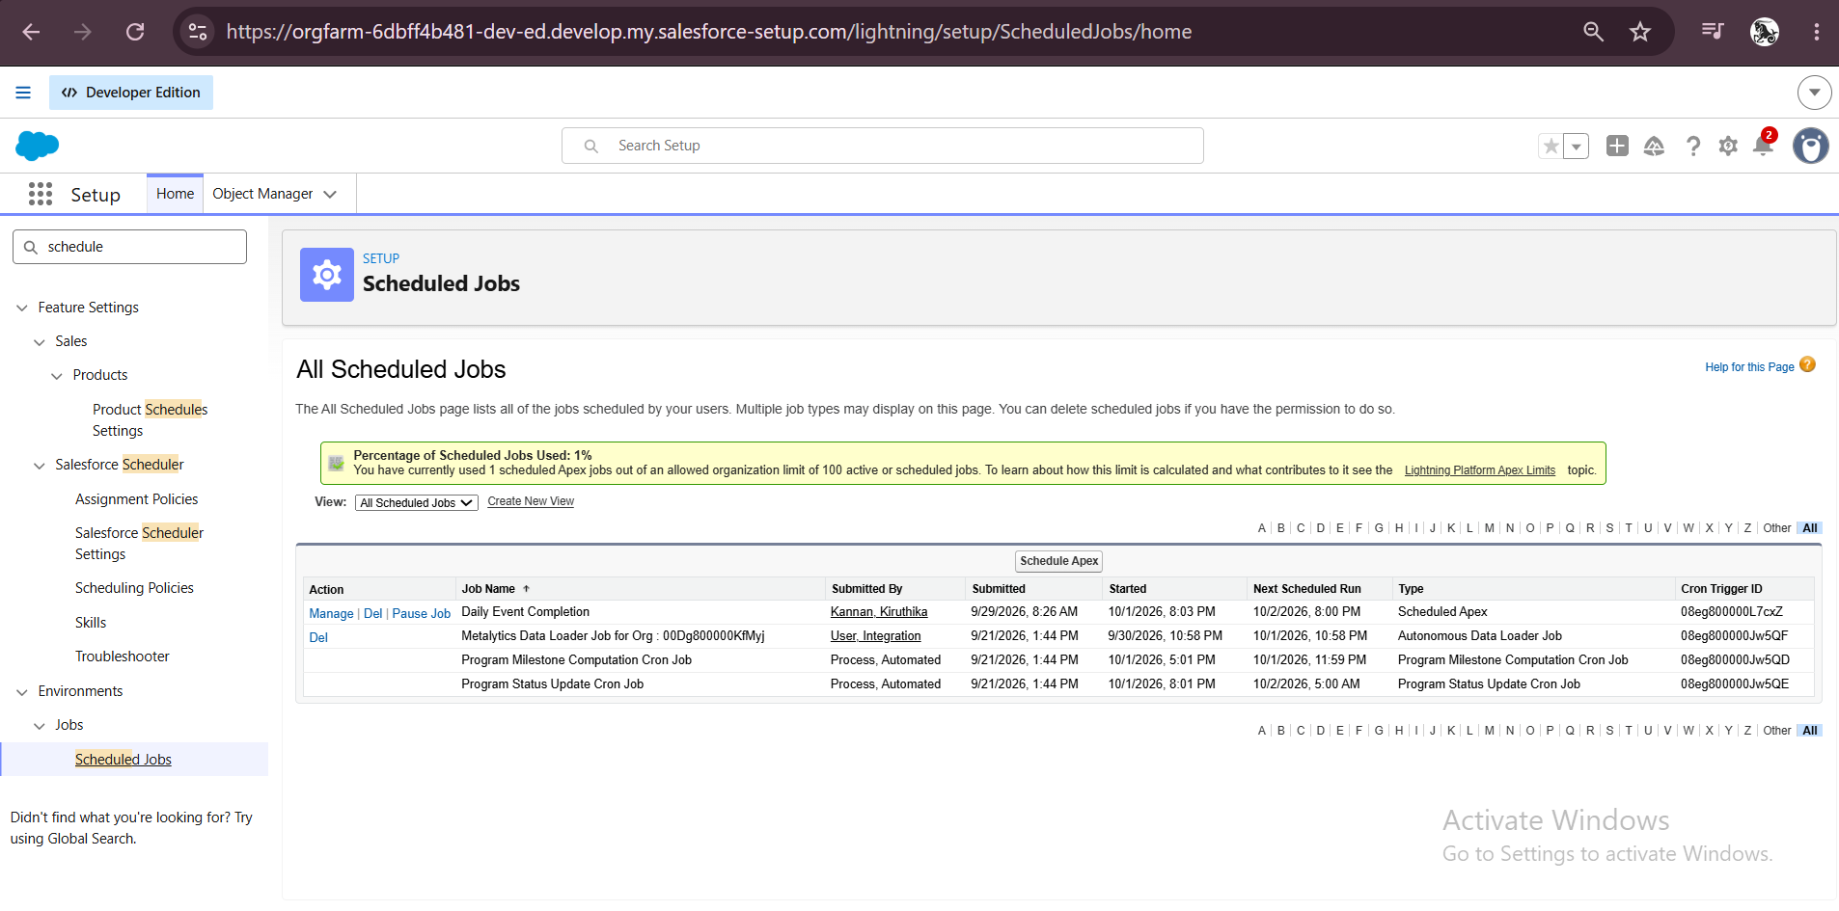
Figure 28: Scheduled job Daily Event Completion

9. Phase 3: UI/UX Development and Customization
This phase gave users a simple workspace and a clear view of the data.

9.1 Lightning App
A Lightning App named Event Planner was created from Setup, App Manager, New Lightning App. A logo image was uploaded and the navigation items Events, Clients, Vendors, Venues, Feedbacks, Reports and Dashboards were added. The app opens from the App Launcher.
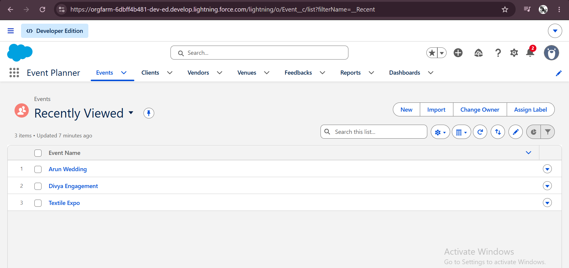
Figure 29: Event Planner app with its navigation tabs

9.2 Report
A report folder named EventForce Report was created. The report Upcoming Events by Month was built on the Events report type and saved in that folder.
Item | Setting
Columns | Event Name, Event Date, Event Type, Event Budget, Venue, Client
Filters | Event Date greater than or equal to TODAY; Event Status not equal to Canceled
Grouping | Event Date grouped by Calendar Month
Summary | Record count (row counts, subtotals and grand total enabled)
Chart | Bar chart of record count for each month

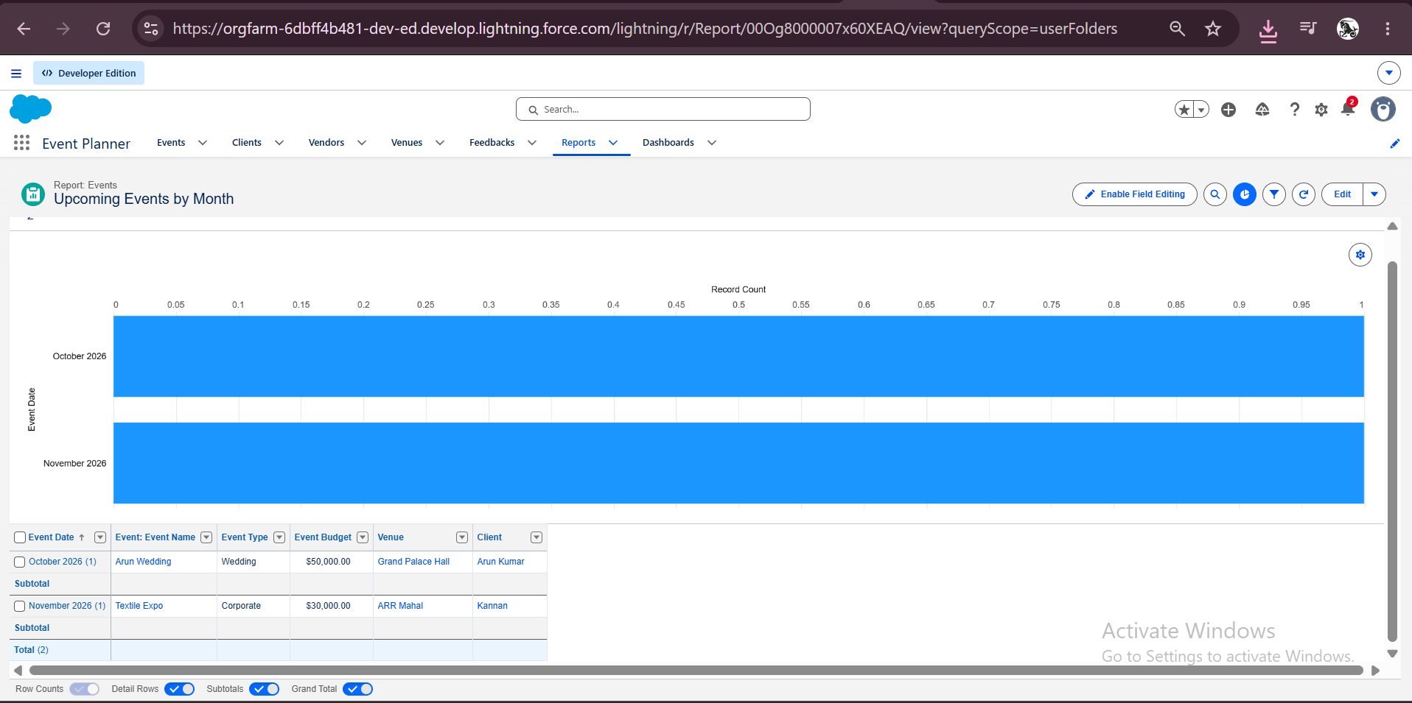
Figure 30: Upcoming Events by Month report with chart

9.3 Dashboard
The dashboard EventForce Operations Dashboard contains a donut chart widget based on the Upcoming Events by Month report, with a maximum of 6 values displayed, the subtitle "Upcoming Events Overview" and the light theme.
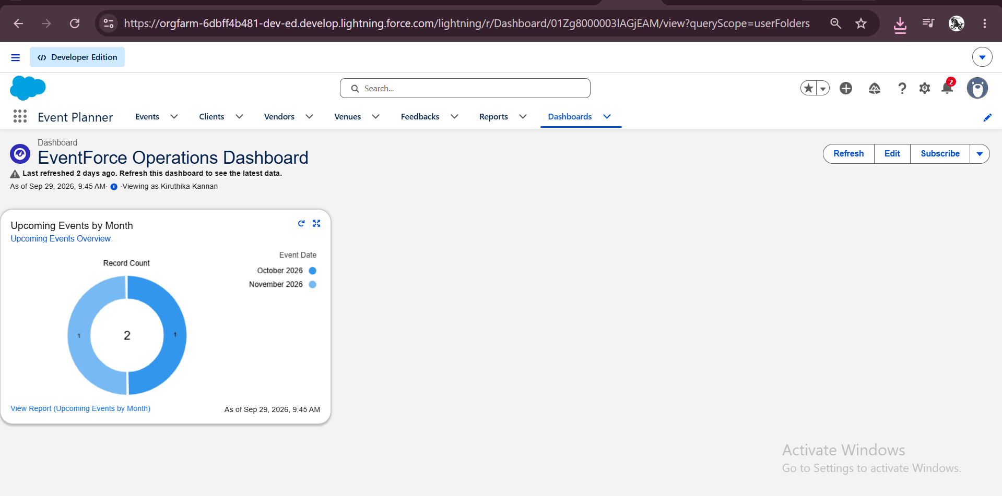
Figure 31: EventForce Operations Dashboard

10. Phase 4: Data Migration, Testing and Security

10.1 Sample Data
Sample records were created for the Event and Client objects so that every feature could be tested, for example the events Arun Wedding and Textile Expo that appear in the report and dashboard. For larger data sets the Data Import Wizard (Setup, Data Import Wizard, Custom Objects) can be used with CSV files, loading parent objects first so that lookups can be matched.

10.2 Roles
A role hierarchy was created under the organization name. The roles Event Admin, Vendor Manager, Client, Event Manager and Event Coordinator were added, so that users higher in the hierarchy can see the records of the users beneath them.
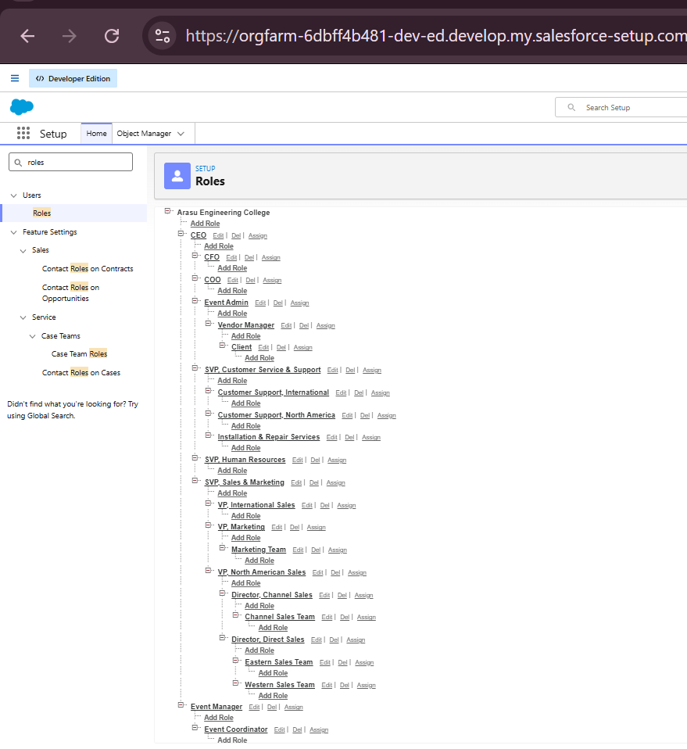
Figure 32: Role hierarchy

10.3 Profiles
Custom profiles Event Coordinator, Vendor Manager and Client Profile were created as clones of a standard profile, and each was given object access that matches the role.
Profile | Intended object access
Event Coordinator | Event: create, read, edit, delete. Client: read, edit. Vendor and Venue: read. Feedback: create, read.
Vendor Manager | Read-only access to Event, Venue, Client and Feedback.
Client Profile | Event: read only. Feedback: create, read. No access to Vendor and Venue.

10.4 Users
Users were created for the Event Coordinator, Vendor Manager and Client roles. Each user has the matching role and profile, as shown below. The administrator account keeps the System Administrator profile.
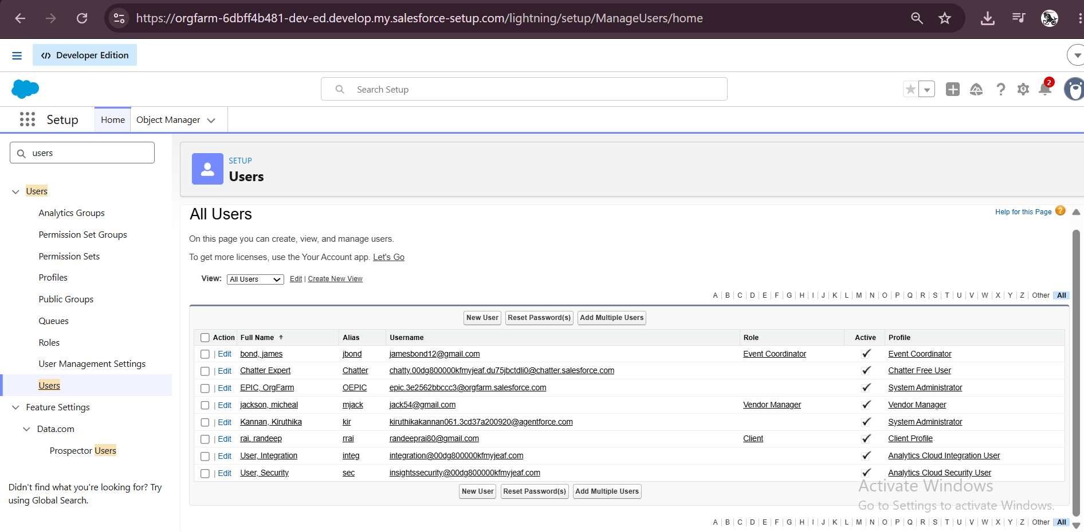
Figure 33: Users with their roles and profiles

10.5 Permission Set
A permission set named Feedback Manager was created to grant extra object permissions on Feedback (read, create, edit and delete) without changing a user's profile.
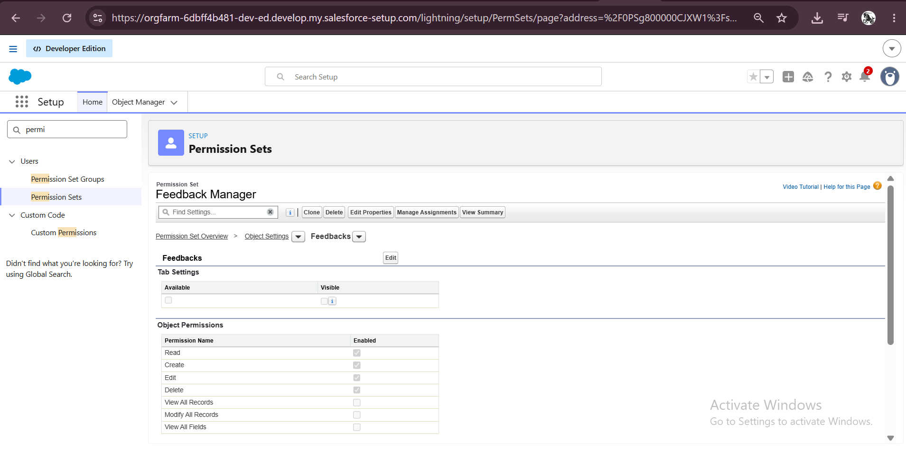
Figure 34: Feedback Manager permission set, object permissions for Feedbacks

10.6 Sharing Settings
The organization-wide default for the Event object was set to Private for internal and external access. Client, Feedback, Vendor and Venue are Public Read/Write internally. To let vendor managers see events, an owner-based sharing rule was created on Event: records owned by members of the Event Coordinator role are shared with the Vendor Manager role with Read Only access.
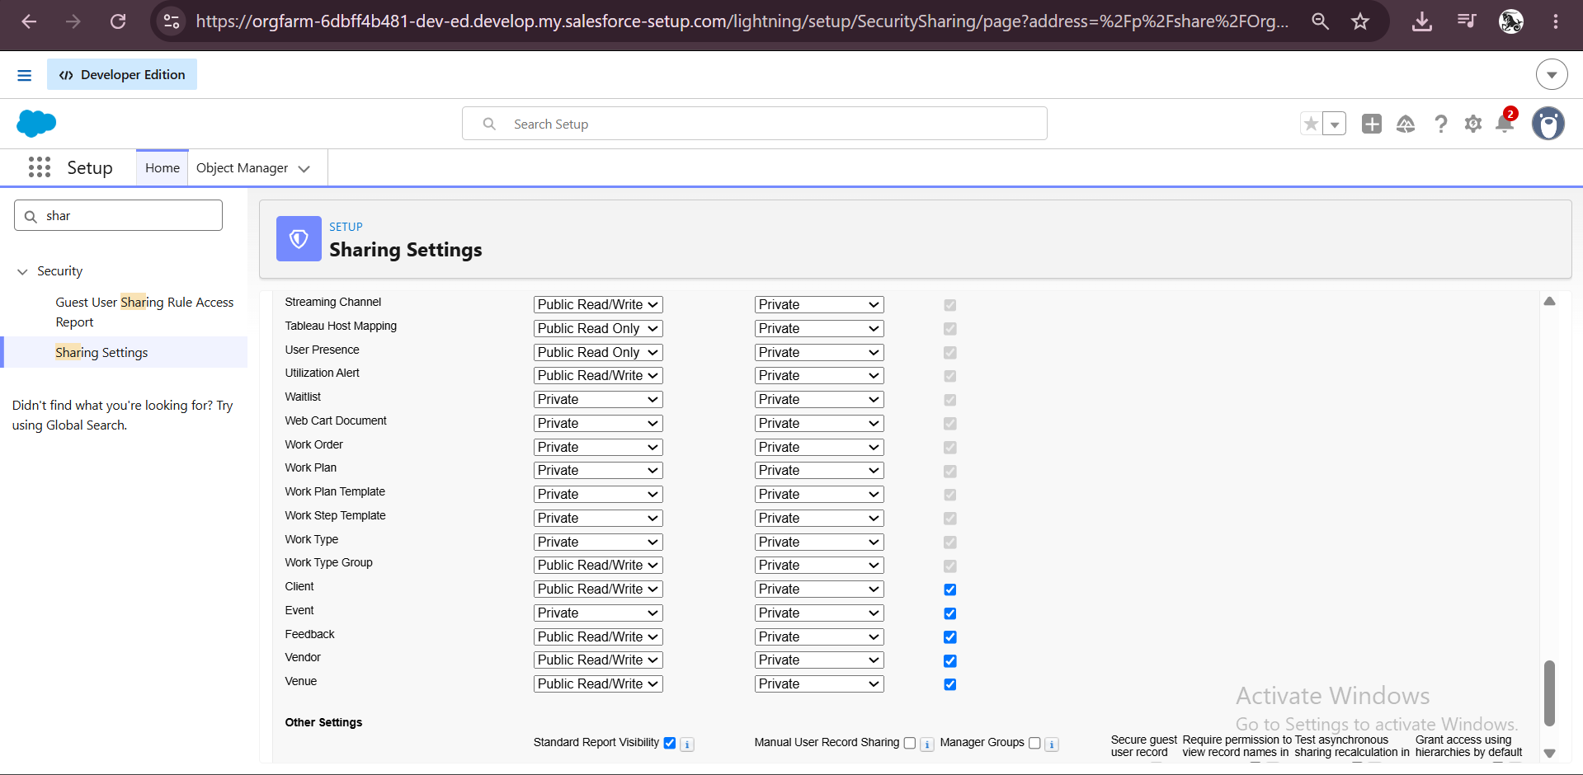
Figure 35: Organization-wide defaults
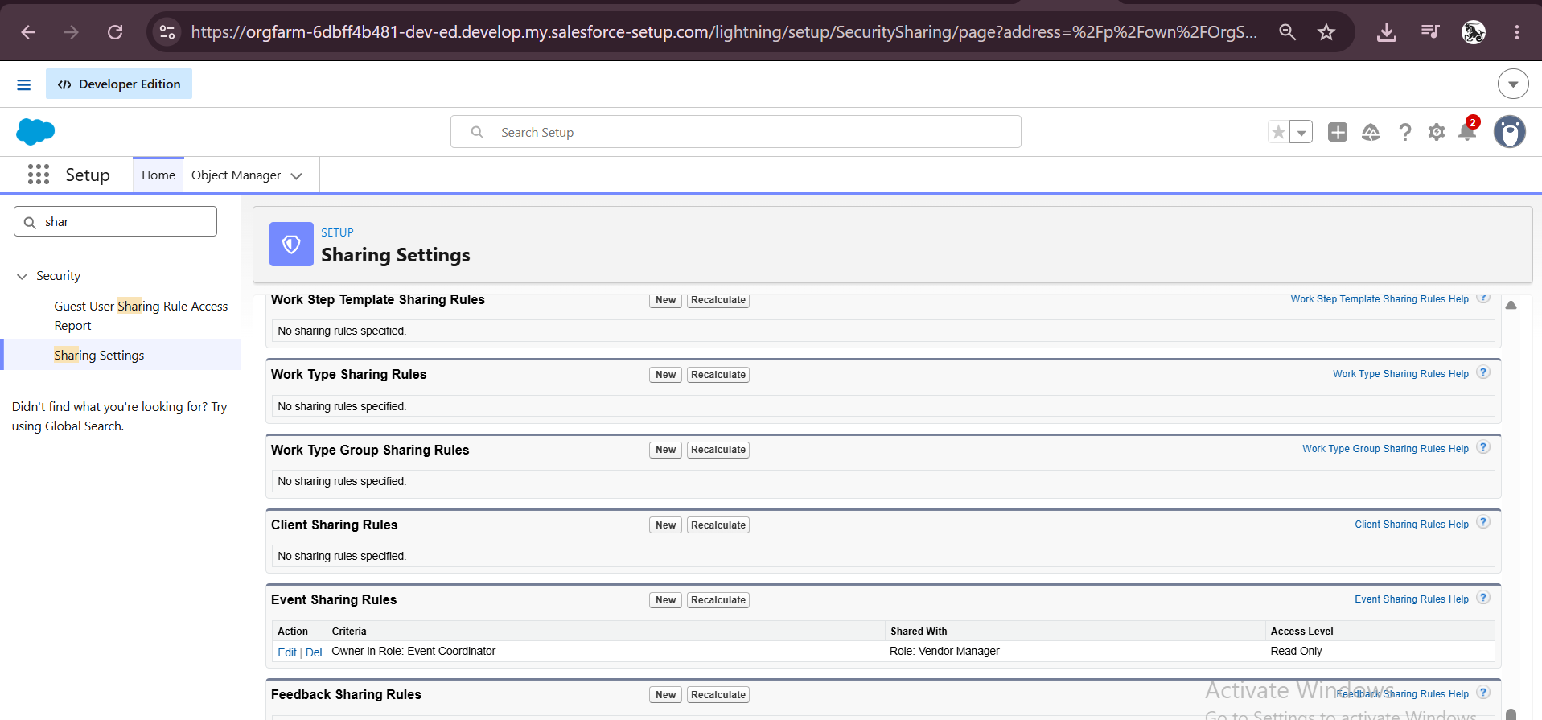
Figure 36: Event sharing rule: Event Coordinator to Vendor Manager (Read Only)

10.7 Testing
Each feature was tested after it was built. The results are summarized below.
No. | Test case | Expected result | Result
1 | Save a client with an invalid email | Error: Please Enter Valid Email Address | Pass
2 | Create events of type Wedding and Corporate | Event Budget shows 50,000 and 30,000 | Pass
3 | Book a second event at the same venue on the same date | Error: This Venue is already booked on this date. | Pass
4 | Schedule the nightly Apex job | Job Daily Event Completion appears in Scheduled Jobs with a next run time | Pass
5 | Open the report and dashboard | Events grouped by month; dashboard shows the donut chart | Pass

Functional testing evidence
Each result above was checked in the Salesforce user interface. The screenshots below show the outcome of the tests.
Figure 37: Test 1: invalid email blocked by the validation rule
Figure 38: Test 3: double booking blocked by the Apex trigger
Figure 39: Test 4: nightly Apex job scheduled
Figure 40: Test 5: report showing upcoming events by month
Figure 41: Test 5: dashboard showing the donut chart

Performance considerations
The Apex code is written for bulk processing. The triggers collect records in sets and maps, run one query and one update for the whole batch of records, and the nightly job processes records in chunks of 200, so the code stays within Salesforce governor limits.

11. Phase 5: Deployment, Documentation and Maintenance

11.1 Deployment
All configuration and code was built and tested in a Developer Edition org. A Developer Edition org is a standalone environment and is not connected to a production org, so a real production deployment was not carried out. In an enterprise setting the same components (objects, fields, flows, Apex, reports and dashboards) would be moved through a sandbox using change sets or Salesforce DX with version control such as GitHub. The code and documentation of this project are kept in a GitHub repository so that they are organized and ready for migration.

11.2 Maintenance, Monitoring and Troubleshooting
- Monitor Apex jobs, flows and approval processes regularly to catch failures early.
- Fix access problems by checking profiles, permission sets, roles and sharing rules.
- Debug triggers and flows with the Developer Console and debug logs.
- Update validation rules and sharing settings as business needs change.

11.3 Documentation
This document records the business purpose, the data model, the automation, the security model and the testing of the system, together with screenshots. It is intended to help future developers and administrators understand and extend the application.

12. Challenges Faced and Fixes
Problem | Cause | Fix
Apex error: Illegal string literal, line breaks are not allowed | The SOQL query inside BatchCompleteEvents was split over two lines. | The query string was written on a single line.
Send Email action in the Flow showed an error | The recipient address was empty. | The recipient was set to the triggering Event's Client email.
Approval step showed "You must enter a value" | The approver field was left blank. | A user was selected as approver with the lookup icon.
Report displayed "No Results" | Event records had dates in the past, so the TODAY filter excluded them. | Events with future dates were created and the report was refreshed.
Double-booking error did not appear | The PreventDoubleBooking trigger body was empty. | The full trigger code was pasted and saved, and the error then appeared.

13. Conclusion
The EventForce Management System shows how Salesforce can organize and automate the work of an event planning business. With a clear data model, a validation rule, an approval process, a reminder Flow, Apex logic, a Lightning App, a report and a dashboard, the application reduces manual effort and gives every user a clear, secure view of the data they need.
Building the project gave practical experience in requirement analysis, object and relationship design, declarative automation, Apex development, security configuration, testing and documentation. Although the project was completed in a Developer Org for learning, it reflects how a real Salesforce implementation is planned and delivered, and it can be extended in the future with production deployment, more reports and integrations.

Appendix A: Apex Source Code

VenueStatusHelper.cls
public with sharing class VenueStatusHelper {
public static void updateVenueStatus(List<Event__c> events){
List<Venue__c> venues = new List<Venue__c>();
for(Event__c ev : events){
if(ev.Venue__c != null){
if(ev.Event_Status__c == 'Confirmed'){
venues.add(new Venue__c(Id=ev.Venue__c, Availability_Status__c='Reserved'));
} else if(ev.Event_Status__c == 'Canceled'){
venues.add(new Venue__c(Id=ev.Venue__c, Availability_Status__c='Available'));
}
}
}
if(!venues.isEmpty()) update venues;
}
}

EventTrigger13.trigger
trigger EventTrigger13 on Event__c (after insert, after update) {
VenueStatusHelper.updateVenueStatus(Trigger.new);
}

PreventDoubleBooking.trigger
trigger PreventDoubleBooking on Event__c (before insert, before update) {
Set<Id> venueIds = new Set<Id>();
for(Event__c ev : Trigger.new){
if(ev.Venue__c != null) venueIds.add(ev.Venue__c);
}
Map<Id, List<Event__c>> venueEventMap = new Map<Id, List<Event__c>>();
for(Event__c e : [SELECT Id, Venue__c, Event_Date__c FROM Event__c WHERE Venue__c IN :venueIds]){
if(!venueEventMap.containsKey(e.Venue__c)){
venueEventMap.put(e.Venue__c, new List<Event__c>());
}
venueEventMap.get(e.Venue__c).add(e);
}
for(Event__c ev : Trigger.new){
if(ev.Venue__c != null && venueEventMap.containsKey(ev.Venue__c)){
for(Event__c existing : venueEventMap.get(ev.Venue__c)){
if(existing.Event_Date__c == ev.Event_Date__c && existing.Id != ev.Id){
ev.addError('This Venue is already booked on this date.');
}
}
}
}
}

BatchCompleteEvents.cls
global class BatchCompleteEvents implements Database.Batchable<sObject> {
global Database.QueryLocator start(Database.BatchableContext bc) {
return Database.getQueryLocator(
'SELECT Id, Event_Date__c, Event_Status__c FROM Event__c WHERE Event_Date__c < TODAY AND Event_Status__c != \'Completed\''
);
}
global void execute(Database.BatchableContext bc, List<Event__c> scope) {
for (Event__c ev : scope) {
ev.Event_Status__c = 'Completed';
}
update scope;
}
global void finish(Database.BatchableContext bc) {
System.debug('Past events marked as Completed');
}
}

ScheduleCompleteEvents.cls
global class ScheduleCompleteEvents implements Schedulable {
global void execute(SchedulableContext sc){
Database.executeBatch(new BatchCompleteEvents(), 200);
}
}

