**DIRECTORY STRUCTURE:**

assignment/

│

├── src/

│ ├── com.kce.course.exception/

│ │ └── EnrollmentException.java

│ ├── com.kce.course.main/

│ │ └── MainApp.java

│ ├── com.kce.course.model/

│ │ ├── Course.java

│ │ ├── Enrollment.java

│ │ ├── Instructor.java

│ │ ├── Payment.java

│ │ ├── PremiumStudent.java

│ │ ├── Receipt.java

│ │ └── Student.java

│ └── com.kce.course.service/

│ ├── CourseService.java

│ ├── EnrollmentService.java

│ └── StudentService.java

│

└── module-info.java

**CODE:**

**Course.java**

package com.kce.course.model;

import java.math.BigDecimal;

import java.util.Objects;

public class Course {

private String courseId;

private String title;

private Instructor instructor;

private int capacity;

private BigDecimal fee;

public Course(String courseId, String title, Instructor instructor, int capacity, BigDecimal fee) {

this.courseId = courseId;

this.title = title;

this.instructor = instructor;

this.capacity = capacity;

this.fee = fee;

}

public String getCourseId() {

return courseId;

}

public String getTitle() {

return title;

}

public Instructor getInstructor() {

return instructor;

}

public int getCapacity() {

return capacity;

}

public BigDecimal getFee() {

return fee;

}

public void setTitle(String title) {

this.title = title;

}

public void setInstructor(Instructor instructor) {

this.instructor = instructor;

}

public void setCapacity(int capacity) {

this.capacity = capacity;

}

public void setFee(BigDecimal fee) {

this.fee = fee;

}

public boolean isAvailable() {

return capacity > 0;

}

public boolean reduceCapacity() {

if (capacity > 0) {

capacity--;

return true;

}

return false;

}

@Override

public String toString() {

return courseId + " - " + title + " Instructor: " + instructor.getName()

+ " Seats: " + capacity + " Fee: " + fee;

}

@Override

public boolean equals(Object o) {

if (this == o) return true;

if (!(o instanceof Course)) return false;

Course c = (Course) o;

return Objects.equals(courseId, c.courseId);

}

@Override

public int hashCode() {

return Objects.hash(courseId);

}

}

**Enrollment.java**  
  
package com.kce.course.model;

import java.util.UUID;

public class Enrollment {

public enum *Status* {

***PENDING***, ***CONFIRMED***

}

private String enrollmentId;

private Student student;

private Course course;

private *Status* status;

public Enrollment(Student student, Course course) {

this.enrollmentId = UUID.*randomUUID*().toString();

this.student = student;

this.course = course;

this.status = *Status*.***PENDING***;

}

public String getEnrollmentId() {

return enrollmentId;

}

public Student getStudent() {

return student;

}

public Course getCourse() {

return course;

}

public *Status* getStatus() {

return status;

}

public void confirm() {

this.status = *Status*.***CONFIRMED***;

}

}

**Instructor.java**

package com.kce.course.model;

public class Instructor {

private String instructorId;

private String name;

private String email;

public Instructor(String instructorId, String name, String email) {

this.instructorId = instructorId;

this.name = name;

this.email = email;

}

public String getInstructorId() { return instructorId; }

public String getName() { return name; }

public String getEmail() { return email; }

public void setName(String name) { this.name = name; }

public void setEmail(String email) { this.email = email; }

*@Override*

public String toString() {

return name + " (ID:" + instructorId + ", " + email + ")";

}

}

**Payment.java**  
  
package com.kce.course.model;

import java.math.BigDecimal;

import java.time.LocalDateTime;

public class Payment {

private BigDecimal amount;

private String method;

private boolean success;

private LocalDateTime time;

public Payment(BigDecimal amount, String method, boolean success) {

this.amount = amount;

this.method = method;

this.success = success;

this.time = LocalDateTime.now();

}

public BigDecimal getAmount() { return amount; }

public String getMethod() { return method; }

public boolean isSuccess() { return success; }

public LocalDateTime getTime() { return time; }

}  
  
**PremiumStudent.java**   
package com.kce.course.model;

import java.math.BigDecimal;

public class PremiumStudent extends Student {

private double discountPercent;

public PremiumStudent(String studentId, String name, String email, double discountPercent) {

super(studentId, name, email);

this.discountPercent = discountPercent;

}

*@Override*

public BigDecimal getFeeForCourse(Course course) {

BigDecimal fee = course.getFee();

BigDecimal discount = fee.multiply(BigDecimal.*valueOf*(discountPercent / 100.0));

return fee.subtract(discount);

}

*@Override*

public String toString() {

return super.toString() + " [Premium " + discountPercent + "% discount]";

}

}

**Receipt.java**  
  
package com.kce.course.model;

import java.time.LocalDateTime;

public class Receipt {

private Enrollment enrollment;

private Payment payment;

private LocalDateTime issuedAt;

public Receipt(Enrollment enrollment, Payment payment) {

this.enrollment = enrollment;

this.payment = payment;

this.issuedAt = LocalDateTime.*now*();

}

public Enrollment getEnrollment() { return enrollment; }

public Payment getPayment() { return payment; }

*@Override*

public String toString() {

return "Receipt for Enrollment " + enrollment.getEnrollmentId() +

"\nStudent: " + enrollment.getStudent().getName() +

"\nCourse: " + enrollment.getCourse().getTitle() +

"\nAmount: " + payment.getAmount() +

"\nMethod: " + payment.getMethod() +

"\nSuccess: " + payment.isSuccess() +

"\nIssued: " + issuedAt;

}

}

**Student.java**  
  
package com.kce.course.model;

import java.math.BigDecimal;

public class Student {

private String studentId;

private String name;

private String email;

public Student(String studentId, String name, String email) {

this.studentId = studentId;

this.name = name;

this.email = email;

}

public String getStudentId() { return studentId; }

public String getName() { return name; }

public String getEmail() { return email; }

public void setName(String name) { this.name = name; }

public void setEmail(String email) { this.email = email; }

public BigDecimal getFeeForCourse(Course course) {

return course.getFee();

}

*@Override*

public String toString() {

return name + " (ID:" + studentId + ", " + email + ")";

}

}

**CourseService.java**

package com.kce.course.service;

import com.kce.course.model.Course;

import com.kce.course.model.Instructor;

import java.math.BigDecimal;

import java.util.*;

public class CourseService {

private Map<String, Course> courses = new LinkedHashMap<>();

public CourseService() {

// Optionally pre-populate some sample courses

}

public void addCourse(Course course) {

courses.put(course.getCourseId(), course);

}

public Optional<Course> findById(String courseId) {

return Optional.ofNullable(courses.get(courseId));

}

public List<Course> listCourses() {

return new ArrayList<>(courses.values());

}

public boolean exists(String courseId) {

return courses.containsKey(courseId);

}

}  
  
**EnrollementService.java**

package com.kce.course.service;

import com.kce.course.model.*;

import java.math.BigDecimal;

import java.util.*;

public class EnrollmentService {

private final List<Enrollment> enrollments = new ArrayList<>();

private final Map<String, Receipt> receipts = new HashMap<>();

public Enrollment createEnrollment(Student s, Course c) {

Enrollment e = new Enrollment(s, c);

enrollments.add(e);

return e;

}

public boolean makePaymentAndConfirm(Enrollment e, BigDecimal amount, String method, boolean success) {

BigDecimal expected = e.getStudent().getFeeForCourse(e.getCourse());

if (!success || amount.compareTo(expected) < 0) return false;

if (!e.getCourse().reduceCapacity()) return false;

e.confirm();

Payment p = new Payment(amount, method, true);

Receipt r = new Receipt(e, p);

receipts.put(e.getEnrollmentId(), r);

return true;

}

public Optional<Receipt> getReceiptForEnrollment(Enrollment e) {

return Optional.ofNullable(receipts.get(e.getEnrollmentId()));

}

public List<Enrollment> listEnrollments() {

return new ArrayList<>(enrollments);

}

}

**StudentService.java**

package com.kce.course.service;

import com.kce.course.model.Student;

import java.util.*;

public class StudentService {

private final List<Student> students = new ArrayList<>();

public void addStudent(Student s) { students.add(s); }

public Optional<Student> findById(String id) {

return students.stream().filter(s -> s.getStudentId().equals(id)).findFirst();

}

public List<Student> listStudents() { return new ArrayList<>(students); }

}

UML:

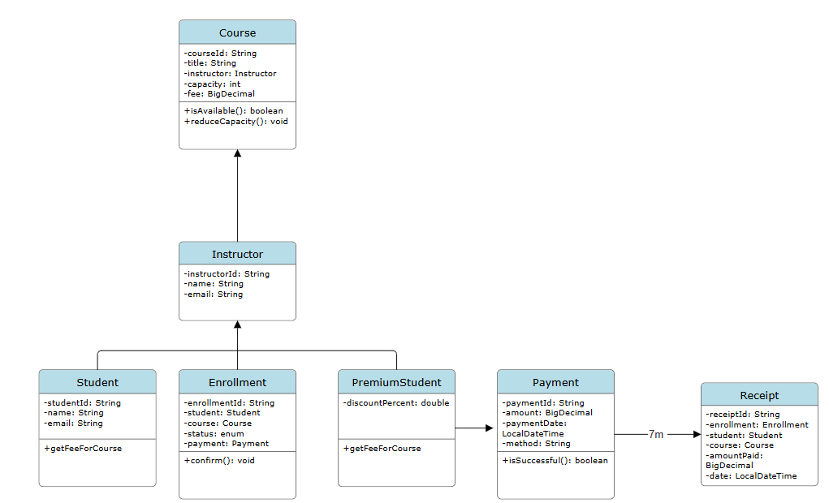

OUTPUT:

