
RAJALAKSHMI INSTITUTE OF TECHNOLOGY
(An Autonomous Institution, Affiliated to Anna University, Chennai)

DEPARTMENT OF CSE (ARTIFICIAL INTELLIGENCE AND MACHINE LEARNING)
ACADEMIC YEAR 2025 - 2026
SEMESTER III
ARTIFICIAL INTELLIGENCE LABORATORY
MINI PROJECT REPORT

REGISTER NUMBER | 2117240030067
NAME | S KIRUTHIKA DEVI
PROJECT TITLE | Smart Study Helper
DATE OF SUBMISSION
FACULTY IN-CHARGE | Mrs. M. Rubina begam

Signature of Faculty In-charge

INTRODUCTION
1.1 Overview of Artificial Intelligence
Artificial Intelligence (AI) refers to the simulation of human intelligence processes by machines, particularly computer systems. These processes include learning, reasoning, problem-solving, perception, and language understanding. In the educational domain, AI has revolutionized how students interact with learning materials, enabling more personalized and efficient study experiences.

1.2 Background Context
With the digital transformation of education, students increasingly rely on digital notes and study materials. However, the challenge remains in efficiently retrieving specific information from extensive documents. Traditional search methods like keyword matching (Ctrl+F) often fail to understand the context and semantics of queries, leading to irrelevant results or missed information.

1.3 Problem Significance
- Time Efficiency : Students spend considerable time manually searching through notes
- Context Understanding: Existing tools lack semantic comprehension of queries
- Learning Optimization: Inefficient information retrieval hinders effective studying
- Accessibility: Need for intelligent systems that understand natural language

1.4 Project Objectives
The “StudyMate AI” project aims to develop an intelligent study assistant that:
- Processes and understands study notes semantically
- Answers natural language questions based on uploaded content
- Provides precise, context-aware responses instantly
- Demonstrates practical application of AI in education technology
- Offers an offline-capable solution for personalized learning

PROBLEM STATEMENT
Primary Problem:
Students and learners lack an efficient method to quickly retrieve specific, contextually relevant information from their extensive digital study notes using natural language queries
.
Specific Challenges:
- Semantic Gap: Traditional search tools (Ctrl+F, keyword matching) cannot understand the meaning and context behind queries
- Time Consumption: Manual scanning of lengthy documents for specific information is inefficient and time-intensive
- Context Ignorance: Existing methods fail to recognize semantic relationships and conceptual connections within the content
- Precision Issues: Keyword-based approaches often return irrelevant results or miss conceptually related content
Core Issue:
The absence of an intelligent system that can:
- Understand natural language questions semantically
- Identify and extract relevant information based on meaning rather than exact word matches
- Provide instant, accurate responses from personal study materials
- Operate without internet dependency for privacy and accessibility

GOAL
Expected Results:
- Upload notes and ask questions in normal English
- Get exact answers from your specific notes
- Fast answers without internet needed
- Understands meaning, not just keywords
Possibilities:
- Find specific answers in seconds instead of minutes
- Study more efficiently before exams
- Quick revision of important topics
- Better understanding of complex subjects
- Personalized learning assistant
THEORETICAL BACKGROUND
Problem Theory
- Semantic Search: Finding information based on meaning, not just keywords
- Vector Embeddings: Converting text to numbers that capture meaning
- Similarity Matching: Measuring how closely questions match content
Algorithms Considered:
Keyword Search
- Good: Fast and simple
- Bad: No understanding of meaning
TF-IDF
- Good: Better than basic keywords
- Bad: Still no true semantic understanding
BERT
- Good: High accuracy
- Bad: Too slow, needs heavy hardware
Sentence-BERT ✓ CHOSEN
- Good: Fast + understands meaning
- Good: Works on normal computers
Why Sentence-BERT?
- Creates "meaning vectors" for sentences
- Fast enough for real-time use
- Good accuracy for study notes
- Perfect balance for our needs

ALGORITHM EXPLANATION WITH EXAMPLE
How It Works
Step 1: Break notes into small pieces
Step 2: Convert text to number vectors
Step 3: Convert question to vector
Step 4: Find closest matching vector
Step 5: Return best answer
Example:
Notes: "Machine learning is AI subset"
Question: "What is ML?"
Process:
"Machine learning is AI subset" → [0.2, 0.8, ...]
"What is ML?" → [0.3, 0.7, ...]
Match: 92% → Return ML definition
IMPLEMENTATION AND CODE
Backend (app.py)
from flask import Flask, request, jsonify
from sentence_transformers import SentenceTransformer
import numpy as np

app = Flask(__name__)
model = SentenceTransformer('all-MiniLM-L6-v2')
chunks = []

@app.route('/upload', methods=['POST'])
def upload():
file = request.files['file']
text = file.read().decode('utf-8')
global chunks
chunks = text.split('. ') # Simple splitting
return jsonify({"message": "Uploaded!"})

@app.route('/ask', methods=['POST'])
def ask():
question = request.json['question']
# Find best matching chunk
question_vec = model.encode([question])
chunk_vecs = model.encode(chunks)
similarities = np.dot(chunk_vecs, question_vec.T)
best_index = np.argmax(similarities)
return jsonify({"answer": chunks[best_index]})

if __name__ == '__main__':
app.run(debug=True)

AI Processor (document_processor.py)
from sentence_transformers import SentenceTransformer
import numpy as np

class DocumentProcessor:
def __init__(self):
self.model = SentenceTransformer('all-MiniLM-L6-v2')
self.chunks = []

def load_document(self, file):
text = file.read().decode('utf-8')
self.chunks = self._chunk_text(text)
self.embeddings = self.model.encode(self.chunks)

def find_answer(self, question):
question_embedding = self.model.encode([question])
similarities = np.dot(self.embeddings, question_embedding.T)
best_match_index = np.argmax(similarities)
return self.chunks[best_match_index]

OUTPUT
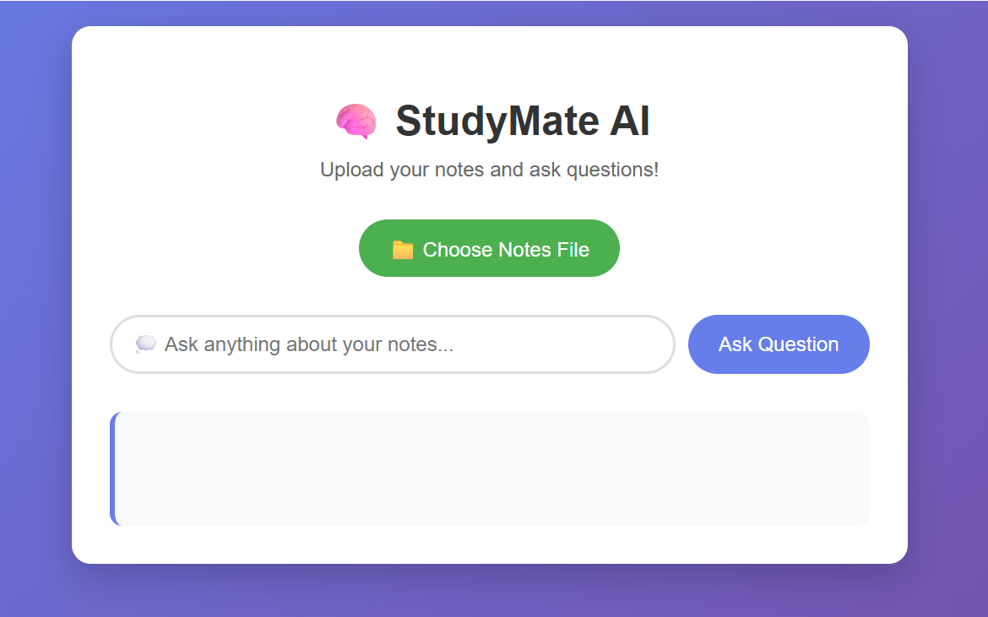
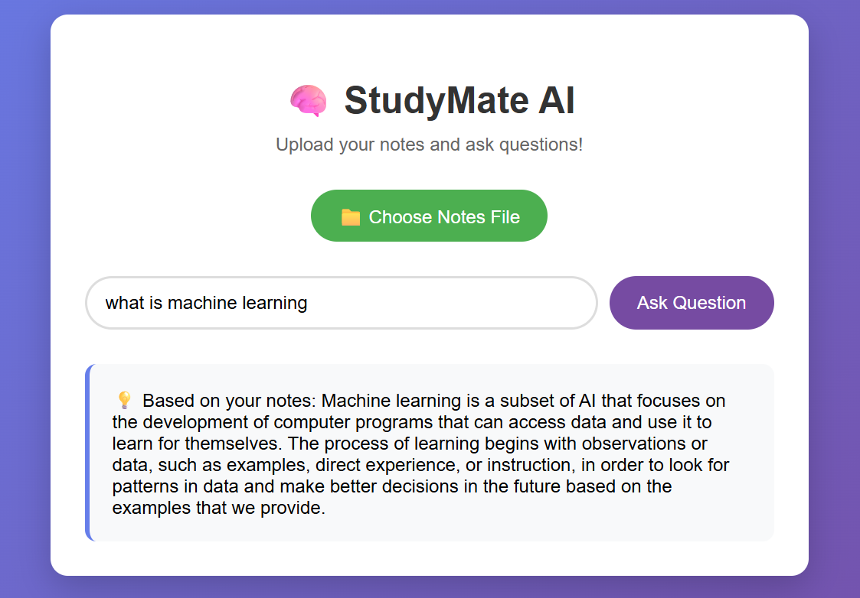
RESULTS AND FUTURE ENHANCEMENT
Results
- Working AI study assistant
- understands question meaning
- Fast 2-3 second responses
- Simple upload & ask interface
Comparison
Keyword Search - Only exact words ❌
TF-IDF - Basic statistics ❌
Our Solution - Understands meaning ✅
Why Better?
- Balances speed and accuracy
- Works on normal computers
- No internet needed
Future Plans
- PDF support
- Mobile app
- Voice questions
Git Hub Link of the project and report | https://github.com/KiruthikaDevi08/studymate-ai
REFERENCES
- "Natural Language Processing in Action" - Hobson Lane, Cole Howard
- "Sentence-BERT" Research Paper - Nils Reimers, Iryna Gurevych
- Stanford CS224N NLP Course - Online lectures
- Hugging Face Documentation - Official docs
- "Applied Text Analysis with Python" - Benjamin Bengfort
- "Hands-On Machine Learning" - Aurélien Géron

