**SSN COLLEGE OF ENGINEERING**

**KALAVAKKAM-603110**

**INTERNALLY FUNDED STUDENT PROJECT -2019**

**B.A.R.F**

**(Blind Abled Reading Frame)**

By

Kshitij sharma -2nd year -CSE -(185001080)

Kiruthika J -2nd year -CSE -(185001078)

Raghav.R -2nd year -CSE -(185001119)

Under guidance by

Dr. D.Thenmozhi

Associate Professor CSE

**Budget: RS 9,000 /-**

**Project Duration: 11 Months.**

1.

2.

3.

Signature of the project students Signature of the project guide

Signature of the HOD

**1. Project Title:**

B.A.R.F

(BLIND ABLED READING FRAME)

**2. Broad Subject:**

B.A.R.F is cognitive frame that can help the visually disabled to read and live a better life. It aims at removing the use of fingers to read a book and expand the options available for the blind to read books. It uses a camera that attached to the frame that captures pictures and sends it back to the processor via a wireless medium (Bluetooth) to process the image. B.A.R.F is able to easily understand any text and process it at fast rates, after processing it sends it back to the frame where it is read out through a speaker, so that the user can understand the text.

**3. Project Duration:**

B.A.R.F is estimated to take up to **11 months** to complete and make fully functional.

**4. Budget:**

B.A.R.F is estimated to cost about **Rs 9,000** to manufacture.

**5. Project Summary:**

B.A.R.F is a highly light weight image processing frame that has a miniature camera attached to its end. This camera has a high resolution and a long battery life with just a charge of 30 minutes. Once the image is captured it is sent to the processor via Bluetooth this is then converted into a pdf by the processor. The processor (bolt platform or raspberry pi) then converts the pdf into text using a text processor. The processor is chosen based on the compatibility of the camera and the processing rates. The text is then converted into a speech using a speech convertor, then the data packets are sent to the speakers via Bluetooth again. This a fast process and aims at removing time lag between the image capturing and processing. The future aim of this project is to recognize currency, time and faces to make life of a visually disabled person much simpler. The speakers a high-quality noise resolution pods that are comfortable to wear and use they have a battery life of 3-4 days with 5 hrs charge. This is a very simple and easily operate able device. The user should just hold the book on one hand or place it on a table and touch the camera on the side of the frame to capture the image, if the image is not in range or to close it will inform the user to make the according adjustments.

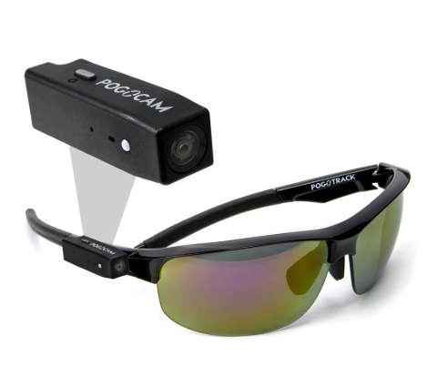 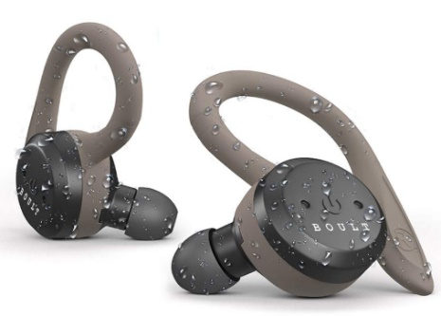

1(a) 1(b) Figure 1: (a) exterior look of the frame and camera (b) portable ear-pods for the user.

**6. Key words:**

Image processing, Text convertor, Speech convertor, High resolution camera, Portable, easy to use and currency, time, object and face recognition (in future proposal).

**7. Objectives:**

* To construct a mechanical, easily portable, operate able model for the visually disabled.
* To incorporate the various modules into a single unit.
* To eradicate the dependency of the blind on their fingers and other to read books.
* To make the day to day life easier for the visually disabled.
* To recognize text at quick rates and in the future various objects and to add other features.

**8. Introduction:**

The number of Visually Impaired (VI) people worldwide is approximately 285 million, in other words more than 3.86% of the entire population. So far devices for improving their understanding of the environment have been invented as well as methods like the Braille, which was introduced as an option for studying engraved text. But this method has two major issues. Firstly, very few books are modified into Braille and secondly only the minority of the blind population can read Braille, in actual fact and according to surveys carried out recently, fewer than 10% of the US legally blind people can read Braille. So, an algorithm has been developed and used on a custom hardware implementation in order for the blind people to read printed books in the same way as normal readers do.

Since the beginning of the 20th century, various devices have been created in order to help VI people to read books. Some of the initial works, according to the literature, are the Optophone and Optacon, which use a sensory substitution to translate the black and white text into time-varying chords of tones. Nowadays, smartphone applications and more advanced devices -which are also wearable- have been developed in order to help VI people to read text material by using OCR (Optical Character Recognition) and TTS (Text To Speech) technologies. A representative device is OrCam which has many hardware similarities with the proposed system, where both of them are constituted by a pair of glasses with micro camera and a processing unit. OrCam is designed to recognize not only text in specific printed material but also real life objects. Another remarkable device is the Finger Reader, a specially designed wearable ring with a micro camera, which is used in a similar way as the one used by VI people reading braille .Also, mobile applications have been implemented that take advantage of the modern cell phones as mobile processing units.

Blind people in the National Federation of the Blind are often heard to say that proper training and opportunity make it possible for us to compete on equal terms with people who are sighted. Of course, we all agree that opportunity means the chance to participate with others in normal, everyday activity, such as jobs, school, recreation and all manner of social and community interaction. We say that the training consists of learning to use alternative techniques to do those tasks which others use eyesight to accomplish. The use of Braille for reading and writing and long white canes and dog guides for getting around independently are alternative techniques most commonly mentioned. However, there is another technique which can be very useful, too. That is the use of "readers."

Exactly what is a reader and what role can a reader play in the life of a blind parson who wants to achieve self-sufficiency and independence? A reader is a person who reads aloud either directly to a blind person who is present or on to a cassette tape to which a blind person will later listen. Let me emphasize from the outset that it is absolutely essential that every blind person be competent in the use of braille so that he/she has a means of reading and writing independently, organizing materials and having first-hand access to written information.

A reader cannot replace a through knowledge of and competency in the use of Braille; a reader can, however, be a valuable supplementary technique for gaining access to information which is not available in Braille--in other words, material which is in print. A reader may work either for pay or as a volunteer. While volunteer readers may save on the pocketbook, there are some important advantages to paying readers. Hiring and employing readers is like running a business. The blind person is the manager of the business. He/she knows what the job entails and wants qualified people to do the job. Being in control of the hiring, screening, interviewing and final selection is very important. Since most of us use readers throughout our lives, the earlier we begin working with them the better. As high school students, blind people should have experience selecting the readers they wish to use, rather than having a teacher or counsellor make the decision. Thus, by the time they reach college and have volumes of print material to go through, blind students will be ready to handle working with readers and all that involves, obtaining funding for recruiting, screening, hiring, managing, etc.

**9. Definition of problem:**

The main problem is the development of an algorithm which automatically “reads” every kind of printed book or written material (e.g. magazines) and turns it into speech, under certain circumstances.

Also, the above described problem encounters the following difficulties:

* Hardware limitations (CPU, RAM, camera resolution).
* Noise in the data (light conditions, reflections, blurring, shadows, finger existence etc.)
* Data variations according to different font styles, font sizes and language.

The system is constituted by the bolt platform, as mobile processing unit, and a pair of glasses equipped with an HD camera, Bluetooth headset and LED light. The aim of the hardware is to help VI people to have the experience in a natural way, without many wires or big cameras.

**10. Review of status of Research and Development in the subject:**

**10.1 National status:**

Many projects have been done to covert a text into speech, but all of the involve a scanner to scan the text. The major drawback is that it is impossible for the visually disabled person to use and carry around. Handwritten text reader for the visually impaired is an extension of the system that was developed to help the visually impaired listen to an audio read-back of printed text only Ragavi et al. (2016). This extension adds two main functionalities: recognition of handwritten text, support for two regional languages (Hindi, Bengali).

**Enhanced portable text to speech converter for visually impaired** is a article published by Selvaraj Chithra and N. Bhalaji, Department of Information Technology, SSN College of Engineering, Chennai, 603110, India January 2018 DOI: 10.1504/IJISTA.2018.10012881 It works on reading a text using a scanner and the converting it to audio for the disabled.

**10.2 International status:**

ORCAM is company founded by Prof. Amnon Shashua and Mr. Ziv Aviram in 2010. They are currently working on glasses for the blind and are in the testing phase and have simultaneously started production of glasses for the blind.

An overview of Tesseract OCR engine has been given by Smith (2007). Sasirekha and Chandra (2012) have described the process of text to speech synthesis. Mithe et al.(2013) have proposed an Android application which obtains images from high-resolution mobile phone cameras, and performs image to speech conversion. This application is proposed for use in fields like office automation, banking etc. This system is not suitable for visually impaired people because they have difficulty in capturing pictures of the text with mobile phone cameras. Gaudissart et al. (2005) have proposed a similar system named SYPOLE which performs the same function, but uses a personal digital assistant. Enhanced portable text to speech converter for visually impaired 3(PDA). The input image is the picture captured by an embedded camera in the PDA, which makes this system also not feasible for visually impaired people. Rakshit and Basu (2010) have described the process of training Tesseract OCR engine to recognise handwritten text.

**11. Novelty Importance of the proposed project in the context of current status:**

The importance of this project is to make the life of the visually disabled person much easier. Also to reduce their dependency on others as well as their fingers to read books. The project is cost efficient and portable. It is user friendly and it is very easy for the blind to operate and use. It easily understands any text and converts it to a speech which is easily understandable by the user. The future applications of this project is to recognize faces, currency, time and various other objects to remove the complete dependency of the visually disabled on others.

**12. Patent Details:**

Yet to apply for any patent, we will apply after the completion of the proposal.

**13. Work plan and Detailed technical information:**

**13.1 Work plan:**

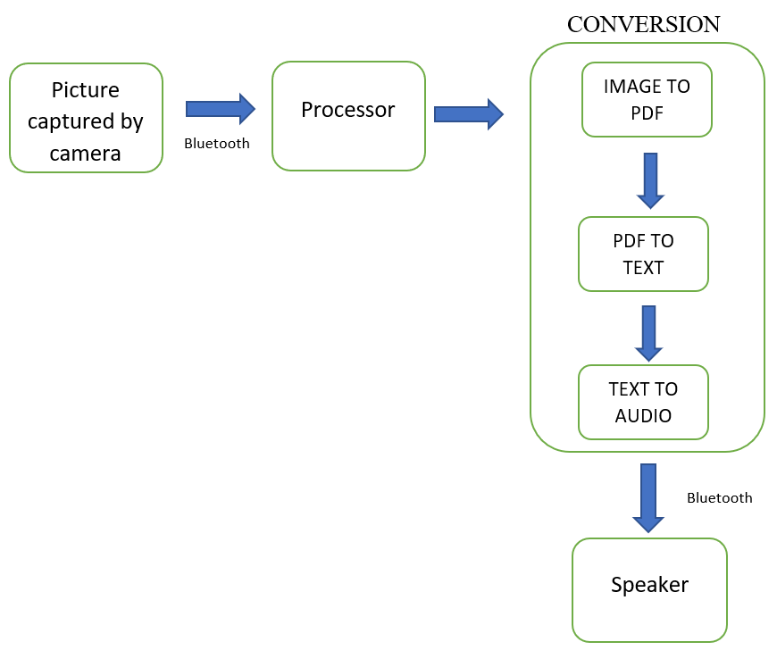

* 1. **Detailed technical information:**

Given below is a list of processes and components used in this model:

* **Camera:** PogoTec PogoCam Wearable HD Camera Wearable 720p30 HD Video Camera,Takes 5MP Still Photos, Attaches to Your Glasses with Magnet, Charges Inside Smart Case, USB or Bluetooth Data Transfers via Case, Three PogoLoop Mounts Included, Safety Ring Included, App Supports Both iOS and Android, Store Videos/Photos in Camera and Case.
* **Processor:** Bolt Iot platform/ Raspberry pi3.
* **Speaker:** Enjoy truly wireless audio with the Shots X5 CHARGE wireless earphones from Noise. Bluetooth v5.0 wireless earphones are compatible with any Bluetooth device, any Bluetooth version. IPX5 rated Bluetooth earbuds IPX5 rated are sweat proof and splash proof. Shots X5 CHARGE wireless earbuds have up to 5 hours battery life each. The Included 2200mAh charging case can recharge the Bluetooth ear pods up to 10 times and can charge your phone as well. Ergonomically designed earbuds with 3 included pairs of silicone tips provide a comfortable and secure fit. Instant access to your voice assistant on Android and iOS, with just a tap on your earbuds.
* **Image to PDF convertor:** A few PDF convertors are available nowadays which are:

1. **Small pdf convertor:** <https://smallpdf.com/jpg-to-pdf>.
2. **Pdfonline:** <https://www.pdfonline.com/convert-jpg-to-pdf/>

* **Pdf to Text convertor:** A few TEXT convertors are available nowadays which are:

1. **Pdftotext convertor:** <https://pdftotext.com/>
2. **Onlineocr convertor:** <https://www.onlineocr.net/>

* **Text to Audio convertor:** A few AUDIO convertors are available nowadays which are:

1. **Fromtexttospeech :** <http://www.fromtexttospeech.com/>
2. **Notevibes:** <https://notevibes.com/>

**14. Time schedule of activities through BAR diagram:**

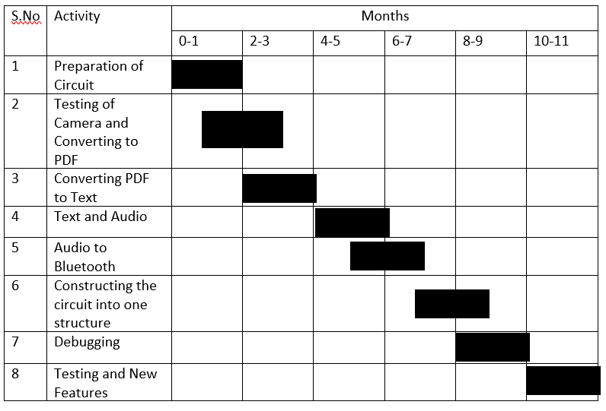

**15. Deliverables:**

* A Portable Device that captures an image.
* Detects the Text in the Image.
* Produces an Audio Output.
* Future Implementation of Face Recognition, Currency Detection and Time Detection.
* Cost effective.
* Easy to use and understand.

**16. Target beneficiaries of the proposed work:**

* For the Visually Impaired.
* Blind People.
* People with special abilities (Eg: people suffering from dyslexia).
* Other people with visual disabilities of different kinds.

**17. Suggested plan of action for utilization of research outcome expected from the project:**

**17.1 As journal publication:**

After the completion of the project we plan to submit a research paper on the algorithm and process used in making B.A.R.F. we would be submitting our paper to the following journals:

* International Journal of Scientific & Engineering Research -IJSER (ISSN 2229-5518) - Call For Research Papers.
* International Journal of Intelligent Systems Technologies and Applications.
* International Journal of Advanced Computer Science and Applications.
* Journal of Computer Science and Technology, ISSN: 1000-9000.
* **International Journal of Engineering and Science Invention (IJESI).**

**17.2 Patent filing:**

Yet to apply for any patent, we will apply a patent on the work flow after the completion of the proposal.

There are a few patents already present in this type of devices such as:

* WO1997017043A1 (Patent number): <https://patents.google.com/patent/WO1997017043A1/en> (Abstract).
* WO2015172418A1 (Patent number): <https://patents.google.com/patent/WO2015172418A1/en> (Abstract).
* US9805619B2 (Patent number): <https://patents.google.com/patent/US9805619B2/en> (Abstract).
* EP2490155A1 (Patent number): <https://patents.google.com/patent/EP2490155A1> (Abstract).
* US20150002676A1 (Patent number): <https://patents.google.com/patent/US20150002676A1/en> (Abstract).

**17.3 Project preparation for submission to external funding:**

By the end of 11 months we expect to submit a full functional prototype which would have exceeded the expected outcome and do much more that it claims in this proposal. We plan to submit our prototype to external funding agents such as:

* **International Science and Engineering Fair (ISEF).**
* Google science fair.

**18. References:**

**Links:**

<https://ieeexplore.ieee.org/document/7857276>

<https://sisu.ut.ee/imageprocessing/book/1>

<https://www.sciencedirect.com/topics/neuroscience/image-processing>

<https://www.tanotis.com/products/pogotec-pogocam-wearable-hd-camera?gclid=CjwKCAjwyqTqBRAyEiwA8K_4O0KltnObzccPM3LnxzOC4RcV1-C3IZAu3eCHWbPnm41mKzN_duWWuRoC5lwQAvD_BwE>

<https://nfb.org/sites/www.nfb.org/files/images/nfb/publications/fr/fr6/issue1/f060109.html>

<https://www.orcam.com/en/>

**Articles and Journals:**

Enhanced portable text to speech converter for visually impaired

Article  in  International Journal of Intelligent Systems Technologies and Applications published by Selvaraj Chithra and N. Bhalaji, Department of Information Technology, SSN College of Engineering, Chennai, 603110, India, January 2018

DOI: 10.1504/IJISTA.2018.10012881

Rakshit, S. and Basu, S. (2010) Development of a Multi-User Handwriting Recognition System

Using Tesseract Open Source OCR Engine, arXiv preprint arXiv:1003.5886.

Ragavi, K., Radja, P. and Chithra, S. (2016) ‘Portable text to speech converter for the visually impaired’, in Proceedings of the International Conference on Soft Computing Systems, Springer, pp.751–758.

Smith, R. (2007) ‘An overview of the Tesseract OCR engine’, ICDAR, IEEE, pp.629–633.

Banerjee, S. (2010) A Study on Tesseract Open Source Optical Character Recognition Engine,Thesis, Jadavpur University.

Chandran, P., Aravind, S., Gopinath, J. and Saranya, S.S. (2015) ‘Text to speech conversion system using OCR’, International Journal of Emerging Technology and Advanced Engineering (IJETAE), Vol. 5, No. 1, pp.389–395.

Gaudissart, V., Ferreira, S., Mancas-Thillou, C. and Gosselin, B. (2005) ‘Sypole: a mobile assistant for the blind’, Proceedings of European Signal Processing Conference, EUSIPCO 2005, Antalya, Turkey.

Marosi, I. (2007) ‘Industrial OCR approaches: architecture, algorithms and adaptation techniques’, Document Recognition and Retrieval XIV, SPIE Jan 2007, 6500–01.

Mithe, R., Indalkar, S. and Divekar, N. (2013) ‘Optical character recognition’, International Journal of Recent Technology and Engineering (IJRTE), Vol. 2, pp.72–75.

**19. List of facilities and Equipment available with the department for the project:**

* Raspberry pi3.
* Basic Connecting wires.
* Bolt iot board (already present with the students).
* USB cables.
* Computers for programming.

**20. Budget Estimates:**

The budgets given below are approximate ones:

|  |  |  |
| --- | --- | --- |
| **S.No** | **Item** | **Price in Rs** |
| 1 | Wearable HD Camera | 5000 |
| 2 | Glasses | 500 |
| 3 | Bluetooth speaker | 3000 |
| 4 | Power supply unit | 500 |

**21. Budget justification:**

All of the above-mentioned items have been checked and have been finalized from the respective websites. The prices have be checked from various websites and have been calculated (including the shipping charges).

**All of the above information is true to our knowledge.**