# DESIGN AND IMPEMENTATION OF ELECTRICAL/ELECTRONICS DEPARTMENT WEBSITE

**BY**

# TABLE OF CONTENT

DESIGN AND IMPEMENTATION OF ELECTRICAL/ELECTRONICS DEPARTMENT WEBSITEi

CERTIFICATIONii

DEDICATIONiii

ACKNOWLEGEMENTiv

TABLE OF CONTENTv

LIST OF FIGURESix

ABSTRACTx

CHAPTER ONE1

INTRODUCTION1

1.1 DEFINITION1

1.2TYPES OF WEBDESIGN1

1.3 APPLICATION OF WEBDESIGN2

1.3.1 Static Website Design - Small Websites2

1.3.2 Basic Brochure Website2

1.3.3 Advanced Static Website2

1.3.4 Dynamic Website Design - Large/Complex Websites2

1.3.5 Content Management System (CMS) Website3

1.3.6 eCommerce Websites3

1.4 SCOPE OF PROJECT3

1.5 AIM AND OBJECTIVES4

1.5.1 AIM:4

1.5.2 OBJECTIVES:4

1.6 JUSTIFICATION5

1.7 SPECIFICATION5

CHAPTER TWO7

LITERATURE REVIEW7

2.1 HISTORY OF WEBDESIGN7

2.1.1 The start of the web and web design7

2.1.2 Evolution of web design8

2.1.3 End of the first browser wars8

2.1.4 Modern browsers9

2.1.5 New standards9

2.2 EXISTING TECHNIQUES9

2.2.1 Marketing and communication design9

2.2.2 User experience design and interactive design10

2.2.3 Page layout10

2.2.4 Typography11

2.2.5 Motion graphics11

2.2.6 Quality of code12

CHAPTER THREE13

DESIGN ANALYSIS13

3.1 INFORMATION GATHERING:13

3.1.1 Analyses13

3.1.1.1 Information that meets the needs of the targeted audience13

3.1.2 Organisation13

3.2 PLANNING / DESIGN ANALYSIS14

3.2.1 WEBSITE COMPONENT (INTERFACE DESIGN)14

3.2.2 THE LOGIN AUTHENTICATION PAGE15

3.2.3 THE HOMEPAGE:15

3.2.4 THE STUDENT SECTION15

3.3 DESIGN/ EXECUTION15

3.3.1 The design of the project was done using 4 methods15

3.4 REQUIREMENT ANALYSIS16

3.4.1 DATA16

3.4.2 TECHNICAL REQUIREMENTS17

3.4.3 SECURITY REQUIREMENTS17

3.4.3.1 ACCESS LEVELS:18

3.4.3.2 AUTHENTICATION18

3.4.3.3ACTIVE RECORDS SCRIPTING FOR THE DATABASE18

3.4.3.4 VALIDATED INPUTS18

3.4.4 DESIGNING THE APPLICATION MAP19

3.4 5 DESIGNING THE DATABASE19

3.4.6 DESIGN OF THE PAGE STRUCTURE19

3.4.7 RESPONSIVE/MOBILE COMPATIBLE DESIGN19

3.5 DEVELOPMENT20

3.6 KILOS OR THOUSAND LINES OF CODE (KLOC)20

CHAPTER FOUR28

TESTING AND OBSERVATION28

4.1 TESTING THE STUDENT SECTION28

4.1.1.STUDENT HOME28

4.1.2.EDIT PROFILE28

4.1.3.PROFILE28

4.1.4.ARTICLES & JOURNAL29

4.1.5.PAST QUESTION29

4.2 TESTING THE ADMIN SECTION29

4.2.1 STAFF29

4.2.2 STUDENT29

4.2.3 SEMINAR:30

4.3 TESTING THE STAFF SECTION30

4.3.1 PROFILE CHECK:30

4.3.2 SUBMIT NOTE30

4.3.4 UPLOAD PRACTISE QUESTION30

4.3.5 STUDENT31

4.3.6 BEST STUDENT31

4.4 TESTING THE EEETOP UP SECTION:31

4.4.1 Viewing student that graduated with above 4.5CGPA:31

4.4.2 To view the best graduating student from the first set till the latest set:31

4.5 TESTING THE SEMINAR SECTION:31

4.6 TESTING THE ALUMNI SECTION:31

4.7 THE CONTACT US SECTION:32

CHAPTER FIVE33

CONCLUSION, RECOMMENDATION AND REFERENCE33

5.1 CONCLUSION33

5.2 RECOMMENDATION34

REFERENCES35

APPENDIX AND IMAGES36

# LIST OF FIGURES

Figure 1.1. Block Diagram Of The Software Development5

Figure 1.2: Website development cycle6

Figure 1.3: Website development phases6

Figure 3.1: Diagram showing the sitemap, the sites usability and content.14

Figure 3.2: Diagram showing flow chart showing part for project execution.16

Figure 3.3: A cross-sectional area showing both staff (Head of department,lecturers form other departments and even the Provost) and student of the college during a Seminar delivered by Dr. Sodipo.17

Figure 3.5: Showing the emblem to be used for the department on the site.19

Figure3.6: Showing the side view of the department of Electrical Electronics Engineering.20

Fig 1.4 EEEOOUIBOGUN Welcome Page.36

Fig 1.5 EEEOOUIBOGUN About Us Page.37

Fig 1.6 EEEOOUIBOGUN Contact us Page.37

Fig 1.7 EEEOOUIBOGUN EEE Top Up Page38

Fig 1.8 EEEOOUIBOGUN Article and Journal Page38

Fig 1.9 EEEOOUIBOGUN Admin Page39

Fig 1.10 EEEOOUIBOGUN Admit Student Page.39

Fig 1.11 EEEOOUIBOGUN Staff Page.40

Fig 1.12 EEEOOUIBOGUN Staff Dashboard.40

Fig 1.13 EEEOOUIBOGUN Student Past Question.41

Fig 1.14 EEEOOUIBOGUN Staff Page.41

# ABSTRACT

For a long time, the department of Electrical/ Electronic of this college has not had a website with guaranteed continuity. Several students in past had made attempts to achieve this but all to no avail. Eventually, with the implementation of this project, the department now has a functional website.

The Website User Interface is designed using the elements of HTML, CSS and Bootstrap, while the functionality is done using PHP. The web application simply updates the database by uploading a formatted CSV file through querying of MYSQL. The website uses some special CSS features and jquery to achieve responsiveness. In addition, the web application obtains useful information from the commondata.

By the time it is fully implemented, it would have solved several problems and created a brand new tool for the Electrical department administration – Challenging student performance and progress with the EEEtop-up in place, getting more enlightened in the field through divers seminars presented in the past, seeing records of alumni and those who had performances worthy of emulation, all at the tap of a button.

# CHAPTER ONE

# INTRODUCTION

## 1.1 DEFINITION

Web design is the process of creating websites. It encompasses several different aspects, including webpage layout, content production and graphic design. While the terms web design and web developments are often used interchangeably, web design is technically a subset of the broader category of web development. Websites are created using a markup language called HTML. Web designers build webpages using HTML tags that define the content and metadata of each page. The layout and appearance of the elements within a webpage are typically defined using CSS, or cascading style sheets. Therefore, most websites include a combination of HTML and CSS that defines how each page will appear in a browser. Some web designers prefer to hand code pages (typing HTML and CSS from scratch), while others use a "WYSIWYG" editor like Adobe Dreamweaver. This type of editor provides a visual interface for designing the webpage layout and the software automatically generates the corresponding HTML and CSS code. Another popular way to design websites is with a content management system like WordPress or Joomla. These services provide different website templates that can be used as a starting point for a new website. Webmasters can then add content and customize the layout using a web-based interface. While HTML and CSS are used to design the look and feel of a website, images must be created separately. Therefore, graphic design may overlap with web design, since graphic designers often create images for use on the Web. Some graphics programs like Adobe Photoshop even include a "Save for Web" option that provides an easy way to export images in a format optimized for web publishing. [1]

## TYPES OF WEBDESIGN

* + Static website-small websites
  + Basic Brochure website
  + Advanced static website
  + Dynamic website Design- large/complex websites
  + Content Management System(CMS) websites
  + eCommerce website

## 1.3 APPLICATION OF WEBDESIGN

### 1.3.1 Static Website Design - Small Websites

A static website is one without any server-side functionality and has no database or interactive content. Static web design is appropriate for smaller websites that don’t need any complex features or content. Static websites can still be designed to look really good with stylish graphics and content, they just can’t do anything clever based upon any behind-the-scenes programming. The advantage is that a static website is easier, faster and cheaper to design and build but is still professional and stylish. [2]

### 1.3.2 Basic Brochure Website

For individuals and small businesses with a low budget; a simple but professional website that acts as a brochure or advert for you and your business. [2] Brochure websites can have as few as one or two pages (usually five or six) and typically follow a common format:

1. Home Page - an eye-catching introduction to your business with clear summary information about what you do
2. About / Philosophy - who you are, your credentials and your values
3. Your Services - one page for each different service you offer
4. Contact - a contact form, address/telephone/email, location map
5. Links

### 1.3.3 Advanced Static Website

For small/medium businesses: static websites can be enhanced with advanced web design features to make them slick, stylish and interesting including: [2]

1. Drop-down navigation
2. Animated jQuery (JavaScript) effects
3. Flash content
4. Multimedia (video/audio)
5. News page
6. Social Network plugins
7. Image gallery

### 1.3.4 Dynamic Website Design - Large/Complex Websites

Dynamic websites make use of server-side programming and databases to store and deliver the content. This allows web pages to perform more complex functions and display complex data and interactive content. This is the standard way that larger websites are designed as it makes adding large numbers of pages based upon the same template very easy. The down side is that it requires more initial work than a static website so it isn’t economical for small sites. [2]

### 1.3.5 Content Management System (CMS) Website

For a firm who want to make frequent changes/updates or want full control over their website CMS is the ideal design for them. A CMS can be part of just about any kind of website. Depending on your needs this can be as simple as the ability to add new items to a news page or image gallery, or full what-you-see-is-what-you-get (WYSIWYG) control over the content of each page. [2]

### 1.3.6 eCommerce Websites

For businesses that make money through their website either by selling goods from an online shop or offering premium (paid for) online services. This can range from simple integration with PayPal to sell a small number of items in an online shop where PayPal handles the entire checkout and stock-management process to large, self-contained shops which securely process credit card payments for hundreds of items. eCommerce websites are (almost) always dynamic and database driven and usually have the provision for the client to add new items and update prices, descriptions, images and stock levels from a dedicated admin system. [2] Sometimes some of the features of an eCommerce website will be integrated into a different kind of website e.g. a

Band/Musician might have a website with images, news and information about their music but also has the ability to sell that music as a digital download.

## 1.4 SCOPE OF PROJECT

**The software environment in which the application will be deployed will comprises of**

1. Web server to host application
2. Web browser (independent of OS) to access application
3. Mobile application for android devices

The application will be hosted on a web server. This is necessary because the administrative backend and the detailed application will be based on PHP. The administrative end will be accessed via a web browser on the PC. This will not be dependent on the OS since it is web based. The student end will run on Android OS.

**The hardware environment in which the application will be deployed will consists**

* PC
* Mobile devices and Tablets

**The human environment on which it will be deployed will comprises of**

* Student
* Returning students
* Alumni
* Staff
* Lecturers
* HOD
* Admin
* Maintenance and application manager
* Developer

The updating and upload of data will be done on PCs. The administrative end is intended to be assessed from a PC. However, students who would like to see their information will be able to do that on their phones or other mobile devices compatible.

## 1.5 AIM AND OBJECTIVES

### 1.5.1 AIM:

To design and implement a website for Electrical-Electronic Engineering Department.

### 1.5.2 OBJECTIVES:

1. To design a responsive Website that will be active and durable, unlike the previous sites.

2. To create and link Database of students both past and present.

3. To connect the department to the World Wide Web, hence giving room for ample development yet to be conceived.

4. To create a site where students can have access to seminar materials, information from lecturers and past questions of courses.

To host the Site with the domain name “EEEOOUIBOGUN”

## 1.6 JUSTIFICATION

Ease of accessibility as far as technology is concerned, this in connection with stress-free dissemination of information and notification between students of the department and the staffs, and also a means of keeping the profile of the alumni for reference and recognition. In addition to the aforementioned points, the site is design to meet responsive specification at this it stands a chance of continuity as it can be accessed with all forms of gprs enabled devices without shrinking.

## 1.7 SPECIFICATION

To design and implement a Responsive Website for the department of Electrical Electronics Engineering, with a hosting of one years

The Website will be able to perform the following functions;

* Download of Lecture notes by students.
* View best performance student in each course.
* Profile of Alumni and Current Student.
* News alert and current trends of information accessible by the department to the student.
* Upload and Download of seminars by lecturers and Students for reference and learning purpose by the Lecturers and Administrator.

**1.8 BLOCK DIAGRAM**

Software development

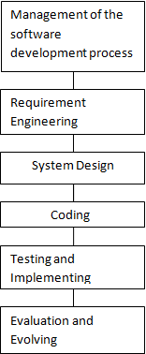

##### Figure 1.1. Block Diagram Of The Software Development

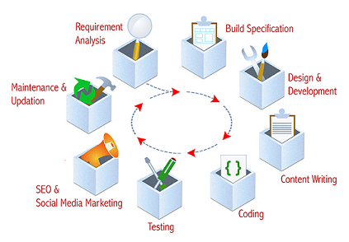

##### Figure 1.2: Website development cycle

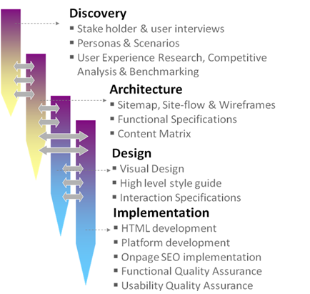

##### Figure 1.3: Website development phases

# CHAPTER TWO

# LITERATURE REVIEW

## 2.1 HISTORY OF WEBDESIGN

Although web design has a fairly recent history, it can be linked to other areas such as graphic design. However web design can also be seen from a technological standpoint. It has become a large part of people’s everyday lives. It is hard to imagine the Internet without animated graphics, different styles of typography, background and music. [3]

### 2.1.1 The start of the web and web design

In 1989, whilst working at CERN Tim Berners-Lee proposed to create a global hypertext project, which later became known as the World Wide Web. During 1991 to 1993 the World Wide Web was born. Text-only pages could be viewed using a simple line-mode browser. [4] In 1993 Marc Andreessen and Eric Bina, created the Mosaic browser. At the time there were multiple browsers, however the majority of them were Unix-based and naturally text heavy. There had been no integrated approach to graphic design elements such as images or sounds. The Mosaic browser broke this mould. [4] The W3C was created in October 1994 to "lead the World Wide Web to its full potential by developing common protocols that promote its evolution and ensure its interoperability. [4] “This discouraged any one company from monopolizing a propriety browser and programming language, which could have altered the effect of the World Wide Web as a whole. The W3C continues to set standards, which can today be seen with JavaScript. In 1994 Andreessen formed Communications Corp. that later became known as Netscape Communications, the Netscape 0.9 browser. Netscape created its own HTML tags without regard to the traditional standards process. For example, Netscape 1.1 included tags for changing background colours and formatting text with tables on web pages. Throughout 1996 to 1999 the browser wars began, as Microsoft and Netscape fought for ultimate browser dominance. During this time there were many new technologies in the field, notably Cascading Style Sheets, JavaScript, and Dynamic HTML. On the whole, the browser competition did lead to many positive creations and helped web design evolve at a rapid pace. [5]

### 2.1.2 Evolution of web design

In 1996, Microsoft released its first competitive browser, which was complete with its own features and tags. It was also the first browser to support style sheets, which at the time was seen as an obscure authoring technique. [5] The HTML markup for tables was originally intended for displaying tabular data. However designers quickly realized the potential of using HTML tables for creating the complex, multi-column layouts that were otherwise not possible. At this time, as design and good aesthetics seemed to take precedence over good mark-up structure and little attention was paid to semantics and web accessibility. HTML sites were limited in their design options, even more so with earlier versions of HTML. To create complex designs, many web designers had to use complicated table structures or even use blank spacer .GIF images to stop empty table cells from collapsing. [5] CSS was introduced in December 1996 by the W3C to support presentation and layout. This allowed HTML code to be semantic rather than both semantic and presentational, and improved web accessibility, see tableless web design. In 1996, Flash (originally known as FutureSplash) was developed. At the time, the Flash content development tool was relatively simple compared to now, using basic layout and drawing tools, a limited precursor to ActionScript, and a timeline, but it enabled web designers to go beyond the point of HTML, animated GIFs and JavaScript. However, because Flash required a plug-in, many web developers avoided using it for fear of limiting their market share due to lack of compatibility. Instead, designers reverted to gif animations (if they didn't forego using motion graphics altogether) and JavaScript for widgets. But the benefits of Flash made it popular enough among specific target markets to eventually work its way to the vast majority of browsers, and powerful enough to be used to develop entire sites. [5]

### 2.1.3 End of the first browser wars

During 1998 Netscape released Netscape Communicator code under an open source license, enabling thousands of developers to participate in improving the software. However, they decided to start from the beginning, which guided the development of the open source browser and soon expanded to a complete application platform. The Web Standards Project was formed and promoted browser compliance with HTML and CSS standards by creating Acid1, Acid2, and Acid3 tests. 2000 was a big year for Microsoft. Internet Explorer was released for Mac; this was significant as it was the first browser that fully supported HTML 4.01 and CSS 1, raising the bar in terms of standards compliance. It was also the first browser to fully support the PNG image format. During this time Netscape was sold to AOL and this was seen as Netscape’s official loss to Microsoft in the browser wars. Since the start of the 21st century the web has become more and more integrated into people’s lives. As this has happened the technology of the web has also moved on. There have also been significant changes in the way people use and access the web, and this has changed how sites are designed. [5]

### 2.1.4 Modern browsers

Since the end of the browsers wars there have been new browsers coming onto the scene. Many of these are open source meaning that they tend to have faster development and are more supportive of new standards. The new options are considered by many to be better than Microsoft's Internet Explorer. [6]

### 2.1.5 New standards

The W3C has released new standards of HTML (HTML5) and CSS (CSS3), as well as new JavaScript API's, each as a new but individual standard. However, while the term HTML5 is only used to refer to the new version of HTML and some of the JavaScript API's, it has become common to use it to refer to the entire suite of new standards (HTML5, CSS3 and JavaScript). [6]

## 2.2 EXISTING TECHNIQUES

### 2.2.1 Marketing and communication design

Marketing and communication design on a website may identify what works for its target market. This can be an age group or particular strand of culture; thus the designer may understand the trends of its audience. Designers may also understand the type of website they are designing, meaning, for example, that (B2B) business-to-business website design considerations might differ greatly from a consumer targeted website such as a retail or entertainment website. Careful consideration might be made to ensure that the aesthetics or overall design of a site do not clash with the clarity and accuracy of the content or the ease of web navigation, especially on a B2B website. [9] Designers may also consider the reputation of the owner or business the site is representing to make sure they are portrayed favorably. [7]

### 2.2.2 User experience design and interactive design

User understanding of the content of a website often depends on user understanding of how the website works. This is part of the user experience design. User experience is related to layout, clear instructions and labeling on a website. How well a user understands how they can interact on a site may also depend on the interactive design of the site. If a user perceives the usefulness of the website, they are more likely to continue using it. [10] Users who are skilled and well versed with website use may find a more unique, yet less intuitive or less user-friendly website interface useful nonetheless. However, users with less experience are less likely to see the advantages or usefulness of a less intuitive website interface. This drives the trend for a more universal user experience and ease of access to accommodate as many users as possible regardless of user skill. Much of the user experience design and interactive design are considered in the user interface design. Advanced interactive functions may require plug-ins if not advanced coding language skills. Choosing whether or not to use interactivity that requires plug-ins is a critical decision in user experience design. If the plug-in doesn't come pre-installed with most browsers, there's a risk that the user will have neither the know how or the patience to install a plug-in just to access the content. If the function requires advanced coding language skills, it may be too costly in either time or money to code compared to the amount of enhancement the function will add to the user experience. There's also a risk that advanced interactivity may be incompatible with older browsers or hardware configurations. Publishing a function that doesn't work reliably is potentially worse for the user experience than making no attempt. It depends on the target audience if it's likely to be needed or worth any risks. [7]

### 2.2.3 Page layout

Part of the user interface design is affected by the quality of the page layout. For example, a designer may consider whether the site's page layout should remain consistent on different pages when designing the layout. Page pixel width may also be considered vital for aligning objects in the layout design. The most popular fixed-width websites generally have the same set width to match the current most popular browser window, at the current most popular screen resolution, on the current most popular monitor size. Most pages are also center-aligned for concerns of aesthetics on larger screens. [6] Fluid layouts increased in popularity around 2000 as an alternative to HTML-table-based layouts and grid-based design in both page layout design principle and in coding technique, but were very slow to be adopted. [5] This was due to considerations of screen reading devices and varying windows sizes which designers have no control over. Accordingly, a design may be broken down into units (sidebars, content blocks, embedded advertising areas, navigation areas) that are sent to the browser and which will be fitted into the display window by the browser, as best it can. As the browser does recognize the details of the reader's screen (window size, font size relative to window etc.) the browser can make user-specific layout adjustments to fluid layouts, but not fixed-width layouts. Although such a display may often change the relative position of major content units, sidebars may be displaced below body text rather than to the side of it. This is a more flexible display than a hard-coded grid-based layout that doesn't fit the device window. In particular, the relative position of content blocks may change while leaving the content within the block unaffected. This also minimizes the user's need to horizontally scroll the page. Responsive Web Design is a newer approach, based on CSS3, and a deeper level of per-device specification within the page's stylesheet through an enhanced use of the CSS @media pseudo-selector. [8]

### 2.2.4 Typography

Web designers may choose to limit the variety of website typefaces to only a few which are of a similar style, instead of using a wide range of typefaces or type styles. Most browsers recognize a specific number of safe fonts, which designers mainly use in order to avoid complications. Font downloading was later included in the CSS3 fonts module and has since been implemented in Safari 3.1, Opera 10 and Mozilla Firefox 3.5. This has subsequently increased interest in web typography, as well as the usage of font downloading. Most site layouts incorporate negative space to break the text up into paragraphs and also avoid center-aligned text. [7]

### 2.2.5 Motion graphics

The page layout and user interface may also be affected by the use of motion graphics. The choice of whether or not to use motion graphics may depend on the target market for the website. Motion graphics may be expected or at least better received with an entertainment-oriented website. However, a website target audience with a more serious or formal interest (such as business, community, or government) might find animations unnecessary and distracting if only for entertainment or decoration purposes. This doesn't mean that more serious content couldn't be enhanced with animated or video a presentation that is relevant to the content. In either case, motion graphic design may make the difference between more effective visuals or distracting visuals. [6]

### 2.2.6 Quality of code

Website designers may consider it to be good practice to conform to standards. This is usually done via a description specifying what the element is doing. Failure to conform to standards may not make a website unusable or error prone, but standards can relate to the correct layout of pages for readability as well making sure coded elements are closed appropriately. This includes errors in code, more organized layout for code, and making sure IDs and classes are identified properly. Poorly-coded pages are sometimes colloquially called tag soup. Validating via W3C can only be done when a correct DOCTYPE declaration is made, which is used to highlight errors in code. The system identifies the errors and areas that do not conform to web design standards. This information can then be corrected by the user. [10]

# CHAPTER THREE

# DESIGN ANALYSIS

## 3.1 INFORMATION GATHERING:

### 3.1.1 Analyses

The first stage of Webdesign can be referred to as the analyses stage of Webdesign, and this includes the contents of the site in view and also the targeted audience. The following are contents of the site in view Home, Student page, Alumni, Seminar, Staff, Contact Us, and About Us.

The site is expected to be a responsive site, in other to be better than the previous ones earlier designed. It is also meant to provide information as well as create an avenue or a platform to promote enlightenment and to step up the department to World class standard.

To show that in Computer Science department, we go through a good drilling process.

To provide access to resourceful material to the student of the department rigor free.

To provide firsthand information from the department to the student thus eliminating complains of poor information dissemination.

To imbibe the culture of using the internet as a platform of getting resourceful materials, hence increase their competence value at graduation.

#### 3.1.1.1 Information that meets the needs of the targeted audience

The targeted audiences as far as this project is concerned are the department Student, Staff and Alumni.

* Resourceful Seminar material
* News alert from the department.
* Lecture notes as pdf.

### 3.1.2 Organisation

The next phase after gathering the contents of the website is organizing the gathered contents in order. Listed below are contents of the Computer Science, as structured in the web site map below:

* Home
* Student page
* Alumni
* Seminar
* Staff
* Contact Us
* About Us

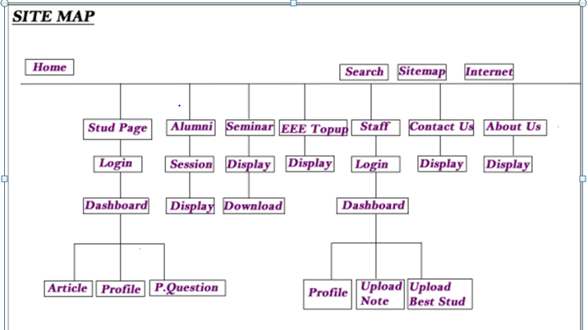

##### Figure 3.1: Diagram showing the sitemap, the sites usability and content.

## 3.2 PLANNING / DESIGN ANALYSIS

Using the information gathered in the first phase, and considering the end users;

Development of a consistent, easy to understand system is created.

Create an easy to navigate site that is relational and can be opened with different user end device resolution.

Develop a sitemap considering list of all major content of the site, as well as sub-topics.

### 3.2.1 WEBSITE COMPONENT (INTERFACE DESIGN)

The project is made up of 5 main sections namely:

The Login/Authentication page

The Dashboards

The Student Section

The Departmental Section

The Management Section

### 3.2.2 THE LOGIN AUTHENTICATION PAGE

This page takes the login parameters and queries the database to see who requesting access is. The visitor is then redirected to the appropriate page based on his role. That is, students are redirected to their page after login and staff likewise.

### 3.2.3 THE HOMEPAGE:

This page is the first page of the site. It contains the result summary. It is dynamic and adapted to each student or staff.

### 3.2.4 THE STUDENT SECTION

This provides a more detailed breakdown of result for the student than that offered by the dashboard. It is visible to Heads of Department, Dean of the faculty and the Provost alongside the student.

## 3.3 DESIGN/ EXECUTION

This is the point where the look and feel of the site is structured, it involves;

* Creating the graphical user interphase (GUI)
* Creating the content
* Converting the Web designs from images into codes (markup) which web browser use to prevent the website in the internet.

### 3.3.1 The design of the project was done using 4 methods

* Requirement Analysis
* Designing the Application Map
* Designing the database
* Designing the page structure

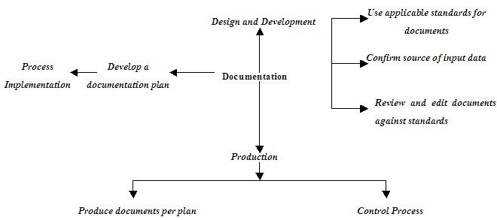

##### Figure 3.2: Diagram showing flow chart showing part for project execution.

## 3.4 REQUIREMENT ANALYSIS

This website would provide various services such electrical student’s profile, lecturer’s profile, alumni records, lecture notes, seminars for both students and lecturers. Along with the aforementioned, the web application should also be able to, upload student’s data, upload lecture notes, upload seminars, change passwords and edit login details.

For the web application to work effectively, various requirements have to be made available. These requirements are further elaborated on:

### 3.4.1 DATA

This involves all the data that would be uploaded into the database for further use by the students and the administrators. The emphasis of this project is data. However, there are basic student information that will help the outcome make more sense.

1. Students’ data
2. Staff data
3. Alumni information
4. Past seminars(by Lecturer and Student)

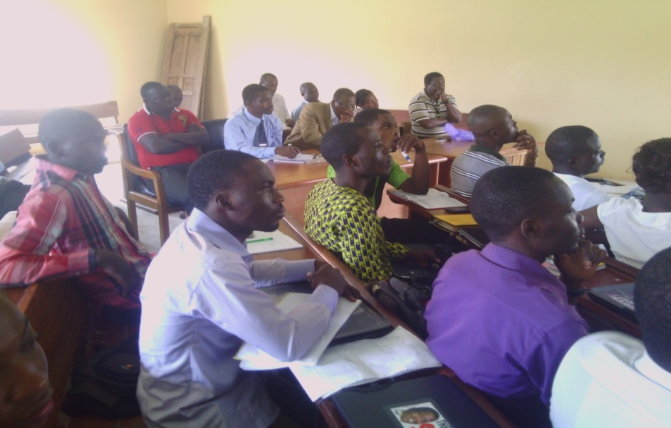

##### Figure 3.3: A cross-sectional area showing both staff (Head of department, lecturers form other departments and even the Provost) and student of the college during a Seminar delivered by Dr. Sodipo.

LOOK FOR A SEMINAR PICTURE HELD IN THE DEPARTMENT AND PLACE IT HERE.

### 3.4.2 TECHNICAL REQUIREMENTS

This involves the various technical tools that would be needed in order to be able to access and use this web application. These tools include:

i. A memory device, preferably an external hard disk drive. This is to be used to store all of the information and data that would be used on the application. The memory device to be used is the 320GB hard disk drive.

ii. A Computer system: This would be used to access the application on the internet. It could either be a desktop or a laptop computer that would have at least a 512MB RAM, a 20GB hard disk drive, a 1.27GHz processor, a 32 bit operating system.

iii. A mobile phone can also be used to access the application but it must be WAP enabled and be able to access the internet. The phone would use wireless technologies such as GPRS, EDGE or 3G to connect to the internet.

### 3.4.3 SECURITY REQUIREMENTS

One of the expectations of such an application is its security and safety. Some of the security measures taken in the course of the development of this application are:

#### 3.4.3.1 ACCESS LEVELS:

There are several access levels-students, staff, and HOD. Each of these access levels have a limit to what amount of information they can see. For example:

Students will only be allowed access to their own profile and not to another student’s personal profile. They are also only allowed access to general information that does not reveal the identity of any student. But the HOD is allowed access to all students and staffs information, since he/she is serving as the admin.

#### 3.4.3.2 AUTHENTICATION

Before any user has access to unique features of this web application, they would be required to login with predefined username and unique password.

#### 3.4.3.3 ACTIVE RECORDS SCRIPTING FOR THE DATABASE

There are several crawlers on the internet that combs the web for database information. This application uses SQLITE. SQLITE databases are accessible with just the username and the password. Active Records is a scripting format that accesses the database with Object Oriented Patterns and returns objects rather than arrays that are readable by most crawlers. This gives the database a level of security from SQL injections. [8]

#### 3.4.3.4 VALIDATED INPUTS

XSS cross site scripting is a hacking technique peculiar to web applications. It uses vulnerability of the site code to obtain information from the users. This can be solved by several methods. One method is validating inputs. This ensures that only the type of data needed are submitted. XSS or CSS attacks are initiated by codes that are usually of a varying format than most data. Another method is the use of Strip tags () feature of PYTHON/DJANGO. This piece of code simply removes HTML tags which are usually used to perpetuate XSS attacks. Html special chars() is also a useful tag. However, unlike strip tags (), it converts the tags to their compatible equivalents rather than removing them out rightly.

### 3.4.4 DESIGNING THE APPLICATION MAP

The application map contains meaningful and essential information about the structure of the page. It also shows all the pages in the application (represented with some blocks) and the main relationship between them.

### 3.4 5 DESIGNING THE DATABASE

A database is an organized collection of data for one or more purposes, usually in digital form. It is designed to offer an organized mechanism for storing, managing and retrieving information through the use entities relationship model. The database design for this project is illustrated in the appendices. It is represented to reduce repetition to the barest minimum. Scaling and integration with existing system is put into consideration.

### 3.4.6 DESIGN OF THE PAGE STRUCTURE

The website makes use of a conventional web page design.

### 3.4.7 RESPONSIVE/MOBILE COMPATIBLE DESIGN

The application makes use of a responsive design model. This model allows the application to be accessible over majority of devices-PC, tablets, pads and phones. This strategy of design reduces development time considerably, that is, the same piece of codes can be used to serve all media devices without having to redesign specifically for separate devices.

##### Figure 3.5: Showing the emblem to be used for the department on the site.

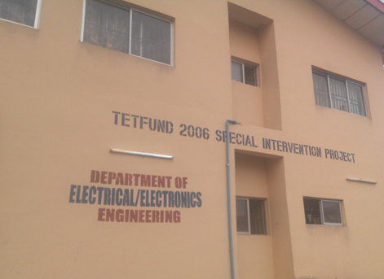INCLUDE DEPARTMENT PICTURE HERE

##### Figure3.6: Showing the side view of the department of Electrical Electronics Engineering.

## 3.5 DEVELOPMENT

We take the content and spread it throughout the site as its appropriate, using necessary web development tools, kits and software’s as the case may be.

We ensured a target of a relational website to avoid repetition of past mistakes that has truncated the effort of the designers or the privilege of the department having a functional website.

# CHAPTER FOUR

# TESTING AND OBSERVATION

## 4.1 TESTING THE STUDENT SECTION

To test the student section we need the correct username and password to login into the homepage from the student login page. The student section starts with the “login” section, for a student login in for the first time, he or she has to first “Activate his or her account” which is slashed with the Login section. When a student logs in he or she is taking to their home page where there are three other sub-section;

UNDER THE LOG-IN

STUDENT HOME

EDIT PROFILE

AFTER SUCCESSFUL LOGIN, THEN STUDENT HOME/ PROFILE, Having the following sub-sections;

* Profile
* Article / Journal
* Past question

### **4.1.1. STUDENT HOME**

This is the page where each student is able to have access to personal details and also group information from the department, to view and engage in exclusive information accessible to only members of the department

### **4.1.2. EDIT PROFILE**

This is the part where each student fills his or her bio-data into the department database in other to have full access to the site.

### **4.1.3. PROFILE**

Each student is able to fill and view his or her data from this region.

### **4.1.4. ARTICLES & JOURNAL**

Access to upload and download seminar topics and past questions and other necessary information required in the site.

### **4.1.5. PAST QUESTION**

Availability of past questions of previous years, spanning across different or all courses.

## 4.2 TESTING THE ADMIN SECTION

There is no separate login created for this user. However, the distinction is done in the login process. The user has a field that represents his role in the database. The application obtains the role and redirects the user to appropriate pages. The pages have been coded to allow only authorized access and only authorized users will be able to see the contents of the page. When the Admin logs in he or she is taking to their home page where he or she has a dashboard having the following sub-sections;

* Staff
* Student
* Seminar

### 4.2.1 STAFF

In this sub-section, the admin has access to utter, change or modify the following information;

* Employ
* View
* Edit
* Delete

### **4.2.2 STUDENT**

In this sub-section, the admin has access to utter, change or modify the following information;

* Admit
* View
* Delete

### 4.2.3 SEMINAR:

In this sub-section, the admin has access to utter, change or modify the following information;

* Upload
* View
* Delete

## 4.3 TESTING THE STAFF SECTION

There is no separate login created for this user. However, the distinction is done in the login process. The user has a field that represents his role in the database. The application obtains the role and redirects the user to appropriate pages. The pages have been coded to allow only authorized access and only authorized users will be able to see the contents of the page. When the Staff logs in he or she is taking to their home page where he or she has a dashboard having the following sub-sections;

* Profile
* Submit note
* Upload practice questions
* Student
* Best Student

### 4.3.1 PROFILE CHECK:

It contains formal distinguishing data or information of the lecturer that show his or her job description and other relevant information which can only be accessed by the Admin and the Lecturer but not by the student.

### 4.3.2 SUBMIT NOTE

Lecturers have the capacity to release assignment to see who has submitted a given assignment on a particular course.

### 4.3.4 UPLOAD PRACTISE QUESTION

This gives the student an opportunity to have access to question (past), released by the lecturer sending out the work.

### 4.3.5 STUDENT

This sub-section gives access to the lecturer to see number of students in the department and those who are registered for his or her course.

### 4.3.6 BEST STUDENT

This gives lecturer the access to paste a list of scores obtained in a particular course, which gives rise to motivation to read in the coming semester

## 4.4 TESTING THE CSTOP UP SECTION:

This is a section which is eyes catching and it involves the following:

[a]Viewing students that graduated with above 4.5CGPA

[b]Best student in each set

### 4.4.1 Viewing student that graduated with above 4.5CGPA:

The name, matric number and the semester with student that graduated with CGPA above 4.5 either in the first semester or the second semester.

### 4.4.2 To view the best graduating student from the first set till the latest set:

The best student that graduated from the first set till the latest graduated set is displayed on the site.

## 4.5 TESTING THE SEMINAR SECTION:

This is a section is grouped into the student seminar and the staff seminar. The student seminar can be viewed and downloaded in the section also the staff seminar can be viewed and downloaded.

## 4.6 TESTING THE ALUMNI SECTION:

This section involves the sets that have graduated from the department. Their names, matric number and the project topic they carried out while in school is viewed on the site.

## 4.7 THE CONTACT US SECTION:

This section is a form that is created in the database that is linked to the email of the department. The contact us page is a way to get feedback from those that has viewed the site, either complaint, suggestion or the likes.

# CHAPTER FIVE

# CONCLUSION, RECOMMENDATION AND REFERENCE

## 5.1 CONCLUSION

The Web took the world by storm, and as a result developed rapidly in many directions. However, it still exhibits many aspects of its early development, such as its visual and computer-screen orientation. But the Web is still developing rapidly: there are now more browsers on mobile telephones than on desktops, and there is a vast diversity in types of devices, types and orientations of screens, and sizes (in number of pixels), and resolutions (in dpi) of screens. It is with great excitement that we present this project. It makes use of technology to a large extent to propagate result information, draw relevant but obscure information from common data and help both students and the administration to see another medium of conversing and sharing of information.

Most web-based applications are developed on Open Source platforms. Open Source development frameworks are free pieces of software that are maintained and supported by online communities. The benefit of this at a business level is the cost effective solutions such platforms can provide. No longer do you have to pay for software licenses and support contracts - everything is free except for the development of the application itself.

Every web-based application is cross platform compatible. This means that they will run on any type of computer with any type of operating system providing the workstation has a compatible web browser installed. From a business point of view, you no longer have to worry about whether your Mac users can access your Windows applications or visa-versa.

With the introduction of SSL Certificates some time ago, web-based applications are now considered to be 100% secure. You do not have to worry about your company data getting into the wrong hands. Use of SSL Certificates will ensure that every piece of data sent via the Internet is encrypted from point to point.

## 5.2 RECOMMENDATION

Upon completion of this project, we hereby recommend the followings;

The Android Application can be extended to incorporate the school management system

The school should adopt the application

Members of the teaching staff should disseminate information through it, this alone will ensure constant visit of the site amongst other reasons.

HOD should appoint someone in respect of being in charge of the admin, who will be responsible for it being active.

If eventually the system is adopted, it should be integrated with the existing school management system instead of being run as an independent application.

# REFERENCES

[1] Tiffany B. Brown (2013) Jump start HTML 5 Basic, IOS press. ISBN 978-9922794-8-6 (eBook).

[2] Jacob Seidelin (Copenhagen), 2012, “HTML5 Games Creating fun with, HTML 5, CSS 3 and webGL, First Edition.

[3] Benjamin LaGrone. (May 2013). HTML and CSS Responsive Webdesign cookbook. Production Reference: 1160513, ISBN 978-184969-544-2.

[4] O’Reilly. “Embedding PHP in HTML”. Retrieved 5 March 2009.

[5] Jackson Joab (2014-07-31). “PHP gets a Formal Specification at last”. ITworld.IDG.

[6] “History of PHP and related project”. The PHP Group. Retrieved 25 February 2008.

[7] PHP Manual. ”Introduction: What can PHP do?” Retrieved 4 March 2008.

[8] Lynn Beighley and Michael Morrison. “ Head First PHP & MYSQL”. First Edition: 2008.

[9] Janet Valade (2008, Nov 6). PHP and MYSQL for Dummies (2ND Edition). [Online]. 29(5). Available: [www.dummies.com/register](http://www.dummies.com/register). [ April 15, 2012].

[10] Julie C. Meloni. “PHP Fast and Easy web development”. Internet: [www.php.net](http://www.php.net), Oct 15, 2002[Dec, 23, 2014].

# APPENDIX AND IMAGES

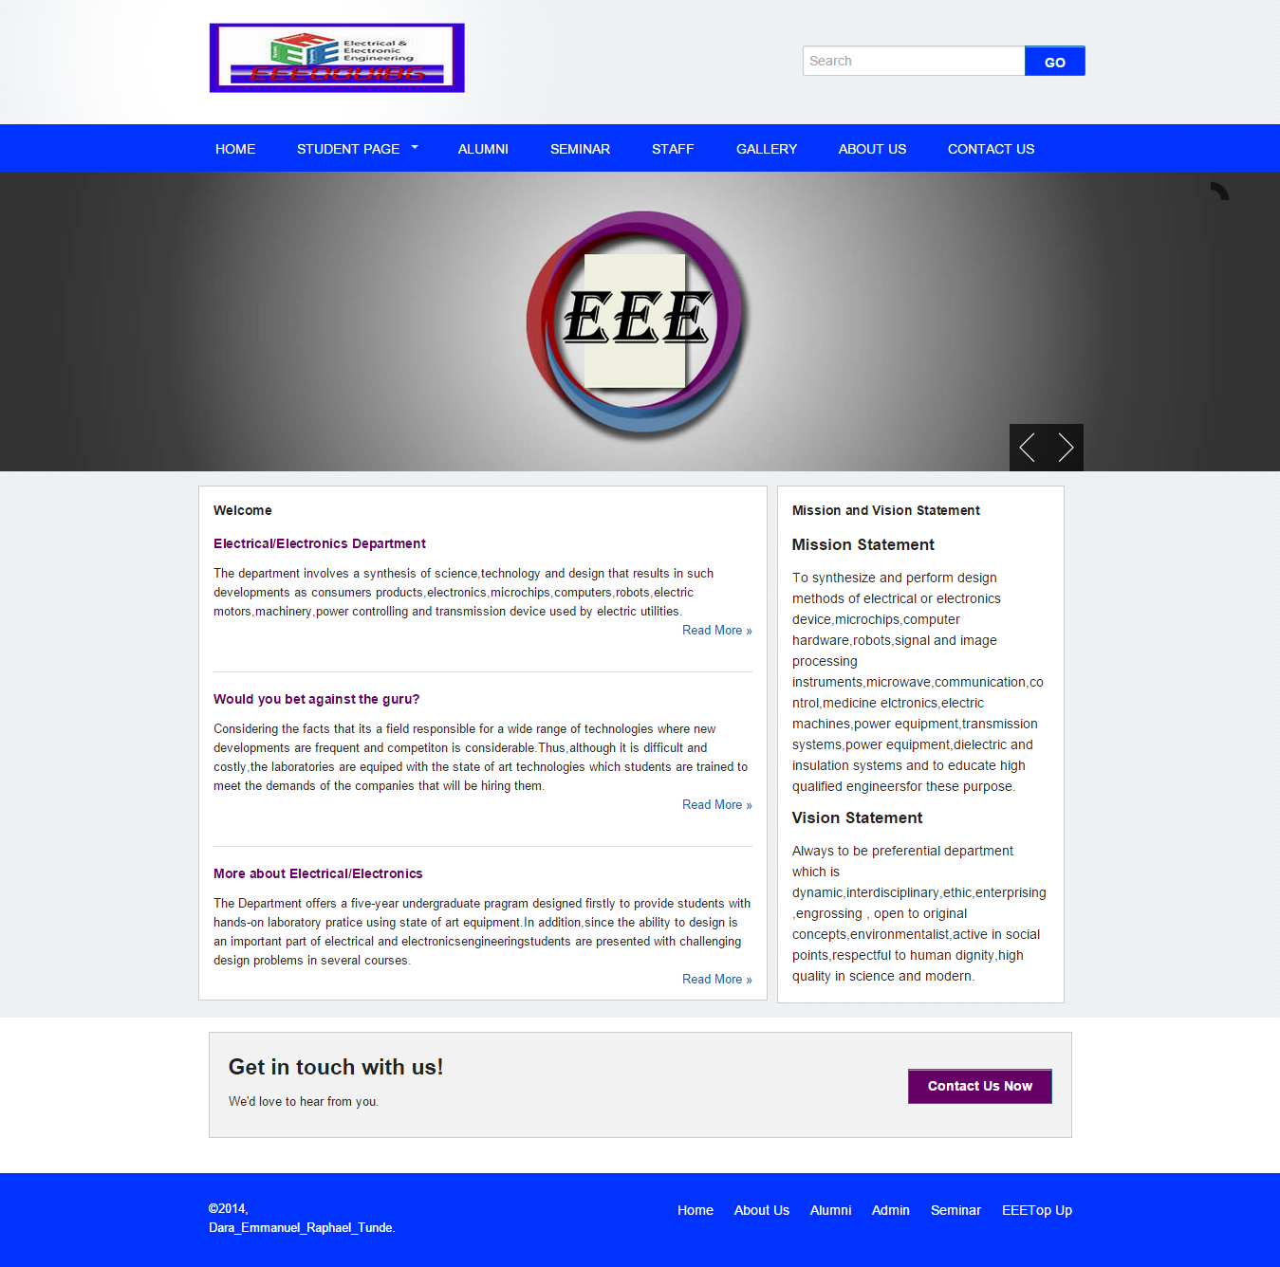

##### Fig 1.4 EEEOOUIBOGUN Welcome Page.

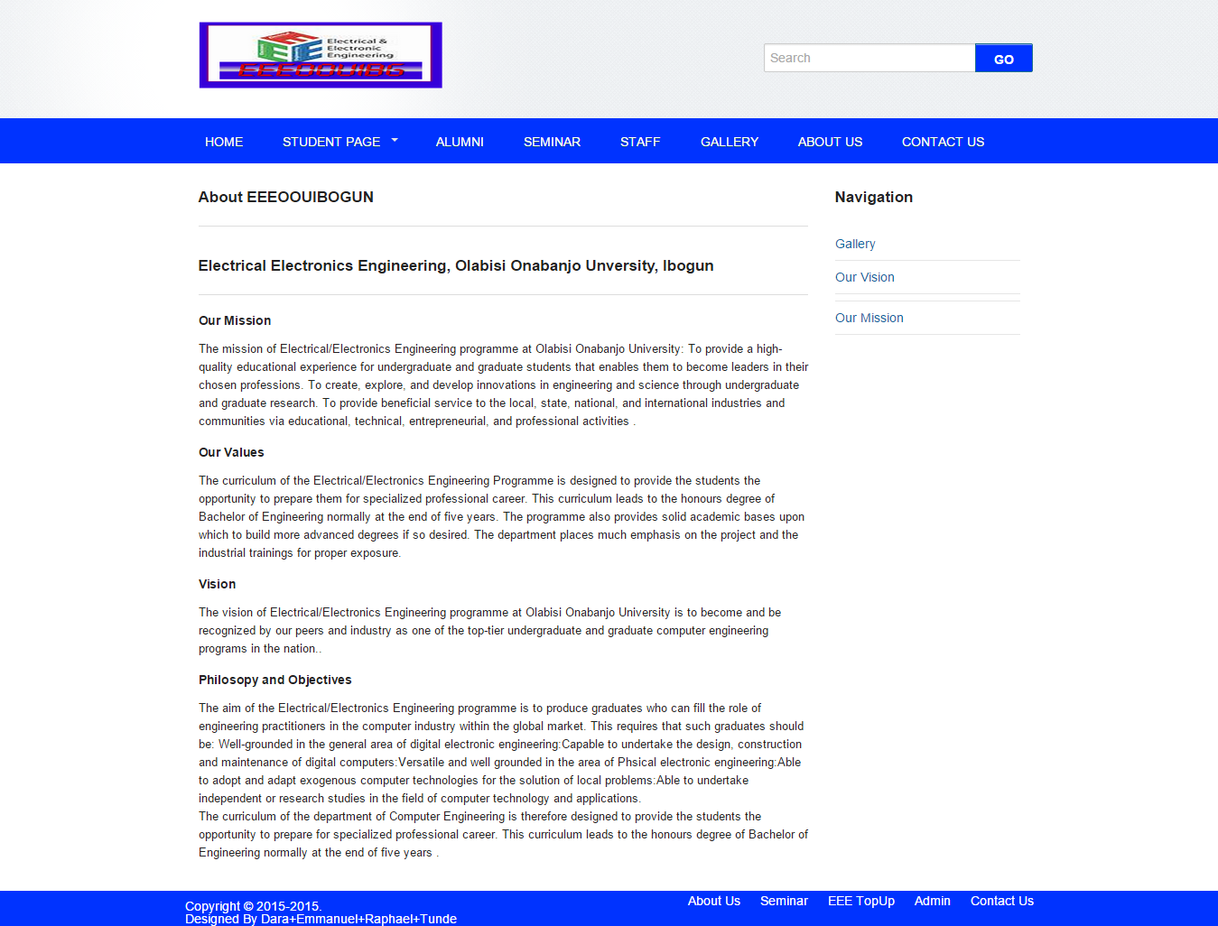

##### Fig 1.5 EEEOOUIBOGUN About Us Page.

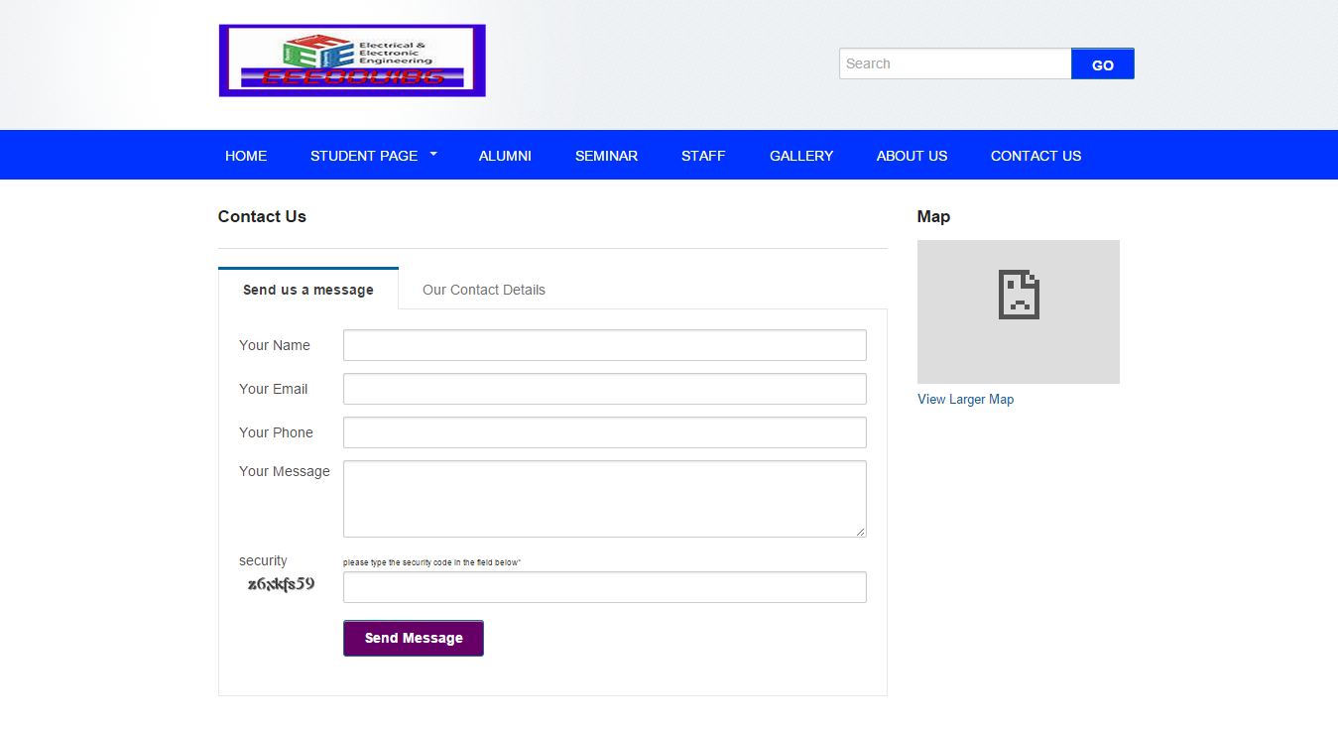

##### Fig 1.6 EEEOOUIBOGUN Contact us Page.

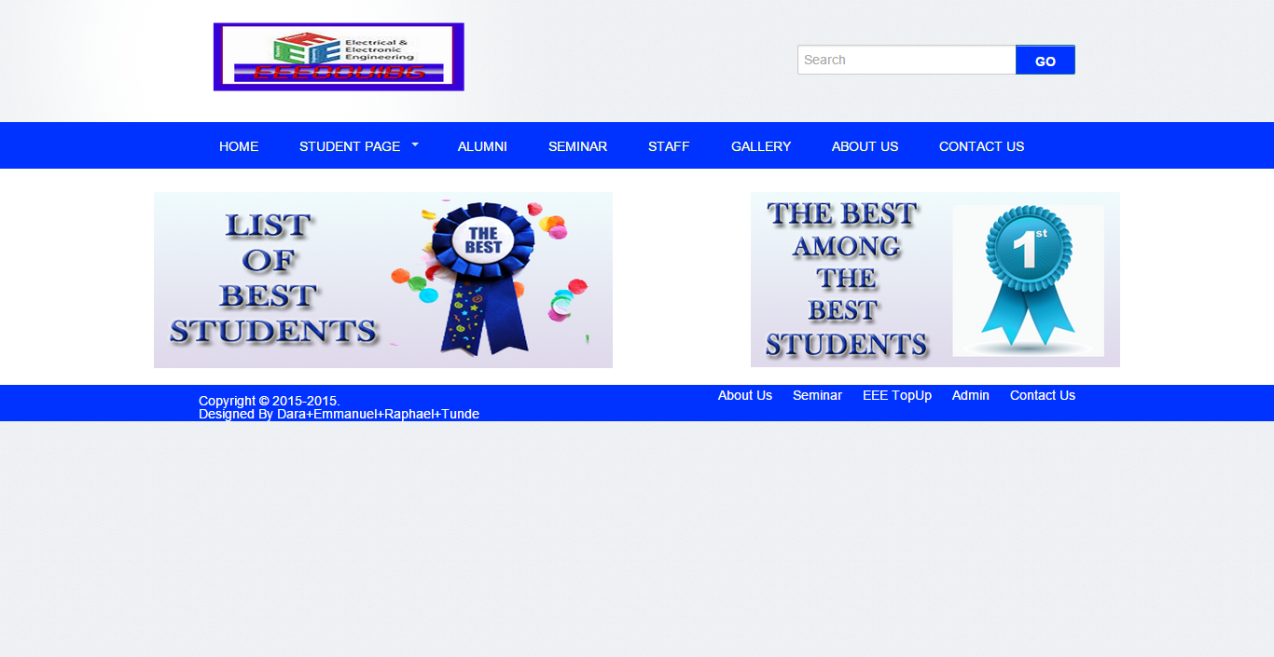

##### Fig 1.7 EEEOOUIBOGUN EEE Top Up Page

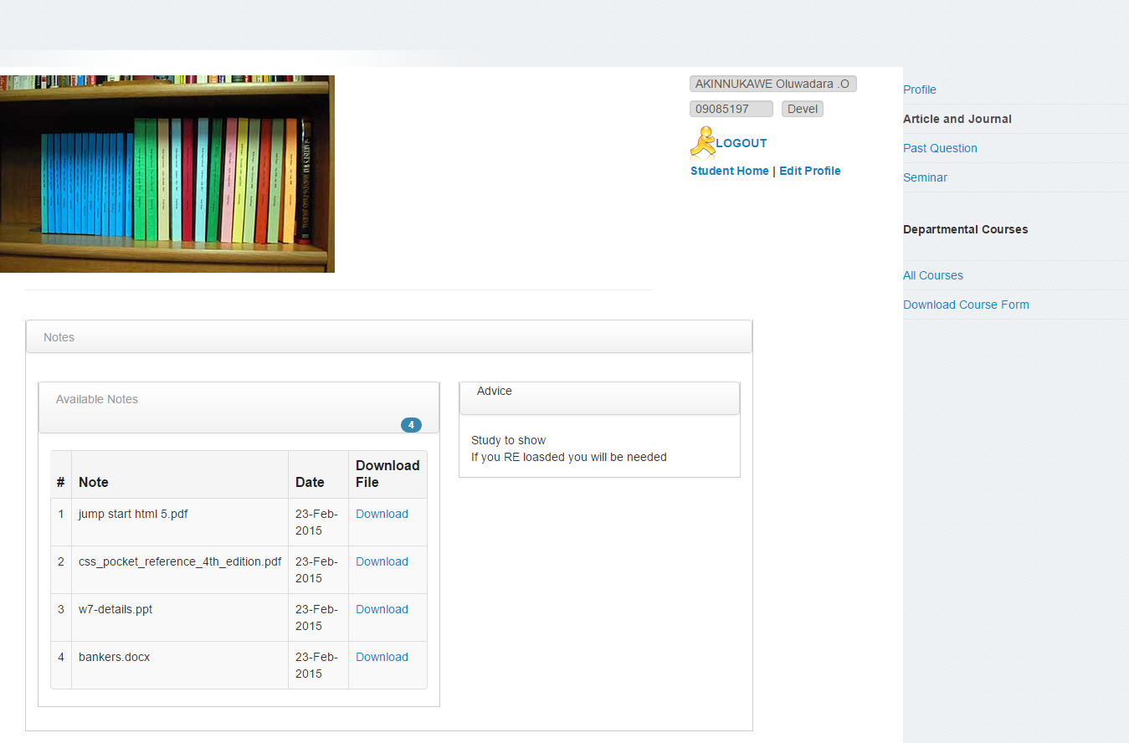

##### Fig 1.8 EEEOOUIBOGUN Article and Journal Page

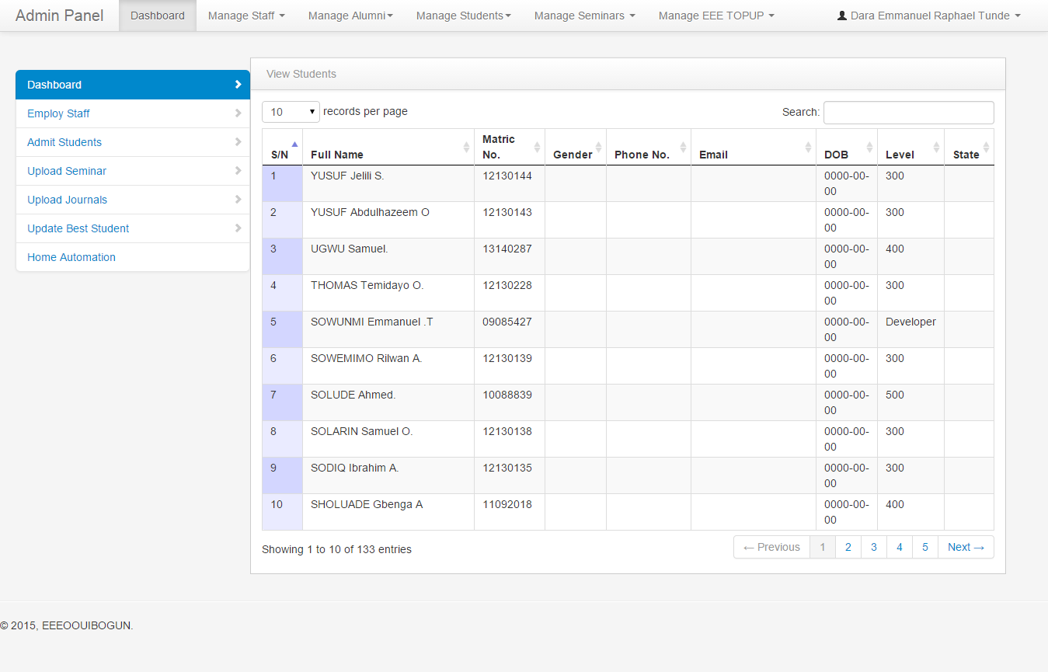

##### Fig 1.9 EEEOOUIBOGUN Admin Page

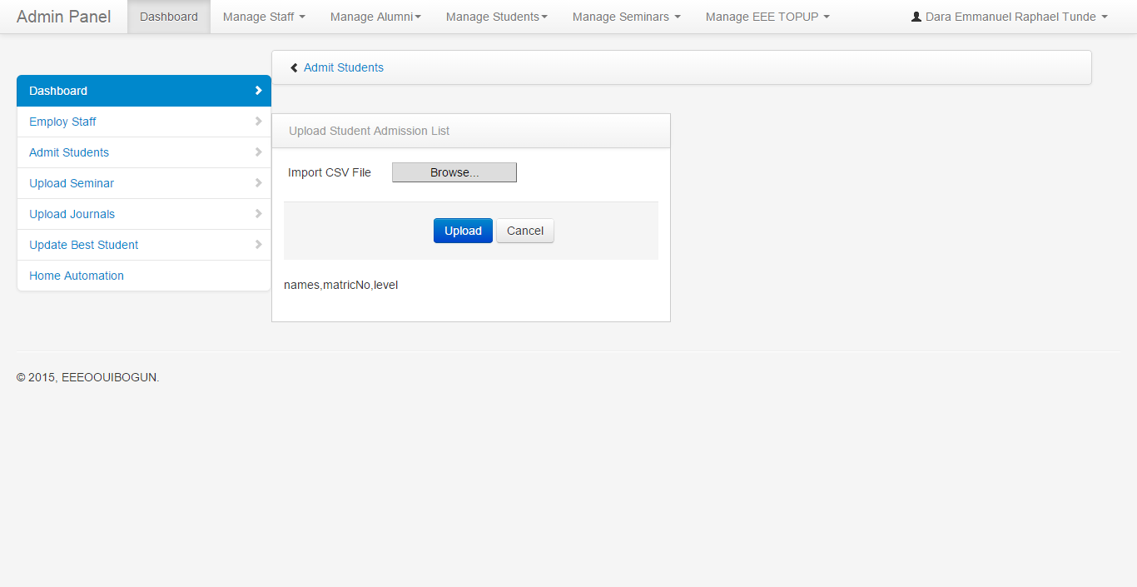

##### Fig 1.10 EEEOOUIBOGUN Admit Student Page.

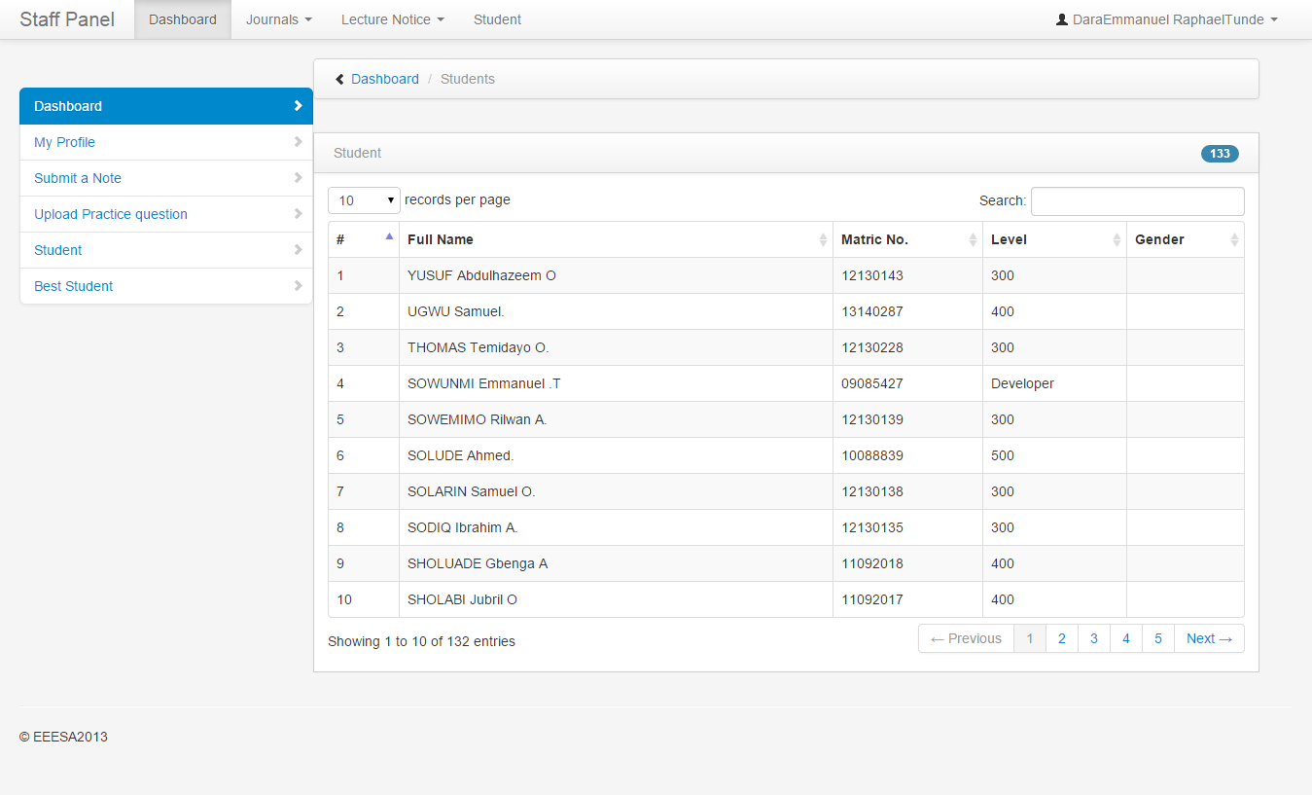

##### Fig 1.11 EEEOOUIBOGUN Staff Page.

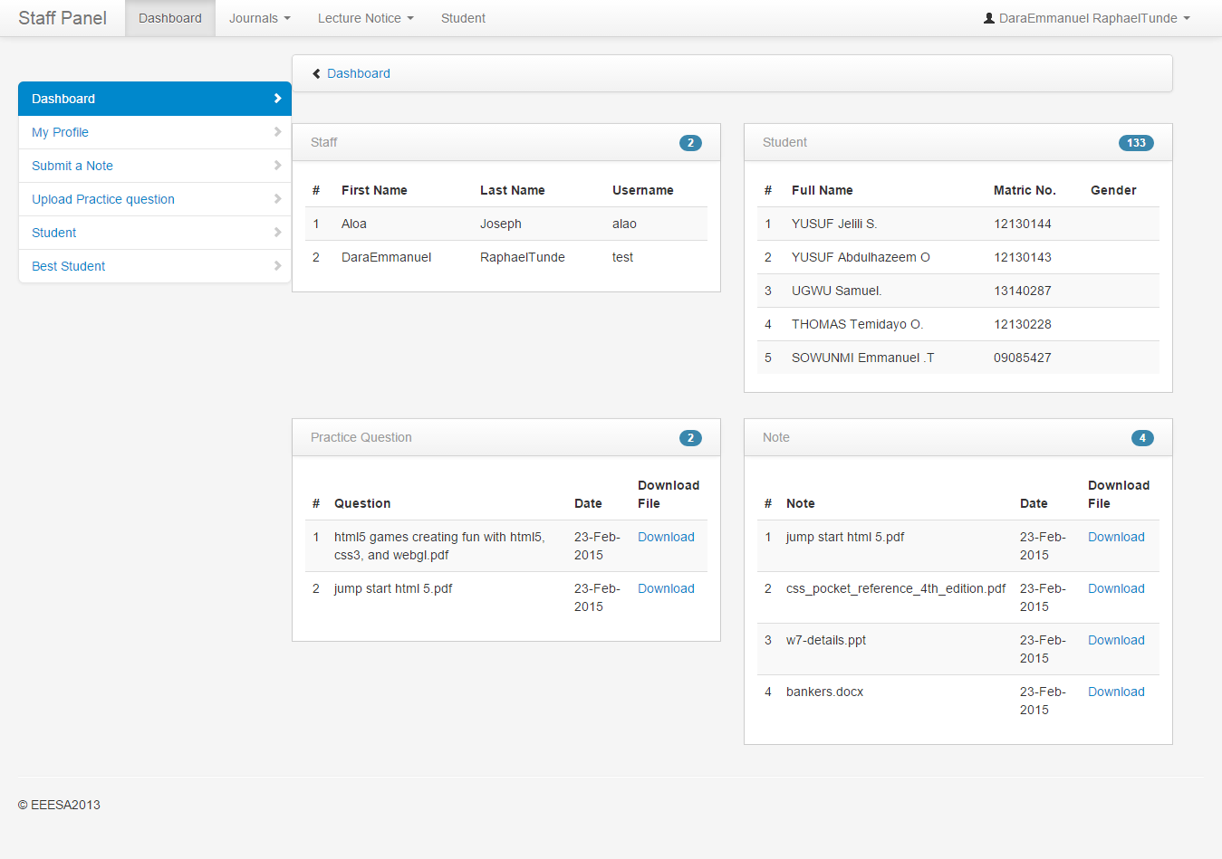

##### Fig 1.12 EEEOOUIBOGUN Staff Dashboard.

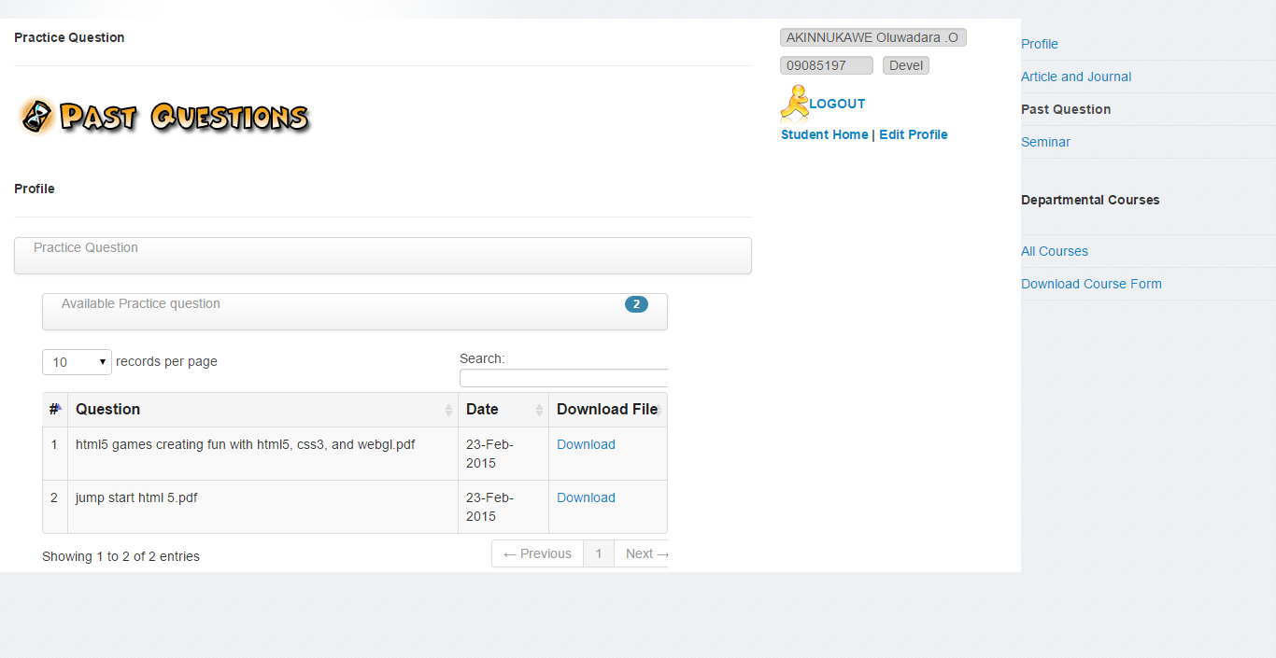

##### Fig 1.13 EEEOOUIBOGUN Student Past Question.



##### Fig 1.14 EEEOOUIBOGUN Staff Page.