

ADipIT02 -Object Oriented Design and Programming

**Individual contribution report in Group Project**

Group Name= “Creation”

Project Name= Nepal Helping Hands Society (NHHS)

Member Name= Tulasa Basnet (NP03A180110)

Submitted date: 2019 December 28th

Submitted to : Sachin Kafle

**Acknowledgement**

I would like to express my special thanks of gratitude to my lecturer Mr. Raj sir and tutor Sachin sir who gave me the golden opportunity to do this wonderful project web application (Nepal helping hands society), which also help me in doing a lot of research.

A special gratitude for my group's members whose contribution in stimulating suggestions and encouragement helped us to coordinate our project.

# 

# 

Table of content:

1. Use Case Diagram 1

2. Sequence Diagram 3

3. Conclusion 5

4. References 6

# 1. Use Case Diagram

In this use case process a donor, directly communicate with organization. The system is use by organization under the donor and receiver. At first, user view the site of NHHS then if he/she wants to donate, money then he/she need to complete this registration and login process. After login with email address and password, the user information data stored on the database server. An organization also can update and delete member's record. There is extend relationship between login and user access denied and update user detail. There is <<include >> relationship between add member record and view details. If there, any members added or deleted also need to update member record so, it is <<include>> relationship. An organization receive donation from Nepal and foreign country through cash and cheque. After getting donation, an organization distribute donation. All the payment history are automatically handle, Maintenance and daily updates by the NHHS organization.

The use case diagram of our web application (Nepal helping hands society) is shown below:

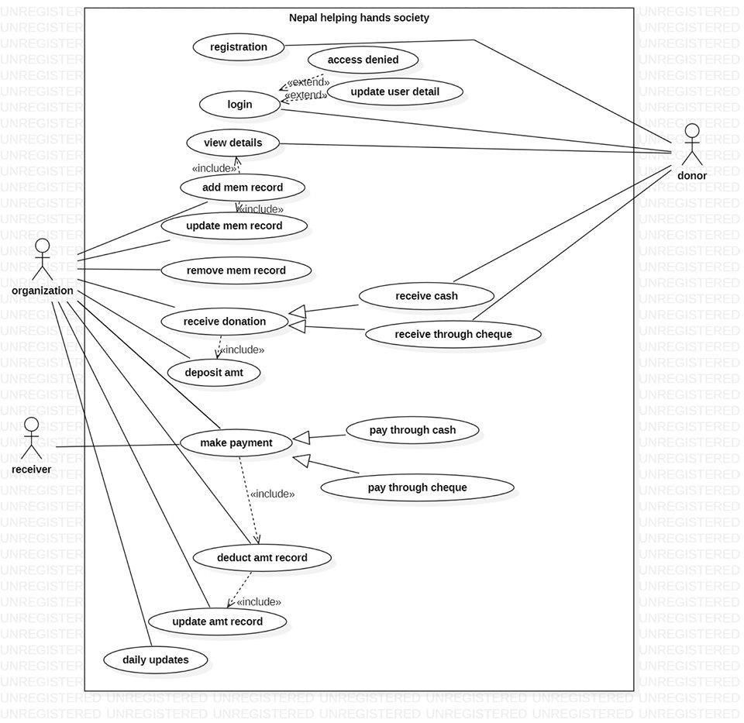

*Figure 1: use case diagram*

# 2. Sequence Diagram

A sequence diagram is shown below:

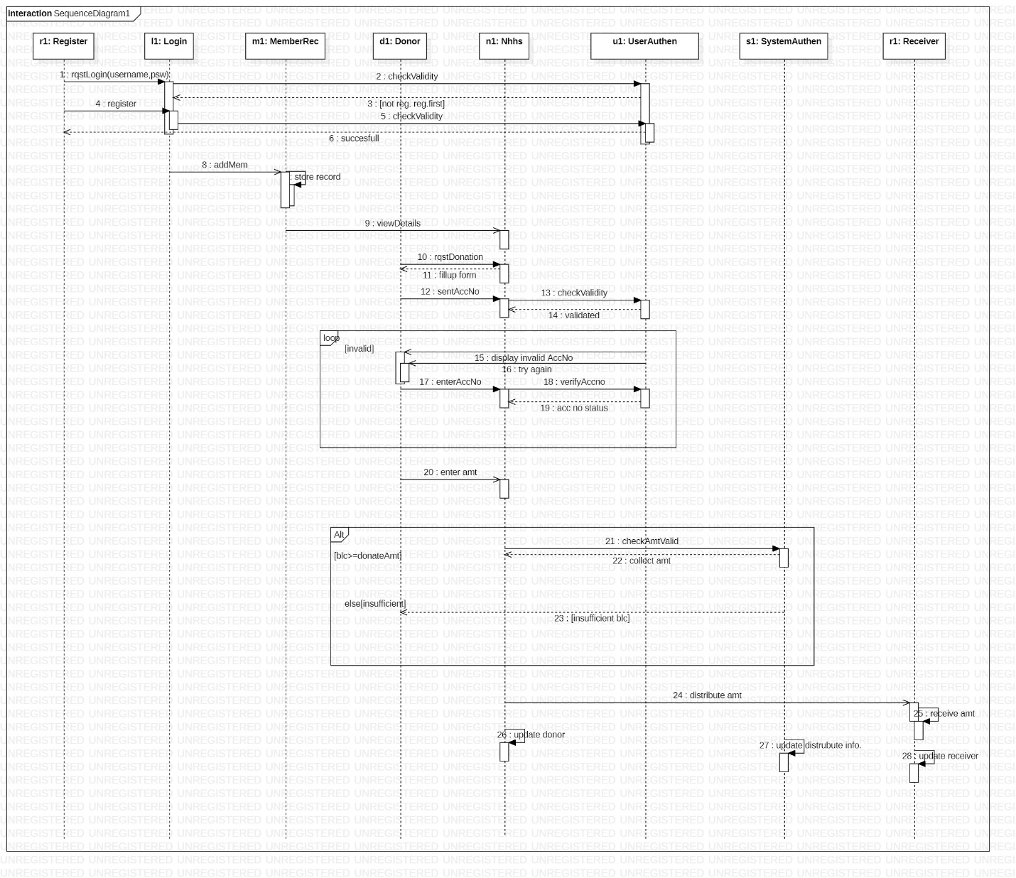

Figure 2: Sequence Diagram

In the figure above, a sequence diagram shows the interactions between a user and the system NHHS (Nepal helping hands society). It shows the object (r1, l1, m1, d1, n1, u1, s1, r1) participating with the interaction by lifeline and the message that are send to each other. It describes how operation are carried out and which message are sent and when. A lifeline represent an individual participation in the interaction. So basically each instance are represented by lifeline. A thin rectangle of a lifeline, called activation. We can see, there are eight classes and eight objects interacting with each other. Some methods are called for response that is the particular communication between lifeline of an interaction, also known as synchronous message ( Paradigm, 2019).

At first, a user entry into the system and try to login using username and password. The provided information are checked by user authentication whether the given information are valid or not. A UserAuthentication reply as meaningful return message [not registered] reg. first and finally it reached to registration form. After completing registration process in the same way and finally returns successful messages.

After registration process completed, user’s data are stored on the memberRecord and finally he/she can reached to the home page. If the member wants to donate, rquestDonation() method calls to the organization(Nepal helping hands society) .

After providing acc no, NHHS process further for validation. If the acc no. is valid, user authentication returns message as acc.no is valid. If the acc.no is invalid, there is loop frame and it displays the message as invalid acc no. try again and request to enter valid acc. No and returns acc no. status (study, 2019).

After acc no. is validated, NHHS request for enter amount. If the entering amt is valid, donationAmount is collected in NHHS . if not system authentication returns message as [insufficient blc.] (Gate, 2019).

Finally, the collected amount are distributed by Nepal helping hands society to receiver. system authentication, donor and receiver are updated automatically after changes are made.

# 3. Conclusion

This coursework which is provided by our module leader is really challenging and difficult. Because of my continue research and hard work, I successfully completed on time. In the coursework, at first I have given to submit use case diagram in the group project which is easier than this sequence diagram. Our team used to continue visit to our tutor and lecturer so finally we have done provided coursework in timely. A sequence diagram helps me to gain more knowledge about a synchronous, asynchronous message, self message, lifeline, activation, obj, class, loop, if/else frame and etc.

# 4. References

Paradigm, V., 2019. *https://online.visual-paradigm.com/.* [Online]   
Available at: https://online.visual-paradigm.com/diagrams/tutorials/sequence-diagram-tutorial/  
[Accessed 26 12 2019].

Gate, R., 2019. *https://www.researchgate.net/.* [Online]   
Available at: https://www.researchgate.net/figure/UML-Sequence-diagram-of-nested-if-else-Fig-6-represents-the-nested-if-else-message_fig6_30790265  
[Accessed 27 12 2019].

study, c., 2019. *https://gyires.inf.unideb.hu/.* [Online]   
Available at: https://gyires.inf.unideb.hu/GyBITT/07/ch02s04.html  
[Accessed 27 12 2019].