Task: Revise the prototype proposed in PA2 to better reflect the requirements and ideas from your team. In this PA, your prototype needs to be working, which means that end-users can interact with it.
- Main Screen

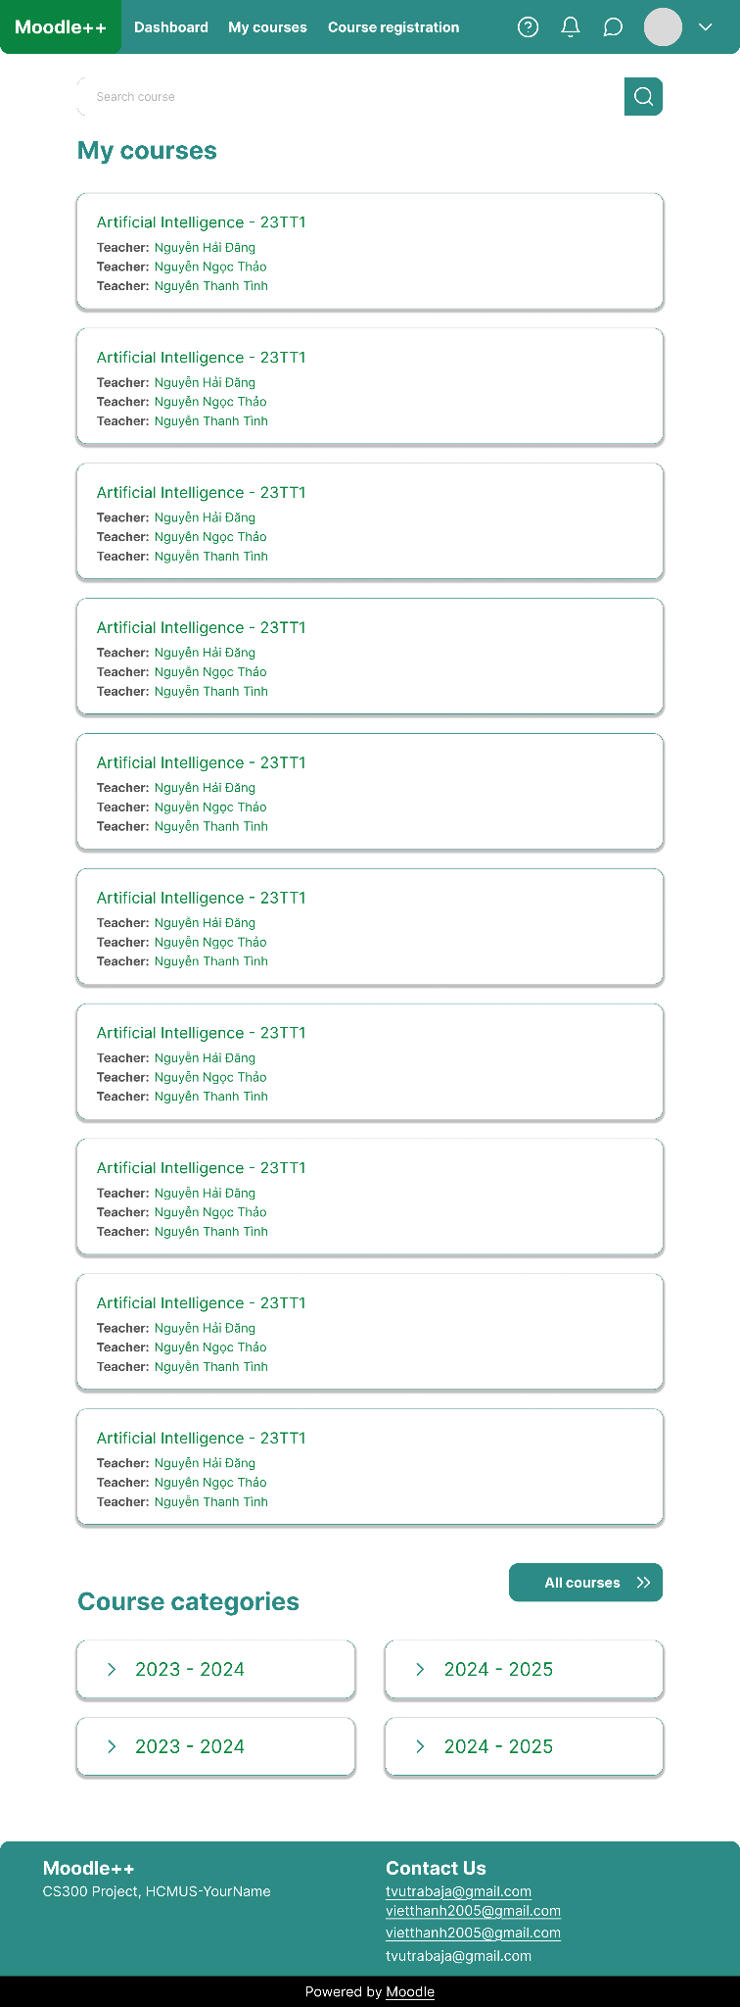
- Log In, Forget Password
