**ShopNest Store Capstone**

**Tasks to do:**Design a comprehensive Power BI dashboard to address key business analytics for a retail dataset. The following analytical questions should be answered through your dashboard:

1. **Top Categories by Total Price:**
   * Identify and visually represent the top 10 product categories by total sales.

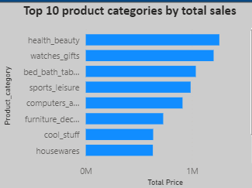

Health Beauty is the leading product category followed by Watches and gifts.

1. **Delayed Orders Analysis:**
   * Determine the number of delayed orders in each category. An order is considered delayed if the actual delivery date is later than the estimated delivery date.

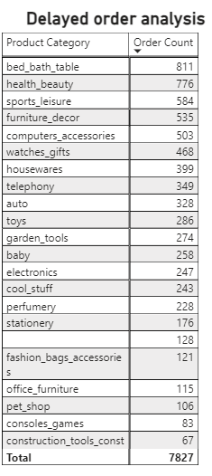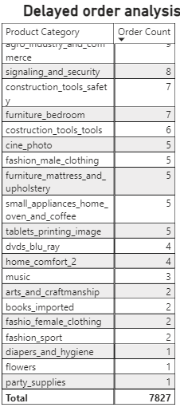

Total number of delayed order count is 7827. Bed_bath_table has the most delayed order count and diapers_and_hygeine, flowers and party_supplies orders are having lowest order count

1. **Monthly Comparison of Delayed and On-Time Orders:**
   * Create a dynamic visual that compares the number of delayed orders to the number of orders received earlier for each month. Utilize the drillthrough cross-report feature to provide a detailed analysis of late and on-time deliveries.

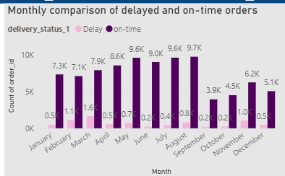

March has the highest count of delayed delivery and September has the highest count of on-time deliveries.

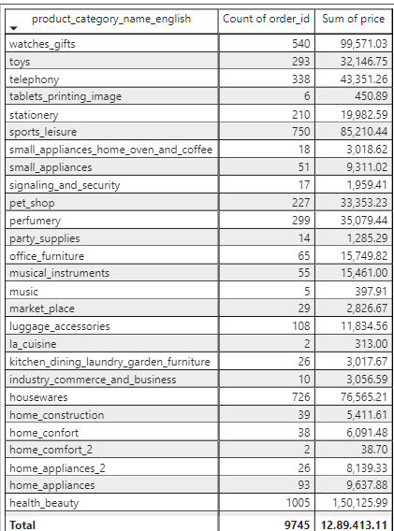

1. **Payment Method Analysis:**
   * Analyze the most frequently used payment methods by customers using a visually appealing representation, such as a pie chart or other suitable visuals.

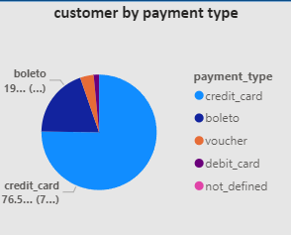

Credit card is the most used payment method

1. **Product Rating Analysis:**
   * Determine the top 10 highest-rated products and the bottom 10 lowest-rated products using a bar or column chart.

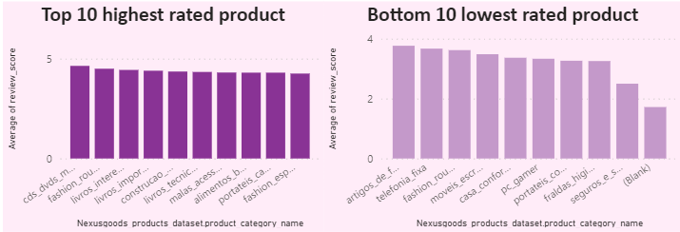

Highest rated product category is cds_dvds_musicals with an average rating of 4.64

Lowest rated product category is security and services

1. **State-wise Sales Analysis:**
   * Identify and visually represent states with high and low sales, providing a clear understanding of regional sales performance.

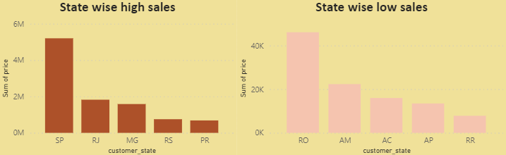

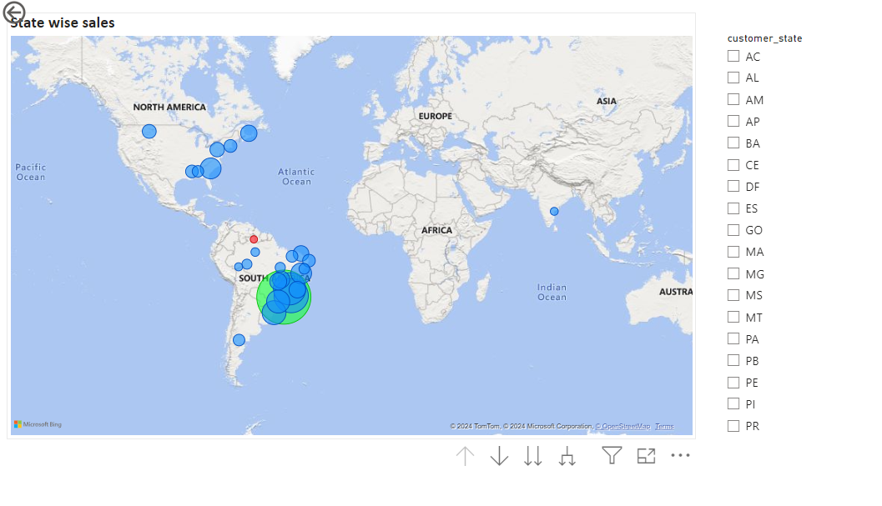

Highest sales rated state is SP

1. **Seasonal Sales Patterns:**
   * Investigate and visualize any seasonal patterns(Quarterly) or trends in sales data over the course of the year.

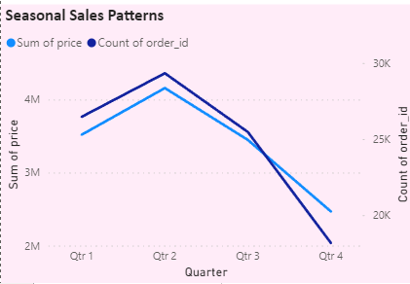

Quarter 2 has highest number of sales and quarter 4 has the lowest number of sales

1. **Revenue Analysis:**
   * Determine the total revenue generated by ShopNest Store and analyse how it changes over time (Yearly). Represent this information through suitable visuals to highlight trends and patterns.

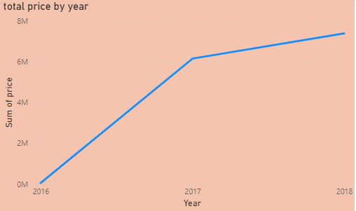

Yearly the price is also increasing