**Secondary Market Research**

Secondary market research is performed by exploring existing agriculture apps in Nepal that are found in google play. While performing a research a smart phone (Samsung Galaxy J7 prime) having 4gb of RAM is used. The major apps that are working in agriculture domain in Nepal includes:

* Hamro Krishi
* Smart Krishi
* Krishi Guru
* Krishi TV

(Note: total number of downloads, app size, ratings and reviews are taken from google play.)

**1. Hamro Krishi** (10k+ downloads, size 8.7 MB, 4.2 rating, 65 reviews)

* Need to give location, camera, contacts and storage permission to open the application.
* Weather forecasting information for next three days by meteorological forecasting division.
* List of agriculture related questions and answers.
* Weather information about locations. (not working)
* Agriculture experts section. (not working)
* Success stories (only PDF files which even takes long time to load).
* Weather bulletin (only PDF files).
* Publication (includes limited and outdated PDF files).
* List of agriculture offices.
* Market price for 12 different cities are listed but data can’t be fetched from any cities for any crops, meat or fish.
* Information on soil section (only PDF files but files doesn’t load).
* Disease management on crops, birds, animals and fish.
* Agriculture policy (PDF files).
* Help center (a form submission).
* A written article on insurance information.
* Ads running in every pages.

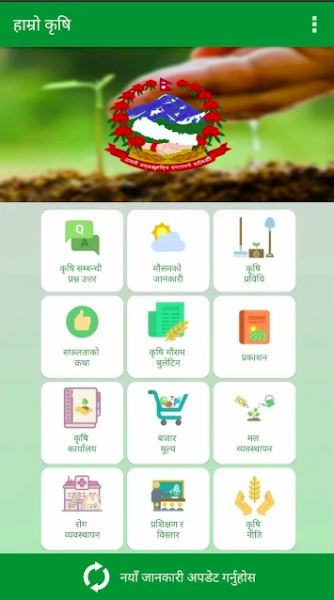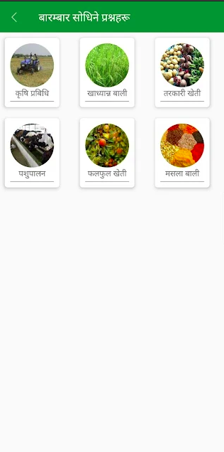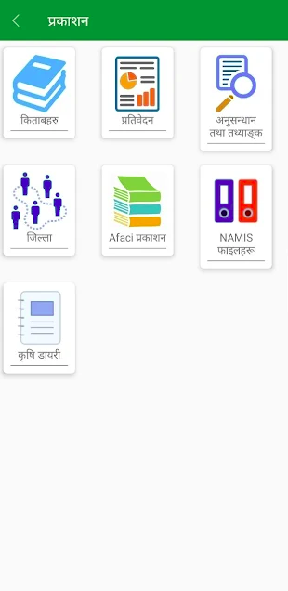

First thing, we can understand an agriculture app needs a location permission to fetch weather data for user current location. But why a simple agriculture app need a camera and contact access? Without giving all the permission we can’t access the system. This may be a privacy concern. Most of the features of the application are missing and outdated. We need to manually update every time to get new information. App is so slow to respond like it sometimes force quit. When user transit from one page to another its reloads every time. The major outcome from the research is, no one has time to wait and see applications loading. Moreover for accessing an information a common user can’t go through the PDF all the time.

**2. Smart Krishi** (100k+ downloads, size 11.49 MB, 4.4 rating, 2k reviews)

* Written information on commercial farming about fruits, vegetables, animals, cash crops and food crops.
* Agriculture library where we can find articles about diseases, organic farming, insurance policy and more.
* List of organizations helping in different domain of farming in Nepal.
* Users can read agriculture news.
* Kalimati market rate though its official website.
* Smart tips center where they post certain tips on fruits, vegetables, animals and more.
* Basic land measuring calculator.
* Weather information section (not working).
* Agriculture programs (only a form submission.)
* Ads on different pages.

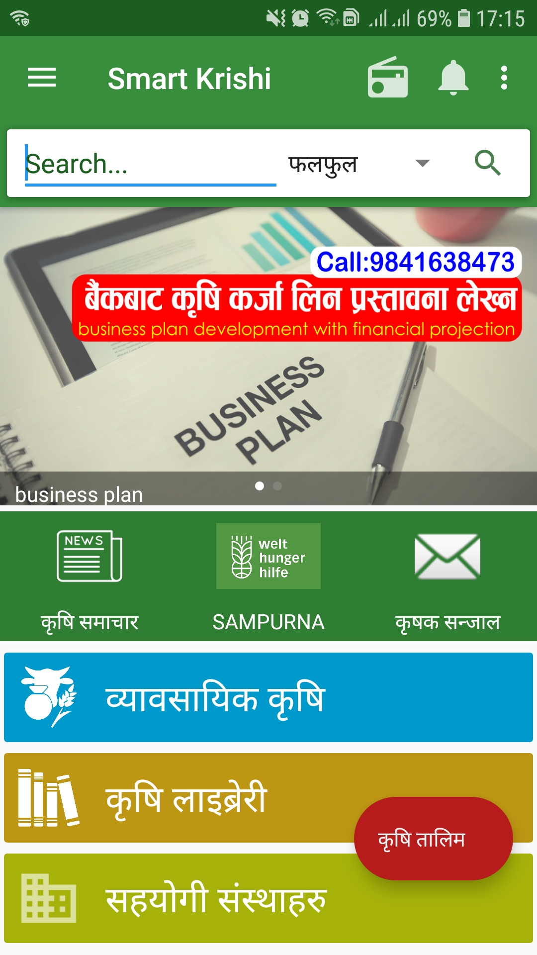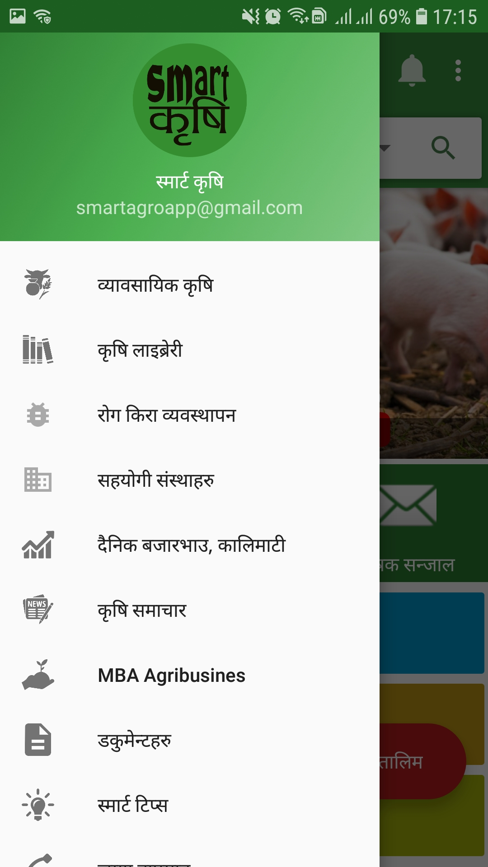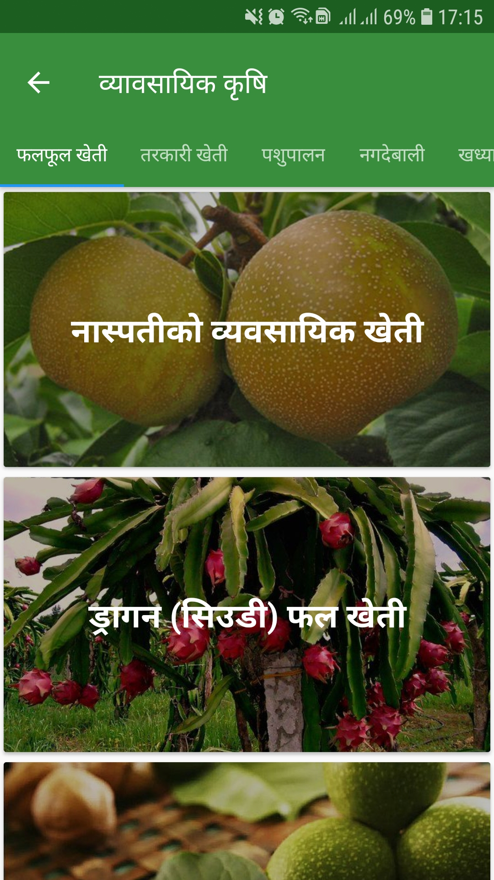

Information on commercial farming is good but we can integrate more subareas. Same for library as well. There are only limited papers that we can access. Information about organizations involved in helping farmers are listed and news are updated from different portals. Only Kalimati market prices are displayed which we can say a limited information. Smart tips center, a concept is good but tips are less. Sometimes a land measuring calculator a good tool. After exploring a doubt comes into the

mind, do any common user prefer to go through papers and articles to understand about his/her need or consult with experts directly which can bring two way interaction?.

**3. Krishi Guru** (100k+ downloads, size 8.5 MB, 4.5 rating, 483 reviews)

* Information on commercial farming that includes written documentation on herbs, fruits, vegetables, cash and food crops, etc.
* Agriculture based calculator with multiple features.
* Market that includes buying and selling of products, Kalimati market price, market analysis, list of sellers in different districts and farms.
* Information about events, training’s and Anudan.
* News section is also available.
* Agriculture related videos embedded from YouTube.
* Expert support though SMS for Ncell users.
* Agriculture library that includes multiple articles and blog posts.
* Weather forecasting for next 3 days.

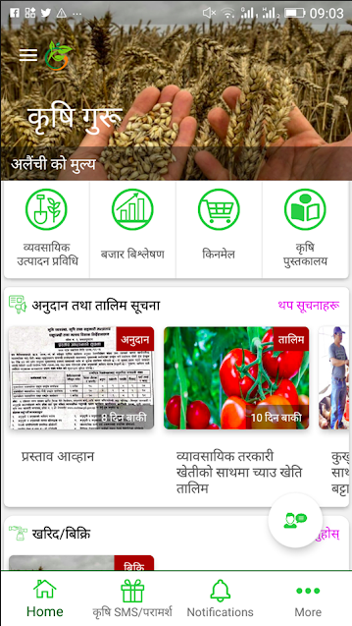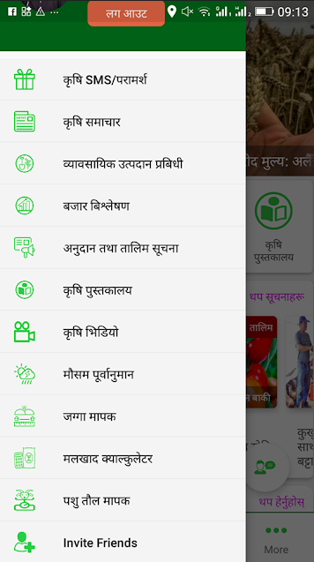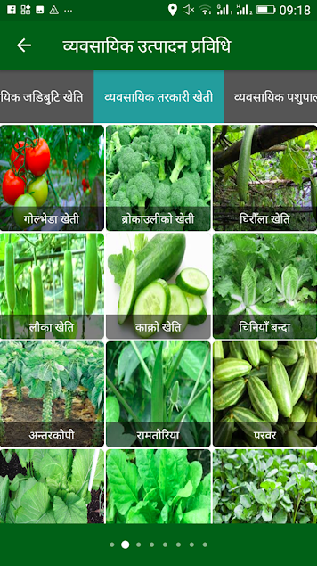

Overall, the system is good compared to Hamro Krishi and Smart Krishi. However there is a problem registering new users. Moreover only Ncell users can get the expert services. As of 2020, Ncell have 17M subscribers and NTC has 22M subscribers (GadgetByte, 2021). This is also the one of major disadvantage for Nepal Telecome users. Market section is there but products are limited and all the products are already sold out.

**4. Krishi TV** (5k+ downloads, size 11 MB, 2.4 ratings, 21 reviews)

* Live TV which broadcasts only official krishi TV channel.
* Recorded videos of krishi TV are available.
* Events are scheduled.

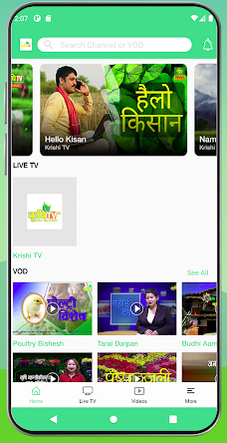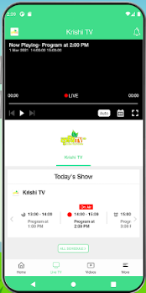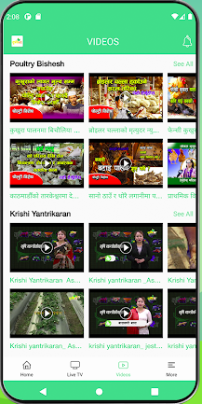

A basic app that broadcasts its personal TV shows. Instead of broadcasting only one channel, multiple agricultural programs from multiple source can be integrated for better user experience. Scheduled events are displayed which is a good feature but user can’t set remainder for the events. Lots of ads kind of irritates users.

**Summary:**

From the research,