Vanier College

Computer Science Department

User Manual

TKB Grading System

Phoeuk Thao, Kishaan Thalaysingam, Brian Arnautov

420-331-VA : Application Development (Sec-01)

Teacher: Syed Nassem Afzal

Friday, December 6, 2024

Introduction: 3

Interactive Features: 3

Graphical User Interface: 4

Identification Page: 4

Student GUI: 5

Student Sign-In: 5

Student Main Menu: 5

Student Grades: 6

See Class Status: 7

Teacher GUI: 7

Teacher Sign-In: 8

Teacher Main Menu: 8

Teacher Operation: 9

Teacher GUI: 10

See Student Status: 11

Add & Modify Grades: 11

Assignment GUI: 12

Application Features: 12

Add and Modify Assignment: 12

Dropout System: 15

Multi-Language: 17

English Menu: 17

French Menu: 17

Spanish Menu: 19

Error Support: 19

Dark Mode: 21

Light Menu: 21

Dark Menu: 22

Data Validation: 22

File Handling: 22

CRUD: 22

Grade Entry and Editing: 22

Grade Weighting: 23

Login Checking: 23

Search and Cancel: 23

# Introduction:

The TKB Grading System is an application designed to help students and teachers keep track of their assignments, grades and the status. This program provides the ability to update, add or remove assignments for the teachers whilst keeping track of the students list. For students, it provides a very easy way to view a courses grade and their status of the selected course. This user’s manual will go in-depth in all the features included in the application.

# Interactive Features:

The TKB provides features never seen before a grade viewing system. This system is easy to use, intuitive and concise. Here are the major features of the TKB Grading System:

* A **viewing status** system that will show the teacher or student the status of student and their average.
* An **add and modify** assignment which will make it easy to edit assignment grades.
* A **search and cancel** system to easily navigate throughout the assignments or students.
* A **dropout system** that drops out a student from a course.
* The ability to **select between 3 languages**: French, English and Spanish for users.
* **Data Validation** makes sure the data is correct for the teachers and students after they log-in
* **File Handling and Data Backup** will ensure that the data is stored properly.
* **CRUD** is making sure that we can create, read, update and delete data safely without error.
* **Grade Entry and Editing** makes sure that our teacher can change and update the data.
* **Grade Weighting** to make sure that the assignments have a weight to the overall grade.
* **Error Support** to ensure that our code supports all sorts of errors.
* **Dark Mode** for convenience for our users.
* **Login Checking** will ensure that the credentials are valid.
* **Selection** makes sure that our teachers and students can only see the data for that specific course.
* **Aesthetics and overall beauty** adds a nice visual depth to the program for the users convenience.

# Graphical User Interface:

The program is programmed in C# and starts with a simple identification menu. This UI does not use inheritance for our forms. When the user clicks on a button it will close the previous tab and open a new one.

## Identification Page:

This is the first page which asks the user if they are a teacher or a student. This page is called **IdentifyForm.cs** which has two buttons one called teacher, and one called student. On the bottom left is the language combo box which will change the language if needed. On the bottom right is the Light and Dark Mode button. If you are a student, please click the student button and follow along. If you are a teacher, click the teacher button and go to page [insert page here] of our manual.

## Student GUI:

This segment is designed for students of our project.

### Student Sign-In:

This form (called **StudentSignInForm.cs**) will be brought after the user has clicked a student. Here you will be asked to put your login information provided for you by an administrator. If you are not a student, please click the back button to go back to the identity form. If you are a student, however, please type your credentials in the boxes above and click the sign-in button.

### Student Main Menu:

After validating your identity, you will be brought to this form (**StudentMainMenuForm.cs**). Here you will be able to select your course of choice to view. If this is not, you’re account please refer to the sign out button on the top to be brought back to the sign in page. Else, once you have selected a course, you can now proceed by clicking the go to class button.

### Student Grades:

Welcome dear student to the **StudentGrades.cs** form. Here you will be able to see all your assignments for this specific course. It includes the weight and the grades. On the left you will see a couple features for your convenience. Starting from the top is our back button to select another class that you would want to look at. Under that button is located a see average for class. Clicking on it will bring you to our **SeeStudentStatus.cs** page. Just under that is our search and clear feature. This feature is meant to help students go through the assignments by searching by name.

If for any reason this course is too difficult or challenging, you are provided with a dropout button. This will enable you to drop the current course and will delete all your current grades for this course. Keep in mind that dropping a course will not let you retake this course for the remainder of the semester. If this is a mistake, please contact an admin a soon as possible!

### See Class Status:

This is the **SeeClassStatus.cs** form. Here you will see a button, your average for this class and your status regarding this class. The close button will be available to close out of this page.

## Teacher GUI:

This segment is dedicated to the teachers of our system.

### Teacher Sign-In:

This is the main sign-in page for our teachers. Like the student sign-in, the teacher sign-in contains a field for a teacher id and password. The back button and the sign-in button are provided as well to go back to the **identifyForm.cs** or when the correct credentials are provided, goes to the **TeacherMainMenu.cs form**.

### Teacher Main Menu:

This is our **TeacherMainMenu.cs** form for the teacher. It is like the students where you will have to choose a class before proceeding. The sign out and go to class will function the same way as the **StudentMainMenu.cs** form. You will need to select a course before doing anything.

### Teacher Operation:

When selecting a course, you will be brought to the **TeacherOperation.cs** form. This page has three buttons the grades button, assignments button and back button. Grades will bring you to the **TeacherGUI.cs** form whilst the assignment button brings you to the **AssignmentGUI.cs**. The back button is to go back to change the course you would like to view.

### Teacher GUI:

Dear teachers, what is before you is the **TeacherGUI.cs** form. Here you will see on the right the student attending this course. On the left will be a list of options, there is three major buttons: add & modify grade, see status and back. Keep in mind that the see status and add & modify grade buttons will not be accessible if you haven’t selected a student to view. At the bottom you will see a search and cancel feature, this will make it easier for one on one’s with a student so you will not have to scroll for their name.

### See Student Status:

After clicking on a student and pressing the see status button, you will be brought to the **SeeStudentStatus.cs** form. Here you will be able to see the selected student’s average for this course and their current status for this current course.

### Add & Modify Grades:

From the **TeacherGUI.cs** form, clicking on the add and modify grade will bring you to this form (**AddModifyGrades.cs**). Here you will be able to see all the assignments for this course and the attributed grade of the student selected. Here you will be able to insert a grade by inputting a grade (by percentage) and by clicking on the insert button. If a grade was already distributed to this student, the grade will be modified. If not, it will attach that grade to the assignment. Keep in mind that you can only insert a grade when selecting a specific assignment.

### Assignment GUI:

Going from the **TeacherOperation.cs** form and clicking the assignments button will bring you to the **AssignmentGUI.cs** form. Here you will be able to create an assignment for the current course and it overall weight for the class. When you have filled out the requirements to create a new assignment, you will be able to click create. After creating the assignment, it will appear on the table. To modify the assignment, you will have to click on the selected assignment you want to change before applying any changes. You can give it a new weight; in case you haven’t had the time to all the assignments noted in the outline. However, deleting it will delete the assignment and any grade associated with said assignment.

# Application Features:

Here we will show you the features that have not been shown previously.

## Add and Modify Assignment:

This is a picture before clicking create on the **AssignmentGUI.cs** form.

This is a picture directly after pressing the create button.

This is a picture directly after pressing the modify button.

After pressing the modify button.

After pressing the delete button.

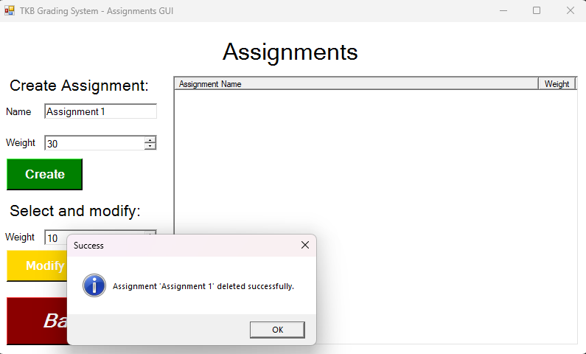

## Dropout System:

Student before dropping out:

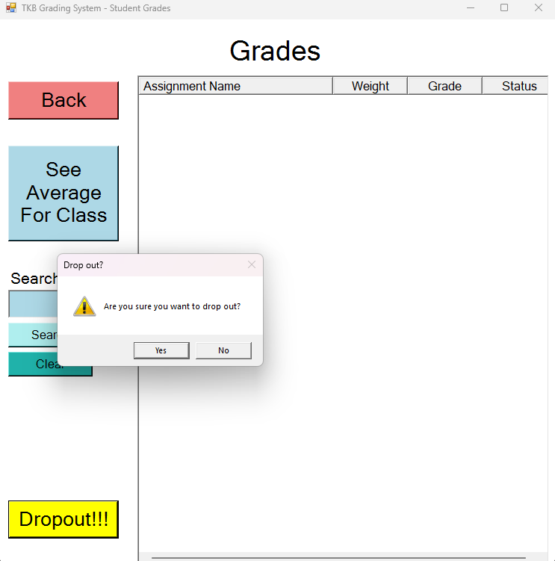

After clicking the yes button:

## Multi-Language:

### English Menu:

### French Menu:

### Spanish Menu:

## Error Support:

Message box if haven’t selected an assignment before clicking on modify button.

Message box if haven’t selected an assignment before clicking on delete button.

Message box. If no student were selected before clicking the button in **TeacherGUI.cs** form.

## Dark Mode:

### Light Menu:

### Dark Menu:

## Data Validation:

## File Handling:

## CRUD:

## Grade Entry and Editing:

## Grade Weighting:

## Login Checking:

## Search and Cancel: