Social Media Platform - Requirements Document
1. Project Overview
1.1 Executive Summary
A scalable, feature-rich social media platform that enables users to share photos and videos, connect with others, and engage through likes, comments, and follows. The platform will demonstrate advanced system design patterns, distributed architecture, and production-grade engineering practices.
1.2 Project Objectives
- Build a production-ready social media application
- Implement scalable backend architecture
- Demonstrate senior-level engineering capabilities
- Create a portfolio-worthy project showcasing distributed systems knowledge

2. Application Name : Pixora ⭐
- Modern, memorable, and brandable
- Domain availability: High likelihood
- Combines "Pix" (pictures) + "ora" (moment/aura)

3. System Roles & Permissions
3.1 User Role (Default)
Primary Audience: All registered users
Capabilities:
- Account management (signup, login, profile editing)
- Content creation (upload photos/videos with captions)
- Social interactions (like, comment, share)
- Following system (follow/unfollow users)
- Feed consumption (view timeline, explore content)
- Search functionality (users, hashtags, locations)
- Save/bookmark posts
- Notifications management
3.2 Admin Role
Primary Audience: Platform administrators and moderators
Capabilities:
- User management (ban/suspend/delete accounts)
- Content moderation (remove violating posts)
- Handle user reports and appeals
- Manage hashtags and trending content
- Access system logs and audit trails
- Configure platform settings
- View comprehensive analytics
- Manage verified accounts
3.3 Analytics Role
Primary Audience: Product managers, data analysts, business intelligence team
Capabilities:
- View user growth metrics (DAU/MAU/WAU)
- Track engagement metrics (likes, comments, shares)
- Monitor content performance
- Analyze retention and churn rates
- Generate custom reports
- View trending patterns
- Export data for analysis
- Restrictions: Cannot modify user data or content

4. Functional Requirements
4.1 Authentication & Authorization
- FR-1.1: User registration with email/phone verification
- FR-1.2: Secure login with JWT-based authentication
- FR-1.3: Password reset via email
- FR-1.4: OAuth integration (Google, Facebook)
- FR-1.5: Multi-factor authentication (2FA)
- FR-1.6: Role-based access control (RBAC)
4.2 User Profile Management
- FR-2.1: Create and edit profile (username, bio, avatar)
- FR-2.2: Profile visibility settings (public/private)
- FR-2.3: View own posts grid
- FR-2.4: Display follower/following counts
- FR-2.5: Account deactivation and deletion
4.3 Content Management
- FR-3.1: Upload images (JPEG, PNG, WebP)
- FR-3.2: Upload videos (MP4, max 60 seconds)
- FR-3.3: Add captions with character limit (2,200 characters)
- FR-3.4: Hashtag support (#tag)
- FR-3.5: Tag users in posts (@mention)
- FR-3.6: Edit post captions
- FR-3.7: Delete own posts
- FR-3.8: Save/bookmark posts
4.4 Social Features
- FR-4.1: Follow/unfollow users
- FR-4.2: Like posts (with unlike option)
- FR-4.3: Comment on posts
- FR-4.4: Reply to comments (nested comments)
- FR-4.5: Delete own comments
- FR-4.6: Share posts (future phase)
4.5 Feed System
- FR-5.1: Chronological home feed from followed users
- FR-5.2: Infinite scroll pagination
- FR-5.3: Pull-to-refresh functionality
- FR-5.4: Explore page with suggested content
- FR-5.5: Trending hashtags section
4.6 Search & Discovery
- FR-6.1: Search users by username/name
- FR-6.2: Search by hashtags
- FR-6.3: Recent search history
- FR-6.4: Suggested users to follow
- FR-6.5: Location-based search (future)
4.7 Notifications
- FR-7.1: Like notifications
- FR-7.2: Comment notifications
- FR-7.3: Follow notifications
- FR-7.4: Mention notifications
- FR-7.5: Mark notifications as read
- FR-7.6: Push notification support (mobile)
4.8 Admin Functions
- FR-8.1: User management dashboard
- FR-8.2: Content moderation queue
- FR-8.3: Ban/suspend users with reason logging
- FR-8.4: View and respond to reports
- FR-8.5: Platform-wide announcements
- FR-8.6: System health monitoring
4.9 Analytics Dashboard
- FR-9.1: User metrics (signups, active users, retention)
- FR-9.2: Content metrics (posts, engagement rate)
- FR-9.3: Trending analysis
- FR-9.4: Custom date range reports
- FR-9.5: Export capabilities (CSV/PDF)

5. Non-Functional Requirements
5.1 Performance
- NFR-1.1: Feed load time < 2 seconds
- NFR-1.2: Image upload time < 5 seconds for 5MB file
- NFR-1.3: API response time < 200ms for 95th percentile
- NFR-1.4: Support 10,000 concurrent users
- NFR-1.5: Database query optimization with proper indexing
5.2 Scalability
- NFR-2.1: Horizontal scaling capability for backend services
- NFR-2.2: CDN integration for media delivery
- NFR-2.3: Database read replicas for query distribution
- NFR-2.4: Caching strategy with Redis (cache hit ratio > 80%)
- NFR-2.5: Load balancer for traffic distribution
5.3 Security
- NFR-3.1: HTTPS encryption for all communications
- NFR-3.2: Password hashing with bcrypt (cost factor 12)
- NFR-3.3: Rate limiting (100 requests/minute per user)
- NFR-3.4: SQL injection prevention
- NFR-3.5: XSS protection
- NFR-3.6: CSRF token validation
- NFR-3.7: Secure file upload validation
- NFR-3.8: API authentication with JWT (15-minute expiry)
5.4 Reliability
- NFR-4.1: System uptime > 99.5%
- NFR-4.2: Automated backup (daily)
- NFR-4.3: Disaster recovery plan
- NFR-4.4: Graceful error handling
- NFR-4.5: Transaction rollback for critical operations
5.5 Maintainability
- NFR-5.1: Clean code architecture
- NFR-5.2: Comprehensive API documentation (OpenAPI/Swagger)
- NFR-5.3: Unit test coverage > 70%
- NFR-5.4: Integration test suite
- NFR-5.5: Structured logging (JSON format)
- NFR-5.6: Code review process
5.6 Usability
- NFR-6.1: Responsive design (mobile-first)
- NFR-6.2: Intuitive UI/UX
- NFR-6.3: Accessibility compliance (WCAG 2.1 Level AA)
- NFR-6.4: Multi-language support (i18n ready)

6. Technical Architecture
6.1 Tech Stack
Backend Options (Choose One):
- Python: Django REST Framework or FastAPI
- Node.js: NestJS or Express
- Java: Spring Boot
- Go: Gin or Fiber
Frontend:
- Web: React with Next.js
- Mobile: React Native or Flutter (optional)
Database:
- Primary: PostgreSQL (relational data)
- Cache: Redis (sessions, feed cache, rate limiting)
- Search: Elasticsearch (optional, for advanced search)
Storage:
- Media: AWS S3 / Google Cloud Storage / Azure Blob
- CDN: CloudFront / Cloudflare
Message Queue:
- Celery / RabbitMQ / Kafka (for async tasks)
Monitoring:
- Application: Prometheus + Grafana
- Logging: ELK Stack or CloudWatch
- Error Tracking: Sentry
6.2 Database Schema Design
Core Tables:
Users
- id (PK)
- username (unique)
- email (unique)
- password_hash
- role (user/admin/analyst)
- bio
- avatar_url
- is_verified
- is_active
- created_at
- updated_at

Posts
- id (PK)
- user_id (FK)
- caption
- media_url
- media_type (image/video)
- created_at
- updated_at

Followers
- id (PK)
- user_id (FK)
- follower_id (FK)
- created_at
- UNIQUE(user_id, follower_id)

Likes
- id (PK)
- user_id (FK)
- post_id (FK)
- created_at
- UNIQUE(user_id, post_id)

Comments
- id (PK)
- user_id (FK)
- post_id (FK)
- parent_comment_id (FK, nullable)
- text
- created_at
- updated_at

Notifications
- id (PK)
- user_id (FK)
- type (like/comment/follow/mention)
- source_user_id (FK)
- post_id (FK, nullable)
- is_read
- created_at

SavedPosts
- id (PK)
- user_id (FK)
- post_id (FK)
- created_at
- UNIQUE(user_id, post_id)

Feed (for fan-out architecture)
- user_id (FK)
- post_id (FK)
- created_at
- PRIMARY KEY(user_id, post_id)
6.3 API Design Patterns
- RESTful API design
- Versioning (/api/v1/)
- Pagination (cursor-based for feed)
- Rate limiting headers
- Proper HTTP status codes
- JWT in Authorization header

7. Strategic Implementation Plan
Phase 1: Foundation (Weeks 1-2)
Goal: Set up infrastructure and core authentication
Tasks:
- Project setup and environment configuration
- Database design and migrations
- User authentication system (signup/login)
- JWT token management
- User profile CRUD operations
- Basic role implementation (User/Admin)
Deliverables:
- Working authentication API
- User profile management
- Development environment documentation

Phase 2: Media & Posts (Weeks 3-4)
Goal: Implement content creation and storage
Tasks:
- S3 bucket configuration
- Signed URL generation for uploads
- Image/video validation and processing
- Post creation API
- Post retrieval (user posts, single post)
- Post deletion
- CDN integration
Deliverables:
- Complete post management system
- Media storage pipeline
- Basic post viewing functionality

Phase 3: Social Graph (Week 5)
Goal: Build follower/following system
Tasks:
- Follow/unfollow API
- Followers list endpoint
- Following list endpoint
- Follower count calculation
- Mutual followers logic (future)
Deliverables:
- Complete social connection system
- API endpoints for relationship management

Phase 4: Feed System (Weeks 6-7)
Goal: Create personalized content feed
Tasks:
- Simple pull-based feed (get posts from followed users)
- Feed pagination (cursor-based)
- Feed caching with Redis
- Feed refresh logic
- Optimize feed queries (indexes, joins)
- Optional: Fan-out architecture with background workers
Deliverables:
- Working home feed
- Efficient feed generation
- Cache strategy implemented

Phase 5: Engagement (Weeks 8-9)
Goal: Add interaction features
Tasks:
- Like/unlike functionality
- Like count caching
- Comment system (create, read, delete)
- Nested comments support
- Notification system (like, comment, follow)
- Notification API (list, mark as read)
- Real-time notifications (WebSocket - optional)
Deliverables:
- Complete engagement features
- Notification system
- Interaction analytics

Phase 6: Search & Discovery (Week 10)
Goal: Enable content discovery
Tasks:
- User search by username
- Hashtag extraction from captions
- Hashtag search
- Trending hashtags calculation
- Explore page (popular posts)
- Suggested users algorithm (basic)
Deliverables:
- Search functionality
- Explore page
- Discovery algorithms

Phase 7: Admin & Analytics (Week 11)
Goal: Build management and insights tools
Tasks:
- Admin dashboard backend
- User management APIs (ban, delete)
- Content moderation endpoints
- Analytics data aggregation
- Metrics APIs (DAU, MAU, engagement)
- Report generation
- Analytics role permissions
Deliverables:
- Admin panel APIs
- Analytics dashboard backend
- Reporting system

Phase 8: Frontend Development (Weeks 12-14)
Goal: Create user interface
Tasks:
- Authentication screens (login, signup)
- Profile page
- Feed interface
- Post upload screen
- Post detail view
- Search interface
- Notifications UI
- Settings page
- Responsive design implementation
Deliverables:
- Complete web application
- Mobile-responsive design
- Intuitive user experience

Phase 9: Testing & Quality (Week 15)
Goal: Ensure reliability and quality
Tasks:
- Unit test suite
- Integration tests
- Load testing
- Security testing
- Bug fixes
- Performance optimization
- Code review and refactoring
Deliverables:
- Test coverage report
- Performance benchmarks
- Security audit results

Phase 10: Deployment & DevOps (Week 16)
Goal: Production deployment
Tasks:
- Docker containerization
- CI/CD pipeline (GitHub Actions)
- Cloud infrastructure setup (AWS/GCP)
- Database migration to production
- CDN configuration
- SSL certificate setup
- Monitoring and logging setup
- Backup automation
- Documentation
Deliverables:
- Production-ready application
- Deployment documentation
- Monitoring dashboards
- Backup strategy

8. Success Metrics
8.1 Technical Metrics
- API response time < 200ms (95th percentile)
- System uptime > 99.5%
- Test coverage > 70%
- Cache hit ratio > 80%
- Zero critical security vulnerabilities
8.2 User Metrics (if launched)
- Daily Active Users (DAU)
- Monthly Active Users (MAU)
- User retention rate (Day 1, Day 7, Day 30)
- Average session duration
- Posts per user per day
- Engagement rate (likes + comments / total posts)
8.3 Performance Metrics
- Feed load time
- Image upload success rate
- Search query response time
- Notification delivery time

9. Risk Assessment
9.1 Technical Risks
Risk | Impact | Mitigation
Database performance degradation | High | Implement caching, indexing, read replicas
S3 upload failures | Medium | Retry logic, client-side validation
Feed generation bottleneck | High | Cache feeds, implement fan-out architecture
Security vulnerabilities | High | Regular security audits, dependency updates
9.2 Project Risks
Risk | Impact | Mitigation
Scope creep | Medium | Strict phase adherence, MVP-first approach
Timeline delays | Medium | Buffer time in schedule, prioritize core features
Technology complexity | Medium | Start with simple solutions, iterate

10. Future Enhancements
Phase 2 Features (Post-MVP)
- Stories (24-hour ephemeral content)
- Direct messaging
- Video calls
- Live streaming
- Shopping integration
- Advertising platform
- Advanced recommendation algorithm
- AR filters
- Multi-image posts (carousel)
- Post scheduling
- Analytics for users (insights)

11. Documentation Requirements
11.1 Technical Documentation
- System architecture diagram
- Database ER diagram
- API documentation (Swagger/OpenAPI)
- Deployment guide
- Development setup guide
11.2 User Documentation
- User manual
- Admin guide
- FAQ section
11.3 Code Documentation
- Inline code comments
- README files
- Architecture decision records (ADRs)

12. Compliance & Legal
12.1 Data Privacy
- GDPR compliance (EU users)
- Data retention policy
- User data export capability
- Right to deletion
12.2 Content Policy
- Terms of service
- Community guidelines
- Copyright policy (DMCA)
- Content moderation rules

Appendix
A. Glossary
- DAU: Daily Active Users
- MAU: Monthly Active Users
- CDN: Content Delivery Network
- JWT: JSON Web Token
- RBAC: Role-Based Access Control
- Fan-out: Pre-computing feeds when content is created
B. References
- System design patterns
- Instagram engineering blog
- AWS best practices
- PostgreSQL performance tuning

Document Version: 1.0
Last Updated: December 2024
Document Owner: Project Lead
Review Cycle: Bi-weekly during development

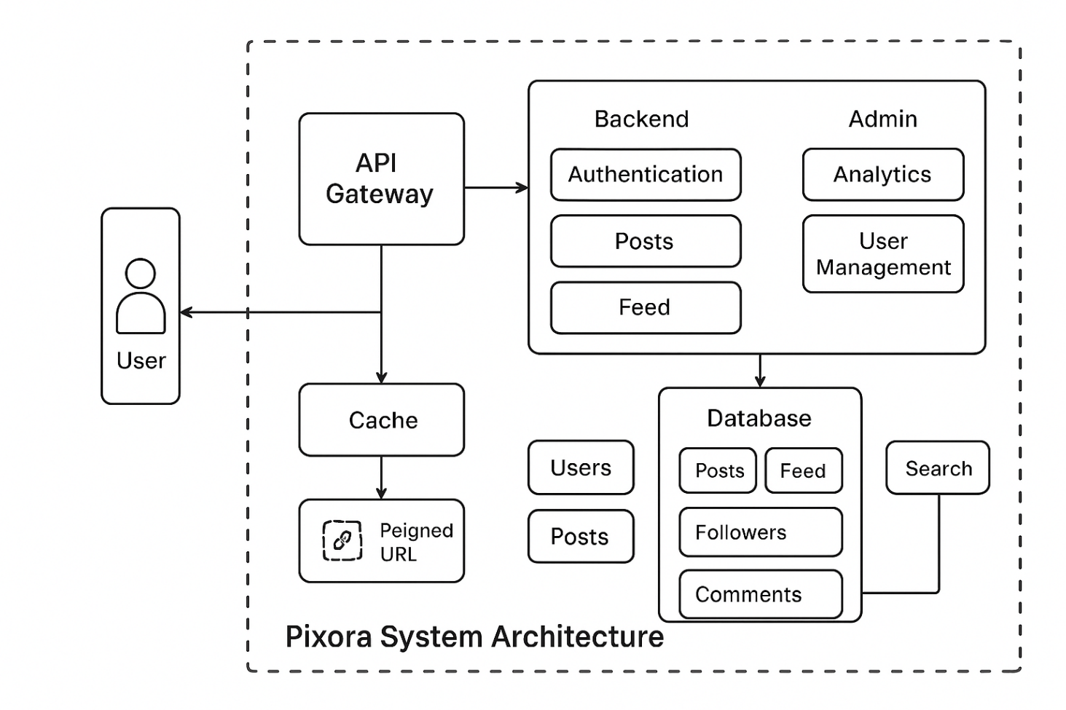
Class diagram

