# Assignment 1: Docker & GitHub

Name: Kishan Prakash

PRN: 250240128020

## Questions

**1. Create a repository on GitHub. Clone on the local machine. Create Linear Regression model for any dataset. Test it.**

**2. Use Docker. Now also generate a pickle file. Push the whole code (.py, dataset, .pkl file, Dockerfile) on to GitHub.**

**3. Accept any 3 numbers from the user and find the largest in Python. Run using Docker.**

**4. Accept 5 names from the user and save in a file using Python. Run using Docker.**

**5. Read the above file and display all the records. Use Docker.**

**Question 1 & 2 :**

GitHub repository : <https://github.com/Kishan-Prakash/docker_assignment.git>

Cloning Repository

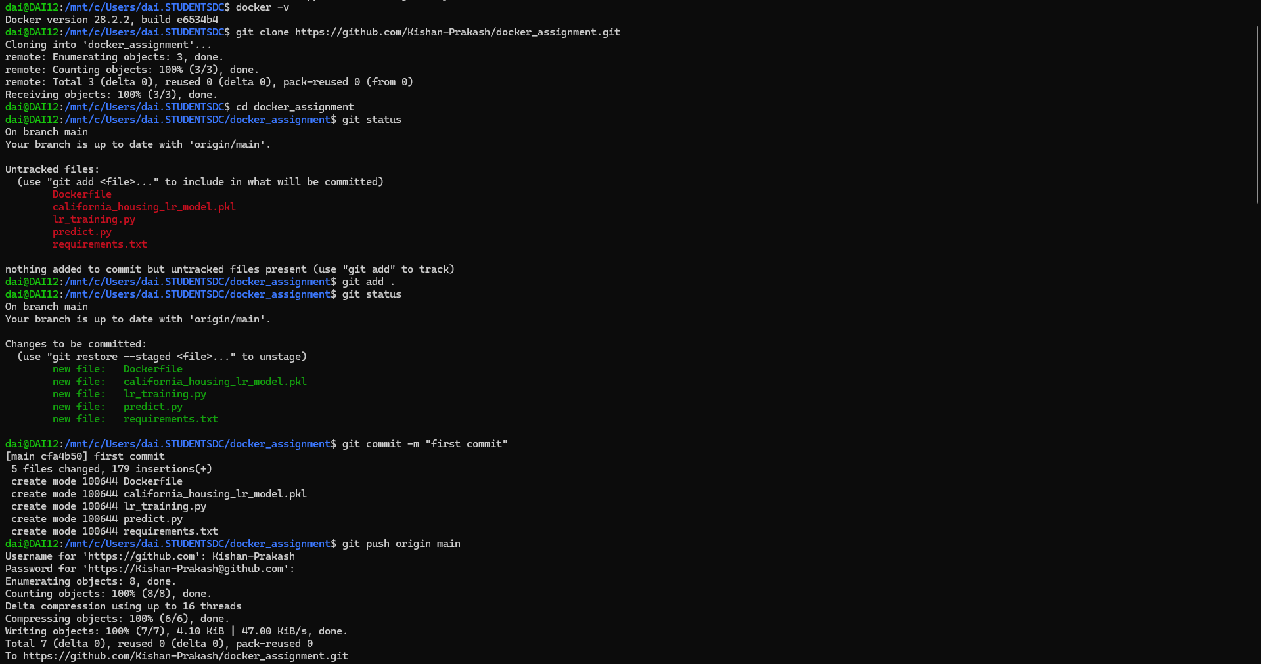

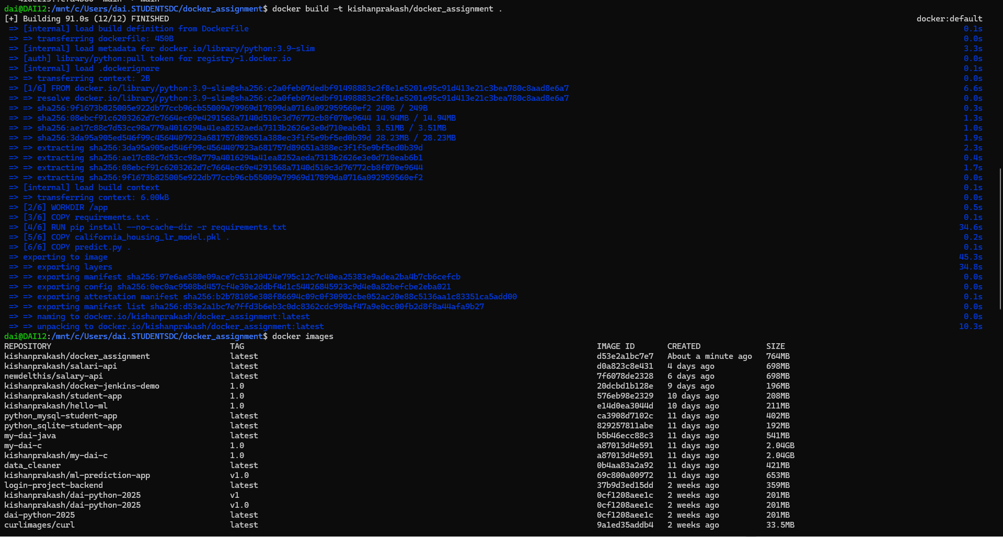Building Docker Image :

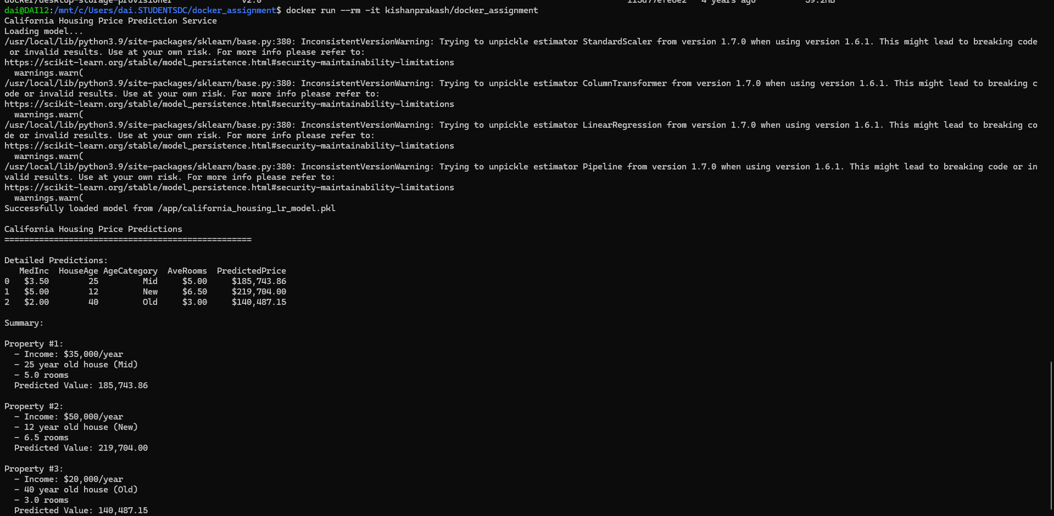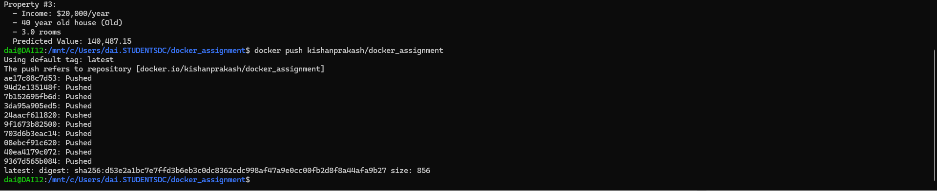Running Docker Image :

Pushing Image to Dockerhub :

Question 3 :

Building docker Image :

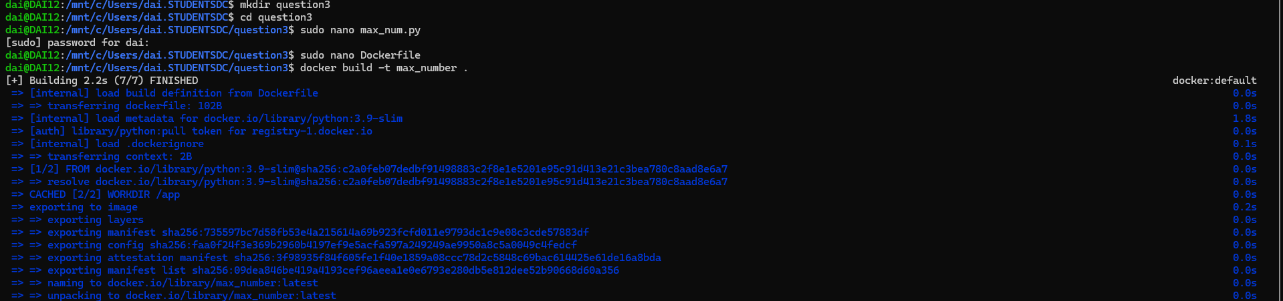

Running docker Image :

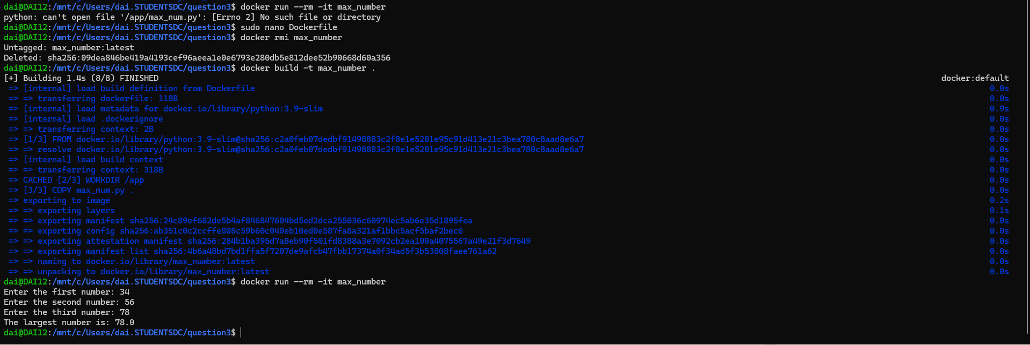

Question 4 & 5 :

Building running Docker Image :

