RBU, Nagpur
CSE III Sem
PRACTICAL NO. 8

Name: | Kishan Saini
Sec-Batch-Rollno: | A4-B4-55

Aim: Implement the Graph Colouring algorithm using the Graph Colouring
concept.
Problem Statement:
A GSM is a cellular network with its entire geographical range divided into
hexagonal cells. Each cell has a communication tower that connects with mobile
phones within the cell. Assume this GSM network operates in different frequency
ranges. Allot frequencies to each cell such that no adjacent cells have the same
frequency range.
Consider an undirected graph G = (V, E) shown in fig. Find the colour assigned to
each node
using the Backtracking method. Input is the adjacency matrix of a graph G(V,
E), where V is the
number of Vertices and E is the number of edges
Graph l:
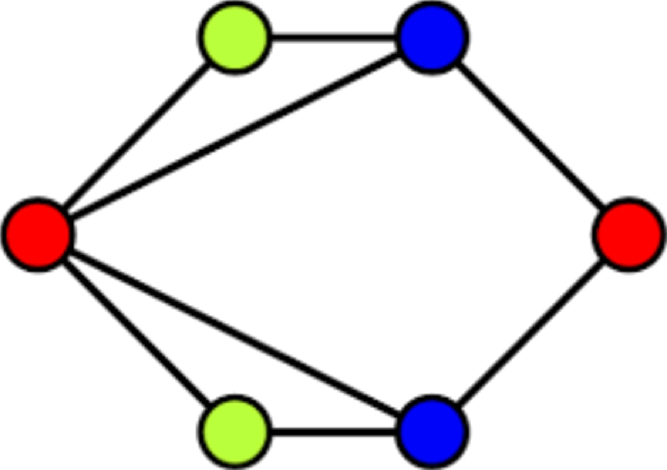
Graph 2:

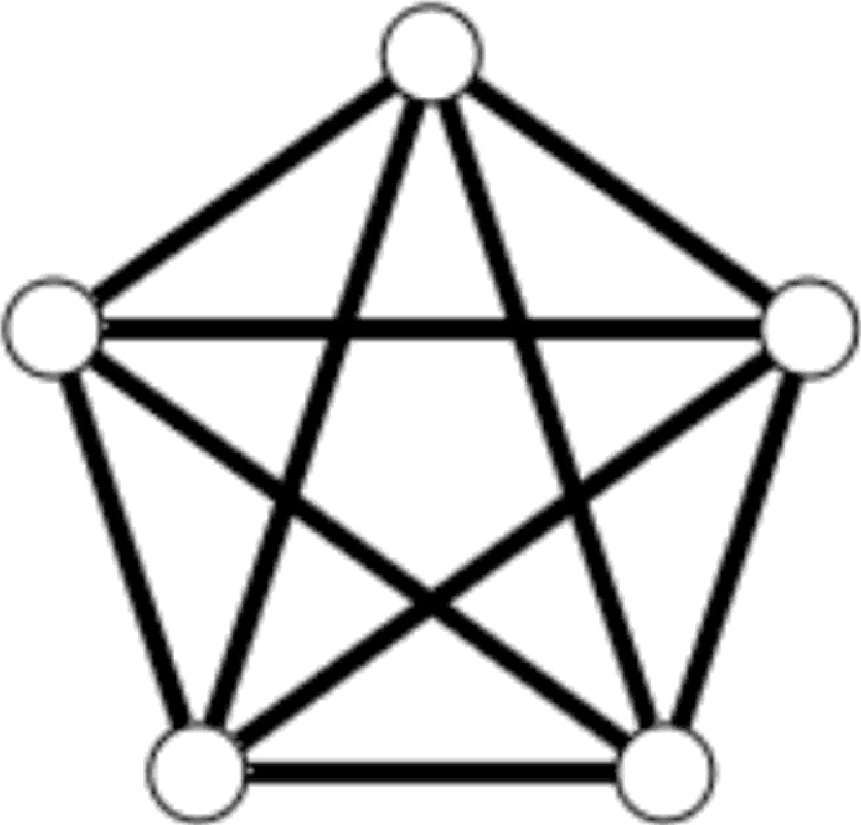

Code:

def print_solution(colors):

print("Solution Exists: Frequencies (colors) assigned are:") for i in range(len(colors)):
print(f" Cell {i} -> Frequency {colors[i]}")

def is_safe(v, graph, colors, c):

V = len(graph)

for i in range(V):

if graph[v][i] == 1 and colors[i] == c: return False
return True

def solve_coloring_recursive(graph, m, colors, v):

V = len(graph) if v == V:
return True

for c in range(1, m + 1):

if is_safe(v, graph, colors, c):

colors[v] = c

if solve_coloring_recursive(graph, m, colors, v + 1): return True
colors[v] = 0

return False

def find_coloring_solution(graph, m, graph_name): print(f"### {graph_name} Solution ###")
V = len(graph) colors = [0] * V

if solve_coloring_recursive(graph, m, colors, 0) == False:

print(f"No solution exists with {m} frequencies (colors).") else:
print_solution(colors)

# --- Graph 1 (from image) ---

graph_1_matrix = [

[0, 1, 1, 1, 1, 0],

[1, 0, 0, 1, 0, 0],

 | [1, | 0, | 0, | 0, | 1, | 0],
 | [1, | 1, | 0, | 0, | 0, | 1],
 | [1, | 0, | 1, | 0, | 0, | 1],
 | [0, | 0, | 0, | 1, | 1, | 0]
]

m_1 = 3

find_coloring_solution(graph_1_matrix, m_1, "Graph 1")

print("\n \n")

# --- Graph 2 (K5 - Complete Graph) --- graph_2_matrix = [
[0, | 1, | 1, | 1, | 1],
[1, | 0, | 1, | 1, | 1],
[1, | 1, | 0, | 1, | 1],
[1, | 1, | 1, | 0, | 1],

[1, 1, 1, 1, 0]
]
m_2_fail = 4
find_coloring_solution(graph_2_matrix, m_2_fail, "Graph 2 (Attempt 1: 4
Colors)")
print("")
m_2_success = 5
find_coloring_solution(graph_2_matrix, m_2_success, "Graph 2 (Attempt 2: 5
Colors)")

Ouľpuľ:
