Experiment 1: Understanding Search Engine & SERP
Observer the Following:
- Paid Ads(Sponsored results)
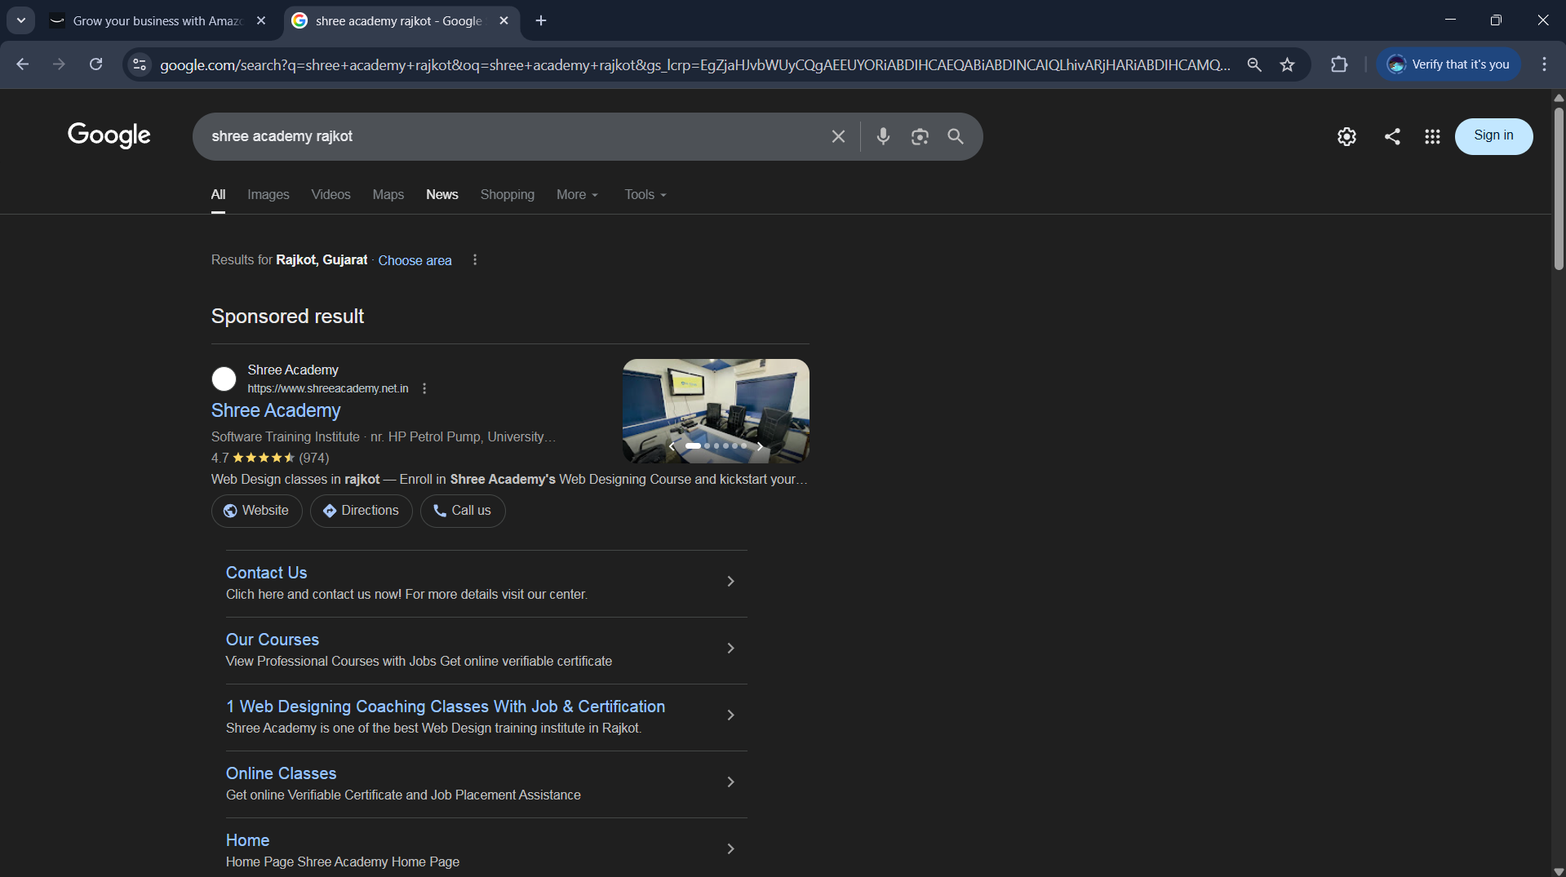
2.organic results
3. website titles
4. URLs
5.Meta descriptions

Experiment – 2
Steps :-
Search What Is SEO
Observe the SERP Carefully

Identifythe following SERP
- Featured snippet
- People also ask
- Knowledge panel
- Images
- videos

