AGILE PROJECT
FOOD ORDERING SYSTEM

Team Members :
- Aashaz Ali – 23MIS0121
- Samyuktha S – 23MIS0282
- Kishan Satish – 23MIS0401

AIM:
To connect VS code and GitHub
Push a file from VS code to GitHub with github commands

echo "# Agile-Devops" >> README.md git init
git add README.md
git commit -m "first commit" git branch -M main
git remote add origin https://github.com/AashazAliKN/Agile-Devops.git git push -u origin main

- Open a folder in VS
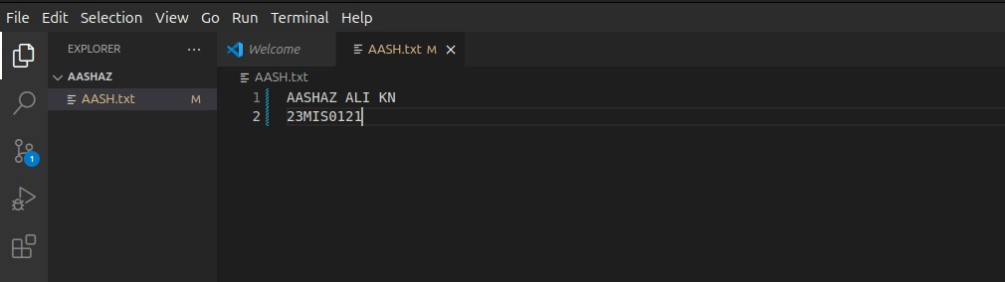

- Open terminal and do git commands
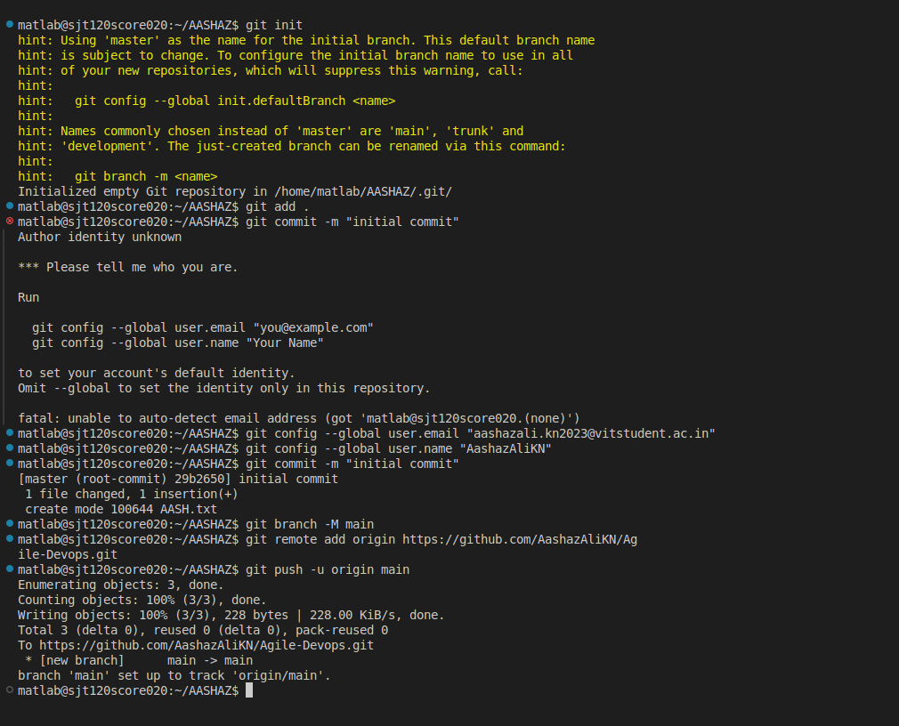

- Create github repository and get git remote add origin link
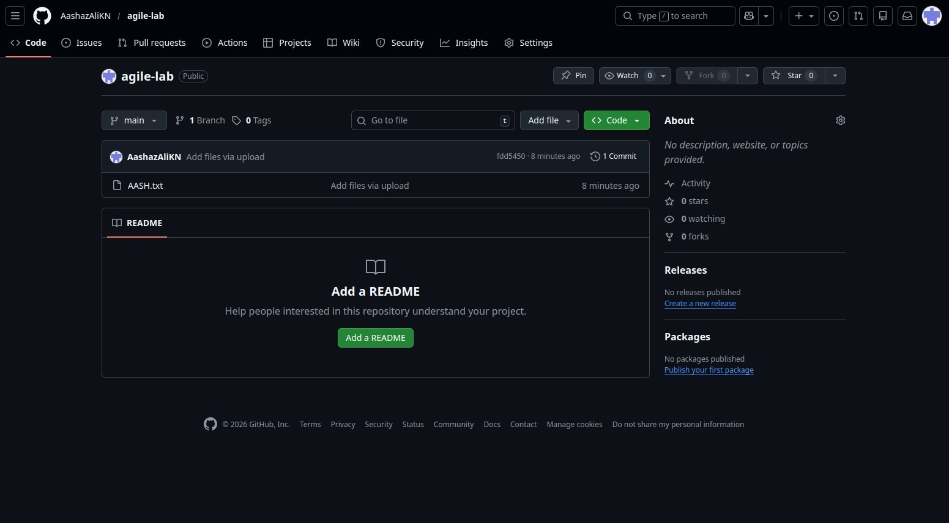
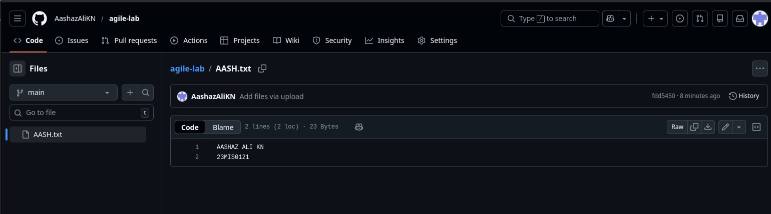

- Add team members as collaborators to the project repository

