Database : student_tracker

Create database student_tracker;

1)Table: Student

Create:

CREATE TABLE Students(student_id int PRIMARY KEY AUTO_INCREMENT,name varchar(100) Not NULL, dob date, gender varchar(7),email varchar(100)UNIQUE, phone_number varchar(15),address varchar(255), admission_date DATE NOT NULL, department_id INT, CONSTRAINT fk_student_department FOREIGN KEY (department_id)REFERENCES Departments(department_id))

Insert Data :
INSERT INTO Students
(name, dob, gender, email, phone_number, address, admission_date, department_id)VALUES
('Aarav Patel', '2003-05-12', 'Male', 'aarav@gmail.com', '9000000001', 'Ahmedabad', '2023-06-15', 1),

('Bhavya Shah', '2002-08-20', 'Female', 'bhavya@gmail.com', '9000000002', 'Bhavnagar', '2022-07-10', 1),

('Chirag Mehta', '2003-01-15', 'Male', 'chirag@gmail.com', '9000000003', 'Rajkot', '2024-01-05', 2),

('Diya Patel', '2002-11-25', 'Female', 'diya@gmail.com', '9000000004', 'Surat', '2023-08-20', 2),

('Eshan Joshi', '2003-03-18', 'Male', NULL, '9000000005', 'Vadodara', '2021-06-12', 3),

('Falguni Shah', '2002-09-09', 'Female', 'falguni@gmail.com', '9000000006', 'Ahmedabad', '2024-02-15', 3),

('Harsh Patel', '2003-07-21', 'Male', 'harsh@gmail.com', '9000000007', 'Rajkot', '2022-06-18', 1),

('Isha Mehta', '2002-12-30', 'Female', 'isha@gmail.com', '9000000008', 'Bhavnagar', '2023-07-12', 2),

('Jay Shah', '2003-04-14', 'Male', 'jay@gmail.com', '9000000009', 'Surat', '2021-07-20', 1),

('Krisha Patel', '2002-10-05', 'Female', 'krisha@gmail.com', '9000000010', 'Ahmedabad', '2024-06-10', 4);

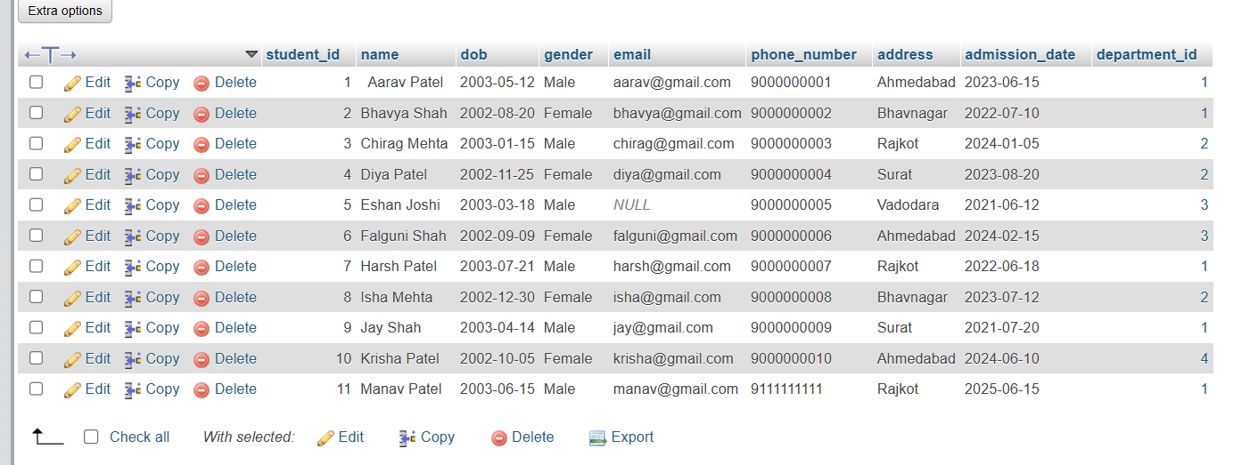

2) Table: Faculty

Create :

CREATE TABLE Faculty (faculty_id INT PRIMARY KEY AUTO_INCREMENT,name VARCHAR(100) NOT NULL,email VARCHAR(100) UNIQUE,phone_number VARCHAR(15),experience_years INT DEFAULT 0,department_id INT,
CONSTRAINT fk_faculty_department
FOREIGN KEY (department_id)
REFERENCES Departments(department_id)
);

Insert Data :
INSERT INTO Faculty(name, email, phone_number, experience_years, department_id)VALUES
('Dr. Amit Shah', 'amit.shah@gmail.com', '9876500001', 10, 1),
('Prof. Neha Patel', 'neha.patel@gmail.com', '9876500002', 6, 1),
('Prof. Rahul Mehta', 'rahul.mehta@gmail.com', '9876500003', 3, 2),
('Prof. Priya Desai', 'priya.desai@gmail.com', '9876500004', 8, 2),
('Prof. Karan Joshi', 'karan.joshi@gmail.com', '9876500005', 2, 3);

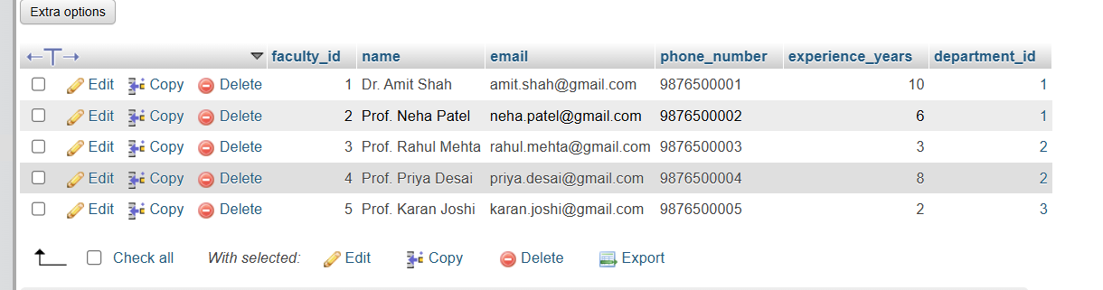

3) Table: Department

Create :
CREATE table Departments(department_id INT PRIMARY KEY AUTO_INCREMENT, department_name VARCHAR(100) NOT NULL UNIQUE);

Insert Data :
INSERT INTO Departments (department_name) VALUES('Computer Science'),('Information Technology'),('Commerce'),('Management');

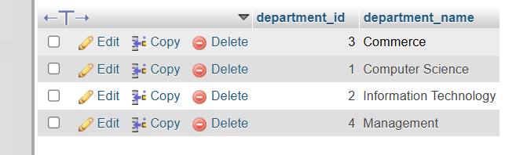

4) Table: Courses

Create:
CREATE TABLE Courses (course_id INT PRIMARY KEY AUTO_INCREMENT, course_name VARCHAR(100) NOT NULL, faculty_id INT NULL,

CONSTRAINT fk_course_faculty FOREIGN KEY (faculty_id)REFERENCES Faculty(faculty_id)ON DELETE SET NULL);

Insert Data :
INSERT INTO Courses(course_name, faculty_id)VALUES
('Database Management System', 1),
('Data Structures', 2),
('Web Development', 3),
('Python Programming', 4),
('Computer Networks', 1),
('Software Engineering', 2),
('Business Accounting', NULL);

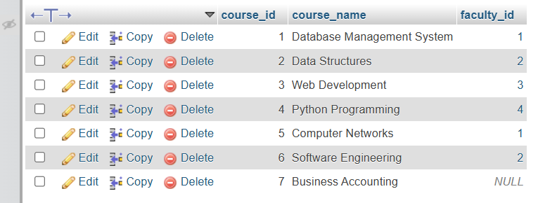

5) Table: Enrollments

Create:
CREATE TABLE Enrollments (enrollment_id INT PRIMARY KEY AUTO_INCREMENT, student_id INT NOT NULL,course_id INT NOT NULL,
enrollment_date DATE NOT NULL,CONSTRAINT fk_enrollment_student FOREIGN KEY (student_id)REFERENCES Students(student_id) ON DELETE CASCADE,

CONSTRAINT fk_enrollment_course
FOREIGN KEY (course_id)
REFERENCES Courses(course_id)
ON DELETE CASCADE,

CONSTRAINT uq_student_course
UNIQUE (student_id, course_id));

Insert Data :

INSERT INTO Enrollments(student_id, course_id, enrollment_date)
VALUES
(1, 1, '2023-07-01'),
(1, 2, '2023-07-02'),
(1, 5, '2023-07-03'),

(2, 1, '2022-07-15'),
(2, 2, '2022-07-16'),
(2, 6, '2022-07-17'),

(3, 3, '2024-01-15'),
(3, 4, '2024-01-16'),
(3, 5, '2024-01-17'),

(4, 3, '2023-09-01'),
(4, 4, '2023-09-02'),
(4, 6, '2023-09-03'),

(5, 7, '2021-07-01'),
(5, 6, '2021-07-02'),

(6, 7, '2024-03-01'),
(6, 6, '2024-03-02'),

(7, 1, '2022-07-01'),
(7, 5, '2022-07-02'),
(7, 6, '2022-07-03'),

(8, 3, '2023-08-01'),
(8, 4, '2023-08-02'),
(8, 5, '2023-08-03'),

(9, 1, '2021-08-01'),
(9, 2, '2021-08-02'),
(9, 5, '2021-08-03');

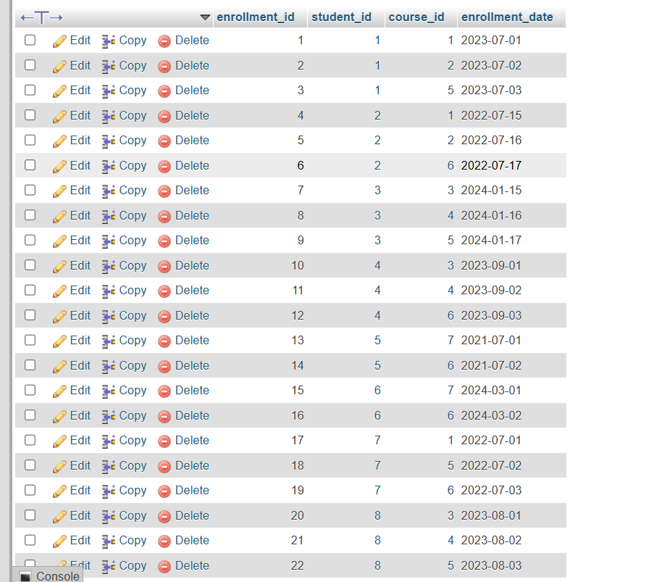

6) Table: Attendance

Create:
CREATE TABLE Attendance (attendance_id INT PRIMARY KEY AUTO_INCREMENT,
student_id INT NOT NULL, course_id INT NOT NULL, attendance_date DATE NOT NULL,
status ENUM('Present', 'Absent', 'Late') NOT NULL,

CONSTRAINT fk_attendance_student
FOREIGN KEY (student_id)
REFERENCES Students(student_id)
ON DELETE CASCADE,

CONSTRAINT fk_attendance_course
FOREIGN KEY (course_id)
REFERENCES Courses(course_id)
ON DELETE CASCADE,

CONSTRAINT uq_attendance
UNIQUE (student_id, course_id, attendance_date));

Insert Data :

INSERT INTO Attendance(student_id, course_id, attendance_date, status)VALUES
-- Student 1 - Mostly Present
(1, 1, '2023-07-05', 'Present'),
(1, 1, '2023-08-05', 'Present'),
(1, 1, '2023-09-05', 'Present'),
(1, 1, '2023-10-05', 'Present'),
(1, 1, '2023-11-05', 'Present'),
(1, 1, '2023-12-05', 'Late'),

(1, 2, '2023-07-06', 'Present'),
(1, 2, '2023-08-06', 'Present'),
(1, 2, '2023-09-06', 'Present'),
(1, 2, '2023-10-06', 'Present'),
(1, 2, '2023-11-06', 'Present'),

-- Student 2 - Medium Attendance
(2, 1, '2022-08-05', 'Present'),
(2, 1, '2022-09-05', 'Absent'),
(2, 1, '2022-10-05', 'Present'),
(2, 1, '2022-11-05', 'Absent'),
(2, 1, '2022-12-05', 'Present'),
(2, 1, '2023-01-05', 'Late'),

(2, 2, '2022-08-06', 'Present'),
(2, 2, '2022-09-06', 'Absent'),
(2, 2, '2022-10-06', 'Present'),
(2, 2, '2022-11-06', 'Present'),

-- Student 3 - High Attendance
(3, 3, '2024-02-05', 'Present'),
(3, 3, '2024-03-05', 'Present'),
(3, 3, '2024-04-05', 'Present'),
(3, 3, '2024-05-05', 'Present'),
(3, 3, '2024-06-05', 'Late'),

(3, 4, '2024-02-06', 'Present'),
(3, 4, '2024-03-06', 'Present'),
(3, 4, '2024-04-06', 'Present'),
(3, 4, '2024-05-06', 'Present'),

-- Student 4 - Good Attendance
(4, 3, '2023-09-10', 'Present'),
(4, 3, '2023-10-10', 'Present'),
(4, 3, '2023-11-10', 'Absent'),
(4, 3, '2023-12-10', 'Present'),
(4, 3, '2024-01-10', 'Present'),

(4, 4, '2023-09-11', 'Present'),
(4, 4, '2023-10-11', 'Present'),
(4, 4, '2023-11-11', 'Present'),
(4, 4, '2023-12-11', 'Absent'),

-- Student 5 - Low Attendance
(5, 7, '2021-08-01', 'Absent'),
(5, 7, '2021-09-01', 'Absent'),
(5, 7, '2021-10-01', 'Present'),
(5, 7, '2021-11-01', 'Absent'),
(5, 7, '2021-12-01', 'Absent'),
(5, 7, '2022-01-01', 'Absent'),
(5, 7, '2022-02-01', 'Absent'),
(5, 7, '2022-03-01', 'Present'),
(5, 7, '2022-04-01', 'Absent'),
(5, 7, '2022-05-01', 'Absent'),
(5, 7, '2022-06-01', 'Absent'),
(5, 7, '2022-07-01', 'Absent'),
(5, 7, '2022-08-01', 'Absent'),
(5, 7, '2022-09-01', 'Present'),
(5, 7, '2022-10-01', 'Absent'),

-- Student 6 - Excellent Attendance
(6, 7, '2024-03-10', 'Present'),
(6, 7, '2024-04-10', 'Present'),
(6, 7, '2024-05-10', 'Present'),
(6, 7, '2024-06-10', 'Present'),
(6, 7, '2024-07-10', 'Present'),

(6, 6, '2024-03-11', 'Present'),
(6, 6, '2024-04-11', 'Present'),
(6, 6, '2024-05-11', 'Present'),
(6, 6, '2024-06-11', 'Present'),

-- Student 7 - Low Attendance
(7, 1, '2022-08-05', 'Absent'),
(7, 1, '2022-09-05', 'Absent'),
(7, 1, '2022-10-05', 'Absent'),
(7, 1, '2022-11-05', 'Present'),
(7, 1, '2022-12-05', 'Absent'),
(7, 1, '2023-01-05', 'Absent'),

(7, 5, '2022-08-06', 'Absent'),
(7, 5, '2022-09-06', 'Present'),
(7, 5, '2022-10-06', 'Absent'),
(7, 5, '2022-11-06', 'Absent'),

-- Student 8 - High Attendance
(8, 3, '2023-09-01', 'Present'),
(8, 3, '2023-10-01', 'Present'),
(8, 3, '2023-11-01', 'Present'),
(8, 3, '2023-12-01', 'Present'),
(8, 3, '2024-01-01', 'Late'),

(8, 4, '2023-09-02', 'Present'),
(8, 4, '2023-10-02', 'Present'),
(8, 4, '2023-11-02', 'Present'),
(8, 4, '2023-12-02', 'Present'),

-- Student 9 - Good Attendance
(9, 1, '2021-09-05', 'Present'),
(9, 1, '2021-10-05', 'Present'),
(9, 1, '2021-11-05', 'Present'),
(9, 1, '2021-12-05', 'Absent'),
(9, 1, '2022-01-05', 'Present'),

(9, 2, '2021-09-06', 'Present'),
(9, 2, '2021-10-06', 'Present'),
(9, 2, '2021-11-06', 'Present'),
(9, 2, '2021-12-06', 'Present');

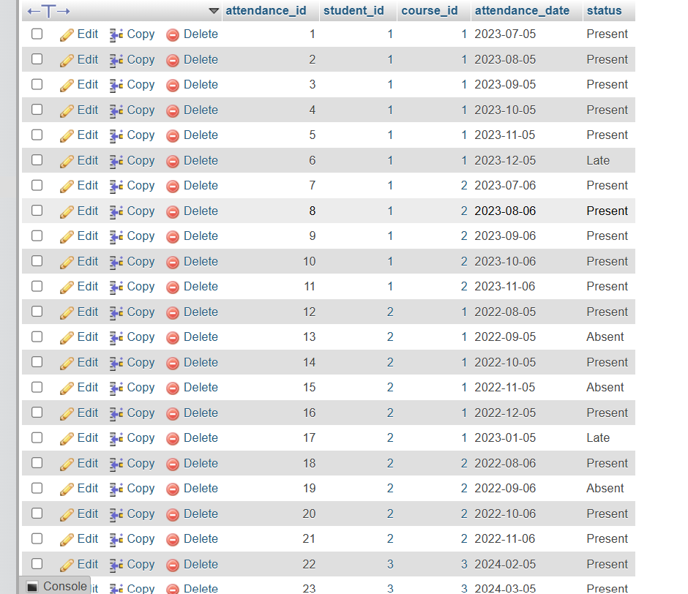

7) Table: Grades

Create :
CREATE TABLE Grades (grade_id INT PRIMARY KEY AUTO_INCREMENT, student_id INT NOT NULL,course_id INT NOT NULL,marks_obtained DECIMAL(5,2) NOT NULL,grade VARCHAR(5),

CONSTRAINT fk_grade_student
FOREIGN KEY (student_id)
REFERENCES Students(student_id)
ON DELETE CASCADE,

CONSTRAINT fk_grade_course
FOREIGN KEY (course_id)
REFERENCES Courses(course_id)
ON DELETE CASCADE,

CONSTRAINT uq_student_course_grade UNIQUE (student_id, course_id));

Insert Data :
INSERT INTO Grades(student_id, course_id, marks_obtained, grade)VALUES
(1, 1, 95, 'A+'),
(1, 2, 88, 'A'),
(1, 5, 92, 'A+'),

(2, 1, 78, 'B+'),
(2, 2, 69, 'C'),
(2, 6, 82, 'A'),

(3, 3, 91, 'A+'),
(3, 4, 85, 'A'),
(3, 5, 76, 'B+'),

(4, 3, 72, 'B'),
(4, 4, 94, 'A+'),
(4, 6, 88, 'A'),

(5, 7, 65, 'C'),
(5, 6, 58, 'D'),

(6, 7, 93, 'A+'),
(6, 6, 79, 'B+'),

(7, 1, 55, 'D'),
(7, 5, 61, 'C'),
(7, 6, 73, 'B'),

(8, 3, 89, 'A'),
(8, 4, 97, 'A+'),
(8, 5, 90, 'A'),

(9, 1, 84, 'A'),
(9, 2, 96, 'A+'),
(9, 5, 87, 'A');

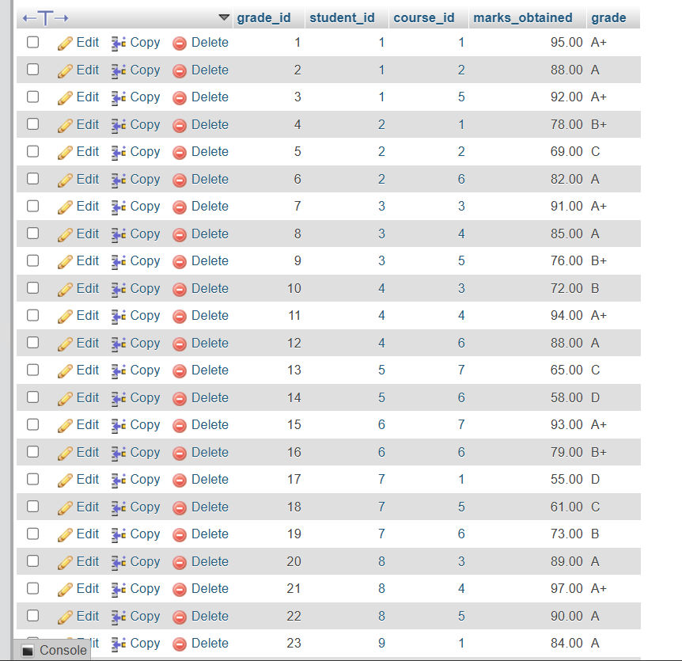
- Queries

- Add new student

INSERT INTO Students(name, dob, gender, email, phone_number, address, admission_date, department_id)VALUES('Manav Patel', '2003-06-15', 'Male', 'manav@gmail.com','9000000011', 'Ahmedabad', '2025-06-15', 1);

- Update student record

UPDATE Students SET phone_number = '9111111111',address = 'Rajkot'WHERE student_id = 11;

- Search Student

SELECT *FROM Students WHERE student_id = 11;

- Delete Student

DELETE FROM Students WHERE student_id = 11;

- Where Clause
SELECT *FROM Students WHERE department_id = 1;

- Limit
SELECT student_id,marks_obtained FROM Grades ORDER BY marks_obtained DESC LIMIT 10;

- Having
SELECT course_id,AVG(marks_obtained) AS average_marks FROM Grades GROUP BY course_id HAVING AVG(marks_obtained) > 80;

- Attendance below 75%
SELECT student_id,COUNT(*) AS total_classes,SUM(status = 'Present') AS present_classes, ROUND(SUM(status = 'Present') * 100.0 / COUNT(*),2)AS attendance_percentage FROM Attendance GROUP BY student_id HAVING attendance_percentage < 75;
- And Operator
SELECT s.student_id,s.name,g.marks_obtained FROM Students s JOIN Grades g ON s.student_id = g.student_id WHERE g.marks_obtained < 60 AND s.student_id IN (SELECT student_id FROM Attendance GROUP BY student_id HAVING SUM(status = 'Present') * 100.0 / COUNT(*) < 50);

- Or Operator
SELECT DISTINCT s.student_id,s.name FROM Students s LEFT JOIN Grades g ON s.student_id = g.student_id WHERE g.marks_obtained > 90 OR s.student_id IN (SELECT student_id FROM Attendance GROUP BY student_id HAVING SUM(status = 'Present') * 100.0 / COUNT(*) = 100);

- Not Operator
SELECT f.faculty_id,f.name FROM Faculty f WHERE NOT EXISTS (SELECT 1 FROM Courses c WHERE c.faculty_id = f.faculty_id);

- Order By
SELECT *FROM Students ORDER BY name ASC;

- Group By
SELECT department_id,COUNT(*) AS total_students FROM Students GROUP BY partment_id;

- Group By + Avg
SELECT course_id,AVG(marks_obtained) AS average_marks FROM Grades GROUP BY course_id;

- Aggregate Functions + PK/FK Relationships

- AVG(Average Attendance Percentage)
SELECT ROUND(AVG(attendance_percentage),2) AS average_attendance_percentage FROM (SELECT student_id,SUM(status = 'Present') * 100.0 / COUNT(*) AS attendance_percentage FROM Attendance GROUP BY student_id) AS attendance_summary;

- Max
SELECT course_id,MAX(marks_obtained) AS highest_marks FROM Grades GROUP BY course_id;

- Min
SELECT course_id,MIN(marks_obtained) AS lowest_marks FROM Grades GROUP BY course_id;

- Count
SELECT department_id,COUNT(*) AS total_students FROM Students GROUP BY department_id;

- Sum
SELECT course_id,SUM(marks_obtained) AS total_marks FROM Grades GROUP BY course_id;

- Verify the Primary Keys of all project tables.
SELECT TABLE_NAME,COLUMN_NAME,CONSTRAINT_NAME FROM INFORMATION_SCHEMA.KEY_COLUMN_USAGE WHERE TABLE_SCHEMA = 'student_tracker' AND CONSTRAINT_NAME = 'PRIMARY';

- Verify all Foreign Key relationships in the database.
SELECT TABLE_NAME,COLUMN_NAME,CONSTRAINT_NAME, REFERENCED_TABLE_NAME,REFERENCED_COLUMN_NAME FROM INFORMATION_SCHEMA.KEY_COLUMN_USAGE WHERE TABLE_SCHEMA = 'student_tracker' AND REFERENCED_TABLE_NAME IS NOT NULL;

- Ensure that a student cannot enroll in the same course more than once.
SHOW CREATE TABLE Enrollments;

- Joins

- Retrieve student details along with their department using INNER JOIN.
SELECT s.student_id, s.name AS student_name, s.email, d.department_id, d.department_name FROM Students s INNER JOIN Departments d ON s.department_id = d.department_id;
- Get a list of students who have not enrolled in any course using LEFT JOIN.
SELECT s.student_id, s.name AS student_name FROM Students s LEFT JOIN Enrollments e ON s.student_id = e.student_id WHERE e.enrollment_id IS NULL;
- List courses that have no faculty assigned using RIGHT JOIN.
SELECT c.course_id, c.course_name, f.faculty_id, f.name AS faculty_name FROM Faculty f RIGHT JOIN Courses c ON f.faculty_id = c.faculty_id WHERE f.faculty_id IS NULL;
- Show students without grades using FULL OUTER JOIN.
SELECT s.student_id, s.name AS student_name, g.grade_id, g.marks_obtained FROM Students s LEFT JOIN Grades g ON s.student_id = g.student_id UNION SELECT s.student_id, s.name AS student_name, g.grade_id, g.marks_obtained FROM Students s RIGHT JOIN Grades g ON s.student_id = g.student_id;
- SubQueries
- Find students with marks above the average score.
SELECT s.student_id, s.name, g.marks_obtained FROM Students s INNER JOIN Grades g ON s.student_id = g.student_id WHERE g.marks_obtained > (SELECT AVG(marks_obtained) FROM Grades);
- Retrieve courses taught by faculty members with at least 5 years of experience.
SELECT course_id, course_name, faculty_id FROM Courses WHERE faculty_id IN (SELECT faculty_id FROM Faculty WHERE experience_years >= 5);

- Identify students who have missed more than 10 classes.
SELECT s.student_id, s.name, COUNT(a.attendance_id) AS missed_classes FROM Students s INNER JOIN Attendance a ON s.student_id = a.student_id WHERE a.status = 'Absent' GROUP BY s.student_id, s.name HAVING COUNT(a.attendance_id) > 10;

- Date & Time Function

- Extract the month from attendance_date to analyze attendance trends.
SELECT attendance_id, student_id, course_id, attendance_date, MONTH(attendance_date) AS attendance_month FROM Attendance;
- Calculate the number of years since a student's admission.
SELECT student_id, name, admission_date, TIMESTAMPDIFF(YEAR, admission_date, CURDATE()) AS years_since_admission FROM Students;
- Format attendance_date as DD-MM-YYYY.
SELECT attendance_id, attendance_date, DATE_FORMAT(attendance_date, '%d-%m-%Y') AS formatted_date FROM Attendance;

- String Function

- Convert all faculty names to uppercase.
SELECT faculty_id, UPPER(name) AS faculty_name FROM Faculty;
- Trim unnecessary spaces from student names.
SELECT student_id, TRIM(name) AS cleaned_name FROM Students;
- Replace NULL email fields with "Email Not Provided".
SELECT student_id, name, COALESCE(email, 'Email Not Provided') AS email FROM Students;

- Window Function
- Rank students based on their overall marks.
SELECT student_id, student_name, overall_marks, RANK() OVER (ORDER BY overall_marks DESC) AS student_rank FROM (SELECT s.student_id, s.name AS student_name, AVG(g.marks_obtained) AS overall_marks FROM Students s INNER JOIN Grades g ON s.student_id = g.student_id GROUP BY s.student_id, s.name) AS student_scores ORDER BY student_rank;
- Show the cumulative attendance percentage per course.
SELECT attendance_id, course_id, attendance_date, status, SUM(status = 'Present') OVER (PARTITION BY course_id ORDER BY attendance_date, attendance_id ROWS BETWEEN UNBOUNDED PRECEDING AND CURRENT ROW) AS cumulative_present, COUNT(*) OVER (PARTITION BY course_id ORDER BY attendance_date, attendance_id ROWS BETWEEN UNBOUNDED PRECEDING AND CURRENT ROW) AS cumulative_classes, ROUND(SUM(status = 'Present') OVER (PARTITION BY course_id ORDER BY attendance_date, attendance_id ROWS BETWEEN UNBOUNDED PRECEDING AND CURRENT ROW) * 100.0 / COUNT(*) OVER (PARTITION BY course_id ORDER BY attendance_date, attendance_id ROWS BETWEEN UNBOUNDED PRECEDING AND CURRENT ROW), 2) AS cumulative_attendance_percentage FROM Attendance ORDER BY course_id, attendance_date, attendance_id;
- Display the running total of students enrolled per month.
SELECT enrollment_month, monthly_enrollments, SUM(monthly_enrollments) OVER (ORDER BY enrollment_month ROWS BETWEEN UNBOUNDED PRECEDING AND CURRENT ROW) AS running_total FROM (SELECT DATE_FORMAT(enrollment_date, '%Y-%m') AS enrollment_month, COUNT(*) AS monthly_enrollments FROM Enrollments GROUP BY DATE_FORMAT(enrollment_date, '%Y-%m')) AS monthly_data ORDER BY enrollment_month;

- Case Expression
1)Assign student performance levels:
- Excellent → marks > 90
- Good → 75–90
- Needs Improvement → otherwise
SELECT student_id,course_id,marks_obtained,CASE WHEN marks_obtained > 90 THEN 'Excellent'WHEN marks_obtained BETWEEN 75 AND 90 THEN 'Good'ELSE 'Needs Improvement' END AS performance_level FROM Grades;

2) Categorize attendance records:
- Regular → attendance above 80%
- Irregular → 50%–80%
- Defaulter → otherwise
SELECT student_id,total_classes,present_classes,attendance_percentage,CASE WHEN attendance_percentage > 80 THEN 'Regular' WHEN attendance_percentage BETWEEN 50 AND 80 THEN 'Irregular' ELSE 'Defaulter' END AS attendance_category FROM (SELECT student_id,COUNT(*) AS total_classes,SUM(status = 'Present') AS esent_classes,ROUND(SUM(status = 'Present') * 100.0 / COUNT(*),2) AS attendance_percentage FROM Attendance GROUP BY student_id) AS attendance_summary;

