Experiment 10

AIM: Develop a Laravel/Django based web application

- Open VS Code -> Terminal -> New Terminal

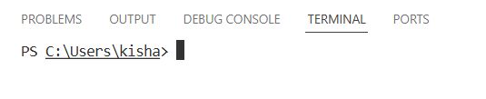

- Create New Project
python -m django startproject myproject or django-admin startproject
myproject
cd myproject
pip install Django

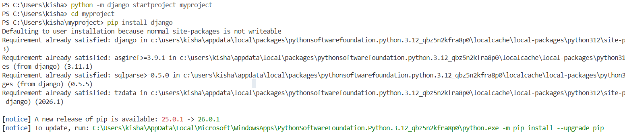

- Run Server (First Test)
python manage.py runserver
Open browser:
http://127.0.0.1:8000/

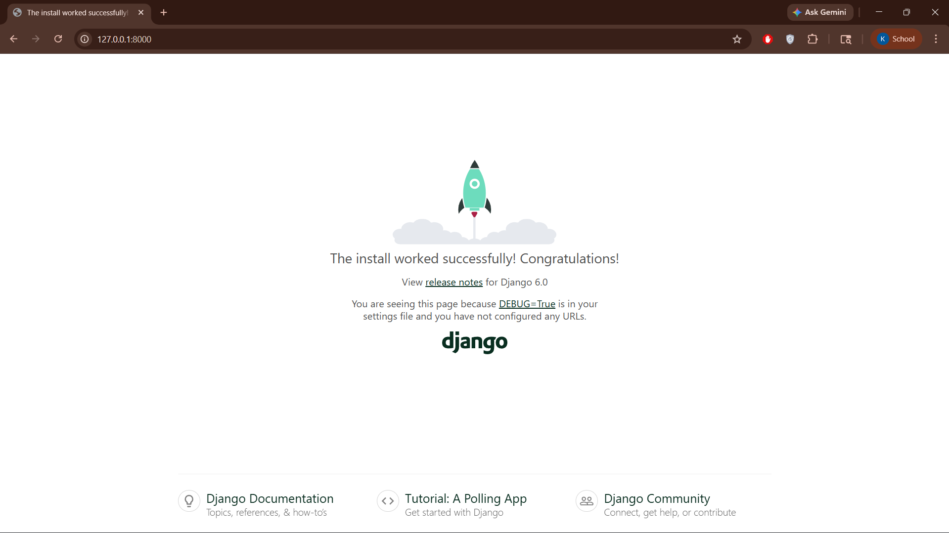

- Create Simple App
python manage.py startapp myapp

- Register App
Open: myproject/settings.py and include the below code
INSTALLED_APPS = [
'django.contrib.admin',
'django.contrib.auth',
'django.contrib.contenttypes',
'django.contrib.sessions',
'django.contrib.messages',
'django.contrib.staticfiles',
'myapp', # your app
]

- Create Simple View
Open: myapp/views.py and include below code
from django.http import HttpResponse
def home(request):
return HttpResponse("Hello from VS Code Django!")

- Create URL File
Create file: myapp/urls.py and include below code
from django.urls import path

from . import views
urlpatterns = [
path('', views.home),

]
- Connect URLs
Open: myproject/urls.py include below code
from django.contrib import admin
from django.urls import path, include
urlpatterns = [
path('', include('myapp.urls')),
path('admin/', admin.site.urls),
]

- Run
python manage.py runserver
Open:
http://127.0.0.1:8000/

Output:

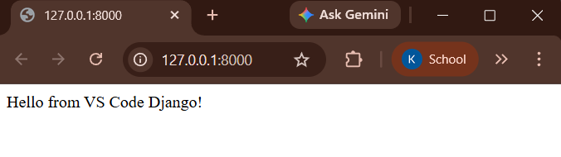

To add GUI:
1. Create Template Folder
Inside myapp, create:

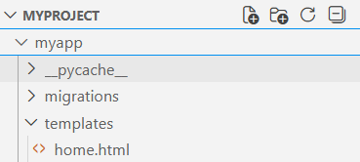

2. Add the below GUI Code
<!DOCTYPE html>
<html>
<head>
<title>Django UI Demo</title>

<link href="https://fonts.googleapis.com/css2?family=Poppins&display=swap" rel="stylesheet">

<style>
body {
font-family: 'Poppins', sans-serif;
margin: 0;
background: linear-gradient(135deg, #4facfe, #00f2fe);
color: #333;
}

.container {
text-align: center;
padding: 60px 20px;
}

h1 {
color: white;
font-size: 40px;
margin-bottom: 10px;
}

p {
font-size: 18px;
color: #d02323;
}

.card {
background: white;
margin: 40px auto;
padding: 30px;
border-radius: 15px;
width: 300px;
box-shadow: 0px 8px 20px rgba(0,0,0,0.2);
}

button {
padding: 12px 25px;
border: none;
border-radius: 25px;
background: #4facfe;
color: white;
font-size: 16px;
cursor: pointer;
transition: 0.3s;
}

button:hover {
background: #007bff;
transform: scale(1.05);
}

.footer {
margin-top: 50px;
color: white;
font-size: 14px;
}
</style>
</head>

<body>

<div class="container">
<h1>Welcome to Django UI 🚀</h1>
<p>This is a modern styled interface</p>

<div class="card">
<h2>Hello User 👋</h2>
<p>Click the button below</p>
<button onclick="showMessage()">Click Me</button>
</div>

<div class="footer">
<p>Developed using Django + HTML + CSS</p>
</div>
</div>

<script>
function showMessage() {
alert("🎉 Welcome to your Django App!");
}
</script>

</body>
</html>

3. Update views.py
Open: myapp/views.py and include below code
from django.shortcuts import render
def home(request):
return render(request, 'home.html')

4. Run Server
python manage.py runserver

